State of Kansas
Using SMART Chartfield and Configuration Values Queries
Statewide Management, Accounting and Reporting Tool

Date Created: | 01/14/2013
Version: | 2.0
Last Updated: | 03/21/2019
Purpose of the FIN Queries in SMART: | The FIN Queries allow SMART end users to run queries containing lists of their Agency’s data such as ChartField values.  The information provided in these queries is stored ‘behind the scenes’ in SMART in a series of data tables called “Control Tables”. These Control Tables store data such as Chartfield values or Agency data by either the ‘Effective Date’ and/or by the ‘As of Date’.  The SMART Control tables contain lists of Chartfield values and Agency data that are shared across a Business Unit (Agency).
Security Access to FIN Queries in SMART: | - SMART Security Role Access: GL_Viewer  - SMART Business Unit (BU) Security: Business Unit Security is applied.  Agencies only have access to journals with their Agency’s business unit.
List of FIN Queries in SMART: | The FIN queries provide data contained within the SMART Control Tables. On the following pages, you will find a table containing the list of the FIN Queries contained within SMART, which end users can run.  Following the table containing the list of FIN queries, you will find the instructions on “How to Run a SMART FIN Query” (on Page 6 of this document).

Navigation:  From the SMART Homepage, click on ‘General Ledger/KK page’, then click on ‘GL Utilities tile’, then click on ‘Query Viewer’ | State of Kansas – SMART – FIN Queries (General Ledger):  Query Name Description Definition Query Parameters Prompt Values Populated Result Sorts  FIN0004_ACCOUNT_TYPES Account Types Account types categorize accounts that normally appear on a balance sheet versus those that appear on an income statement, and also specify whether or not accounts are ‘balance forward’ accounts in the GL ACTUALS ledger close process. Find all SMART Account Types. SetID: SOKID SetID Type Description Short Desc Bal Fwd  FIN0010_GL ACCOUNTS Account Codes Accounts categorize monetary values stored in ledgers and classify the nature of a transaction. The Account code stores an identifier which indicates if the account is for an asset, liability, fund/equity, revenue or expenditure type account. Find all SMART Account Codes. SetID: SOKID As of Date: T (for today’s date) SetID Account Descr Short Desc Type  FIN0011_DEPARTMENT_CODES Department IDs Department IDs identify the organizational entity associated with a particular financial transaction Find Department IDs by Business Unit. SetID:5 digit Business Unit number As of Date: T (for today’s date) SetID Dept Description As of Date Short Desc Budgetary Only  FIN0013_VALID_PROJECT_IDs Project IDs The Project ID is a unique ID to track grant and project financial activity, which can cross budget years, funds and departments. Find all Project IDs. SetID: SOKID SetID Project Proj Type Description  FIN0017_VALID_SET_IDS Set IDs SetID defines the accounting structure and processing rules for a particular business unit or group of business units. Tables or processes that are shared across multiple business units use SetID SOKID. Find all valid SetIDs. None SetID Description Short Desc  FIN0024_BUD_REF Budget Unit The Budget Unit is a four-digit code created for each appropriation authorized by the Legislature Multiple budget units may be established in a fund to differentiate between different lines of Appropriation or different funding sources Find Budget Units by Business Unit. SetID: 5 digit Business Unit number Effective Date: T (for today’s date) SetID Bud Unit Descr Short Desc Budgetary Only Eff Date  FIN0037_CHARTFIELD1 Agency Use Field The Agency Use Chartfield is used to accommodate agency specific financial data that can’t be captured in another ChartField. Find Agency Use Codes by Business Unit. SetID: 5 digit Business Unit number Effective Date: T (for today’s date) SetID Agy Use Status Descr Eff Date Short Desc Bud.Only  FIN0038_CHARTFIELD2 ChartField 2 ChartField2 is used by a limited number of agencies to accommodate agency specific financial data that can’t be captured in another ChartField. Find ChartField 2 by Business Unit. SetID: 5 digit Business Unit number Effective Date: T (for today’s date) SetID ChartField Eff Date Status Descr As of date Short Desc Budgetary Only  FIN0050_VALID_FUNDS Fund Codes The Fund Code defines a fiscal and accounting entity with a self-balancing set of accounts. Find all Fund Codes. SetID: SOKID As of Date: T (for today’s date) SetID Fund Descr Budgetary Only As of Date Attribute Attribute Value Descript  FIN0052_VALID_PROGRAMS Programs The Program Code allows the user to track the cost of providing goods and services in response to an identified social or individual need or problem. Find Program Codes by Business Unit. SetID: 5 digit Business Unit number As of Date: T (for today’s date) SetID Program Description Manager Name Budgetary Only As of date  FIN0053_VALID_APPROPRIATIONS Service Locations The Service Location ChartField captures the concept of location (state, county, city, district, building, etc). Find Service Locations by Business Unit. SetID: 5 digit Business Unit number As of Date: T (for today’s date) SetID Svc Loc Descripton Budgetary Only As of Date

How to Run a FIN Query:
1. | From the SMART Homepage, click on ‘General Ledger/KK page’, then click on ‘GL Utilities tile’, then click on ‘Query Viewer’  - Enter the desired FIN Query Name into the ‘begins with’ field on the Query Viewer page.  - Click the “Search” button.  - In the Query section: Select the “Excel” link in the ‘Run to Excel’ column***. | 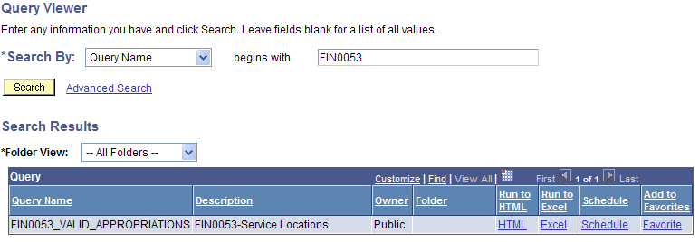
2. | - Enter the Prompt Values data for the selected FIN Query.  Note: Refer to the FIN Queries table (on the previous pages) which contains the FIN Queries information.  - Then, select the “View Results” button. |  | 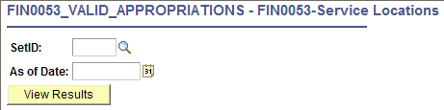
3. | A ‘File Download’ dialog box opens.  - Select the “Open” button. |  | 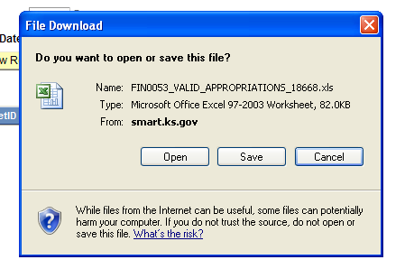
4. | The FIN Query results (based on the Prompt Values you entered) are displayed in an Excel spreadsheet. |  | 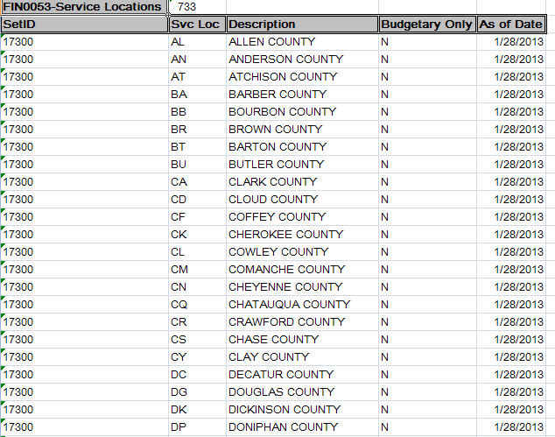
NOTE: |  |  | *** If desired, you can select the “HTML” link on the Query Viewer page (instead of the “Excel’ link).  Selecting the ‘HTML’ link prompts SMART to display the FIN query results on a new page (on-line within the SMART environment).  The SMART on-line page contains an ‘Excel’ link which you can then click from that page to export the into an Excel spreadsheet, if desired.

