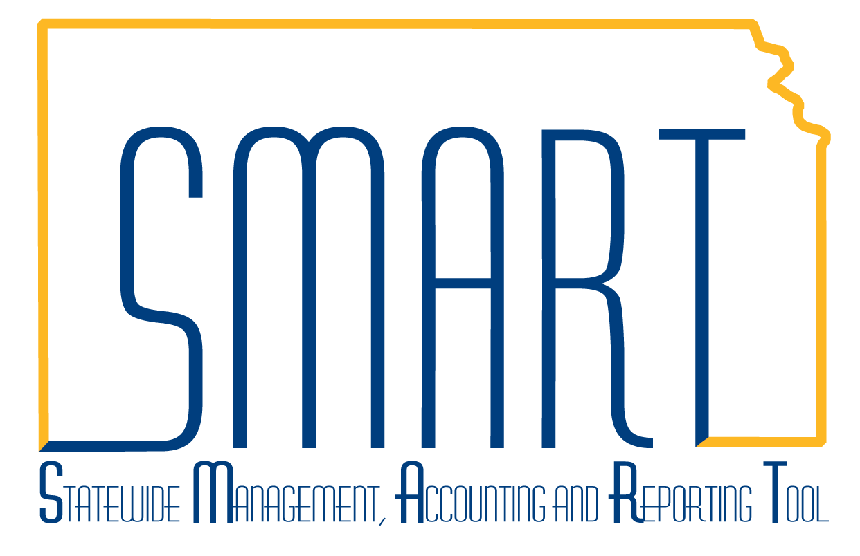
State of Kansas
Requisitions & PCards Homepage Guide
Statewide Management, Accounting and Reporting Tool

Date Created: | 3/15/2019
Version: | 1
Last Updated Date: | 3/15/2019
Background: | The Requisitions & PCards Homepage contains elements of the eProcurement and Purchasing modules used to create and maintain Requisitions and PCards.
General Ledger/KK Homepage: | The Requisitions & PCards homepage contains the following tiles:  - eProcurement Messages  - Create Requisitions  - Manage Requisitions  - Procurement Cards  - Buyer WorkCenter  - Training Resources  - Req & PCards Reporting  - Utilities  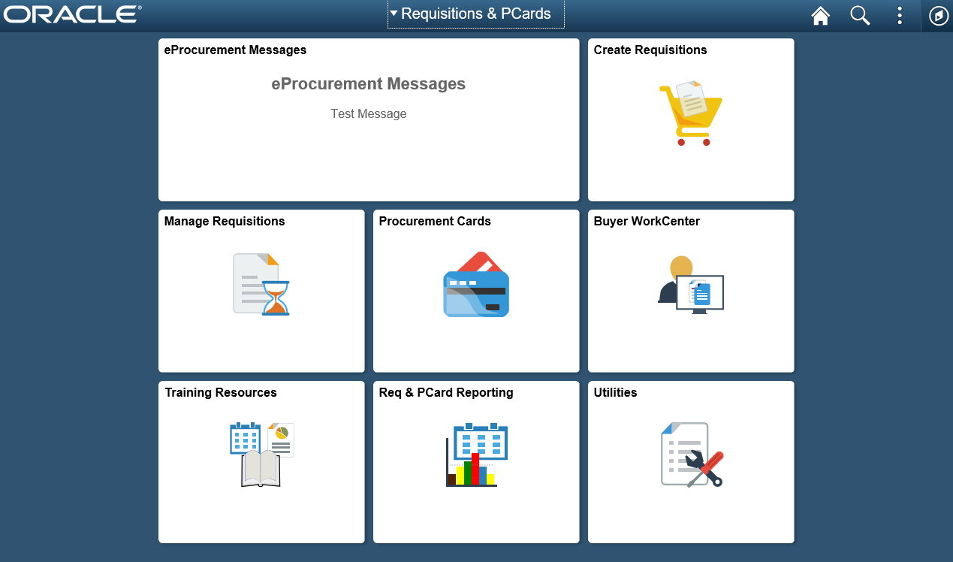

eProcurement Messages | This tile will contain any important messages that need communicated to users of the Requisitions & PCard community. Unless there is a message that users need to see, this tile will remain blank.  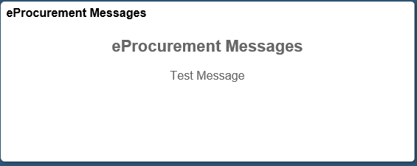
Create Requisitions | This tile is a direct link to the Requisitions Settings page to enter a new requisition.  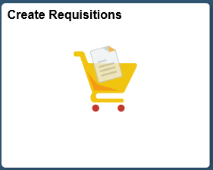
Manage Requisitions | This tile allows users to inquire, manage, and approve requistions.  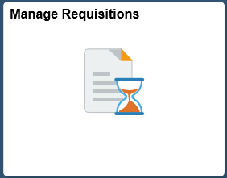  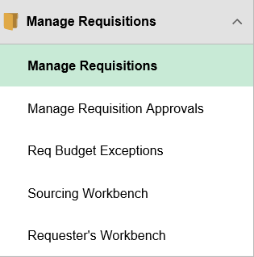
Procurement Cards | This tile allows users to reconcile transactions and manage PCard information.  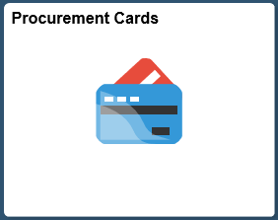  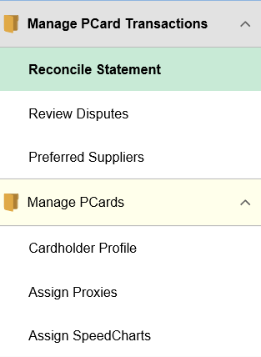

Buyer WorkCenter | This tile is for the Buyer WorkCenter that was introduced with the original upgrade to Peoplesoft 9.2. It allows users to perform various tasks that relate to the eProcurement and Purchasing areas.  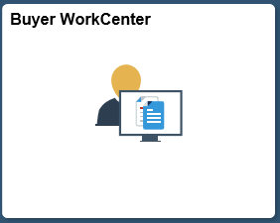  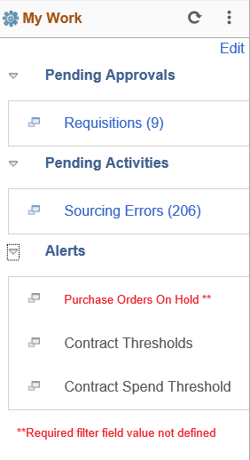  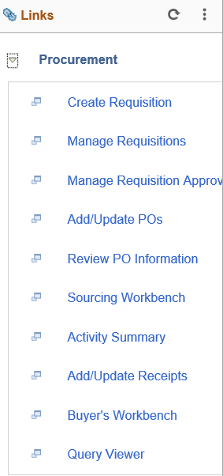  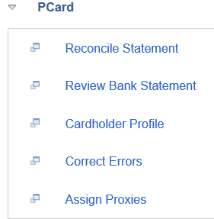  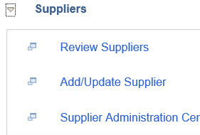  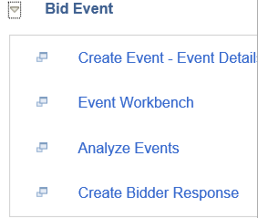  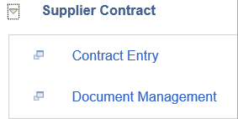
Training Resources | This tile provides users access to training documents and procurement directives from multiple resources across the state.  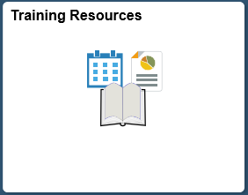  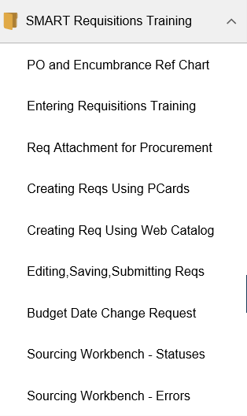  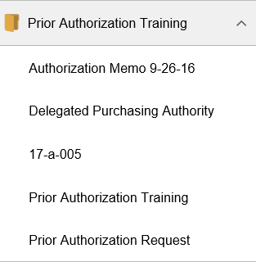  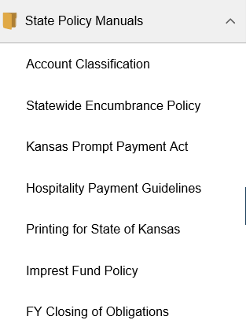  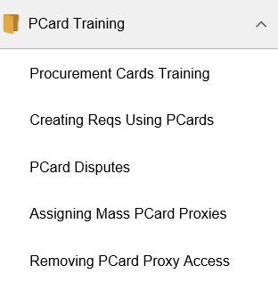

Req & PCard Reporting | This tile allows users to run various eProcurement and PCard reports.  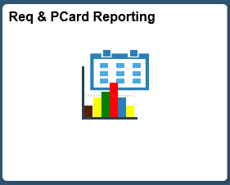  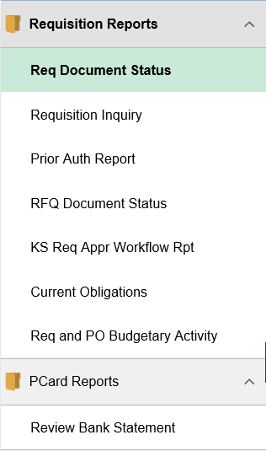
Utilities | This tile allows users to acccess the Process Monitor, Queries, Report Manager, Worklist, and a link to the SMARTWeb Reporting page.  