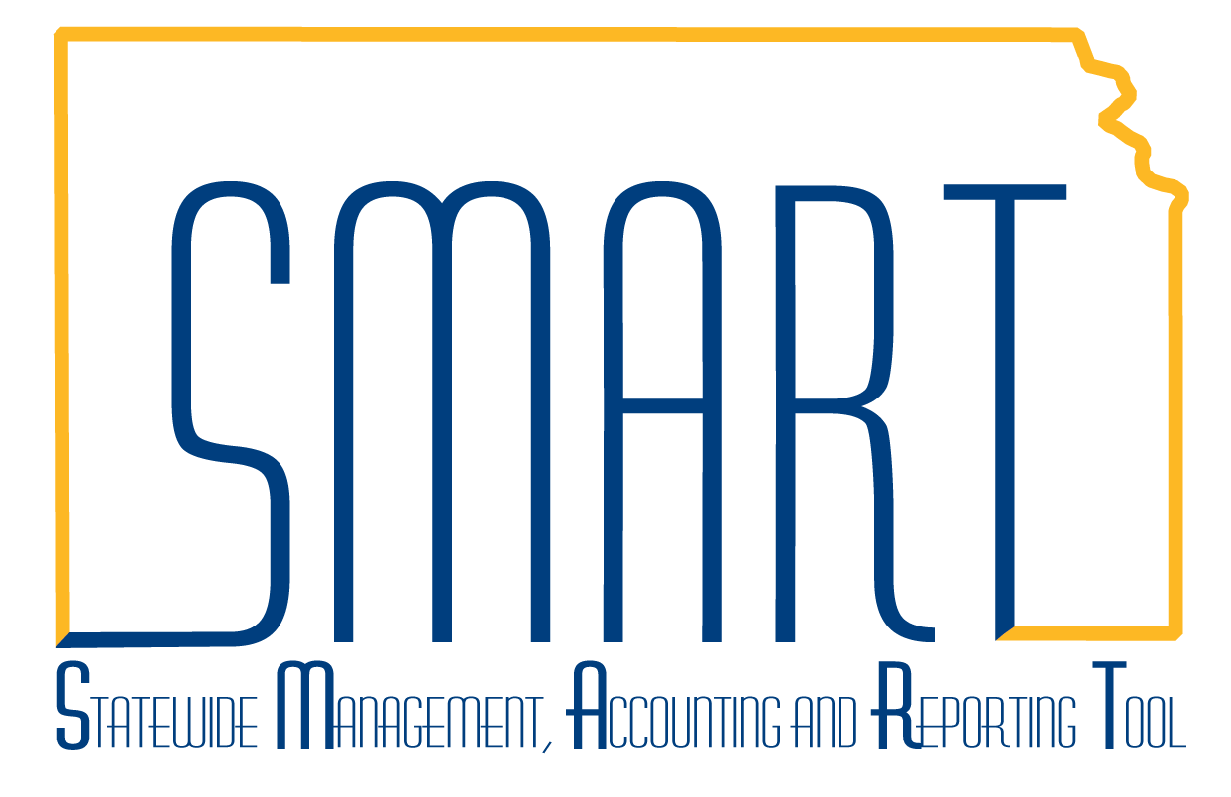State of Kansas
Kansas eSupplier Public Portal Guide
Statewide Management, Accounting and Reporting Tool

Date Created: | 3/11/2019
Version: | 1
Last Updated Date: | 3/11/2019
Background: | The Kansas eSupplier Public Portal allows external bidders and suppliers to do business with the State of Kansas. It provides a convenient links to the Office of Procurement and Contracts website where users can find bidder resources.
Kansas eSupplier Public Portal homepage: | The Kansas eSupplier Public Portal homepage contains the following tiles:  - Sign In  - Welcome to Kansas eSupplier  - User Registration  - Procurement and Contracts  - Calendar  - Announcements  - FAQs | Contact Us  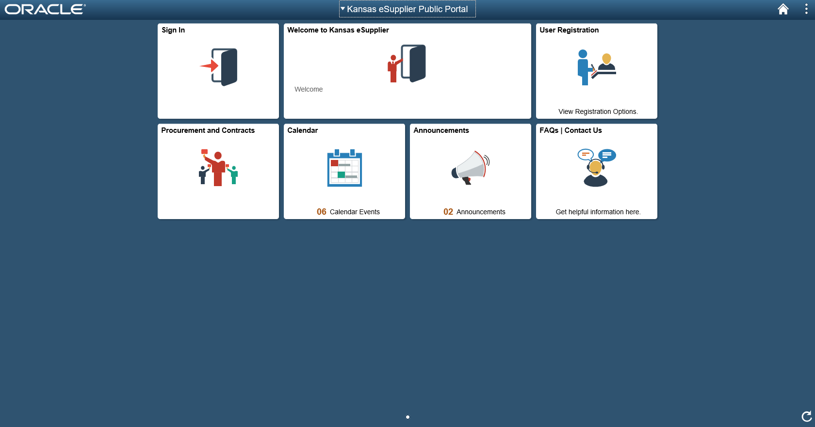

Sign In | The ‘Sign In’ tile opens a pop-up window that allows users who have already registered in eSupplier to login to the portal.  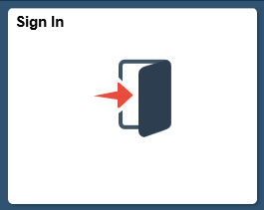  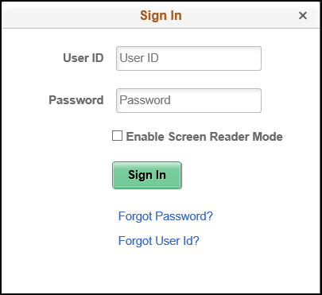

Welcome to Kansas eSupplier | The ‘Welcome to Kansas eSupplier’ tile takes users to a page that contains the Office of Procurement and Contracts mission statement, as well as the disclaimer statement for the use of the Kansas eSupplier portal.  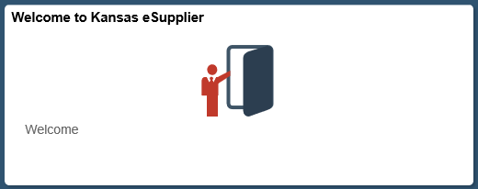
User Registration | This tile goes to a page where the user can choose to register themselves as a new bidder with the State of Kansas, or to register themselves for a supplier user account, depending on whether they have done business with the State of Kansas previously.  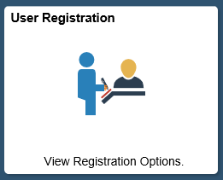  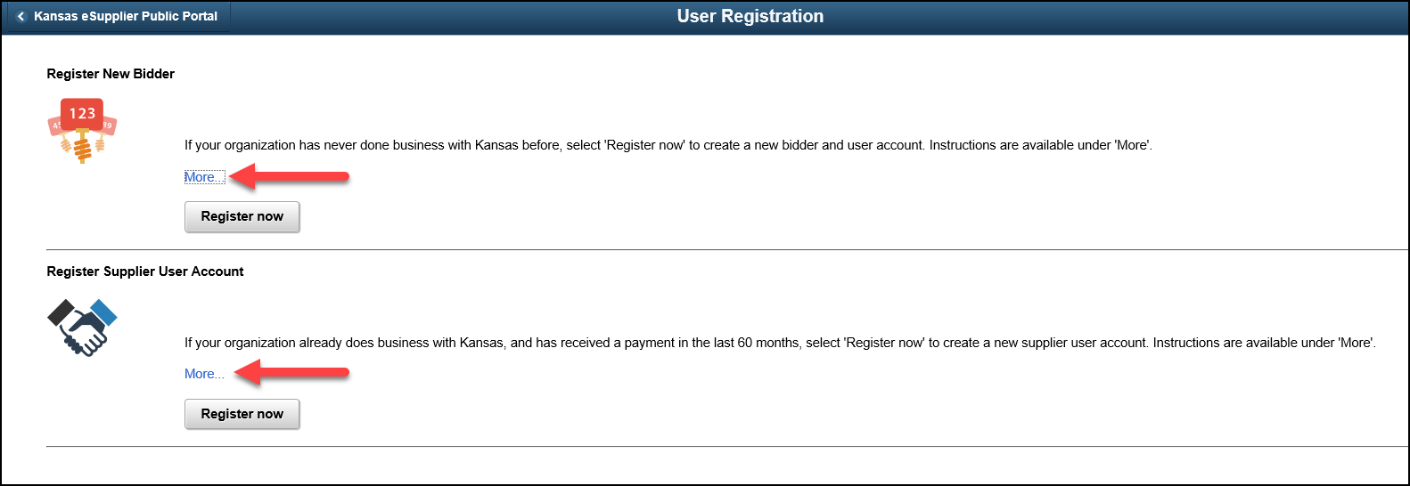  NOTE: Job aids with detailed steps for each registration process can be found by clicking the “More…” link in each section.

Procurement and Contracts | This tile open a new window to the State of Kansas Office of Procurement and Contracts website. This is where users can find bid solicitations and information on active state contracts.  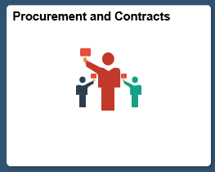
Calendar | This tile takes users to a calendar that provides the schedule of state holidays, maintenance dates when the portal will be unavailable, etc. Bid date information will not be on this calendar.

Announcements | This tile provides a place for announcements that pertain to the bidder/supplier community.  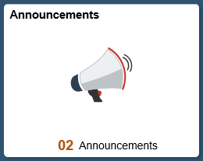
FAQs | Contact Us | This tile contains links to helpful resources, such as job aids for the registration process, browser compatibility information and how to get assistance with login/password issues.  