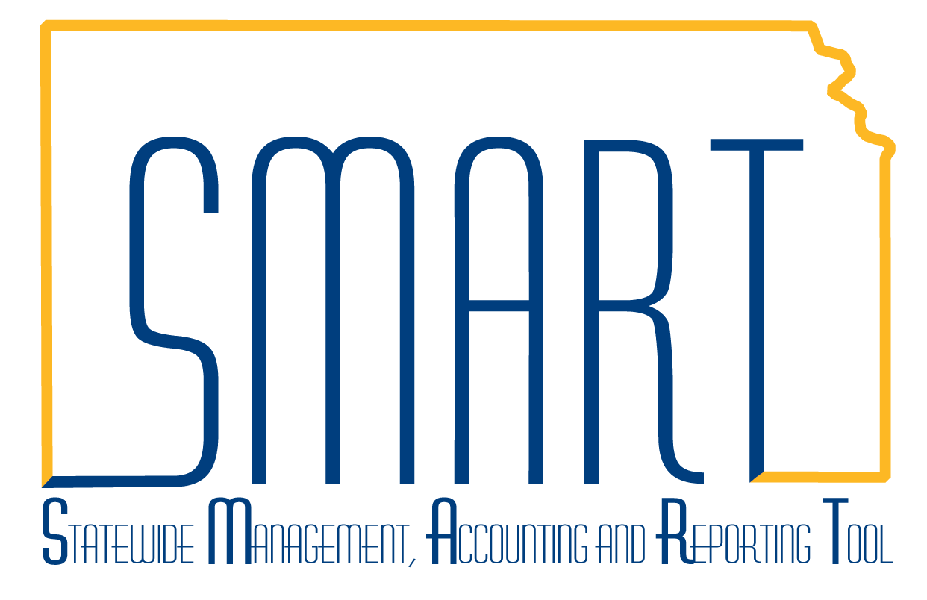
State of Kansas
General Ledger/KK Homepage Guide
Statewide Management, Accounting and Reporting Tool

Date Created: | 3/5/2019
Version: | 1
Last Updated Date: | 3/5/2019
Background: | The General Ledger/KK Homepage contains the General Ledger and Commitment Control modules. Additionally, ChartField Request can be inititated and reviewed on this homepage.
General Ledger/KK Homepage: | The General Ledger/KK homepage contains the following tiles:  - General Ledger & KK Messages  - GL WorkCenter  - General Ledger  - Commitment Control  - ChartField Maintenance  - GL & KK Reports  - GL Utilities  - Allocations(ADB)  - Close  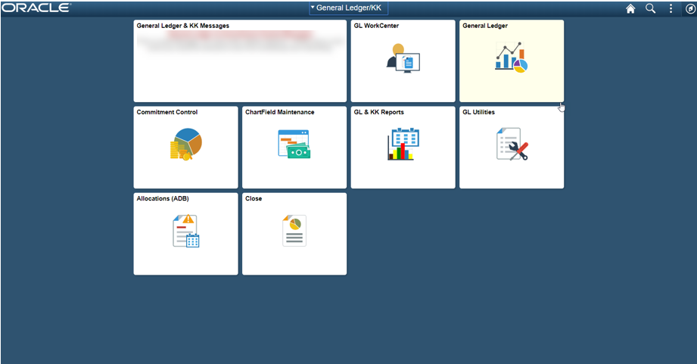

General Ledger & KK Messages | The ‘General Ledger & KK Messages’ tile will contain any important messages that need communicated to users of the General Ledger/KK community. Unless there is a message that users need to see, this tile will remain blank.  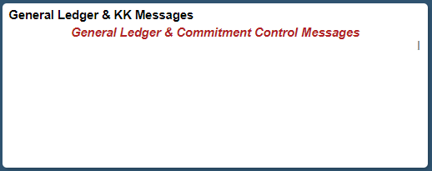
GL WorkCenter tile | This tile is for the GL WorkCenter that was introduced with the original upgrade to Peoplesoft 9.2. It allows users to perform various tasks and access some job aids that relate to GL and KK areas.  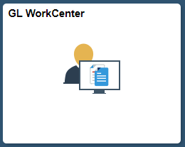  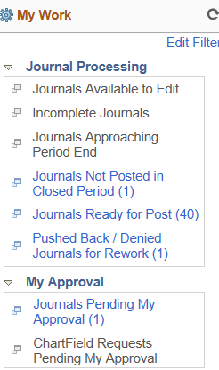  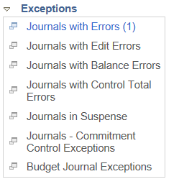  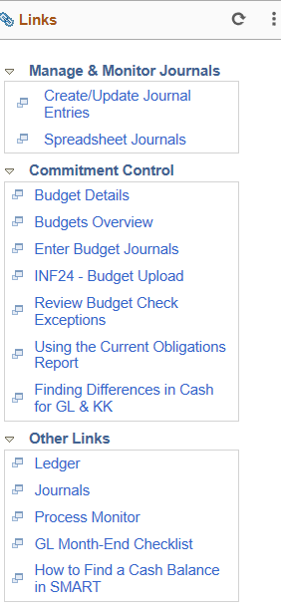  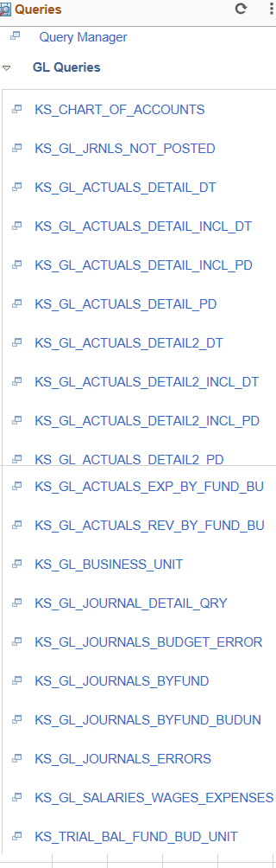  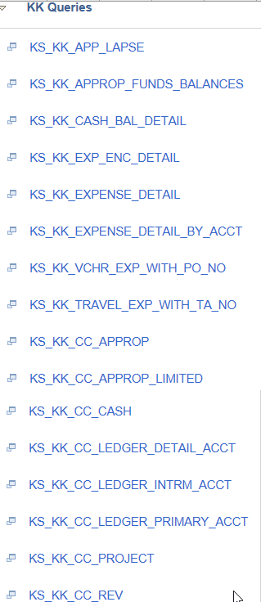  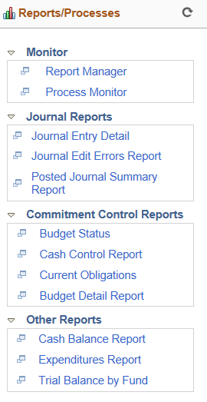
General Ledger tile | This tile allows users to enter, approve, process, and inquire on journals and entries into the General Ledger.  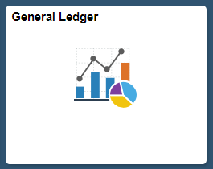  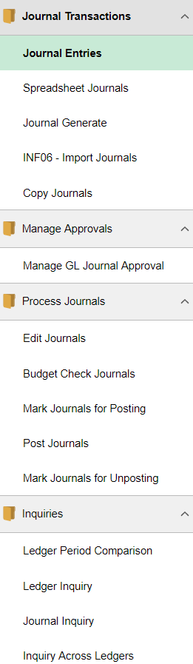

Commitment Control tile | This tile allows users to enter and review budget journals and to review budget activities in Commitment Control.  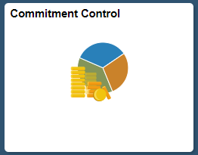  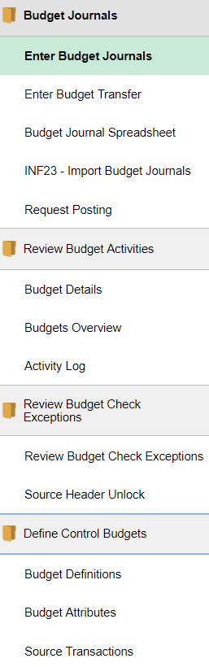
ChartField Maintenance tile | This tile allows users to review and enter select ChartFields, as well as viewing and updating Trees and Combo Edit Rules with proper security access.  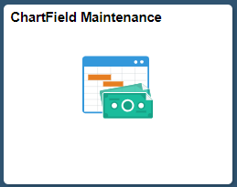  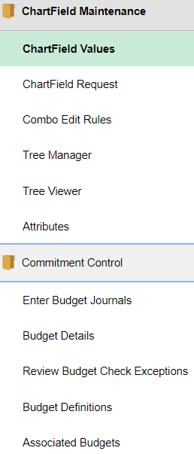
GL & KK Reports tile | This tile allows users to run various General Ledger and Commitment Control Reports and access the Process Monitor, Report Manger, Queries, nVision Reports and BI Analytics.  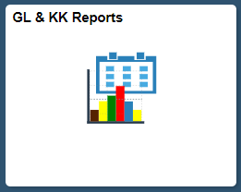  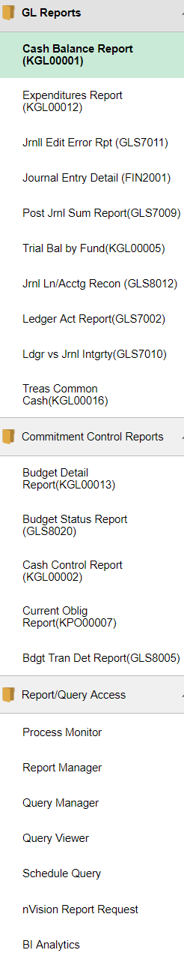

GL Utilities | This tile allows users to acccess the Process Monitor, Queries, Report Manager, Worklist, nVision and BI Analytics.  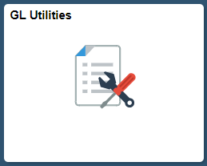  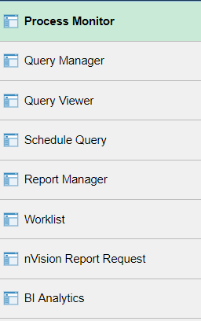
Allocations (ADB) | This tile allows users to run the allocation process and upload and review related journals.  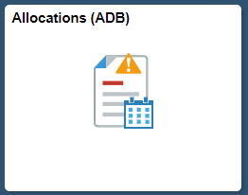  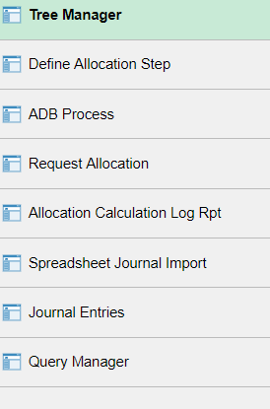
Close | This tile is primarily for Central Staff and allows for the initiation of various System Configuration and Closing Processes.  