State of Kansas
Expenses Homepage Guide
Statewide Management, Accounting and Reporting Tool

Date Created: | 03/06/2019
Version: | 1
Last Updated Date: | 03/07/2019
Background: | The Expenses homepage contains the navigation to the most commonly used pages for creating, approving, and maintaining expense transactions.
Expenses Homepage: | The Expenses homepage contains the following tiles:  - Expenses Messages  - Expense Reports  - Travel Authorizations  - Cash Advances  - EX Approvals  - Employee Info & Security  - EX Accounting  - Process Expenses  - EX Reporting  - Expense WorkCenter  - Ex Utilities  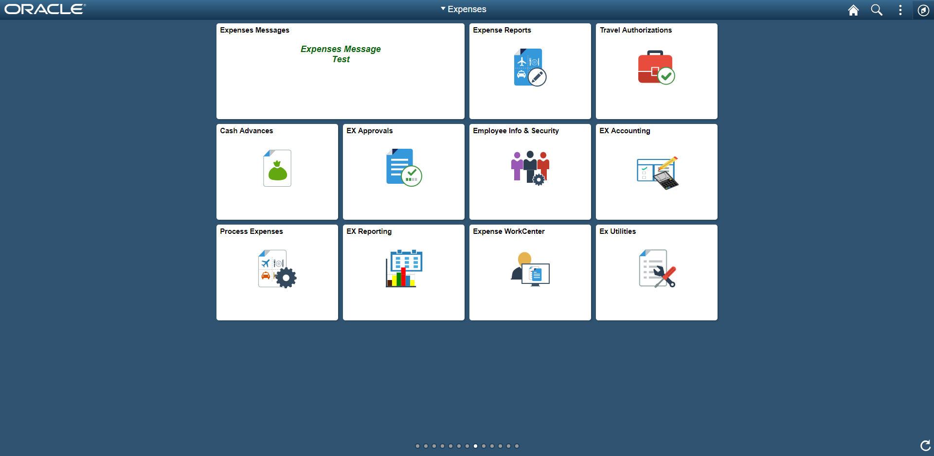

Expenses Messages | The ‘Expenses Messages’ tile will contain any important messages that need to be communicated about the Expenses module. Unless there is a message that users need to see, this tile will remain blank.  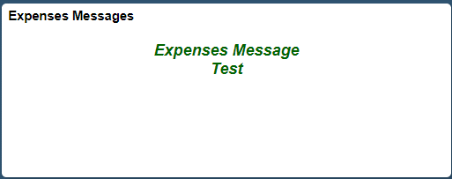
Expense Reports | The ‘Expense Report’ tile contains the pages used to create/modify, print, view, or delete expense reports. Users can also modify approved expense reports, mark expense reports for close, or create a journal expense report.  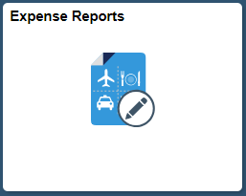  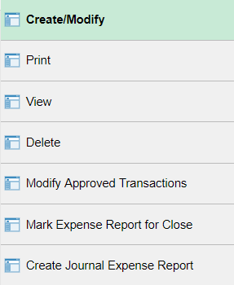
Travel Authorizations | The ‘Travel Authorizations’ tile contains the pages used to create/modify, view, delete, cancel, or print travel authorizations. Users can also modify approved travel authorizations.  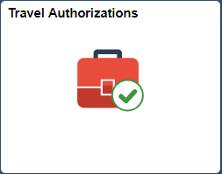  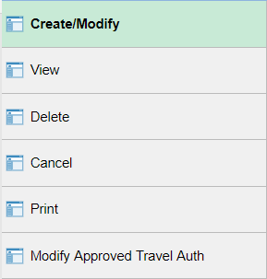

Cash Advances | The ‘Cash Advances’ tile contains the pages used to create/modify, view, delete, or print cash advances. Users can also modify approved cash advances, reconcile cash advances, or mark a cash advance for close.  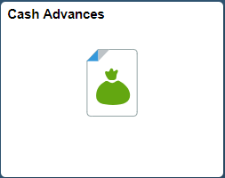  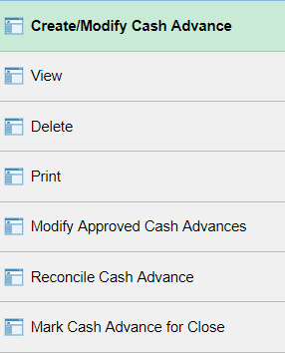
EX Approvals | The ‘EX Approvals’ tile contains the pages to approve expense transactions, modify approved transactions, or reassign approval work. Users with the proper roles will also have access to the approver assignments page.  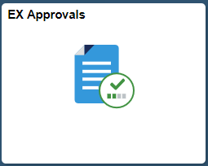  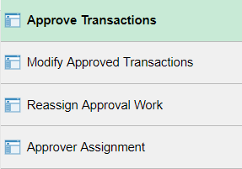
Employee Info & Security | The ‘Employee Info & Security’ tile contains two folders: Employee Profile and Security. Users can update employee information, authorize users, and reassign approval work. The following pages are available within the folders:  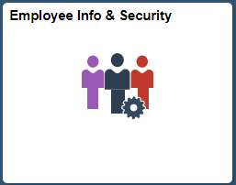  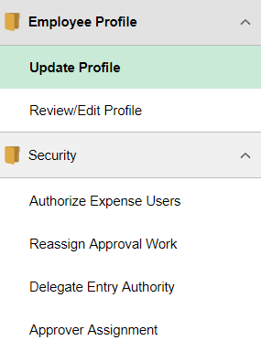

EX Accounting | The ‘EX Accounting’ tile contains two folders: View/Adjust Accounting Entries and Budget Checking. Users can create journal expense reports, view accouting entries, and make adjustments to accounting entries. The following pages are available within the folders:  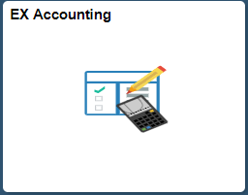  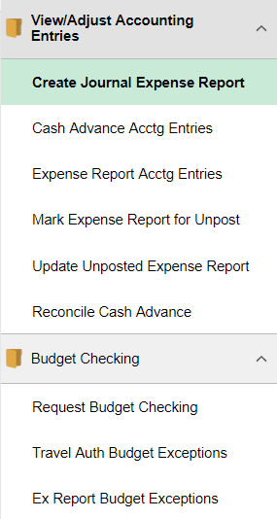
Process Expenses | The ‘Process Expenses’ tile allows users access to the Close Expenses, Review Payments, and Update Staged Payments folders. It also contains the Expense Processing and Cancel Travel Authorizations pages. The following pages are available:  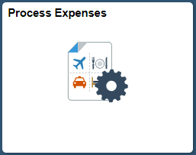  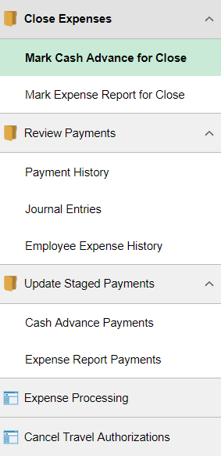
EX Reporting | The ‘EX Reporting’ tile allows users to run reports and queiries. The following pages are available:  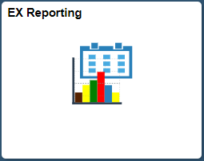  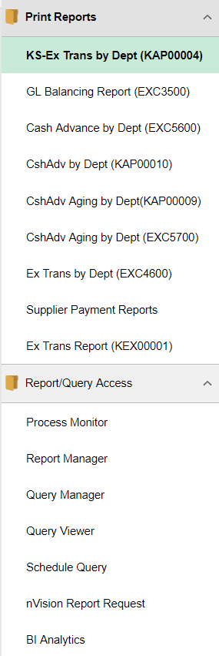
Expense WorkCenter | The Expense WorkCenter tile contains the following:  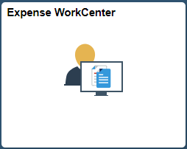  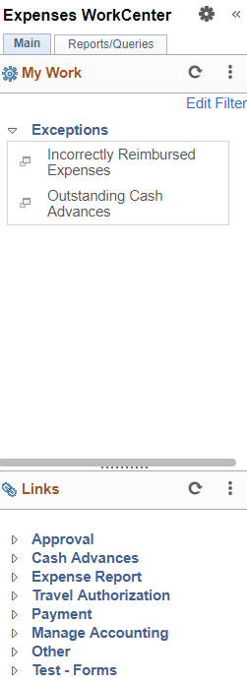
Ex Utilities | The Ex Utilities tile contains the following:  