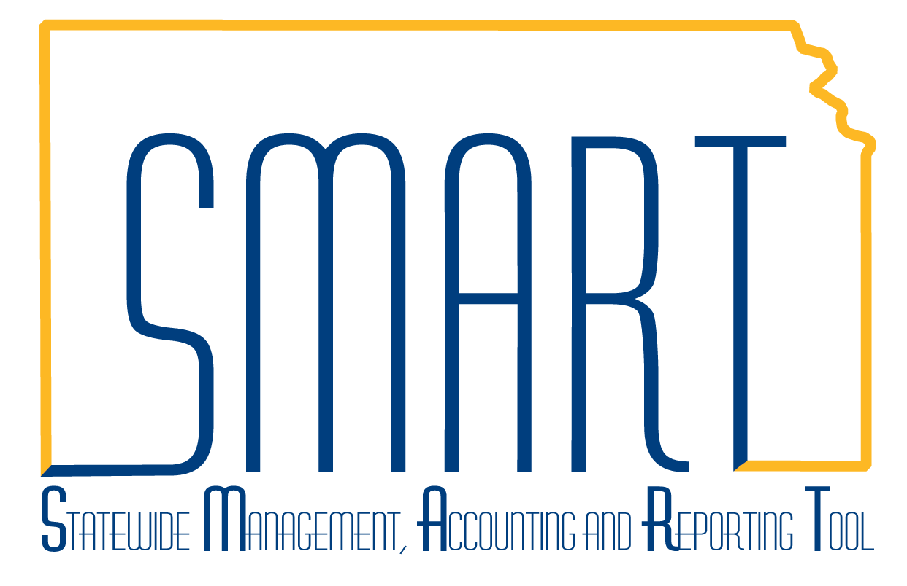
State of Kansas
Contracts & Strategic Sourcing
Homepage Guide
Statewide Management, Accounting and Reporting Tool
Date Created: | 3/15/2019
Version: | 1
Last Updated Date: | 3/15/2019
Background: | The Contracts & Strategic Sourcing Homepage contains elements of the Supplier Contracts and Strategic Sourcing module used to create and maintain Supplier Contracts, Bid Events, and Bidders.
Contracts & Strategic Sourcing Homepage: | The Contracts & Strategic Sourcing homepage contains the following tiles:  - Contracts & Sourcing Messages  - Supplier Contracts  - Strategic Sourcing  - Buyer WorkCenter  - Training Resources  - Contracts & Sourcing Reports  - Utilities  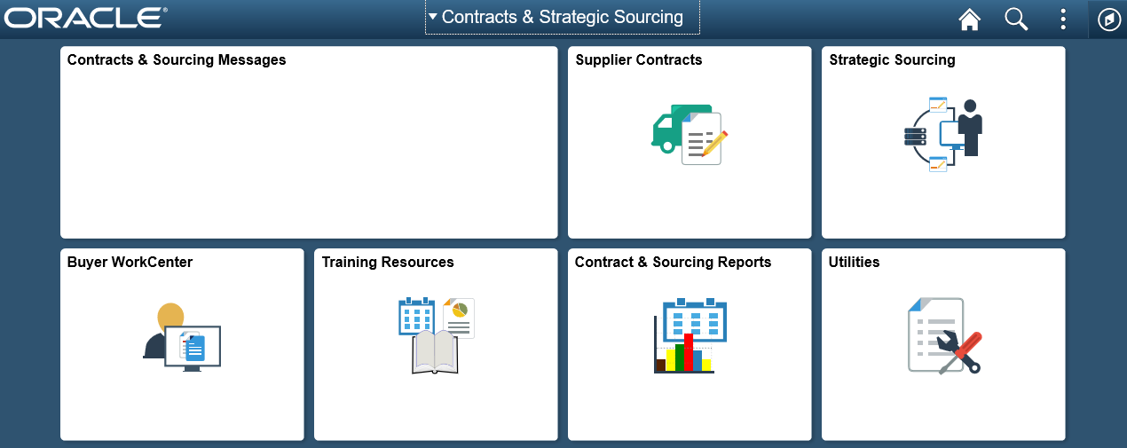

Contracts & Sourcing Messages | This tile will contain any important messages that need communicated to users of the Contracts & Strategic Sourcing community. Unless there is a message that users need to see, this tile will remain blank.
Supplier Contracts | This tile allows users to create, inquire, and manage supplier contracts.  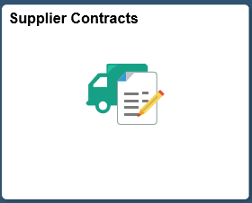  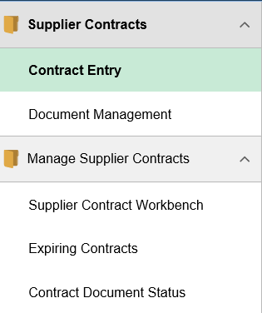
Strategic Sourcing | This tile allows users to create and maintain bid events, and manage bidder information.  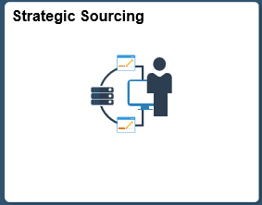  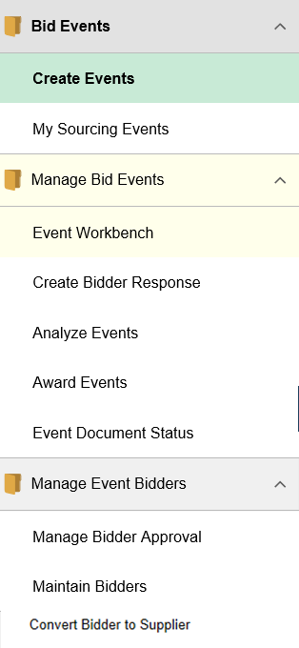  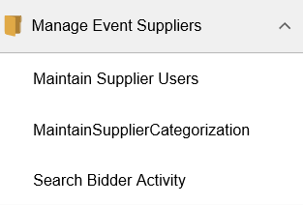
Buyer WorkCenter | This tile is for the Buyer WorkCenter that was introduced with the original upgrade to Peoplesoft 9.2. It allows users to perform various tasks that relate to the Supplier Contract and Strategic Sourcing areas.  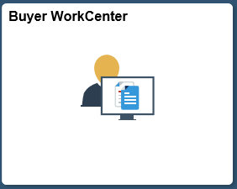  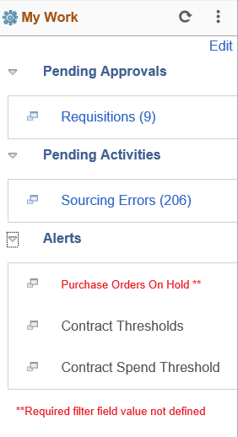  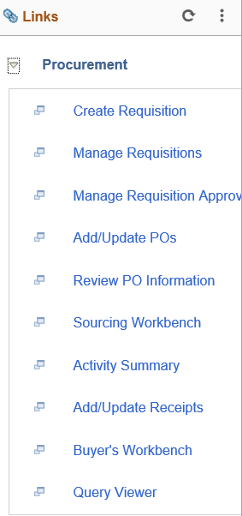  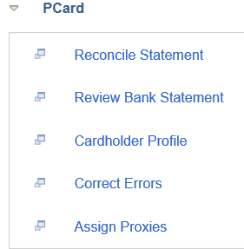  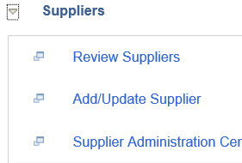  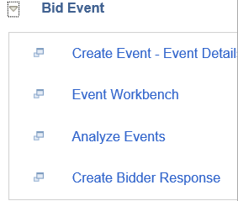  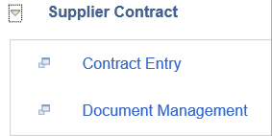
Training Resources | This tile provides users access to training documents and procurement directives from multiple resources across the state.  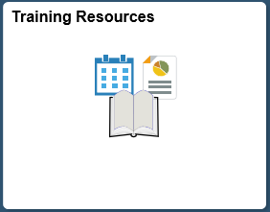  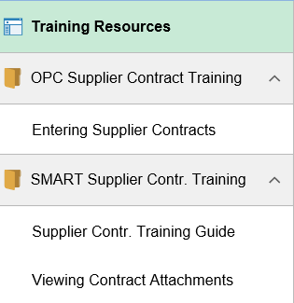
Contract & Sourcing Reports | This tile allows users to run various Supplier Contract and Strategic Sourcing reports.  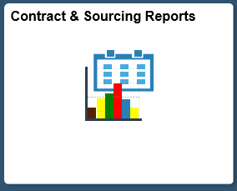  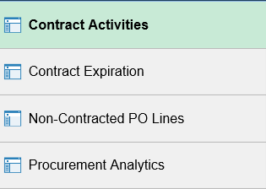

Utilities | This tile allows users to acccess the Process Monitor, Queries, Report Manager, Worklist, and a link to the SMARTWeb Reporting page.  