State of Kansas
Asset Management Homepage Guide
Statewide Management, Accounting and Reporting Tool

Date Created: | 3/11/2019
Version: | 1
Last Updated Date: | 3/11/2019
Background: | The Asset Management Homepage contains transaction, processing and reporting pages from the Asset Management module.
Asset Management Homepage: | The Asset Management homepage contains the following tiles:  - Asset Transactions  - Depreciation  - Accounting Entries  - Send/Receive Information  - Asset Management WorkCenter  - Asset Management Reports  - Utilities  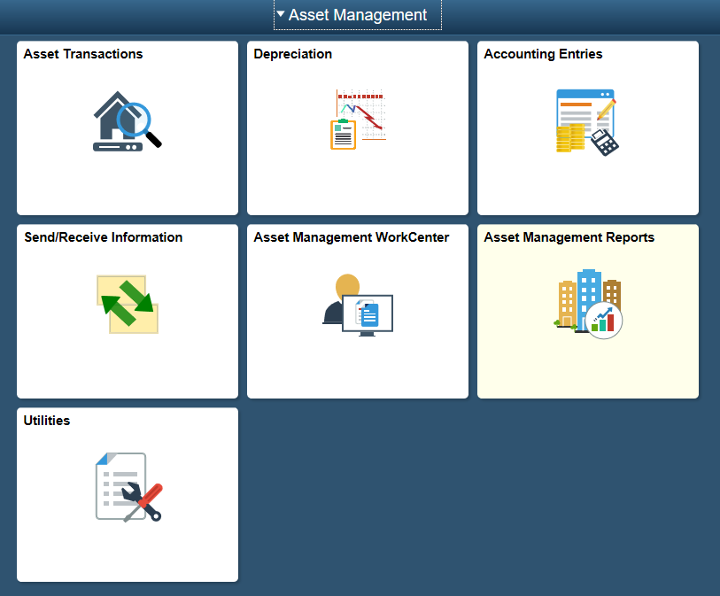
Asset Transactions | The ‘Asset Transactions’ tile contains the pages used to enter assets online and review asset information. Parent-Child relationship information is entered on this tile. Cost Adjustments, transfers, disposals and cost history are all entered and reviewed via this tile as well.  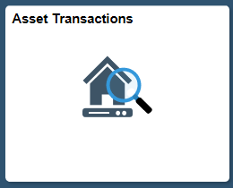  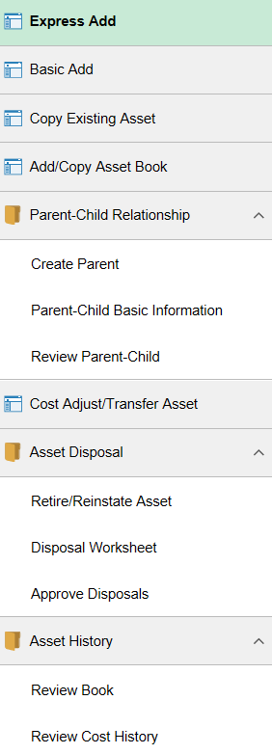
Depreciation | The ‘Depreciation’ tile is used to review open transactions, calculate depreciation and review depreciation.  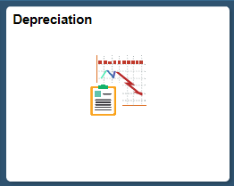  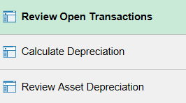
Accounting Entries | The ‘Accounting Entries’ tile is used to create accounting entries, run the Depreciation Close process and review financial entries.  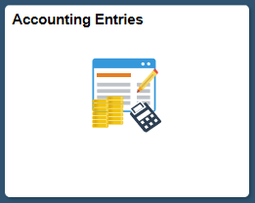  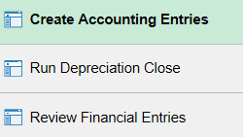

Send/Receive Information | The ‘Send/Receive Information’ tile is used to process interface transactions and to approve and review financial and physical asset transactions.  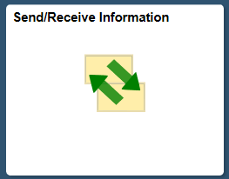  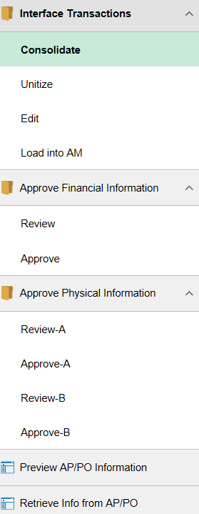
Asset Management WorkCenter | The ‘Asset Management WorkCenter’ tile is a direct link to the Asset Management WorkCenter.  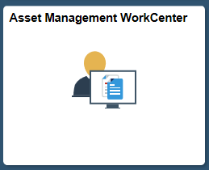  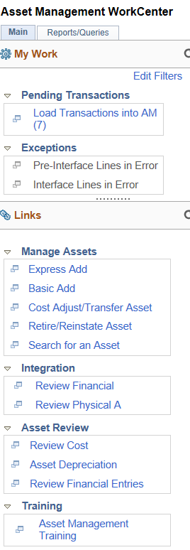
Asset Management Reports | The ‘Asset Management Reports’ tile includes pages used to run Cost Activity, Depreciation Activity, Asset Net Book Value and Retirement Activity reports.  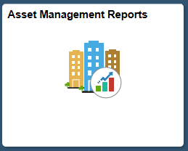  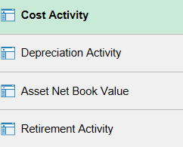
Utilities | The ‘Utilities’ tile includes Process Monitor, Query Manager, Query Viewer, Schedule Query, Report Manager, Worklist and Define Report Request.  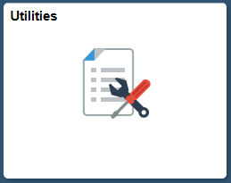  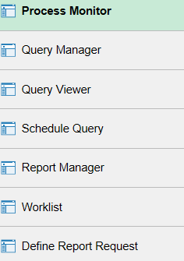
Appendix A | Below is a cross-walk to show the old Classic navigation path vs. the new homepage navigation for pages that are now accessible via the Asset Management homepage. The old path can still be accessed using the NavBar > Navigator in the upper-right corner of the top banner.  