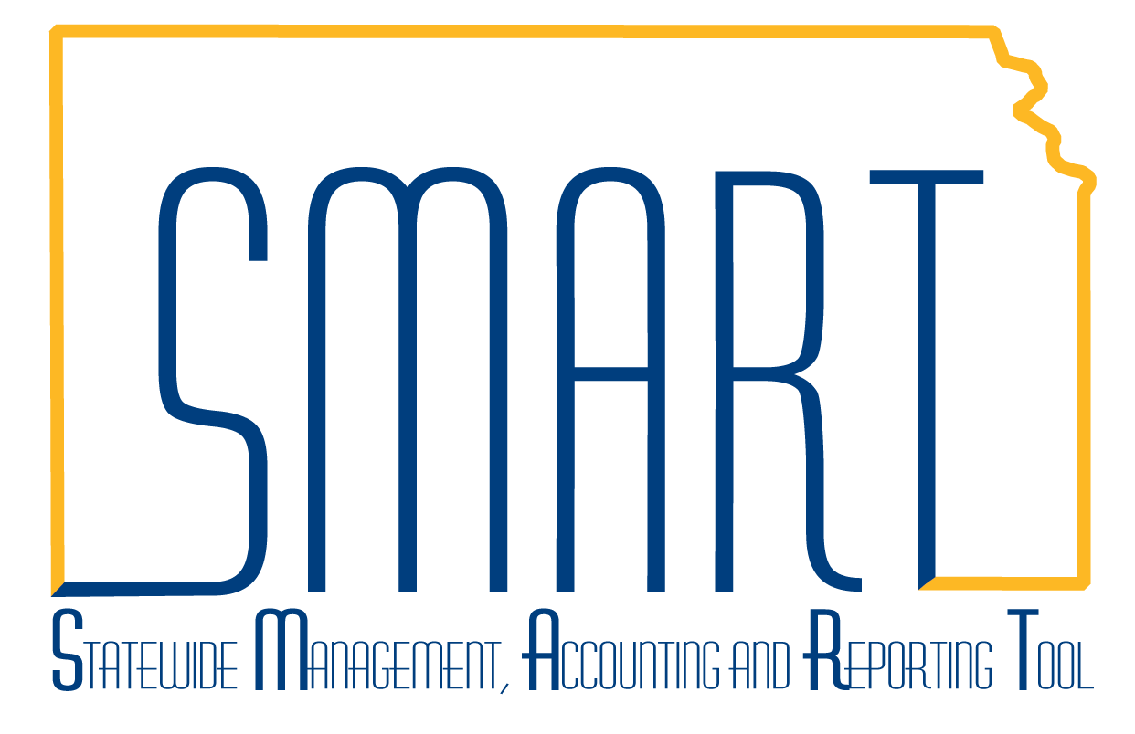
State of Kansas
Accounts Payable Homepage Guide
Statewide Management, Accounting and Reporting Tool

Date Created: | 3/20/2019
Version: | 2
Last Updated Date: | 3/20/2019
Background: | The Accounts Payable Homepage includes functionality associated with the Accounts Payable module which includes vouchers, payments, and suppliers.
Accounts Payable Homepage: | The Accounts Payable homepage contains the following tiles:  - Accounts Payable Messages  - Vouchers  - Approvals  - Payments  - Interfunds  - Suppliers  - 1099  - Accounts Payable WorkCenter  - AP Reports  - AP Training/Resources  - Utilities  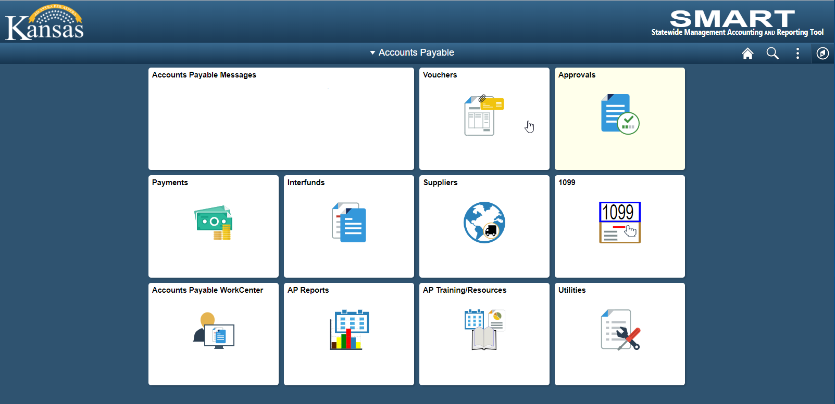

Accounts Payable Messages | The ‘Accounts Payable Messages’ tile will contain any important messages to be communicated to Accounts Payable users. Unless there is a message for users, this tile will remain blank.
Vouchers | This tile allows users to enter, maintain, approve, and inquire on vouchers in SMART. Users can also access accounting entries, match workbench, agency-maintained tables, user-initiated batch processes, and control group functionality with proper security access.  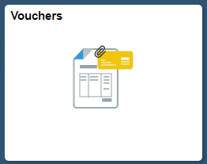  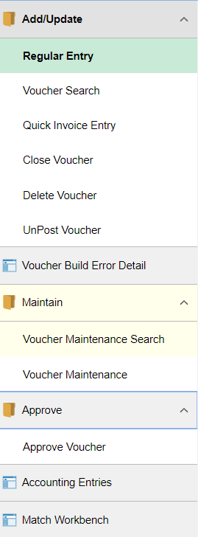  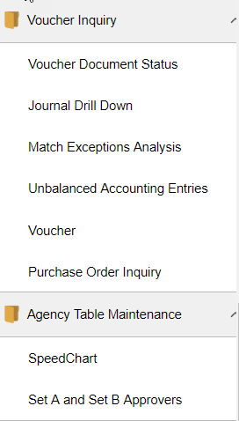  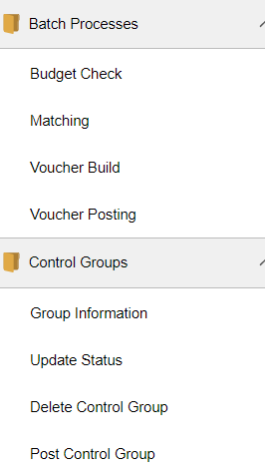
Approvals | This tile allows users to access the ‘Voucher Approval AF’ search page.  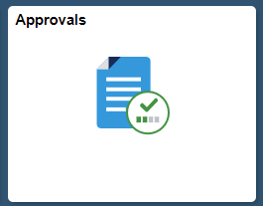

Payments | This tile allows users to inquire on SMART payment activity and initiate payment-related processes including paycycle, cancel/void payments, and setoff processing based on the user’s security access.  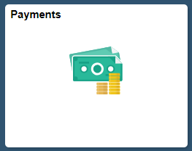  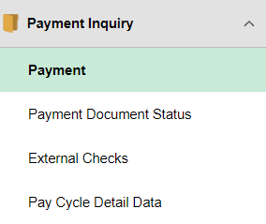
Interfunds | This tile allows users to access the Interfund Details Page.  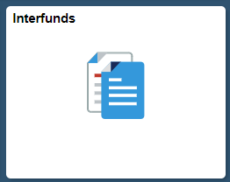

Suppliers | This tile allows users to add and review SMART supplier records.  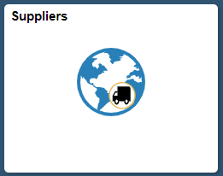  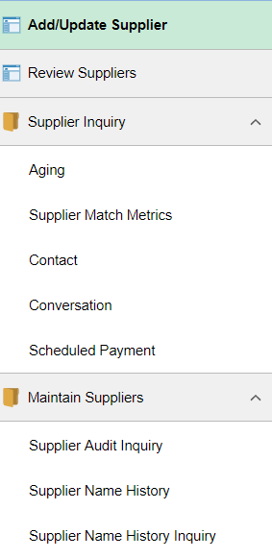

1099 | This tile allows users to acccess 1099-related inquiries and supplier records.  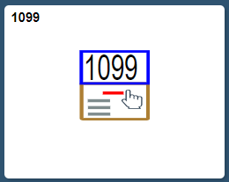  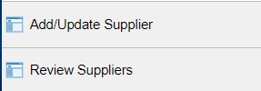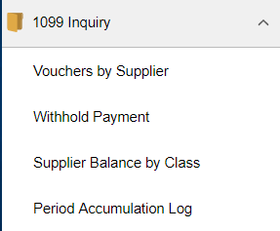

Accounts Payable WorkCenter | This tile allows users to access the Accounts Payable WorkCenter that was introduced with the upgrade to Peoplesoft 9.2. It allows users to view work in process and navigate to some commonly used SMART screens, and some AP Reports and Queries.  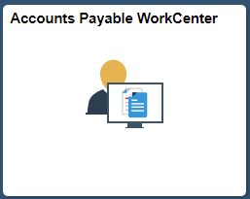
AP Reports | This tile allows users to run various Accounts Payable Reports and access the Process Monitor, Report Manager, Queries, the Reporting Catalog, and Reporting Job Aids.  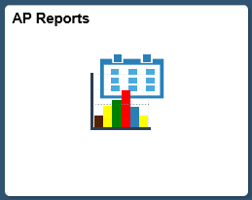  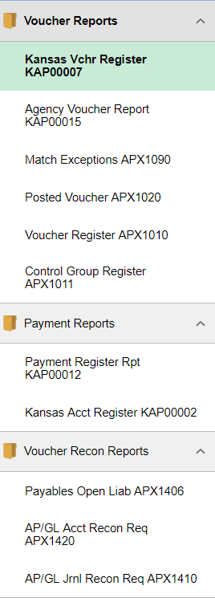  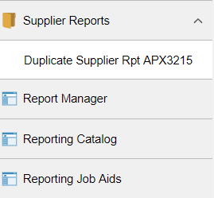

AP Training Resources | This tile links to the Accounts Payable training materials page on SMARTWeb.  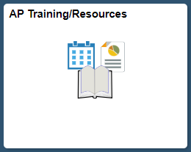
Utilities | This tile allows users to access the Process Monitor, Queries, Report Manager, Worklist, nVision Report Request, BI Analytics, Reporting Catalog, and Reporting Job Aids.  