**State of Kansas**



**High-Level Changes from 9.0 to 9.2 in Asset Management:**

**RF Template on Cost and Depreciation Reports**

***Statewide Management, Accounting and Reporting Tool***

|  |  |
| --- | --- |
| **Date Created:** | 10/28/2015 |
| **Version:** | 1.0 |
| **Last Updated Date:** |  |
| **Purpose:** | *This document highlights one of the changes between 9.0 and 9.2 in the Asset Management module.* |
| **Security:** | * Role Security: The following roles are applicable:   Agency Asset Viewer  BU Security: Business Unit Security is applied. Agencies will only have access to the assets in their Business Unit. |

Procedure

Cost and depreciation report enhancements include a new Report Print Option template that enables you to control which fields to print, their order on the report, their labels, and the length of the fields.

In this example, we will run the Cost Activity report and specify that we only wish to see the Beginning and Ending Balances for each asset.

| **Step** | **Action** |
| --- | --- |
|  | Click the **Main Menu** button. |
|  | Click the **Asset Management** menu. |
|  | Click the **Financial Reports** menu. |
|  | Click the **Cost and Depreciation** menu. |

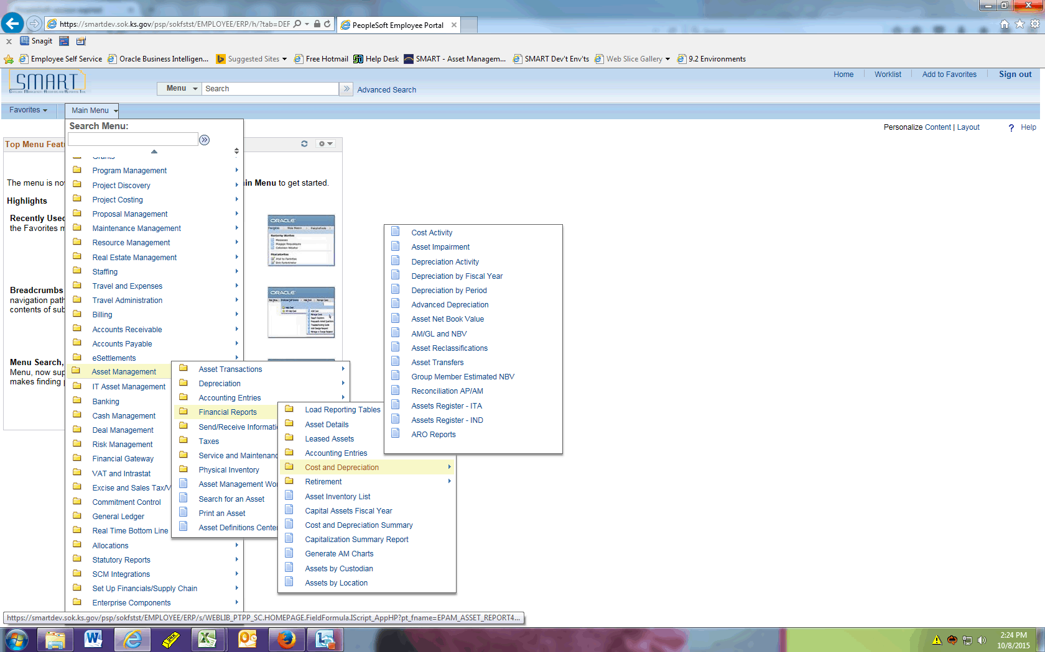

| **Step** | **Action** |
| --- | --- |
|  | Click the **Cost Activity** menu. |
|  | Enter the desired information into the **Run Control ID** field. Enter "**RF_TEMPLATE**". |
|  | Click the **Add** button. |

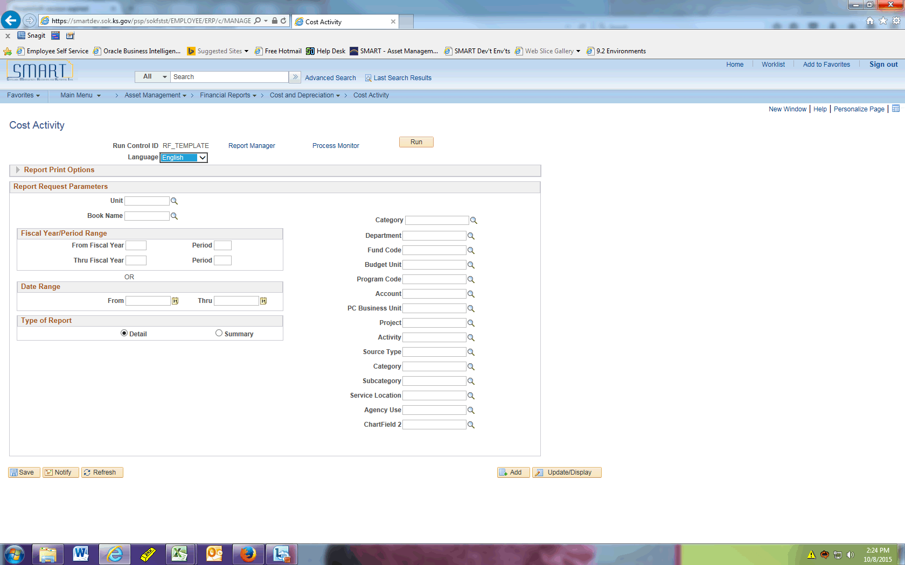

| **Step** | **Action** |
| --- | --- |
|  | Click the **Expand section Report Print Options** link. |
|  | Click the **Report By** list. |

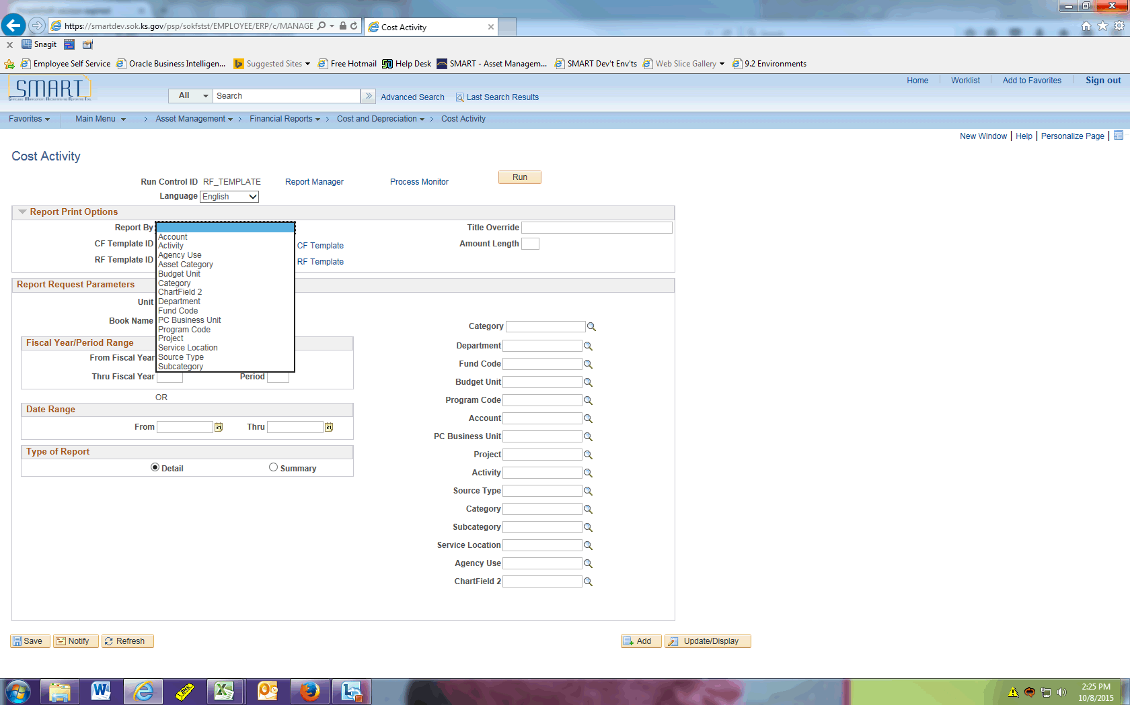

| **Step** | **Action** |
| --- | --- |
|  | Click the **Asset Category** list item. |
|  | Click the **Update/Add CF Template** link. |

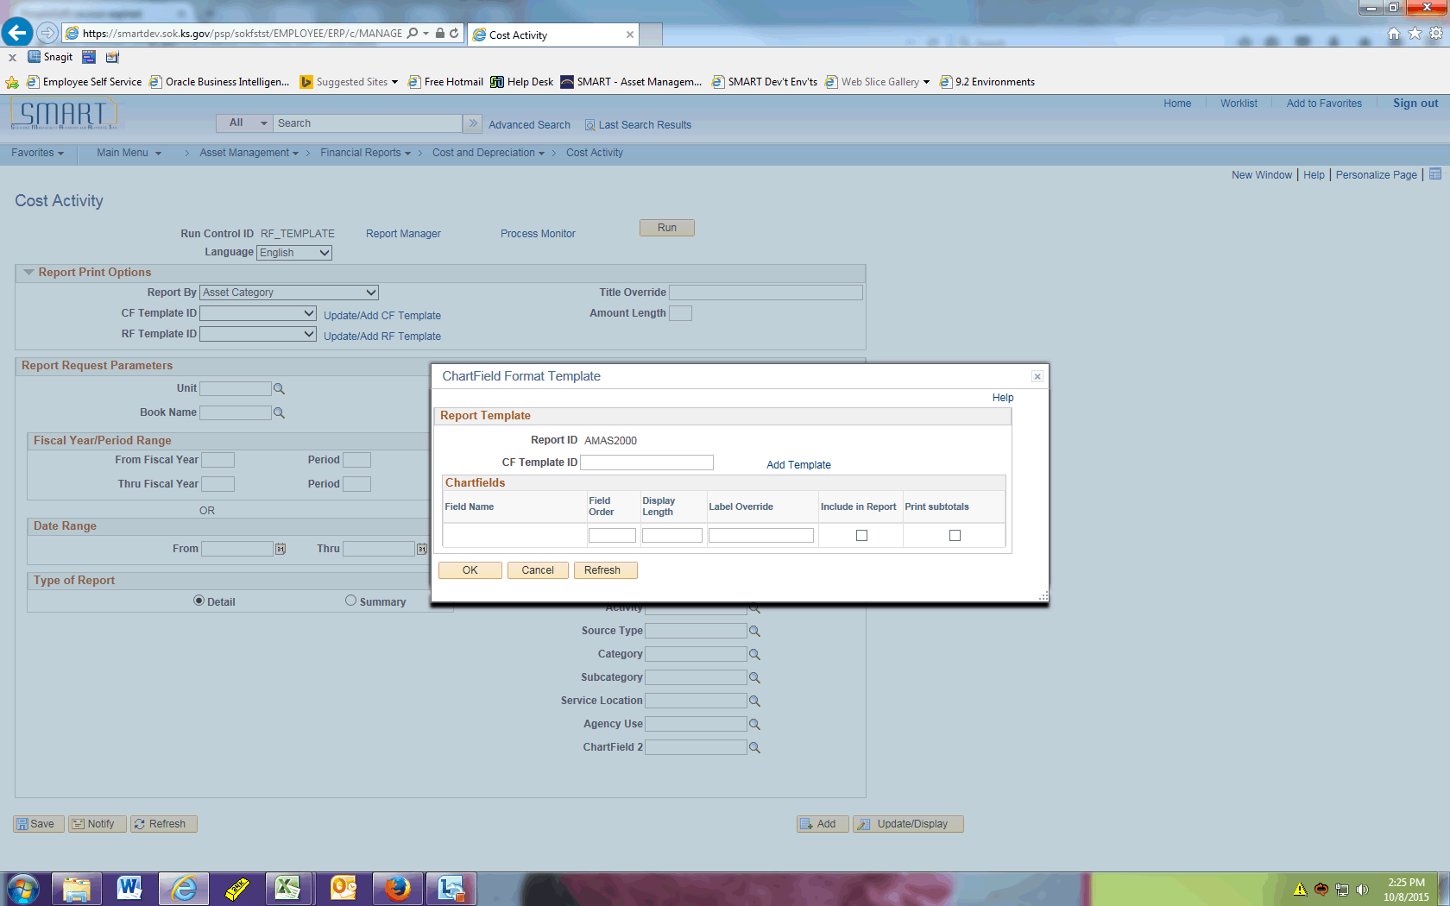

| **Step** | **Action** |
| --- | --- |
|  | Enter the desired information into the **CF Template ID** field. Enter "**AMAS2000.1**". |
|  | Click the **Add Template** link. |

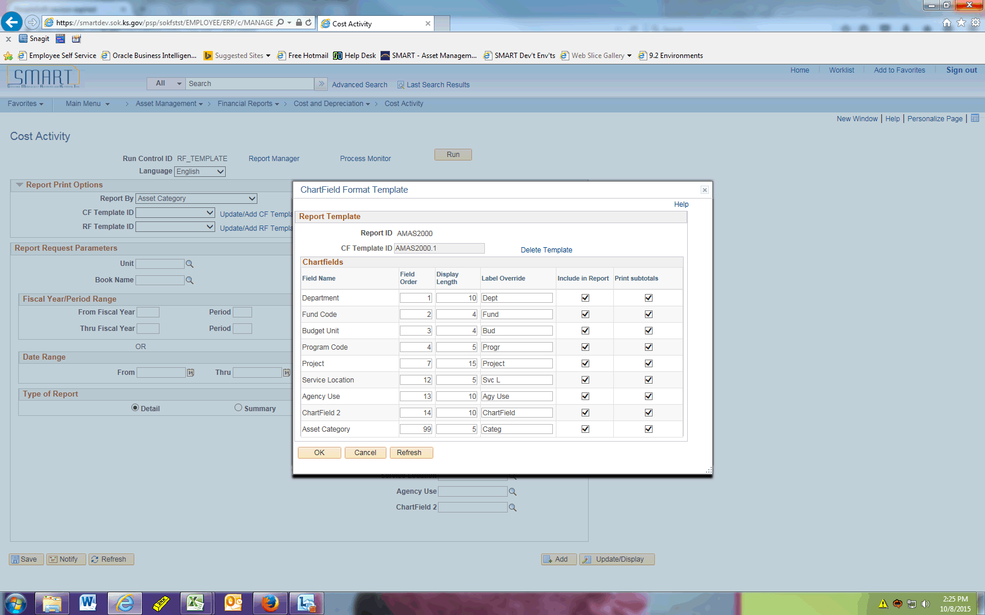

| **Step** | **Action** |
| --- | --- |
|  | Now you can decide which chartfields to include and subtotal by in this report.  You should deselect any chartfields your agency does not utilize. |

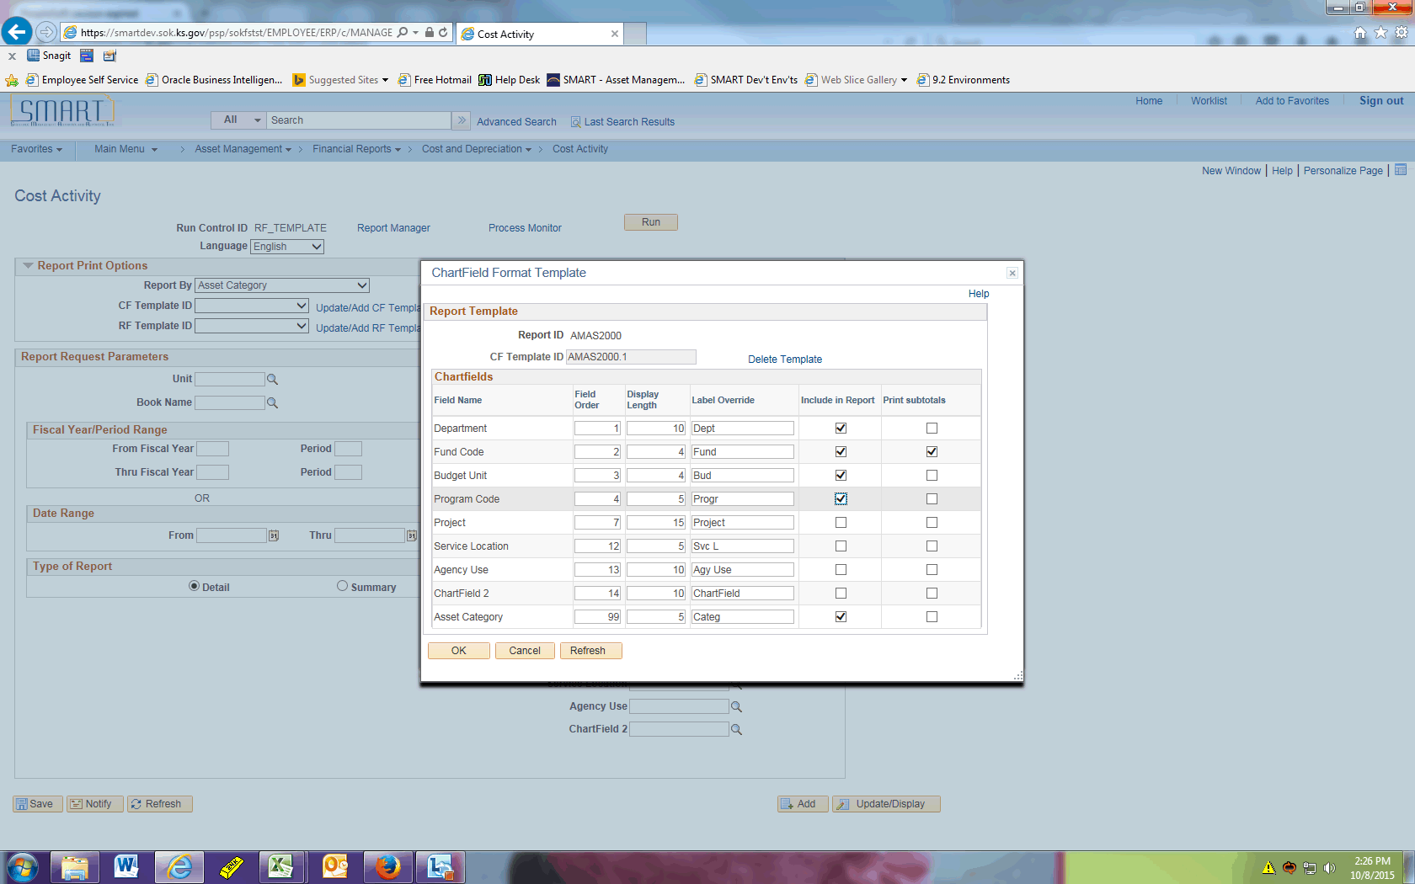

| **Step** | **Action** |
| --- | --- |
|  | Click the **OK** button. |
|  | Click the **Update/Add RF Template** link. |

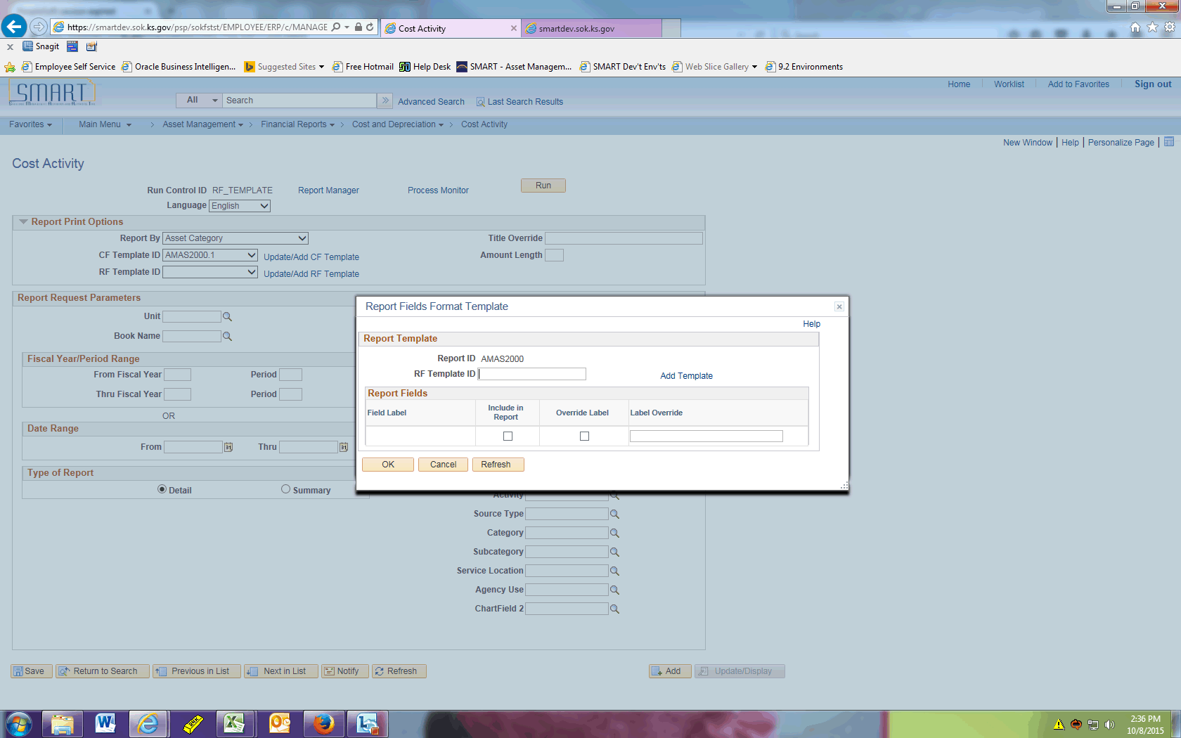

| **Step** | **Action** |
| --- | --- |
|  | Enter the desired information into the **RF Template ID** field. Enter "**AMAS2000.1**". |
|  | Click the **Add Template** link. |

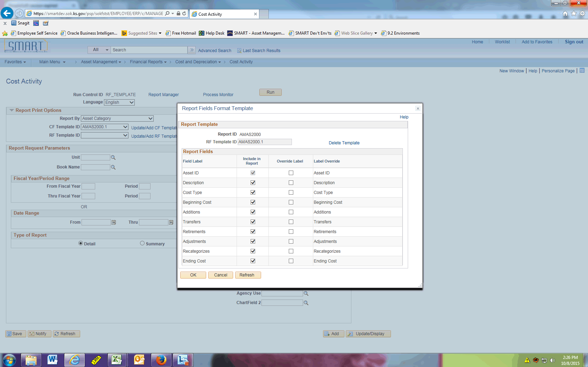

| **Step** | **Action** |
| --- | --- |
|  | Now you have the option to specify what fields to include in your report. In this example, we only want to see Asset ID, Description, Beginning Cost, and Ending Cost.  Also note you can override the label if needed. |
|  | Click the **Include in Report** option. |

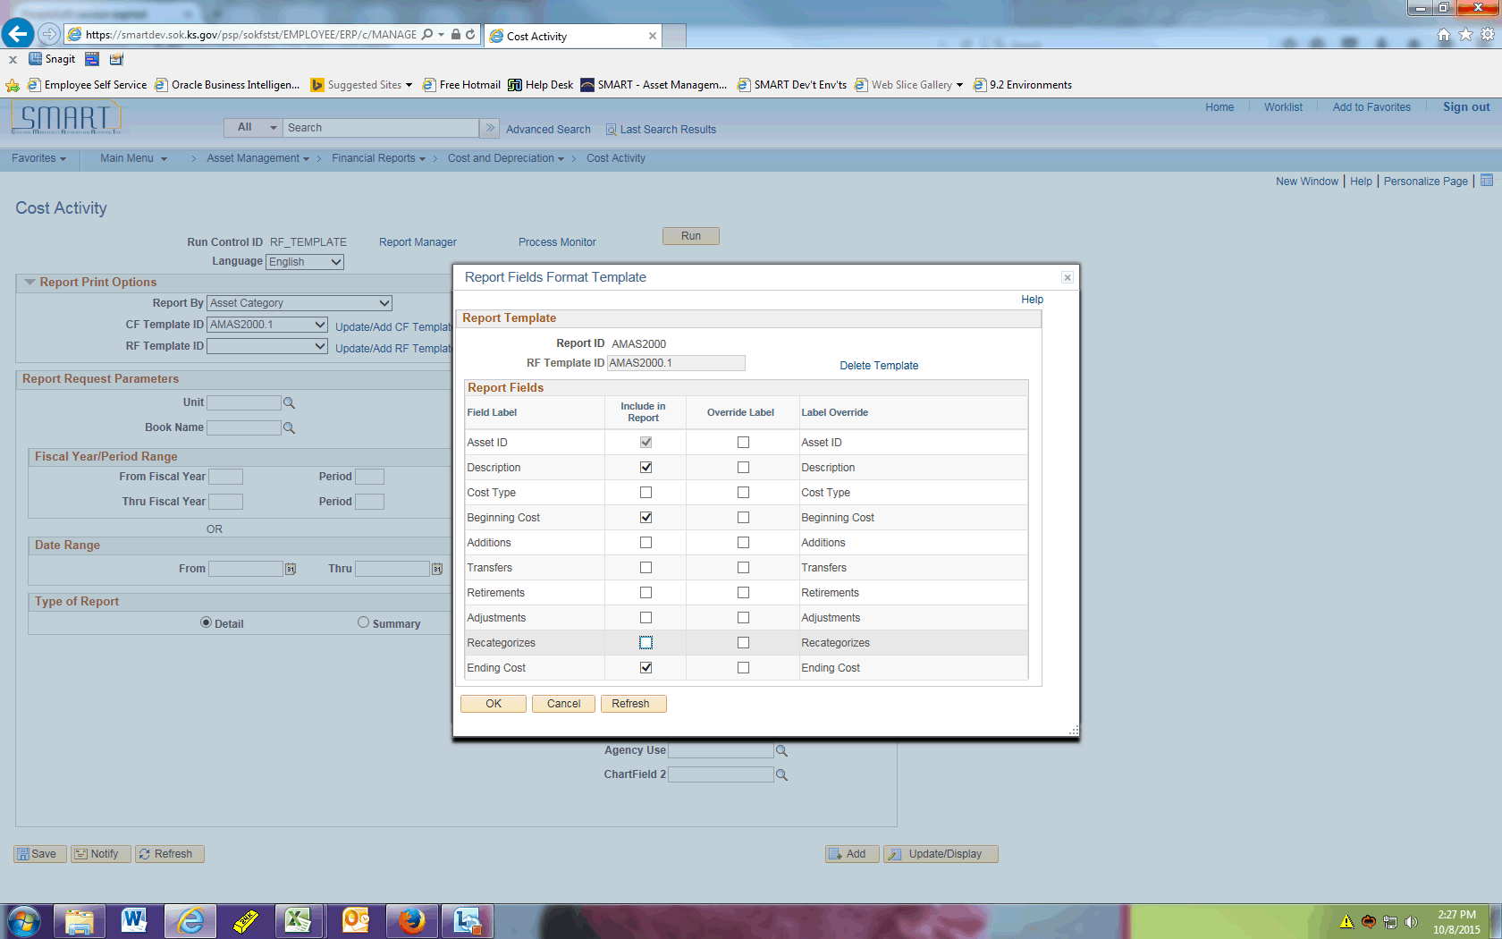

| **Step** | **Action** |
| --- | --- |
|  | Click the **OK** button. |
|  | Click the **Look up Unit (Alt+5)** button. |
|  | Click the **17300** link. |
|  | Click the **Look up Book Name (Alt+5)** button. |
|  | Click the **CAFR** link. |
|  | Enter the desired information into the **From Fiscal Year** field. Enter "**2015**". |
|  | Enter the desired information into the **Period** field. Enter "**1**". |
|  | Enter the desired information into the **Thru Fiscal Year** field. Enter "**2015**". |
|  | Enter the desired information into the **Period** field. Enter "**12**". |

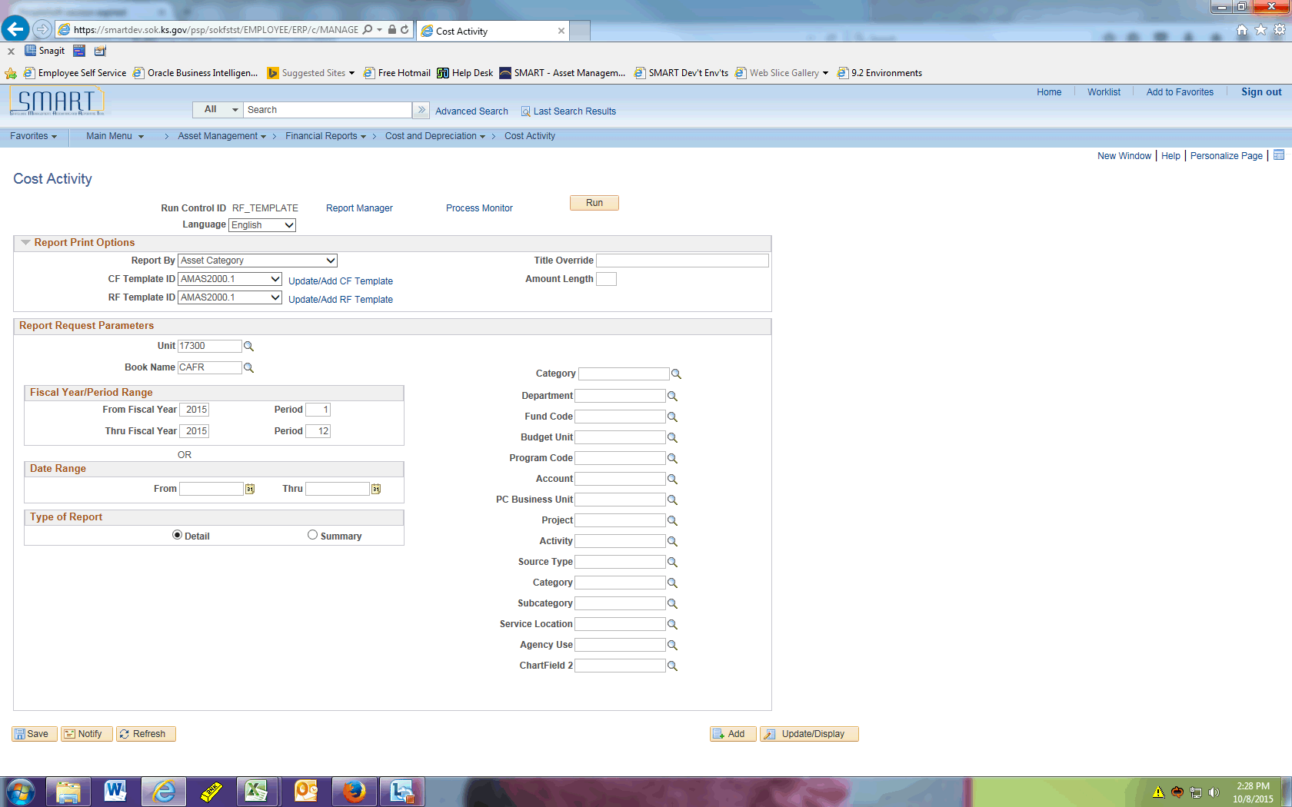

| **Step** | **Action** |
| --- | --- |
|  | Click the **Run** button. |

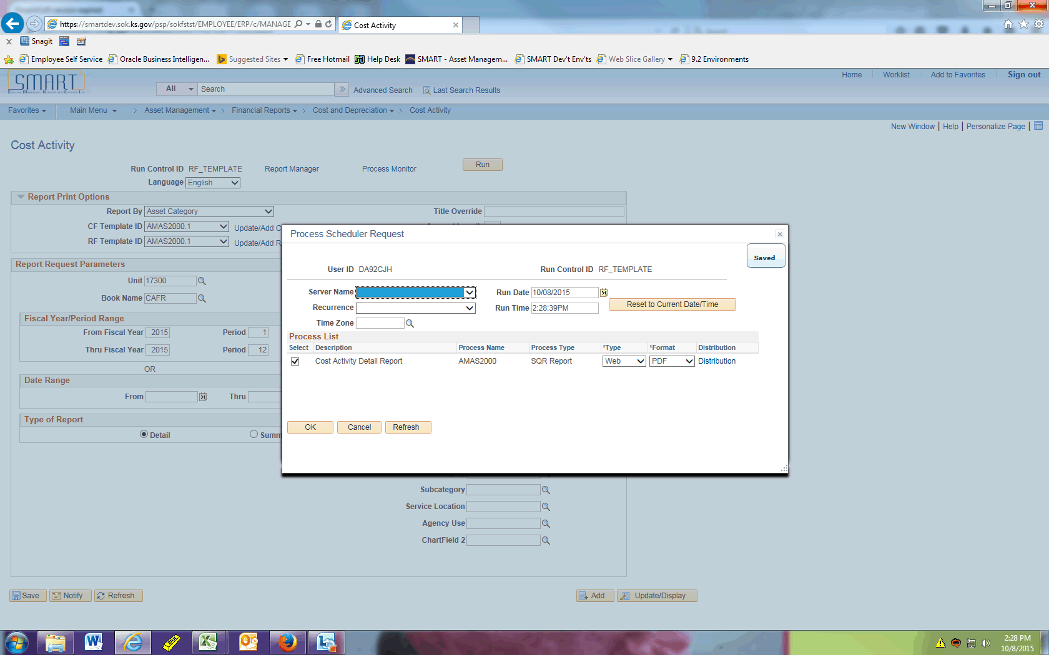

| **Step** | **Action** |
| --- | --- |
|  | Click the **OK** button. |
|  | Click the **Process Monitor** link. |
|  | Click the **Refresh** button periodically until the report has a Run Status of Success and Distribution Status of Posted. |

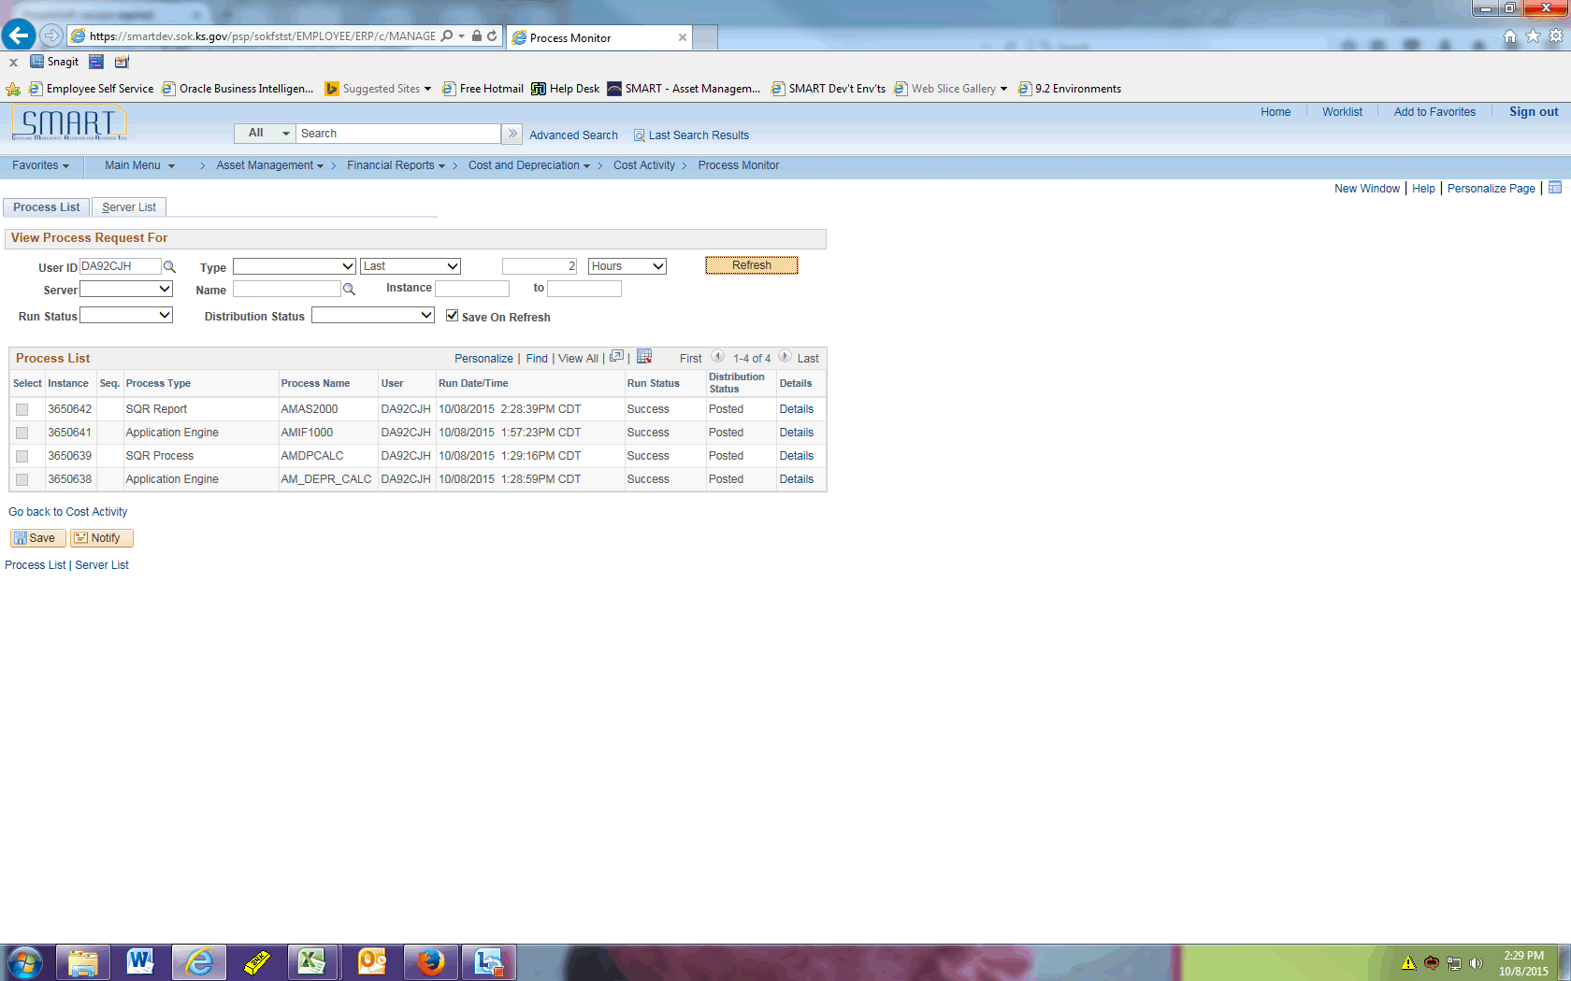

| **Step** | **Action** |
| --- | --- |
|  | Click the **Details** link. |

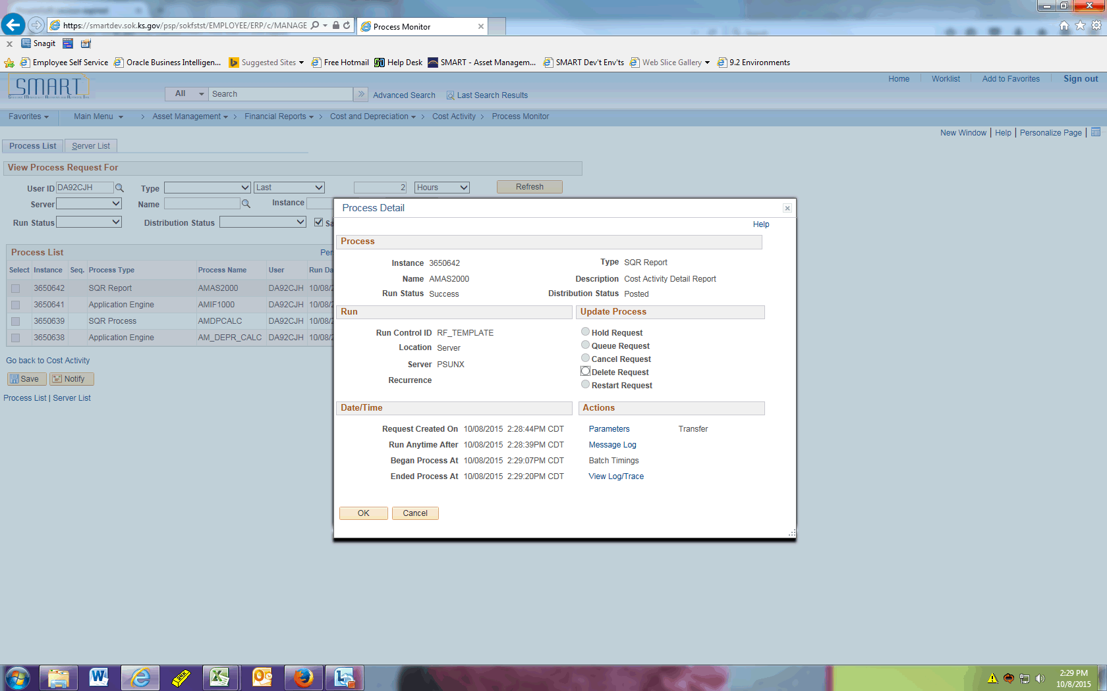

| **Step** | **Action** |
| --- | --- |
|  | Click the **View Log/Trace** link. |
|  | Click the **amas2000_3650642.PDF** link. |

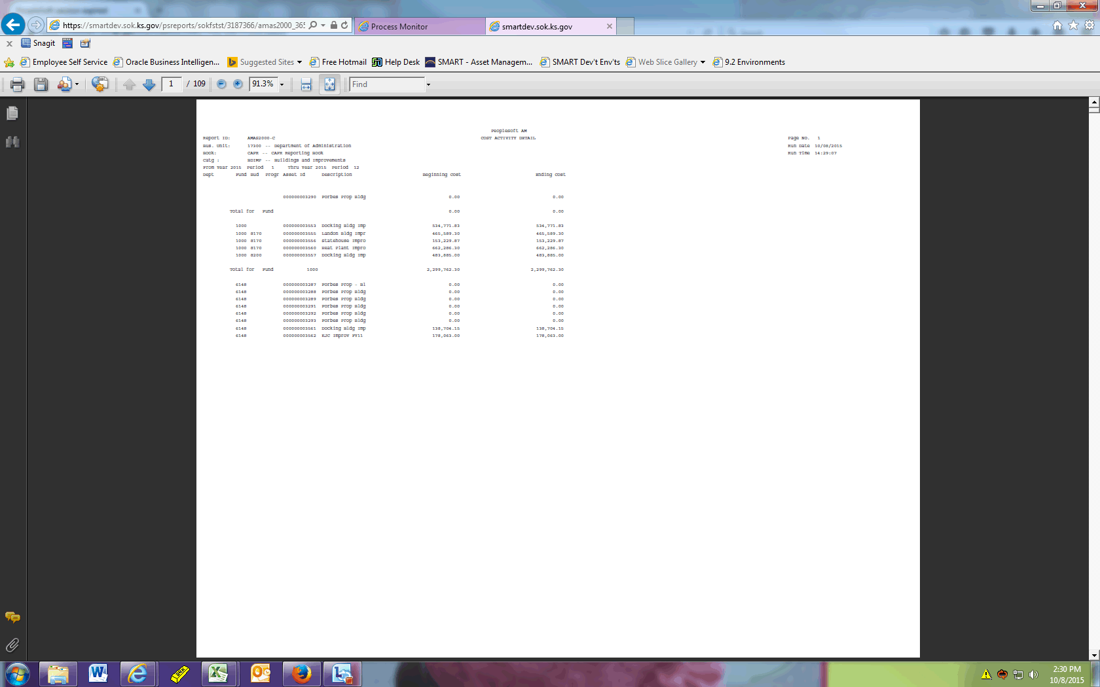

| **Step** | **Action** |
| --- | --- |
|  | The report now shows only the Asset ID, Description, Beginning Cost, and Ending Cost as defined on the RF Template ID. The chartfields specified in the CF Template ID are also displayed. |
|  | This concludes the 'AM - RF Template on Cost and Depreciation Reports' topic. Thank you for taking this course.  **End of Procedure.** |