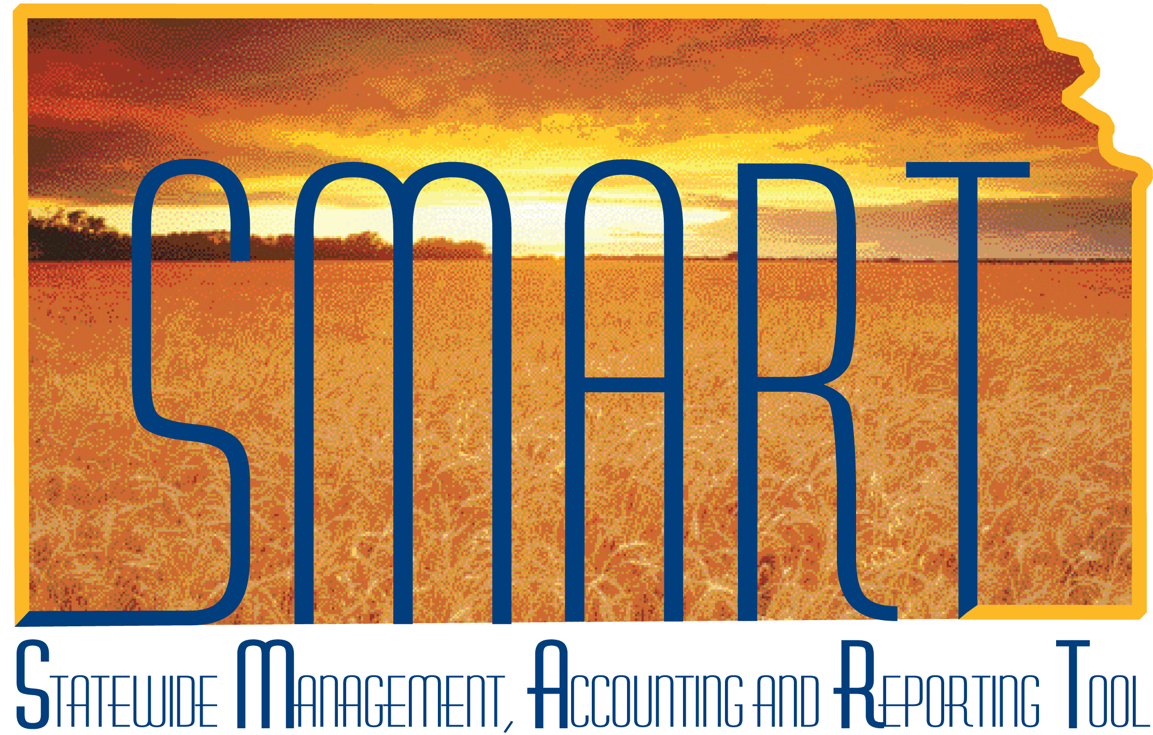

Training Guide – Asset Management
Retiring and Reinstating Assets

State of Kansas

Applicable Role(s):

Agency Adjustment/Transfer/Retirement Processor
Table of Contents
Retirements and Reinstatements--Overview 3
Steps to Individually Retire an Asset 3
Retiring an Asset by Trade-In 7
Mass Retirements via the Disposal Worksheet 12
Retirements and Parent-Child Assets 17
Reinstating Assets 19

Retiring and Reinstating Assets

Retirements and Reinstatements--Overview
- Most assets will be retired using the Retire/Reinstate Asset page in SMART.
  - There are two exceptions:
    - Operating Leases are retired on the Retire/Reinstate Non-Fin Asset page. See the “Operating Leases” job aid for more information.
    - The Disposal Worksheet can be used when an agency needs to retire a mass number of assets at the same time.
- When you retire an asset, SMART creates the appropriate accounting and depreciation entries through a batch process, which is automatically run on a monthly basis. The accounting entries are sent to the General Ledger and update the value and depreciation information for the asset.

Steps to Individually Retire an Asset

- Navigate to the Retire/Reinstate Asset page.
Page Name | Navigation via AM Homepage or NavBar
Retire/Reinstate Asset | Asset Management>Asset Transactions>Asset Disposal>Retire/Reinstate Asset

- Select a Disposal Code from the Retire As dropdown.
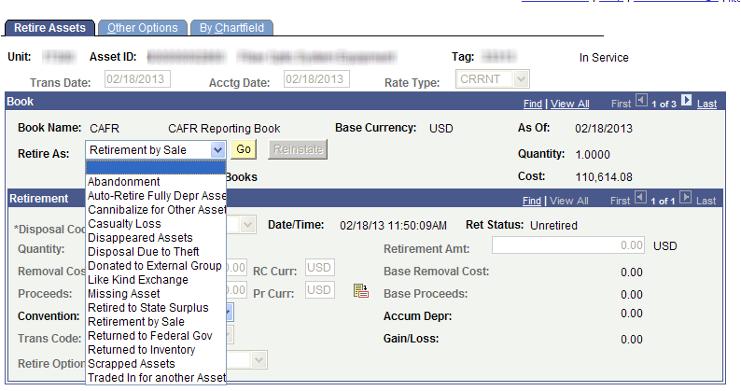
Retire Assets Page
Field | Description
Retire As: | Select a Disposal Code from the dropdown.  The most commonly used ones are:  - Retirement by Sale – Use when you sell an asset by Local Disposition Authority—see Note 1 below this table. This is also the Default value which should be used if no other Disposal Code applies.  - Retired to State Surplus – Use when an asset is sent to State Surplus. See Note 2 below this table.  - Scrapped Assets – Use when the asset is no longer useful and has no resale value.  Other less frequently used ones are:  - Missing Asset or Disappeared Asset—These two can be used interchangeably for when an asset can’t be located. There are no proceeds or removal costs.  - Donated to External Group – Use when an asset is donated.  - Traded In for Another Asset – Use when you are trading one asset in for another.  - Cannibalize for Other Assets – Use when the asset has been dismantled and the parts reused within your agency.  - Abandonment – Use when the asset has no resale value and is left behind.  - Casualty Loss – Use when an asset is unintentionally destroyed. If you cannot sell the asset, you might incur removal costs disposing of it.  - Returned to Inventory – Use when an asset has been returned to a vendor.  - Returned to Federal Government - Use when an asset is returned to the Federal Government.  - Disposal Due to Theft – Use when an asset has been stolen.  Do not use the following:  - Auto-Retire Fully Depr  - Like Kind Exchange
Disposal Codes
Note 1: The Asset Management module allows the proceeds received from the sale of an asset to be recorded when a Retirement by Sale transaction is recorded. This would occur when the agency had been granted Local Disposition Authority. The actual deposit for the cash received is not recorded in the Asset Management module. Record this transaction in the Accounts Receivable module as a deposit, which then posts to the GL Actuals Ledger in the General Ledger module. (There is no integration between the actual receipt/deposit and the Asset Management module.)
Note 2: Assets sent to State Surplus are no longer considered an agency’s property. The retirement should occur at the time the asset is relinquished to them. Therefore, when the asset is sold, the agency does not record the proceeds in Asset Management.
- Click Go.
- Populate the remaining fields on the Retire Assets page.
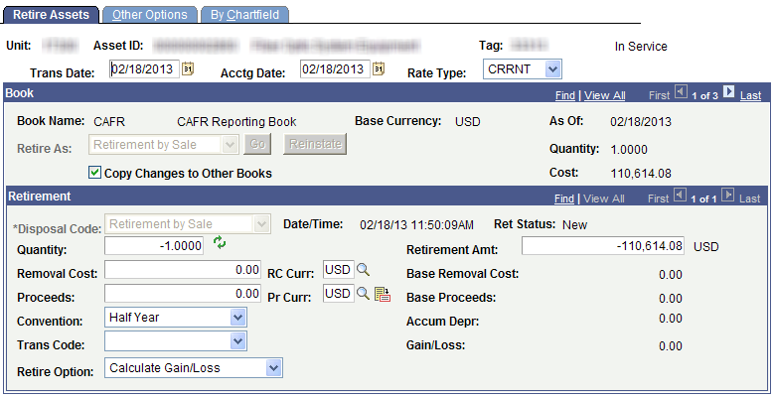
Retire Assets page

Fields | Description
Transaction Date | The current date will be the default. If necessary, override this date to the actual date of the transaction.  Note: This date cannot be greater than the Accounting Date.
Accounting Date | The current date will be the default. The Accounting Date field is dependent on when the General Ledger is open. Therefore, this date should not be changed.
Copy Changes to Other Books | This checkbox defaults as checked. The State of Kansas has chosen to keep all books in sync. Therefore, any changes you make are automatically copied to all books for this asset.  You should not uncheck this box unless you do not want changes to be the same in all books. That situation should be rare.
Quantity | Typically, this value will be the same as the Quantity field in the upper right part of the page under the As Of date. That quantity will default.  Note: If your agency’s business practice is to have multiple assets under the same Asset ID, a partial retirement may be applicable. In that case, enter the quantity being retired. This business practice is not advised.
Removal Cost | Enter the amount of any cost for removal.
Proceeds | Enter the amount of proceeds resulting from the transaction, if applicable.  See Note 1 under the Disposal Codes table for additional information on recording the deposit.
Convention | Defaults based on the asset profile. Do not change this field.
Retire Option | The Calculate Gain/Loss option defaults. Do not change this field.
Retirement Amt | Typically, this value will be the same as the Cost field in the upper right part of the page under the As Of date. That Cost will default in.  Note: If your agency’s business practice is to have multiple assets under the same Asset ID, a partial retirement may be applicable. In that case, enter the cost being retired. This business practice is not advised.
Retirement Fields—Retire Assets page
- Provide a description of the retirement on the Other Options tab. This step is optional. It might be beneficial for future reference to have documentation as to why the retirement occurred.
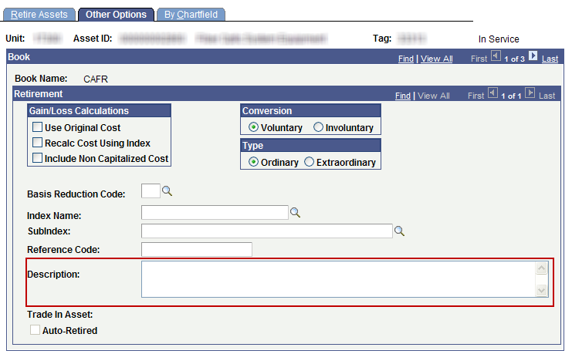
Other Options Page
- Click Save. The Asset Status on the upper right of the Retire Assets page will immediately change to “Disposed.”

Retiring an Asset by Trade-In

- The trade-in value of the retired asset is included in the cost valuation of the new asset.
- New assets resulting from a trade-in must use the “Trade-in” acquisition code.
- Use Express Add to add the new asset. An agency must use Express Add so that the Acquisition Code can be changed. If the asset is integrated, the Acquisition Code cannot be changed.
- Depreciation has to be run on the asset being traded in before the new asset is added. Depreciation runs in the nightly batch.
Steps to Retire an Asset by Trade-In
- Navigate to the Retire/Reinstate Asset page.
Page Name | Navigation via AM Homepage or NavBar
Retire/Reinstate Asset | Asset Management>Asset Transactions>Asset Disposal>Retire/Reinstate Asset

- Select “Traded in for another Asset” from the Retire As dropdown.

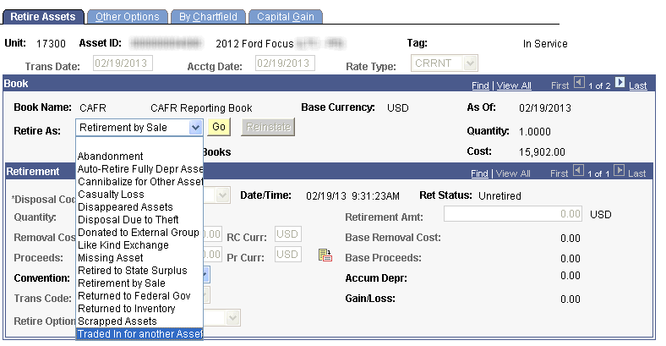
Retire Assets Page
- Click Go.
- Enter the trade-in value in the Proceeds field.
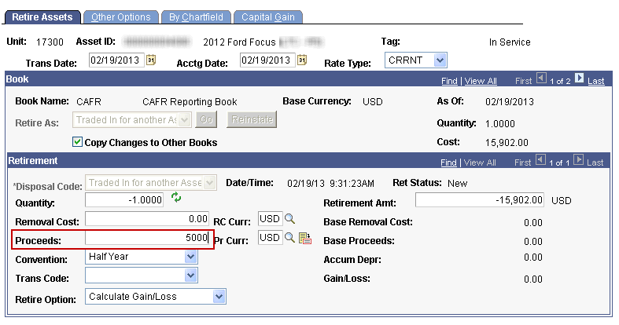
- Click Save. The Asset Status on the upper right will immediately change to “Disposed.”
***Depreciation must run in nightly batch before continuing to step 6.
- Add the new asset via Express Add. See the “Adding an Asset Using Express Add” Training Guide for additional instruction.
- In the Cost field, enter the amount your agency paid for the asset, not including trade-in value.
- In the Asset Additional Information section, change the Acquisition Code to Trade In.
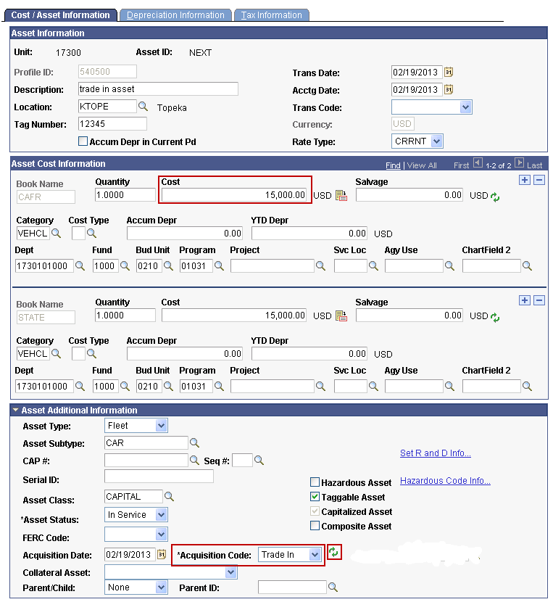
- Click the Refresh button (two green arrows next to Acquisition Code.) You’ll be prompted to enter the Asset ID of the traded in asset.
- Once you’ve selected the Asset ID of the traded in asset, the Cost field will update automatically with the total value of the new asset (trade in value from the old asset plus the out of pocket expense on the new asset).
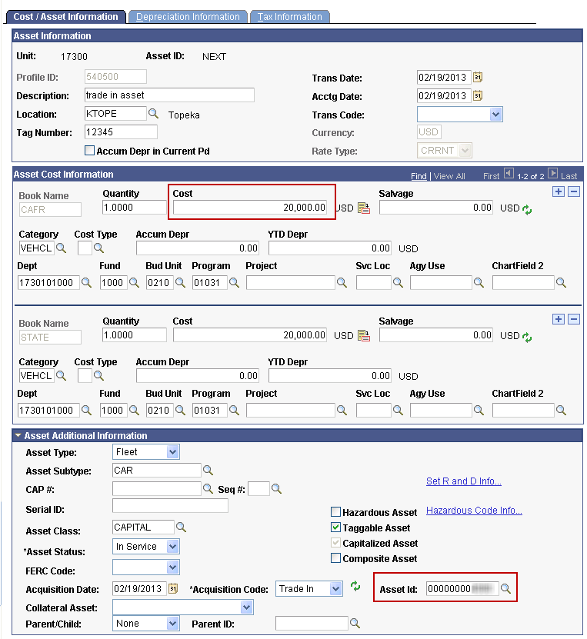
- Click Save.

Mass Retirements via the Disposal Worksheet

- The Disposal Worksheet page provides a quick method to select assets to retire based on the following elements: Category, Book, Location, Profile ID, Acquisition Details, and Chartfield values.
- Use this page with caution, as there is no mass reinstatement process if you incorrectly retire a large number of assets.
Steps to use the Disposal Worksheet
- Navigate to the Disposal Worksheet page.
Page Name | Navigation via AM Homepage or NavBar
Disposal Worksheet | Asset Management>Asset Transactions>Asset Disposal>Disposal Worksheet

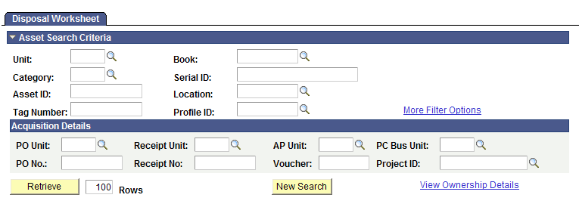
Disposal Worksheet Page
- Populate the Asset Search Criteria and Acquisition Details sections.
Fields | Description
Asset Search Criteria | Use the Asset Search Criteria section to identify assets that are eligible for disposal based on specified criteria. Available options are:  - Unit  - Category  - Asset ID  - Tag Number  - Book  Note: If the Book field is left blank, the system will assume you want capital assets only. If you want to include noncapital assets in your search results, specify the STATE book or another agency-specific book, if applicable.  - Serial ID  - Location  - Profile ID  - More Filter Options—this hyperlink allows you to specify a chartfield or chartfields as a search criterion.
Acquisition Details | You may also provide source document information if known to limit your search results.  - PO Unit (purchasing unit)  - PO No. (PO number)  - Receipt Unit  - Receipt No (receipt number)  - AP Unit (payables unit)  - Voucher  - PC Bus Unit (project costing business unit)  - Project ID
Disposal Worksheet Fields
- Click Retrieve to view results. The Disposal Worksheet page will display.
  - If the results are not what you expected, you can begin again by clicking the New Search button.
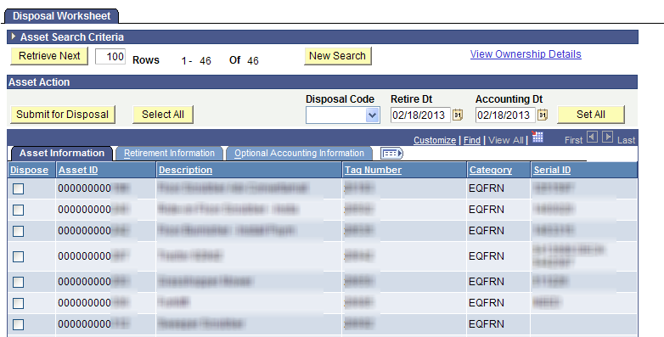
- Select the assets to be retired.
  - Click the Select All button to select all assets from the search results. The Select All button should be used with extreme caution. Otherwise, individually select the assets to be retired from the list using the Dispose checkboxes.

- Click on the Retirement Information tab. Populate the applicable fields.

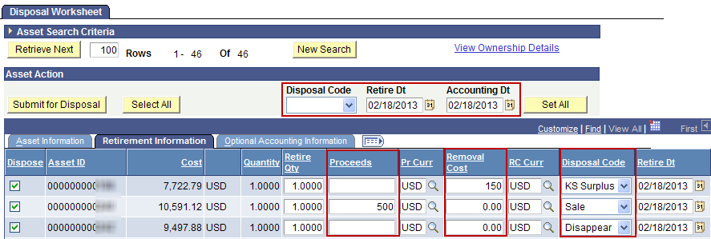

Fields | Description
Proceeds | Enter any proceeds from the retirement.
Removal Cost | Enter any costs associated with the removal of the asset.
Disposal Code | Select the disposal code for all assets to be retired in the worksheet list.  Sale will default as the Disposal Code. You can manually change that value. You can also use the Disposal Code dropdown in the Asset Action section if all the assets to be retired should have the same Disposal Code. Click Set All after selecting the Disposal Code if using that dropdown.
Retire Dt | Enter the retirement date.  Note: The default is the current date.
Accounting Dt | Today’s date will default and should not be changed.
Disposal Worksheet – Retirement Information tab
- Click the Submit for Disposal button when you have completed the disposal worksheet. A warning will display asking if you want to submit the selected assets for disposal. Click OK to continue.
- Determine the Interface ID that includes the retirements.
Page Name | Navigation via AM Homepage or NavBar
Review Financial Information | Asset Management>Send/Receive Information> Approve Financial Information>Review
- Set search parameters as shown in the screenshot below and click Search. A list of the retirements processed should display. All retirements will be included in one Interface ID.
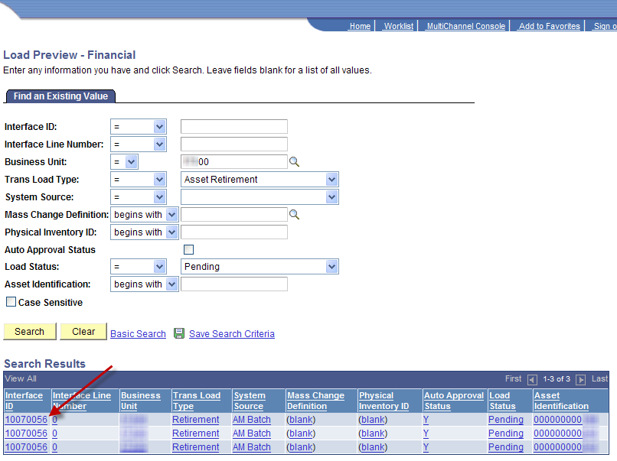
Search Parameters:

Business Unit: Enter BU
Trans Load Type: Asset Retirement
Load Status: Pending

- Run the Transaction Loader to process the retirements.
Page Name | Navigation
Transaction Loader | Asset Management Homepage>Send/Receive Information>Interface Transactions>Load Into AM  Or  NavBar: Navigator>Asset Management> Send/Receive Information>Load Transactions>Load Transactions Into AM
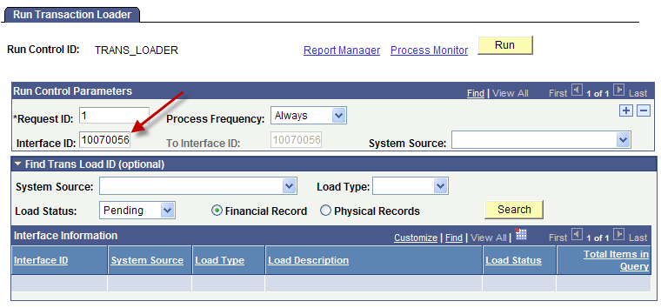
Interface ID identified in step 7
- Click Run.
- Click OK on the Process Scheduler Request page.
- Click the Process Monitor link.
- Click Refresh until AMIF1000 has a status of Success and Posted. Now the assets have been successfully retired. The Asset Status for all assets retired via the Disposal Worksheet will be “Disposed” when viewed online.

Retirements and Parent-Child Assets

- Parent and Child Assets can be transacted against separately or together. You have the option to retire only the Parent, only the Child, or both.
- A separate Child Asset tab is visible when a Parent/Child relationship has been established.
- Follow steps 1-5 from the “Steps to Individually Retire an Asset” section above to retire the Parent Asset.
- Click the Child Assets tab and select the appropriate Child Asset(s) that should be retired as well.
  - Click Select All to select all Child Assets. Otherwise, individually select the appropriate Child Assets.
  - Check the Include Parent Asset checkbox if the Parent Asset should be included in the transaction.
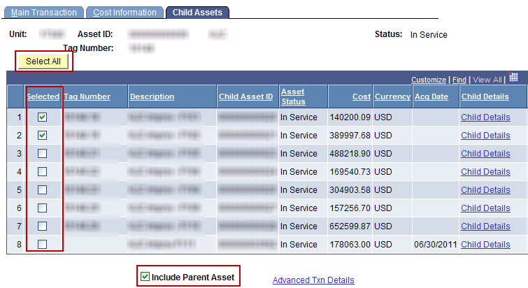
Child Assets Page
- Click Save. A warning may appear about selecting Child Assets if not all were selected.
- Review the Cost History page to validate the transaction.

Navigation
Asset Management Homepage>Asset Transactions>Asset History> Review Cost History

or

NavBar: Navigator>Asset Management>Asset Transactions> History> Review Cost
- All selected assets will have a transaction of RET. The Asset Status on the upper right will be Disposed.

Reinstating Assets
- Only one asset can be reinstated at a time
- Reinstating an asset reverses all journal entries created by the retirement
Steps to Reinstate Asset
- Navigate to the Retire/Reinstate Asset page.
Page Name | Navigation AM Homepage or NavBar
Reinstate Assets | Asset Management>Asset Transactions>Asset Disposal>Retire/Reinstate Asset
- Click the Reinstate button.
  - The status of the asset being reinstated must be Disposed for the Reinstate button to be available.
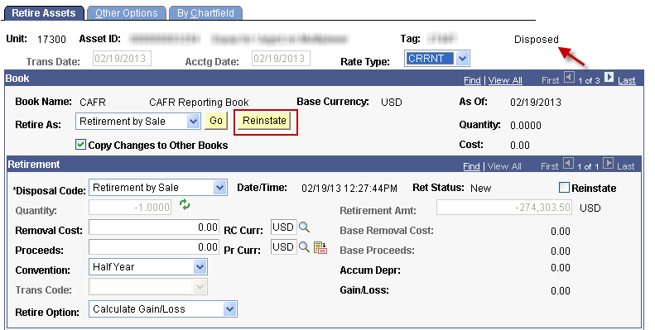
- Click Save. All previous journal entries from the retirement will be automatically reversed when the month-end batch runs. The Asset Status on the upper right will immediately change to In Service.

