

Training Guide – Asset Management
Property Assets and Related Improvements

State of Kansas

Applicable Role(s):

Agency Asset Processor
Table of Contents
Guidelines 3
Entering a Property Asset 4
Procedures 6
Land 6
Buildings 7
Land Improvements 7
Building Improvements 8
Additional Considerations 8
Appendix A: Asset Subtype Definitions 9

Property Assets and Related Improvements

Guidelines
- The Asset Property functionality will be used to create an association between a building and a land record. The Parent-Child relationship will be utilized to associate improvements with the respective land or building assets. When entering a property asset, remember the following guidelines:
  - Land assets and building assets must use the Asset Type of “Property”. This defaults when you select a land or building Profile ID.
  - Each building must be linked to a land asset by creating the association on the Asset Property tab
  - Land assets and building assets must be defined as Parent Assets when subsequent improvements have been made to the asset.
  - All improvements—land and building—must use the Asset Type of “Facility”
    - Each land improvement will be a child asset of the parent land record
    - Each building improvement will be a child asset of the parent building
- All land and buildings (both capital and noncapital) must be entered in SMART. See Information Circular 13-a-007 for more information.
- Only land improvements and building improvements that are capital must be entered in SMART. It is up to the agency whether or not to track noncapital improvements in SMART.

Entering a Property Asset
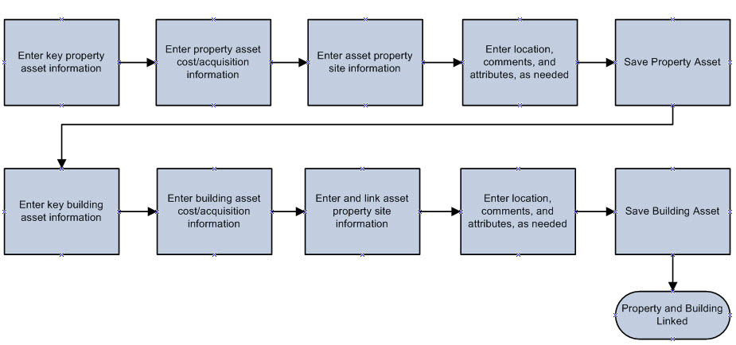
Entering Property Assets Process
- Entering a property asset follows the same steps as entering a non-property asset except that when you select a Land or Building Asset Profile, it will default in an Asset Type of Property. You cannot choose the asset type. SMART then displays an additional tab in Basic Add called Asset Property.
- The Asset Property tab is used to create an association between a building and a land record.
  - Note: You must enter the Land asset before adding the Building. That allows you to link the Building to the Land in the Hierarchy section.

Page Name | Navigation
Asset Property | Asset Management>Asset Transactions>Owned Assets>Basic Add>Asset Property

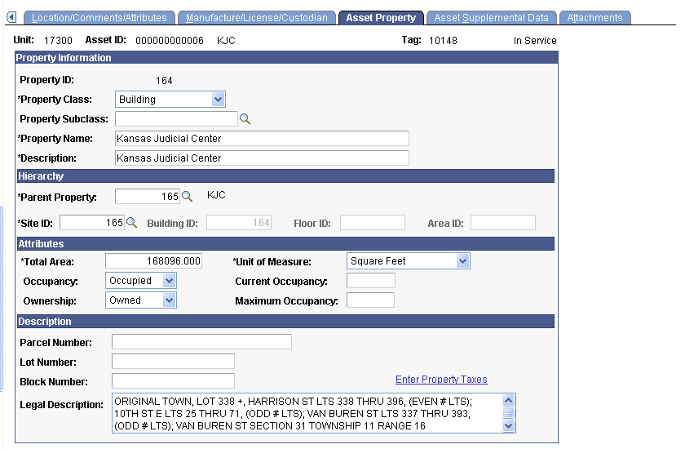
Asset Property Page
Fields | Description
Property ID | SMART displays the property asset ID after you save.
Property Class | SMART delivers the following hierarchy of property classes: Site, Building, Floor, Area, Space.  The State of Kansas only utilizes the Site (land) and Building levels.
Property Name and Description | Enter the best description of the property that you can. Simply entering “Land” doesn’t allow a user to easily determine what land is being referenced.  When Express Add is used, values are not populated automatically.
Hierarchy section | Do NOT use the lookup in the Parent Property field.  For a Site (land), the system will autopopulate the Site Id and Parent Property after you save.  For a Building, select the corresponding Site ID from the Site ID lookup. You should be able to tell which piece of land the building sits on based on the Property Description and Property Name fields that display.
Attributes section | Enter information about the total area and occupancy of the asset. Land should have “Acres” as the Unit of Measure while a building should have “Square Feet.”
Legal Description | Use this field to record the legal description for the property.
Asset Property Fields

Procedures
To create relationships between land, buildings, land improvements, and building improvements, the following procedures will be used.

Land
- All land records (both capital and noncapital) must be entered in SMART.
- Land records will be defined using the Asset Type of “Property”
- An appropriate Asset Subtype should be selected to determine the primary use of the land. See Appendix A at the end of this lesson.
- Each land asset record shall be designated as a parent asset when improvements have been made to the land.
- The In-Service Date shall be the date of possession
- Fill in the following fields on the Asset Property tab:
  - A Property Class of “Site” should be selected. SMART will assign a Site ID upon saving.
  - Do not select a value in the Property Subclass field
  - Enter as much unique, descriptive information as possible in the Property Name and Property Description fields. This will allow users to more easily identify the correct land record when adding a building.

Buildings
A building is a structure that is permanently attached to the land, has a roof, is partially or completely enclosed by walls, and is not intended to be transportable or moveable.

- All buildings (both capital and noncapital) must be entered in SMART.
- Building records will be defined using the Asset Type of “Property”
- An appropriate Asset Subtype should be selected to determine the primary use of the building. See Appendix A at the end of this lesson.
- Each building asset record shall be designated as a parent asset when improvements have been made to the asset.
- The In-Service Date shall be the date of possession for purchased buildings. The In-Service Date shall be the date of the Certificate of Occupancy for constructed buildings.
- Fill in the following fields on the Asset Property tab:
  - A Property Class of “Building” should be selected.
  - Do not select a value in the Property Subclass field
  - Enter as much unique, descriptive information as possible for the Property Name and Property Description to more easily identify the building.
  - SMART will require that the building be assigned to a site. Assign the building to the correct Site ID.
- SMART will assign a Building ID upon saving.

Land Improvements*
A land improvement is a nonstructural improvement which includes examples such as ponds, terraces, dikes, drainage ditches, fences, landscaping, walks, drives, streets, curbs, water wells, and boat ramps.

- Only land improvements that are capital must be entered in SMART. It is up to the agency whether or not to track noncapital improvements in SMART.
- Land improvements will be defined using an Asset Type of “Facility”
- One of the following Asset Subtypes shall be selected for each Land Improvement record
Depr Land Imp | Depreciable Land Improvement: Permanent improvements, other than buildings, that add value to the land, and have a definite useful life. Examples include fences, retaining walls, utility installations, parking lots.
NDepr Land Imp | Nondepreciable Land Improvement: Basic site improvements (excavation, grading, fill) that have an indefinite useful life.

- Each land improvement shall be designated as a child asset. The appropriate land record shall be selected as the land improvement record’s parent. (See the Parent-Child Relationships lesson for more information on how to designate the improvement as a child asset.)
- The In-Service Date shall be the date the improvement was completed and put in place for use.

Building Improvements*
Building improvements are costs that add value to an existing building either by lengthening its estimated useful life or increasing service capacity.

- Only building improvements that are capital must be entered in SMART. It is up to the agency whether or not to track noncapital improvements in SMART.
- Building improvement records will be defined using an Asset Type of “Facility”
- The asset subtype of “Bldg Imprvmnt” shall be selected
- Each building improvement shall be designated as a child asset. The appropriate building record shall be selected as the building improvement record’s parent. (See the Parent-Child Relationships lesson for more information on how to designate the improvement as a child asset.)
- The In-Service Date shall be the date the improvement was completed and put in place for use.

Additional Considerations
*When determining whether to create an asset for land, buildings and related improvements:

- The agency should consider the cost of the entire project, rather than each payment or vendor separately.

- Professional judgment should be used by the agency to determine if an improvement is a normal maintenance repair or an improvement. Normal maintenance repairs are not GAAP reportable, regardless of the cost. Generally, an addition or improvement either enhances the asset's functionality (effectiveness or efficiency) or extends the assets useful life.

Appendix A: Asset Subtype Definitions

Property Assets
Asset Type = Property

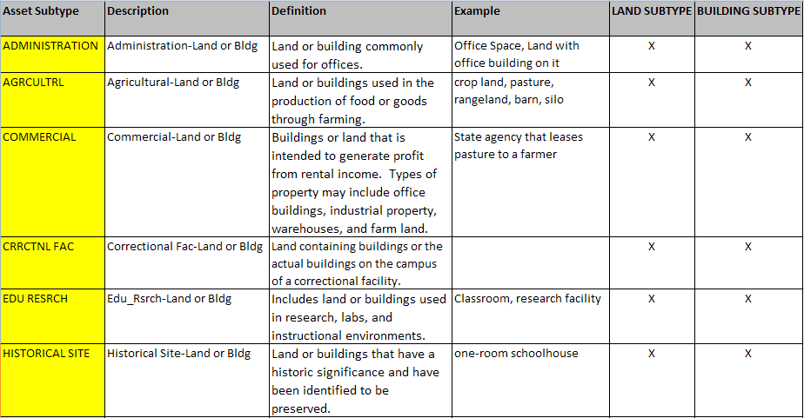
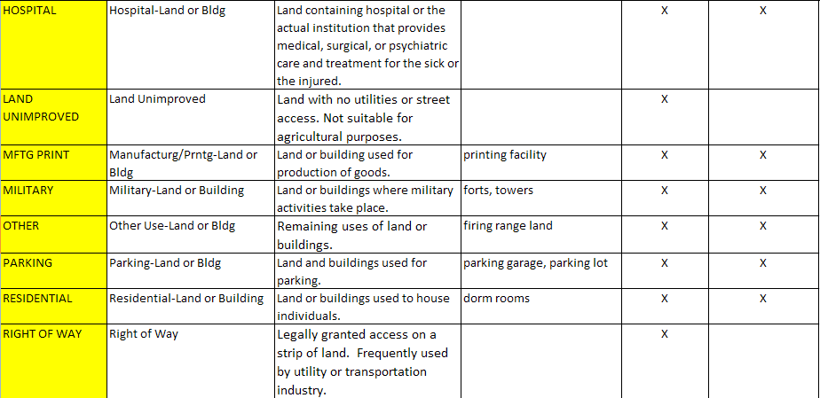

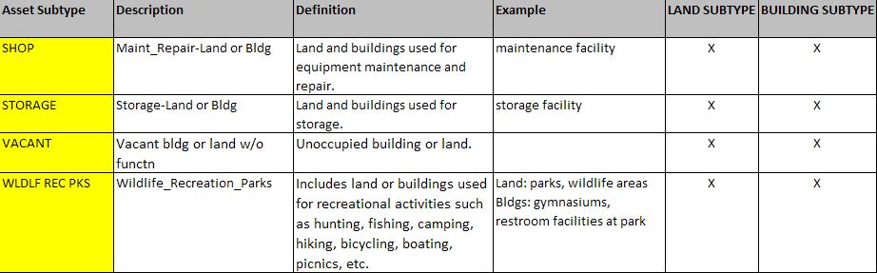

Improvement Assets
Asset Type = Facility



