**State of Kansas**



**High-Level Changes from 9.0 to 9.2 in Asset Management:**

**Interface ID Load Status Updates**

***Statewide Management, Accounting and Reporting Tool***

|  |  |
| --- | --- |
| **Date Created:** | 10/28/2015 |
| **Version:** | 1.0 |
| **Last Updated Date:** |  |
| **Purpose:** | *This document highlights one of the changes between 9.0 and 9.2 in the Asset Management module.* |
| **Security:** | * Role Security: The following roles are applicable:   Agency Asset Processor  BU Security: Business Unit Security is applied. Agencies will only have access to the assets in their Business Unit. |

Procedure

Sometimes it is necessary to change an Interface ID's Load Status. For instance, if data integrates into the Transaction Loader Tables that should not have because it is a service and not an asset, agency users change the Load Status from *Pending* (which indicates that line is available to be processed by the Transaction Loader process) to *Replaced* (which does not allow that line to be picked up by the Transaction Loader). A status of *Replaced* indicates that line has been reviewed, and it has been determined that line should never load.

Agency users who have changed the Load Status in 9.0 will recall that you must change the Load Status on both the Financial and Physical sides of the Interface ID. In 9.2, you only have to change the status in one place.

| **Step** | **Action** |
| --- | --- |
|  | Click the object. |
|  | Click the **Asset Management** menu. |
|  | Click the **Send/Receive Information** menu. |
|  | Click the **Approve Financial Information** menu. |

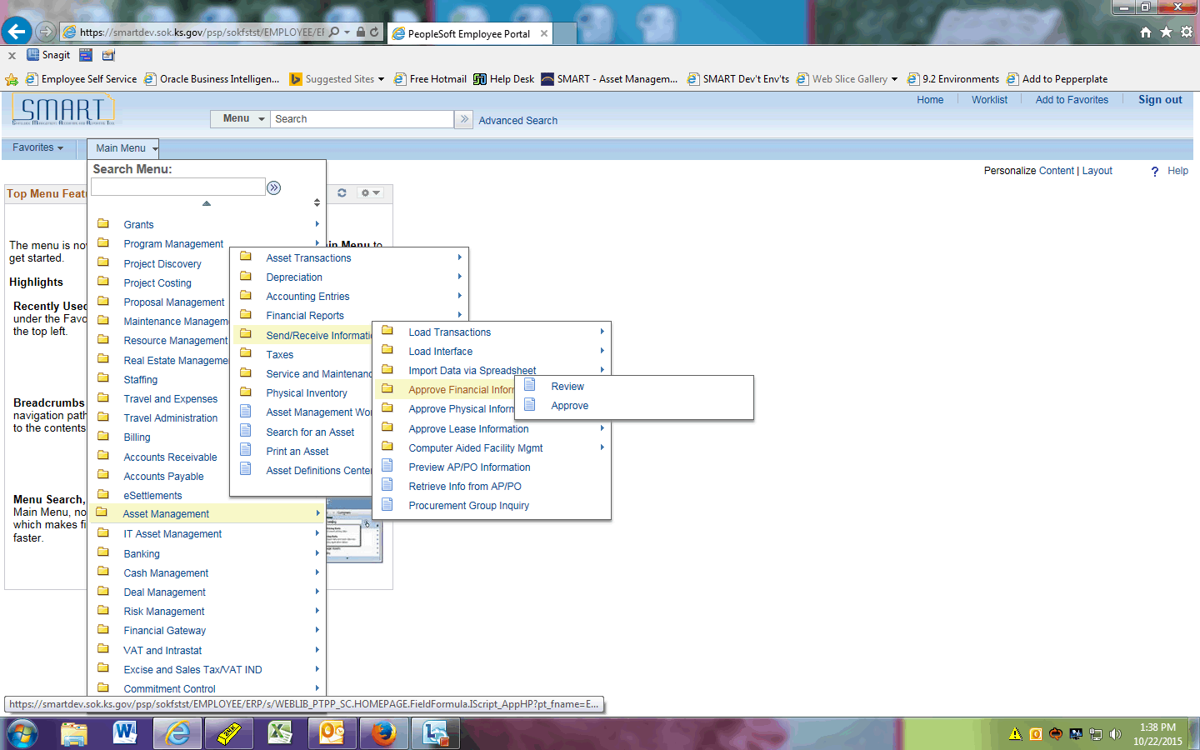

| **Step** | **Action** |
| --- | --- |
|  | Click the **Review** menu. |

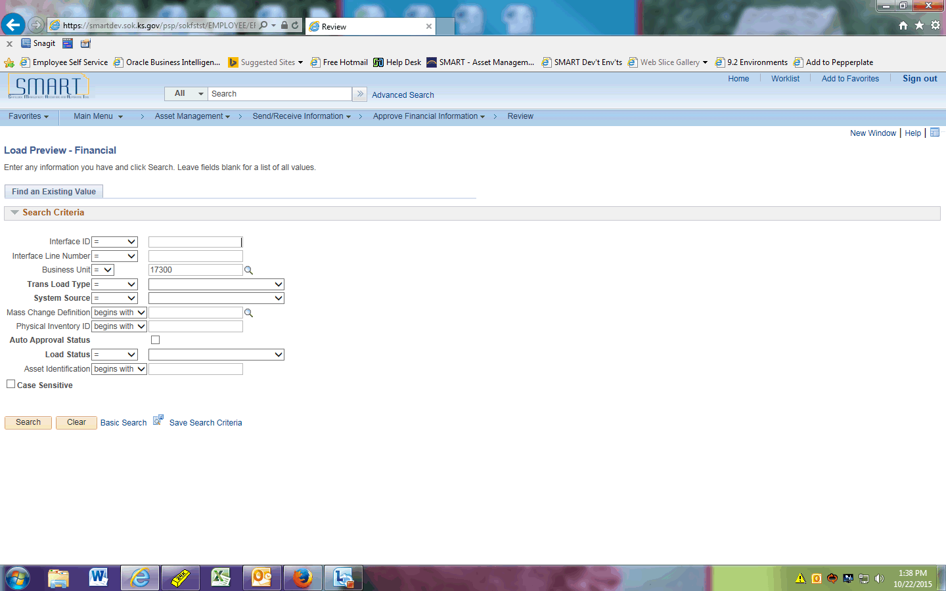

| **Step** | **Action** |
| --- | --- |
|  | In this example, we are going to change an Interface ID's status from *Pending* to *Replaced*. First we'll search for a Pending Interface ID.  Click the **Pending** list item. |
|  | Click the **Search** button. |

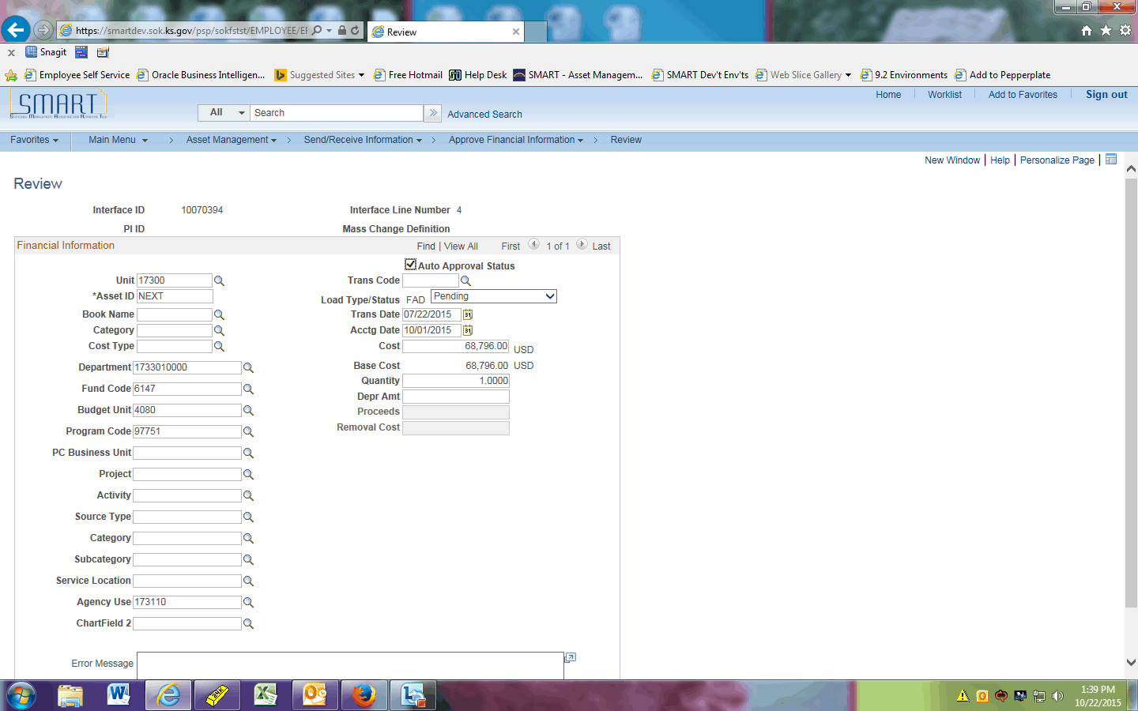

| **Step** | **Action** |
| --- | --- |
|  | After reviewing the financial data, we determine this line should never load. Now we will change the Load Status.  Click the **Load Type/Status** dropdown. |

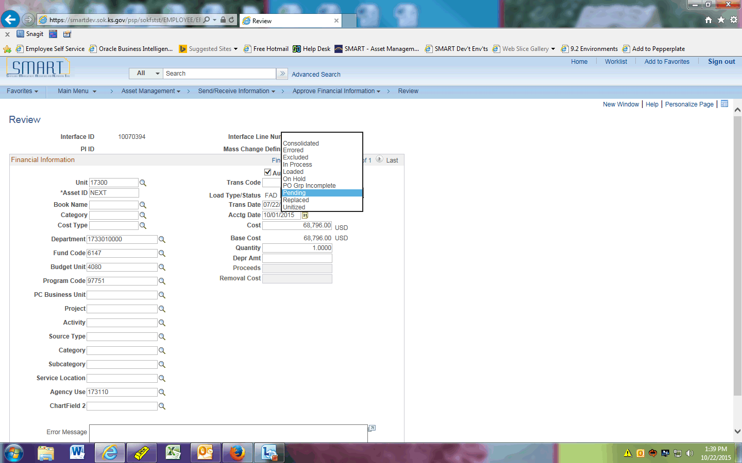

| **Step** | **Action** |
| --- | --- |
|  | Click the **Replaced** list item. |

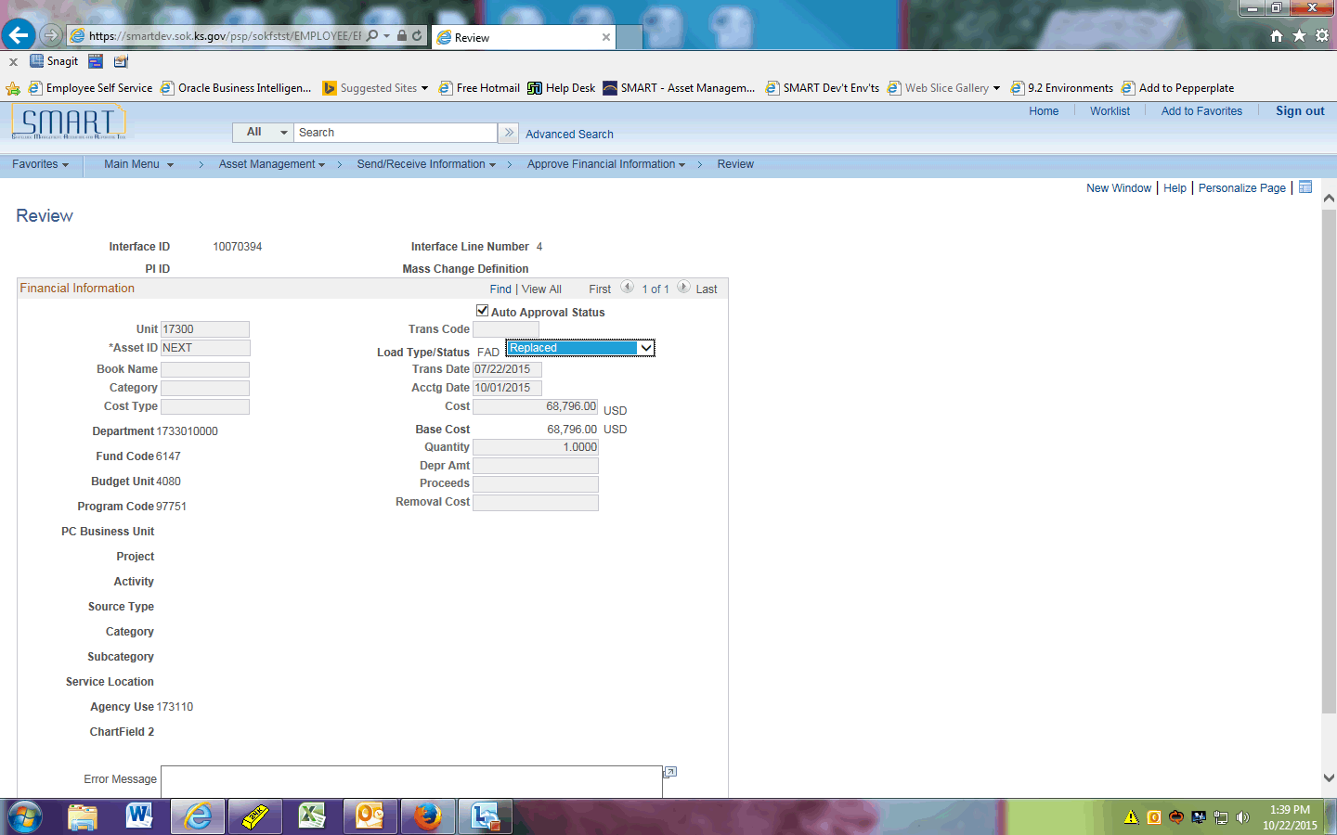

| **Step** | **Action** |
| --- | --- |
|  | Click the **Save** button.  After saving in 9.0, you would navigate to Asset Management > Send/Receive Information > Approve Physical Information > Review-A to change the Load Status there as well. But in 9.2, saving it in one place automatically updates the other side of the Interface ID. (It will also work if you change the Physical side first. The Financial side would then update automatically.) |

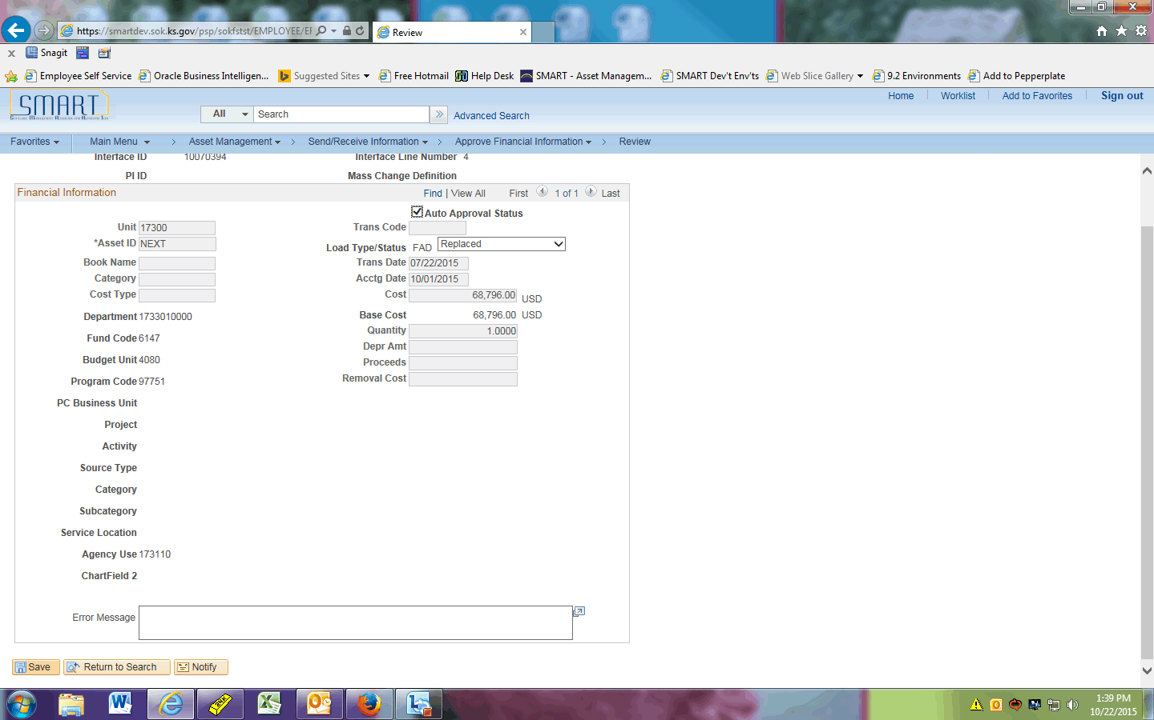

| **Step** | **Action** |
| --- | --- |
|  | Navigate to the Physical side to show that it updated automatically.  Click the **Send/Receive Information** button. |
|  | Click the **Approve Physical Information** object. |

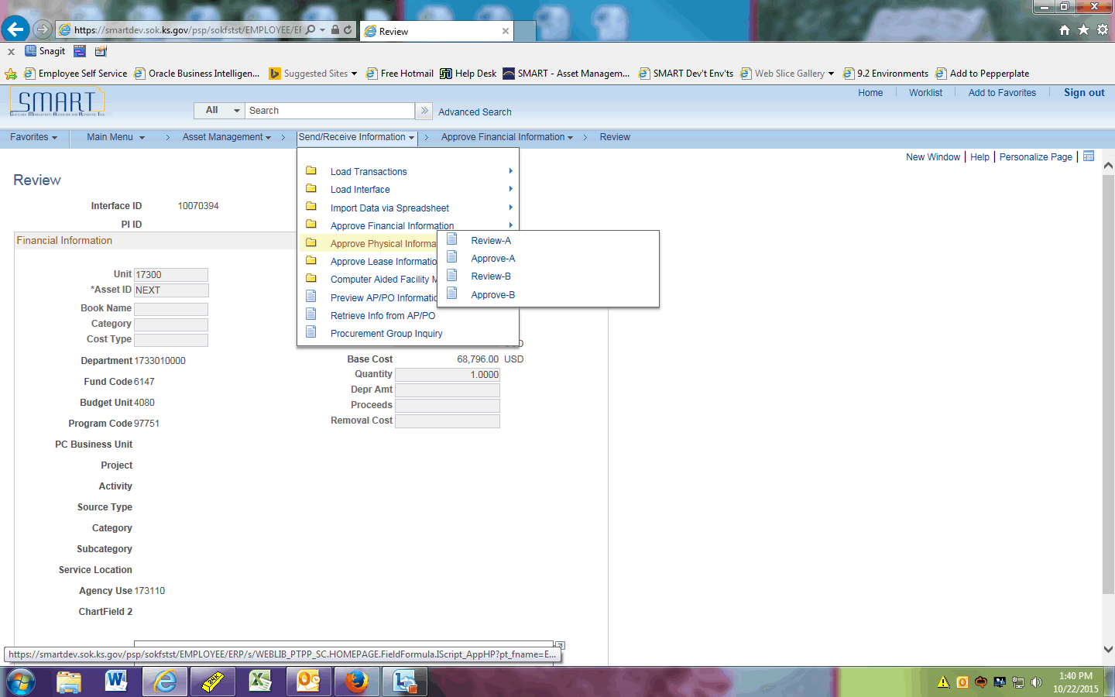

| **Step** | **Action** |
| --- | --- |
|  | Click the **Review-A** menu. |

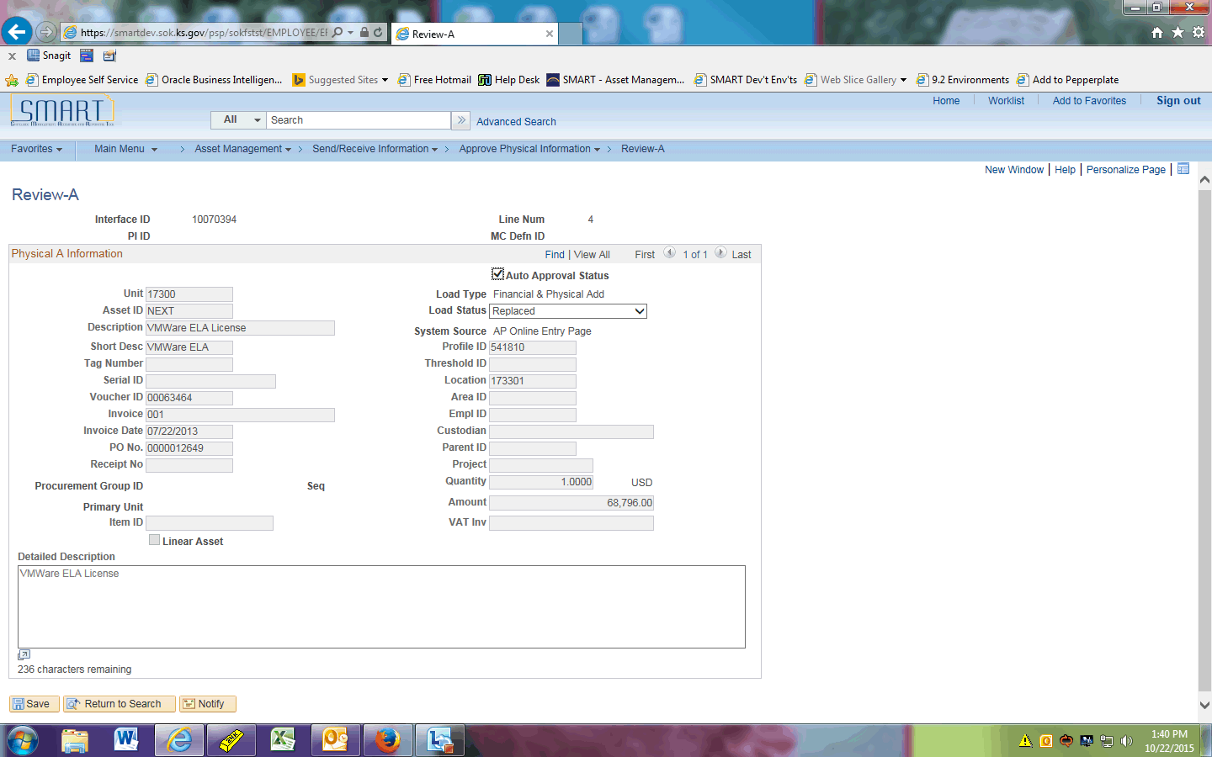

| **Step** | **Action** |
| --- | --- |
|  | Notice the Interface ID we were just working on opens automatically. The Load Status has been updated to *Replaced*. |
|  | This concludes the 'AM - Interface ID Load Status Updates' topic. Thank you for taking this course.  **End of Procedure.** |