State of Kansas
Asset Management
Entering and Updating Physical Information in Basic Add
Statewide Management, Accounting and Reporting Tool
Date Created: | 11/02/2015
Version: | 2.1
Last Updated Date: | 03/29/2019
Security: | Role Security: The following roles are applicable:  Agency Asset Processor  Agency Asset Maintainer  KS Assets Viewer  BU Security: Business Unit Security is applied. Agencies will only have access to the assets in their Business Unit.

Table of Contents
Entering and Updating Physical Information in Basic Add 2
General Information page 2
Operation/Maintenance page 3
Asset Acquisition Detail page 4
Location/Comments/Attributes page 6
Manufacture/License/Custodian page 8
Asset Supplemental Data page 9

Entering and Updating Physical Information in Basic Add

- Use Basic Add to enter and update physical details for an asset. Examples include changing Custodians or Location Codes or updating Descriptions and Tag Numbers.
- You can navigate to Basic Add directly after entering an asset via Express Add or integration.
- Any physical details in Basic Add can be updated at any time.
- After all updates have been made, click Save.

Page Name | Navigation
Basic Add | Asset Management Homepage>Asset Transactions>Basic Add  Or  NavBar: Navigator>Asset Management>Asset Transactions>Owned Assets>Basic Add

There are multiple tabs within Basic Add.
General Information page – Use this page to enter and update Description, Tag Number, Asset Type/Asset Subtype, and Asset Status fields. This tab also houses the Profile ID and Parent/Child information.
- Attachments can also be added from the General Information page. Please see the ‘Attachments’ training document for additional information.
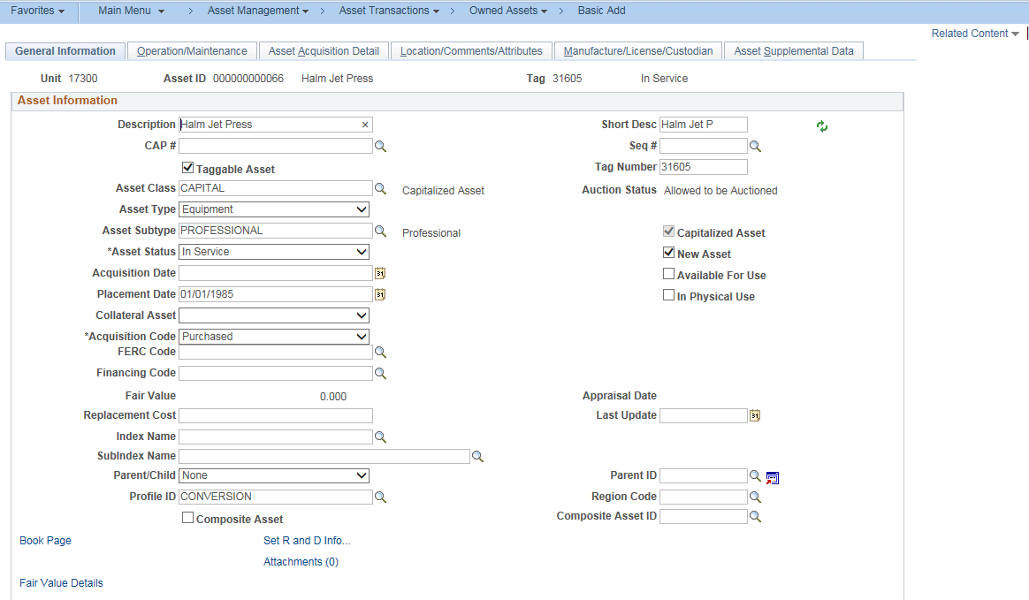
General Information Page
Operation/Maintenance page – Use this page to enter whether the asset is hazardous, the asset’s Serial ID, and manufacturing information.
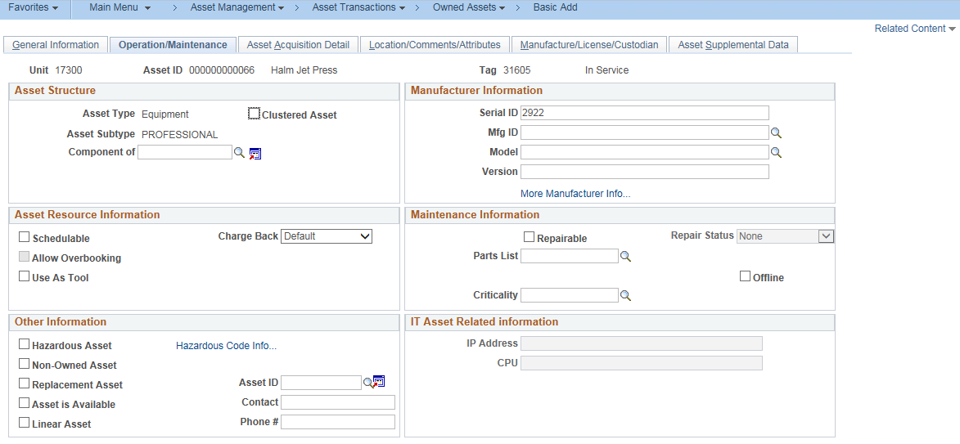
Operation/Maintenance Page
Fields | Description
Serial ID | Enter or update the Serial ID of the asset.
Mfg ID | Indicates the manufacturer of the asset
Model | Indicates the model number of the asset
Hazardous Asset | Use this checkbox to indicate if an asset is hazardous
Hazardous Code Info… | Use this hyperlink to access a page where you can assign the associated hazardous code that identifies the hazardous material(s) an asset contains
IP Address | This field is only available when the asset type is “hardware” and is used to indicate the IP address of the device where the asset is installed
CPU | This field is only available when the asset type is “hardware” and is used to indicate the number of CPUs that a hardware device has installed
Operation/Maintenance Fields

Asset Acquisition Detail page – Use this page to review cost, funding information, and integration details if applicable.
  - Note: This page ONLY shows the cost and funding information used when the asset was originally entered. Any adjustments to cost or changes to funding do NOT show on this page. For current cost and funding details, navigate to the Cost History page (Asset Management Homepage > Asset Transactions > Asset History > Review Cost History or NavBar: Navigator > Asset Management > Asset Transactions > History > Review Cost) or select the Related Content hyperlink in the upper right and select Cost History to open a pagelet within Basic Add displaying the financial transactions.
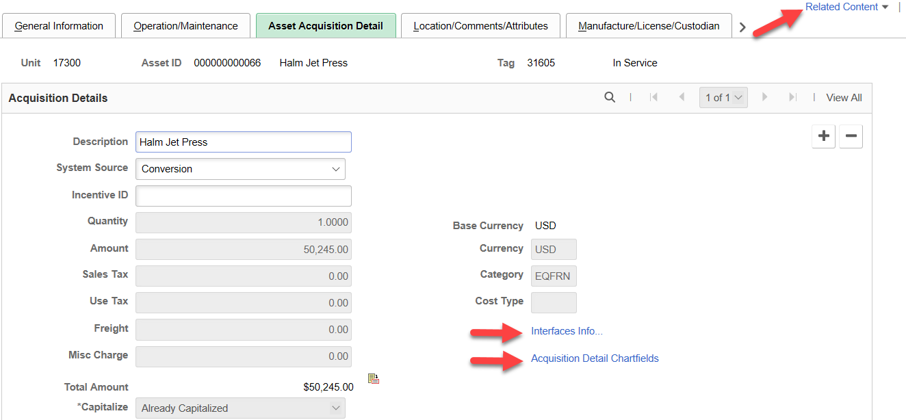
Asset Acquisition Detail Page
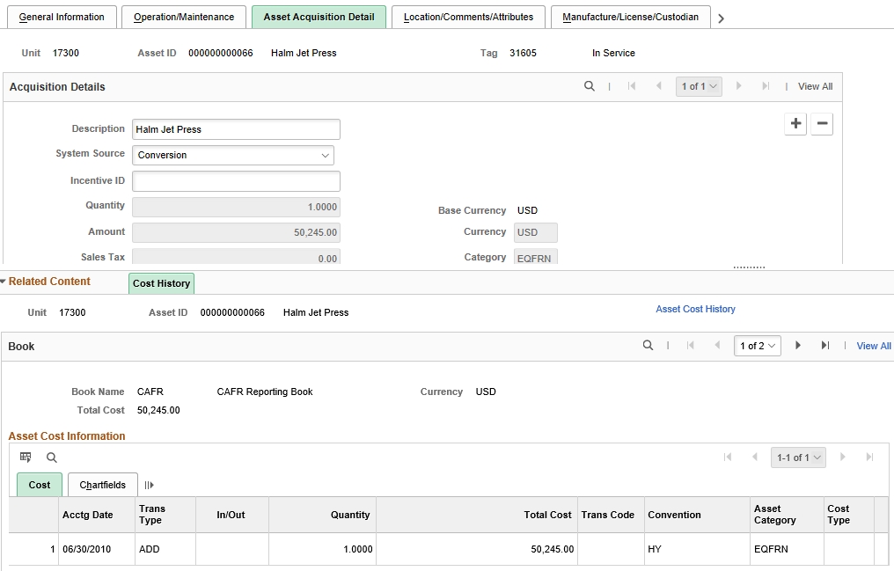
Asset Acquisition Detail Page with Related Content > Cost History pagelet

  - Click the Interfaces Info… hyperlink to review the Purchasing and Accounts Payable source documents associated with this asset. This information is only available if your agency utilizes the integration.
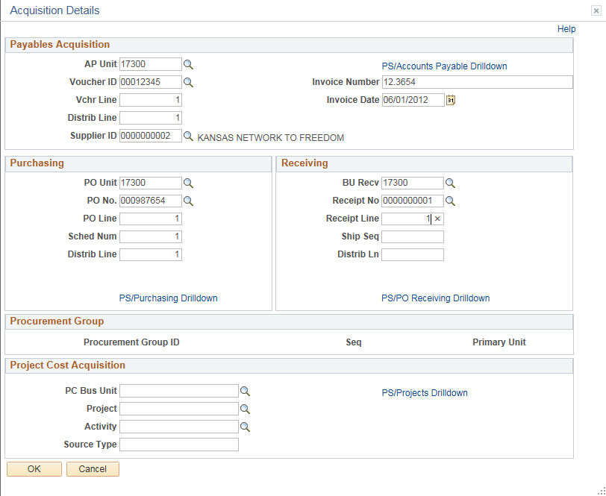
Acquisition Details Page
  - Click the Acquisition Detail Chartfields hyperlink to view the chartfields used when the asset was originally entered. Again, the chartfields on this page will not update when changes to chartfields are processed. For current cost and funding details, navigate to the Cost History page (Asset Management Homepage > Asset Transactions > Asset History > Review Cost History or NavBar: Navigator > Asset Management > Asset Transactions > History > Review Cost) or select the Related Content hyperlink in the upper right and select Cost History to open a pagelet within Basic Add displaying the financial transactions.
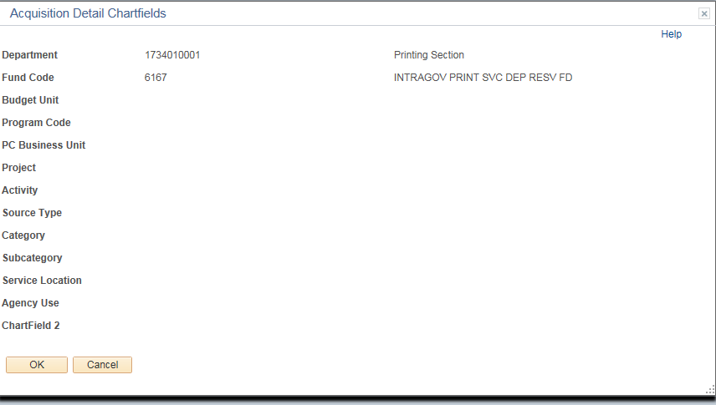
Acquisition Detail Chartfields Page
Location/Comments/Attributes page – Use this page to update the Location and/or area ID of the asset, add additional comments, and update physical and custom attributes such as color, height, and weight of the asset.

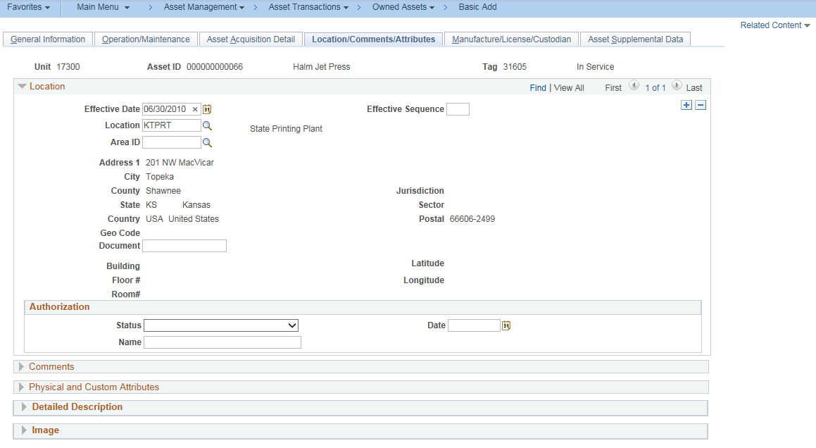
Location/Comments/Attributes (Top of Page)

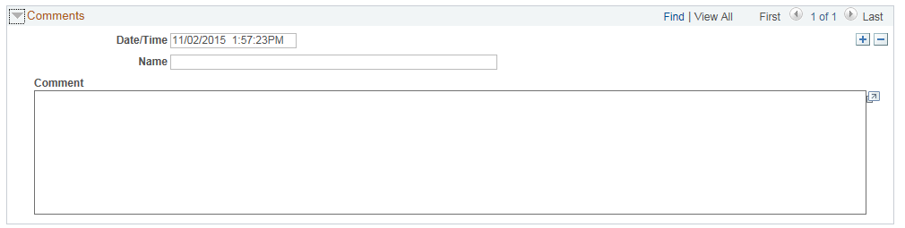
Comments Expanded
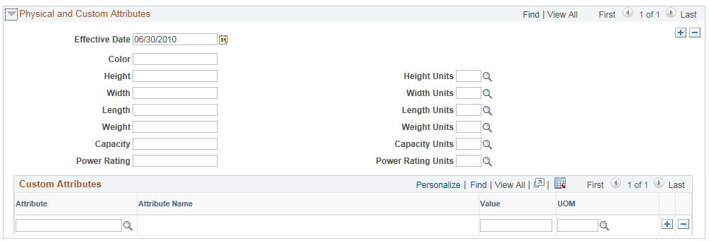
Physical and Custom Attributes Expanded

Fields | Description
Location Code | The full address defaults based on the Location Code that was used.  You must click the “+” button to add a new Location Code.  Note: The Purchasing Ship-To Locations use the same table to store Location Codes. Therefore, SMART Asset Management uses a unique naming convention. All asset locations begin with K (for Kansas), then the next letter is the first letter of the city. For example, all asset locations in Topeka would start “KT”. The last 3 characters are unique to the property.
Area ID | Select an area ID to provide a more detailed level that further identifies an asset’s location, such as room number or floor. Area ID’s are not required fields and are agency-maintained. See the “Adding and Inactivating Area IDs” job aid for more information.
Comments | Enter miscellaneous comments about the asset and assign the date, time, and name of the person who entered the comments.  Some agencies that do not utilize integration track PO and Voucher information here.
Physical and Custom Attributes | Enter or modify physical details such as color, height, width, length, weight, capacity, and power rating
Location/Comments/Attributes Fields

Manufacture/License/Custodian page – Use this page to record information from the manufacturer, update the licensing information, or update the custodian of the asset. Any updates made to manufacturer information on the Manufacture/ License/Custodian page default in to the Operation/Maintenance page and vice versa. You can also enter the VIN if the asset is a vehicle.

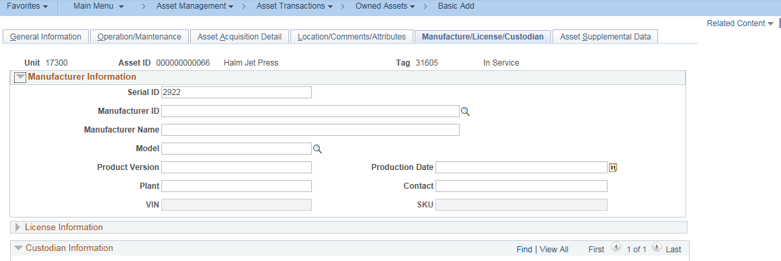
Manufacturer/License/Custodian (Top of Page)
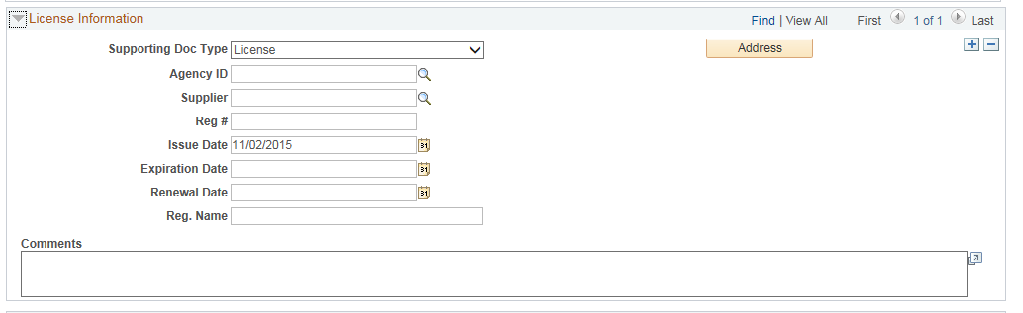
License Information Expanded
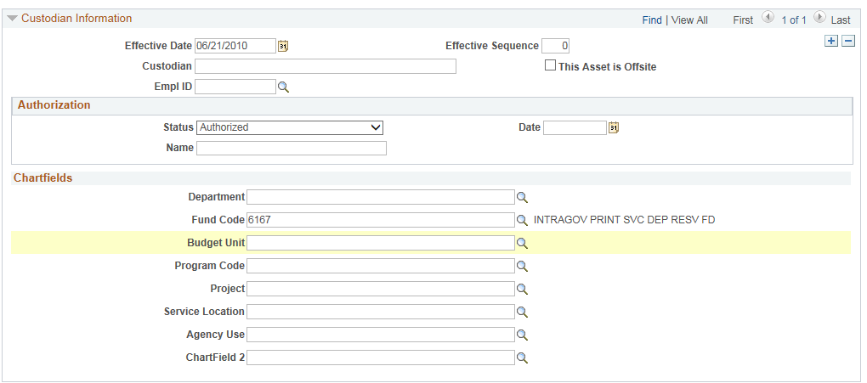
Custodian Information Expanded
Fields | Description
Manufacturer Information section | Enter manufacturing details about the asset. This section works in conjunction with the Operation/Maintenance tab.
Agency ID | Use this field to record the entity that governs licensing for the asset
Reg # | Use this field to record the asset's license number
EmplID | Select the Employee ID of the State employee who is custodian of the asset  Note: You must click the “+” button to add a new custodian record. This is true for the first custodian as well because saving an asset in Express Add doesn’t allow you to assign a Custodian.
Custodian | The name of the employee defaults based on the selected Employee ID.
ChartFields | You can track the use of the asset by ChartField values. These fields are informational only. They do not change with updates made to chartfields. If changes to chartfields are needed, process an IntraUnit Transfer.
Manufacturer/License/Custodian Fields

Asset Supplemental Data page – Use this page to record the Asset Condition and whether or not the asset has Special Disposal Restrictions.
- Supplemental Data fields can be agency-specific. If an agency has additional attributes that need to be tracked, please log a ManageEngine Service Desk ticket with that information.
