State of Kansas
Asset Management: Copying an Existing Asset
Statewide Management, Accounting and Reporting Tool

Date Created: | 11/2/2015
Version: | 2.1
Last Updated Date: | 03/28/2019
Security: | Role Security: The following roles are applicable:  Agency Asset Processor  BU Security: Business Unit Security is applied. Agencies will only have access to the assets in their Business Unit.
Copying an Existing Asset

- Copying an asset saves time if the existing asset’s financial and physical information is similar to the asset that you want to create. After the copy is complete, you only need to change the information that is different between the existing asset and the new asset.
  - You can change any value, including those in the Cost and Chartfields tabs.
- After you copy an asset, SMART assigns a different asset ID to the new asset(s) automatically
- SMART automatically copies the basic asset information, book, cost, custodian, and location. Use the Asset Copy options to choose whether to copy:
  - Acquisition information
  - Attributes
  - Insurance information
  - Comments
  - Lease information
  - License/registration information
  - Maintenance information
  - Noncapitalized costs
  - Warranty information
- Child assets can be copied. Parent assets can not be copied.
- The Num of Asset Copies to Create box is used to enter the number of copies made. After clicking the Create Assets button, the correct number of assets will be displayed. Each asset’s information can be changed (example-Description, Tag Number, Serial ID, chartfields).
- Always specify a description in the Description field. Otherwise, the Profile ID’s default description (not the description from the asset being copied) will populate.

See procedure below.
Step | Action
 | Navigate to: Asset Management Homepage > Asset Transactions > Copy Existing Asset or NavBar: Navigator > Asset Management > Asset Transactions > Owned Assets > Copy Existing Asset

Step | Action
 | Enter the desired information into the Asset Identification field. Enter "000000000045".
 | Click the Search button.
In this example, 2 assets will be created. Both were acquired in a prior month, and one needs to have the funding changed from what defaults from the existing asset.

SMART automatically copies the basic information, book, cost, custodian, and location. Other options are selected in the Asset Copy Options section and can be unchecked if applicable.

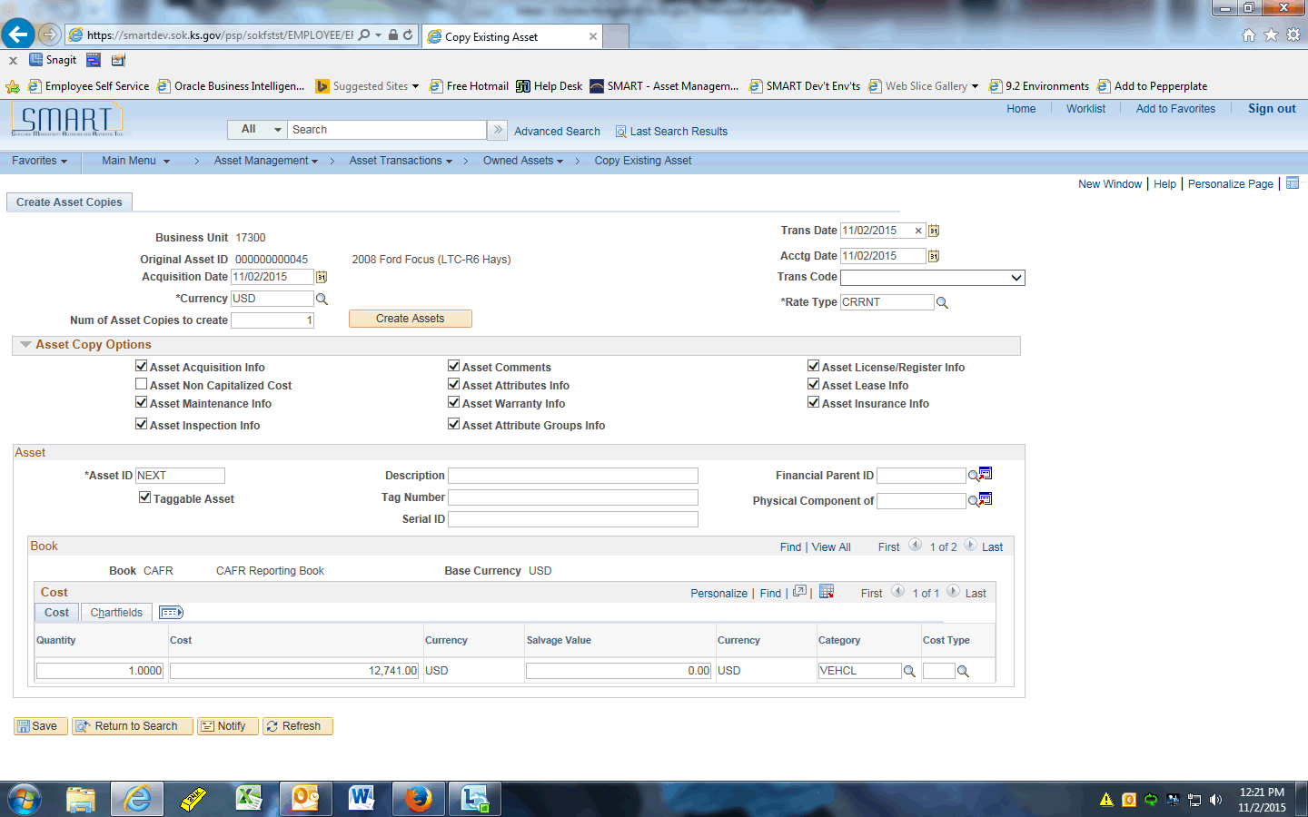

Step | Action
Enter the desired information into the Acquisition Date field. Enter "08/01/2015".

This is the date the asset was acquired, which is why we are backdating this field.
 | Enter the desired information into the Num of Asset Copies to create field. Enter "2".
Enter the desired information into the Trans Date field. Enter "08/01/2015".

This is the date the asset was put in service. This drives the depreciation start date.
 | Click the Create Assets button.
Notice that the Asset ID fields change to NEXT and NEXT1. This means that the next two available Asset IDs will be used when these copies are saved.

A new asset section is added for every copy being created. This allows you to change any information that defaulted from the original, such as cost and funding.
Always specify a description in the Description field. Otherwise, the Profile ID’s default description (not the description from the asset being copied) will populate here.

Enter the desired information into the Description field. Enter "2008 Ford Focus Copy 1".
 | Enter the desired information into the Tag Number field. Enter "123QWE".
 | Enter the desired information into the Description field. Enter "Ford Focus Copy 2".
 | Enter the desired information into the Tag Number field. Enter "456POI".
 | Click the Chartfields object.
Now we'll change the default funding on the second asset.

Click the Look up Fund (Alt+5) button.
 | Click the 2017 link.
 | Click the Save button.
 | The system immediately assigns the Asset IDs. These assets can now be viewed in Basic Add.

