**State of Kansas**



**High-Level Changes from 9.0 to 9.2 in Asset Management:**

**Attachments**

***Statewide Management, Accounting and Reporting Tool***

|  |  |
| --- | --- |
| **Date Created:** | 10/28/2015 |
| **Version:** | 1.0 |
| **Last Updated Date:** |  |
| **Purpose:** | *This document highlights one of the changes between 9.0 and 9.2 in the Asset Management module.* |
| **Security:** | * Role Security: The following roles are applicable:   Agency Asset Processor  KS Assets Viewer  BU Security: Business Unit Security is applied. Agencies will only have access to the assets in their Business Unit. |

Procedure

In 9.2, you have the option of adding attachments to assets. There are some considerations to take regarding attachment use:

– The recommended size limit for a file being attached is 1 MB.

– Agencies should not attach CAD (Computer Aided Design) files or picture files (examples- .jpg, .tif, .png, or .gif).

– Excel, Word, PDF, or similar files are appropriate.

– Multiple attachments are allowed.

– Avoid attaching documents that do not add value to the transaction.

– System retention for attachment files is expected to be 3 years. This period may be reduced if storage space becomes an issue.

– Agencies should not rely on SMART as the method for meeting record retention policies.

| **Step** | **Action** |
| --- | --- |
|  | Click the object. |
|  | Click the **Asset Management** menu. |
|  | Click the **Asset Transactions** menu. |
|  | Click the **Owned Assets** menu. |

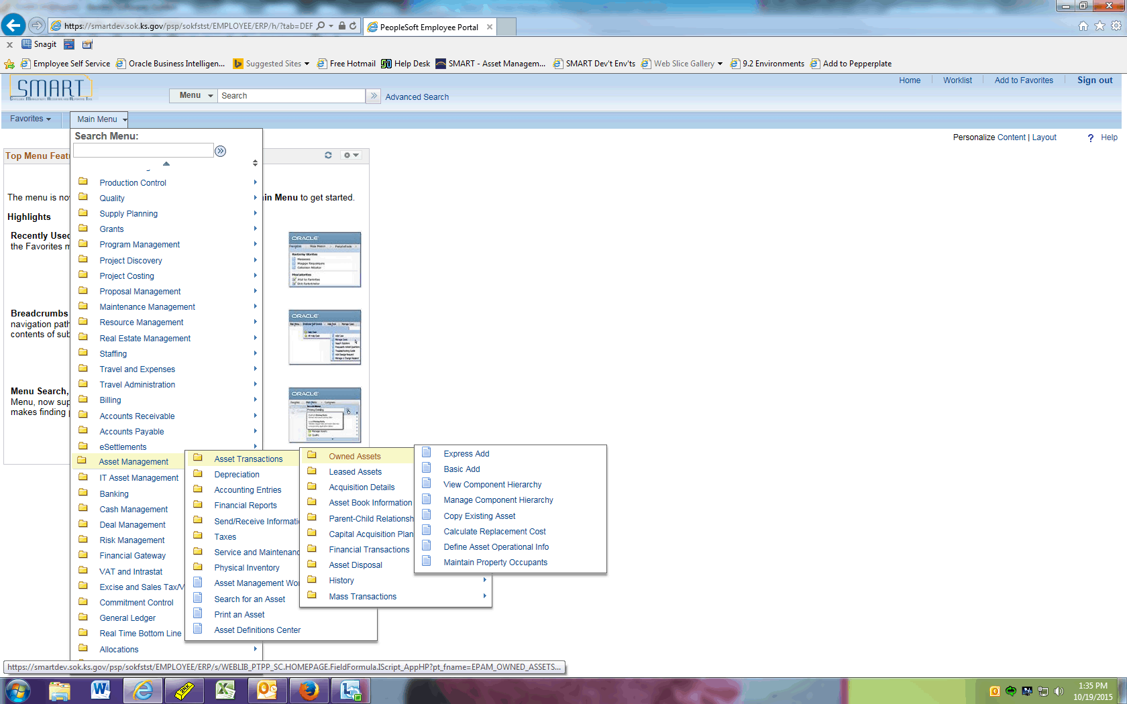

| **Step** | **Action** |
| --- | --- |
|  | Click the **Basic Add** menu. |
|  | Click the **Search** button. |
|  | Select the asset you wish to open. |

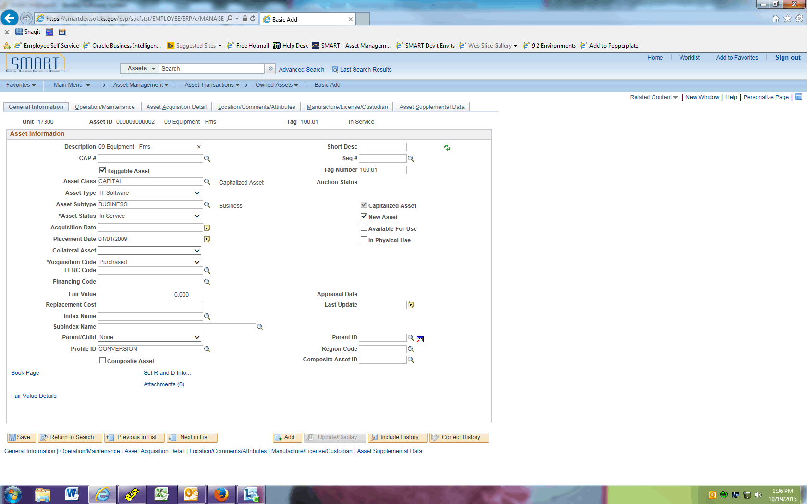

| **Step** | **Action** |
| --- | --- |
|  | Click the **Attachments (0)** link. |

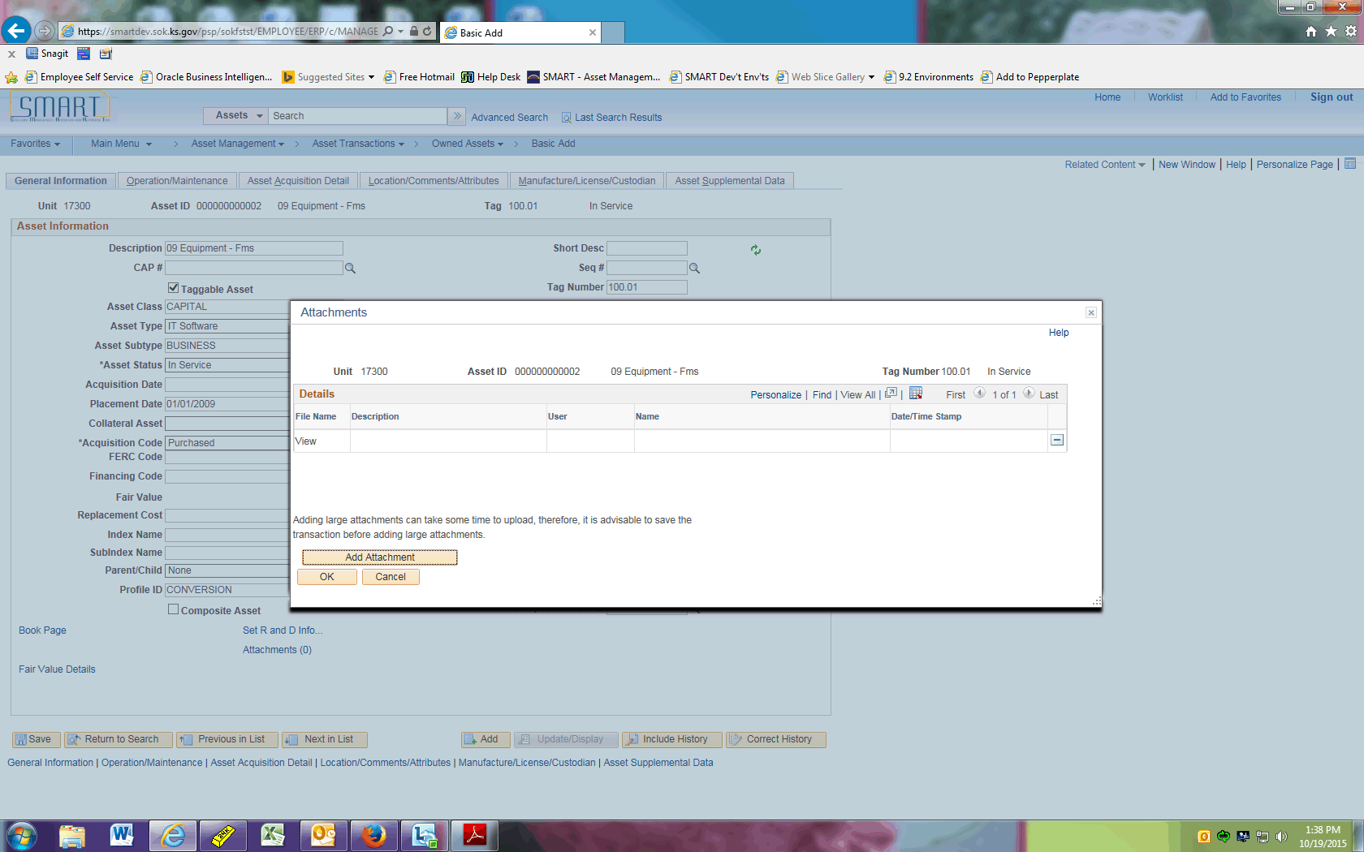

| **Step** | **Action** |
| --- | --- |
|  | Click the **Add Attachment** button. |

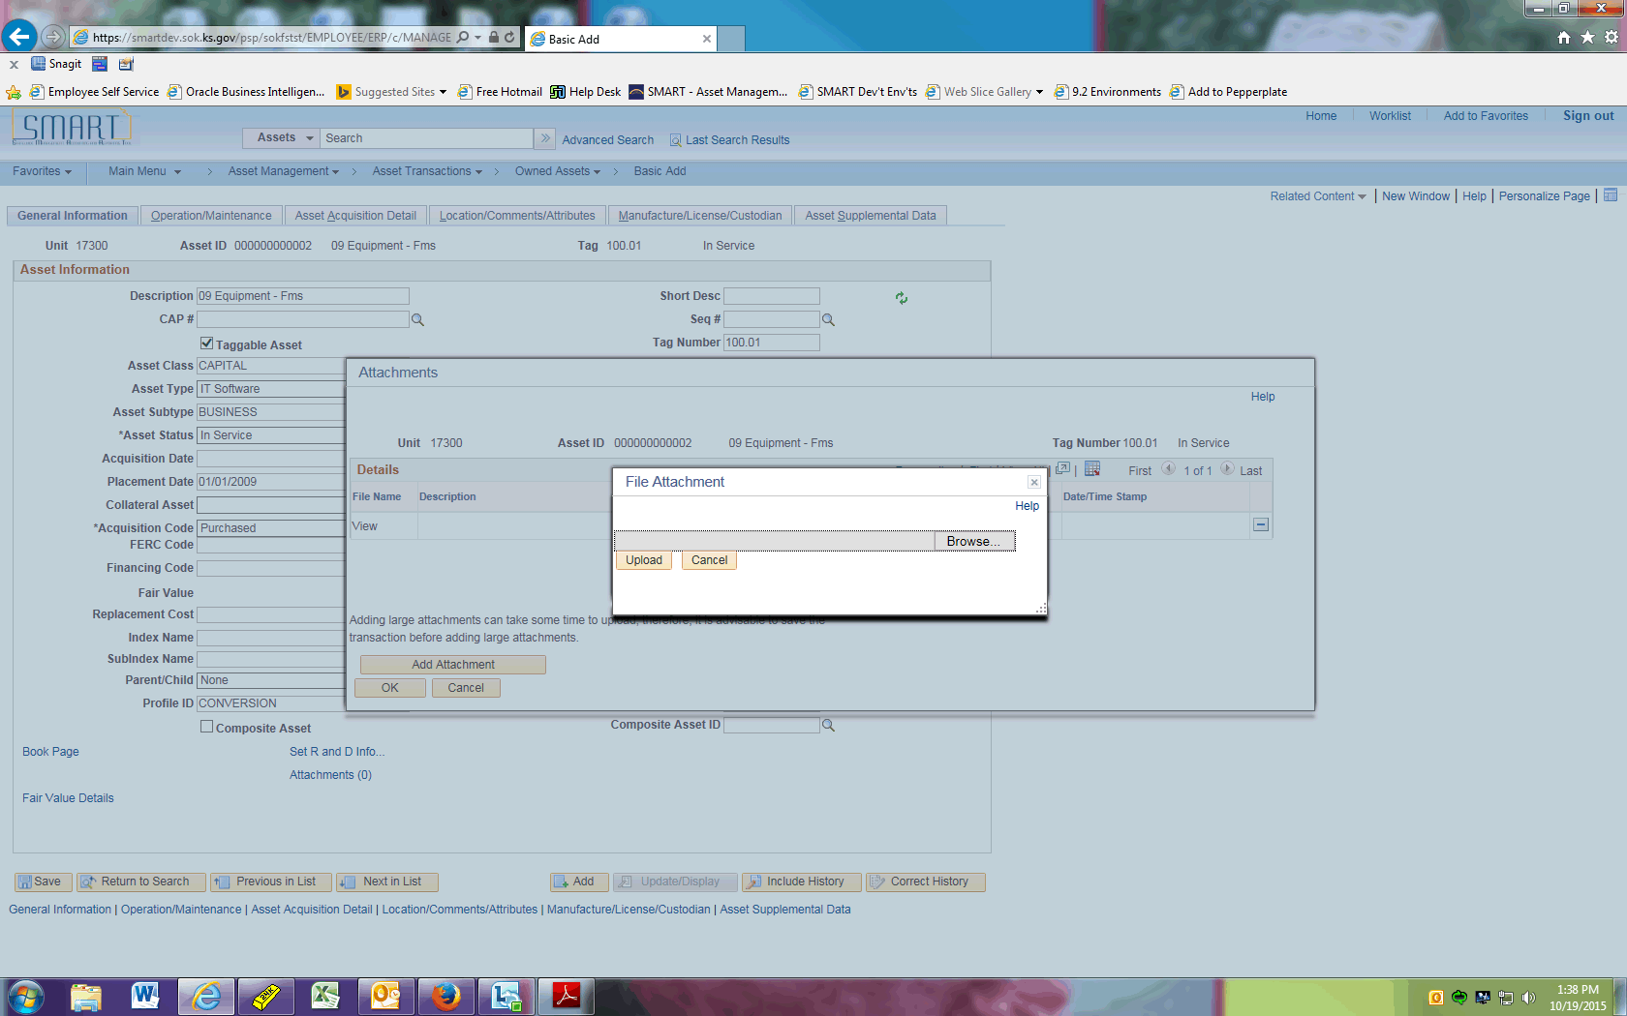

| **Step** | **Action** |
| --- | --- |
|  | Click the **Browse** button. |

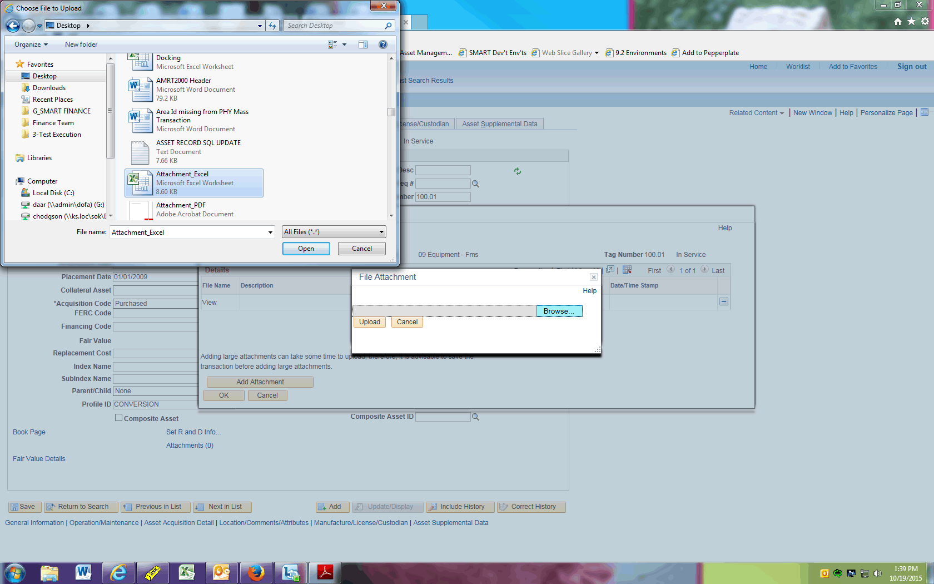

| **Step** | **Action** |
| --- | --- |
|  | Select the file you wish to attach, then click the **Open** button. |

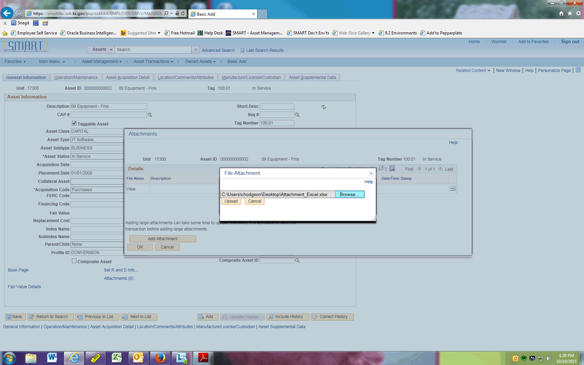

| **Step** | **Action** |
| --- | --- |
|  | Click the **Upload** button. |

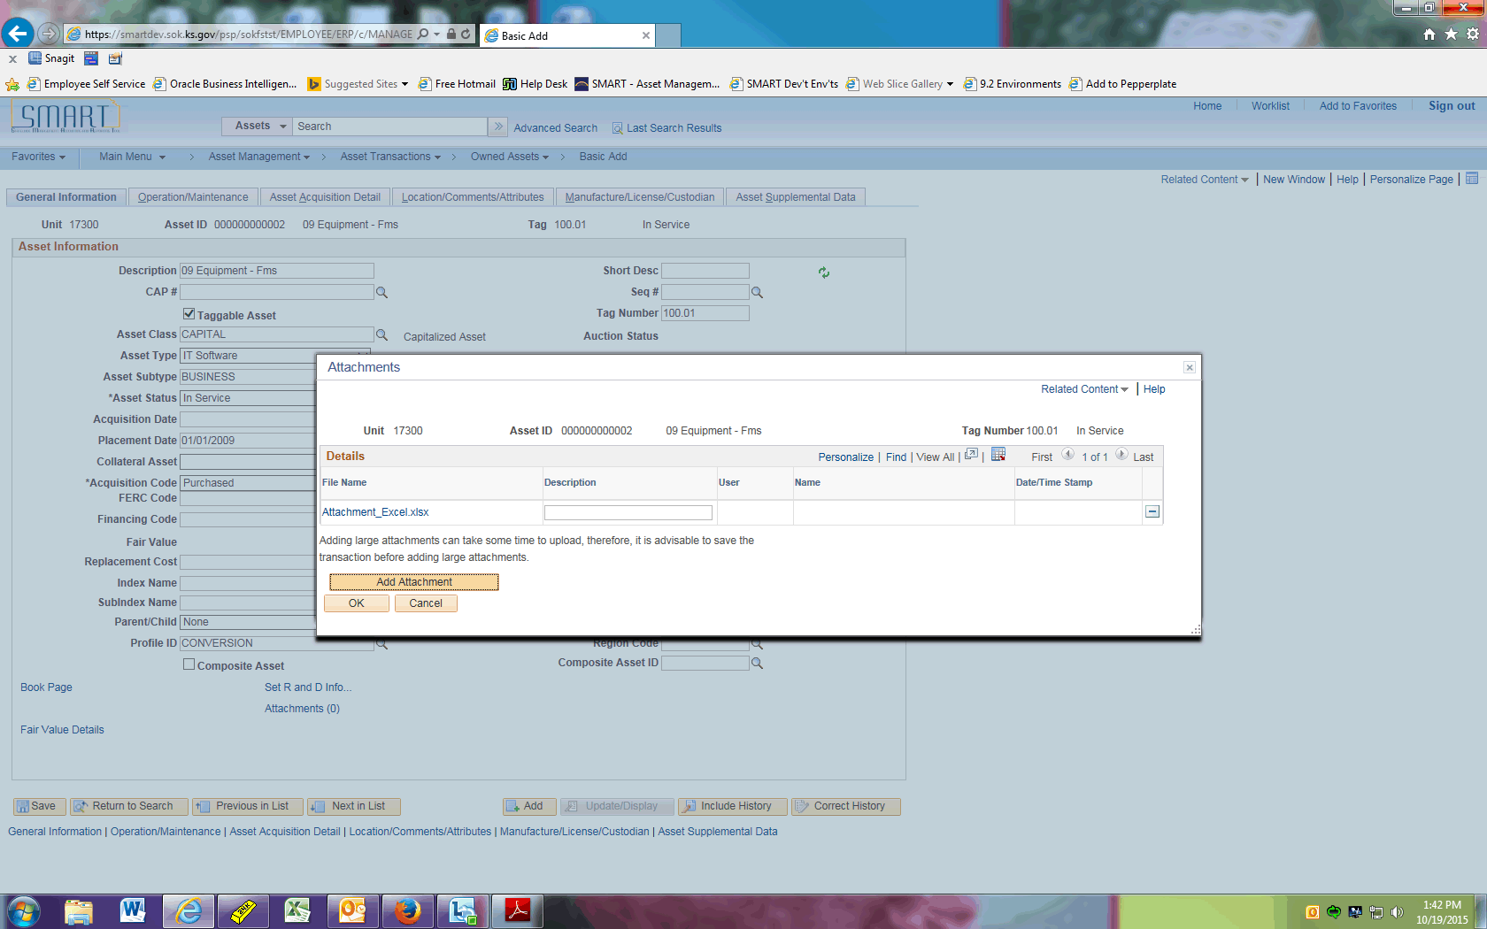

| **Step** | **Action** |
| --- | --- |
|  | Click the **Add Attachment** button to add another attachment. |

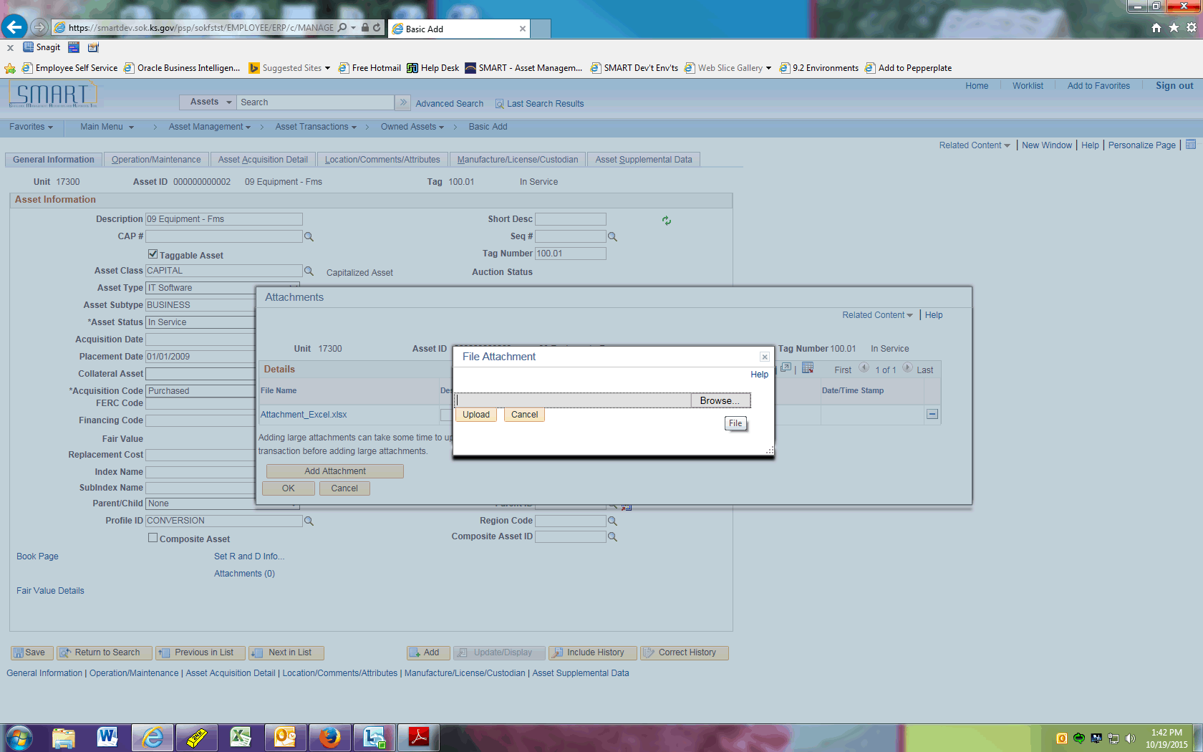

| **Step** | **Action** |
| --- | --- |
|  | Click the **Browse** button. |

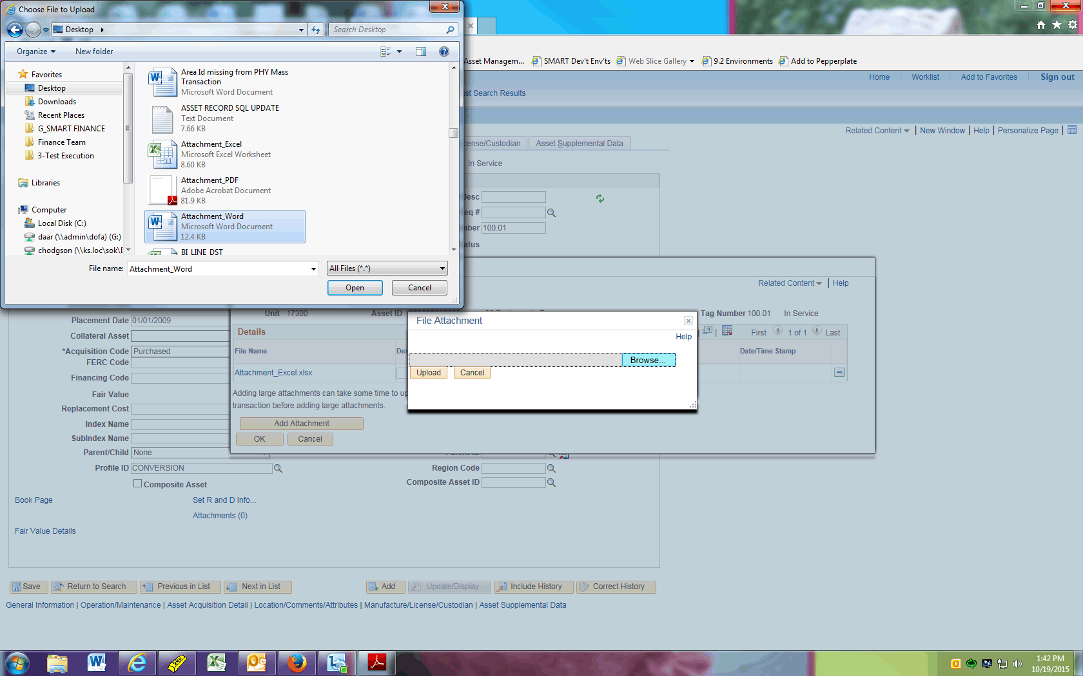

| **Step** | **Action** |
| --- | --- |
|  | Select the file you wish to attach, then click the **Open** button. |

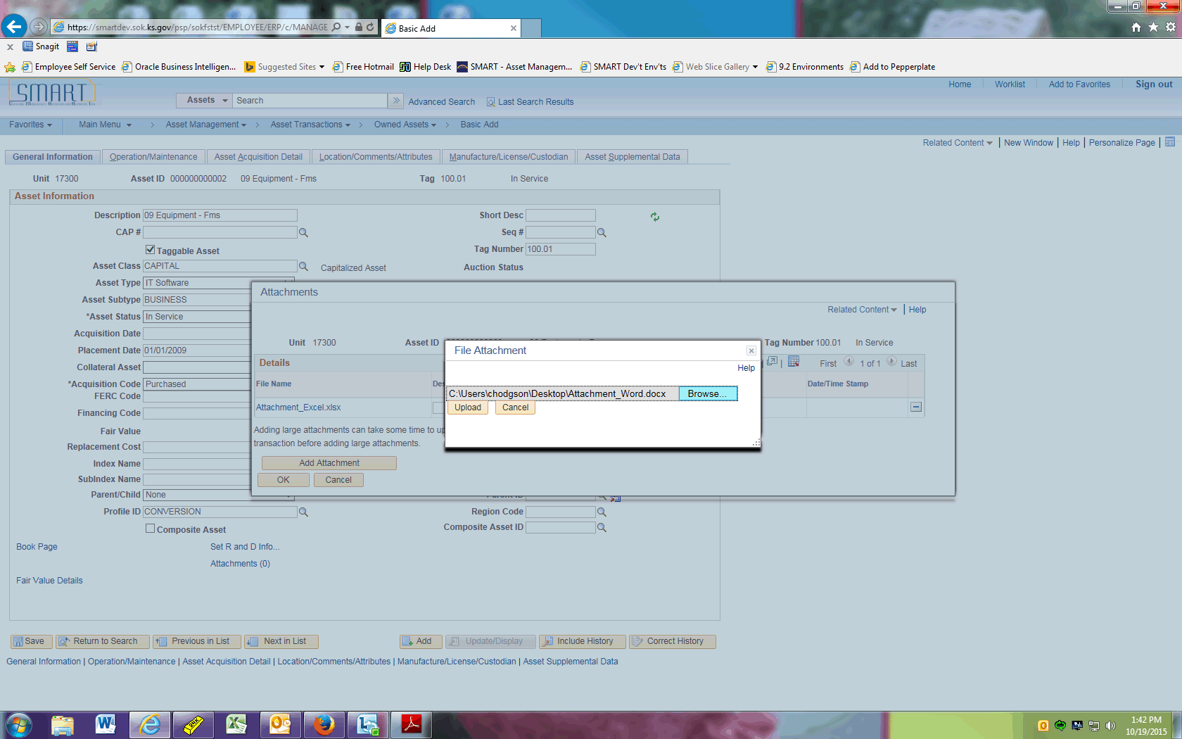

| **Step** | **Action** |
| --- | --- |
|  | Click the **Upload** button. |

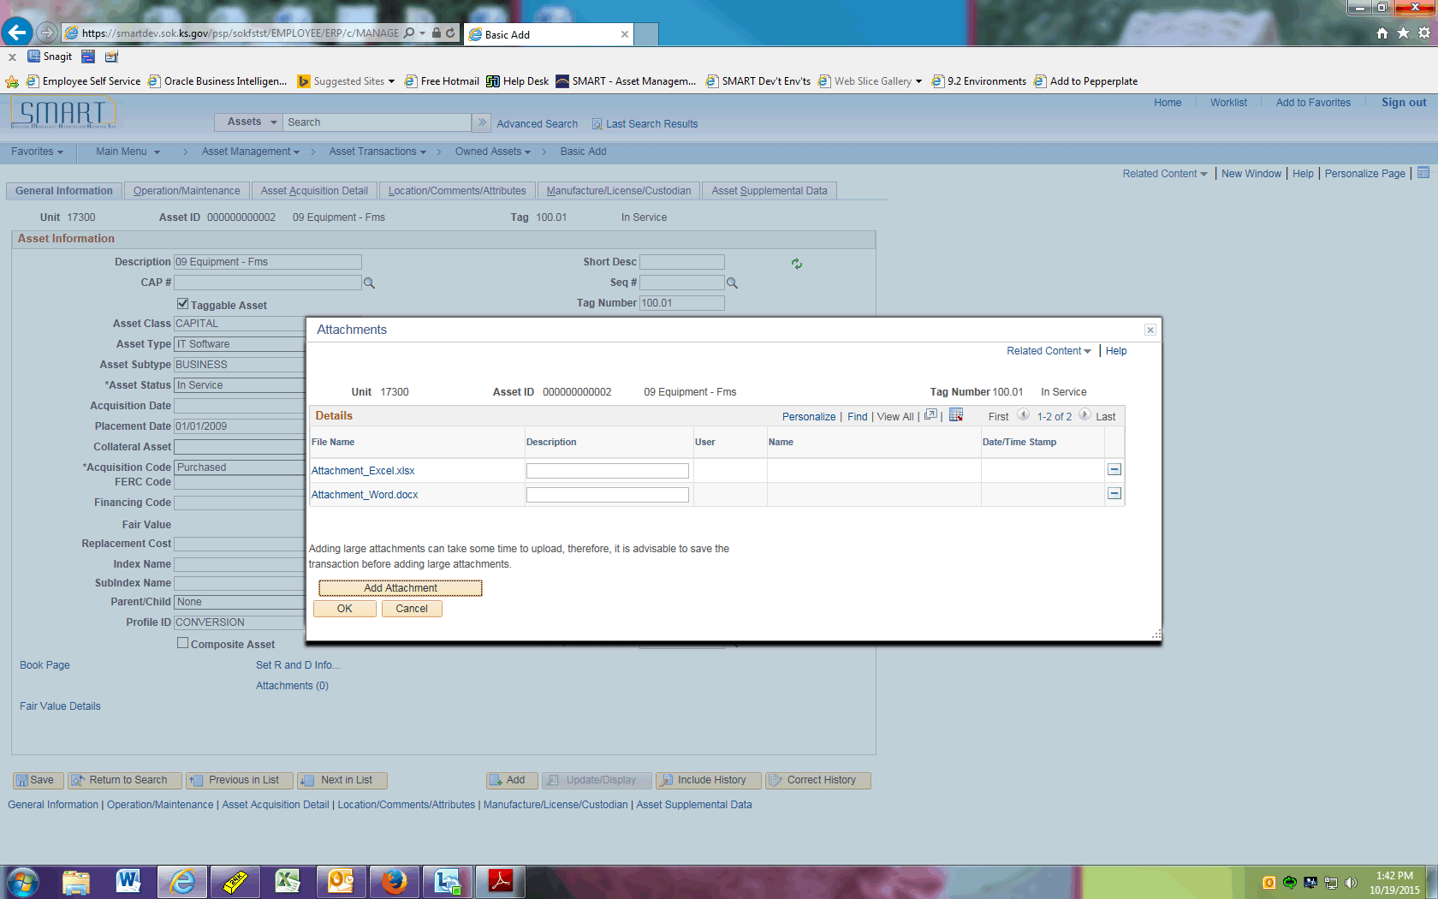

| **Step** | **Action** |
| --- | --- |
|  | Simply click the hyperlink to open the attachment you wish to view. |
|  | Click the **OK** button. |
|  | This concludes the 'AM - Attachments' topic. Thank you for taking this course.  **End of Procedure.** |