Version 1.2 04/24/2019

Scenario - Multiple Assets with One Distribution Line on Same Receipt
AM Scenario 1.1: Multiple Assets with One Distribution Line on Same Receipt

There are two options for processing a receipt that includes multiple assets with the same funding source.

Option 1: Serial Button Not Checked
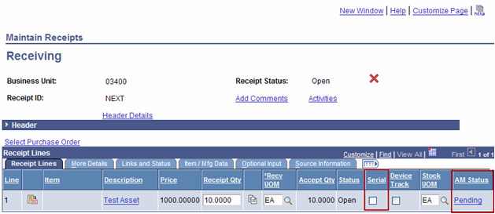

Click on the ‘Pending’ hyperlink.
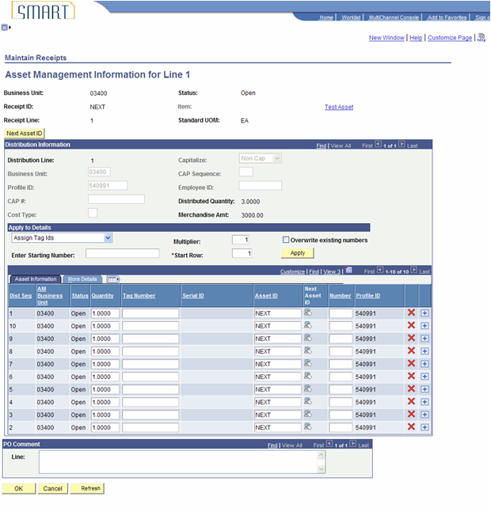

After adding the correct number of rows by clicking the
+ button (one for each asset), the page would look similar to this illustration.

Each Receipt Distribution Sequence Line that is interfaced into the AM Interface tables will be a separate Load Line, so each asset should have its own line.

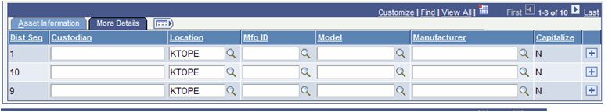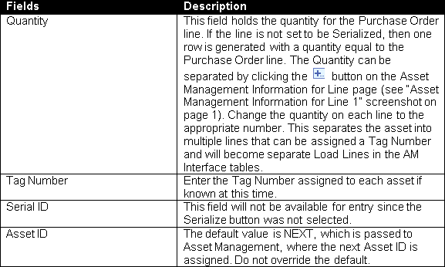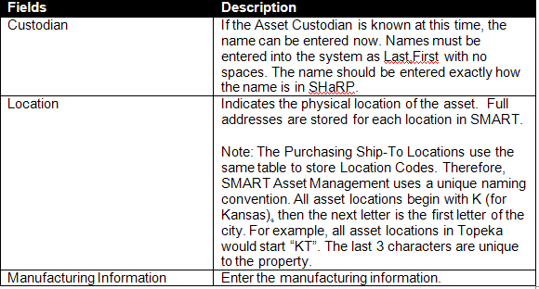

The More Details Tab holds additional Asset Physical Information.

Click OK and Save. When the receipt is saved, a batch job will automatically run. The AM Status should change to Moved when you navigate back into the receipt. Asset IDs will be assigned automatically in the Asset Management module. Those assets will have a status of ‘Received’ until cost is integrated from the voucher.

Option 2: Serial Button Checked
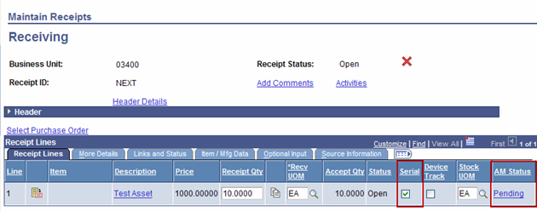

Click on the ‘Pending’ hyperlink.

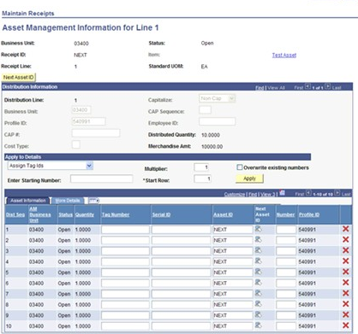

Each Receipt Distribution Sequence Line that is interfaced into the AM Interface tables will be a separate Load Line, so each asset should have its own line.

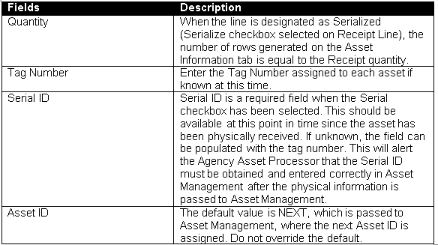

The More Details Tab holds additional Asset Physical Information.

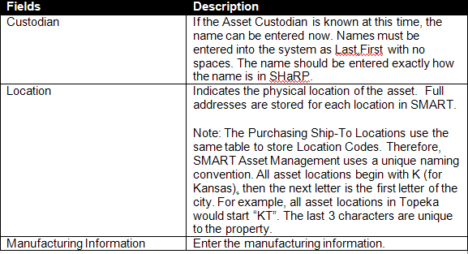

Click OK and Save. When the receipt is saved, a batch job will automatically run. The AM Status should change to Moved when you navigate back into the Receipt. Asset ID’s will be assigned automatically in the Asset Management module. Those assets will have a status of ‘Received’ until cost is integrated from the voucher.

