- This Desk Aid instructs users on the INF43 & INF44 process and how to research and address errors.

- INF43 – Deposit Spreadsheet Upload is available to all State of Kansas Agencies utilizing the Accounts Receivable Module in SMART.

- INF44 – Deposit Interface is available to State of Kansas Agencies that have expressed interest and have been set-up to use in the Accounts Receivable Module in SMART.

There are 3 layers of tables affected by INF43 and INF44 transactions. Batch jobs in SMART handle moving the data from table-to-table. The batch jobs listed below run hourly from 9:00am
- 4:00pm and once nightly.

  - The first layer of tables affected are the ‘Excel Tables’.
    - When a user clicks the ‘Generate XML’ button within the INF43 Spreadsheet, these tables are populated.
    - When the INF44 process runs, these tables are populated.
  - The second layer of tables affected are the ‘Staging Tables’.
    - The Excel Edit process moves data from the ‘Excel Tables’ into the ‘Staging Tables’.
  - The third and final layer of tables affected are the ‘Payment Tables’.
    - The PayLoader process moves data from the ‘Staging Tables’ to the permanent ‘Payment Tables’ within SMART.

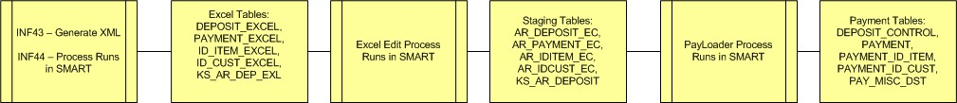

Example of INF44 flow through SMART (these are approximate times):

9:30am – INF44 file is placed on the Mainframe 10:00am – INF44 process runs in SMART 10:15am – Excel Edit process runs in SMART 10:30am – PayLoader process runs in SMART
11:00am – Deposit is available online for approval if no errors were encountered. If the deposit is not viewable from the Excel Error Correction page or online, a ManageEngine Service Desk ticket should be logged. Be sure to include the time that the INF44 file was placed on the Mainframe and the .ERR file (if one was generated).

Example of INF43 flow through SMART (these are approximate times):

9:30am – INF43 file is XML Generated 10:15am – Excel Edit process runs in SMART 10:30am – PayLoader process runs in SMART
11:00am – Deposit is available online for approval if no errors were encountered. If the deposit is not viewable from the Excel Error Correction page or online, a Help Desk ticket should be logged. Be sure to include the time that the INF43 XML was generated and the Excel document that was used if possible.

Errors for INF43 and/or INF44 will most likely occur during the first two layers of processing. The listing below describes errors that may be encountered. They are as follows:

First Layer Errors
When an error is encountered in the first layer of processing it results in the entire file being rejected. It must be corrected and resubmitted. A few examples include:

INF43: Error in Excel when generating XML
INF44: Control totals and/or counts not balancing. INF44: Incorrect formatting of the file

When an INF44 is not loaded due to error, a .ERR file is created on the mainframe. There is no .ERR file for INF43.
It is best practice for agencies to monitor the flow of all interfaced/uploaded deposits.

The jobs responsible for moving INF43/INF44 through SMART are scheduled
to run hourly from 9:00am-4:00pm.

Second Layer Errors
Depending on the error encountered in this layer of processing, it may be correctable online through the Excel Error Correction Page. The following errors are examples of things correctable online:

Received Date Accounting Date Control Total Amount Control Count

It is the agency’s discretion as to whether they correct these errors online. The best practice would be to delete the deposit, correct the source and resubmit.

Deposits with errors corrected online will be processed through Excel Edit once more in the
next scheduled run of the job.

Invalid ChartField errors on a deposit ARE NOT correctable online. The deposit must be deleted and the ChartFields must be corrected in the source file and resubmitted.

If there are multiple Accounting Lines in the deposit and just one has errors, the whole deposit must be deleted, the line must be corrected in the source file and resubmitted.

Step 1: Locate Online Errors in the INF43/INF44 file

Navigation: Accounts Receivable Homepage>Payments>Deposit Upload Results

Or

NavBar: Navigator>Accounts Receivable>Payments>Electronic Payments>Excel Error Correction
- Enter the Deposit Unit.
- Clear Deposit ID, Payment ID and User ID fields.
- Select the ‘Error Deposits Only’ radio button.
- Click the ‘Search’ button.

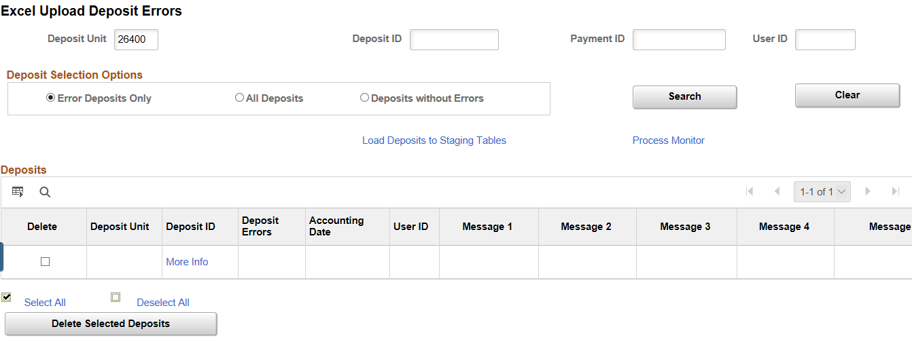

Step 2: Select the Deposit you would like to view
All deposits for the Business Unit that are in error will be displayed. Each deposit will display up to 5 error messages. Once an error is corrected, it will no longer be displayed. If there are more than five errors, new messages will be displayed as previous errors are corrected.
- Click the Deposit ID link.

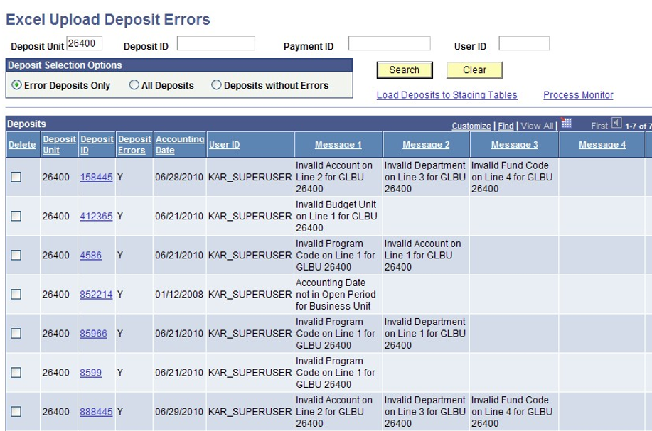

Step 2: Select the Deposit you would like to view
- If there is more than one payment in error, the ‘Get Payments with Errors’ button will be
yellow. Click it to view all payments with errors.

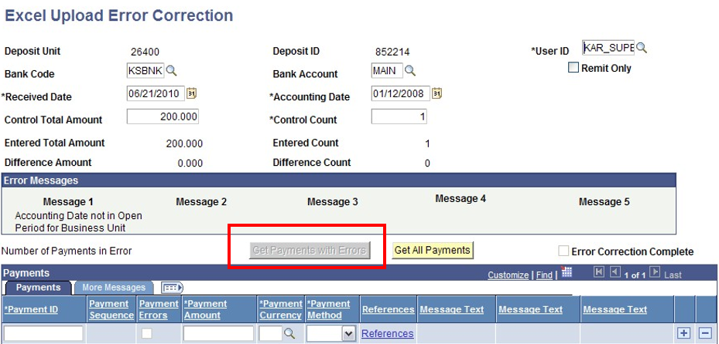

Step 3: Review/Make Corrections
- Review errors and make corrections if applicable; click the ‘Apply’ button.
- The next scheduled run of Excel Edit will validate the Deposit once more and either send to
error or move it on for further processing.
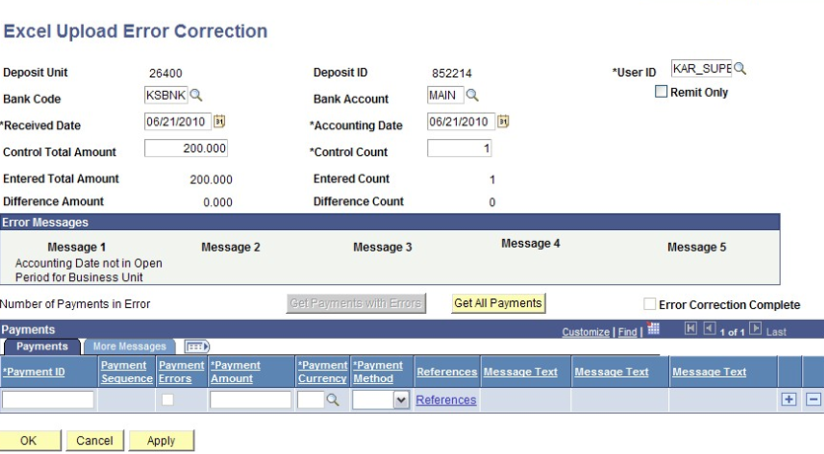

Note: The correction made was due to an ‘Accounting Date’ error.

Step 4: Delete Deposit
If the error cannot be corrected online or the agency wishes to correct the source file
and reload the deposit, the deposit in error must be deleted.
- Place a check mark in the ‘Delete’ box on the deposit row.
- Click the ‘Delete Selected Deposits’ button.
- The deposit is now deleted from SMART. It can be corrected at the source and resubmitted.
