Training Guide – Accounts Receivable
Creating and Maintaining Customer Deposits

State of Kansas

Applicable Role(s): Deposit Processor - Agency, AR Agency Administrator - Central and Agency and AR Maintainer – Agency

Table of Contents

Customer Deposits Overview, Roles and Processes ................................................. 3

Customer Deposits Overview ...................................................................................... 3

Deposit Roles .............................................................................................................. 3
End-to-End AR Update Process .................................................................................. 4
Payment Life Cycle and Payment Status .................................................................... 5

Entering Payments........................................................................................................ 6

Key Deposit Concepts ................................................................................................. 6
Entering and Posting Regular Deposits ....................................................................... 7
Totals Page ................................................................................................................. 7
Payments Page ........................................................................................................... 9

Applying Payments ..................................................................................................... 11

Payment Worksheets ................................................................................................ 11
Step 1: Payment Worksheet Selection ..................................................................... 13
Step 2: Payment Worksheet Application................................................................... 15
Step 3: Payment Worksheet Action .......................................................................... 18
Payment Predictor .................................................................................................... 19
Deposit Adjustments for Credit Card Receipts from Customers……………………....19
Building & Applying Payments on Worksheets for Unidentified Payments ............... 19
Building & Applying Payments on Worksheets for Underpayments & Overpayments 20
Viewing Payment Activities ........................................................................................ 21

Reviewing Payments .................................................................................................. 21

Deposit Approval Process ......................................................................................... 21
Viewing All Deposits .................................................................................................. 21
Viewing Cash Received by a Business Unit .............................................................. 22
Viewing Payment Groups .......................................................................................... 24
Payment Control Page .............................................................................................. 24
Payment 1 Page........................................................................................................ 24
Payment 2 Page........................................................................................................ 25
Payment 3 Page........................................................................................................ 26
Viewing Incomplete Payments .................................................................................. 26
Reviewing Payment Predictor ................................................................................... 27
All Payments Page .................................................................................................... 28

Customer Deposits Overview, Roles and Processes

Customer Deposits Overview
- A Customer Deposit consists of payments that are grouped together for processing and can be associated with a pending item.
- Customer Deposit payments can be applied to multiple items for a single customer or multiple items for different customers.
  - The three basic steps to completing a Customer Deposit are:
    - Entering Payments
      - Enter control totals and deposit characteristics on the Totals page.
      - Enter payment information on the Payments page.
    - Applying Payments
      - Create and complete accounting entries using Payment Worksheets or Payment Predictor.
Note: The ‘Direct Journal Payments’ page is used only when creating accounting entries for non-AR cash. Non-AR cash is a deposit that cannot be associated to an Accounts Receivable pending item.
    - Deposit Review and Approval
- Payment Worksheets and Payment Predictor are utilized to apply payments that correspond to customer pending items. When payments are applied to customer pending items, the customer balance is impacted.
- Payment Worksheets and Payment Predictor are not used in non-AR Cash Direct Journal payments. (See ‘Creating and Maintaining Deposits for Non-AR Payments Training Guide.)

Deposit Roles
SMART has three roles for Accounts Receivable deposits:
Role | Description
Deposit Processor Agency | This role is responsible for entering deposits and viewing customer, payment, and deposit information
AR Agency Administrator - Central and Agency | This role is responsible for approving agency deposits in addition to creating and updating customers and contact information
AR Maintainer – Agency | This role has the ability to apply payments, review customer accounts, and maintain receivables using maintenance worksheets
Accounts Receivable Deposit Roles

End-to-End AR Update Process
- The AR Update process is a batch process that runs hourly and is used to update customer balances.
- The AR Update process job is the only method that SMART Accounts Receivables uses to update posted information.
- The AR Update determines whether the accounting date for the payment application activity is in an open period for the business unit and transaction type in SMART Accounts Receivables and SMART General Ledger. If the accounting date is not within an open period, AR Update issues a posting error.

The following diagram represents the AR Update End-to-End Process.
AR Update End-to-End Process Diagram

Payment Life Cycle and Payment Status

The following diagram shows the highlights of the Payment Life Cycle:
Payment Life Cycle Process Diagram

- Payment Life Cycle – The payment life cycle begins when the payment is received. Generally, multiple payments are grouped together in a single deposit. Deposits are interfaced or entered online.
- Electronic Payment – Electronic revenue comes in the form of credit card or eCheck payments. These types of deposits go through the Treasurer’s Office. Once the deposit is posted, the agency can do a deposit adjustment to assign the correct ChartField string and apply it to the Customer’s account.
Payment Status – When a payment is received by a State of Kansas agency, it goes through the payment life cycle. The payment status changes at each stage. The status indicates the information that can be changed for the payment at a particular stage of the life cycle. This status depends on the payment entry method that was used and the way in which the payment was last processed.

  - Unidentified – This indicates that the payment was entered without customer or reference information. All payment information can be changed as appropriate at this point.

  - Identified – This means that the payment has customer ID or payment references. All payment information can be changed as appropriate at this point.

  - Worksheet – This status indicates that the payment has a saved worksheet that is not marked for posting to the receivables system. In this state, you can change the identifying information for the payment or assign it to the Payment Predictor if accounting entries have not been created. However, you cannot change any deposit information, payment amounts, IDs, or dates.

  - Applied – Indicates that the payment is applied and either the accounting entries have been created online or the payment has been set to post. You cannot change any deposit or payment information after you save the entry pages in this state.
  - Complete – After the AR Update program in SMART successfully posts the payment, it is assigned the status Complete. You can then review information about the payment but not change it. To change any information for a posted deposit, you will need to create a deposit adjustment.

Entering Payments

Key Deposit Concepts
- You can update deposit information at any time prior to applying the payments. Otherwise, only customer or item reference information is available for modification.

- Receiving Payments – There are several ways to receive payments:

  - EFT –The only type of automated or interfaced EFT payment is electronic revenue for credit card and eCheck revenue. This interface is controlled and maintained by the State Treasurer’s Office.
  - Mail – Any form of payment received in the mail
  - Point of Sale
  - In person

Entering and Posting Regular Deposits

Totals Page
Page name | Homepage Navigation
Regular Deposit - Totals | Accounts Receivable Homepage>Payments>Online Deposit Search/Entry>Regular Deposit>Add a New Value: Enter Deposit Unit and ‘Add’

Page name | NavBar Navigation
Regular Deposit - Totals | Accounts Receivable>Payments>Online Payments>Regular Deposit>Add a New Value: Enter Deposit Unit and ‘Add’

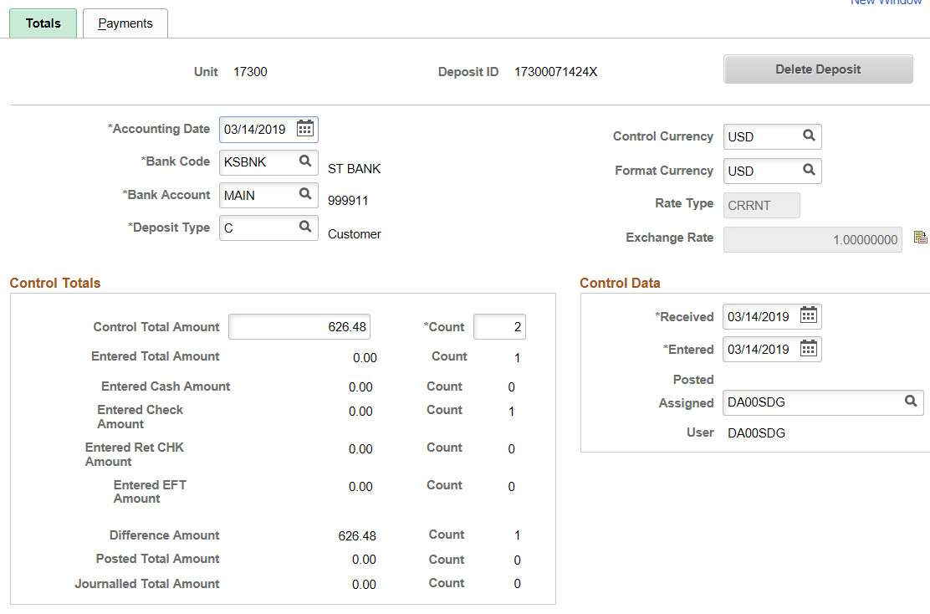
Totals Page
Field | Description
Accounting Date | This field defaults to the current date. SMART validates the accounting date to make sure it falls within the open period for the business unit and transaction type as defined on the Open Period page for the business unit.
Deposit Type | Deposit type is used to designate the type of deposit being entered. Deposit Types for the State of Kansas are as follows: A - Adjustments, C - Customer receipts, E - EFT receipts, M - Miscellaneous receipts. There are also two Interfund related Deposit Types, I - Initiating Interfunds and R- Reciprocating Interfunds. I and R Deposit Types are auto-assigned on deposits created from within an interfund.
Control Total Amount/Count | Enter the control totals for the amount and count of the payments in this deposit.
Entered Total Amount/Count | These fields display the amount and count of the payments that you have entered.
Entered Cash Amount and Count | The total amount of cash for this deposit and the number of cash payments included in the deposit.
Entered Check Amount and Count | The total amount of all checks for this deposit and the number of checks included in the deposit.
Entered EFT Amount and Count | The total amount of EFT for this deposit and the number of EFT payments included in the deposit.
Entered Returned Check Amount and Count | The total amount of all returned checks for this deposit and the number of returned checks included in the deposit.
Difference Amount/Count | These fields display any difference between the payments entered and the control totals. If the control and entered totals and count are not equal, you cannot create accounting entries and the deposit will not be able to be approved.
Posted Total Amount/Count | This field displays the amount and count of AR Pending Item payments that are successfully posted.
Journalled Total Amount/Count | This field displays the amount and count of Direct Journal payments that are successfully journalled.
Received Date and Entered Date | These fields default to the current date but can be overridden. The received date is generally the date you received the payment and the entered date is generally the date the payment was entered in SMART. Because of normal processing delays, the received date may be different from the entered date.
User | Displays the user ID of the individual assigned to the deposit. If you received an electronic deposit, the Payment Loader process assigns the user ID of the individual who created the run control ID for the process. If another user modifies the deposit in the Regular Deposit component, SMART automatically changes the user ID to that person's user ID.
Comments | This free-form field can be used for various purposes. It is required by the State Treasurer, that the deposit preparer’s name and phone number are in this field.
Totals Page Elements

Payments Page

Page name | Homepage Navigation
Regular Deposit - Payments | Accounts Receivable Homepage>Payments>Online Deposit Search/Entry>Regular Deposit>Add a New Value: Enter Deposit Unit and ‘Add’

Page name | NavBar Navigation
Regular Deposit - Payments | Accounts Receivable>Payments>Online Payments>Regular Deposit

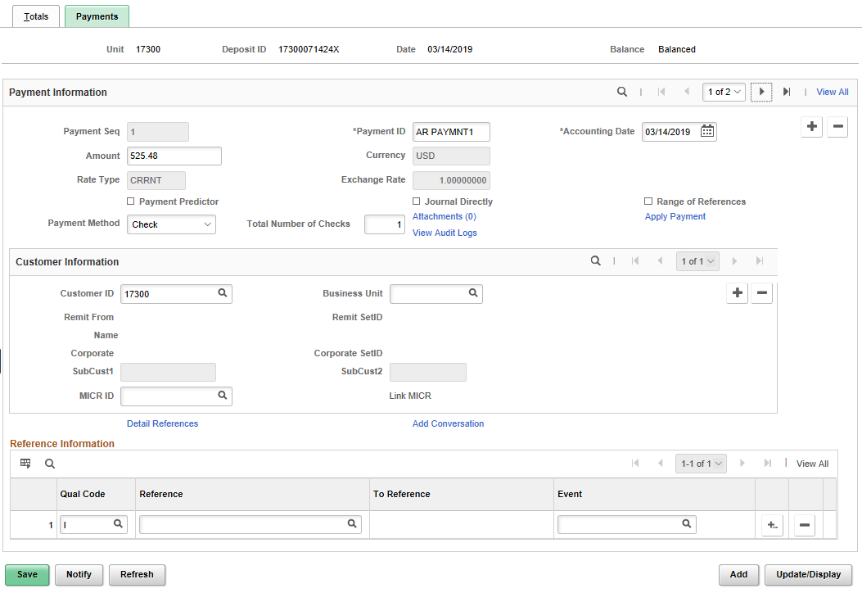

Field | Description
Balance | Displays the balancing status of the deposit. When the entered total amount and count are equal to the control total amount and count on the Regular Deposit - Totals page, the status changes from Not Balanced to Balanced. The deposit must be in a balanced status before you can create accounting entries or a payment worksheet.
Payment Seq (sequence) | Displays the sequence number for each payment. When you enter a Payment ID, SMART assigns the sequence numbers in sequential order so you can track the order in which payments are entered.
Payment ID | This is a free form field of a maximum of 15 characters for the agency to enter reference information
Accounting Date | This field defaults from the accounting date on the Totals page
Amount | This field is where the payment amount is entered.
Payment Predictor | Only select Payment Predictor if you do not want to manually apply the payment using a payment worksheet. Select this check box to use the Payment Predictor process to automatically apply this payment to a pending item. If a worksheet already exists for this payment, this check box is unavailable.
Journal Directly | Do not select this check box if you want the payment to update a Customer Account. Select this check box if a payment should be handled as miscellaneous cash received rather than applied to pending items. Payments marked as Journal Directly cannot be processed in payment worksheets, do not go through the AR Update process and do not update Customer accounts.
Payment Method | Select Check, Cash, Returned Check, or EFT. Cash, check, and returned check can be entered in any combination. EFT must be entered alone.
Total Number of Checks | This field becomes available when payment method of Check or Returned Check is selected. The purpose of this field is to enter the total number of checks if all the checks in the group go to a single line of accounting. This saves users from having to enter in each check as an individual line to retain the correct number of checks entered.
Attachments | To add payment documentation as an attachment, click on the ‘Attachments’ hyperlink. Click the ‘Add Attachments’ button. Click Browse and find the attachment that should be added to this deposit by clicking once on the file. Click ‘Open’. Click the ‘Upload’ button. Enter a description for the file attachment and click the Internal checkbox. Click ‘OK’. The Attachments hyperlink has a number next to it indicating the number of attachments to this payment. Click ‘Save’.
Apply Payment | PeopleSoft 9.2 provides this link to create accounting entries for the payment directly from the Payments page, without having to navigate back to the menu.
Customer ID | This field needs to be populated with the Customer ID when entering a payment for a pending item.
MICR ID | This is a free form field of a maximum of 26 characters for agencies to enter additional reference information. It has no functionality in SMART.
Qual Code (qualifier code) | This field is to be populated with an ‘I’ for ‘Item’ when entering a payment for a pending item.
Reference (reference value) | This field is to be populated with a reference number that identifies an Item ID when entering a payment for a pending item.
Detail References Link | The State of Kansas is not utilizing this link.
Payments Page Elements

Applying Payments to Pending Items

A Payment Worksheet or Payment Predictor is used to create customer deposit accounting entries and apply payments that correspond to customer pending items. When payments are applied to customer pending items, the customer balance is impacted.

Payment Worksheets - Payment Worksheets are used to manually create accounting entries for customer deposits and apply payments to open items. There are two ways to begin applying payments to pending items. 1) Use the Apply Payments link on the Payments tab of the deposit or 2) navigate to the ‘Create Worksheet’ page.

Apply Payment link: PeopleSoft 9.2 provides a link to create accounting entries and apply the payment directly from the Payments page, without having to navigate back to the menu. Click on the ‘Apply Payment’ link to go directly to the Worksheet Selection page. Once the payments have been applied to an item, the Apply Payments link is no longer available.
Page name | Homepage Navigation
Regular Deposit - Payments | Accounts Receivable Homepage>Payments>Online Deposit Search/Entry>Regular Deposit>Add a New Value: Enter Deposit Unit and ‘Add’

Page name | NavBar Navigation
Regular Deposit - Payments | Accounts Receivable>Payments>Online Payments>Regular Deposit

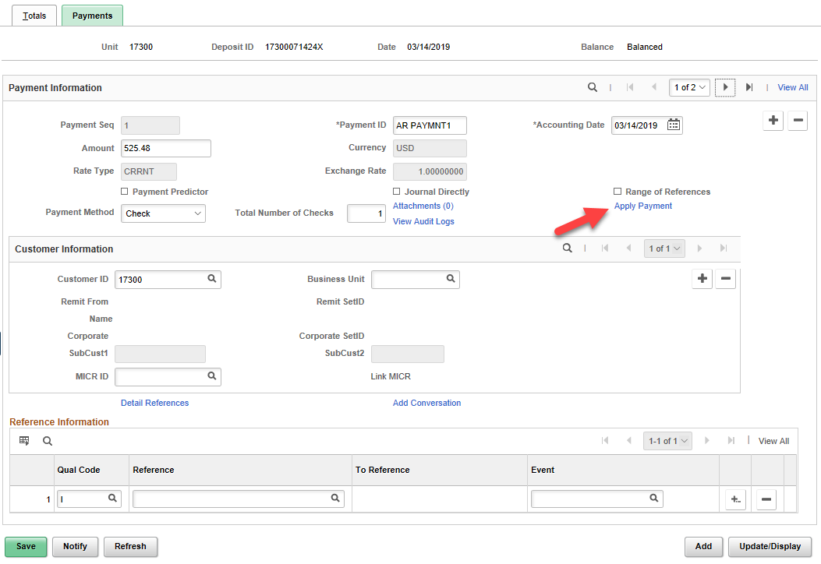

If navigating to the Worksheet Selection page, enter the Deposit Unit and Deposit ID for which you want to apply payments. Search. Select Payment Sequence.

Page name | Homepage Navigation
Worksheet Selection | Accounts Receivable Homepage>Payments>Apply Payments>Create Worksheet>Find an Existing Payment

Page name | NavBar Navigation
Worksheet Selection | Accounts Receivable>Payments>Apply Payments>Create Worksheet>Find an Existing Payment

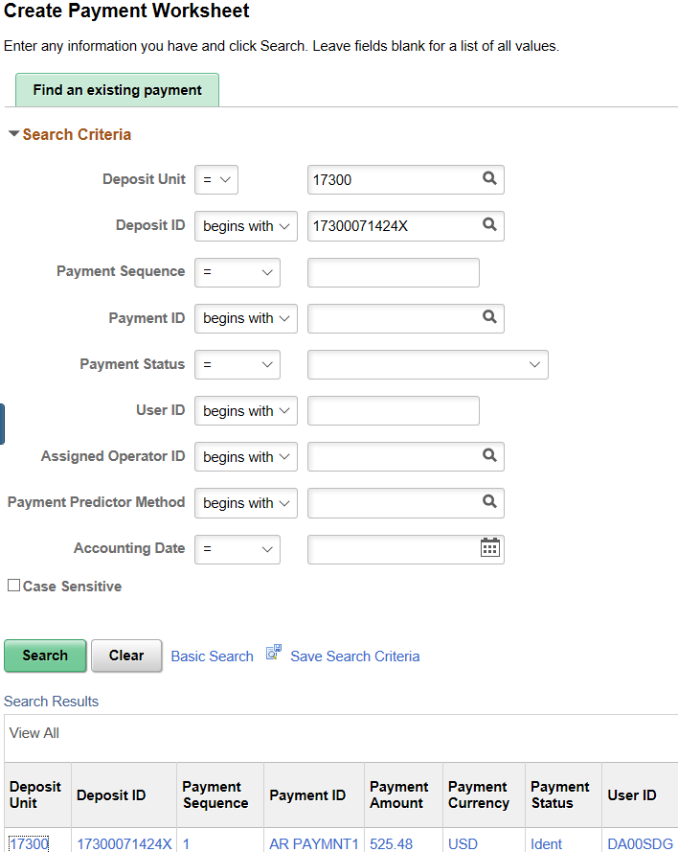

Payment Worksheet creation includes three steps: 1) Worksheet Selection, 2) Worksheet Application and 3) Worksheet Action.

Step 1: Worksheet Selection

- Worksheet Selection is the process used to manually match payments with existing items in order to close open items. If you determine that you need to make changes, you can clear the selection criteria and rebuild the worksheet.
- The deposit must be prepared first, keeping in mind the following:
- A worksheet for a payment can only be created after a deposit containing that payment has been entered into SMART.
- On the Regular Deposit - Payments page, do not mark either the Payment Predictor or Journal Directly checkboxes.
- Enter the Customer ID in the Customer Information section.
- Save the deposit and note the Deposit ID.
- The Worksheet Selection page is keyed by the deposit business unit for each payment that is contained in the deposit. Utilize the new ‘Apply Payment’ link on the Regular Deposits - Payments page or navigate to ‘Create Payment Worksheet’ to begin worksheet selection.
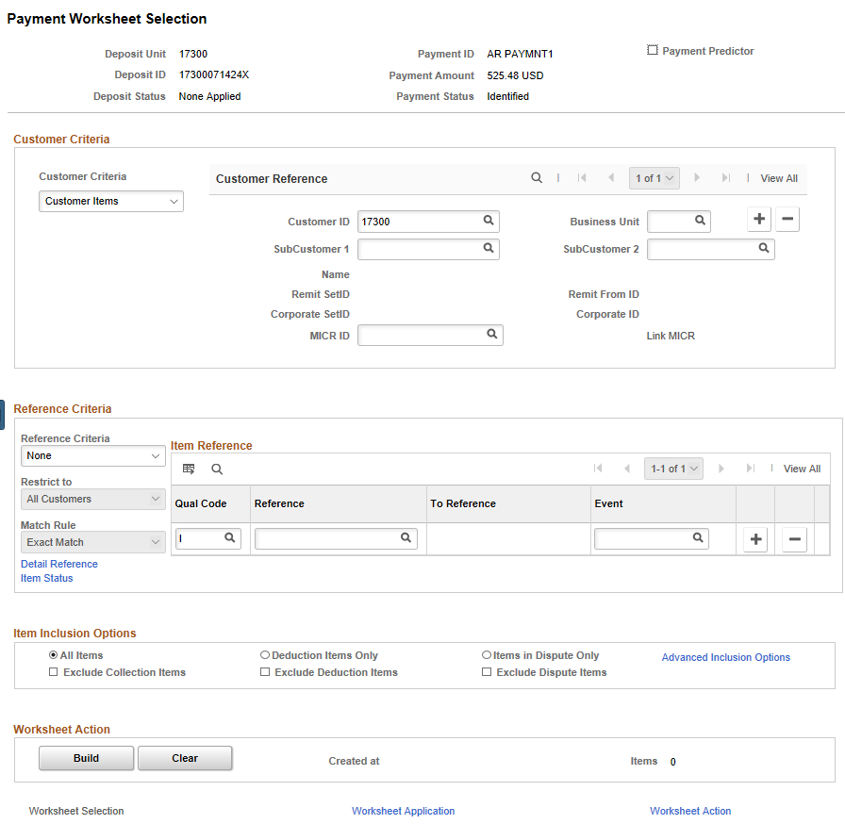

Payment Worksheet Selection Page

Field | Description
Customer Criteria section
Customer ID | The Customer ID from your selected Payment line will populate the Customer ID field.
Reference Criteria section
Reference field | If you have entered an Item ID in the Reference Information on your Deposit Payments page, it will populate here. If Item ID is unknown, the Build button will provide a list of Pending Items for this customer.
Reference Criteria: | If Item ID is unknown, you can restrict the “Build” results by selecting Specific Value in the Reference Criteria field, specifying Like Match. A Like Match enables you to use a wildcard (%) to identify the reference, as long as you provide the beginning letters or numbers in the Reference field.
Item Inclusion Options section
All Items, or Items in Dispute Only | Selecting one of these options can also be used to restrict items included in the worksheet. If you select the All Items radio button, you can select one or both of the following check boxes to exclude those item types from the worksheet: Exclude Collection Items, and Exclude Dispute Items.
Worksheet Action section
Build button | Click to create a worksheet listing the Pending Items available for this Payment line’s customer.  The following may occur if the payment is out of balance or there are duplicate payments:  - If the Build button is unavailable, the deposit containing this payment is out of balance, or the deposit is a duplicate deposit. Correct these problems using the Regular Deposit Balancing page.  - If you build a worksheet that references the same item multiple times, a warning message appears indicating that you have duplicate payments for the item when you save the worksheet.
Clear button | Click to remove all items from an existing worksheet
Payment Worksheet Selection Page Elements

Step 2: Worksheet Application
Before you apply payments on a worksheet, you must have performed these tasks:
- Entered Items into SMART Accounts Receivable
- Entered Deposit of payments into SMART

Application
- The purpose of Worksheet Application is to apply payments to an item on the payment worksheet and select posting options for the payment. You can also create adjustments as needed to balance the worksheet.
- You use the Worksheet Application page to achieve a zero balance with the items and payments that are contained on the worksheet. An out-of-balance worksheet cannot be posted. Achieving a zero balance may be as simple as selecting the item or items that equal the payment amount, it may require selecting an item and creating a new item for the remaining amount, or you may need to write off a remaining amount.
Page name | Homepage Navigation
Worksheet Application | Accounts Receivable Homepage>Payments>Apply Payments>Update Worksheet>Worksheet Application  You can also navigate to Worksheet Application by clicking the Worksheet Application link at the bottom of the Worksheet Selection page.

Page name | NavBar Navigation
Worksheet Application | Accounts Receivable>Payments>Apply Payments>Update Worksheet>Worksheet Application

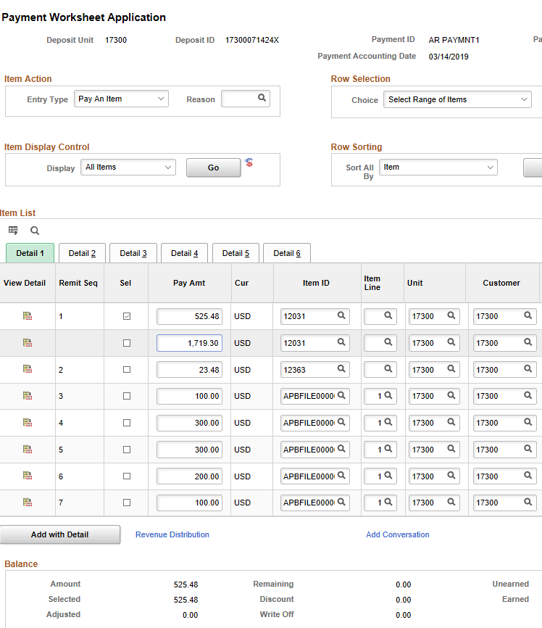

Payment Worksheet Application Page
Field | Description
Entry Type | AO – Adjust Overpayment  AU – Adjust Underpayment  MC – Maintenance Credit  MD – Maintenance Debit  OI – Offset an Item  OA – On Account  RRC – Refund Remaining Credit  PR – Prepayment  PY – Payment  OC – Overdue Charges  WAO – Write-Off Overpayment  WAU – Write-Off Underpayment  WO – Write-Off  WOC – Write-Off Credit  WOD – Write-Off Debit  Note: Entry types in bold require a reason code.
Choice and Range | Select an option to select or clear multiple items at a time. Options are – Select All, De-Select All, Select Range, De-Select Range.  If you select Range or De-Select Range, enter the range in the Range field. For example, enter (4-7).
Go | Click to apply your selections to the items in the grid and to update the worksheet balances
Display | Use to limit the display to all items by using the % wildcard or to a particular type of item. Choices are – All Items, Blank, New Items, Other, Selected, or Unselected.
Refresh | Click to refresh the list of items in the grid
Sort All | Use to sort all items in the worksheet, not just the items that are displayed in the scroll area. Options are Due Date or Item. Then click Go to resort all items in the worksheet. Click the arrows to view different chunks of data.
 | Click the View Detail button to view or update details for a selected item on a worksheet and to copy or write off the item
Remit Seq (sequence number) | This sequence number relates to the order in which the items were entered on the Worksheet Selection page. Initially the items appear in this order. If you sort the worksheet based on the value in another column, the number stays with the item, but the grid order changes. Use this column to sort the worksheet in the original order.
Pay Amt (payment amount) | This field initially displays the open amount for the item. Change the amount to make a partial payment.
Payment Worksheet Application Page Elements
*Note: See instructions below for additional scenarios:
- Building and Applying Payments on Worksheets for Unidentified Payments
- Building and Applying Payments on Worksheets for Underpayments and Overpayments

Step 3: Worksheet Action
- The Worksheet Action page is used to create and review accounting entries and to select a posting action for the payment.
Page name | Homepage Navigation
Worksheet Action | Accounts Receivable Homepage>Payments>Apply Payments>Finalize Worksheet>Worksheet Action  You can also navigate to Worksheet Action by clicking the Worksheet Action link at the bottom of the Payment Worksheet Application page.

Page name | NavBar Navigation
Worksheet Action | Accounts Receivable>Payments>Apply Payments>Finalize Worksheet>Worksheet Action

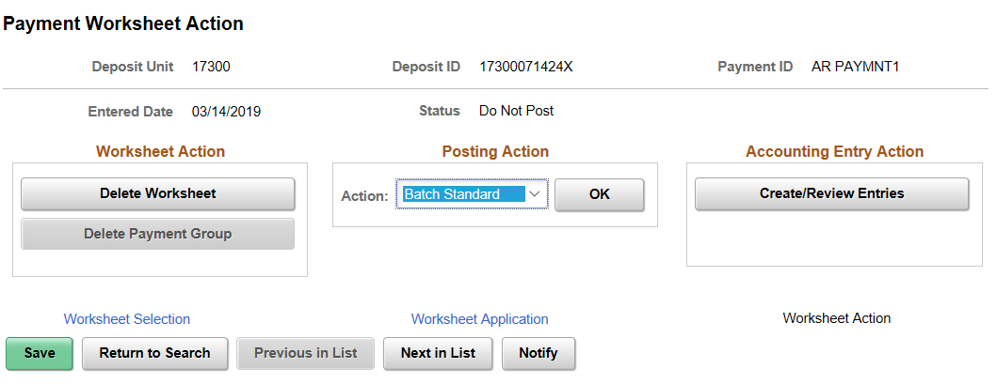
Payment Worksheet Action Page
Field | Description
Create/Review Entries | Click to create and review accounting entries. Always create account entries for the worksheet before setting the payment worksheet to Batch Standard.
Action | Select a posting action for the group and click OK to execute the action. The option for the State of Kansas is Batch Standard. This will post the worksheet the next time AR Update is run.
Delete Worksheet | Use this button to delete the entire worksheet, plus any accounting entries created for the worksheet.
Delete Payment Group | Use this button to delete the accounting entries that you created but leave the worksheet intact.
Payment Worksheet Action Page Elements

Payment Predictor
- Payment Predictor automates the process of applying payments to open receivable items and creates accounting entries.
- Payment Predictor is like an automated version of the payment worksheet, which is used to match payments manually to open items.
- When the Payment Predictor box is checked on the Regular Deposits-Payments page and after the Payment Predictor process runs, the deposit can be agency approved.
- In order for Payment Predictor to match a payment to an item, the following must occur:
  - The customer ID must be known.
  - The Item ID must be known.
  - The amount received must exactly equal the amount of the Item.
If all three criteria are not met, a payment worksheet must be used to manually apply the payment.

Entering and Posting Deposit Adjustments for Credit Card Receipts from Customers
See Job Aid – Credit Card Transactions

For Pending Item payments from customers, process entries on the Deposit Adjustment per the Job Aid EXCEPT, on the Payments page:

- In the Payment Information section, select the Payment Predictor checkbox instead of the Journal Direct checkbox.
- In the Customer Reference section, enter the Customer ID.
- In the Reference Information section, enter an I for Item under the Qual Code and enter or choose the Pending Item ID from the drop-down list under Reference.
- Payment Predictor process will need to run to create the accounting entries before you will be able to agency approve the Deposit Adjustment.

Building and Applying Payments on Worksheets for Unidentified Payments
If the Item ID is unknown, a regular deposit can be entered, referencing the payment and the customer. A payment worksheet can be used to apply the payments in the deposit to the appropriate item.

Enter a Regular Deposit at Accounts Receivable>Payments>Online Deposit Search/Entry>Regular Deposit>Add a New Value.
  - Make note of the Deposit ID
  - Verify ‘Balanced’ shows on the Payments page
  - Save
Use a Payment Worksheet to apply the payment to the correct pending item at Accounts Receivable>Payments>Apply Payments>Create Worksheet>Create Payment Worksheet: Find an existing payment.
  - Enter Deposit Unit and Deposit ID
  - On Payment Worksheet Selection, enter Customer ID
  - Click Build button
  - On Payment Worksheet Application, select Item ID
  - Save
  - Click Worksheet Action link
  - On Payment Worksheet Action, click ‘Create/Review Entries’
  - Review Accounting Entries in Distribution Lines section
  - Click ‘Return to Previous Panel’
  - For Posting Action, select ‘Batch Standard’
  - OK
  - Save

Building and Applying Payments on Worksheets for Underpayments and Overpayments
- After a worksheet builds, the items can be sorted and analyzed to determine how to apply or write off items. Adjustments and prepayments (credits) can be created to balance the worksheet.
- The Payment Worksheet provides a method to manually apply payments to items and make partial payments.
- When creating adjustments, label new item ID’s using the original ID followed by the appropriate Type code (e.g. 35209001_AU or 35210001_OA). This indicates a history with the original item.
Enter a Regular Deposit at Accounts Receivable>Payments>Online Payments>Regular Deposit>Add a New Value.
  - Make note of the Deposit ID
  - Verify ‘Balanced’ shows on the Payments page
  - Save
Use a Payment Worksheet to apply the payment to the correct pending item at Accounts Receivable>Payments>Apply Payments>Create Worksheet>Create Payment Worksheet: Find an existing payment.
  - Enter Deposit Unit and Deposit ID
  - On Payment Worksheet Selection, verify Customer ID
  - Click Build button
  - On Payment Worksheet Application, select Item ID
  - Click the Add a Row button at the right end of the selected line
  - Click OK or press Enter to add 1 row
  - Enter the amount of the under/overpayment (an underpayment of $25, would be entered as 25.00; An overpayment of $25 would be entered as -25.00).
  - Enter the item ID as ‘Item ID_AU’ for underpayment and ‘Item ID_OA’ for overpayment.
  - Enter type AU (Adjust Remaining Underpayment) for underpayment or OA (Place an amount on Account) for overpayment.
  - Enter Reason ADJUP (Adjustment Due to Underpayment) for underpayment or ONACT (On Account) for overpayment.
  - Click ‘Refresh’ to make sure Type and Reason codes are correct
  - Save
  - Click Worksheet Action link
  - On Payment Worksheet Action, click ‘Create/Review Entries’
  - Review Accounting Entries in Distribution Lines section
  - Click ‘Return to Previous Panel’
  - For Posting Action, select ‘Batch Standard’
  - OK
  - Save

Viewing Payment Activities
- You use inquiry pages to view customer balances and summaries of other payment activities at the business unit level. SMART enables you to view a single-line summary of each payment-related activity.
- Menu Path: Accounts Receivable>Receivables Update>Posting Results-Payments>Payment Group-All Items
- Enter Deposit Unit and search by Deposit ID or Payment ID.

Reviewing Payments

Deposit Approval Process
There are two levels to the Deposit Approval Process. Both approval boxes are located on the Totals page of the Regular Deposit. Once both levels of Approvals have been completed, the State Treasurer performs a Daily Release, which allows budget check to process and journals to generate in the General Ledger, making monies available to spend against. (Deposit Types related to Interfunds are covered in SAR355)
  - Agency Approval
    - Once a deposit has been entered and accounting entries have been created the deposit is ready for Agency Approval
    - The Agency Administrator role has the responsibility of approving deposits of all types
    - Once the deposit has been approved by the Agency, it is ready for the second level of approval: State Treasurer Approval
  - State Treasurer Approval
    - The State Treasurer approves Deposit Types of C – Customer Receipts, E – EFT Receipts, M – Miscellaneous Receipts, and N – Insufficient Funds.
    - Accounts & Reports approves the Deposit Type of A – Adjustment.

Viewing All Deposits
- SMART enables you to view the deposit status for a single deposit either to find problems associated with a specific deposit or to locate errors in posting. SMART enables you to view details about one specific deposit ID, including control totals and status, or scan all deposits, one at a time.

Use the All Deposits page to view details about a specific deposit ID (including control totals and status) or scan all deposits, one at a time.

Page name | NavBar Navigation
All Deposits | Accounts Receivable>Payments>Review Payments>All Deposits
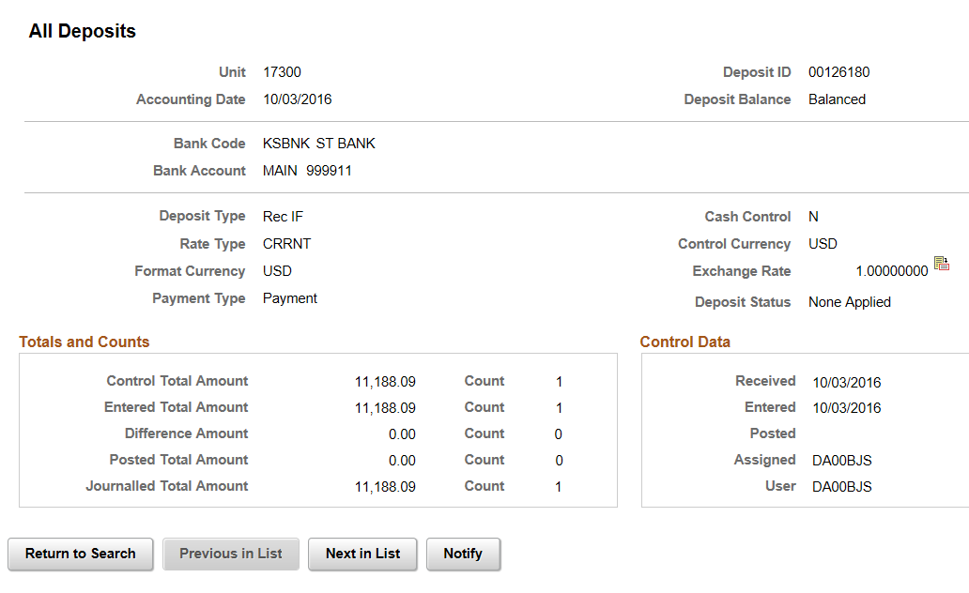
Figure 1. All Deposits Page

Viewing Cash Received by a Business Unit
- You can review the deposits for a single business unit for one or more days or for a specified period. If you have security access to more than one business unit, view the inquiry for one business unit at a time.
Use the Cash Received by Unit page to view cash received by one business unit.
Page name | NavBar Navigation
Cash Received by Unit | Accounts Receivable>Payments>Review Payments>By Unit>Cash Received by Unit

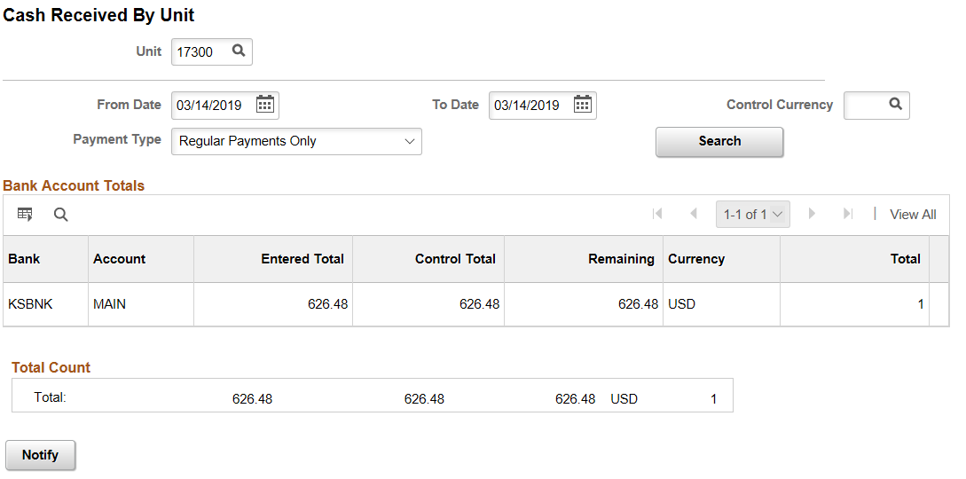
Figure 2. Cash Received By Unit Page

Viewing Payment Groups
- Payments can be viewed after they have been posted. SMART enables you to view a payment group consisting of all payments that have been posted or for which you have created accounting entries.
- Use the Payment Control page to review the control totals and group status for the group.

Page name | Navigation
Payment Control | Accounts Receivable>Receivables Update>Posting Results-Payments>Payment Group-All Items>Payment Control Tab

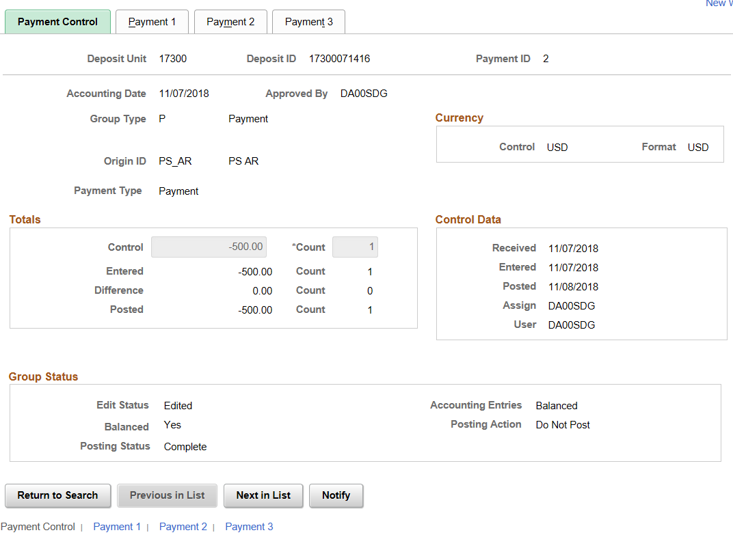
Payment Control Page
Use the Payment 1 tab to view item information, including payment amounts, due dates and customer.
Page name | Navigation
Payment 1 Tab | Accounts Receivable>Receivables Update>Posting Results-Payments>Payment Group-All Items>Payment 1 Tab

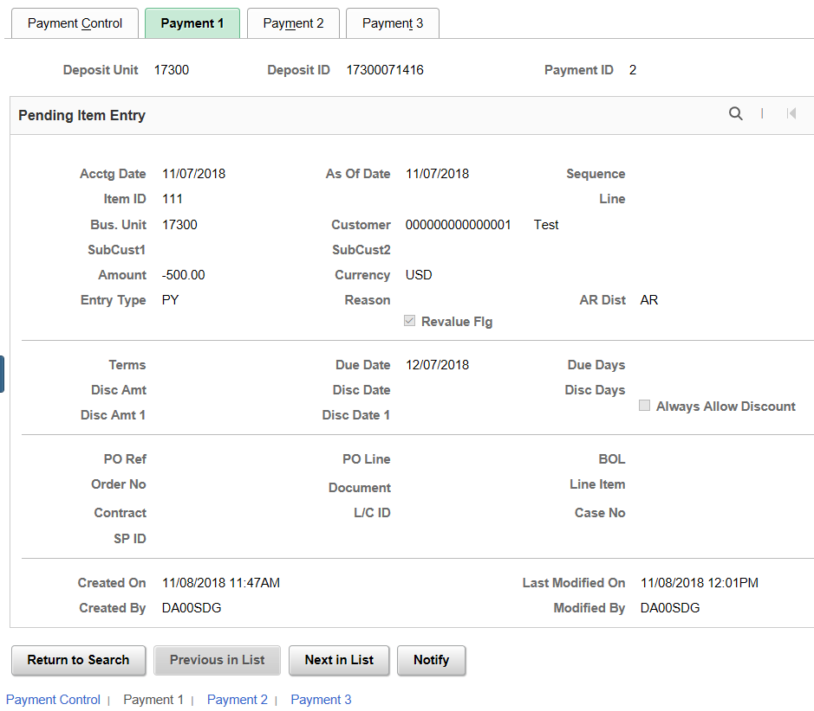
Payment 1 Page
Use the Payment 2 tab to view assigned support personnel, and correspondence information.
Page name | Navigation
Payment Control | Accounts Receivable>Receivables Update>Posting Results-Payments>Payment Group-All Items>Payment 2 Tab

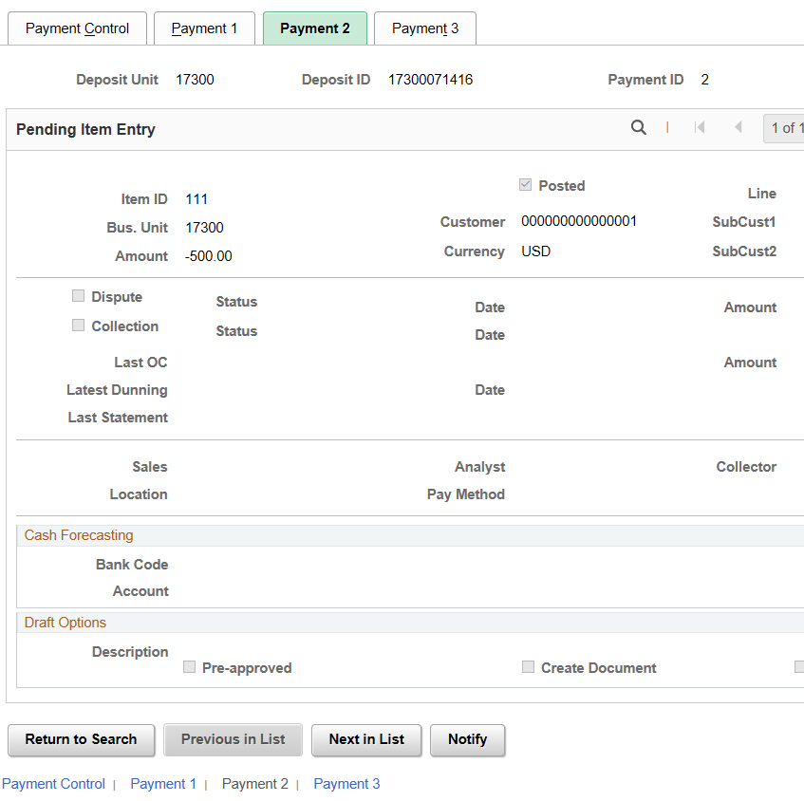
Payment 2 Page
Use the Payment 3 tab to view user-defined fields.

Page name | Navigation
Payment Control | Accounts Receivable>Receivables Update>Posting Results-Payments>Payment Group-All Items>Payment 3 Tab

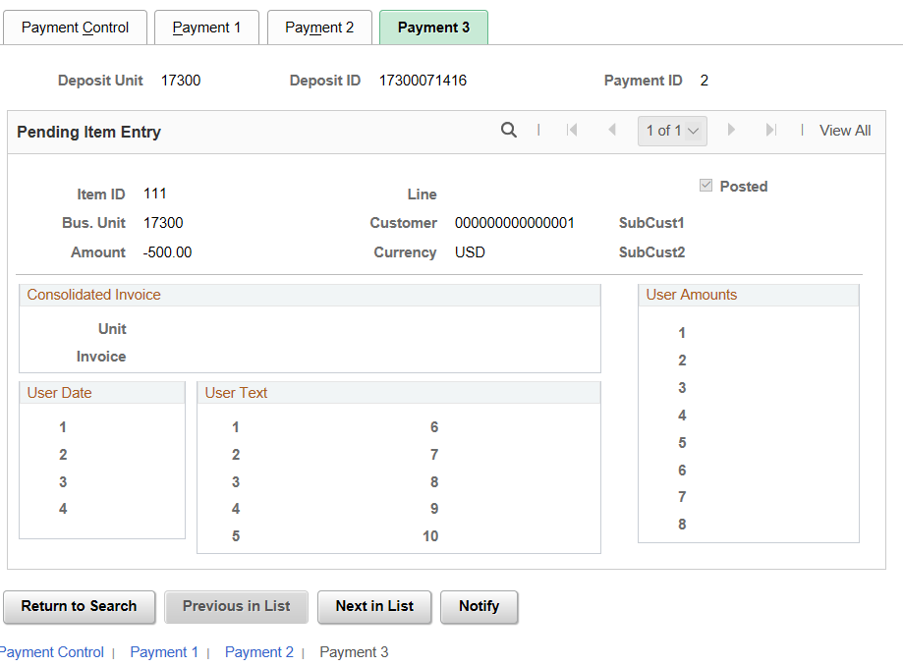
Payment 3 Page

Viewing Incomplete Payments
- SMART enables you to view incomplete payments i.e. payments that have not been posted. This also includes the payments that failed to post or the payments that are Direct Journals or assigned to Payment Predictor. You can choose to view either one payment or a range of payments or only payments that are assigned to a particular operator.

Use the Incomplete Payments page to view payments that are not complete (not yet posted).

Page name | NavBar Navigation
Incomplete Payments | Accounts Receivable>Payments>Review Payments>Incomplete Payments>Incomplete Payments

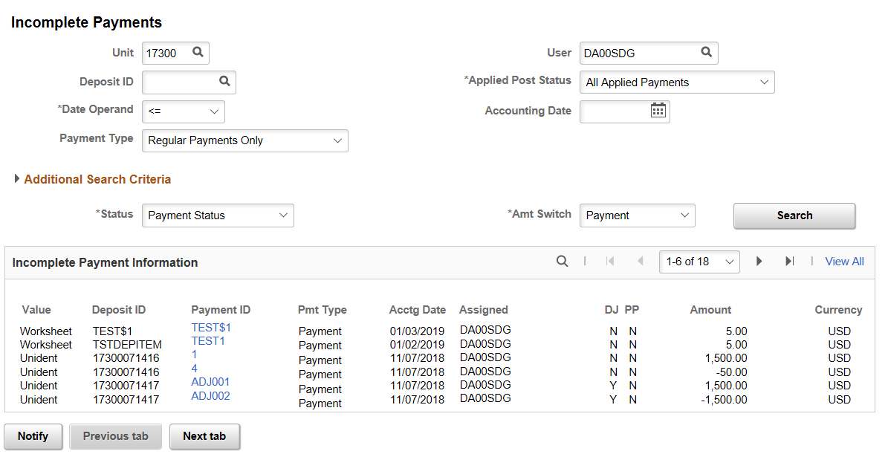
Incomplete Payments Page
Field | Description
Date Operand | Use the Date Operand list to select date to define your search criteria. In this example, less than or equal to is shown.
Applied Post Status | Use the Applied Post Status selection to select the payments that will be included in the search.
Payment ID | Select the Payment ID link to display the All Payments page.
Incomplete Payments Fields

Reviewing Payment Predictor
- When the Payment Predictor has finished processing, you can check to see that the payment has posted. Ideally, payments are completely applied by Payment Predictor.
This table lists the different Payment Predictor process statuses for payments that appear on inquiries, reports, payment worksheets, and messages:
Payment Predictor Payment Status | Description |  | Pay Status | Post Status
I (processed) |  | Payment was considered, and it did not meet the criteria of the method, or it did not have items selected for it. | Identified |  | Not applicable
W (worksheet) |  | Payment was applied and payment worksheet was built by the Payment Predictor process for review. | Worksheet |  | No action
A (applied) |  | Payment was applied and Pending Groups were created by the Payment Predictor process for posting. | Applied |  | Batch Standard
Payment Predictor Payment Statuses
You can review Payment Predictor results on the All Payments page. Payments that have completed successfully will show a Payment Status of Complete.

Page name | NavBar Navigation
All Payments | Accounts Receivable>Payments>Review Payments>All Payments
All Payments Page
