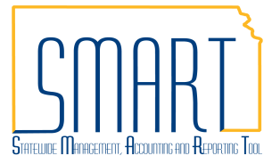
State of Kansas
AR Collections Workbench
Statewide Management, Accounting and Reporting Tool

Date Created: | 11/03/2015
Version: | 1.1
Last Updated Date: | 3/14/2019
Purpose of the Job Aid: | To assist SMART User in using the AR Collections Workbench
Security: | - Role Security: Only those individuals with one of the following roles will have access to the AR Collections Workbench: KAR_Agy_Admin  BU Security: Business Unit Security is applied. Agencies will only have access to AR Collections Workbench data for their agency’s business unit.
Process | - Navigate to: NavBar > Navigator > Accounts Receivable>Collections Workbench
 | - Enter SetID. SetID: <Business Unit>
 | - Enter Business Unit. Business Unit: <enter same value as the SetID in step 2>
 | - Click the Customer ID magnifying glass and choose a customer with activity. Customer ID: <valid value>
 | - Click the Search button
 | - Review customer information regarding Bill To Address/State/City, Last Payment Date, Last Payment Amount, Balance Due, Past Due, and contact information if applicable.
 | - Use the ‘More Button’ next to the primary contact to add a new contact. Enter new contact information and ‘Apply’.
 | - Use the ‘Payments’ tab to review payments.
 | - Use the ‘Items’ tab to create a maintenance worksheet. Note: Do not use any option in the ‘Item Action’ drop down list, other than ‘Create a Maintenance Worksheet’.
 | - Review Conversations, Correspondence and Aging on respective tabs.

