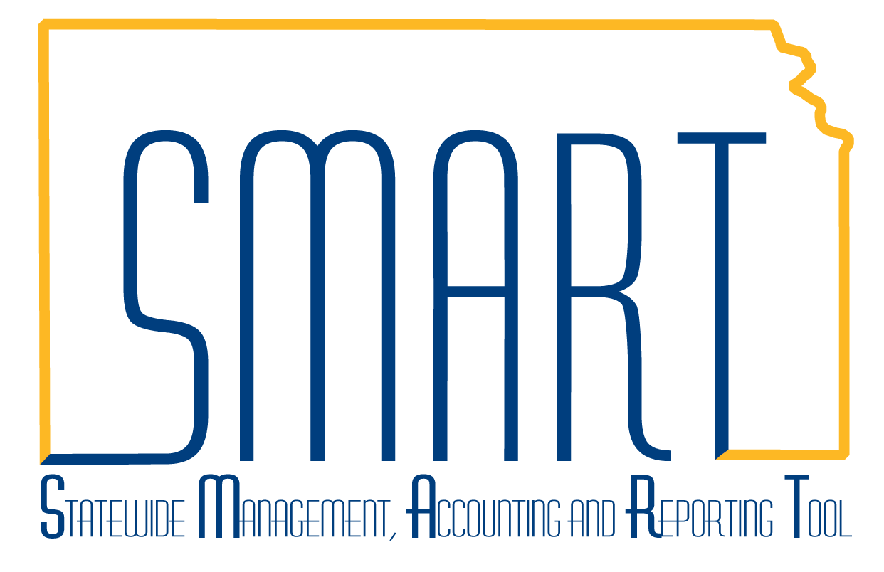
State of Kansas
Worksheet Cross Reference
Statewide Management, Accounting and Reporting Tool

Date Created: | 10/12/2017
Version: | 1.2
Last Updated Date: | 2/26/2019
Security Roles: | KAR_AGY_Billing_Admin, KAR_Agy_Billing_Processor, KAR_KS_Billing_Viewer
The Worksheet Cross Reference is a new feature being released with the 9.2.24 Upgrade. Invoices processed prior to the 9.2.24 Upgrade will not have this feature. | The Worksheet Cross Reference is available for Billings processed through the Project Costing/Grants/Customer Contracts/Billing modules where transactions create a temporary billing invoice on the Billing Worksheet. Once the Billing Worksheet is approved, an invoice number is assigned which flows into the Accounts Receivable module as the Item ID. This will provide traceability for transactions throughout SMART.
In the Billing module, navigate to Billing Homepage > Process Billing Worksheets > Search for Bills > Billing Information Details or Navigator > Billing > Review Billing Information > Details. Search for the Invoice. Select the Worksheet Cross Reference hyperlink. | 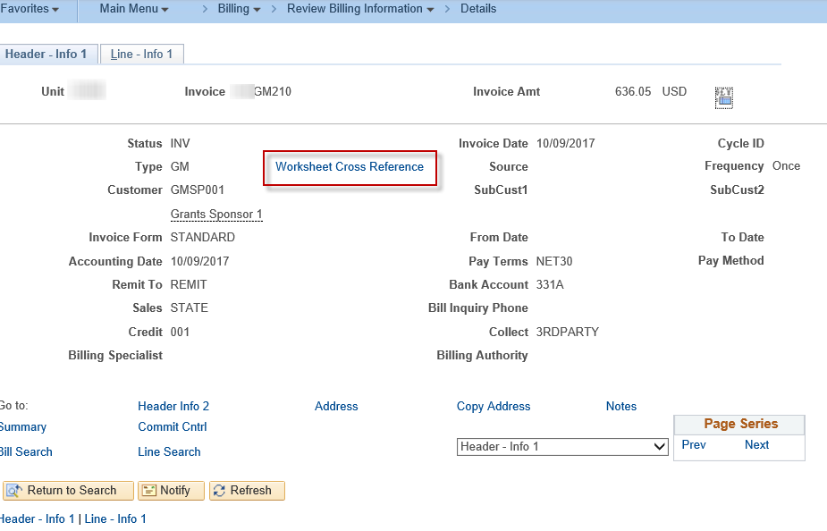
The modal window is displayed with the BU, Invoice, and Temporary Invoice information. | 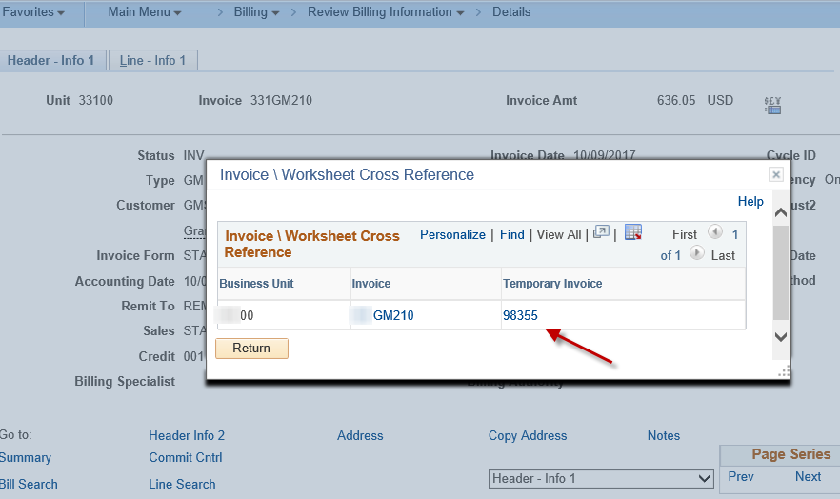
Searching for either the Billing Worksheet Temporary Invoice or the generated Invoice provide the same Worksheet Cross Reference information. | 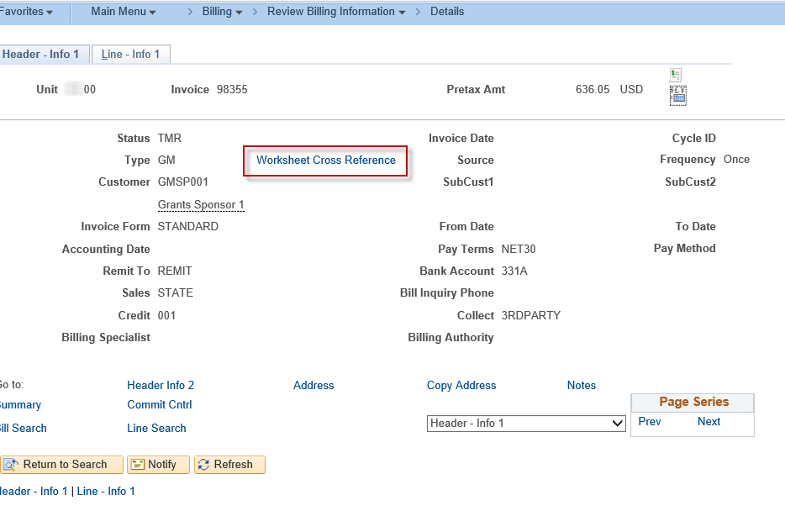
NavBar: Navigator > Accounts Receivable > Customer Accounts > Item Information > Item Billing Data. Search by either the Temporary Invoice or by Invoice/Item number.  In the Go To lookup, select Bill Line – General Info 1. | 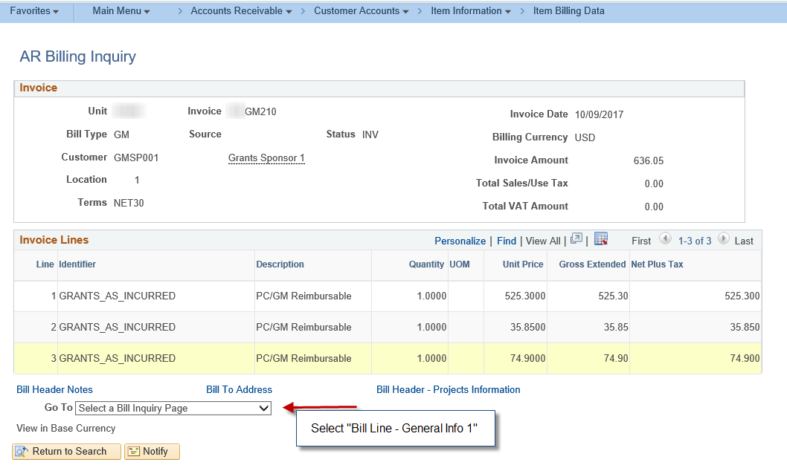
Select the Worksheet Cross Reference hyperlink. | 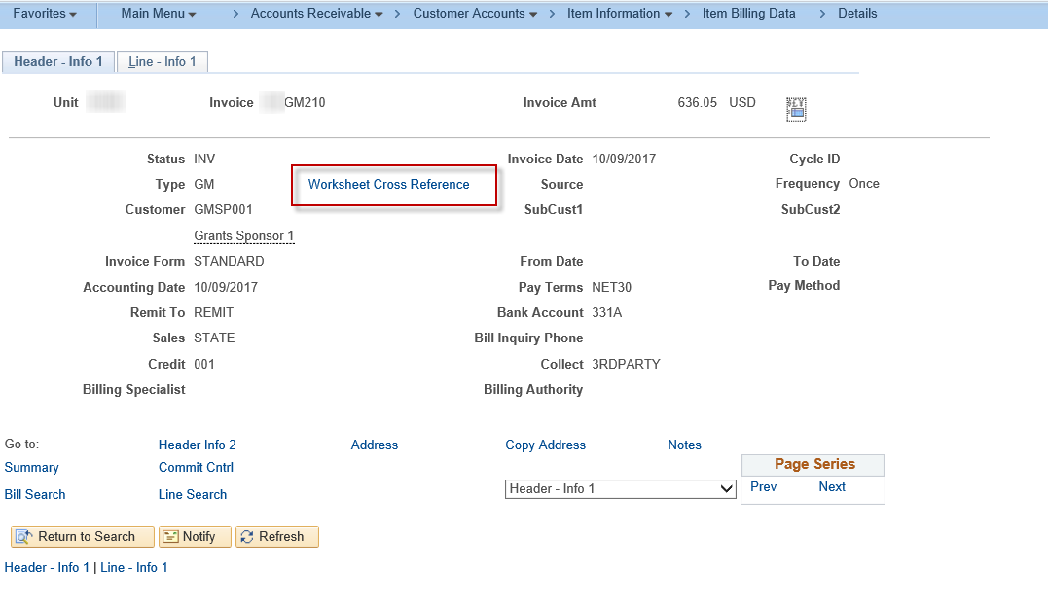
The Invoice\Worksheet Cross Reference will be displayed. | 