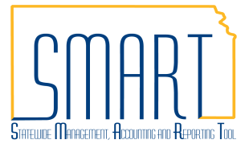
State of Kansas
Voucher Build Error Detail
Statewide Management, Accounting and Reporting Tool

Date Created: |  | 01/26/2018
Version: |  | 2.1
Last Update |  | 04/26/2019
Security: |  | - Role Security: Only those individuals with the following role will have access to correct voucher build errors:  - Agency AP Processor (KAP_Agy_AP_Processor)  - Agency AP Maintainer (KAP_Agy_AP_Maintainer)  - BU Security: Business Unit Security is applied. Agencies will only have access to the vouchers associated to their agency business unit.
Navigation |  | - Accounts Payable Homepage > Vouchers > Voucher Build Error Detail  - NavBar: Navigator > Accounts Payable > Vouchers > Maintain > Voucher Build Error Detail
1. | Search for Vouchers in Build Error  To locate all vouchers with build errors, search by Business Unit only.  From the results section, click on the voucher to view the error details. If there is only one voucher in build error, it will display immediately upon clicking ‘Search’. | 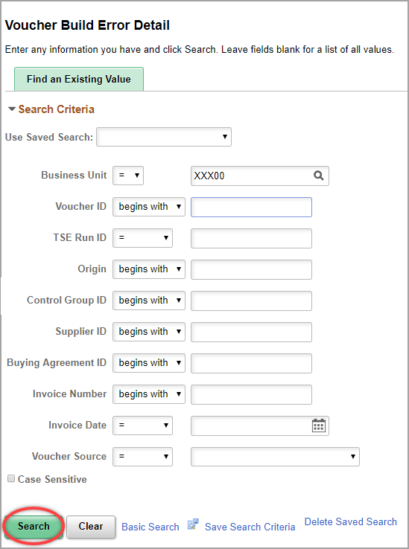  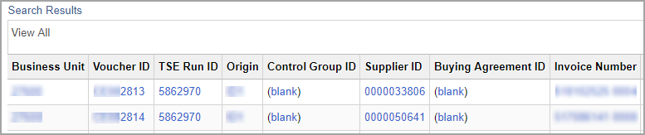

2. | Use Quick Invoice to Correct Vouchers  Review the errors for the selected voucher. Both voucher header and invoice line errors are displayed on the Voucher Build Error Detail page.  Click the ‘Correct Errors’ link. This will take you to the Quick Invoice page for the voucher selected.  a. To review errors listed on the Voucher Build Error Page click the ‘Review Errors’ link on the Quick Invoice page.  b. To pull a PO into the voucher use the ‘Copy From Source Document’ section.  c. Click the ‘Edit Combinations’ button to see if there are errors associated with combination edits. | 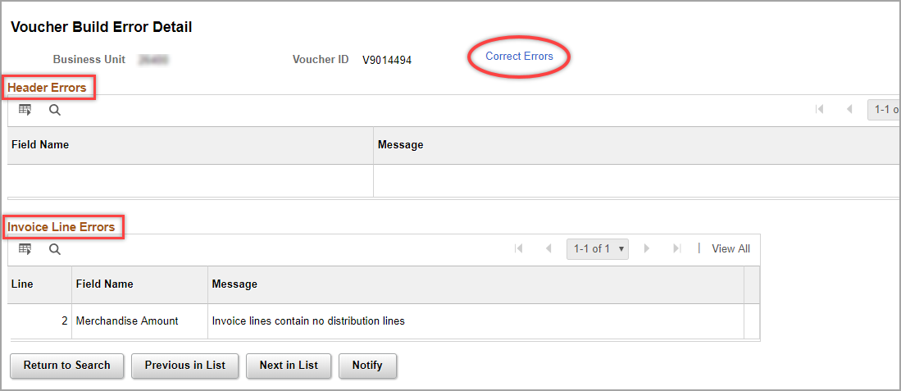  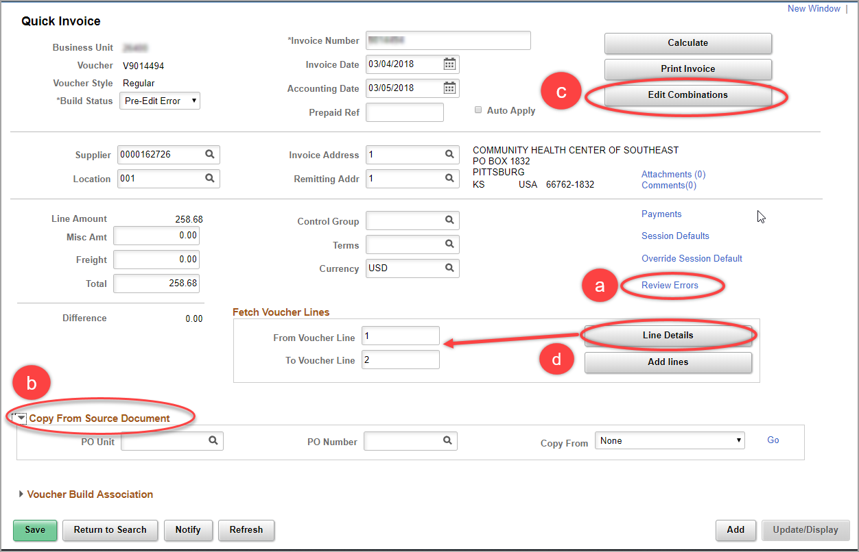  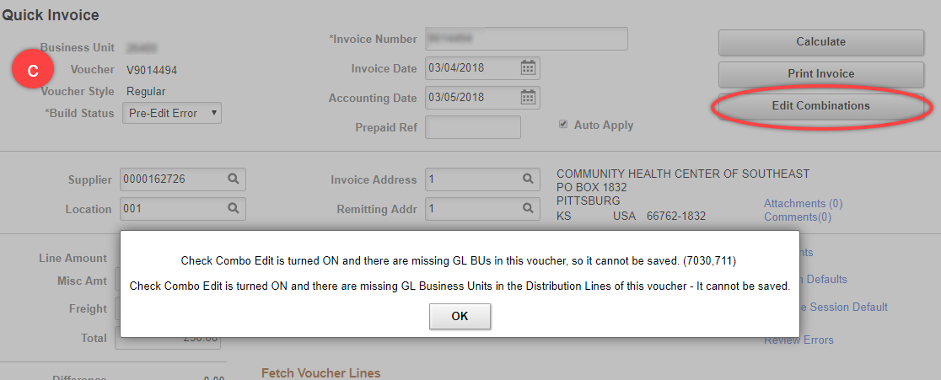

 | d. To correct errors on lines, click the ‘Line Details’ button. This will give you access to modify the lines.  --Make corrections to the distribution lines as necessary.  --Update the PO information on each line as necessary. | 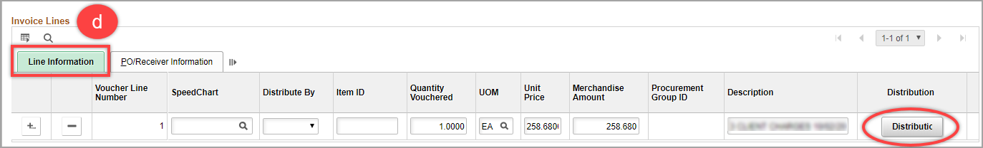  --If you need to view the distribution lines associated with an Invoice Line click the ‘Distribution’ button in the Line Information tab.  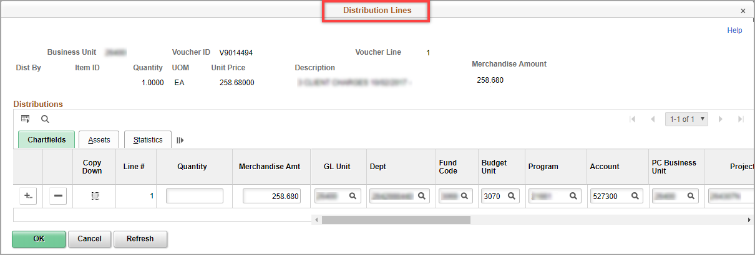  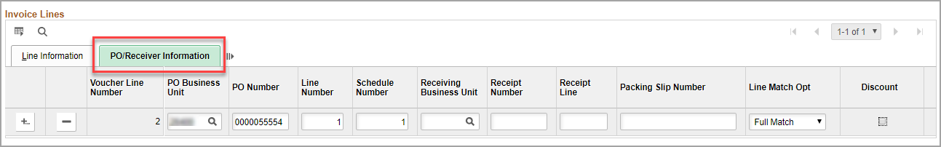
3. | Reset the Build Status and click ‘Save’.  Once the errors are corrected, select ‘Build Voucher’ in the Build Status drop-down menu and click ‘Save’.  The voucher can also be deleted by selecting ‘Delete Voucher’ from the drop-down and clicking the ‘Save’ button.  If all corrections were successful, the voucher will show up in the Regular Entry section of Accounts Payable after the next hourly batch processes are run.  If the errors remain, repeat steps to fix the error(s) on the voucher. | 