State of Kansas
Unmatch a Voucher
Statewide Management, Accounting and Reporting Tool

Date Created |  | 04/29/2019
Version |  | 1.0
Security |  | - Role Security: Only those individuals with the following roles will have access to unmatch a voucher:  - Agency AP Processor (KAP_Agy_AP_Processor)  - Agency AP Maintainer (KAP_Agy_AP_Maintainer)  - BU Security: Business Unit Security is applied. Agencies will only have access to the vouchers, purchase orders, and receipts associated to their agency business unit.
Information |  | Unmatch voucher functionality is used when a voucher associated to a Purchase Order has not been posted and corrections need to be made to the voucher. Only vouchers in Matched status are eligible to be Unmatched.
Navigation |  | Any of the following paths will take the user to the Match Workbench  - Accounts Payable Homepage > Vouchers > Match Workbench  - NavBar: Navigator > Accounts Payable >Review Accounts Payable Info > Vouchers > Match Workbench
1. | Navigate to the Match Workbench and specify search criteria.  Business Unit – Enter your agency’s business unit.  Match Status – Select ‘Matched’ from the drop-down menu.  Voucher ID – Select ‘equal to’ from the drop-down menu. Enter the Voucher ID in the open field.  Click the ‘Search’ button. | 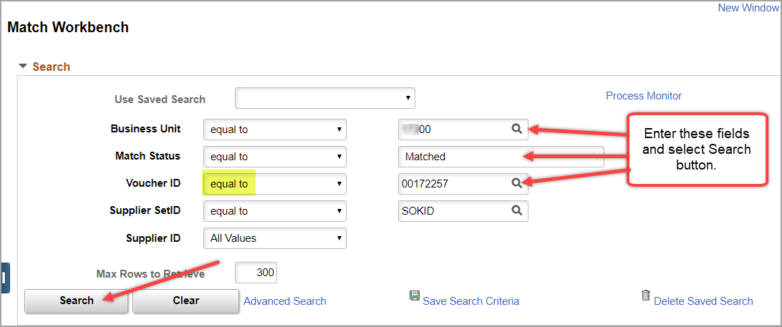

2. |  | - To unmatch the voucher, place a checkmark in the ‘Undo Match’ checkbox, select ‘Undo Matching’ from the Action drop-down menu, and click the ‘Run’ button.  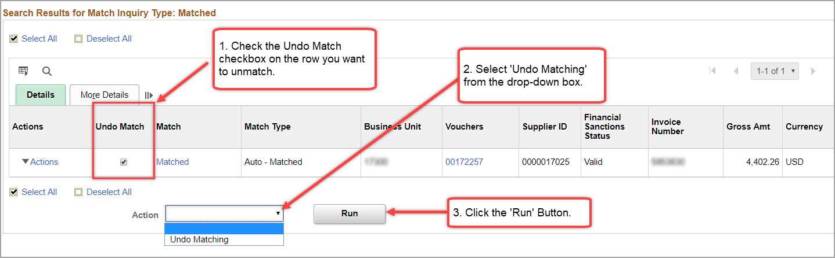  - A message will display indicating that ‘Undo Matching has been launched with Process Instance Number 9999999’. Select OK.  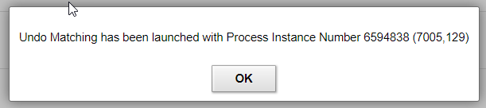  - Select the ‘Process Monitor’ link.  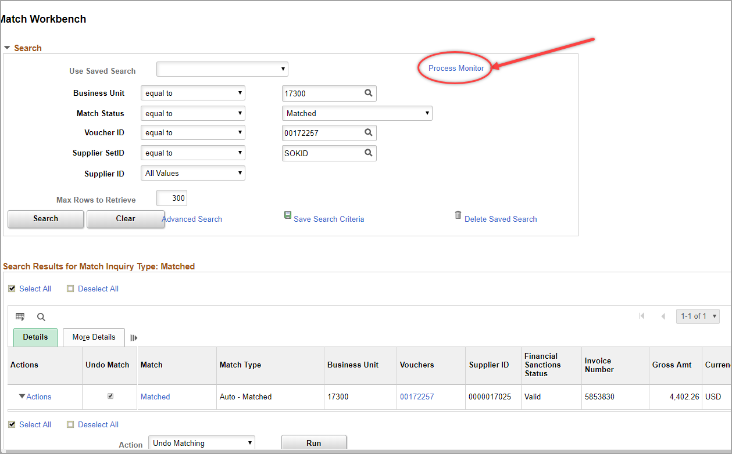  - On the Process List tab, click Refresh periodically until the Run Status and Distribution Status are ‘Success’ and ‘Posted’ on the row corresponding to the Process Instance Number from the pop-up message in Step c.  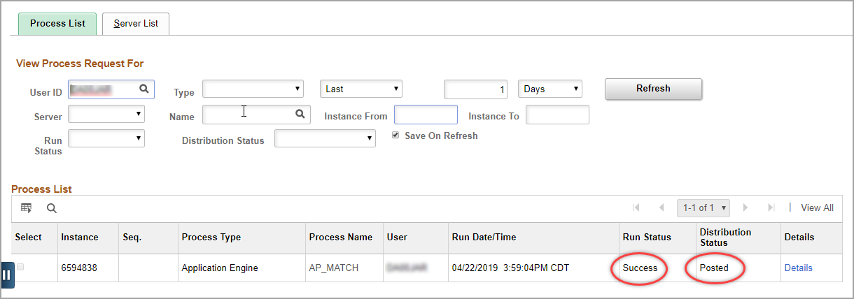
Navigation |  |  | - Accounts Payable Homepage > Vouchers > Add/Update > Regular Entry  - NavBar: Navigator > Accounts Payable > Vouchers > Add/Update > Regular Entry
3. | To confirm the voucher is unmatched, navigate to the Summary tab of the voucher.  The Match Status should be ‘Ready’.  The match status will remain ‘Ready’ until matching is run in the next hourly or nightly AP batch or if matching is manually triggered.  The voucher must be deleted or modified before it is rematched in a subsequent matching process or it will have to be unmatched again. |  | 