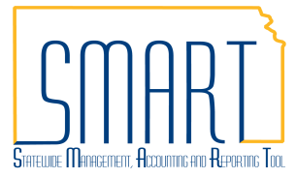
State of Kansas
Troubleshooting Unprocessed Vouchers
Statewide Management, Accounting and Reporting Tool

Date Created | 05/18/2018
Version | 2.0
Last Update | 06/17/2019
Documents this Job Aid Replaces | Pay Cycle Troubleshooting Guide 11-19-12  Voucher Will Not Process For Payment V.1.2 02-01-13
Security | - Role Security: Only those individuals with the following role will have access to modify a voucher:  - Agency AP Processor (KAP_Agy_AP_Processor)  - BU Security: Business Unit Security is applied. Agencies will only have access to the vouchers and interfunds associated to their agency business unit.
Purpose of Job Aid  There are multiple situations or reasons that a voucher will remain unprocessed and not be picked up for payment. This job aid covers the list of topics to the right. | - Close Status 1  - Voucher Entry Status 2  - Match Status 3  - Budget Status 3  - Approval Status 4  - Scheduled Due Date 5  - Hold Payment 5  - Supplier Status 6  - Credit Balance 7
Navigation | Any of the following paths will take the user to the Voucher Pages  - Accounts Payable Homepage > Vouchers > Add/Update > Regular Entry  - NavBar: Navigator>Accounts Payable>Vouchers>Add/Update>Regular Entry
A. Close Status  On the Summary tab, vouchers with a Close Status of “Closed” are not eligible for payment.  If a voucher has a Close Status of “Closed”, the voucher can NOT be used because the voucher cannot be re-opened.  A closed voucher has gone through a process that backs out all accounting entries associated with it so there is no net accounting impact.  Solution: Create a NEW voucher. | 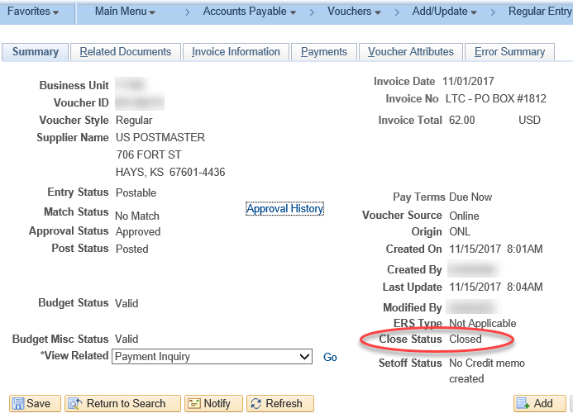

B. Voucher Entry Status  A voucher’s Entry Status on the Summary tab should be “Postable”.  If a voucher is in “Recycle” status, there may be an error on the voucher that is preventing it from further processing.  AP Processors have the ability to view and correct information on vouchers.  - Check the Error Summary tab for additional Information. Correct the error or if there is no information on this tab, move to step 2.  - Check the Invoice Information tab to see if the voucher is in “Incomplete” status. Click the ‘Save’ button right next to the ‘Save For Later’ button to kick a voucher out of “Incomplete” Status. If the voucher remains in “Incomplete” status, there may be errors on the voucher that need to be fixed.  Submit a ManageEngine Service Desk ticket for assistance. | 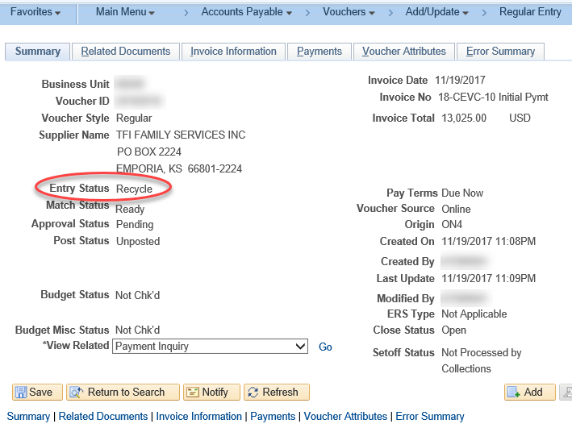  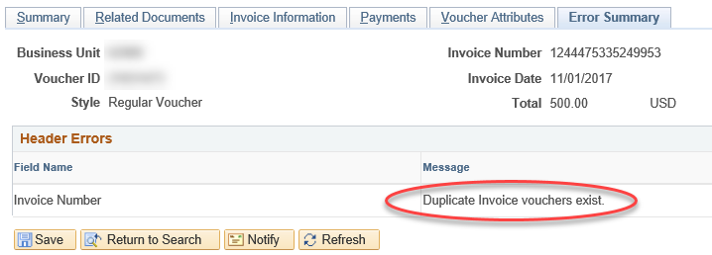  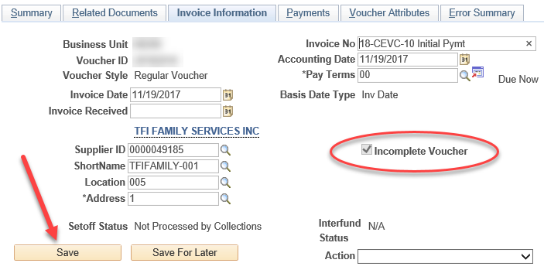

C. Match Status  On the Summary tab, vouchers must have a Match Status of “No Match”* or “Matched” to be eligible for payment.  Vouchers with a Match Status of “Exceptions” are NOT eligible for payment.  *Vouchers with a Match Status of “No Match” are Non-Purchase Order Vouchers which do not go through the matching process in SMART. These vouchers are fine to move forward through processing. | 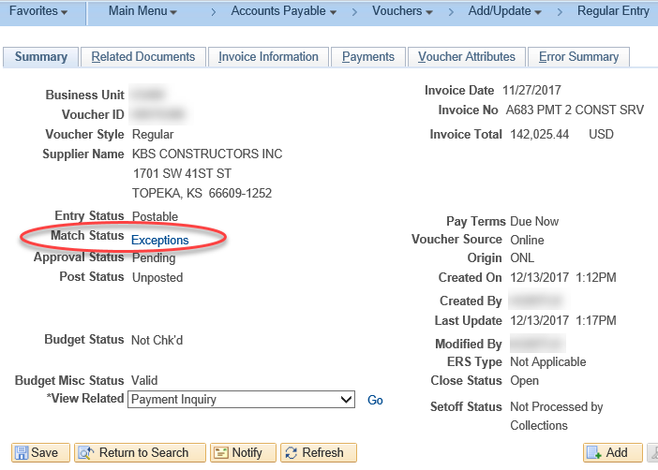  For additional information on how to work through Match Exceptions on Vouchers review the job aid located on the Accounts Payable page of SMARTWeb.
D. Budget Status  On the Summary tab, vouchers must have a Budget Status of “Valid” to be eligible for payment.  Vouchers with a Budget Status of “Not Chk’d” will likely be picked up by the next hourly budget checking batch process. Vouchers with Match Exceptions will be prevented from going through budget checking until the match error is resolved. See section C. for information about Match Status.  Vouchers with a Budget Status of “Exceptions” are NOT eligible for payment. | 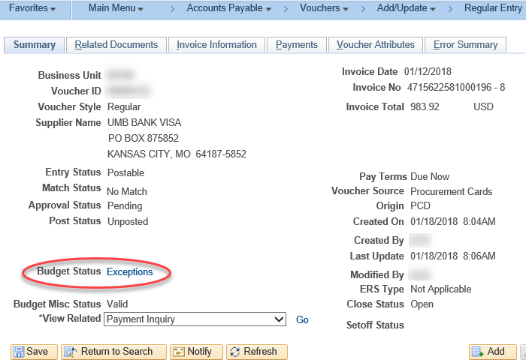  For additional information on how to work through Budget Exceptions on Vouchers review the job aid located on the Accounts Payable page of SMARTWeb.

E. Approval Status  On the Summary tab, vouchers must have an Approval Status of “Approved” to be eligible for payment.  Vouchers with an Approval Status of “Pending” or “Denied” are NOT eligible for payment.  Vouchers that have an Approval Status of “Pending” are awaiting approval. Click the “Approval History” hyperlink to view additional details on approval for the voucher.  Each approval step has a hyperlink which, if clicked, will indicate the approvers in each set or, if already approved, the user who approved at each step.  The “Approval History” hyperlink will not appear on vouchers that have not been through the hourly batch processes to be successfully matched, budget checked, and submitted into approval workflow.  Vouchers that have an Approval Status of “Denied” have been denied at one of the approval steps. Click the “Approval History” hyperlink for details on the denied status of the voucher.  Denied vouchers need to be either updated so they can go back through approval workflow or deleted from the system. To retrigger workflow on a voucher see the voucher-approval job aid (Step 11). | 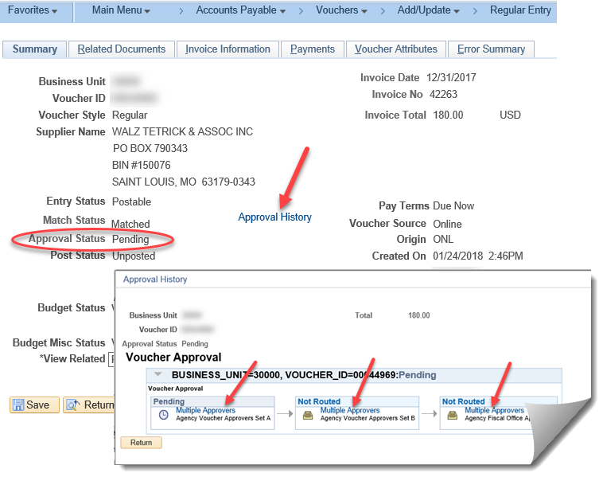  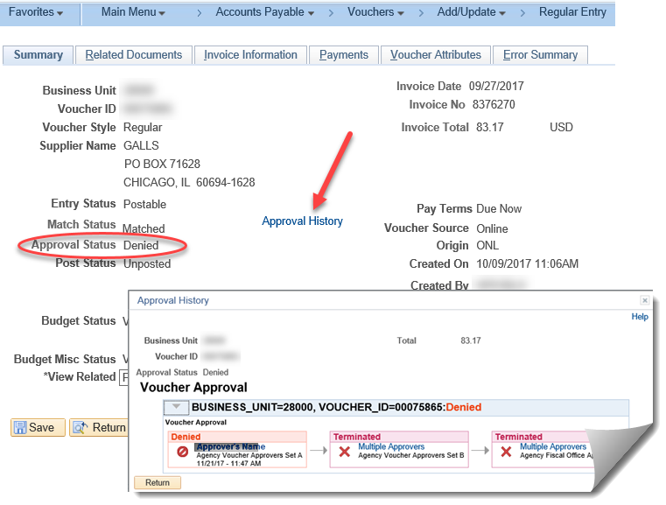  For additional information on AP Voucher Approval review the job aid located on the Accounts Payable page of SMARTWeb.

F. Scheduled Due Date  On the Payments tab, vouchers that have a Scheduled Due date which is in the future will NOT be selected for payment until that date has arrived. This date is auto-calculated using the Invoice Date and Pay Terms on the voucher.  The Scheduled Due date on the voucher can manually be changed to a different date. | 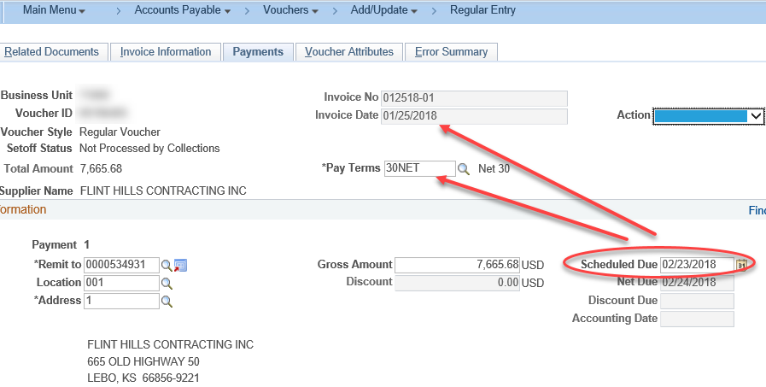
G. Hold Payment  On the Payments tab, vouchers that have the “Hold Payment” checkbox selected are NOT eligible to process for payment.  Vouchers may be placed on “Hold Payment” for a variety of reasons (either by the Agency or by Central Processing), including during the SetOff analysis process. Research the reason for the Hold Payment. If appropriate, remove the Hold Payment from the voucher so it can process. If it was placed on hold by Central Processing, check with the contact person before removing the Hold Payment. Submit a ManageEngine Service Desk ticket for assistance.  Setoff Hold Payment  Hold Payment is checked when a voucher is in one of two different Setoff Statuses: “Rdy to Snd for Collctns Analys” or “In Collections Eligiblty Analys”.  Once analysis is complete, the voucher gets released from Hold Payment and the Setoff Status is updated accordingly. | 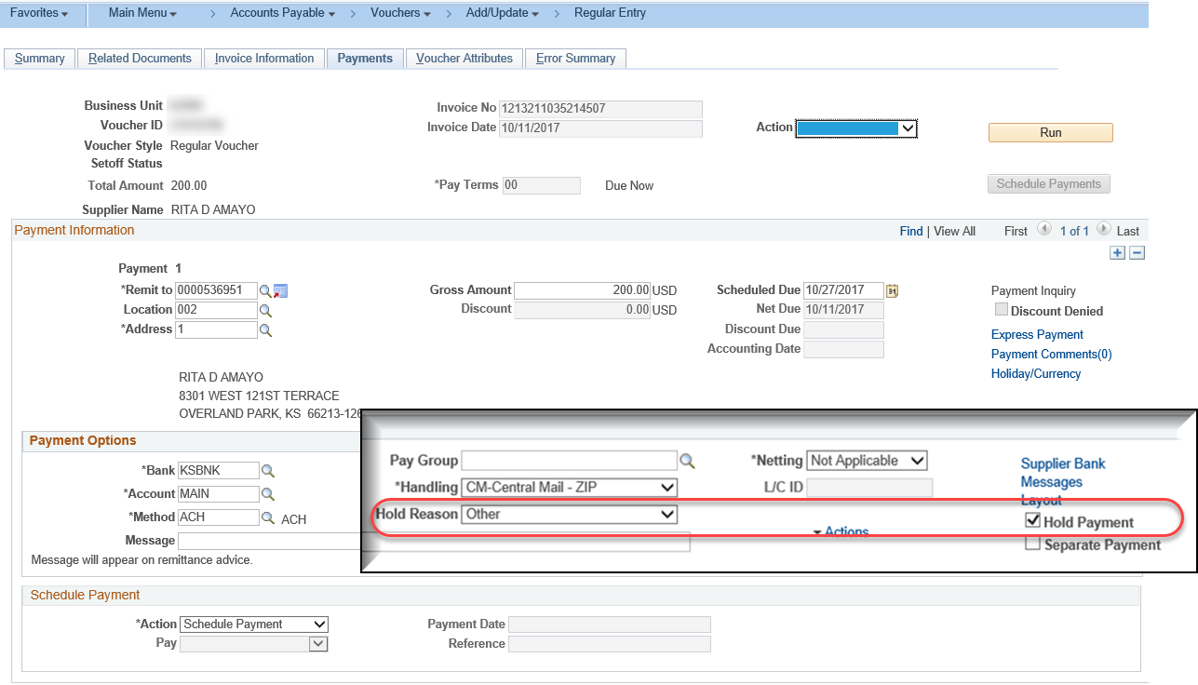  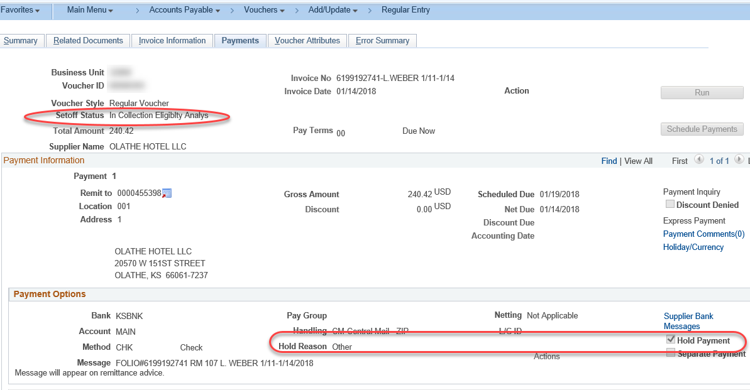  For more information on the Setoff/Offset Impact on Vouchers and Suppliers review the job aid located on the Accounts Payable page of SMARTWeb.

H. Supplier Status  To be eligible for payment, the Supplier, Supplier Location, and Supplier Address listed on the Payments tab of the voucher must each be in “Active” status.  - Inactive Supplier  One clue that a supplier has been inactivated is the “Supplier Name” field is filled with a description of the reason for inactivation. The Status of a supplier can be viewed on the Summary tab of the Supplier Record. Submit a ManageEngine ticket with appropriate documentation to get the supplier into “Active” status once again.  - Inactive Location  On the Payments tab of a voucher, if there is an graphic next to the “Remit To” field, this indicates the payment location is inactive. To view the reason for the inactive location, select the looking glass icon next to the “Location” field. Select a different location on the voucher or submit a ManageEngine Service Desk ticket for further assistance.  - Inactive Address  The only way to know a supplier address is inactive is to view the Supplier Record.  On the address tab, view the Effective Status of the Address ID that correlates to the one used on the Payments tab of the voucher. Select an active address for the voucher or submit a ManageEngine Service Desk ticket for assistance. | 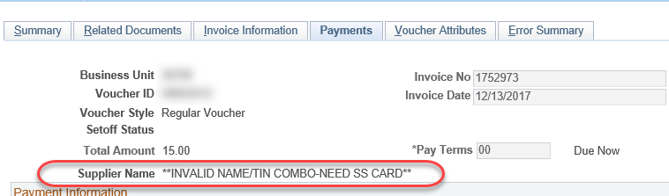  Navigation to Supplier Record:  - Accounts Payable Homepage > Suppliers > Add/Update Supplier > Find an Existing Value  - NavBar: Navigator > Suppliers > Supplier Information > Add/Update > Supplier  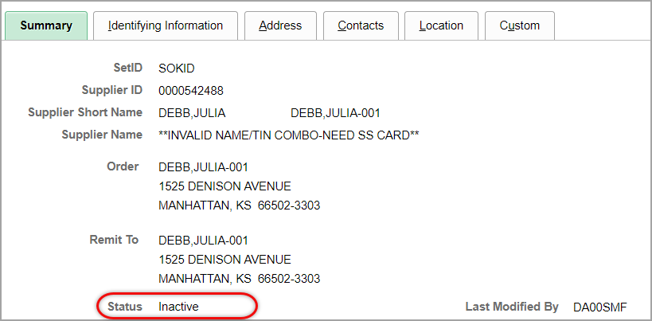  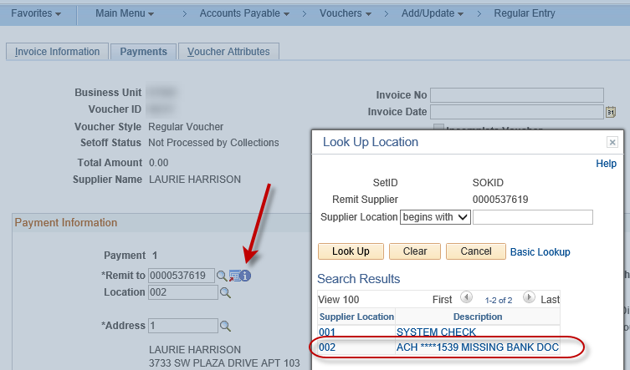  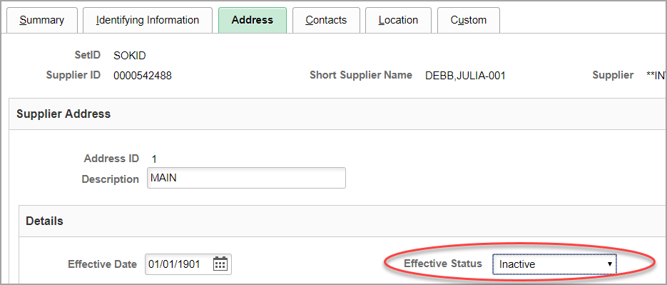
I. Credit Balance  All scheduled payments to a specific supplier must have a net balance of $0.00 OR a positive dollar amount balance in order to be eligible for payment.  Additionally, fields that must be the same on each voucher in order for them to net against each other include:  a. Supplier ID  b. Location  c. Address  d. Payment Method  e. Handling Code  f. “Separate Payment” box must NOT be checked on the vouchers in question.  To determine if there is a Credit Balance preventing payment of the voucher, note the Supplier ID on the voucher and navigate to the Scheduled Payment Inquiry page.  Fill in the “From Business Unit” and “To Business Unit” fields as well as the “From Supplier ID” and “To Supplier ID” fields. Then click Search.  The vouchers in queue for payment are displayed at the bottom of the page along with the Total Gross Amount which is what is due to the Supplier.  If the Total Gross Amount is negative this means there is a credit balance. To move toward a positive balance, so vouchers will pay, make sure all current and future vouchers are set up with matching fields on the Payments tab, as shown in the top screenshot of this section. | This example shows a voucher that has not paid because of a Credit Balance. Also shown are the fields that must match on each voucher in order for multiple vouchers to the same supplier to net against each other and create a payment.  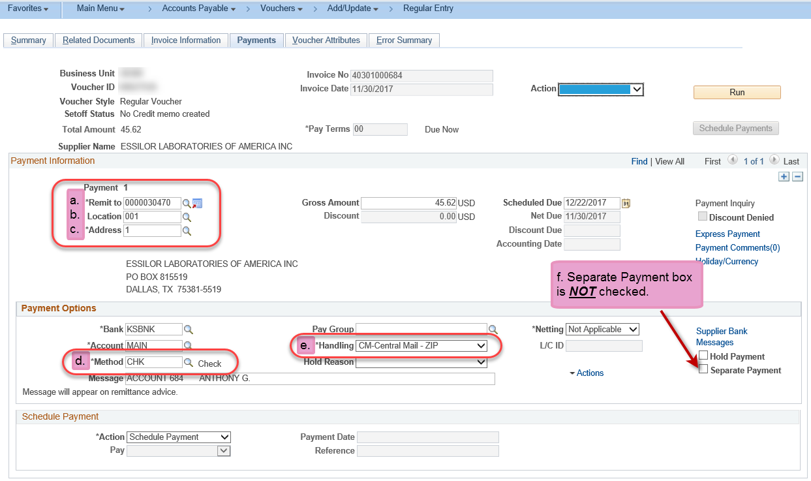  Navigation to Scheduled Payment Inquiry page:  - Accounts Payable Homepage > Suppliers > Supplier Inquiry > Scheduled Payment  - NavBar: Navigator > Accounts Payable > Review Accounts Payable Info > Supplier > Scheduled Payments  