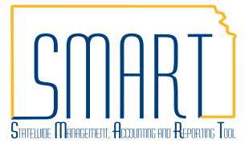
State of Kansas
Imprest Fund and Petty Cash Fund:
Replenish Fund by Creating a Voucher
Statewide Management, Accounting and Reporting Tool

Date Created: | 11/10/2014
Version: | V.1.2.
Last Updated Date: | 04/21/2017
Security: | - Role Security: Only those individuals with the following role will have access to create a voucher in Accounts Payable:  - Agency AP Processor (KAP_Agy_AP_Processor)  - BU Security: Business Unit Security is applied. Agencies will only have access to the vouchers associated to their agency business unit.
Reason for Job Aid: | Imprest Funds and Petty Cash Funds shall be replenished by the 15th day of the following month.  Creating a voucher to replenish an Imprest Fund or Petty Cash Fund is step 2 in a 2 step process. Recording the expenditure is step 1 – see job aid Imprest Fund and Petty Cash Fund: Record Expenditures by Creating a Voucher.  See PM 14,002 – Fiscal Year Closing of Obligations for fiscal year end closing requirements.

Navigation |  | Main Menu > Accounts Payable > Vouchers > Add/Update > Regular Entry
1.1 | Create a Voucher  Use the ‘Add a New Value’ tab:  Required Fields:  Business Unit: Your Business Unit number will default.  Note: If you use multiple Business Units, change the Business Unit value as necessary.  Voucher ID: Either accept the default value of ‘NEXT’ or follow your Agency’s business process for assigning Voucher ID numbers.  Voucher Style drop-down list: Select the ‘Regular Voucher’ option as shown in the screenshot to the right – this is the default. | 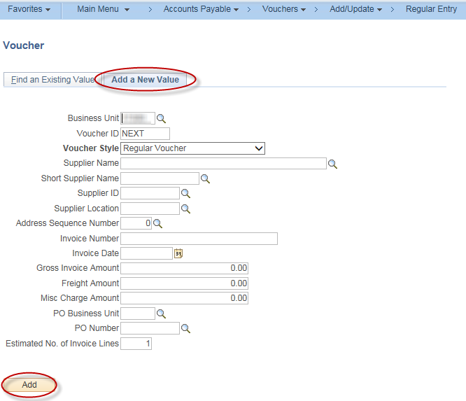
1.2 | Populate Remaining Fields:  Complete the remaining fields on the Add a New Value tab:  Supplier ID, Invoice Number, Invoice Date, and Gross Invoice Amount.  After filling in the fields, click the ‘Add’ button. | Supplier ID: Use the Supplier ID assigned to your agency.  DO NOT use the 5-digit agency supplier number used for interfund vouchers.  Invoice Number: The expenditure Voucher ID shall be entered to make the connection between the two documents in this 2-step process.
1.3 | Invoice Information:  Enter data in the Voucher Header, Invoice Lines and Distribution Lines.  Invoice Lines: The expenditure Voucher ID shall be entered in the Description field to make the connection between the two documents.  Distribution Lines: Refer to PM 10,752 – Petty Cash Fund Policy and PM 10,802 – Imprest Fund Policy for details regarding the fund(s) to be used. | 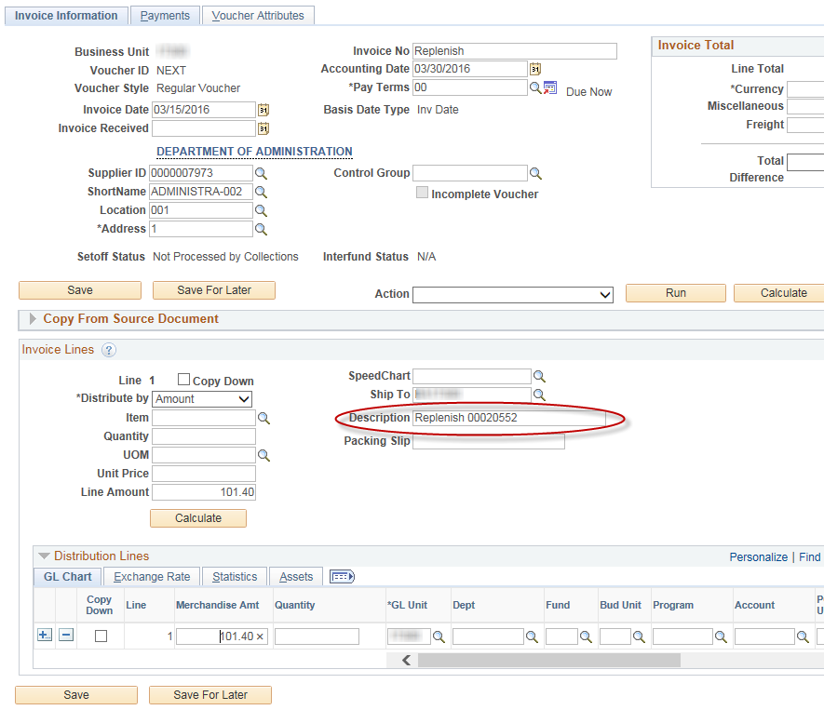
1.4 | Account code usage:  The Account to be used on the replenishment voucher will be 1103XX, where XX is the agency assigned imprest or petty cash account. This GL Account code is auto-generated on the expenditure voucher’s Cash Distribution Payment Accounting Entry. To review Accounting Entries for a voucher use the navigation: Accounts Payable > Review Accounts Payable Info > Vouchers > Accounting Entries  Use the Look Up Account by clicking on the magnifying glass to the right of the Account field to see the options available for your agency.  *The Account may also be found by using the following query in Reporting Tools > Query > Query Viewer  KS_AP_IMPR_PETTY_BANK_ACCT_KEY | 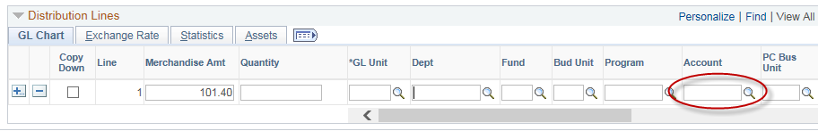  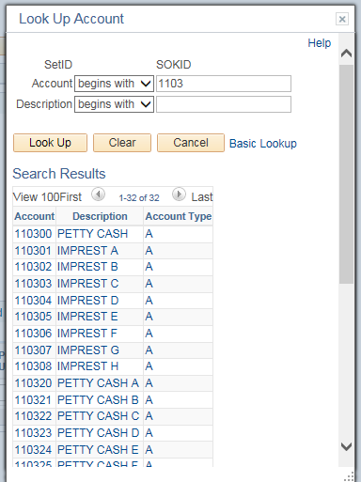

1.5 | Payments:  Verify values in the Voucher Header and Payment Information.  Payment Options:  Bank: KSBNK (default)  Account: MAIN (default)  Method: CHK (Check), ACH or WIR (Wire)  Note: If WIR (Wire) payment method is selected, the agency must follow the job aid WIRE Transfer Vouchers.  Message (optional): Message or note may be entered.  Payment Comments (optional – link is on right of screen): Message or note may be entered.  Select ‘Save’. Voucher ID is assigned upon saving. | 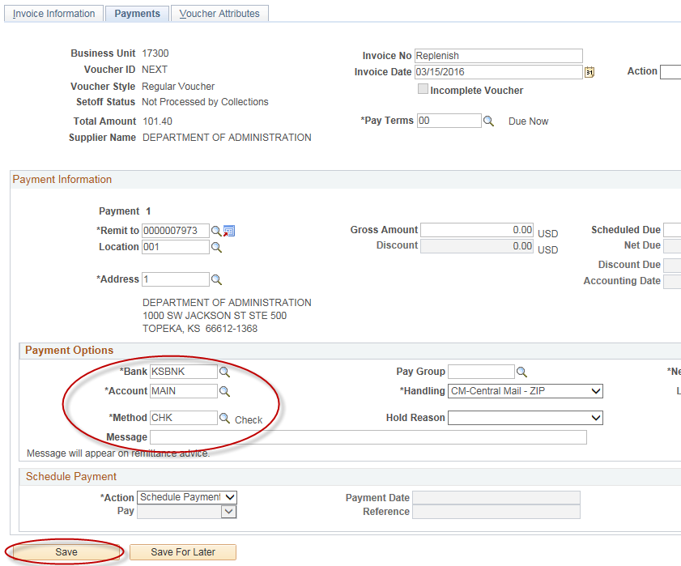
1.6 | Voucher will go through the agency workflow process for approval.

