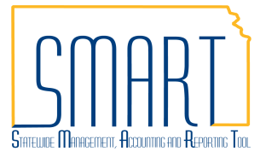
State of Kansas
Create a Voucher
Statewide Management, Accounting and Reporting Tool

Date Created |  | 09/18/2018
Version |  | 1.2
Last Update |  | 06/17/2019
Documents this Job Aid Replaces |  | Voucher Styles 11-19-12
Security |  | - Role Security: Only those individuals with the following role will have access to create a voucher:  - Agency AP Processor (KAP_Agy_AP_Processor)  - Agency AP Interfund Processor (KAP_Interfund_Processor)  - BU Security: Business Unit Security is applied. Agencies will only have access to the vouchers and interfunds associated to their agency business unit.
Navigation |  | - Accounts Payable Homepage > Vouchers > Add/Update > Regular Entry  - NavBar: Navigator > Accounts Payable > Vouchers > Add/Update > Regular Entry
1. | Navigate to the ‘Add a New Value’ tab to populate the fields as necessary for your voucher creation.  The top 3 fields on this page cannot be changed once the ‘Add’ button is clicked.  - The Business Unit will automatically populate based on the user’s profile.  - The Voucher ID field will automatically populate with ‘NEXT’. This will assign the next available 8 digit number as the Voucher ID. This can be modified if a different Voucher ID is desired.  - Use the dropdown menu to select Voucher Style. Different fields on this page will be available based on the Voucher Style that is selected.  See the Voucher Style Table on page 4 for additional information on Voucher Styles. | 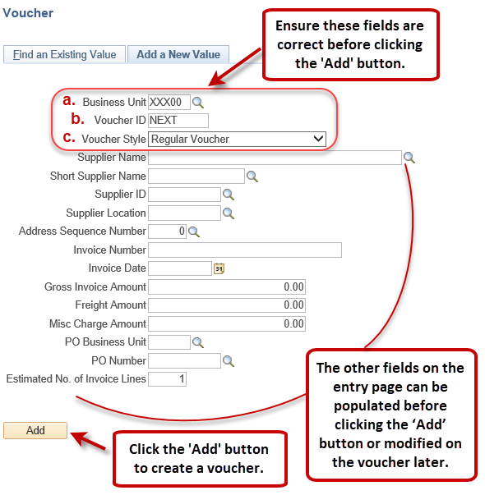  *Note: If a PO Number is populated on the Entry Page, the voucher will be set up as a ‘PO Voucher’ which requires at least one Invoice Line be associated to a Purchase Order.
2. Populate the fields in the Invoice Information tab of the voucher
At the header level of the Invoice Information tab there are several fields to complete.
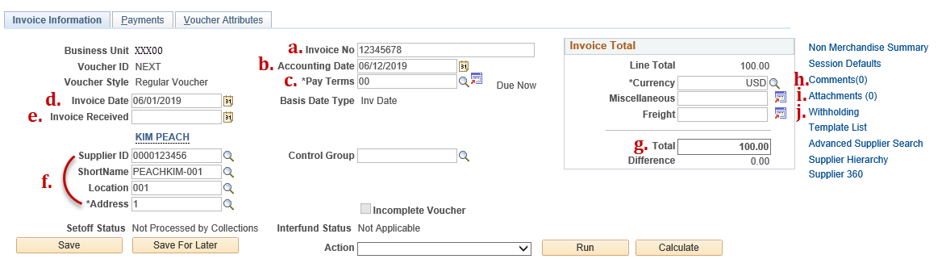
Those with asterisks are required fields.
 | Field | Description
a. | *Invoice No | It is best practice to enter this as just the Invoice number with no leading words or symbols so the Supplier can recognize it when they look up information on the payment received.
b. | *Accounting Date | This is auto-populated as the current date. The Accounting Date must be in an Open Period.
c. | *Pay Terms | This is auto-populated as ‘00’ or if there is a PO associated to the voucher, the Pay Terms will auto-populate according to how the PO is set up.
d. | *Invoice Date | This should reflect the actual invoice date on the invoice from the Supplier.
e. | Invoice Received | This field is not required but can be used for tracking purposes.
f. | *Supplier Info | Entering the Supplier ID will cause the other fields in this section to auto-populate. The Location and Address auto-populate according to what is set up as the default in the supplier record but can be modified on the voucher as needed.
g. | *Total | This is the total amount of the voucher and should match the Line Total.
h. | Comments | This hyperlink allows the user to add comments about the voucher for internal purposes.
i. | Attachments | This hyperlink allows the user to attach documents to the voucher such as invoices or receipts. The size limit is 1 MB per attachment.
j. | Withholding | This hyperlink allows the user to update the withholding information for the voucher. This hyperlink will only be visible on vouchers that have a supplier which is set up for withholding.

Populate the fields in the Invoice Lines section of the Invoice Information tab. Required fields include: Line Amount, Merchandise Amount, Dept, Fund, Bud Unit, Program, & Account.
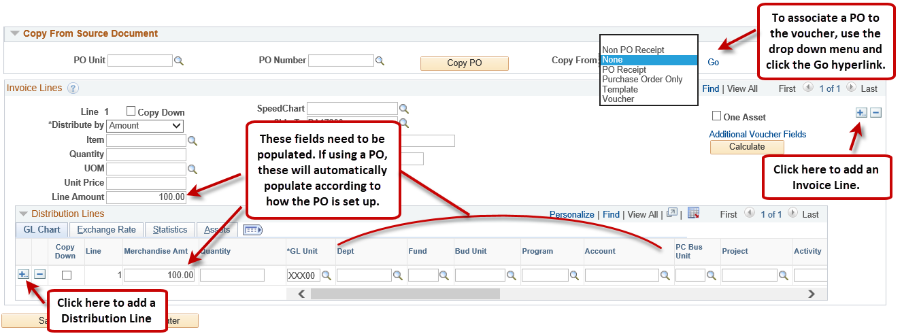

3. Populate the fields in the Payments tab of the voucher
There are several fields on the Payments tab that need to be completed before Saving the voucher.
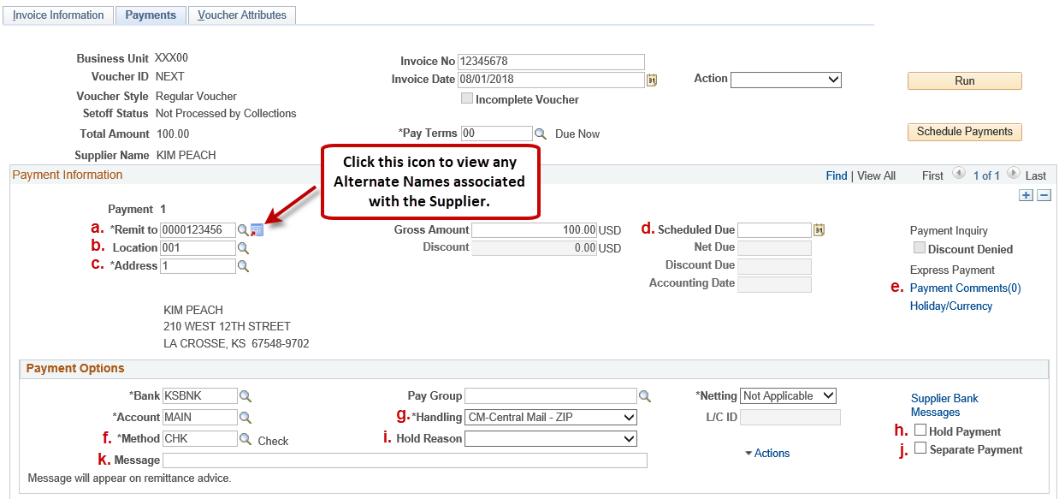
Those with asterisks are required fields.
 | Field | Description
a. | *Remit to | The Supplier ID in this field should match that which is on the Invoice Information tab. If there are Alternate Names, a check payment will be made out to the Alternate Name(s). Alternate Names can be viewed by clicking the icon next to the Remit to supplier ID field.
b. | *Location | This location is what will drive the payment Method (CHK, ACH, GE). Update this location as necessary to ensure the desired Method is selected.  Note: GE payment method should only be used on vouchers that will be paid on an interfund.
c. | *Address | This address will be printed on the check and is where the payment will be mailed (if it is a CHK payment). Update this as necessary.
d. | Scheduled Due | This box can be populated with the date you are wanting the payment to process. Once the voucher is Saved, this box will auto-populate with the scheduled due date based on the Pay Terms and Invoice Date on the voucher. It can be edited is necessary.
e. | Payment Comments | This hyperlink allows the user to add a note for internal purposes about the voucher or payment.
f. | *Method | The payment Method is tied to the supplier Location that is selected on the Payments tab. This may be updated for vouchers that require specific payment methods such as those created for Imprest/Petty Cash expenditure recording or vouchers created for WIRE transfers.  Note: GE payment method should only be used on vouchers that will be paid on an interfund.
g. | *Handling | The handling field will auto-populate according to how the supplier is set up. 'CM-Central Mail - ZIP', which means the check will be mailed to the address selected on the Payments tab, is the most common value populated into this field. To have a check returned to the agency, select the appropriate handling code from the drop-down menu. This setting will not impact payments that do not have CHK as the Method.
h. | Hold Payment | Select this box to prevent the voucher from going through Pay Cycle. When this box is checked, a Hold Reason will also need to be selected.
i. | Hold Reason | Use this drop-down menu to select a reason for the 'Hold Payment' box being checked.
j. | Separate Payment | Check this box to make sure a separate payment is sent for this specific voucher. Leaving this box unchecked will allow payments from the same agency to be combined on one CHK, ACH, or GE payment if the vouchers go through the same Pay Cycle and the Supplier, Location, Address, Method, and Handling settings on the Payments tab are matching on each voucher.
k. | Message | Enter any information in this field that will help the Supplier apply the payment. This field will hold up to 70 characters.

4. Once all fields are completed, save the voucher.
Voucher Style Table
Voucher Style | Definition
Adjustments | Used for entering a credit or debit memo. Also used for relating one voucher to another voucher. To link a source voucher to the Adjustment Voucher, use the Copy From Source Document section on the Invoice Information page. Click the 'Copy From Worksheet' hyperlink to associate individual lines from a source voucher. Multiple vouchers can be associated to one Adjustment voucher as long as they all use the same supplier ID.
 | Note: A negative Adjustment voucher will not pay and finish processing until there is a zero dollar or positive balance, based on Business Unit/Supplier combination. The negative and positive vouchers must have the following fields matching in order for them to process together: Business Unit, Remit Supplier ID, Location, Address, Method, and Handling. Also, the Separate Payment box must NOT be checked on either voucher.
 | Note: Source vouchers are Regular vouchers and must have the same business unit and supplier ID as the adjustment being created.
Journal | Used for correcting accounting entries on a posted or paid voucher. Source documents cannot be copied into journal vouchers. To link the journal voucher to the voucher that is being adjusted, use the Related Voucher field on the Invoice Information tab. The Invoice Total of the journal voucher must be $0.00.
Regular | Used for entering vouchers that are purchase order and non-purchase order related vouchers. This is the default setting in SMART.
 | Note: Setoff Credit Memos are Regular Style vouchers with a negative amount.
 | Note: Interfund type vouchers are Regular Style vouchers with unique origin codes ('I' or 'R'). They must be attached to an interfund and there must be a reciprocating deposit attached to the same interfund in order for them to pay and finish processing.
Reversal | Used to undo a transaction, including backing out incorrect vouchers, restoring the encumbrance for actuals and budgets, and reducing the purchase order’s matched quantity or amount. Reversal vouchers are always credit vouchers and all voucher lines that reference a purchase order must be less than zero.
 | Note: The reversal voucher will not pay and finish processing until there is a zero dollar or positive balance, based on Business Unit/Supplier combination. The Reversal voucher and source voucher must have the following fields matching in order for them to process together: Business Unit, Remit Supplier ID, Location, Address, Method, and Handling. Also, the Separate Payment box must NOT be checked on either voucher.
 | Note: Source vouchers are Regular vouchers and must have the same business unit and supplier ID as the reversal being created.
Single Payment | Used for entering a voucher that does not have a supplier ID tied to it. This type of voucher is created for a payment to a one-time supplier, such as a rebate or refund recipient. This is an exception to the normal process since most vouchers should be regular vouchers which have supplier IDs tied to them.
 | Note: In the SMART supplier file, there will be a generic Single Payment supplier ID. The remaining supplier-identifying information, such as name, address, and bank information, is added directly on the voucher during creation.
 | Note: If the supplier is an existing supplier in SMART or the payment is 1099 Reportable, do NOT use this voucher style. Create a Regular voucher instead.
Template | Used for creating a supplier specific template to generate regular vouchers. This is an efficiency tool in SMART and enables the user to pull in a Template during the creation of a Regular voucher so the Invoice Line(s) and Payment specifics will be copied over automatically.
 | Note: Templates can only be copied into Regular vouchers created in the Accounts Payable module. They cannot be used for interfund type vouchers, adjustments, journal, reversal, or single payment vouchers.
See the Accounts Payable SMARTWeb page for more details about each Voucher Style.

