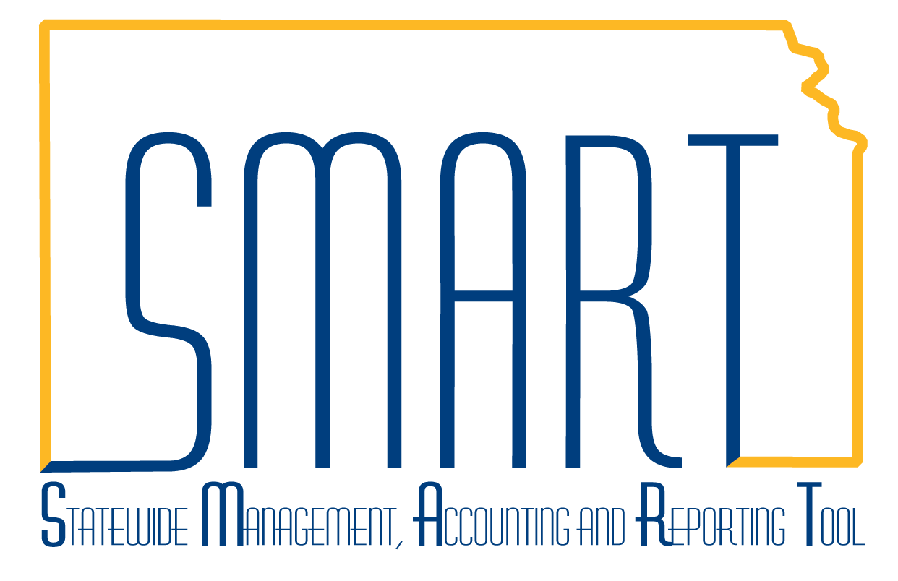
State of Kansas
Create a Single Payment Voucher
Statewide Management, Accounting and Reporting Tool
Date Created |  | 09/25/2013
Version |  | 1.1
Last Update |  | 04/12/2019
Purpose |  | Single Payment Vouchers are created for payments to a one-time supplier, such as a refund recipient. This is an exception to the normal voucher procedure. Most vouchers should be regular vouchers that use a supplier ID.  - If the supplier is an existing supplier in SMART, do NOT use this voucher style. Use the Regular Voucher process.  - If the payment is 1099 Reportable, do NOT use this voucher style. Use the Regular Voucher process.
Security |  | - Role Security: Only those individuals with the following role will have access to create a voucher:  - Agency AP Processor (KAP_Agy_AP_Processor) with the ability to process Single Payment Vouchers  - BU Security: Business Unit Security is applied. Agencies will only have access to the vouchers and interfunds associated to their agency business unit.
Navigation |  | Accounts Payable Homepage > Vouchers > Add/Update > Regular Entry  or  NavBar: Navigator>Accounts Payable>Vouchers>Add/Update>Regular Entry
1. | Navigate to the ‘Add a New Value’ tab.  The top 3 fields on this page cannot be changed once the ‘Add’ button is clicked.  - The Business Unit populates based on the user profile.  - The Voucher ID field automatically populates with ‘NEXT’. This assigns the next available 8 digit number as the Voucher ID. This can be modified if a different Voucher ID is desired.  - Select ‘Single Payment Voucher’ from the Voucher Style dropdown menu.  - Populate the supplier fields by selecting the magnifying glass next to the Supplier ID and select the record returned.  - Fill in remaing fields as necessary and click ‘Add’. | 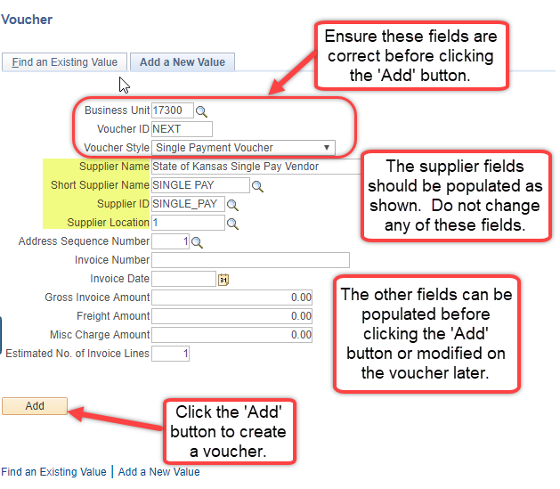
2. | Populate the fields on the Single Payment Supplier tab of the voucher.  Enter the Supplier Name and Address information. At a minimum, you must include Supplier Name, Address 1, City, State, and Postal.  The Payment Method defaults to ‘CHK’.  If you wish to pay the supplier using the ‘ACH’ payment method, navigate to the Payments tab of the voucher, and change the Payment Method to ‘ACH’. Navigate back to the Single Payment Supplier tab, select the ‘Supplier Bank’ link located at the top left of the page.  Complete the highlighted fields with the supplier’s ACH banking information and click the ‘OK’ button.  Use of the DA-130 is recommended to obtain the supplier’s ACH authorization and required bank account information. The DA-130 should be retained by the agency.  The DA-130 job aid provides information concerning the form, and agency responsibilities for validation of the completed form and accompanying documentation. Only steps 1-4 and 9 apply to single payment vouchers. | 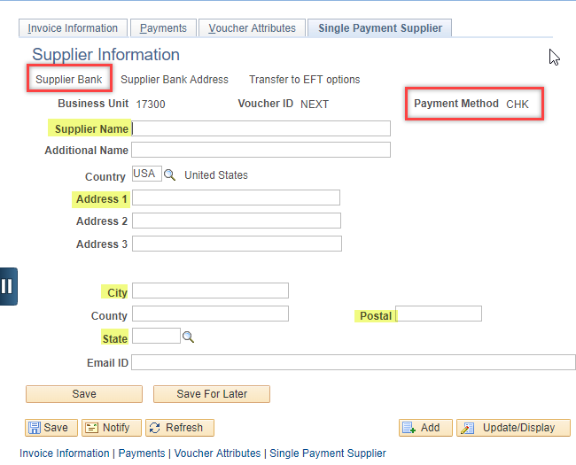  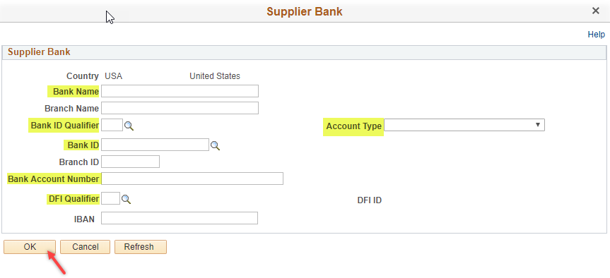  - Bank Name - Name of the supplier’s bank.  - Bank ID Qualifier – Always use ‘001’.  - Account Type – Use ‘Check Acct’ for a checking account or ‘Time Dep’ for a savings account.  - Bank ID – Supplier’s bank routing number. SMART validates this field and returns an error if this is an invalid value. Do not continue if you receive an error. Contact the supplier for correct information.  - Bank Account Number – Supplier’s bank account. Include any leading zeros and carefully enter the account number.  - DFI Qualifier: Always use ‘01’.  - Double check your entry and use the DA-130 or other source document to verify the information entered.

3. Populate the fields on the Invoice Information tab of the voucher
At the header level of the Invoice Information tab there are several fields to complete.
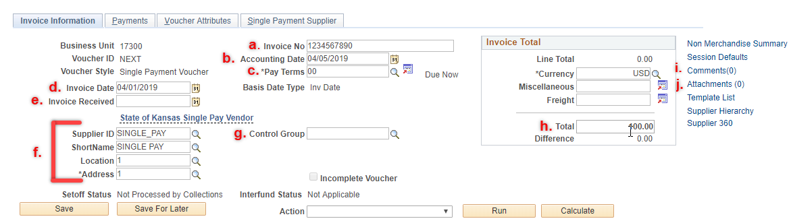

Those with asterisks are required fields.
 | Field | Description
a. | *Invoice No | It is best practice to enter this as just the Invoice number with no leading words or symbols so the Supplier can recognize it when they look up information on the payment received.
b. | *Accounting Date | This is auto-populated as the current date. The Accounting Date must be in an Open Period.
c. | *Pay Terms | This is auto-populated as ‘00’.
d. | *Invoice Date | This should reflect the actual invoice date on the invoice from the Supplier.
e. | Invoice Received | This field is not required but can be used for tracking purposes.
f. | *Supplier Info | These fields were populated on the ‘Add a New Value’ tab and should not be changed.
g. | Control Group | This field is not required, however, if the user is set up to use Control Groups, this field is available and can be modified.
h. | *Total | This is the total amount of the voucher and should match the Line Total.
i. | Comments | This hyperlink allows the user to add comments about the voucher for internal purposes.
j. | Attachments | This hyperlink allows the user to attach documents to the voucher such as invoices or receipts. The size limit is 1 MB per attachment.

Populate the fields in the Invoice Lines section of the Invoice Information tab. Required fields include: Line Amount, Merchandise Amount, Dept, Fund, Bud Unit, Program, & Account.

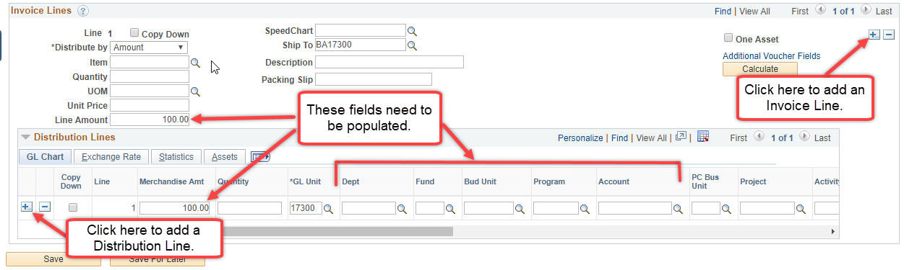

4. Populate the fields in the Payments tab of the voucher
There are several fields on the Payments tab that need to be completed before Saving the voucher.
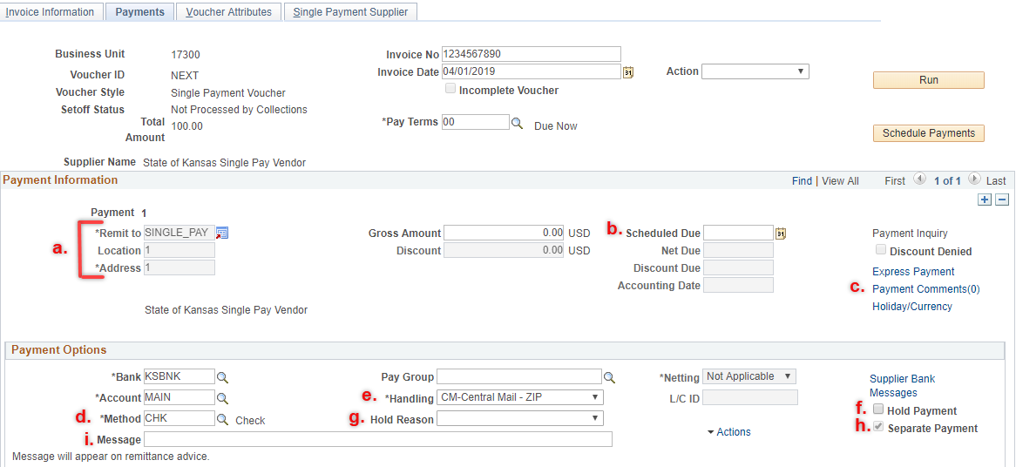
Those with asterisks are required fields.
 | Field | Description
a. | *Remit Supplier Info | These fields were populated on the ‘Add a New Value’ tab and should not be changed.
b. | Scheduled Due | This box can be populated with the date you want the payment to process. Once the voucher is Saved, this box will auto-populate with the scheduled due date based on the Pay Terms and Invoice Date on the voucher. It can be edited as necessary.
c. | Payment Comments | This hyperlink allows the user to add a note for internal purposes about the voucher or payment.
d. | *Method | The Payment Method defines how a payment will be made to the supplier. If ACH is selected, the supplier’s bank-related information must be entered on the Single Payment Supplier Tab of the voucher using the Supplier Bank link. This can be updated for vouchers that require specific payment methods such as those created for Imprest/Petty Cash expenditure recording.
e. | *Handling | The handling field will auto-populate according to how the supplier is set up. 'CM-Central Mail - ZIP', which means the check will be mailed to the address selected on the Payments tab, is the most common value populated into this field. To have a check returned to the agency, select the appropriate handling code from the drop-down menu. This setting will not impact payments that do not have CHK as the Method.
f. | Hold Payment | Select this box to prevent the voucher from going through Pay Cycle. When this box is checked, a Hold Reason will also need to be selected.
g. | Hold Reason | Use this drop-down menu to select a reason for the 'Hold Payment' box being checked.
h. | Separate Payment | This box is always checked for Single Payment Vouchers.
i. | Message | Enter any information in this field that will help the Supplier apply the payment. This field will hold up to 70 characters.

5. Once all fields are completed, save the voucher.

