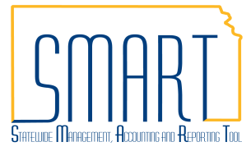
State of Kansas
Copy a Purchase Order or Receipt
into a Voucher
Statewide Management, Accounting and Reporting Tool

Date Created |  | 07/25/2017
Version |  | 3
Last Update |  | 05/03/2019
Security |  | - Role Security: Only those individuals with the following roles will have access to copy a Purchase Order or Receipt into a voucher:  - Agency AP Processor (KAP_Agy_AP_Processor)  - *Agency AP Maintainer(KAP_Agy_AP_Maintainer)  - BU Security: Business Unit Security is applied. Agencies will only have access to the vouchers, purchase orders, and receipts associated to their agency business unit.  *This role is only necessary if the user needs to manage the Matching Process on the Match Workbench.
Information |  | This job aid documents how to either copy a PO or copy a Receipt into a voucher. These are two different ways to associate a purchase order and/or receipt to a voucher. The user is not required to both copy a PO and copy a Receipt into the same voucher.
Navigation |  | Any of the following paths will take the user to the Voucher Entry page  - Accounts Payable Homepage > Vouchers > Add/Update > Regular Entry: Add a New Value  - NavBar: Navigator > Accounts Payable > Vouchers > Add/Update > Regular Entry: Add a New Value
1. | Add a new voucher or navigate to an existing voucher  When copying from a Purchase Order or Receipt, it is preferred to leave the Supplier ID and Gross Invoice Amount fields blank. | 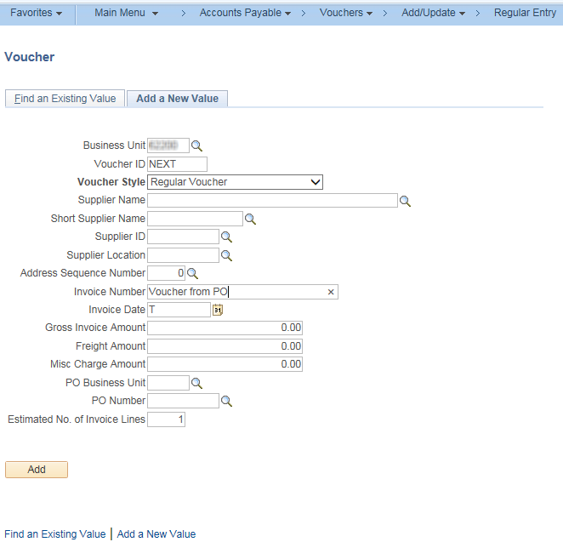

2.1 | Copy in a PO  - On the Invoice Information tab, click the arrow to reveal the Copy From Source Document section of the voucher. Select “Purchase Order Only” from the drop down list next to the Copy From field. Click “Go”.  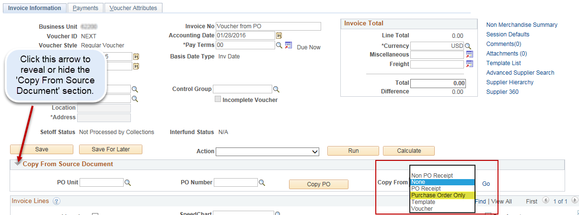  - Fill in the PO Business Unit and PO Number From fields then click Search.  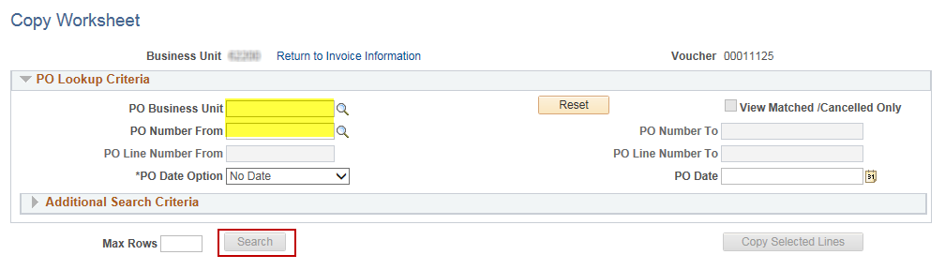  - To view all available lines on the PO click the “View All” link. Check the box next to each line you want to pull in. Adjust the Quantity Vouchered or Merchandise Amount as necessary. Click the “Copy Selected Lines” button to bring the lines into the voucher.  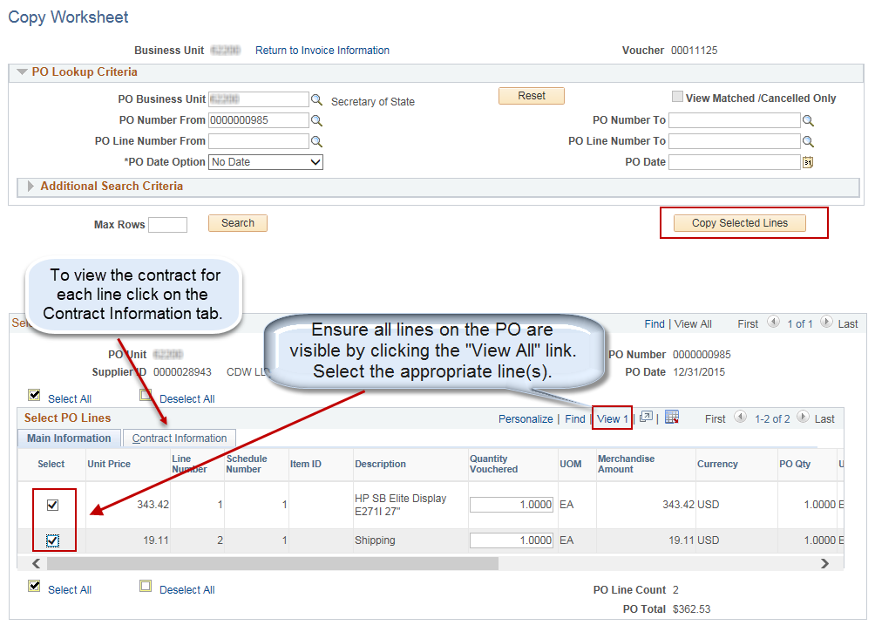
2.2 | Review PO Lines in Voucher  Click the “View All” link to show all the lines on the voucher. Ensure amounts/quantities are correct. Save the voucher.  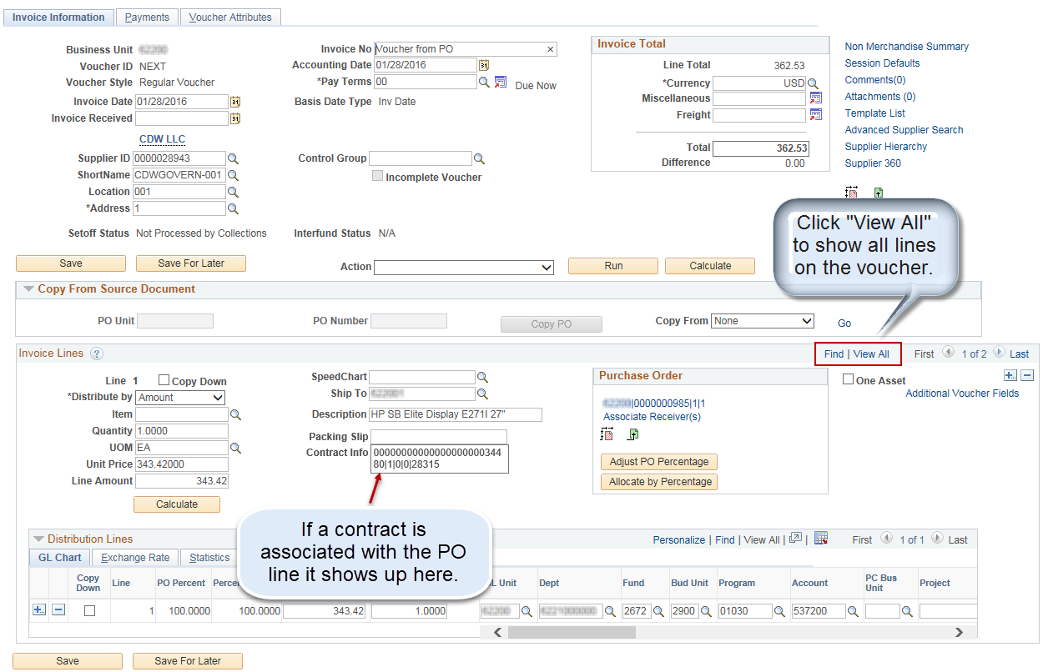  *A voucher can have multiple POs from the same Supplier copied into it. Repeat Step 2.1 for each PO you wish to copy into a voucher. The voucher will need to be in “Ready” status for Matching in order to copy in additional POs. View the Match Status on the Summary tab of the voucher. To manage matching for a voucher please go to the Match Workbench. See the Unmatch a Voucher job aid for details.  Any of the following paths will take the user to the Match Workbench  - Accounts Payable Homepage > Vouchers > Match Workbench  - NavBar: Navigator > Accounts Payable >Review Accounts Payable Info > Vouchers > Match Workbench

2.3 | Adjust Distribution Lines to Match PO Percentage for Quantity POs  The distribution lines for POs that are quantity based don’t pull into a voucher Invoice Line as allocated based on the quantity selected. These distribution lines will always pull in with the original full allocation for merchandise amount and quantity as set up on the PO line. The following steps walk the user through how to adjust those distribution lines so that they are allocated based on the quantity selected when the PO line is associated with the voucher Invoice Line. These steps can also be used to correct the allocation on Amount Only PO Invoice Lines if necessary.  - On the Voucher Invoice Line, click the ‘Adjust PO Percentage’ button to adjust the Percent Values showing on the distribution lines to match the PO Percent.  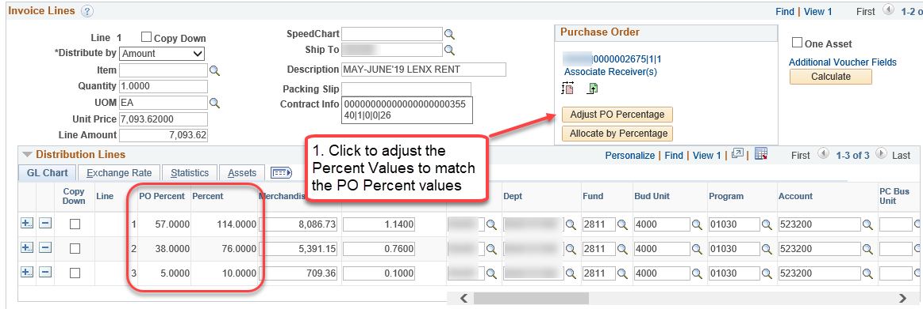  A popup box will appear asking if you want to override the Distribution Percentage with the PO Percentage for all Distribution lines. Click ‘Yes’.  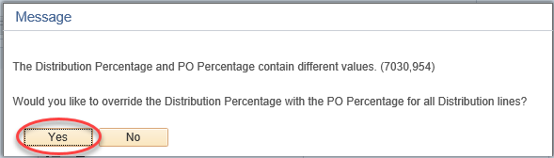  - Click the ‘Allocate by Percentage’ button to allocate the Merchandise Amounts and Quantity breakdown by the newly updated Percent values.  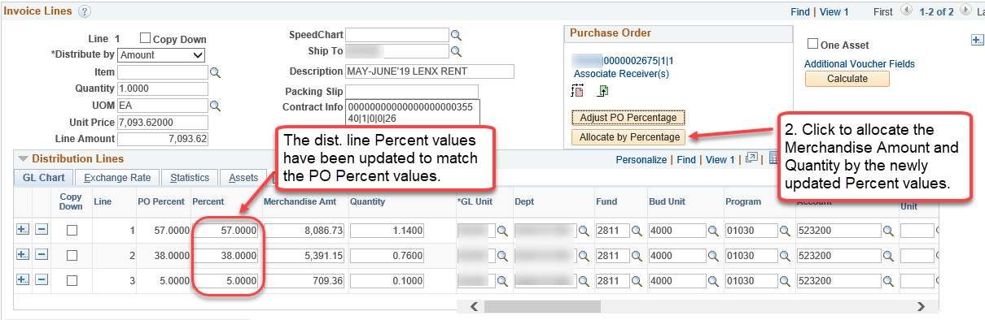  - Click the ‘Calculate’ button to make sure the distribution line merchandise amounts add up to the full ‘Line Amount’.  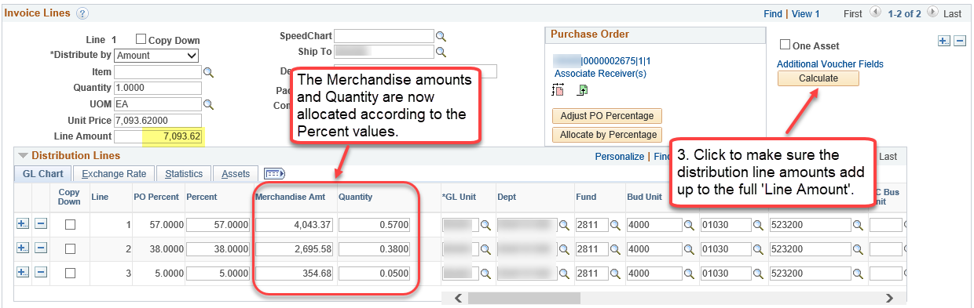  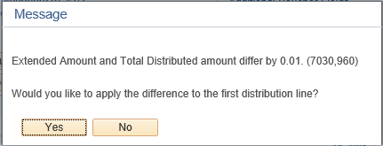  A popup box will appear if there is a difference in the amounts. Click ‘Yes’ to automatically apply the difference to the first distribution line. Click ‘No’ to manually adjust on whichever lines are appropriate.  If ‘No’ is selected, a Difference box on the Invoice Line will appear. This box will remain until the difference is resolved.  Adjust the amounts on the distribution lines as necessary and click the ‘Calculate’ button again to confirm there is no difference in the amounts.  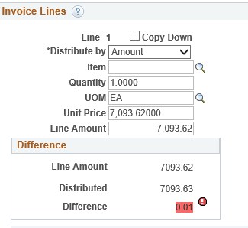  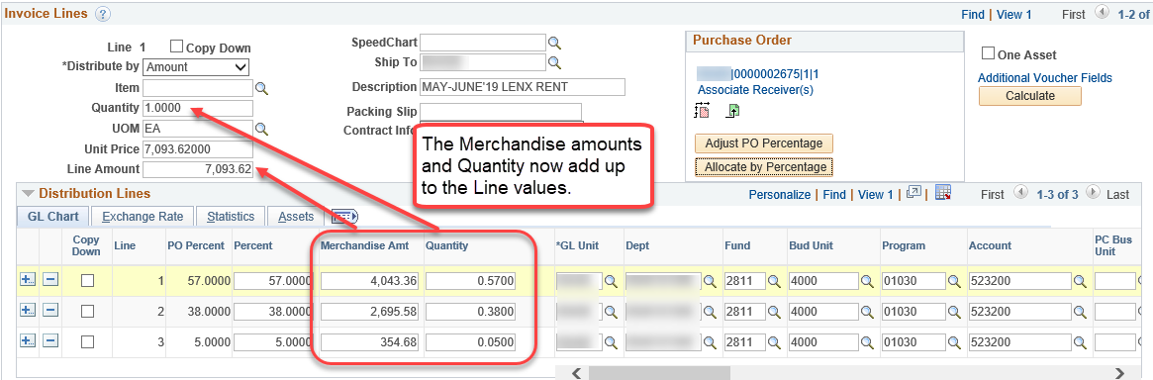

3.1 | Copy in a Receipt  - To add a new Invoice Line that is associated to a receipt, click the arrow to reveal the Copy From Source Document section. Select “PO Receipt” from the drop down list next to the Copy From field. Click “Go”.  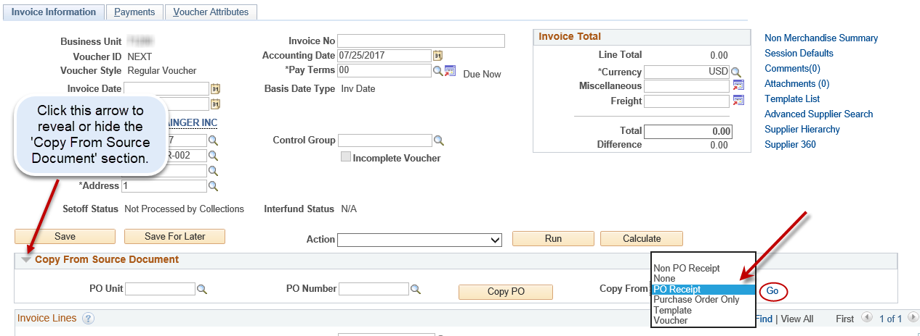  - Fill in the PO Business Unit and PO Number fields then click Search.  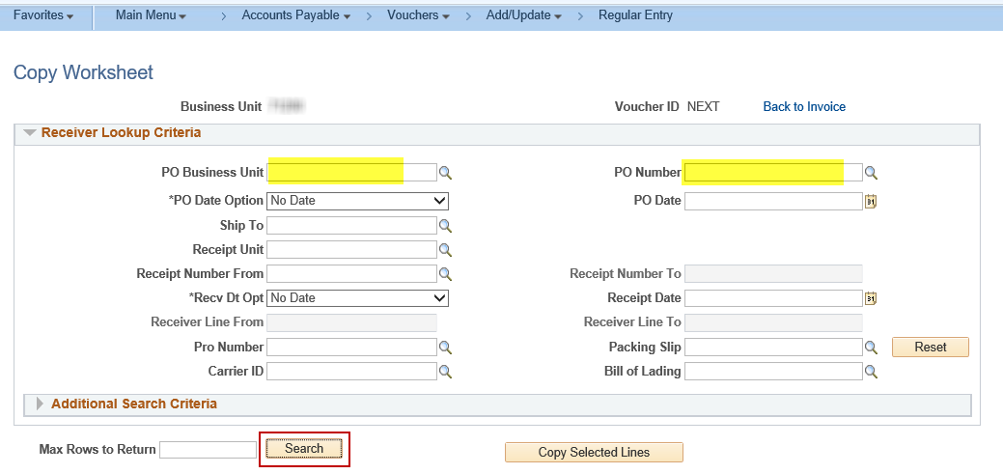  - To view all available lines on the Receipt click the “View All” link. Check the box next to each line you want to pull in. Adjust the Quantity or Merchandise Amount as necessary. Click the “Copy Selected Lines” button to bring the lines into the voucher.  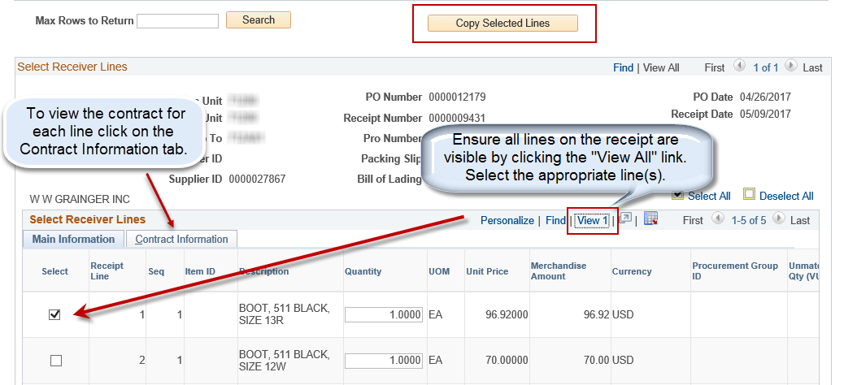

3.2 | View, Modify, or Associate a Receipt on an existing Invoice Line  - On the Invoice Information tab of a voucher view the Invoice Line and click the ‘Associate Receiver(s)’ link to view the receipt associated with the Invoice Line.  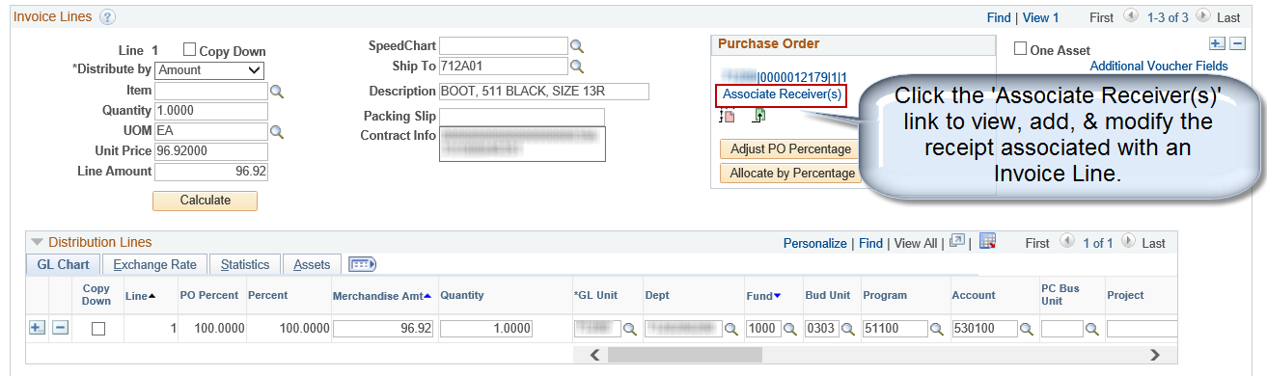  - View/Modify the Receipt  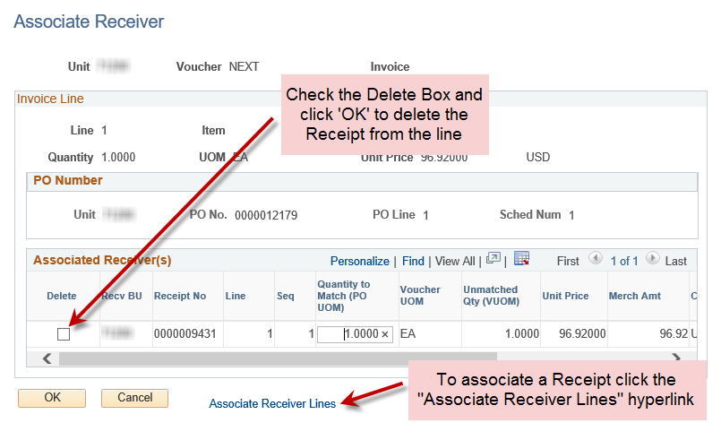  From this page the quantities or amounts can be adjusted as necessary. There is also the option to delete a receipt already associated to the line or to associate a new or different receipt to the line.  - Associate a Receipt  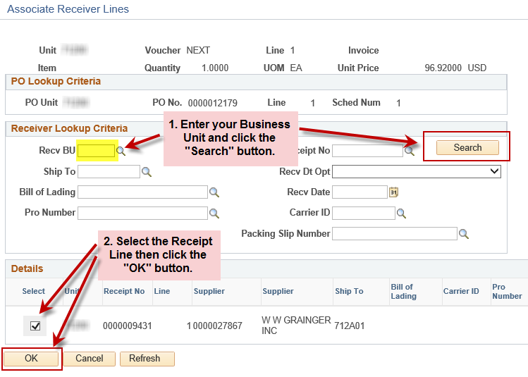  Find the receipt to associate to the Invoice Line by keying the Business Unit into the field and clicking the ‘Search’ button. Select the Receipt Line and click ‘OK’.  Once the correct receipt(s) is/are associated to the Invoice Line click “OK” to exit the Associate Receiver page.

