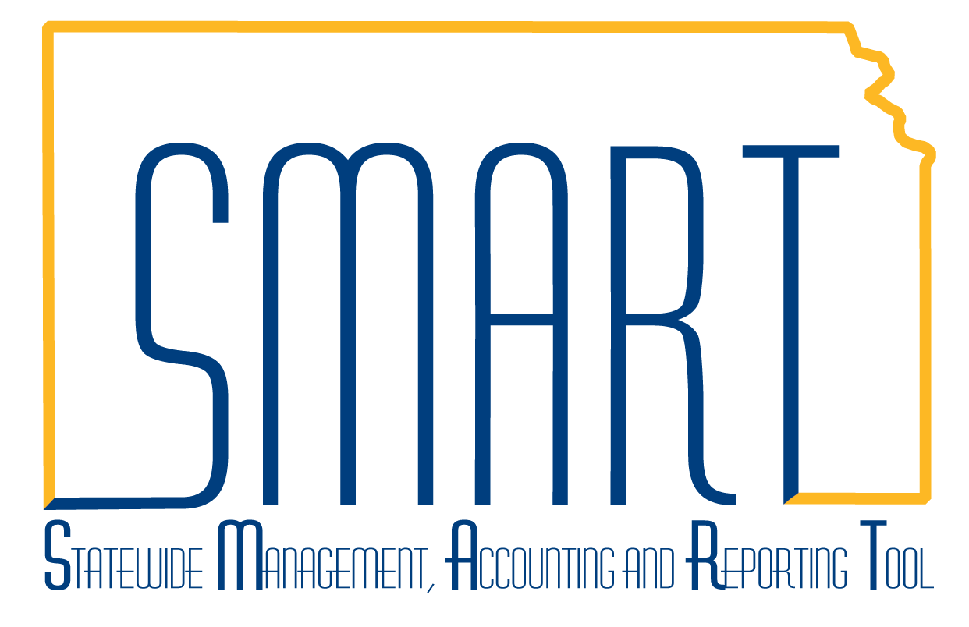
State of Kansas
Voucher Approval
Statewide Management, Accounting and Reporting Tool
Date Created |  | 11/16/2015
Version |  | 1.2
Last Update |  | 09/23/2019
Security |  | Role Security: Only users with the following roles will have access to approve a voucher:  - Agency - AP Approver Set A (KAP_AGY_AP_A_APPR)  - Agency – AP Approver Set B (KAP_AGY_AP_B_APPR)  - Agency Fiscal Office Approver (KAP_AGY_AP_FO_APPR)  We recommend users have the following role to view the voucher:  - Agency AP Processor (KAP_Agy_AP_Processor)  BU Security: Business Unit Security is applied. Agencies will only have access to the vouchers associated to their agency business unit.
Navigation |  | Any of the following paths will take the user to the Approval Page  - Accounts Payable Homepage > Approvals  - Accounts Payable Homepage > Vouchers > Approve > Approve Voucher  - Worklist  - NavBar: Navigator > Accounts Payable > Vouchers > Approve > Approval Framework – Vouchers
1. | Enter a voucher in SMART.  The voucher must have a ‘Valid’ Budget Status before it can be approved.  The preferred business practice is to allow the voucher to budget check during the AP hourly batch. | 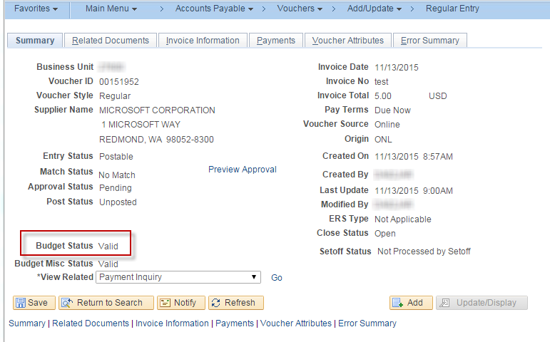

2. | Once the voucher has been budget checked, the Preview Approval link is displayed on the Summary Tab. | 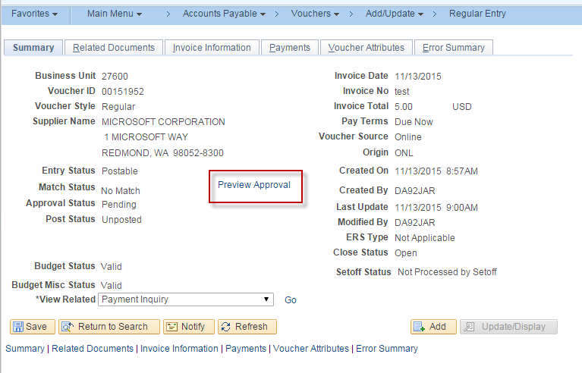
3. | Selecting the Preview Approval Link displays the expected approval path for the voucher. The voucher has not been submitted to workflow, and is not available for approval.  NOTE: A user cannot be the only approver on vouchers they have entered. SMART requires at least one additional user to approve the voucher. This is to ensure that the same user cannot both enter and approve a voucher. | 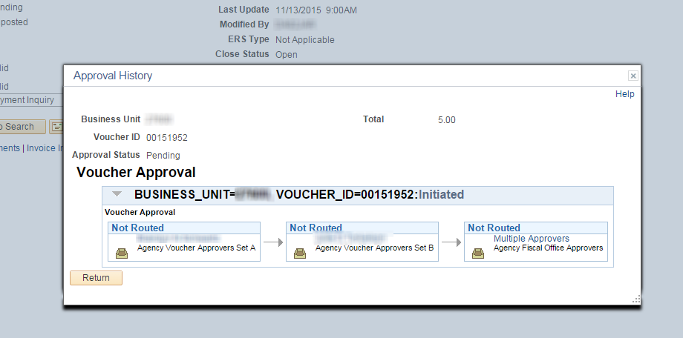
4. | Submit a Voucher into Approval Workflow  The preferred business practice is to allow the SMART batch processes to submit vouchers into AP workflow.  However, if a voucher must be approved prior to the next hourly batch, users can submit the voucher into workflow immediately by selecting the ‘Submit Approval’ Button on the Invoice Information Tab of the voucher. | 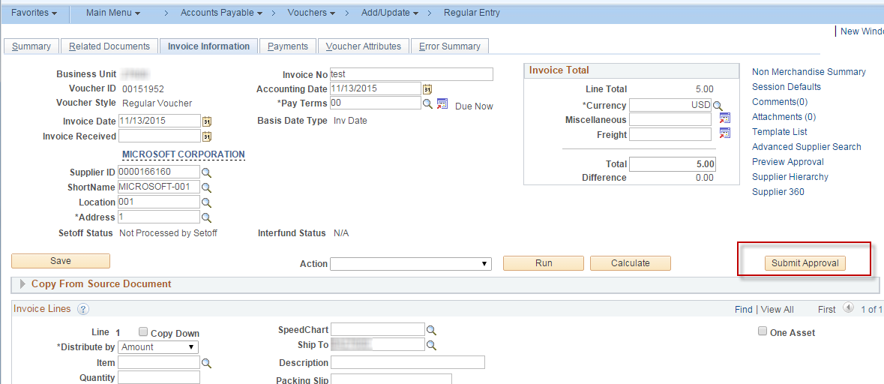

5. | A pop-up box is displayed where the user can add approval-related comments. This is optional. Select ‘OK’ to complete the workflow submission. | 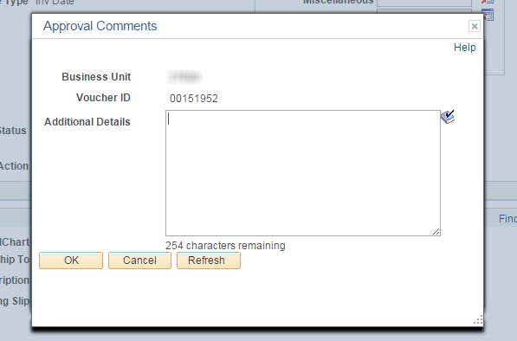
6. | Once a voucher has been submitted into approval workflow, the ‘Pending Approval’ link on the summary tab of the voucher will change to ‘Approval History’. | 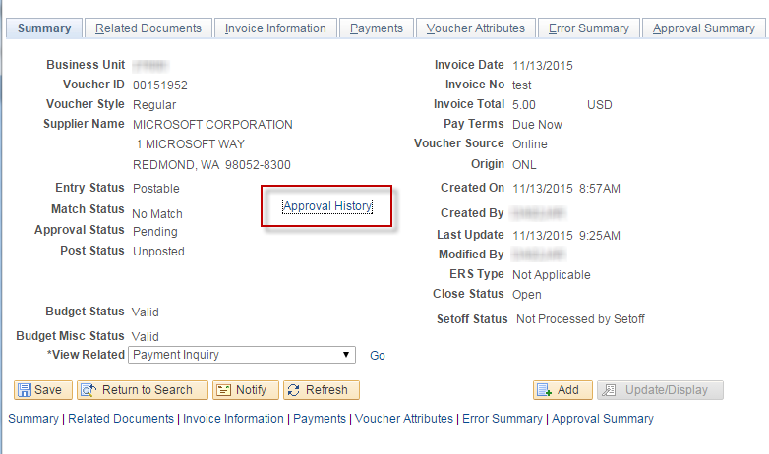

7. | Approve the Voucher Navigate to the Voucher Approval Page using one of the navigations listed in the ‘Navigation’ section above.  If, when you access the voucher, you are a user for which the voucher is in ‘Pending’ approval status, the appropriate action buttons will be available for your use.  This screenshot assumes that the user is a Set A approver. The ‘Approve’ Button is available, as is ‘Deny’. Select the ‘Add Comments’ button if you would like to record additional approval comments. | 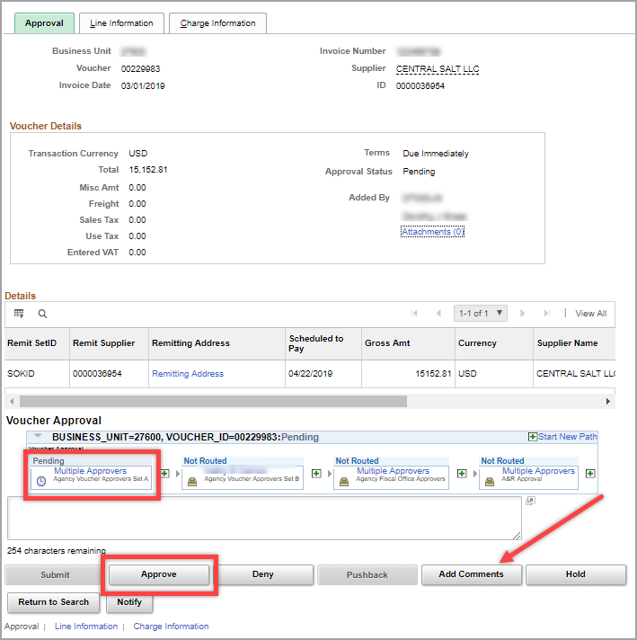
8. | When the Set A approver selects ‘Approve’, the ‘Pending’ status for the Set A approver changes to ‘Approved’ and the Set B approver box changes to ‘Pending’. | 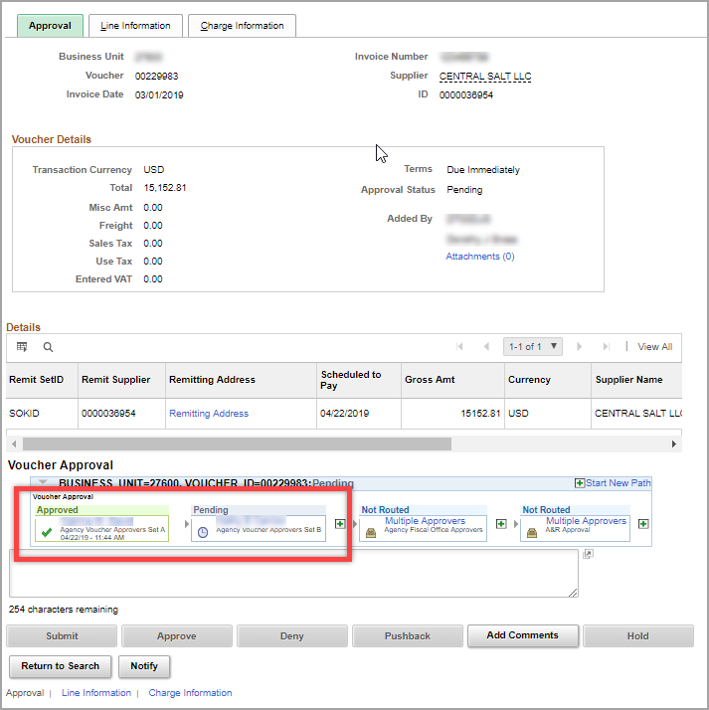
9. | When the Set B approver navigates to the voucher approval screen, this is how the voucher is displayed. The Set B approver can Approve, Deny, Pushback (send the voucher back one level to Set A), Add Comments, or put the approval on Hold.  This step is repeated by the Agency Fiscal Office Approver (for all vouchers), and by the A & R Approvers (for vouchers $5,000 and greater). | 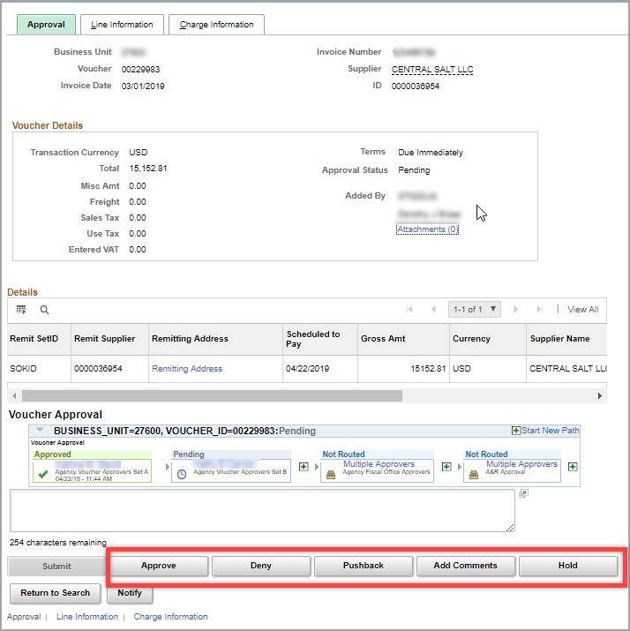
10. | Final Approval  When a voucher has gone through all stages of approval, the approval status on the Summary tab of the voucher will show as ‘Approved’. It is at this point that the voucher will continue through processing to be paid which may include going through the Setoff/Offset analysis process.  The ‘Approval History’ link can be clicked to view approval details for each step. | 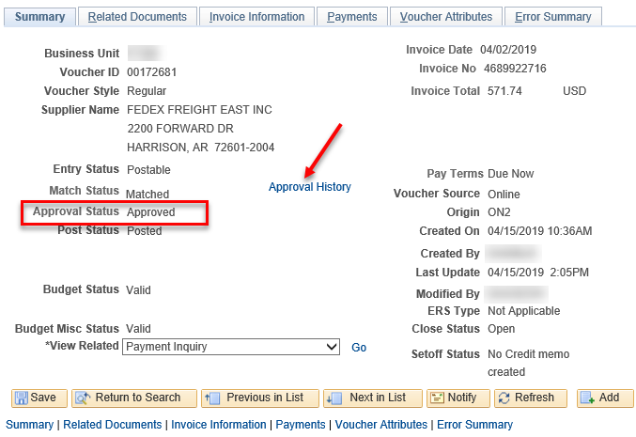

11. | Retrigger Workflow on a Voucher  If a voucher has not paid, and changes are made to the fields listed in this section, the voucher is returned to a pending approval status—unless it was preapproved—and workflow is retriggered which requires the voucher to be reapproved. This is also true if any new voucher lines or distribution lines are inserted.  If fields are changed related to the budgetary information, the voucher will also need to be budget checked again before it can be resubmitted to workflow. | Voucher Voucher line Distribution Line  Invoice ID PO Business Unit GL Business Unit  Invoice Date PO ID Statistics Code  Supplier ID PO Line Quantity  Total Amount PO Schedule Merchandise Amount  Currency Merchandise Amount Asset  Payment Terms Item ID Asset Management Business Unit  Quantity Asset ID  Scheduled Payments Unit of Measure Profile ID  Remit Supplier Unit Price all Chartfields  Remit Address Sequence Withholding Link  Receiver Business Unit  Receiver ID  Receiver Line  Receiver Schedule  Match Line Option  Distribution Method  Ship to ID  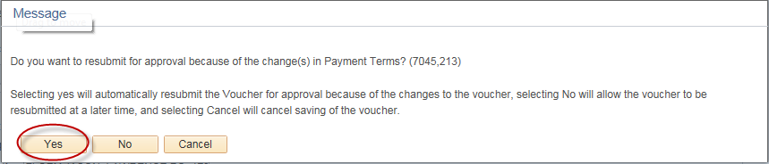  This pop up box will appear when the Save button is clicked after a change is made on the voucher. Click ‘Yes’ to retrigger workflow immediately.

