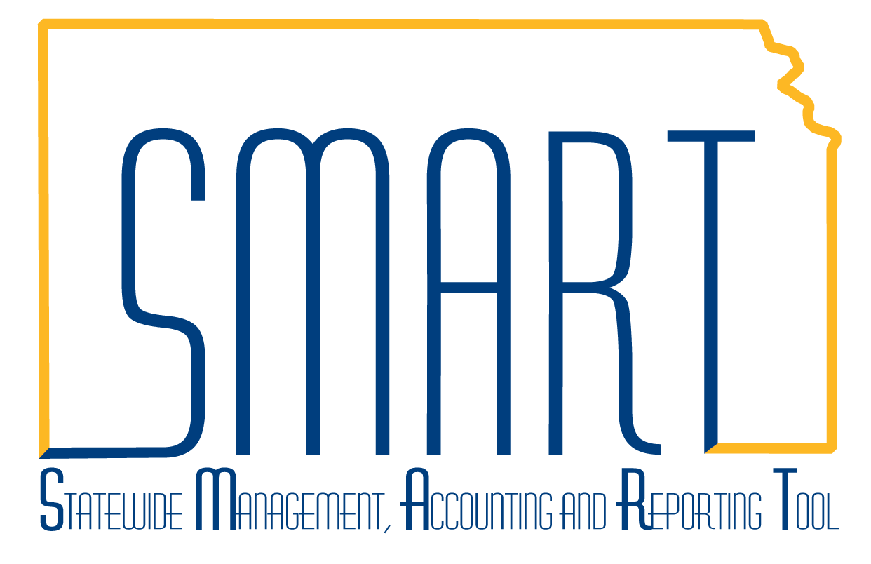
State of Kansas
Creating New SMART Supplier Record
Statewide Management, Accounting and Reporting Tool
Date Created: | July 18, 2014
Version: | V 2.0
Last Updated: | January 2021
General Information: | KAP_Agy_Vendor_Processor security role in SMART is necessary to perform this task.  Documents required (one of the following):  - W-9 (current dated and signed)  - IRS documents (SS-4)  - W-8BEN  - W-8BENE  Ensure all steps are complete prior to saving. The supplier record will be locked to agency changes once it is saved and you have exited the record.
Contents | 1. Check for Existing Supplier Record  2. Navigation  3. Add a New Value  4. Identifying Information tab  5. Address tab  - Supplier Address  - Details  - Payment/Withholding Alt Names  - Phone Information  6. Location tab  Direct Deposit (ACH)  - Location number  - Description line  - Effective Date  - Add 1099 Information  - Add Banking Information  System Check  - Add 1099 Information  7. Attaching documents  8. Review and Save  9. Duplicate TIN warning  10. Record status  11. Foreign Supplier documents  - Individual (W-8BEN)  - Entities (W-8BEN-E)  12. Adding Foreign or Federal supplier  Navigation  Add a New Value  Identifying Information tab  Address Tab  - Supplier Address  - Details  - Payment/Withholding Alt Names  - Phone Information  Location Tab  - Location  - Add 1099 Information  - Attach documents  13. Review and Save  14. Warning Message  15. Record Status
1. Check for Existing Supplier Record | Before entering a new supplier in SMART, verify that the supplier has not been entered previously.  Use the Check for Existing Supplier Record job aid for further instructions.  By ensuring the supplier does not already exist in SMART, you prevent duplicate records from inadvertently being entered. Duplicate records may delay payment processing.
2. Navigation | Log in to SMART. From SMART Homepage, navigate to Accounts Payable homepage>Suppliers tile  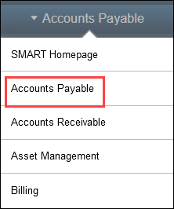  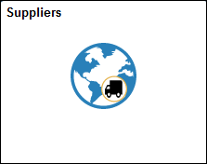
3. Add a New Value | In Add/Update Supplier>Supplier Information, click on Add a New Value.  If this is a foreign or federal supplier, skip to step 12.  Do not change any of the information on this page.  Click ADD.  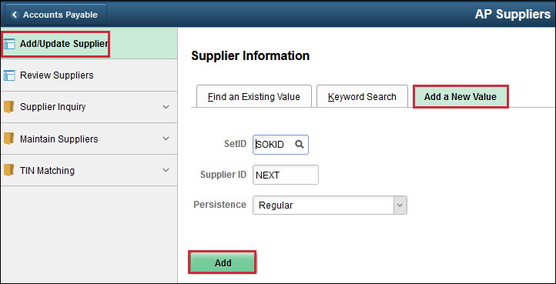
4. Identifying Information tab | Supplier must provide a current dated and signed W-9. Use the W-9 to enter the following information:  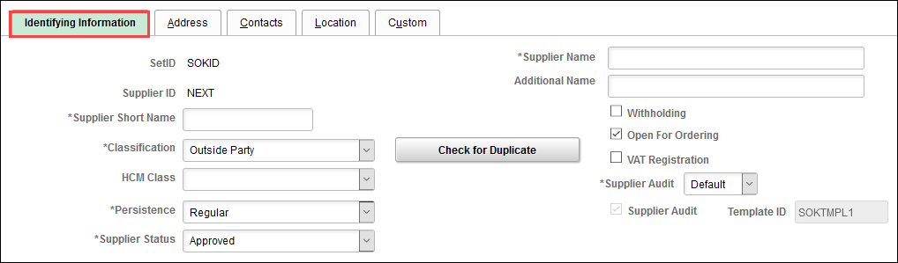  Supplier Name **REQUIRED**  - Enter name exactly as shown on the W-9  - Individuals: Format FIRSTNAME MIDDLENAME/INITIAL LAST NAME (i.e., spaces are highlighted below)  - Business: Format the company name as shown on the W-9  - No punctuation  Additional Name  - If there is a name on Line 2 of the W-9, enter exactly as shown  - No punctuation  - Do not enter the initials DBA on Line 2 unless the supplier has entered on the W-9  Supplier Short Name **REQUIRED**  - Maximum of 10 characters only. This includes spaces.  - Individual: Format LASTNAME,FIRST Use a comma to separate. No spaces.  (Example: Susan Smith will be entered as SMITH,SUSA)  - Individual with suffix: Format LASTNAME,FIRST Use a comma to separate. No spaces. (Example: John Smith Jr will be entered as SMITH,JOHN)  - Business: If the supplier’s W-9 lists a name on Line 1 only, enter as shown on W-9 (Example: Murphys Steakhouse will be entered as MURPHYS ST)  (Example: John Smith DDS would be entered as JOHN SMITH)  - Business with DBA: If supplier lists name on Line 2 of W-9  (Example: Smith & Sons will be entered as SMITH & SO)  Withholding checkbox  - Check Withholding box unless the W-9 indicates the business is:  - INC, Incorporated  - LLC-C  - LLC-S  - Church, University, Non-Profit (501(c)(3))  - Government related (i.e., city, county, etc.)  - Association  To assist in determining if a supplier is reportable for withholding, refer to the 1099 and Withholding Information Training Guide link below:  https://smartweb.ks.gov/training/accounts-payable  If you are unsure if the supplier is subject to withholding, check the withholding box.  Classification **REQUIRED**  - Defaults as Outside Party  - Classification must remain as Outside Party unless supplier is used by Payroll (HCM)  Supplier Status **REQUIRED**  - Status defaults to APPROVED status.  - Status will change to UNAPPROVED when the supplier record is saved.
Additional ID Numbers

This section is for Office of Procurement and Contracts use only.
- Do not enter any information into the ID Numbers area at the bottom of the Identifying Information tab. Any information entered into this section that is not for Office of Procurement and Contracts use will be deleted.
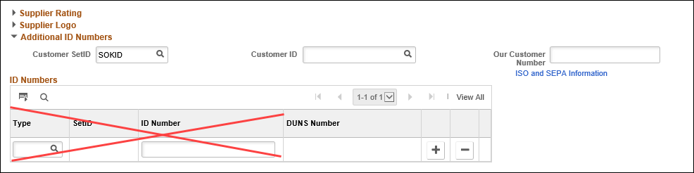
5. Address tab.  Supplier  Address  Details  Payment/  Withholding Alt  Name  Phone Information | Use the instructions in each subsection to enter address information.  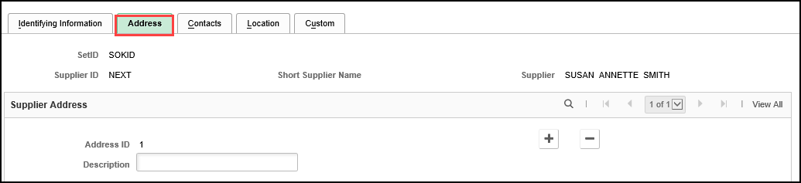  Description  - Address ID 1 Description will always be MAIN.  Anything other than MAIN will be corrected by the Supplier Maintenance Team.  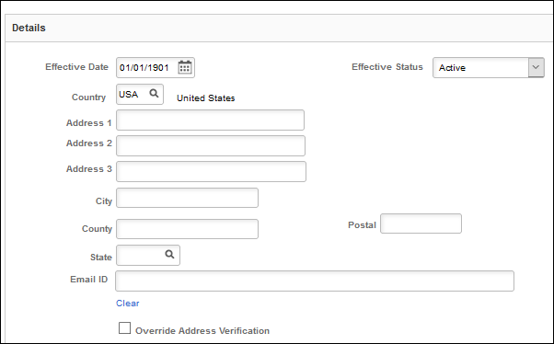  - If supplier is a business, enter the corporate address in Address ID 1  - This Address ID must remain as ACTIVE at all times.  If supplier provides both street address and PO Box (which is usually a Remit To address), the street address is entered as Address ID 1, and the PO Box is entered as Address ID 2.  Effective Date  - Date defaults to 01/01/1901. Do not change.  Effective Status  - Address ID 1 must always be in ACTIVE status.  Country  - Defaults to USA (United States)  - If adding a foreign address, go to Step 10 – Adding Foreign or Federal Supplier for further instructions.  Address 1  - Street address or PO Box  - No punctuation  Address 2  - Street address or PO Box  - No punctuation  Address 3  - To be used for Medicaid Provider ID only  Postal (or ZIP)  - Enter the ZIP code.  - Clean Address verifies addresses listed with the United States Postal Service. This process runs in the background.  - Clean Address will populate the +4.  City/County/State  - When the ZIP code is entered, Clean Address will automatically populate the City, County, and State.  Override Address Verification  - If Clean Address cannot verify the address entered, the message below will display and list suggestions:  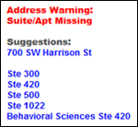  - If you know the address entered is correct, check the Override Address Verification box.  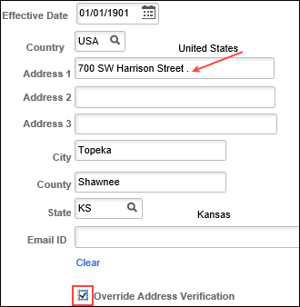  - At the end of Address 1, you will now see a period. This indicates the address has been overridden.  Email ID  - If supplier provides their email (whether it is personal or business/company), enter the information here.  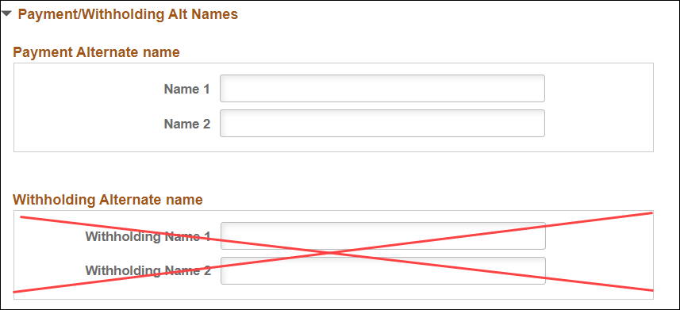  Payment Alternate name  - Leave this section blank. Checks will be issued to the Supplier Name and Additional Name (if entered) on the Identifying Information tab  Withholding Alternate name  - Do not enter any information into this section  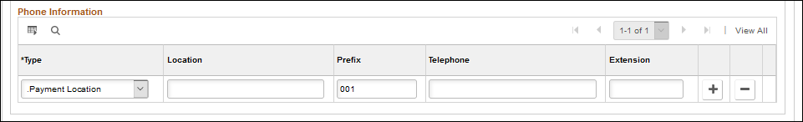  Type  - This will default as Payment Location. Do not change this information.  Prefix  - This will default as 001. Do not change this information.  Telephone and Extension  - This is at agency discretion
6. Location tab | There are two methods for remitting payments to suppliers:  - Automated Clearing House (ACH)  - System Check  The Department of Administration highly encourages agencies to use direct deposit for remitting payments to suppliers. Direct deposit allows suppliers to receive their payment(s) in a more timely and secure method.  **NOTE: Foreign banks cannot be paid by ACH. If supplier has a foreign bank and wants electronic payment, they must provide wiring instructions to agency. Wiring instructions are to be sent from the agency to the State Treasurer’s Office. Do not enter wiring information in SMART.**  If the supplier has provided ACH payment information, do not enter a SYSTEM CHECK location. The Supplier Maintenance Team will be responsible for adding the SYSTEM CHECK location later, if needed.  The DA-130 is not listed on the Department of Administration’s website nor should it be saved to any public website. Request the current DA-130 form via a ManageEngine Service Desk ticket. The DA-130 can be saved to a user’s desktop or to an agency’s shared folder.
Direct Deposit (ACH)  Location number  Description line  Effective Date  Add 1099  information  Add Banking  Information | Agency is responsible for providing the DA-130 form to supplier upon request. Supplier will then provide the following to agency:  - A completed DA-130 form (Rev. 11-2019) Part I, Part II and Part IV.  - A voided check or bank letter as supporting documentation (as instructed in Part II of the DA-130). Deposit slips are not accepted.  When the DA-130 is received, agency is responsible to ensure the DA-130 and supporting documentation are valid and complete before entering in SMART.  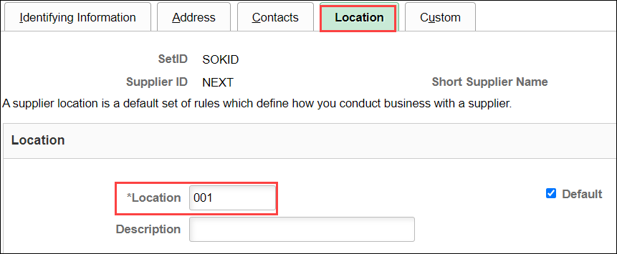  Payment location numbers are three (3) digits and listed sequentially:  - 001  - 002  Location numbers that do not follow this rule will be corrected by the Supplier Maintenance Team.  Agencies must wait until the newly entered supplier has been approved by the Supplier Maintenance Team before creating an accounts payable voucher.  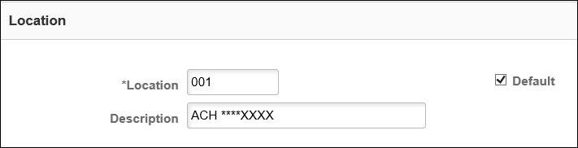  - Enter ACH ****XXXX (enter last four digits of supplier’s bank account number)  - ACH locations should be checked as Default payment method.  Effective Date defaults to 01/01/1901. Do not alter this date.  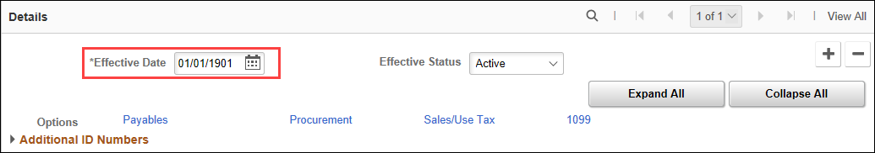  Click on 1099 link.  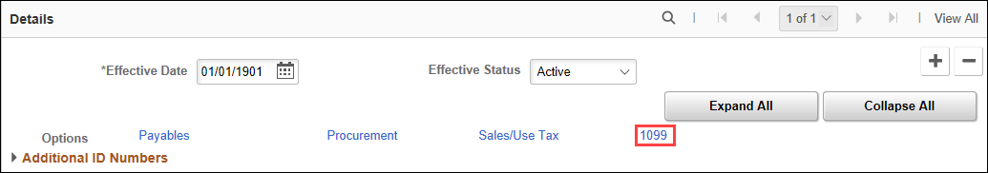  Complete both 1099 Information line and 1099 Reporting Information line when supplier is 1099 reportable. (For this example, supplier is an individual and is considered 1099 reportable)  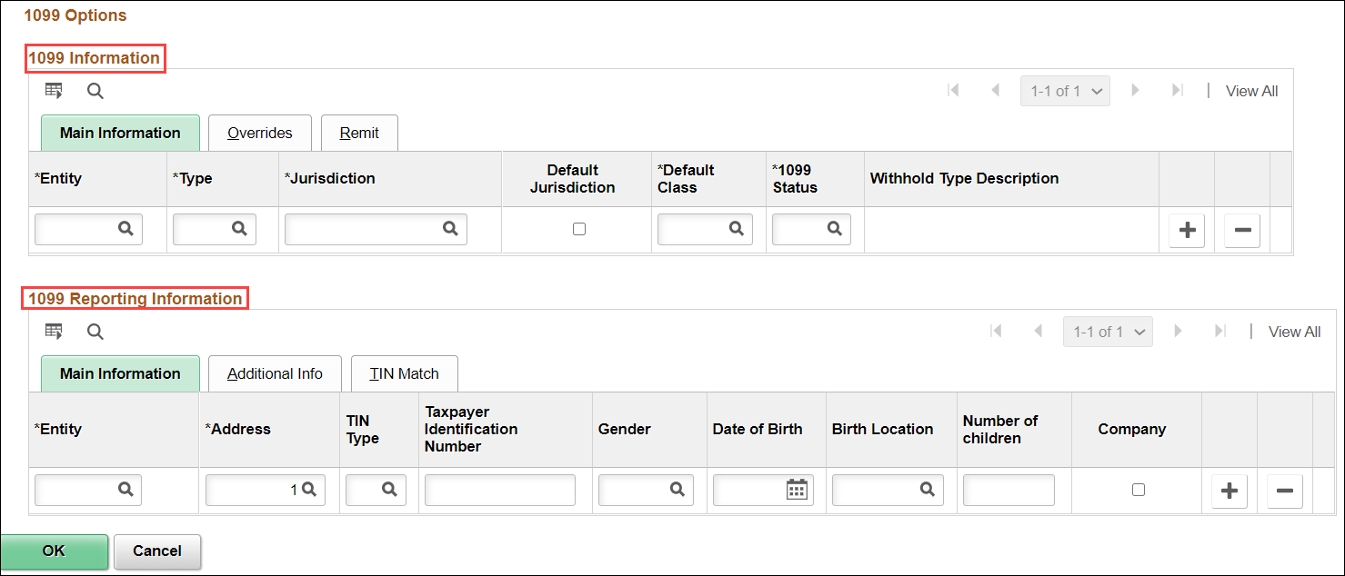  1099 Information:  If unsure, click the magnifying glass  - Entity: IRS (Only one choice)  - Type: 1099N  - Jurisdiction: FED (Only one choice)  - Default Jurisdiction: Check the box  - Default Class: 01  - 1099 Status: RPT. This will deafult after previous boxes are completed. Do not alter this information.  1099 Reporting Information  If unsure, click the magnifying glass  - Entity: IRS (Only one choice)  When you key in IRS, your 1099 Reporting Information line will now look like this: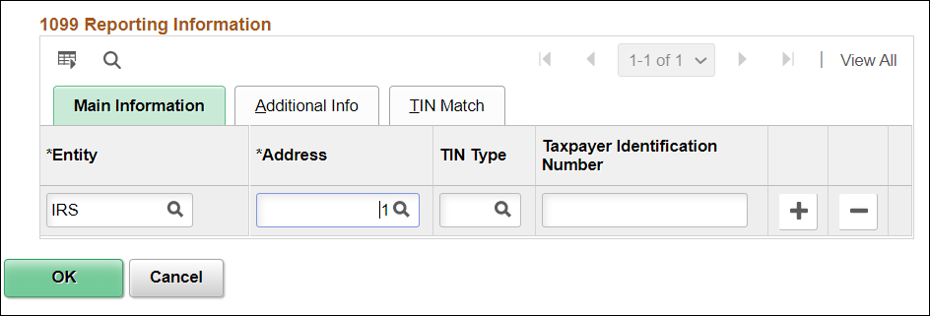  - Address: This defaults to 1. Do not alter this box.  - TIN Type: “S” – Social Security number (Individual)  “F” – FEIN (Federal Employer Identification Number) or EIN (Employer Identification Number)  - Taxpayer Identification Number: This will be 9 digits. (No dashes/punctuation)  Click OK when finished.  Click on Payables link  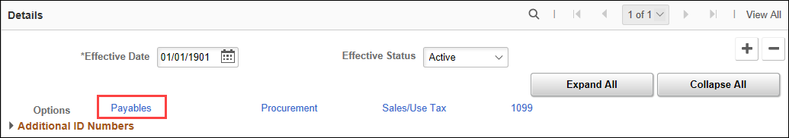  Open Additional Payables Option  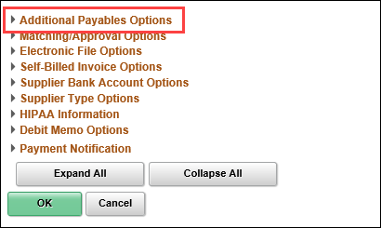  Additional Payment Information  This section must be completed to make an ACH. If this area is not completed exactly as shown below, the payment will process as a SYSTEM CHECK regardless of whether or not banking information has been entered.  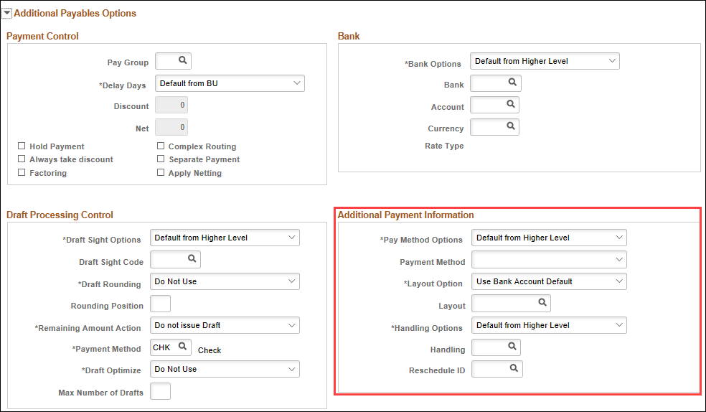  - In Pay Method Options, click on SPECIFY in the drop-down list.  - In Payment Method, click on AUTOMATED CLEARING HOUSE in the drop-down list.  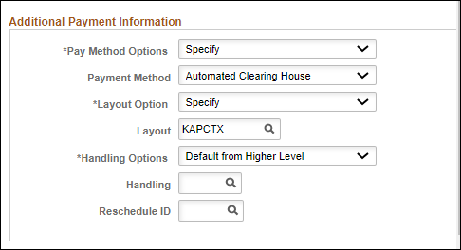  Open Supplier Bank Account Options  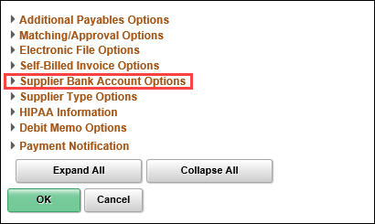  Enter information directly from the supporting documentation (voided check or bank letter). Do not key from the DA-130.  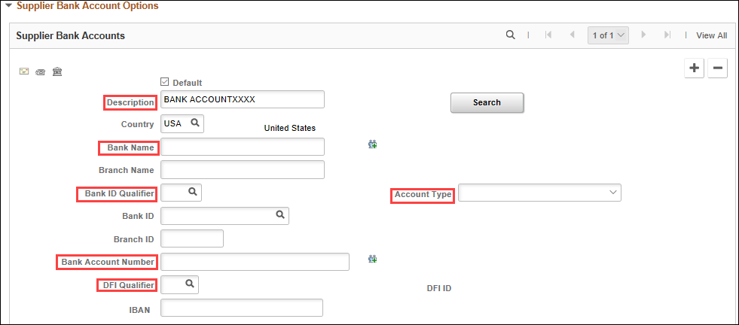  - Description: BANK ACCOUNT (enter last 4 digits of bank account number)  - Bank Name: As presented on bank letter or voided check  - Bank ID Qualifier: 001 (mandatory – will reflect United States Bank)  - Account Type: Check Acct (Checking account)  Time Dep (aka Savings)  - Bank Account Number: Enter as presented on supporting documentation. Include leading zeroes – these are considered place holders for receiving bank.  - DFI Qualifier: 01 (mandatory – will reflect as Transit Number)  When you are satisified everything has been entered correctly, click OK.  You will receive this message. Click Yes.  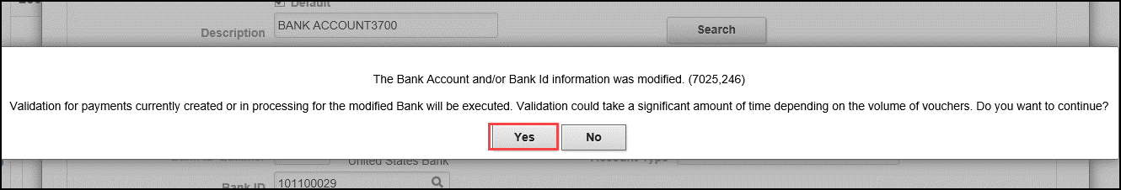  You will be directed back to the Location tab.
System Check  Location number and  description  Add 1099  Information | If supplier opts to receive payments by paper check instead of by direct deposit, agency will need to add the SYSTEM CHECK location.  The process for adding a SYSTEM CHECK location is the same as adding an ACH location. The differences between the two locations are SYSTEM CHECK is entered in the desciption line and no banking information is entered.  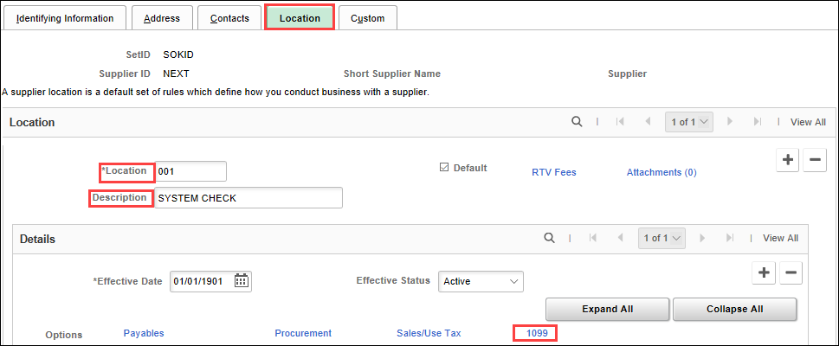  - Location: 001  - Description: SYSTEM CHECK  Entering anything different for a location number will be corrected by the Supplier Maintenance Team.  Agencies must wait until the newly entered supplier has been approved by the Supplier Maintenance Team before entering an accounts payable voucher.  Click on 1099.  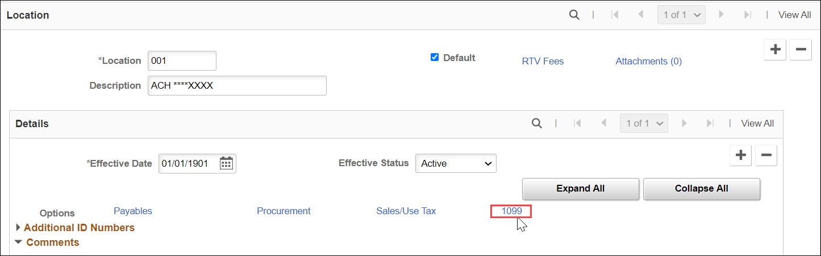  Complete both 1099 Information line and 1099 Reporting Information line when supplier is 1099 reportable. (For this example, supplier is an individual and is considered 1099 reportable)  1099 Information:  If unsure, click on the magnifying glass  - Entity: IRS (Only one choice)  - Type: 1099N  - Jurisdiction: FED (Only one choice)  - Default Jurisdiction: Check the box  - Default Class: 01  - 1099 Status: RPT. This defaults in when the previous boxes are completed. Do not alter this information.  1099 Reporting Information  If unsure, click on the magnifying glass  - Entity: IRS (Only one choice)  When you key in IRS, your 1099 Reporting Information line will now look like this:  - Address: This defaults to 1. Do not alter this box.  - TIN Type: “S” – Social Security number (Individual)  “F” – FEIN (Federal Employer Identification Number) or EIN (Employer Identification Number)  - Taxpayer Identification Number: This will be 9 digits. (No dashes/punctuation)  Click when finished.  You will be directed back to the Location tab.
7. Attaching  Documents | Agencies should not rely on SMART as the method for meeting record retention policies.  Informational Circular 16-A-007 covers attachments to SMART.  Supplier documents must be attached before exiting the supplier record. These documents are:  - W-9. Signed and current dated (within previous 12 months)  - W-8BEN (if foreign entity)  - DA-130. Completed by supplier and confirmed by agency.  - Bank account supporting documentation - copy of voided check or bank letter.  Documents can be attached on either:  - Location tab (preferable)  - Identifying Information tab  Attachment requirements:  - Documents 1MB or greater cannot be uploaded to SMART supplier record. Rescan/resize document to be under this limit.  - EXCEL, WORD, PDF, or similar files, are appropriate.  - Agencies should not attach CAD (Computer Aided Design) files or picture files (examples- .jpg, .tif, .png, or .gif).  - Multiple attachments are allowed. Be sure each is under the 1MB limit.  - Avoid attaching documents that do not add value to the transaction.  - System retention for attachment files is expected to be 3 years. This period may be reduced if storage space becomes an issue.  Save document in a folder on desktop or shared agency folder for retrieval when attaching document(s) to supplier record. The specific location is determined by the agency. Follow your agency’s document naming protocol.  Click on Attachments link.  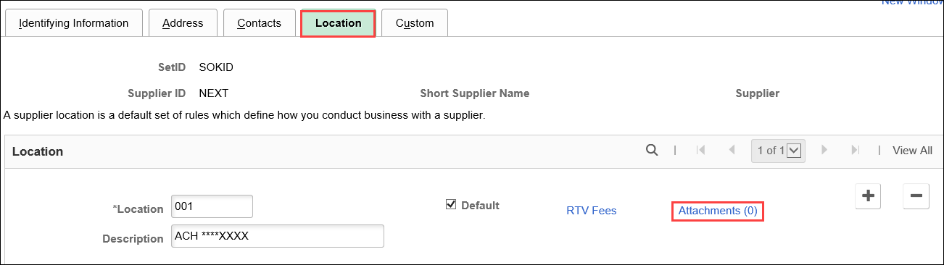  Click on Add Atttachment.  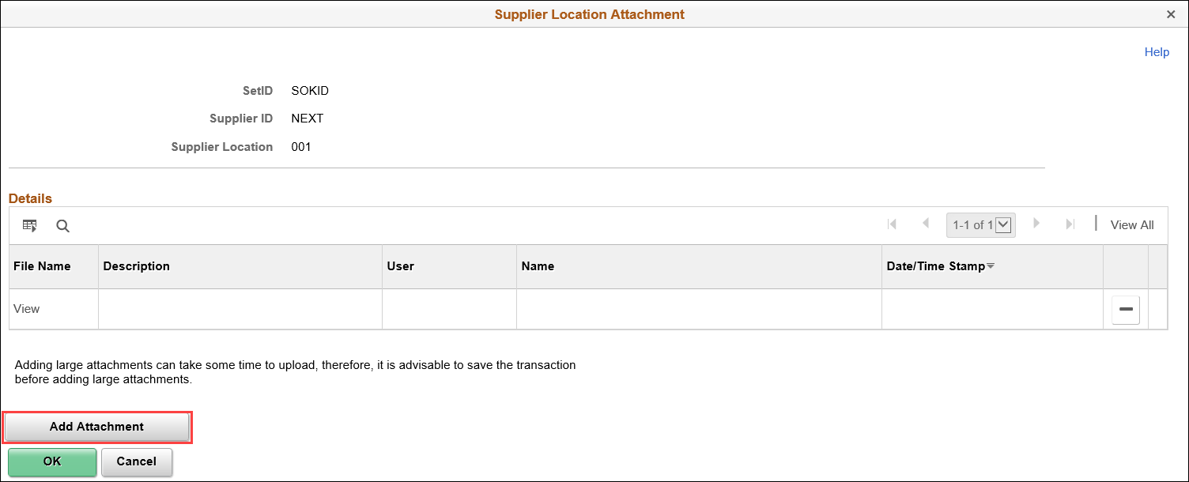  Click on Browse to locate attachment.  When document has been located, click on it so it shows in File Name box. Click Open  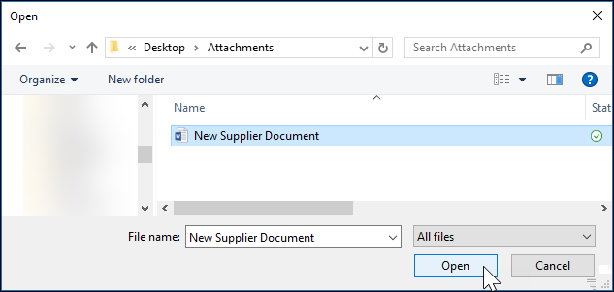  Review to make sure the correct attachment will be uploaded. Click Upload.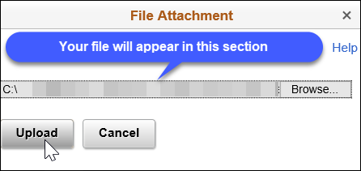  Attachment will upload. When you are sure you have attached the correct document, click OK.  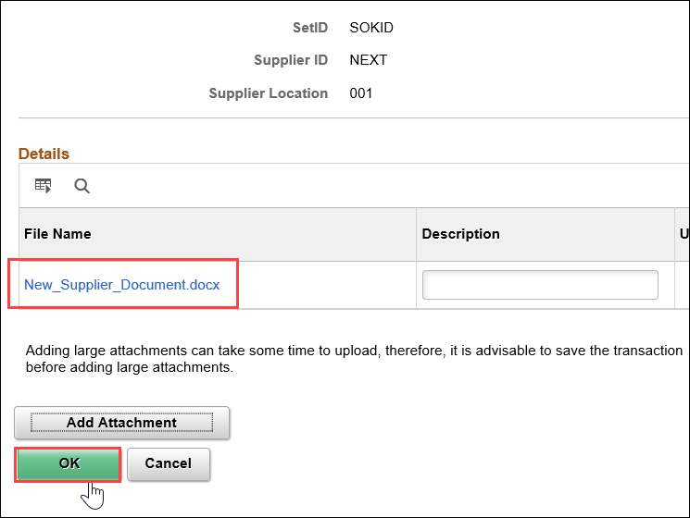  You will be directed back to the Location tab. Review to make sure your attachment is there.  After exiting saved record, agencies will only see the number of documents attached. Agencies do not have the access to view any of the attachments.  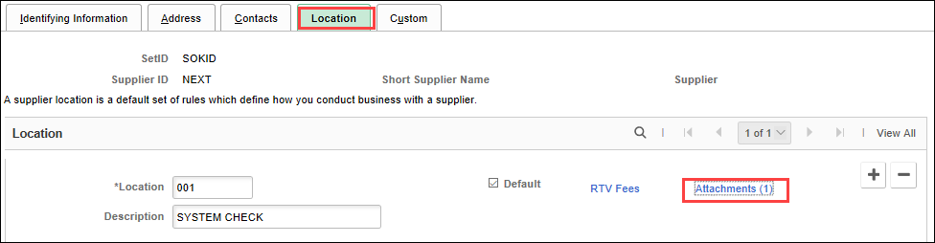
8. Review and Save | Carefully review the supplier record before saving to confirm information has been entered accurately.  Once user has SAVED and EXITS (or Returns to Search), user is locked out and will not be able to edit the supplier record.  If you do not need to make any changes to record (no typos, documents are attached, etc.), click SAVE at the bottom of the Location tab.  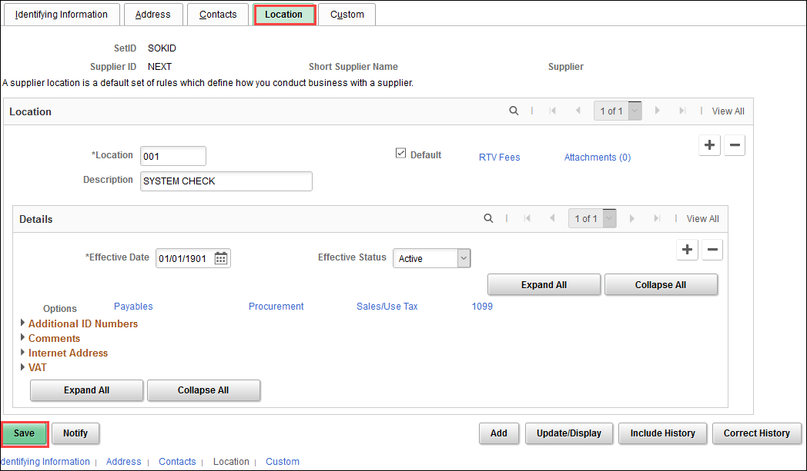  SMART automatically assigns the record its own Supplier ID. All supplier IDs are sequential.
9. Duplicate TIN warning | In the event a duplicate TIN has been detected in SMART, you will receive this warning message when saving the new record:  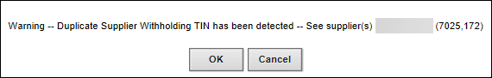  The message will provide the supplier ID(s). Click on Cancel to prevent adding a duplicate supplier record.  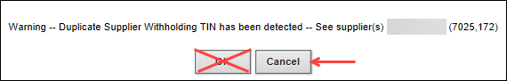  (Clicking on OK will add a duplicate supplier record which will be shut down and directed to the original supplier record).
10. Record status | SMART supplier record is now set to UNAPPROVED status.  The Supplier Maintenance Team will approve all newly entered suppliers the following day.
11. Foreign supplier  documents | There are two types of forms foreign suppliers are to download and provide to the agency:  - W-8BEN. https://www.irs.gov/pub/irs-pdf/fw8ben.pdf This is used by foreign individuals who receive non-business income in the United States.  - W-8BEN-E. https://www.irs.gov/pub/irs-pdf/fw8bene.pdf This is used by foreign entities/businesses who receive money from US employers.  Supplier is to download the appropriate form from the IRS website and provide the signed and current dated form (within previous 12 months) to agency.  Foreign suppliers will not utilize a regular United States tax identification number issued by the IRS
Individual  W-8BEN  Lines 1-4  Lines 5-10  Certification | This form can only be used by individuals. This is a 1-page document.  This is general information to assist supplier with determining which form they are to provide to agency. If they are in doubt as to which form they are to provide, they will need to contact their accountant or tax attorney.  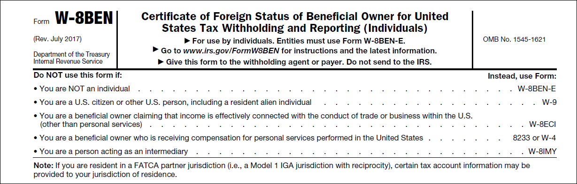  Supplier will complete the form to the best of their ability.  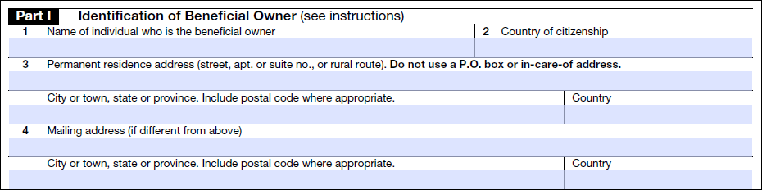  Supplier may or may not complete these areas:  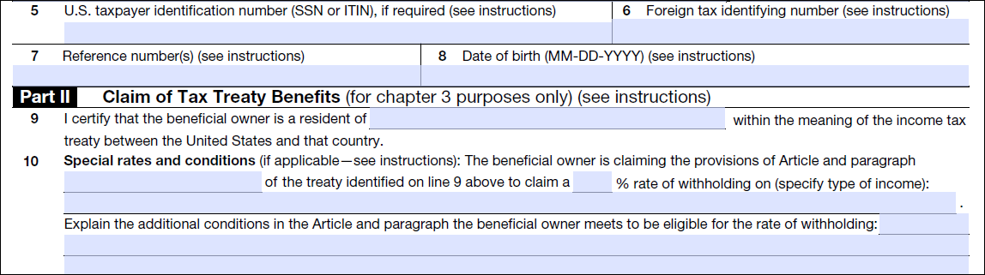  Supplier must sign and date Certification section.  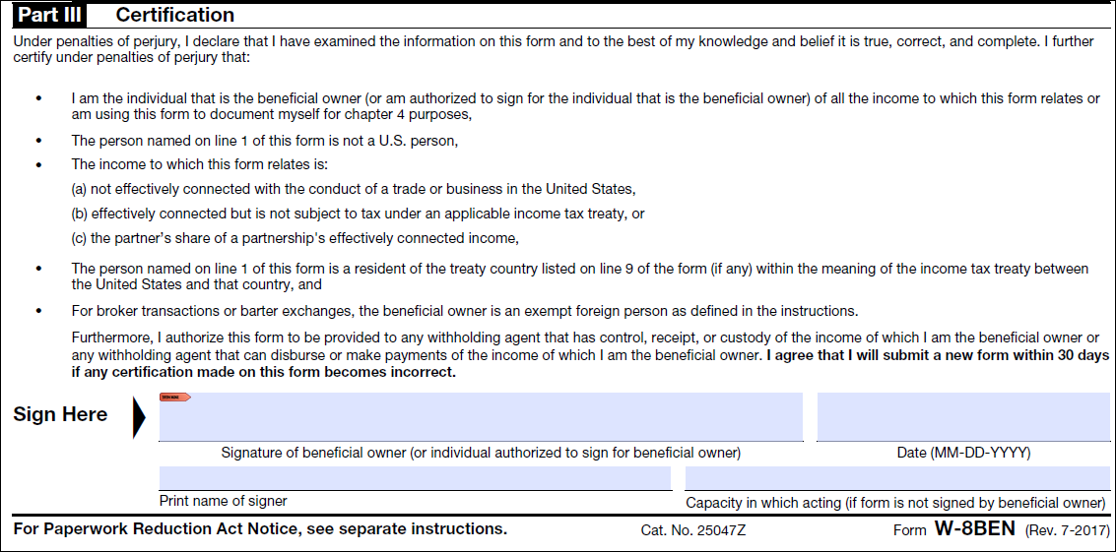
Entities  W-8BEN-E  Part I Lines 1-7  Part I Lines 8-10  Parts II – XXIX  Part XXX  Certification | This form is to be used by businesses only. This is an 8-page document.  This is general information to assist supplier with determining which form they are to provide to agency. If they are in doubt as to which form they are to provide, they will need to contact their accountant or tax attorney.  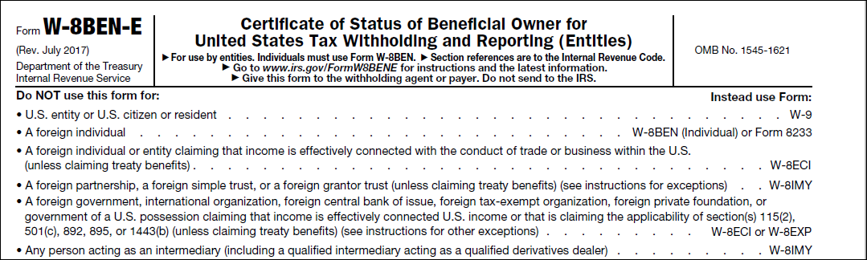  Supplier will complete the form to the best of their ability.  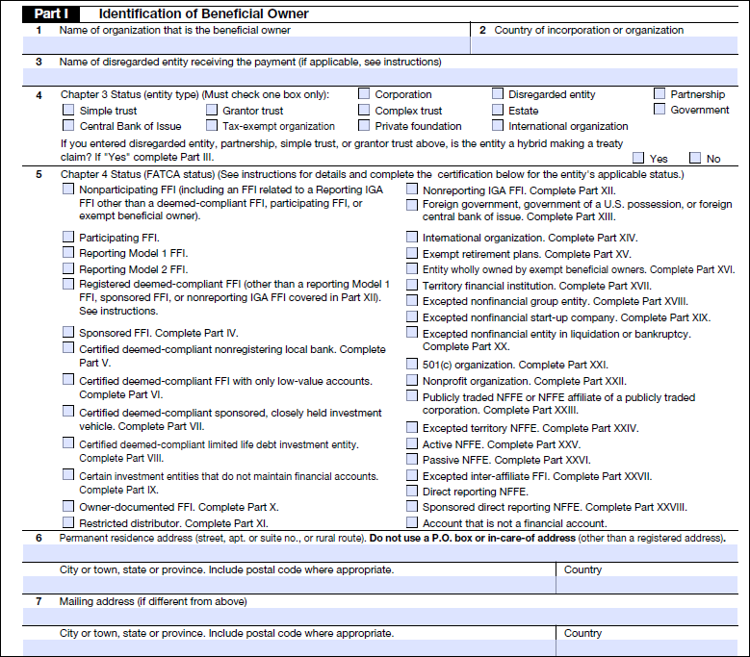  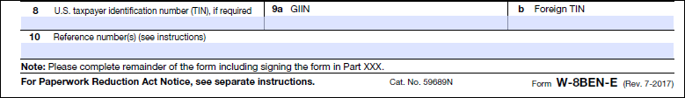  Line 8. If supplier entered a number in this box, enter into SMART. It may or may not match IRS records.  Line 9a. Does not pertain to SMART.  Line 9b. If supplier enters a number in this box, do not enter this number into SMART. This is foreign country tax identification number. It does not relate to the United States.  Line 10. Does not pertain to SMART.  Lines 11-43 and Part XXIX  Supplier may or may not complete these sections.  Supplier must sign and date Certification section.  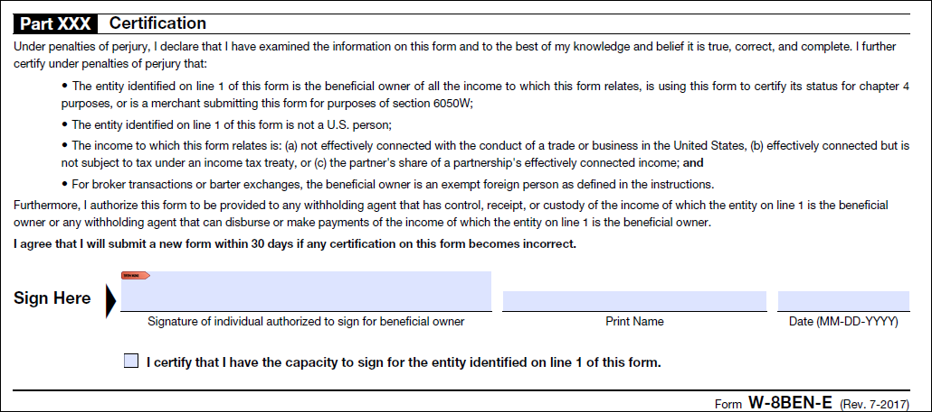
12. Adding Foreign or Federal supplier  Navigation | Foreign or federal suppliers do not utilize a 9-digit number. The word FOREIGN will be used instead.  It is rare to have a federal government agency request to be a supplier. They may provide a W-9 to agency without a tax identification number listed. If a request is received, direct to the Department of Administration for further review.  Log in to SMART. From SMART Homepage, navigate to Accounts Payable homepage>Suppliers tile
Add a New Value | In Add/Update Supplier>Supplier Information, click on Add a New Value.  Do not change any of the information on this page.  Click on ADD.
Identifying  Information tab | Supplier Name **REQUIRED**  - Enter name exactly as presented on W-8BEN or W-8BEN-E.  - Individuals: Format FIRSTNAME MIDDLENAME/INITIAL LAST NAME (i.e., spaces are highlighted below)  - Business: Format as shown on the W-8BEN or W-8BEN-E.  - No punctuation  Additional Name  - Enter exactly as presented.  - No punctuation  Supplier Short Name **REQUIRED**  - Maximum of 10 characters only. This includes spaces.  - Individual: Format LASTNAME,FIRST Use comma to separate. No spaces.  (Example: Susan Smith will be entered as SMITH,SUSA)  - Individual with suffix: Format LASTNAME,FIRST Use comma to separate. No spaces  (Example: John Smith Jr will be entered as SMITH,JOHN)  - Business: If supplier only lists a name on Line 1 of W9, enter as presented on W9  (Example: Murphys Steakhouse will be entered as MURPHYS ST)  (Example: John Smith DDS would be entered as JOHN SMITH)  - Business with DBA: If supplier lists name on Line 2 of W9  (Example: Smith & Sons will be entered as SMITH & SO)  - Withholding checkbox  Withholding box remains unchecked as foreign and federal government suppliers are not 1099 reportable.  Classification **REQUIRED**  - Defaults as Outside Party  - Classification must remain as Outside Party unless supplier is used by Payroll (HCM)  Supplier Status **REQUIRED**  - Status defaults to APPROVED status.  - Status will change to UNAPPROVED when supplier is saved.  Additional ID Numbers  This section is for Office of Procurement and Contracts use only.  - Do not enter any information into the ID Numbers area at the bottom of the Identifying Information tab. Any information entered into this section that is not for Office of Procurement and Contracts use will be deleted.
Address tab | Use the instructions in each subsection to enter the address information.  Clean Address verifies foreign addresses to the best of its ability. There is no right or wrong way to enter a foreign address.
Supplier  Address | Description  - Address ID 1 Description will always be as MAIN.  Anything other than MAIN will be corrected by the Supplier Maintenance Team.
Details  Payment/  Withholding Alt Names  Phone Information | 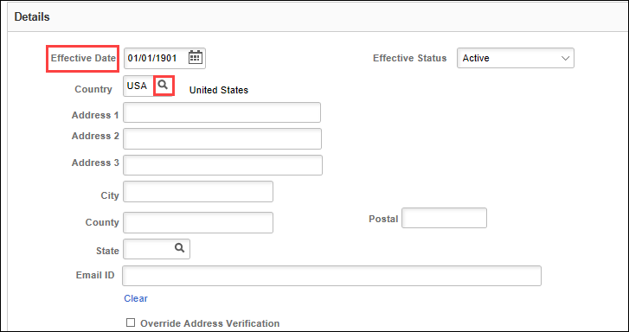  Effective Date  - Date defaults to 01/01/1901. Do not change.  Effective Status  - Address ID 1 must always be in ACTIVE status.  Country  - Defaults to USA (United States)  - To change country, click on the magnifying glass. This will populate a Look Up Country box.  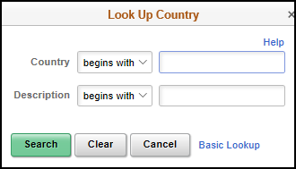  - If you do not know the 3-letter abbreviation (box labeled Country), enter the country’s name in the Description line  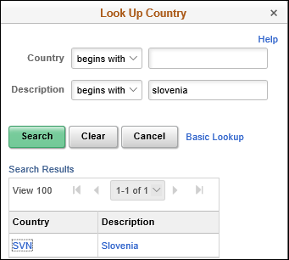  - When the country populates, click on either the Country 3-letter abbreviation or the Description. SMART will pull in that country’s address template.  - The template will be different for each country.  - Enter the foreign address as best you can.  - Do not be surprised to receive error message regarding the validity of the address. If the error message populates, click the Override Address Verification box and move forward with entering the rest of supplier information.  Payment Alternate name  - Leave this section blank. Checks will be issued to the Supplier Name and Additional Name (if entered) on the Identifying Information tab  Withholding Alternate name  - Do not enter any information into this section  Type  - .Payment Location defaults in. Do not change this information.  Prefix  - 001 defaults in. Do not change this information.  Telephone and Extension  - This is at agency discretion
Location Tab  Location  Add 1099 Information | SYSTEM CHECK location will be the payment method for Foreign suppliers.  - Location: 001  - Description: SYSTEM CHECK  Location numbers that do not follow this rule will be corrected by the Supplier Maintenance Team.  Agencies must wait until the newly entered supplier has been approved by the Supplier Maintenance Team before creating an accounts payable voucher.  Click on 1099 link.  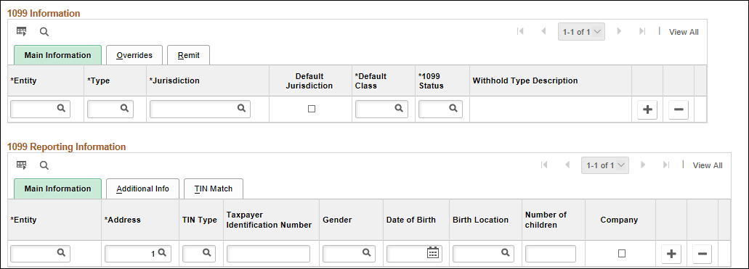  1099 Information line  - Leave this line blank.  1099 Reporting Information  If unsure of choice/information, click on the magnifying glass  - Entity: IRS (Only one choice)  When you key in IRS, your 1099 Reporting Information line will now look like this:  - Address: This defaults to 1. Do not alter this box.  - TIN Type: “S” – Social Security number (Individual)  “F” – FEIN (Federal Employer Identification Number) or EIN (Employer Identification Number)  - Taxpayer Identification Number: FOREIGN  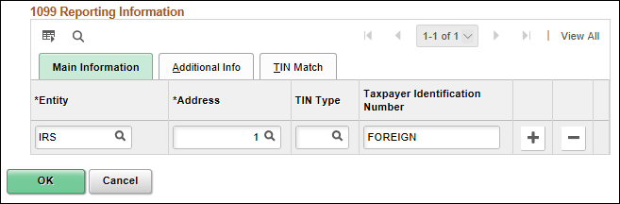  Click OK.  You will be directed back to the Location tab.
Attach documents | Attach all documents to supplier record. Refer to Section 7 for further instructions.
13. Review  and Save | At this point, review supplier record before saving to confirm information has been entered as correctly as possible.  Once user has SAVED and EXITS (or Returns to Search), user is locked out of making any edits to supplier record.  If you do not need to make any changes to record (no typos, attach documents, etc.), click on SAVE at the bottom of the Location tab.
14. Warning  Message | When saving a foreign supplier record, two warning messages will pop-up. The first one will advise of “Duplicate Supplier Withholding TIN has been detected” and a list of suppliers will be evident:  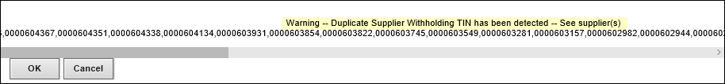  This is an expected message as there will be numerous FOREIGN TINs in SMART.  Click OK.  The second warning message pop-up advise of “Duplicate Supplier Withholding TIN is detected against inactive suppliers”:  This is an expected message as there will be numerous FOREIGN supplier records which have been shut down (inactive) in SMART.  Click OK.  SMART automatically assigns the record its own Supplier ID. All supplier IDs are sequential.
15. Record  Status | SMART supplier record is now set to UNAPPROVED status.  The Supplier Maintenance Team will approve all newly entered suppliers the following day.

