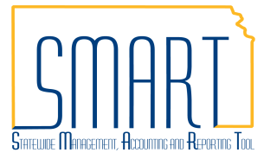
State of Kansas
Accounts Payable Month End Checklist
Statewide Management, Accounting and Reporting Tool

Date Created |  | 11/09/2012
Version |  | 2.3
Last Update |  | 05/10/2019
Security |  | - Role Security: Only those individuals with the following role will have access to work through the month end processing steps below:  - Agency AP Processor (KAP_Agy_AP_Processor)  - BU Security: Business Unit Security is applied. Agencies will only have access to view information associated to their agency business unit.  - Month End Checklists for all SMART modules are on SMARTWeb.
Navigation |  | - Accounts Payable Homepage > Vouchers > Voucher Build Error Detail  - NavBar: Navigator > Accounts Payable > Vouchers > Maintain > Voucher Build Error Detail
1. | Review Vouchers in Voucher Build Error Status  Search Criteria:  Business Unit – Key the agency’s business unit.  Click the ‘Search’ button.  Determine the errors and click the ‘Correct Errors’ hyperlink to begin correcting the errors.  Use the additional Job Aid to assist in resolving voucher build errors: | 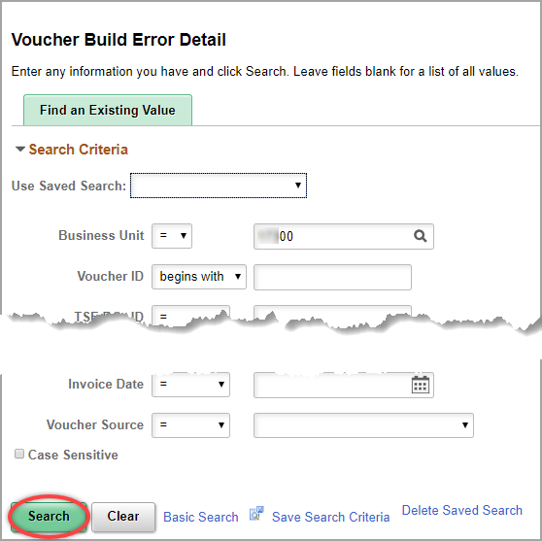  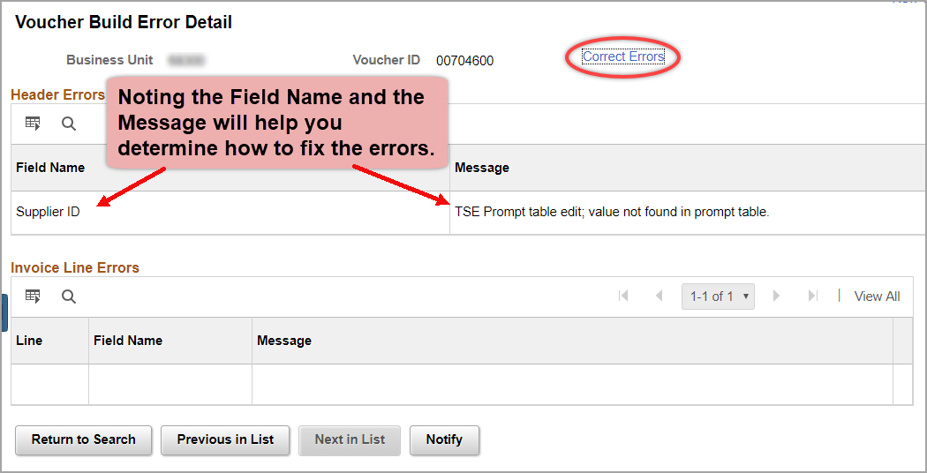  http://smartweb.ks.gov/training/accounts-payable  - Voucher Build Error Detail

Navigation |  | - Accounts Payable Homepage > Vouchers > Match Workbench  - NavBar: Navigator > Accounts Payable > Review Accounts Payable Info > Vouchers > Match Workbench
2. | Review Vouchers with Match Exceptions  Search Criteria:  Business Unit – Key the agency’s business unit.  Match Status – Select ‘Match Exceptions Exist’ from the dropdown menu.  Click the ‘Search’ button.  Determine the reason for the Exceptions by clicking the ‘Match Exceptions Exist’ hyperlink in the results section. Correct the Match Exceptions by modifying the Voucher, PO, or Receipt.  Use the additional Job Aid to assist in resolving match exceptions: | 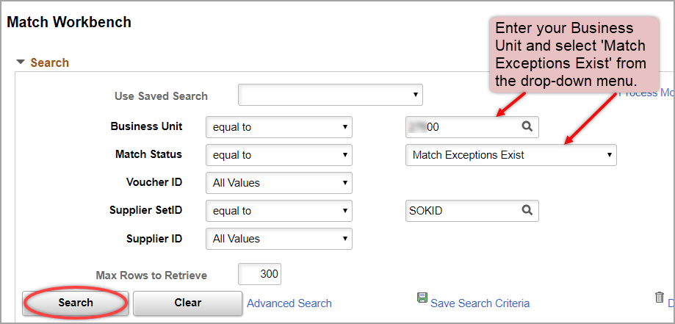  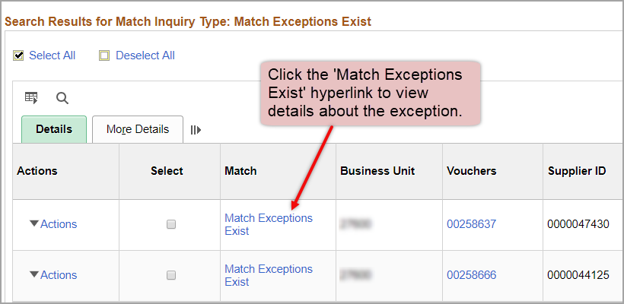  http://smartweb.ks.gov/training/accounts-payable  - Match Exceptions on Vouchers
Navigation |  | NavBar: Navigator > Commitment Control > Review Budget Check Exceptions > Accounts Payable > Voucher
3. | Review Vouchers with Budget Check Exceptions  Search Criteria:  Business Unit – Key the agency’s business unit.  Process Status – Select ‘Errors Exist’ from the dropdown menu.  Click the ‘Search’ button.  Click the voucher ID hyperlink on each result to review it further and determine how to correct the budget exceptions.  Use the additional Job Aid to assist in resolving budget exceptions: | 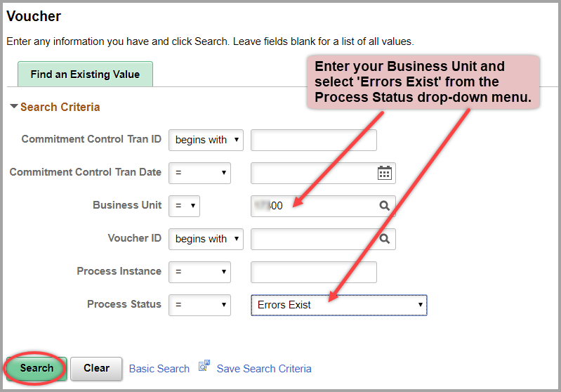  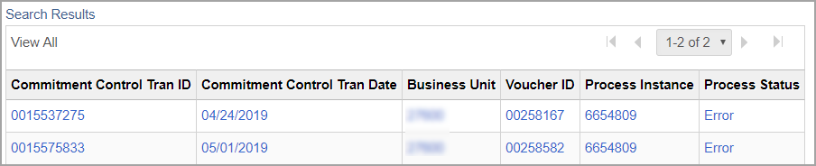  http://smartweb.ks.gov/training/accounts-payable  - Budget Exceptions on Vouchers
Navigation |  | - Accounts Payable Homepage > Utilities > Query Viewer  - NavBar: Navigator > Reporting Tools > Query > Query Viewer
4. | Review Unprocessed and Pending Accounts Payable and Interfund Transactions  Navigate to Query Viewer to use the Unprocessed Voucher queries and the Pending Interfund query. See the descriptions next to each query for further information on what results each query pulls.  For easy future access, these queries can be saved into the user’s favorites in Query Viewer by clicking the ‘Favorite’ hyperlink next to the query or using the dropdown menu.  Use the additional Job Aids to further research the vouchers and interfunds in these query results: | 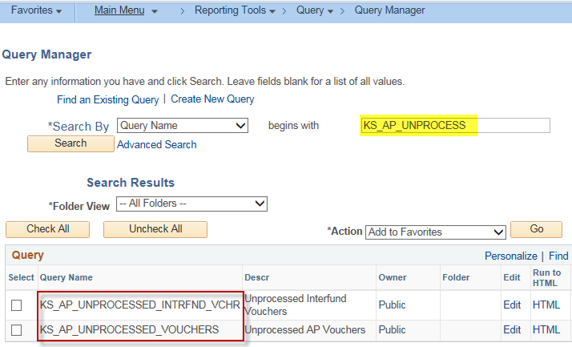  KS_AP_UNPROCESSED_VOUCHERS – This query returns regular vouchers that are unprocessed based on Accounting Date range. There are several reasons that a voucher may be unprocessed. See referenced documents below.  KS_AP_UNPROCESSED_INTRFND_VOUCHERS – This query returns interfund vouchers that are unprocessed based on Accounting Date range. The query results will show the interfund ID that is associated with the voucher. If no interfund information is listed, the interfund voucher is not attached to an interfund and should either be attached to an interfund or deleted from the Accounts Payable module. There are several additional reasons that an interfund voucher may be unprocessed. See referenced documents below.  KS_INTRFNDS_APPR_NOT_POSTED – The query results include information for interfunds associated with your agency on either the deposit or voucher side in which at least one of the following is true:  - Voucher is not posted  - Payment is not posted  - Deposit is not posted  http://smartweb.ks.gov/training/accounts-payable  - Troubleshooting Unprocessed Vouchers  http://www.smartweb.ks.gov/training/interfunds  - Incomplete Interfunds

Navigation |  | - Accounts Payable Homepage > Utilities > Query Viewer  - NavBar: Navigator > Reporting Tools > Query > Query Viewer
5. | Identify & Manage Checks Ready for Escheatment  a. Search for payments that will soon be picked up in the Escheatment process.  Navigate to Query Viewer to use the Escheatment queries to find outstanding checks.  Checks are Escheated on the 15th of the month or the first business day thereafter.  Additional instructions on how to run a report to review Outstanding Checks: | All State of Kansas outstanding checks (including SMART checks, Payroll checks and KDOR refund checks), unless specifically exempted by statute or system limitation, shall be escheated (turned over to the Unclaimed Property Division of the Kansas State Treasurer) after 13 months.  KS_AP_PYR_EXT_CHK_TO_ESCHEAT - to identify outstanding payroll checks  KS_AP_OUTSTANDING_CHECKS – to identify outstanding SMART checks  Enter the Business Unit and Date Range in the query search.  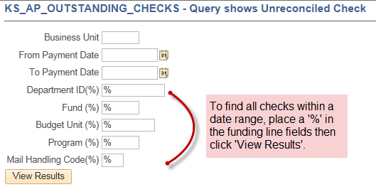  http://smartweb.ks.gov/training/accounts-payable  - Using the KS_ACCT_REGISTER Report
 | b. Review and manage Outstanding Checks.  All agencies are expected to review outstanding checks and take the necessary action prior to the date scheduled for escheatment.  Exceptions – The following types of checks will not be escheated:  - travel and expense checks  - checks from funds exempted from escheatment by statute (only 6 agencies have these funds)  For more information on Escheatment, see the additional training information: | Agencies generally have three options for handling an outstanding check:  - Do nothing – if it has been determined the payment is due to the supplier/employee and the payment remains outstanding, the check will be escheated and transferred to unclaimed property.  - Cancel – if it has been determined the payment is not due to the supplier/employee, the agency is responsible for canceling the payment. Submit a DA-7.  - Reissue – if it has been determined the payment was lost, the agency may request the payment be reissued. Submit a DA-6.  Exceptions Options:  Agencies have two options for handling these outstanding checks:  - Cancel – if it has been determined the payment is not due to the supplier/employee, the agency is responsible for initiating the cancellation of the payment. Submit a DA-7.  - Reissue – if it has been determined the payment was lost, the agency may request the payment be reissued. Submit a DA-6.  To Cancel or Reissue a check, submit a DA-7 or DA-6 form on a ManageEngine Service Desk Ticket. http://www.admin.ks.gov/resources/document-center  http://smartweb.ks.gov/training/accounts-payable  There are multiple reports for Escheatment including the summary report:  - SMART Escheatment – Month End Checklists

Navigation |  | - Accounts Payable Homepage > Utilities > Query Viewer  - NavBar: Navigator > Reporting Tools > Query > Query Viewer
6. | Manage Imprest and Petty Cash Account Balances  - To view information specific to a Business Unit’s Imprest and Petty Cash funds use the Bank Account Key query.  Enter the Business Unit in the field and click ‘View Results’.  To view the Expenditure and Replenish balances and associated vouchers for a specific Imprest or Petty Cash fund, use the Checkbook Record query.  Enter the Business Unit, an Accounting Date range, and the GL Account associated with the fund.  - To view the overall summary of all Imprest & Petty Cash funds for an Agency use the Summary query.  Enter the Business Unit and an Accounting Date range.  The results for the Checkbook & Summary queries show a running balance which is helpful in determining if the payments have been recorded & replenished properly. | Payments from an Imprest Fund or Petty Cash Fund shall be entered in SMART to record the expenditures to the suppliers. There is a 2-step process to Record the Payment and then receive a Replenishment. Payments from an Imprest Fund and Petty Cash Fund as well as the Replenishment for these payments shall be entered in SMART by the 15th day of the following month.  KS_AP_IMPR_PETTY_BANK_ACCT_KEY - BANK ACCOUNT KEY  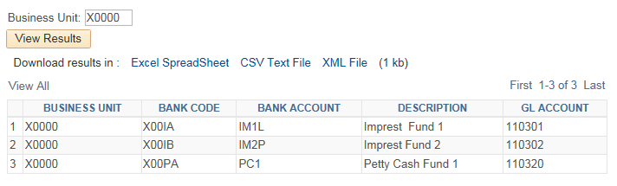  KS_AP_IMPR_PETTY_CSH_CHECKBOOK - CHECKBOOK RECORD  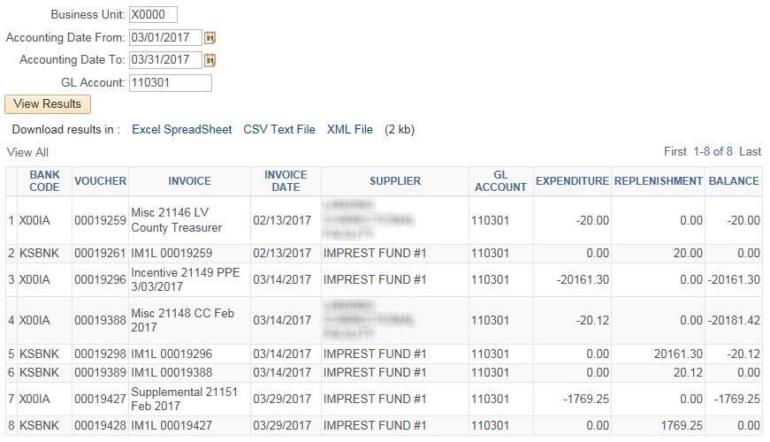  KS_AP_IMPR_PETTY_CSH_SUMMARY - PC AGENCY SUMMARY  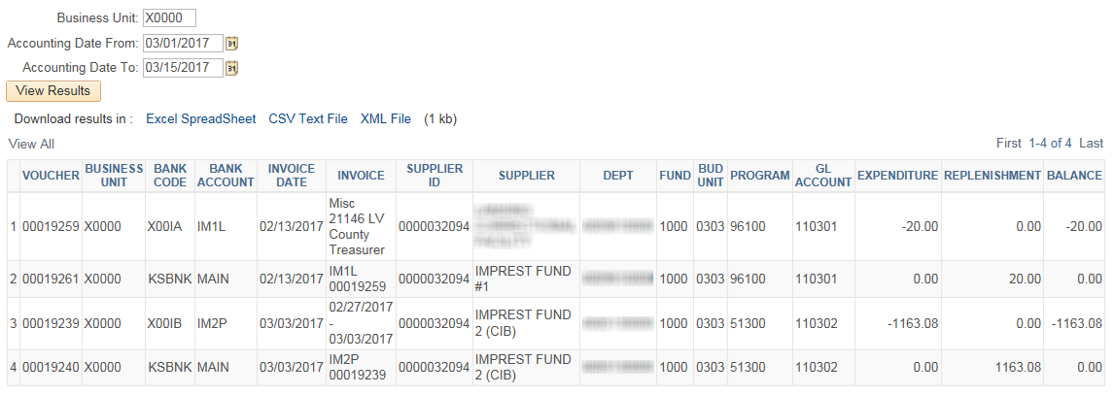  For further information see:  PM 10,752 – Petty Cash Fund Policy  PM 10,802 – Imprest Fund Policy  PM 14,002 – Fiscal Year Closing of Obligations –General  Imprest Fund and Petty Cash Fund: Record Expenditures by Creating a Voucher  Imprest Fund and Petty Cash Fund: Replenish Fund by Creating a Voucher
7. | Travel & Expense Accounts Codes Incorrectly Used in the Accounts Payable Module  As part of the upgrade from SMART 9.0 to SMART 9.2, a new series of account codes were introduced into the system. These travel account codes, 525510 through 525590, will be used only in the Travel & Expense module for all travel occurring on and after January 1, 2016. The existing travel account code series for in-state, out-of-state, and international travel will continue to be used outside of the Travel & Expense module by all agencies. This information was distributed via a SMART Info Blast referencing Informational Circular No.: 16-A-010 which supersedes 16-A-006.  Existing Account Codes used in all modules except Travel & Expense New Account Codes used only in the Travel & Expense module  In-State Out-of-State International All locations  Travel Related Account Code Descriptions  Travel & Subsistence: 52510 52520 52530 52550  Private Vehicle Miles 525110 525210 525310 525510  Hire of Cars Planes Buses 525120 525220 525320 525520  State Car Exp 525130 525230 525330 525530  Air Rail and Bus Fare 525170 525270 525370 525570  Meals and Lodging 525180 525280 525380 525580  Non-Subsistence 525190 525290 525390 525590  - Agencies should regularly check for the usage of these accounts codes on vouchers in the Accounts Payable module by using the query shown below. Corrections should only be made for the current fiscal year and should be performed by Create a Journal Voucher in the Accounts Payable module. The provided query will pull all voucher lines that contain any of the new account codes which includes the journal vouchers that are created to make corrections. Once journal vouchers are created, double check that everything is correct by running the query again and ensuring that all lines with the same supplier and funding total to $0. If there is a balance, a correction/modification needs to be made.  Navigate to:  - Accounts Payable Homepage > Utilities > Query Viewer  - NavBar: Navigator > Reporting Tools > Query > Query Viewer  Search for KS_AP_TE_ACCOUNTS_IN_AP  - Because the query can take several minutes to produce results, it is recommended that it be scheduled rather than running it online. See the job aid for Scheduling a Query which is found in the Reporting section of SMARTWeb.

