
State of Kansas
Searching for Incomplete Interfunds
Statewide Management, Accounting and Reporting Tool

Date Created: |  | 7/10/2014
Version: |  | 1.1
Searching for Incomplete Interfunds |  | This job aid will assist agencies in searching for interfunds that need reciprocating or completion. The initiating side of an interfund is the first of two transactions that make up an interfund. The reciprocating side is the responding side of the two transactions.  The ‘Deposit Type’ of an interfund deposit will be I (Initiating) or R (Reciprocating). The ‘Origin' of an interfund voucher will be either I (Initiating) or R (Reciprocating).  It is optional for the initiating agency to notify the reciprocating agency when transactions are pending and it is optional for the reciprocating agency to notify the initiating agency when transactions are complete. Therefore, it is important to regularly search for interfunds that have been placed in SMART for your agency to reciprocate.
Search for Pending Interfunds Using a Query
1. | Navigate to: Reporting Tools > Query > Query Viewer > Enter KS_APAR_PENDING_INTRFNDS in ‘begins with’ search box and click Search.  Click the Excel link. | 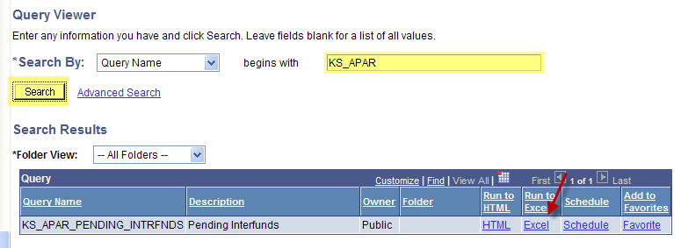
2. | Enter Business Unit  Press the View Results button  Click on ‘Open’ on the File Download pop-up. | 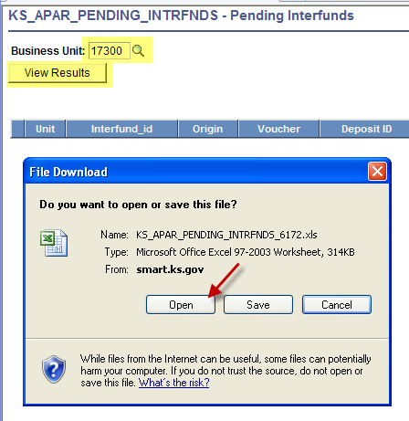
3. | The Pending Interfund list will open in Excel. | 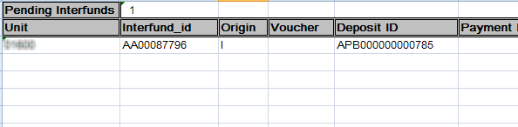
Interfund Details Search – User’s Agency is AR side of Interfund
1. | Search for interfunds where deposit needs to be added by your agency:  Navigate to: Accounts Receivable > Interfund Details or Accounts Payable>Interfund Details  Enter criteria:  Deposit Approval Status: UnApproved  Vendor ID: Your Agency Number  Search | 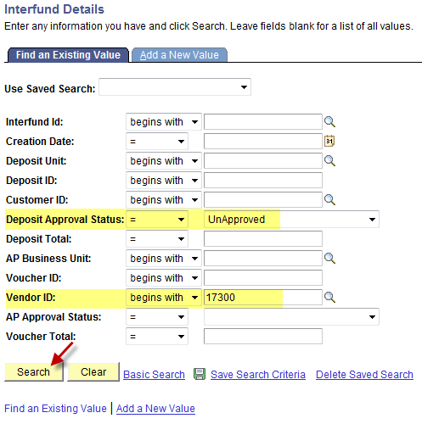
2. | Search for interfunds where deposit is not approved by your agency:  Navigate to: Accounts Receivable > Interfund Details or Accounts Payable>Interfund Details  Enter criteria:  Deposit Approval Status: UnApproved  Deposit Unit: Your Agency Number  Search | 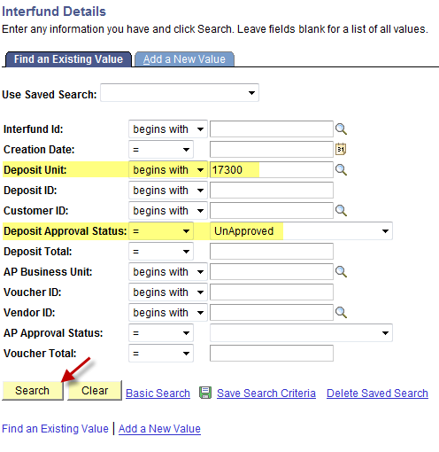
3. | Search for interfunds where your agency’s deposit is entered, but voucher is missing or not approved:  Note: Use at year-end to identify interfunds where your deposit is entered, but the AP side needs completion so your deposit will post in current FY.  Navigate to: Accounts Receivable > Interfund Details or Accounts Payable>Interfund Details  Enter criteria:  AP Approval Status: UnApproved  Deposit Unit: Your Agency Number  Search | 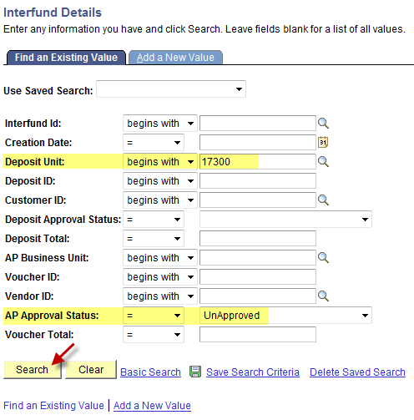

Interfund Details Search – User’s Agency is AP side of Interfund
1. | Search for interfunds where voucher needs to be added by your agency:  Navigate to: Accounts Receivable > Interfund Details or Accounts Payable>Interfund Details  Enter criteria:  Customer ID: Your Agency Number  AP Approval Status: UnApproved  Search | 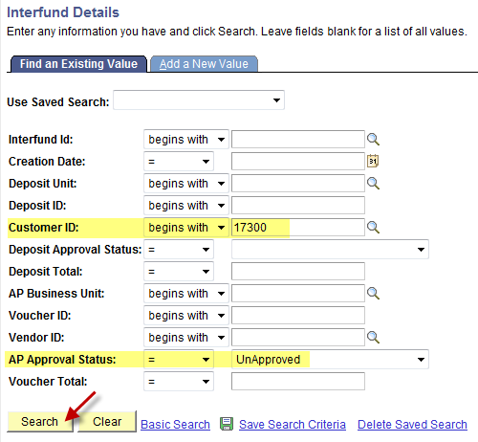
2. | Search for interfunds where voucher is not approved by your agency:  Navigate to: Accounts Receivable > Interfund Details or Accounts Payable>Interfund Details  Enter criteria:  AP Approval Status: UnApproved  AP Business Unit: Your Agency Number  Search | 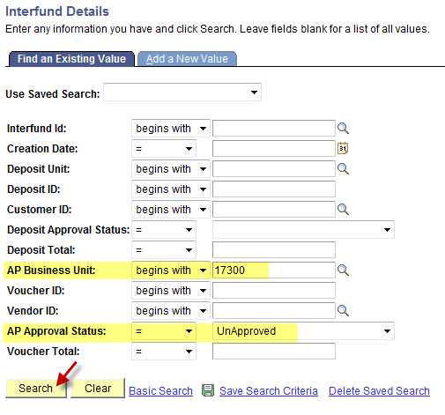
3. | Search for interfunds where your agency’s voucher is entered, but deposit is missing or not approved:  Note: Use at year-end to identify interfunds where your voucher is entered, but the AR side needs completion so your voucher will post in current FY.  Navigate to: Accounts Receivable > Interfund Details or Accounts Payable>Interfund Details  Enter criteria:  Deposit Approval Status: UnApproved  AP Business Unit: Your Agency Number  Search | 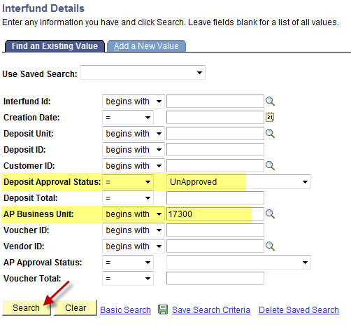
Save Frequently Used Searches
1. | Enter search criteria and click on ‘Save Search Criteria’. | 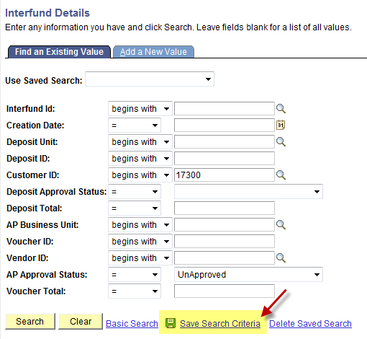
2. | Enter a name for the new search in the ‘Name of Search’ box.  Save | 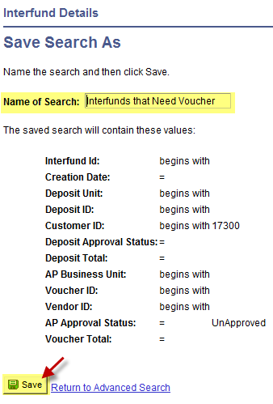
3. | The ‘Interfund Details – Save Search As’ page then appears and displays the name of the newly saved search.  Click ‘Return to Advanced Search’ to return to Interfund Details page. | 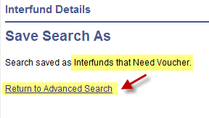
4. | The ‘Use Saved Search’ drop down will now appear on the Interfund Details page for future use. | 

