**State of Kansas**



**Creating Travel Authorizations**

***Statewide Management, Accounting and Reporting Tool***

### 

### Creating Travel Authorizations

Travel authorizations allow employees to submit a request prior to travel that requires approval by their respective supervisor.

When you create a travel authorization, you have options on which to base the new document, and the selection that you make triggers other choices that prompt you for details about the travel authorization. You can start with a blank document or populate one with data.

Procedure

In this scenario, you will create a travel authorization to attend a training class in Wichita.

**Note:** This is an example for training purposes only. In this example, you will enter one expense line for **Meals & Incidental Expenses** and one expense line for **Lodging.**

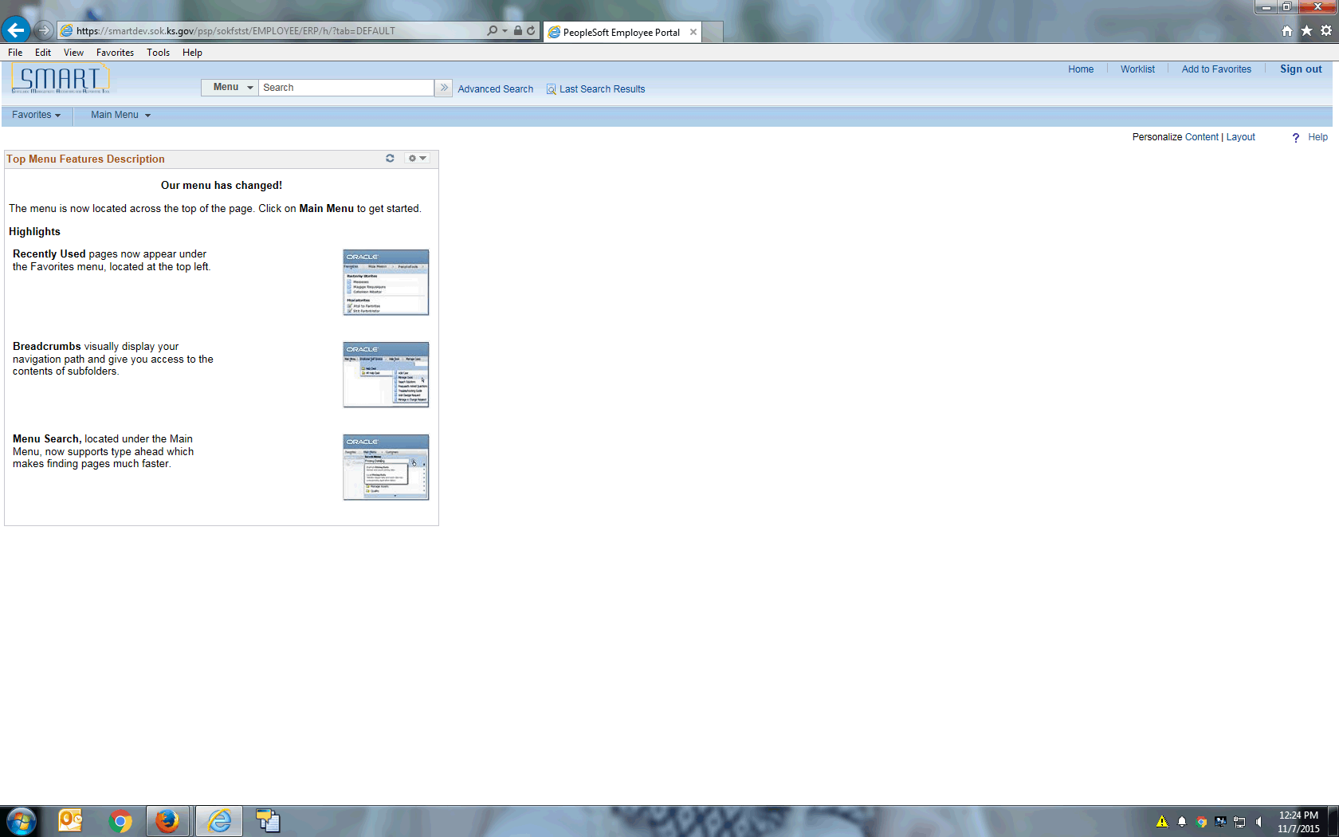

| **Step** | **Action** |
| --- | --- |
|  | Begin by navigating to the **Travel Authorization Entry** page.  Click the **Main Menu** button. |
|  | Click the **Employee Self-Service** menu. |
|  | Click the **Travel and Expense Center** menu. |

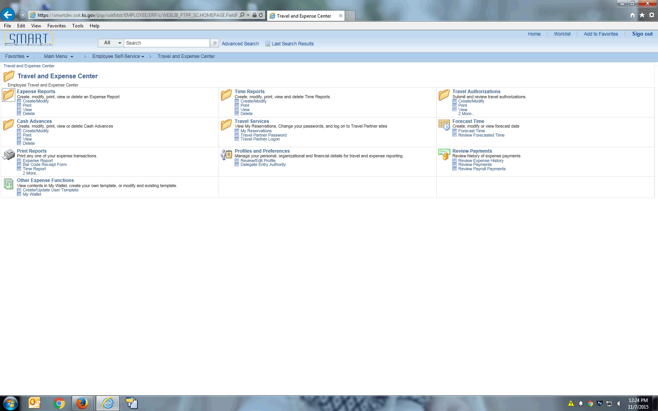

| **Step** | **Action** |
| --- | --- |
|  | Click the Create/Modify link located under the Travel Authorizations heading.  Click the **Create/Modify** link. |
|  | To create a new travel authorization, make sure you are on the **Add a New Value** tab. |

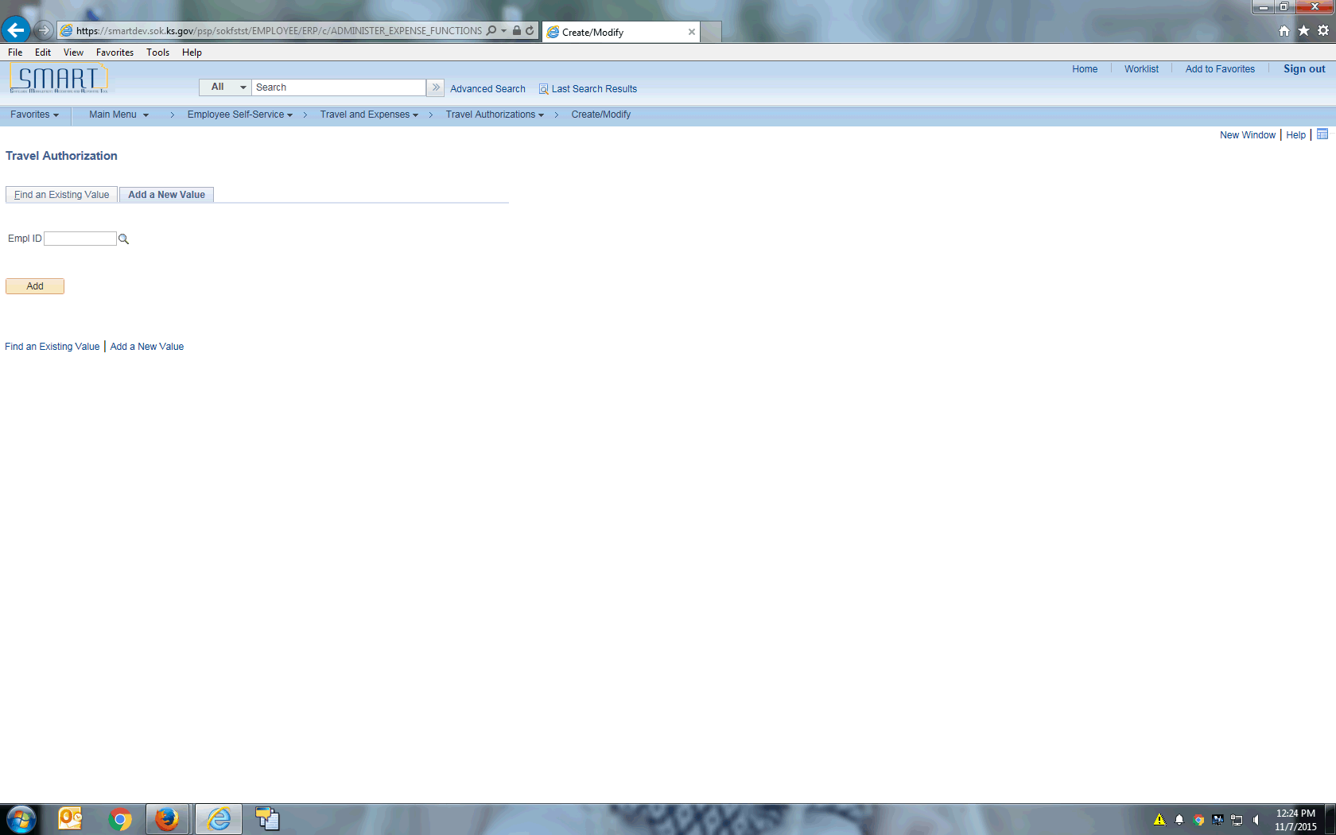

| **Step** | **Action** |
| --- | --- |
|  | Click in the **Empl ID** field. |
|  | Enter the desired information into the **Empl ID** field. Enter "**KS92TEST3**". |
|  | Click the **Add** button. |

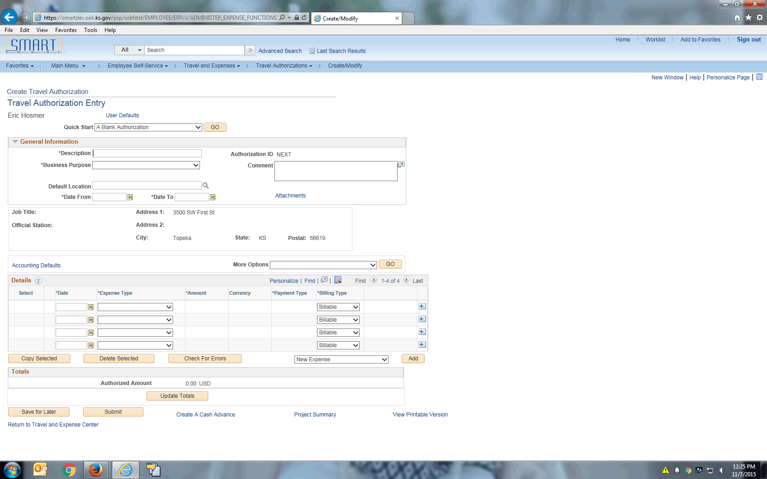

| **Step** | **Action** |
| --- | --- |
|  | Use the **Quick Start** menu to select a creation method for your travel authorization. SMART Expenses initially displays this field based on the setting of your default creation method set on the **Employee Profile - User Defaults** page, which you can override.  Click the **Quick Start** list. |

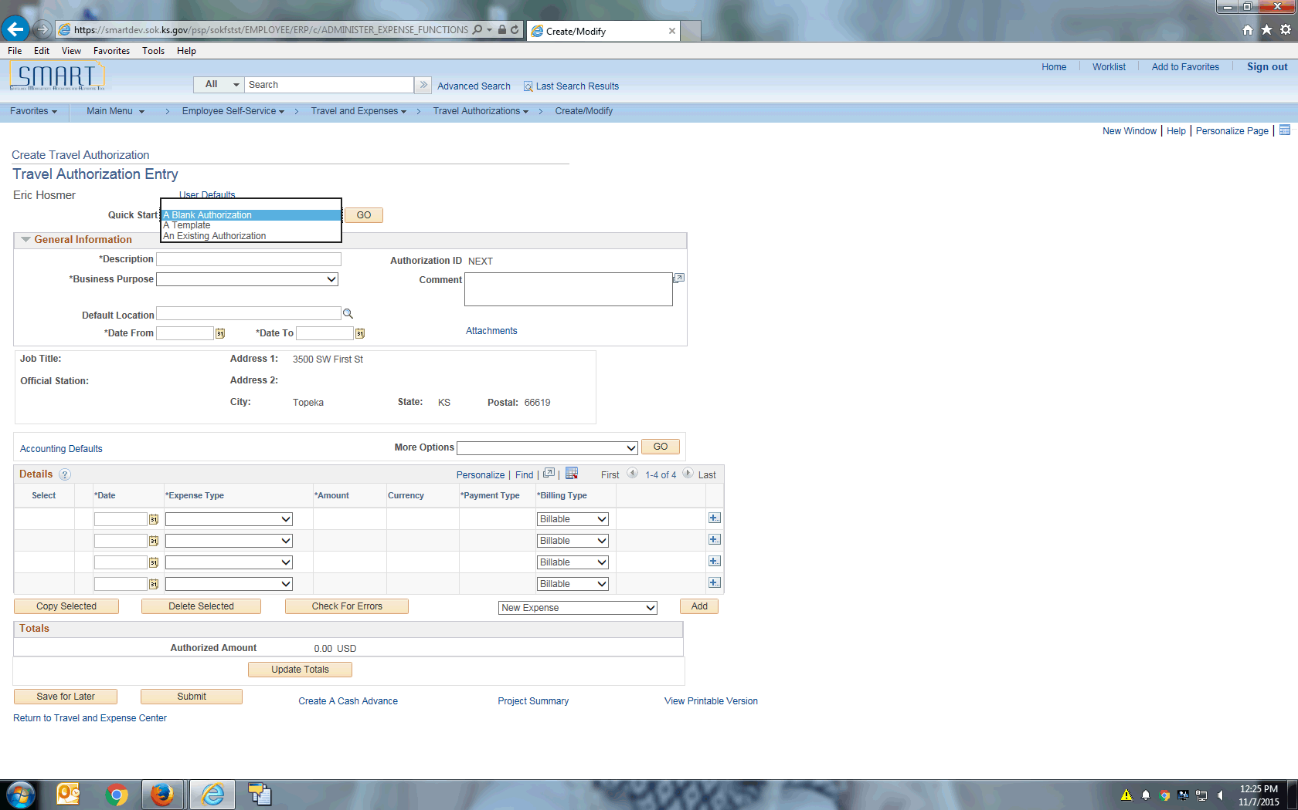

| **Step** | **Action** |
| --- | --- |
|  | The Quick Start values are:  •***A Blank Authorization:*** Select to start with a blank travel authorization.  •***A Template:*** Select to access the Select a Template page and select existing templates from which to copy expense lines to the new travel authorization.  •***An Existing Authorization:*** Click to access the Copy From an Existing Travel Authorization page and select existing travel authorizations to copy to the new travel authorization.  Click the **Quick Start** list item. |

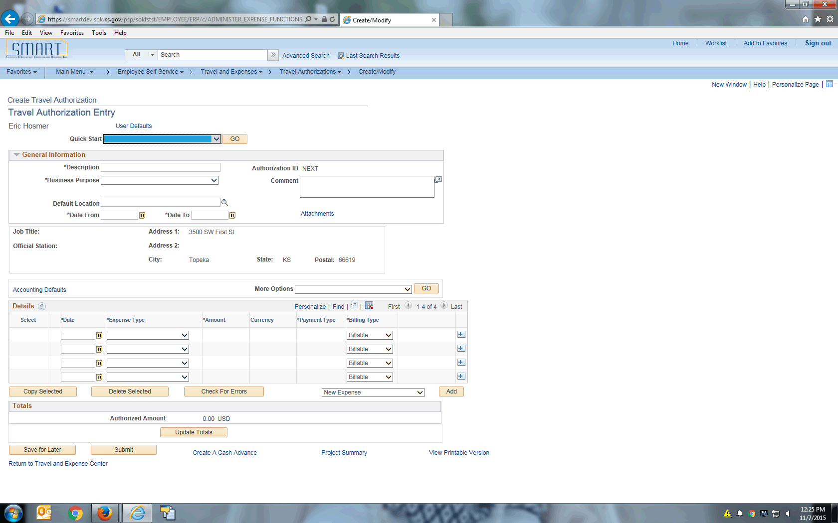

| **Step** | **Action** |
| --- | --- |
|  | Enter a description to identify the travel authorization.  Click in the **Description** field. |
|  | A description is a quick, one-line description of why you are traveling.  Enter the desired information into the **Description** field. Enter "**Class in Wichita**". |
|  | Choose a **Business Purpose** from the predefined list.  Click the **Business Purpose** list. |

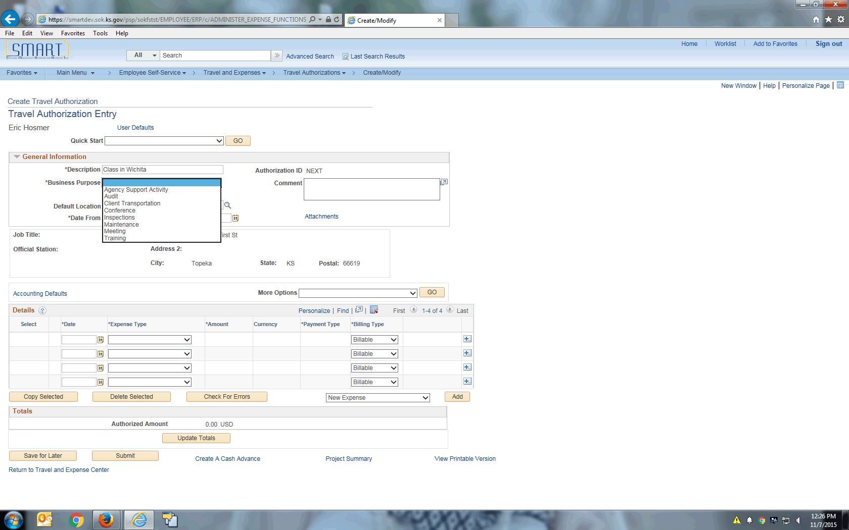

| **Step** | **Action** |
| --- | --- |
|  | Click the **Training** list item. |

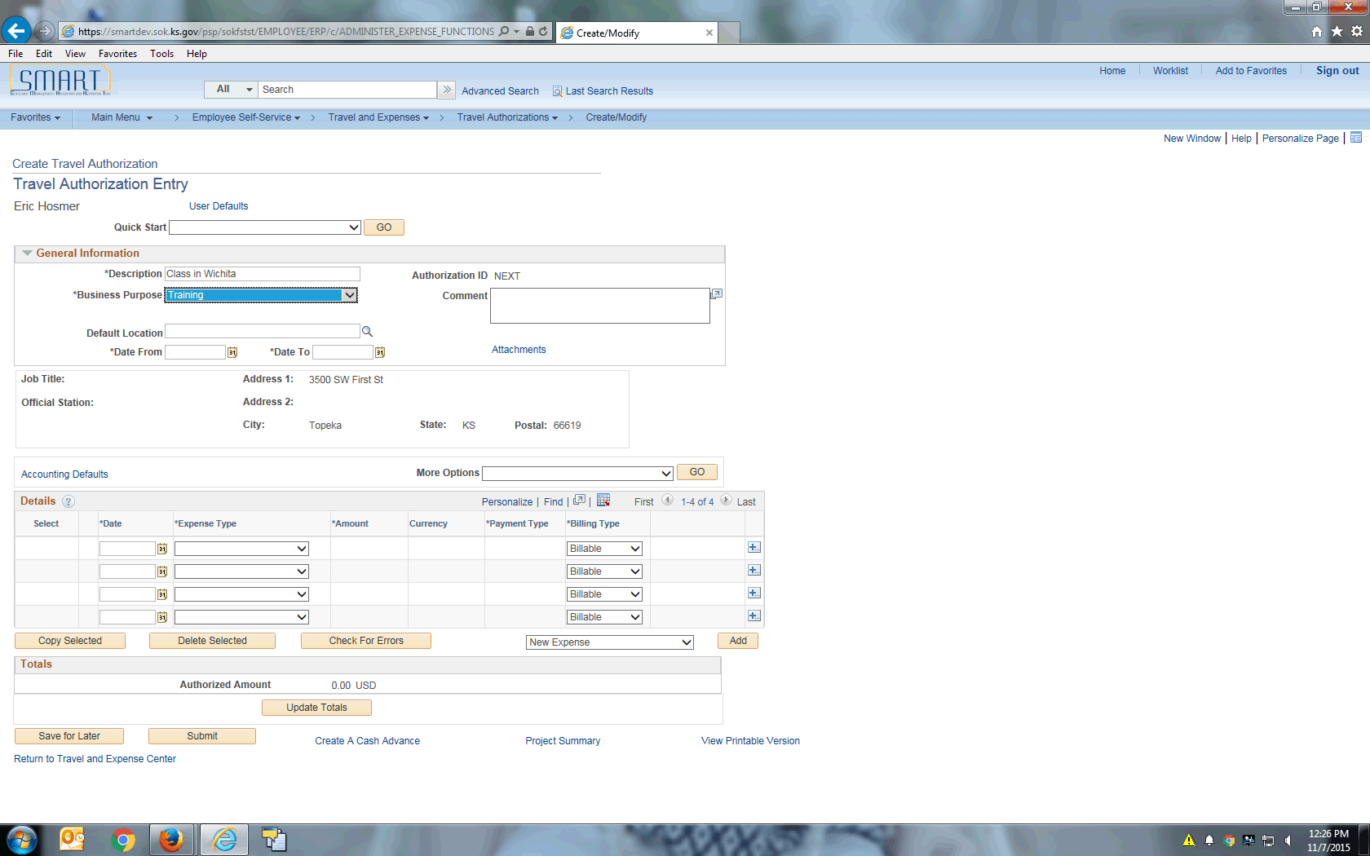

| **Step** | **Action** |
| --- | --- |
|  | Click in the **Date From** field. |
|  | Enter the desired information into the **Date From** field. Enter "**01/05/2016**". |
|  | Enter the desired information into the **Date To** field. Enter "**01/06/2016**". |
|  | In the **Details** table, you will enter each expense that requires travel authorization. You will enter each expense on a separate line item.  In this scenario, you will enter expense lines for **Meals & Incidental Expenses** and **Lodging.**  Use this topic to assist you with entering Travel Authorizations with travel dates of January 1, 2016 and beyond. For travel authorizations with travel dates between November 13, 2015 and December 31, 2015, you will continue to enter the information and amounts just as you did in SMART 9.0. |
|  | Select the beginning date for the expense type.  Click in the **Date** field. |
|  | Enter the desired information into the **Date** field. Enter "**01/05/2016**". |

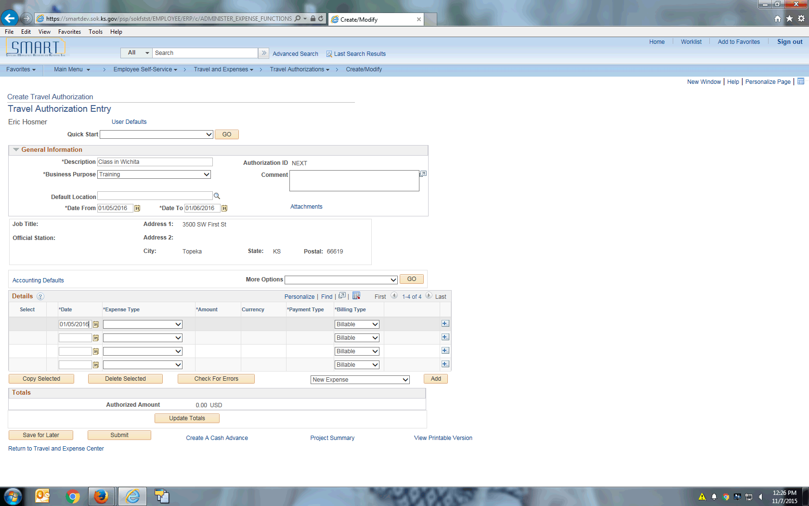

| **Step** | **Action** |
| --- | --- |
|  | Select an expense type to add an expense item.  Click the **Expense Type** menu. |
|  | Click the **MEALS AND INCIDENTAL EXPENSES** list item. |

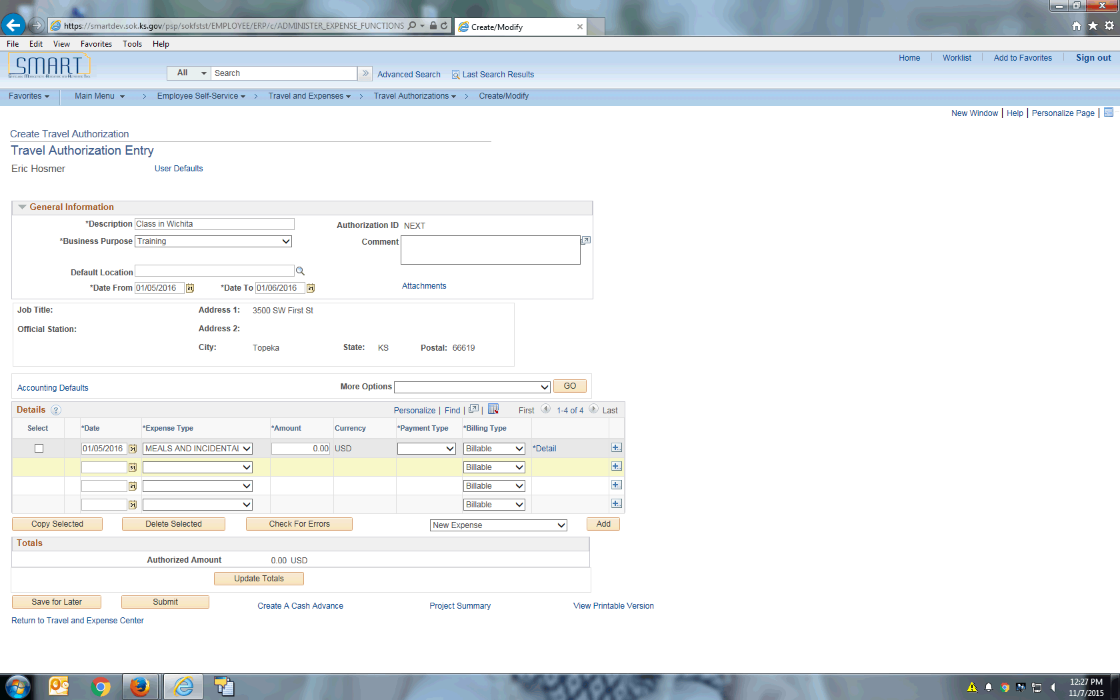

| **Step** | **Action** |
| --- | --- |
|  | Select how you will pay for the expense item.  Click the **Payment Type** list. |

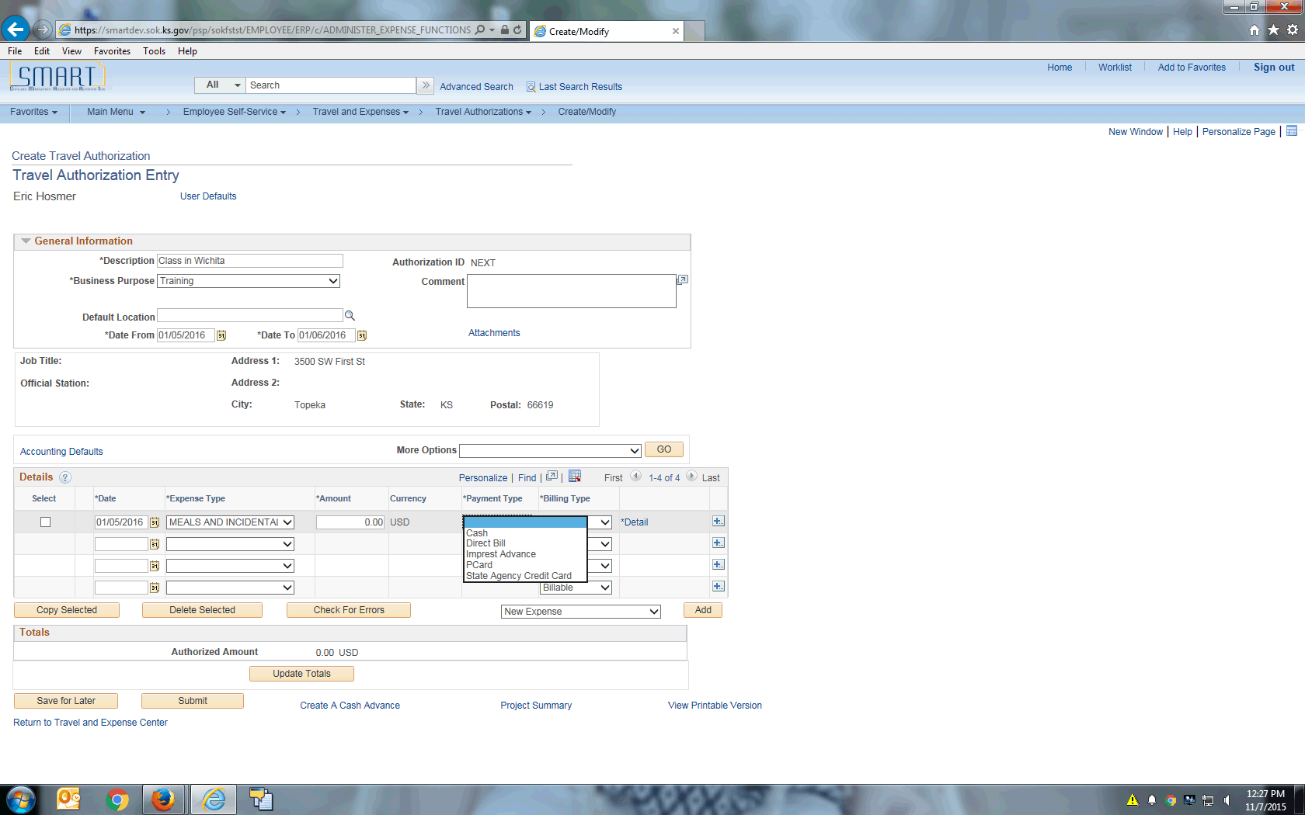

| **Step** | **Action** |
| --- | --- |
|  | Click the **Cash** list item. |
|  | Select Billable or Non Billable for the **Billing Type**. If you use Project Costing, a Billing Type of Billable is required to identify expense items that are charged to a project. Expenses sends the information to Project Costing and Project Costing passes these items to Billing for processing.  The default is **Billable.** |

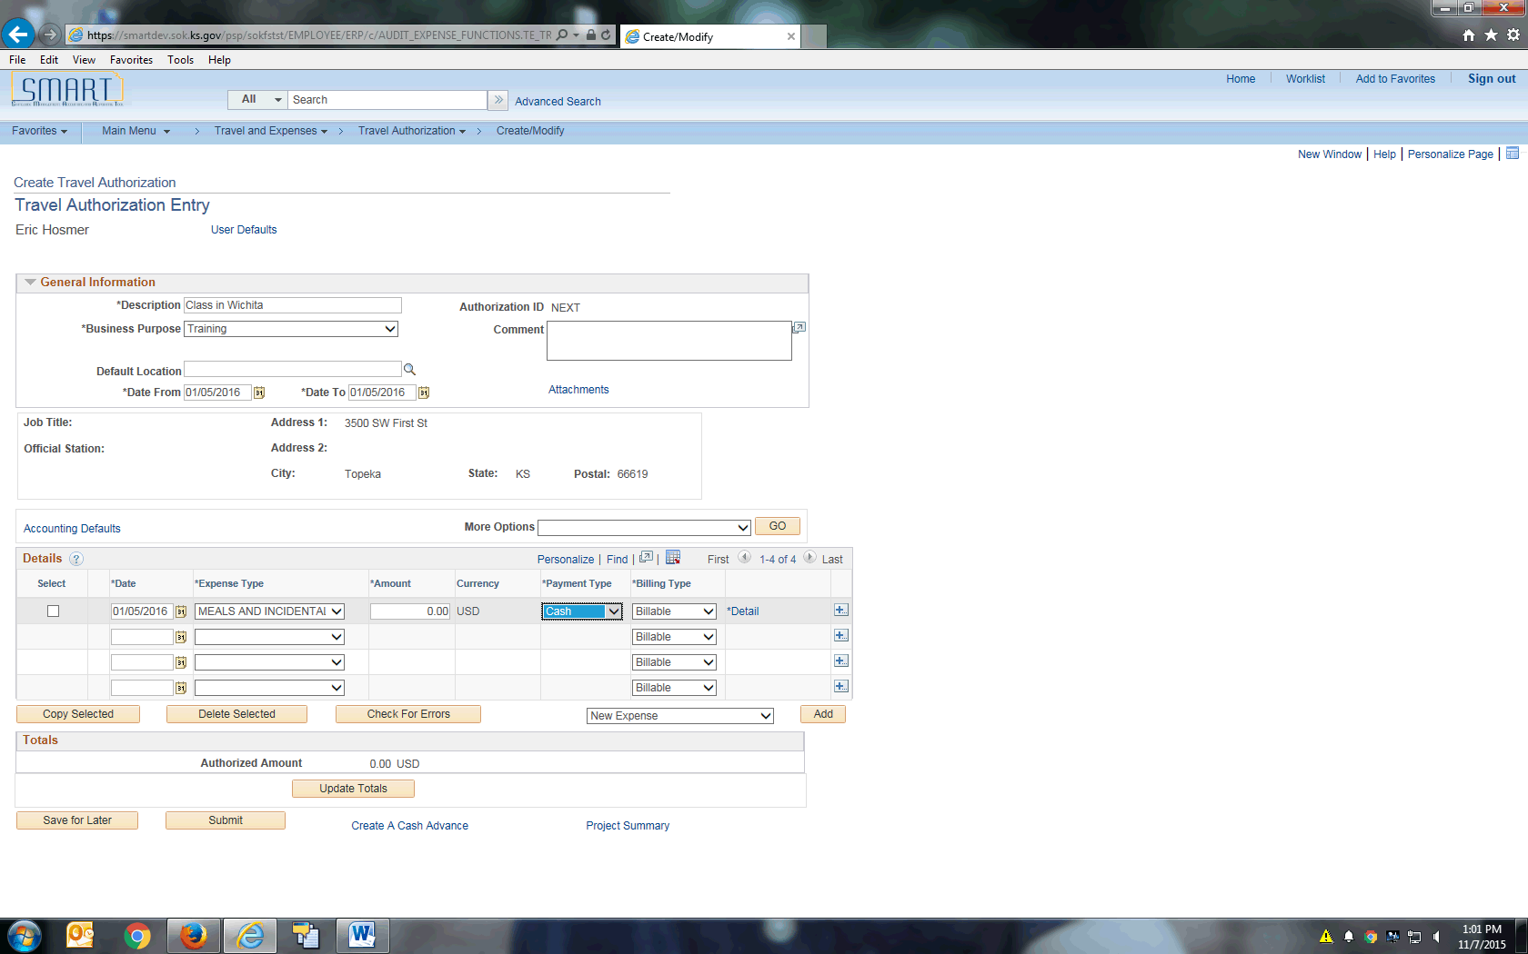

| **Step** | **Action** |
| --- | --- |
|  | Click the **Detail** link to go to the **Authorization Detail** page for the expense type and enter additional information for the expense transaction line.  Click the **Detail** link. |

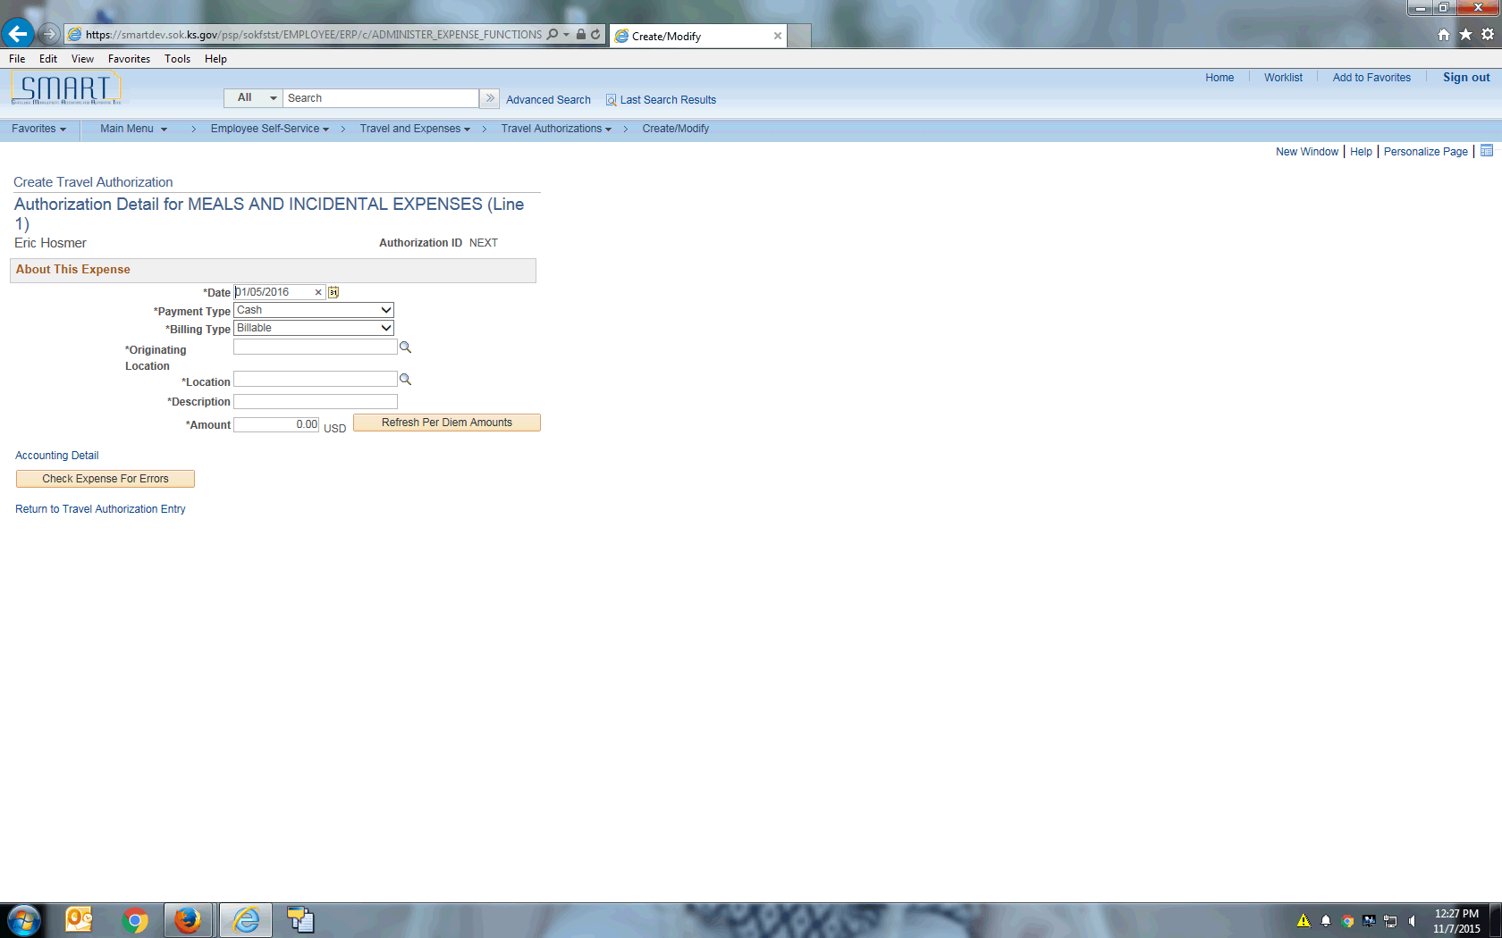

| **Step** | **Action** |
| --- | --- |
|  | In this example, the **Originating Location** is the employee's official station.  Click the **Look Up** button. |
|  | Click the **Advanced Lookup** link. |
|  | You will notice in this **Look Up** menu, both column headings are Originating Location. **Please use the second search field to search by the two-letter state abbreviation and city.**  **Example:** KS, TOPEKA  Click in the **Originating Location** field. |
|  | Enter the desired information into the **Originating Location** field. Enter "**KS, TOPEKA**". |
|  | Click the **Look Up** button. |
|  | Click the **KS, TOPEKA** link. |
|  | The value you choose for the **Location** field will determine the per diem amount.  Click the **Look Up** button. |
|  | Click the **Advanced Lookup** link. |
|  | Click in the **Description** field. |
|  | Enter the desired information into the **Description** field. Enter "**KS, WICHITA**". |
|  | Click the **Look Up** button. |
|  | Click the **KS, WICHITA** link. |
|  | Use the **Description** field to give a quick description of this expense line.  Click in the **Description** field. |
|  | Enter the desired information into the **Description** field. Enter "**Meals in Wichita**". |
|  | Click the **Refresh Per Diem Amounts** button. |
|  | Beginning on January 1, 2016, SMART will populate the per diem in the **Amount** field for the **Meals & Incidentals Expenses** (M&IE) expense type. SMART will also populate the nightly rate for the **Lodging** expense type. You are able to override these amounts if needed. |
|  | After clicking the **Check Expense For Errors** button, any fields with an error will be highlighted in red. This travel authorization had no errors. |
|  | Click the **Return to Travel Authorization Entry** link. |
|  | You will notice that the **Amount** field is now populated with the per diem value from the Authorization Detail page.  **Note:** If you have a traveler that is only gone a partial day or has some meals provided, you can override this field with the correct amount. |

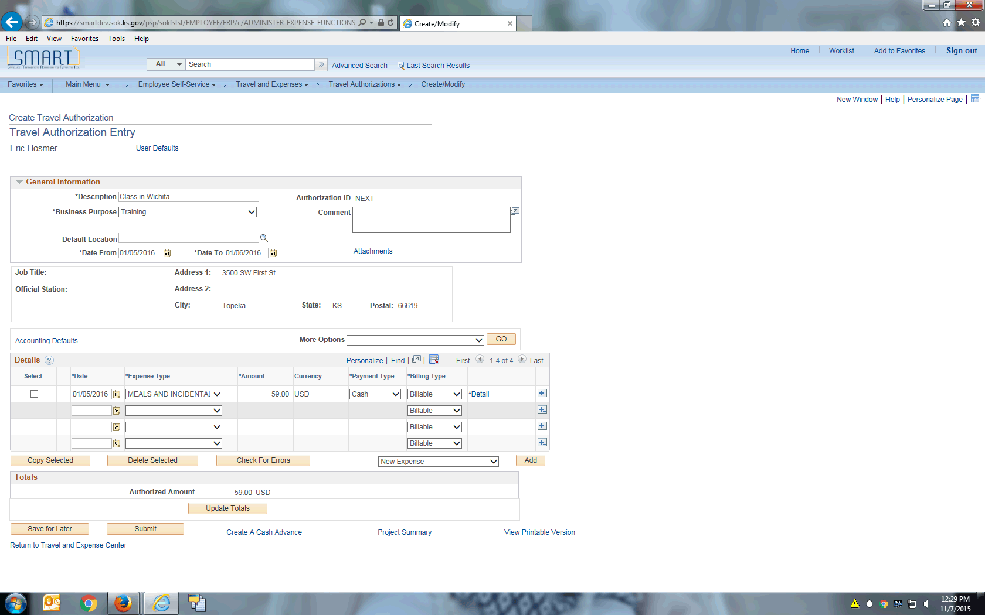

| **Step** | **Action** |
| --- | --- |
|  | Click in the **Date** field. |
|  | Enter the desired information into the **Date** field. Enter "**01/05/2016**". |

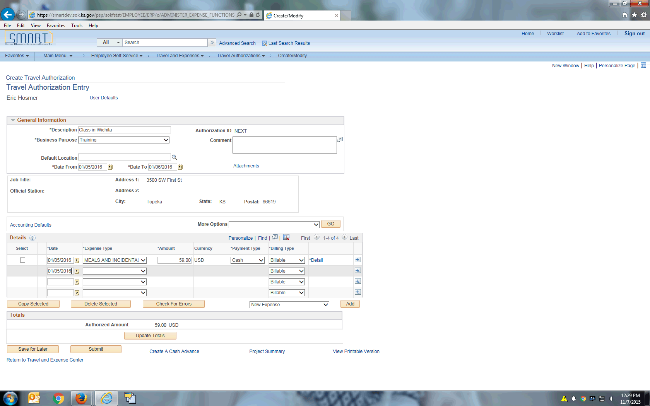

| **Step** | **Action** |
| --- | --- |
|  | Click the **Expense Type** menu. |
|  | Click the **LODGING** list item. |

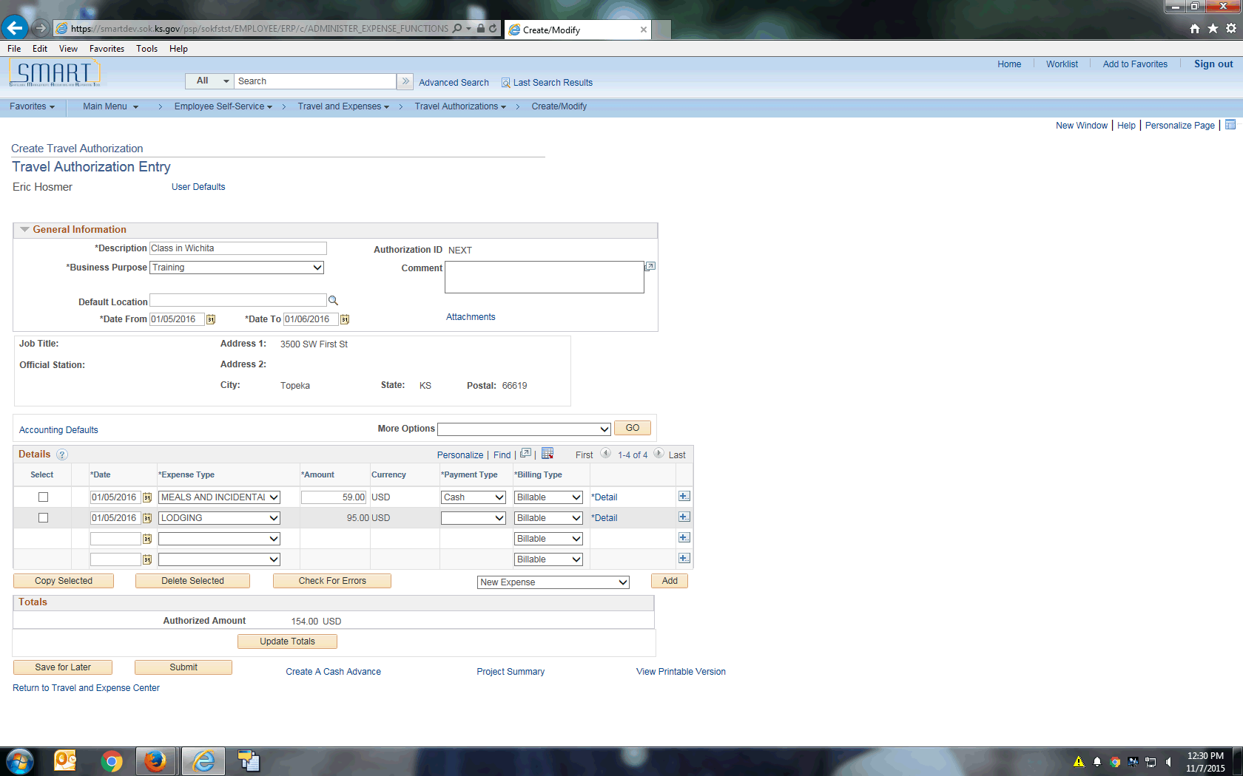

| **Step** | **Action** |
| --- | --- |
|  | Click the **Payment Type** list. |

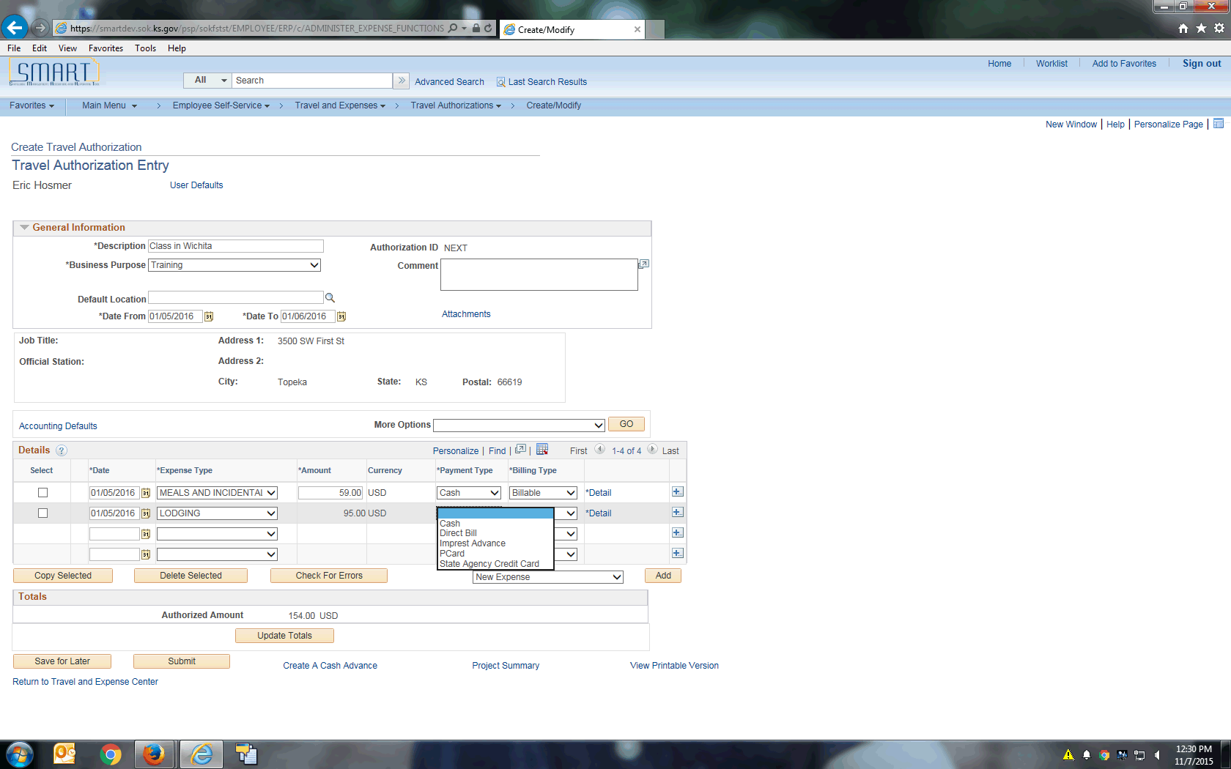

| **Step** | **Action** |
| --- | --- |
|  | Click the **Cash** list item. |

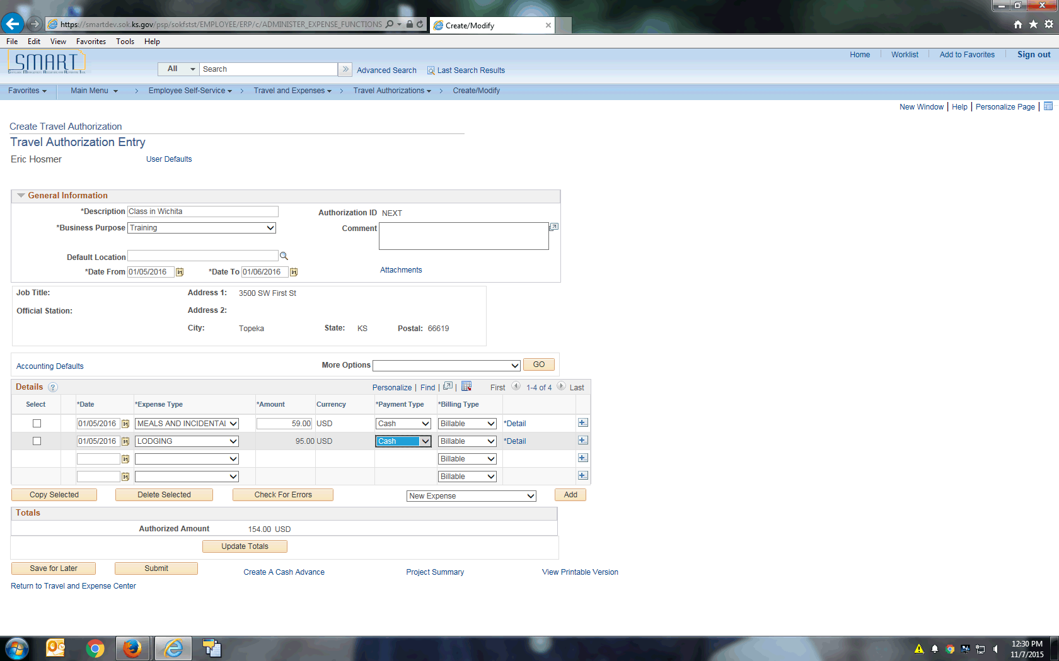

| **Step** | **Action** |
| --- | --- |
|  | Click the **Detail** link. |

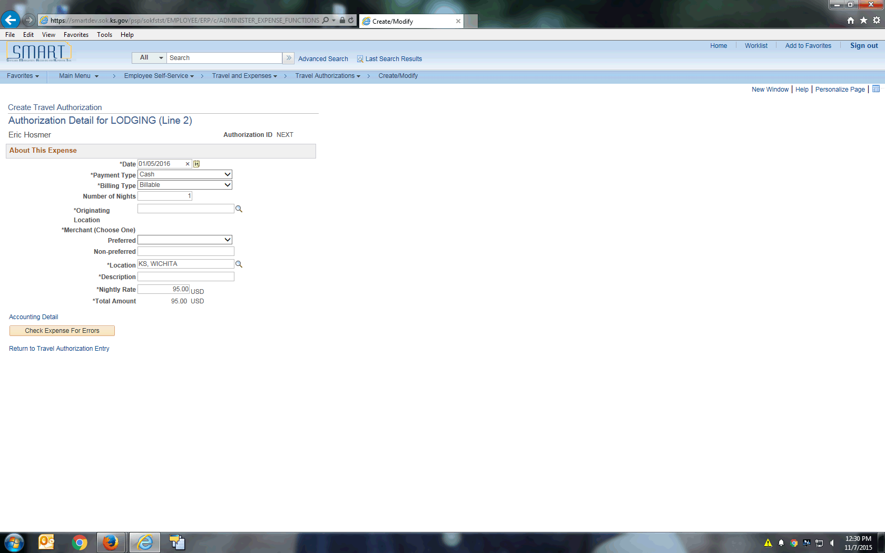

| **Step** | **Action** |
| --- | --- |
|  | For this example, the **Originating Location** is the employee's official station.  Click in the **Originating Location** field. |
|  | Another option when entering the **Originating Location** is to key the value directly into the field. For example, Topeka, KS would be keyed as KS, TOPEKA into the **Location** field. Please pay attention to capitalization, commas and spacing. It must be exact for SMART to take the value. If the value is entered incorrectly, you will receive an error that must be corrected before you can continue.  Enter the desired information into the **Originating Location** field. Enter "**KS, TOPEKA**". |
|  | Click in the **Non-preferred** field. |
|  | Enter the desired information into the **Non-preferred** field. Enter "**Marriott**". |
|  | **Location** is populated here due to the location being selected in expense line 1. You can override this value if needed.  The location selected here determines the **Nightly Rate**, seen below. |
|  | Click in the **Description** field. |
|  | Enter the desired information into the **Description** field. Enter "**1 night at Marriott**". |
|  | The **Nightly Rate** field can be edited if needed.  Click in the **Nightly Rate** field. |
|  | Click the **Check Expense For Errors** button. |
|  | This expense has no errors.  Click the **Return to Travel Authorization Entry** link. |

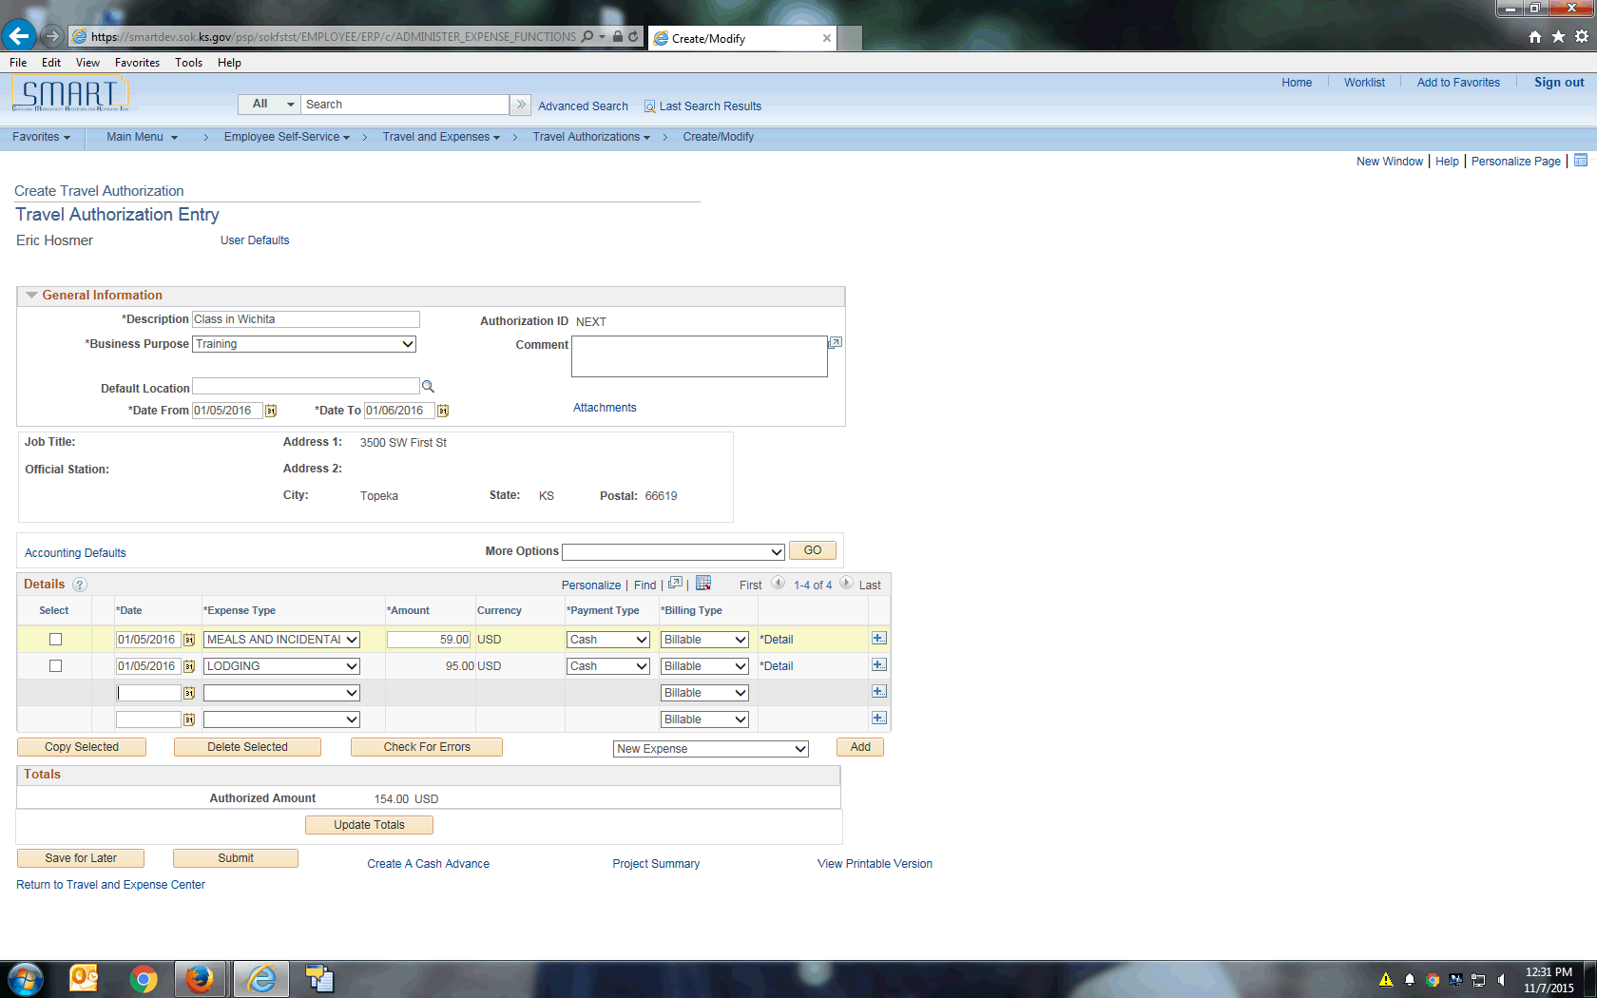

| **Step** | **Action** |
| --- | --- |
|  | If there are errors on the travel authorization, a red flag will appear between the **Select** column and the **Date** column. Errors must be corrected before the travel authorization can be submitted.  This travel authorization has no errors.  Click the **Check For Errors** button. |
|  | Select the **Save for Later** button to save the travel authorization without submitting it for approval. You can save the authorization with invalid or missing information, which you can modify later.  When you click the **Save for Later** button or the **Submit** button, an **Authorization ID** is assigned.  Click the **Save for Later** button. |
|  | When you click the **Submit** button, Expenses displays the **Submit Confirmation** page to indicate that it successfully saved and submitted the travel authorization.  Click the **Submit** button. |

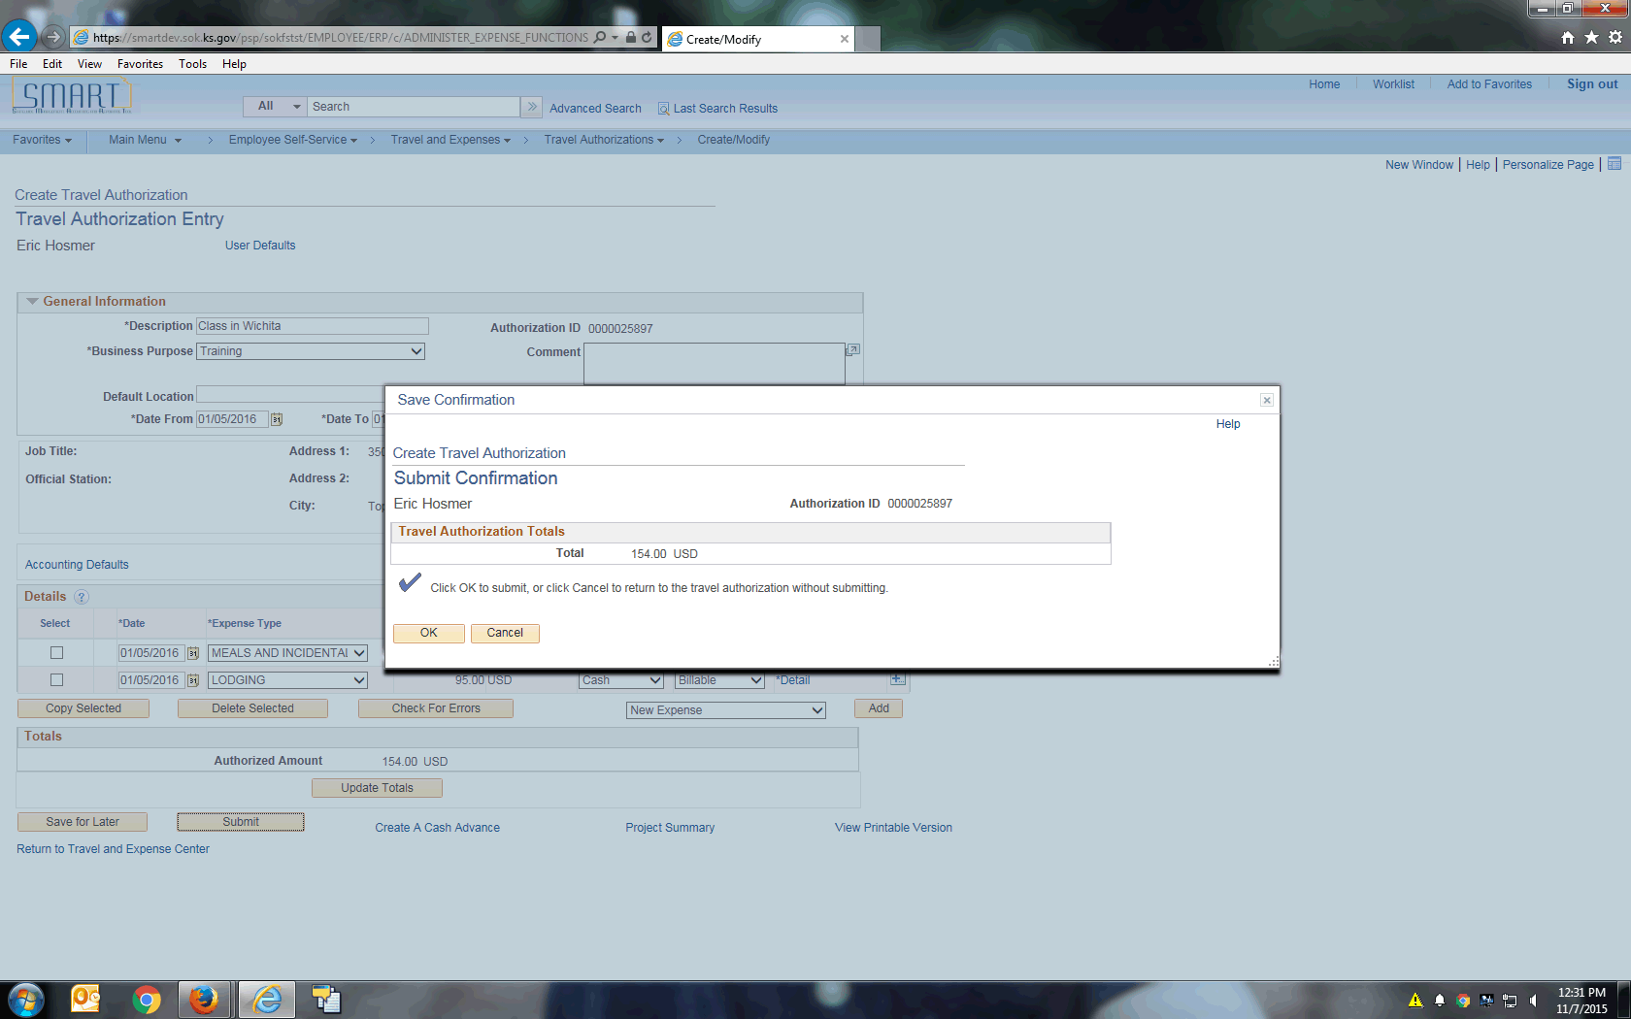

| **Step** | **Action** |
| --- | --- |
|  | Click the **OK** button. |

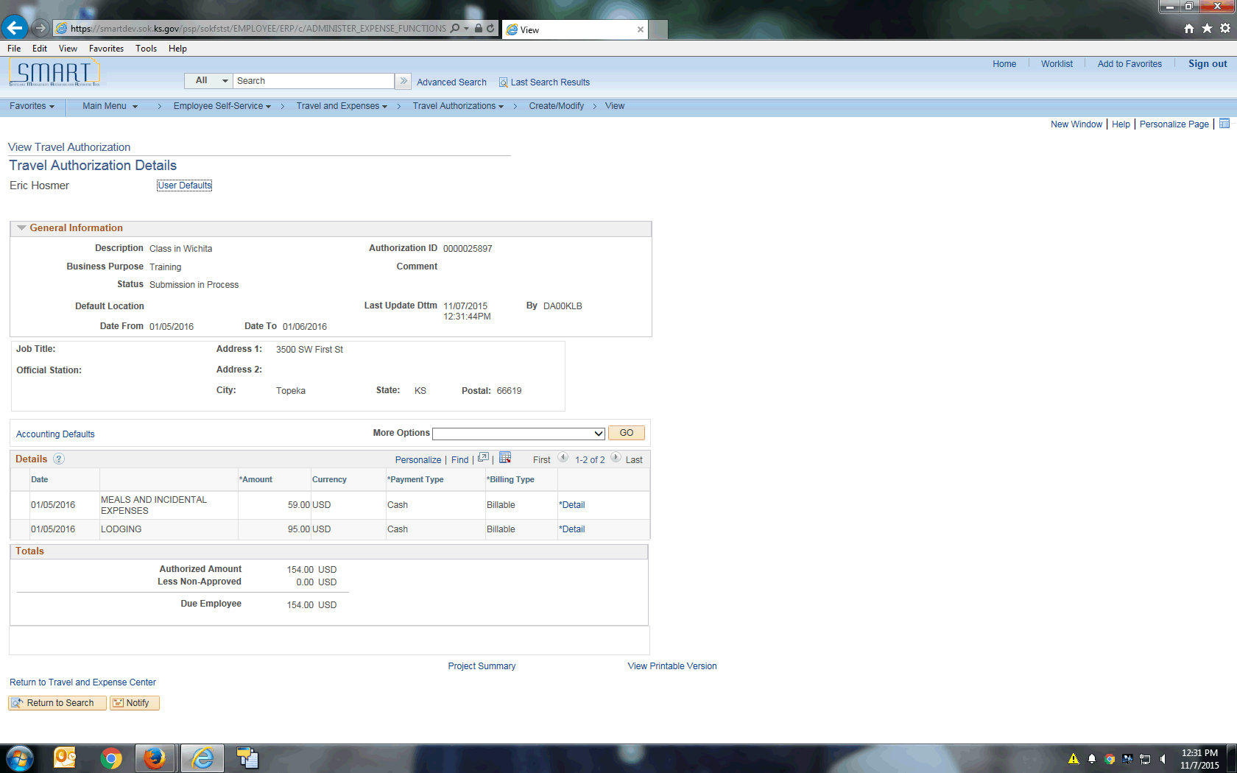

| **Step** | **Action** |
| --- | --- |
|  | The travel authorization has been saved and submitted.  Click the **Return to Travel and Expense Center** link. |
|  | Congratulations! You have successfully completed the **Creating Travel Authorizations** topic!  **End of Procedure.** |