**State of Kansas**

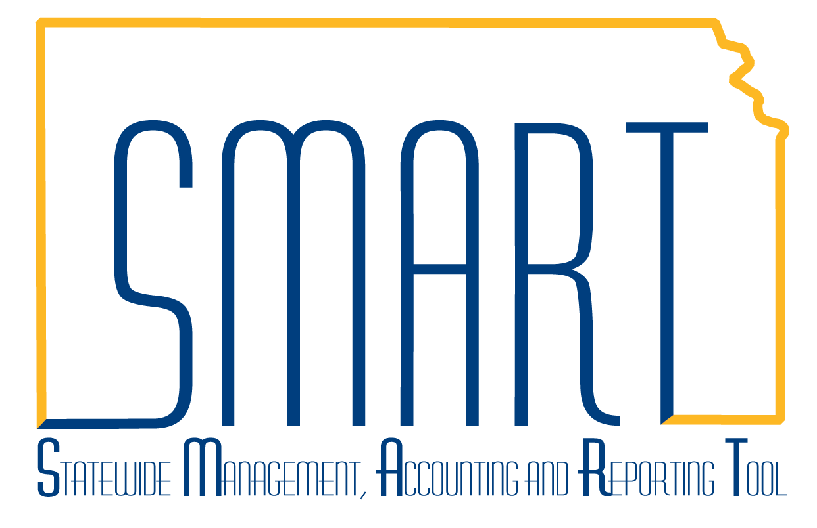

**Modify Sold To Customer**

***Statewide Management, Accounting and Reporting Tool***

|  |  |
| --- | --- |
| **Date Created:** | 10/14/2015 |
| **Version:** | 1.0 |
| **Last Updated Date:** | 10/14/2015 |
| **Purpose of the Configuration:** |  |
| **Security:** | * Role Security: Customer Contracts Manager |
| **Scenario** | A Customer Contract has been entered, and the incorrect Sold To Customer was entered. While the Contract status is still in **Pending status,** the Sold To Customer can be modified. This is new functionality released with the 9.2 upgrade. |
| Step 1. From the Main Menu, navigate to: Customer Contracts> Create and Amend> Modify Sold To Customer. On the Search page, enter the following information:  *Business Unit*  *Contract*  Note: If the Contract ID is not known, the Search will pull up all contracts in **Pending** status. Select the contract requiring the Sold To Customer modification. |  |
| Step 2. The *Modify Sold To Customer* page displays. |  |
|  |  |
| Step 3. In the *New Parameters* grid, use the lookup to select the desired ***Sold To Customer****.* |  |
| Step 4. Select the ***Override Existing Ship To* and *Override Existing Bill******To***checkboxes and click the ***Apply Changes*** button. |  |
| Step 5. Click the ***Save*** button.  Note: After the modification has been saved, the *Existing Parameters* will change and should match the changes applied.  Note: If using LOC ID, the contract must be updated before the contract is activated. See the job aid on *How to Create a Customer Contract* for instructions. |  |