Training Guide – General Ledger
Spreadsheet Journal Upload Process
State of Kansas

Applicable Role(s):

Kansas GL Processor
Kansas GL Approver
Kansas GL Viewer

TABLE OF CONTENTS
Topic 1: Spreadsheet Journals Overview 3
Topic 2: Spreadsheet Journal File Requirements 3
Topic 3: Creating a Spreadsheet Journal 4
Topic 4: Uploading a Spreadsheet Journal 11
Topic 5: Pushing a Spreadsheet Journal directly into SMART 18

Topic 1: Spreadsheet Journals Overview
- The Spreadsheet Journal workbook enables you to enter GL journals offline using Microsoft Excel and then import the journals directly into General Ledger
- The benefits for using spreadsheet journals are:
  - Spreadsheets enable rapid data entry, which is useful for keying large journals
  - Recurring or repetitive journals can be saved and easily updated for changing dates and amounts
  - The accounting data necessary to create a journal is oftentimes already in an Excel spreadsheet and can easily be copied into the spreadsheet template
- The Spreadsheet Journal functionality is different from the online journal. The differences include no dropdown lists for ChartField values and no validation against the database until the journal is imported.

Figure 1. Importing a Spreadsheet Journal Process

Topic 2: Spreadsheet Journal File Requirements
- The files needed for the GL Spreadsheet Journal must be requested with a Manage Engine Service Desk ticket. The files will be sent to you.

Topic 3: Creating a Spreadsheet Journal
Procedure:

- Open a the Spreadsheet Journal Import worksheet to begin entering the data for your spreadsheet upload. You can add many journal sheets as needed, and each journal sheet can contain multiple journals as necessary. Each journal requires a separate journal header and journal lines.
Page Name | Navigation
Spreadsheet Journal worksheet | Open JRNL1 file at workstation

- The Spreadsheet Journal Import menu will be displayed. The definitions for each Menu item are described in the table below.
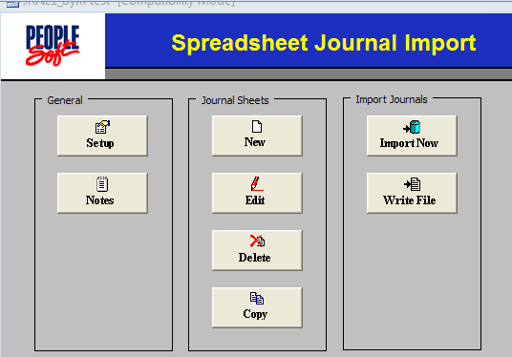
Figure 2. Spreadsheet Journal Import Worksheet

Fields | Description
Setup | Click to access the ‘Define Options and Defaults’ dialog box. Use to set journal header defaults, message logging options, document sequencing options, and online import controls. Options set here will default to journal sheets and journals created within this workbook.
Notes | Click to access another worksheet in the workbook that can be used as a scratch pad. Use the scratch pad for instructions, calculations, notes, and so on.
New | Click to insert a new journal sheet. A workbook can contain as many journal sheets as needed, and each journal sheet can contain as many journals as desired.
Edit | Click to edit an existing journal worksheet
Delete | Click to delete one or more journal sheets in the workbook
Copy | Click to copy one journal sheet to a new journal sheet saved under a new name
Import Now | The State of Kansas will use this functionality
Write File | Click to create and save HTML files for the selected journal sheets. After writing and saving one or more files, you must run the batch spreadsheet journal import process from SMART to upload the file.
Table 1. Spreadsheet Journal Import Control Sheet Fields
- Click on the Setup button. Enter the options and defaults as described below. Click the OK button when all information is entered.
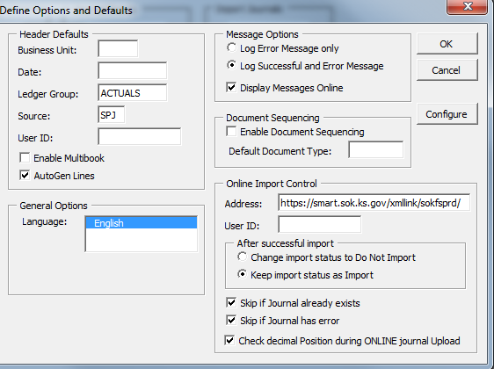
Figure 3. Define Options and Defaults Dialog Box

Fields | Description
Header Defaults section | Fill in your most commonly used journal parameters as defaults. The values are case sensitive. Agencies can enter their Business Unit so it will show on all future journal sheets.For your convenience, the ACTUALS ledger group and SPJ (spreadsheet journal) Source have been pre-filled for all State of Kansas users.
Message Options section | Choose whether you wish to see success and error messages or error messages only. You can also choose to view error messages online rather than using the text file on your workstation.
Online Import Control section | Leave the Address section alone. It is filled with the information necessary to make the Import Now function work. Fill in your User ID if this isn’t shared with other users at your agency. Keep import status as Import, Skip if Journal already exists, Skip if Journal has error, and Check decimal Position during ONLINE journal Upload are all selected.
Table 2. Define Options and Defaults Dialog Box Fields
- Click the New button on the Menu page. On the New Journal Sheet Name page, enter a name for the new journal such as date and purpose or type of journal, etc. Click the OK button and the spreadsheet will open.
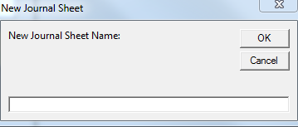
Figure 4. New Journal Sheet page
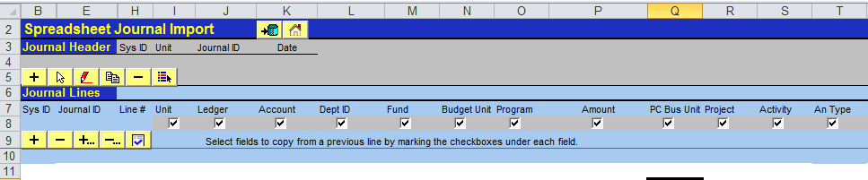
Figure 5. New Spreadsheet Journal Worksheet

- The spreadsheet journal Action buttons are decribed below by Row number:
Fields | Description
Row 2: Overall Actions Buttons
 | The State of Kansas will use the Import Now (Push) button
 | Returns to the Spreadsheet Journal Import Control sheet
Row 5: Journal Header Action Buttons
 | Create a new Journal Header
 | Select a Journal Header
 | Edit a Journal Header
 | Copy a Journal Header and Lines
 | Delete a journal entry
 | Change the import status of a journal
Row 9: Journal Lines Action Buttons
 | Add a journal line in the current selected journal header. Note: If you wish to copy values down to new lines, use the check boxes in row 8. If a check box is not selected, the initial value for that field on the succeeding line is blank.
 | Delete a journal line. Position your cursor on the line and click this button.
 | Add/Copy a block of multiple lines
 | Delete a block of multiple lines
 | Check the amount fields to verify that you have entered amounts with the correct number of decimal points. The default number of decimal points is 2. Click the button to check the number of decimal points before you import the journal.
Table 3. New Spreadsheet Journal Worksheet Fields
- Create a new Journal Header by clicking on the button on Row 5.
Figure 6. New Spreadsheet Journal Worksheet
- Enter the Journal Header information as you would for an online journal. Click the OK button when you are finished.
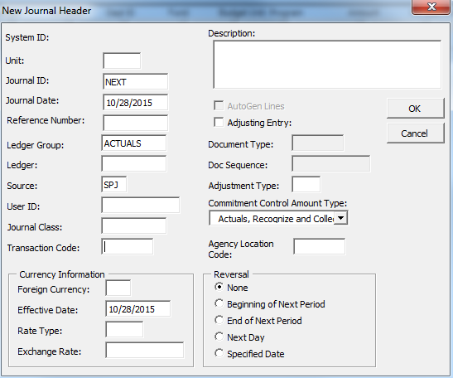
Figure 7. New Journal Header page

Fields | Description
Unit | Agency’s Business Unit
Journal ID | NEXT will assign the next available journal ID or you can enter a journal ID.
Journal Date | Current date. Must be in the General Ledger open period.
Reference Number | Identifies a document, person, invoice, date, or any other piece of information that is associated with a journal entry and is helpful when you need to trace back to the source of a transaction. Error messages that are logged contain the journal header reference to assist in researching the source of a transaction.
Ledger Group | ACTUALS (do not change)
Ledger | Leave blank
Source | SPJ (Spreadsheet journal) do not change
Description | Journal Header Description (254 characters)
Commitment Control Amount Type | Identifies the Commitment Control Amount type for the Journal. Should always be set to Actuals, Recognize, and Collect.
Other ChartFields | Leave blank unless they are mentioned above.
Table 4. New Journal Header Page Fields
- Create one new Journal Line by clicking on the button or multiple lines by clicking the button on Row 9 of the spreadsheet journal.
Figure 8. Spreadsheet Journal Import Journal Lines section
- There are 3 options for adding Journal lines. For all of the options, save the journal before importing the file.
  - Option 1: Enter the funding line ChartFields and Amount in the appropriate columns. If additional lines are need click on the button.
  - Option 2: Cut and paste the ChartFields from another spreadsheet. Prepare a spreadsheet and arrange the spreadsheet’s data in the same order as the columns in the Journal Spreadsheet. Add the number of lines needed using the button. ‘Copy’ the data from the other spreadsheet and ‘Paste as Values’ into the journal spreadsheet. If you have not added enough lines, you will receive an error and will need to add more lines and copy and paste again. If you have added too many lines, delete them using the. or buttons.
  - Option 3: Copy a prior journal and change the ChartFields and/or Amounts, as needed. Click on the button on Row 5 of the spreadsheet journal. In the Copy Journal Dialog Box, click to highlight the journal you wish to copy. Verify the Business Unit, Journal ID, and Journal Date then click on the ‘Copy’ button. After saving the new (copied) journal, make the journal header and line changes as needed.

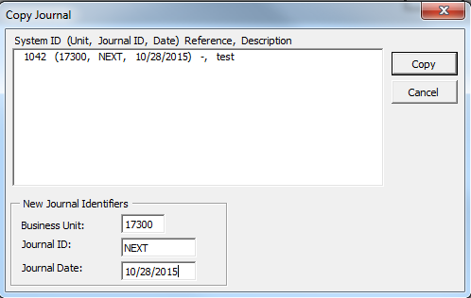
Figure 9. Copy Journal Dialog Box
- Save the file. You are ready to Import the file into SMART. There are two import options which are described below.

Topic 4: Uploading a Spreadsheet Journal
If you are using Spreadsheet Journal Import Process within SMART, Write the file which converts the spreadsheet into an HTML file format ready to be imported into SMART.

Procedure:

- On the Spreadsheet Journal Import Menu page, click on the Write File button.
Figure 10. Spreadsheet Journal Import Menu Page
- Click on the file name you just created. Note the location the file will be saved and press the OK button.

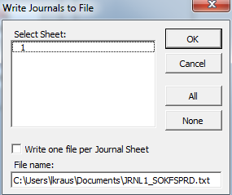
Figure 11. Write Journals to File Dialog Box
Fields | Description
Write one file per Journal Sheet check box | This check box defaults to not selected so that one file is generated for all journal sheets. You have the option of selecting this checkbox to create one file for each journal sheet and an index file.
File Name | Enter a name for the file including the path where you want it saved. **Tip: Note the file name so you can find it on your workstation during the import process.
Table 5. Write Journals to File Dialog Box Fields
- After writing file, log into SMART and use the spreadsheet journal import process to upload the file. Navigate to the import request page:
Page Name | Navigation
Spreadsheet Journal Import | Main Menu>General Ledger>Journals>Import Journals>Spreadsheet Journals

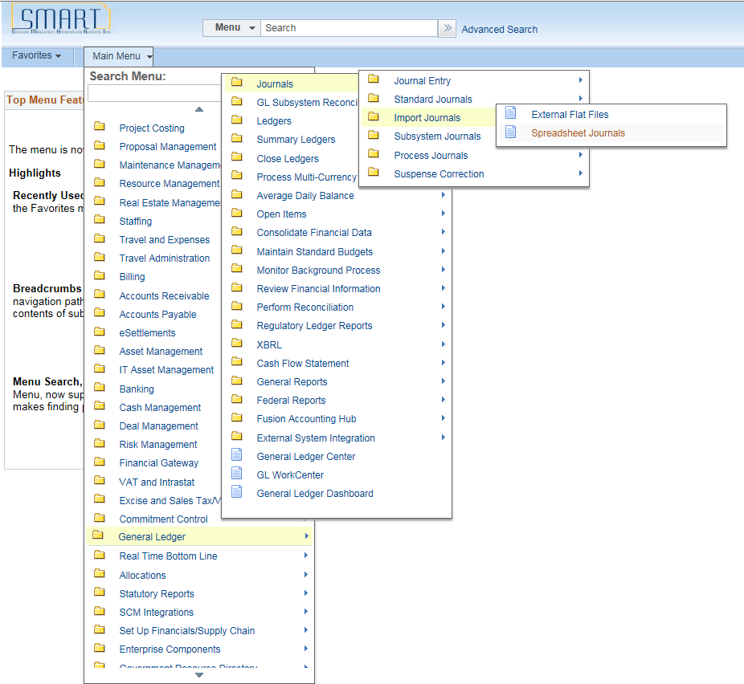
Figure 12. Spreadsheet Journal Import Request Navigation
- Review the Report Request Parameters. Click the Run button.

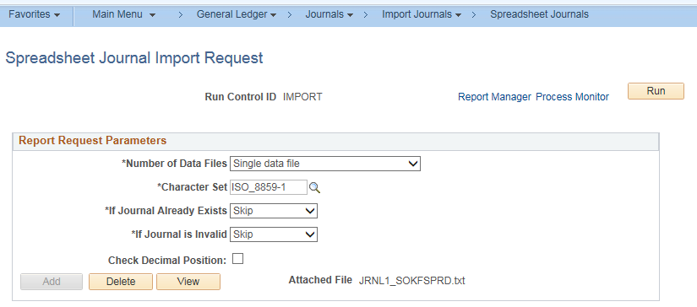
Figure 13. Spreadsheet Journal Import Request Page

Fields | Description
Number of Data Files | - Single data file - The file you attached to this page is the data file containing journal data.  - Index file to other data files - The file you attached to this page is an index file containing file path and file names to one or more data files stored elsewhere.
Character Set | For SMART, the character set is ISO_8859-1 and should not be changed
If Journal Already Exists | Select whether to abort, skip, or update if the journal id already exists
If Journal is Invalid | Select to abort or skip if the journal is invalid
Add | Click to add an attachment. Browse for the file you have written from the spreadsheet journal workbook, and then click Upload.
Delete | Click to delete an attachment
View | Click to display the contents of the attached file
Table 6. Spreadsheet Journal Import Request Page Fields

- Click OK on the Process Scheduler Request page.
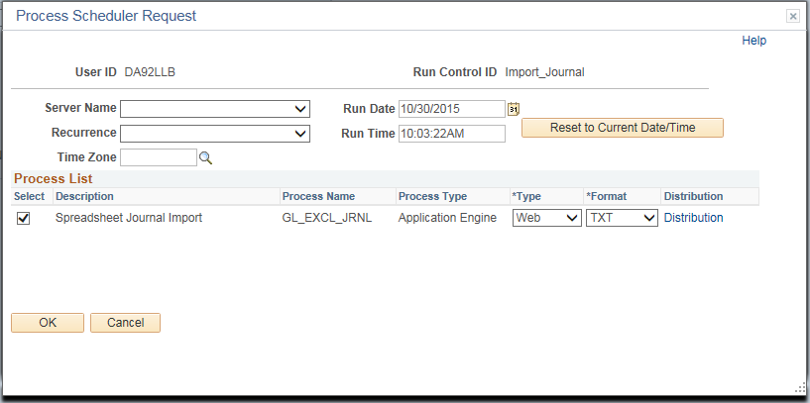
Figure 14. Process Scheduler Request

- Click on the Process Monitor hyperlink.

Figure 15. Spreadsheet Journal Import Request Page

- Click Refresh until the Process Instance shows Success and Posted. Click on the Details tab to view the Message Log.

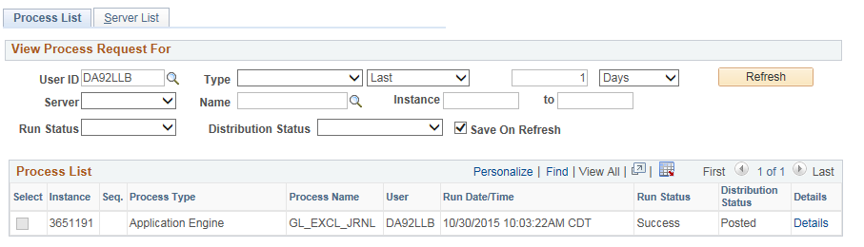
Figure 16. Process List Page

- Click on the Message Log under Actions.
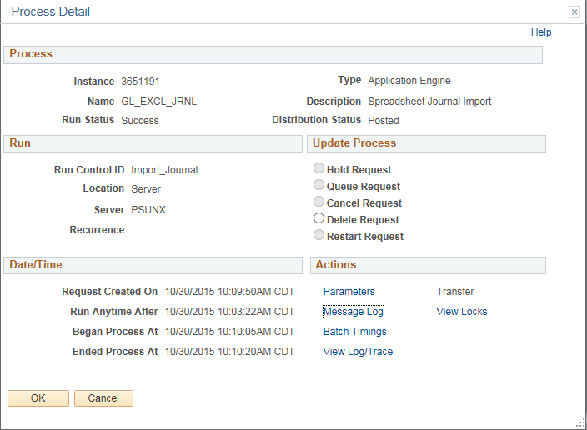
Figure 17. Process Details Page

- The message log will indicate if the Journal was imported. The message log provides reference to the log file and incorporates the Reference ID field value in all the messages logged.
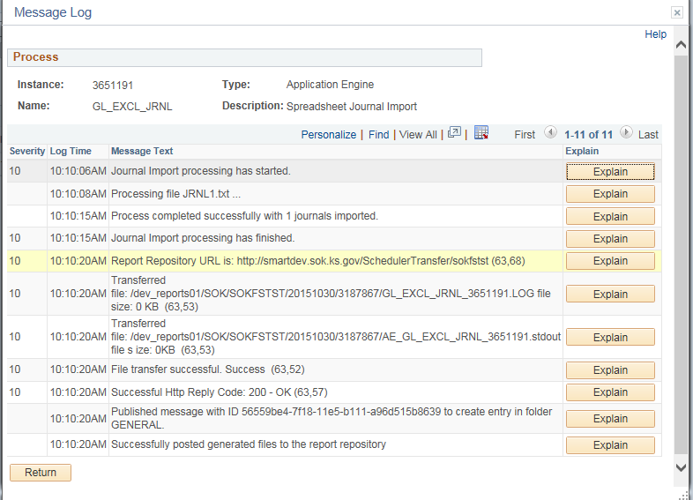
Figure 18. Message Log

- If there is an error, click on View Log/Trace hyperlink and open the Error Log. Spreadsheet journal validation is limited and it is not intended to be as broad as the validation provided with online journal entry. For batch import, error messages are provided in a separate log file and are not part of the message log.
Figure 19. Process Details Page

- The following are examples of error and warning messages that might be logged during spreadsheet journal import:
  - Logs error if “NEXT” is not used where only “NEXT” should be used.
  - Logs journal header validation errors
  - Logs journal line validation errors
  - Logs message for skipped journal headers
  - Logs message for skipped invalid journals
- After importing a journal from a spreadsheet, you must edit the journal before viewing it. If you attempt to open an imported journal before running the edit process, you get a warning message stating that the journal must be edited first. Due to the fact that you cannot access the journal online until it has been edited, we recommend that journal entries imported to SMART be edited using batch edit.
- After the journal is edited and saved, review the journal to ensure the totals are correct. If any changes are made, edit the journal again and submit into workflow.

Topic 5: Pushing a Spreadsheet Journal directly into SMART

- After you created your journal, you may Push the journal into SMART from the Spreadsheet Journal Import template. Click on the Import Now icon.

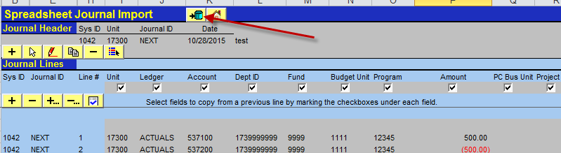
Figure 20. Spreadsheet Journal Worksheet Page

- Enter your User Id and SMART password in Import Journals Now dialog box.
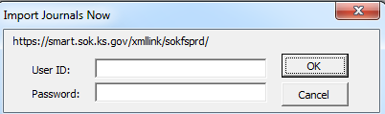
Figure 21. Spreadsheet Journal Worksheet Import Journals Now Dialog Box.

- The Import OK dialog box will be displayed when the journal is successfully imported.
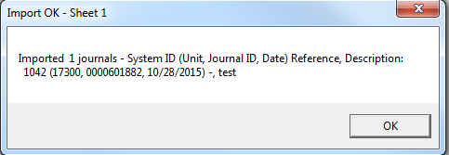
Figure 22. Spreadsheet Journal Worksheet Import Journals Now Page Import Message

- Spreadsheet journal validation is limited and it is not intended to be as broad as the validation provided with online journal entry. Error Message will be displayed in the Import Message if the journal does not successfully load. The journal log spreadsheet will also contain details of successful and unsuccessful imports.
- The following are examples of error and warning messages that might be logged during spreadsheet journal push:
  - Logs journal header validation errors
  - Logs journal line validation errors
  - Logs message for skipped journal headers
  - Logs message for skipped invalid journals
- After pushing a journal from a spreadsheet, you must edit the journal before viewing it. If you attempt to open an imported journal before running the edit process, you get a warning message stating that the journal must be edited first. Due to the fact that you cannot access the journal online until it has been edited, we recommend that journal entries pushed into SMART be edited using batch edit.
- After the journal is edited and saved, review the journal to ensure the totals are correct. If any changes are made, edit the journal again and submit into workflow.

