Training Guide – General Ledger
Online Journal Entries
State of Kansas

Applicable Role(s):

Kansas GL Processor
Kansas GL Approver
Kansas GL Viewer

TABLE OF CONTENTS
Topic 1: Creating a New Journal Entry 3
Topic 2: Saving a Journal with Incomplete Status 8
Topic 3: Adding Attachments 9
Topic 4: Control Totals 12
Topic 5: Copying a Journal Entry 14

Topic 1: Creating a New Journal Entry
Journal entries are made to record the financial transactions of a business. They post in a double entry system, according to Generally Accepted Accounting Principles (GAAP), where debits equal credits.
Journal entries in PeopleSoft consist of a header, which records the information that uniquely identifies the journal entry and detail lines, which record the individual transactions and the affected ChartFields.
Procedure:

- Navigate to Create/Update Journal Entries Tab.
Tab Name | Path
Create/Update Journal Entries | Main Menu>General Ledger>Journals>Journal Entry>Create/Update Journal Entries
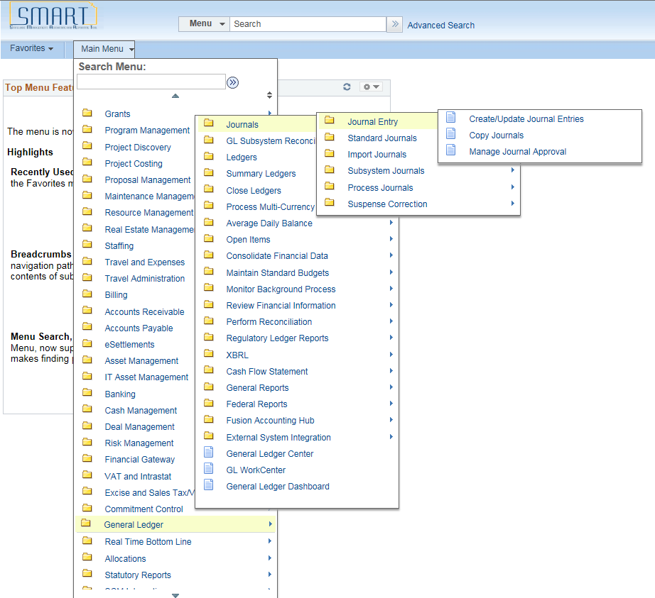

Figure 1. Navigation Page

- To create a new journal entry, click on Add a New Value tab and add/review the Business Unit, Journal ID and Date. Click the Add button.
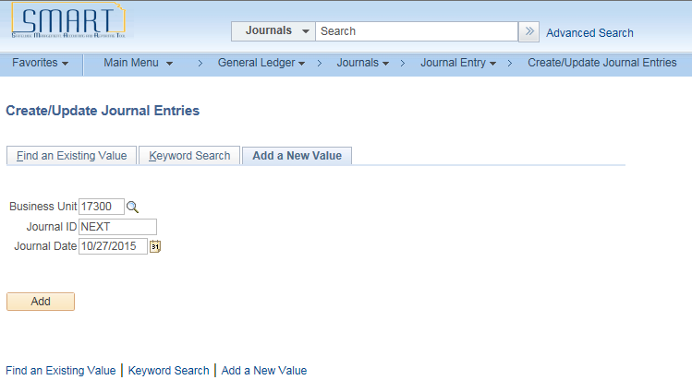
Figure 2. Create/Update Journal Entries Tab
Fields | Description
Journal ID | A unique number to identify the journal. SMART will automatically assign a number or the user can create a journal ID.
Journal Date | This field defaults to the current date. The date can be changed so the journal is posted on the appropriate day of they open accounting period (month).
Table 1. Create/Update Journal Entries Fields

- On the Header Tab,
  - The Business Unit, Journal ID and Date populate from the previous Tab.
  - Enter the Long Description, Ledger Group, and Source.
  - Add Attachments to assist the approver as they review the journal. See Topic 3 for additional information.
  - Click the Save Journal Incomplete Status box to hold the journal from further processing. See Topic 2 for additional information.
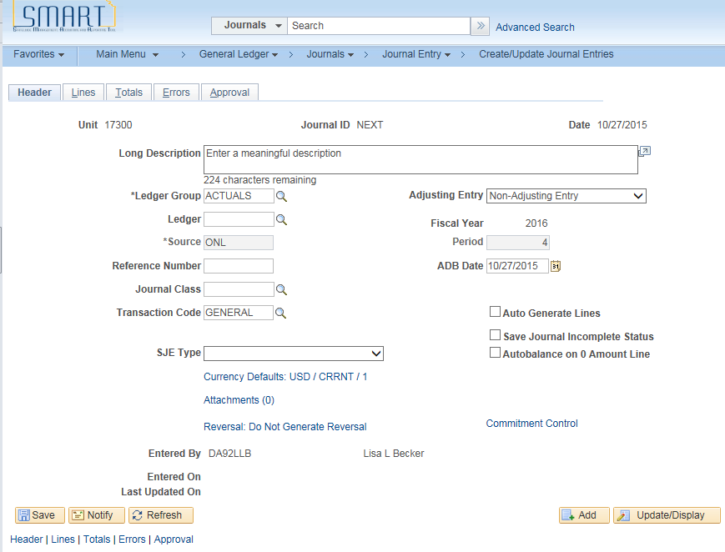
Figure 3. Journal Entries Header Tab
Fields | Description
Ledger Group | SMART auto populates the Ledger Group and Source fields with default information based on the setup of your SMART User ID. The Ledger Group defines where to post the journal.
Source | The Source field defaults with the source from which the journal is originating. If you are entering a journal online, the field defaults to ONL, indicating that this entry is for an online journal entry. If a journal with a subsystem source is copied, the field will need to be changed to ONL.
Long Description | Use the Long Description field to enter information describing the reason for the journal
Save Journal Incomplete Status | If necessary, use the Save Journal Incomplete Status checkbox to finalize the journal later
Attachments | Use this link to add attachments such as work papers or spreadsheets to the Journal. See the Informational Circular 16-A-007 Attachments in SMART for additional information.
Table 2. Header Tab Fields
- On the Lines Tab,
  - The Business Unit, Journal ID and Date populate from the previous Tab.
  - Enter the funding and amount on each line. Use the add and delete buttons, as needed.
  - The Budget Date should be visible on each journal line.
  - Use the scroll bar inside the Lines box to display additional columns.
  - The debits and credits for each Fund and Budget Unit combination must balance.
  - Save the journal and exit. The best practice is to allow the hourly and bi-hourly processes to edit, budget check, and submit the journal into workflow.
  - The hourly and bi-hourly processes run as follows:
    - Budget Checking runs hourly
    - Submit Journal (approvals) run bi-hourly
    - Edit ChartFields runs bi-hourly.
- If you need to process the journal from the Lines tab, see the Process options below.

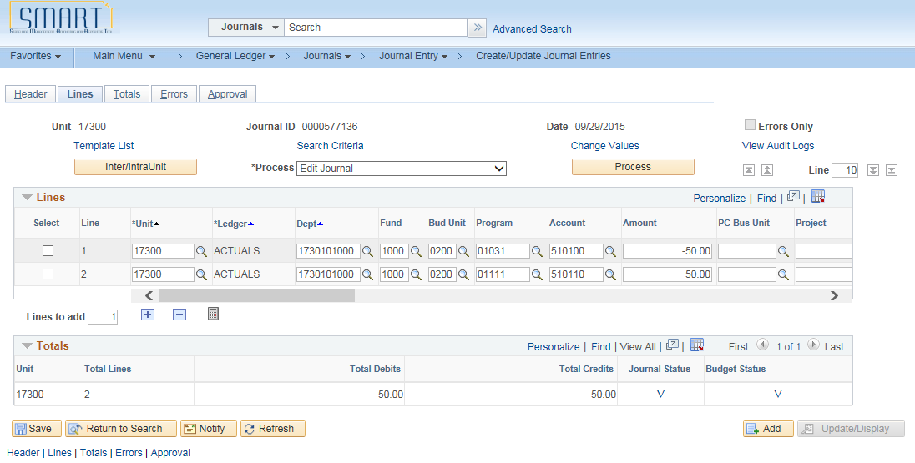
Figure 4. Lines Tab Left Side of Page
Figure 5. Lines Tab Center of Page
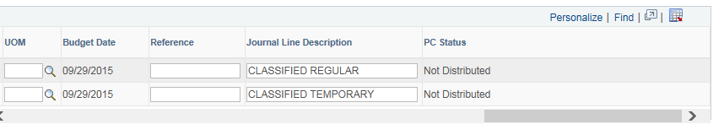
Figure 6. Lines Tab Right Side of Page
Fields | Description
Process | Use the Process field to select a task to run. Choose from the following tasks:  • Budget Check Journal: enables you to check the journal lines for the control budget.  • Copy Journal: enables you to copy your journal to a new journal.  • Delete Journal: enables you to delete the current journal. The journal cannot be posted if you want to Delete.  • Edit / Pre-Check: enables the journal to be edited and run through the Budget Processor. However, the Budget Processor will only check the journal but the funds will not be reserved.  • Edit ChartField: enables you to check if the journal has any ChartField related errors.  • Edit Journal: enables the journal to be edited and budget checked. This process must be ran again if any changes are made to the journal.  • Post Journal: enables you to post the journal. (NOT AVAILABLE TO AGENCY USERS)  • Print Journal: enables you to create the Journal Entry Detail report, GLX7501 (or GLX7502 for separate debit and credit), which is a BI Publisher printed copy of the journal.  • Refresh Journal: enables you to retrieve this journal from the database to the Tab again.  • Submit Journal: enables you to initiate journal approval through workflow processing.
Lines to add | Enter the number of lines that you want to add when you click the Insert Journal Lines button to the right.
 | To add additional lines to the scroll, enter the number of lines to add in the lines to add field, and click the Insert Journal Lines button.
 | Select the check box next to any journal line that you want to delete, and click the Delete Selected Journal Lines button.
Total Debits | You are able to view that the journal is balanced because the value in the Total Debits column is equal to the value in the Total Credits column. Once you have a balanced journal, you may begin processing the journal directly from this Tab.
Total Credits | You are able to view that the journal is balanced because the value in the Total Debits column is equal to the value in the Total Credits column. Once you have a balanced journal, you may begin processing the journal directly from this Tab.
Journal Status | The Journal Status changes to "V" after the journal is successfully edited, where "V" stands for "Valid.” It is important to know that a journal must have a valid journal status before it can be posted. From this point, the journal automatically progresses through to the budget check process.
Budget Status | The Budget Status changes to "V" after the journal is successfully budget checked, where "V" stands for "Valid.” It is important to know that a journal must have a valid budget status before it can be posted. From this point, the journal automatically progresses through workflow to the approval process.
Table 3. Lines Tab Fields

Topic 2: Saving a Journal with Incomplete Status
The ‘Save Journal Incomplete Status’ checkbox on the Header tab is available if you are not ready to submit a journal for processing and approval.

Procedure:
- Click on the journal Header tab.
- Click the check box next to the Save Journal Incomplete Status
- Once you return to the journal and complete your data entry, clear the Save Journal Incomplete Status check box to allow the journal to process.
- If you are planning to edit the journal on the journal Lines tab, it is not necessary to deselect the Save Journal Incomplete Status field.
Figure 7. Journal Header Tab

Topic 3: Adding Attachments
The Attachments link on the Header tab will attach a file with supporting documentation for your journal entry. For example, you might want to attach a spreadsheet that details how the journal entry was derived.
The number in the parenthesis denotes how many documents that you have attached to the journal entry.
Procedure:
  - Save the Journal prior to adding Attachments.
  - On the Header tab, click on the Attachments hyperlink.
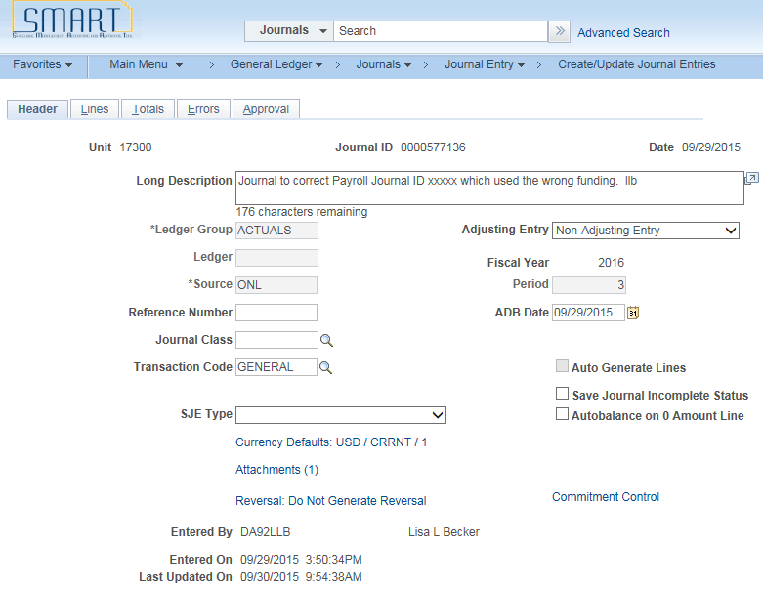
Figure 8. Header Tab

  - The Journal Entry Attachments page will be displayed. Click on the Add Attachment button.
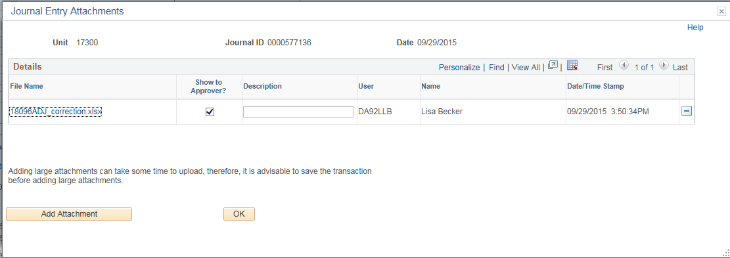
Figure 9. Journal Entries Attachments Page

  - On the File Attachment Tab, browse for the file you are attaching. After you highlight the file name, click the Upload button.
Figure 10. File Attachment Page
  - Click the check box to Show (the attachment) to Approver.
  - Add a Description of the file.
  - Add additional attachments, if needed.
  - Use the button on the file name line to delete an attachment.
Figure 11. Journal Entry Attachments Page

Topic 4: Control Totals
The Totals tab enables you to verify the amounts in a journal entry. As you enter the journal lines, SMART displays a running total of the actual debits, credits, and lines, as well as the net difference between the amounts entered and the control totals.

When you edit the journal and the control totals do not equal the actual totals, SMART flags the journal as having errors. The journal errors need to be corrected before the journal entry can be posted in SMART.

For example, suppose that you have plans to allocate rent expense across several departments and know that the total rent expense is $50,000 USD for 2,000 square feet. Because you know how many departments are involved, you know that there will be 15 lines in the completed journal entry. You enter can these amounts as control totals to ensure that when the journal lines are entered, these amounts match before the journal is posted.

Procedure:

- Click on the Totals tab.
Figure 12. Header Tab

- Review the Business Unit, Ledger, Fund and Bud Unit values. These should be populated from the Lines Tab.
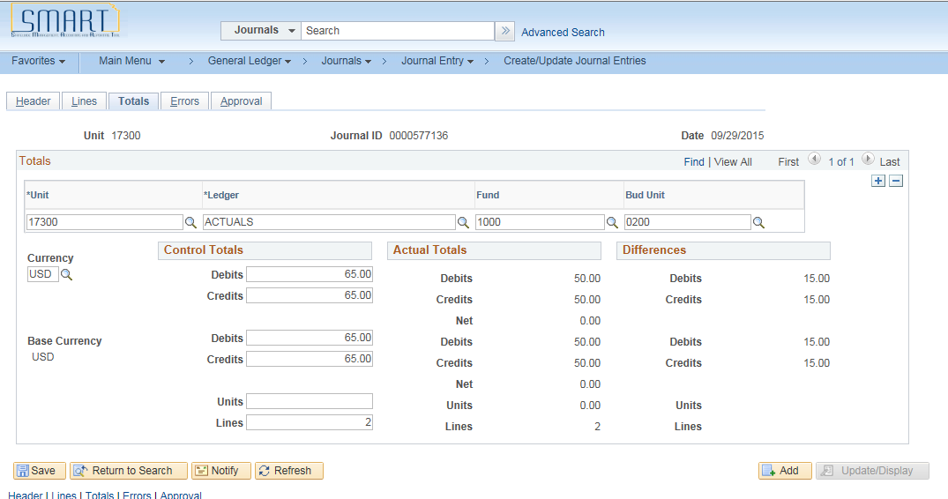
Figure 13. Totals Tab
- Enter the Control Totals Debits and Credits for the Currency and Base Currency.
  - When entering a control total on a journal in SMART, you must first populate an Account number on the Lines Tab.
- Enter the number of total Units and total Lines expected on the journal entry.
- Save or Refresh the Journal to populate the Differences.
- If the Fund and Budget Unit Debit and Credit totals are not balanced, make corrections on the Lines Tab, as needed.
Fields | Description
Fund and Budget Unit | The system will automatically populate the fund and budget unit on the totals Tab as funds and budget units are added in the lines tab. You do not need to pre-populate the fund and budget unit on the total tab but it is an option to do so. The Fund and Budget Unit numbers you enter on the Totals Tab, must MATCH the Fund and Budget Unit numbers you enter on the Lines Tab.
Control Totals Section | Specify the total debits, credits, statistical units, and number of lines to be entered. If you leave any of the control total fields blank, SMART will not validate against the associated actual total.
Actual Totals Section | As you enter the journal lines, SMART displays a running total of the actual debits, credits, units, and lines.
Differences Section | This section displays the differences between the Control Totals fields and the Actual Totals fields. If the Control Totals do not match the Actual Totals, the journal will show as having an error.
Table 4. Totals Tab Fields

Topic 5: Copying a Journal Entry
You might find that similar or identical journals recur with some frequency. To avoid having to retype the same information, you can use an existing journal as the basis for a new journal entry.

You can copy posted or unposted journals and then change the header or detail lines, as needed. The new journal is identified as not yet edited, and you must edit it before it can be posted.

There are two methods for copying a journal:
- Use the Journal Entry Tab and choose the Copy Journal process
- Use the Copy Journals Request Tab to run the copy process

Procedure:

- Navigate to the Create/Update Journal Entries Tab. Choose the Find an Existing Value tab and enter the Business Unit, Journal ID and Date you wish to copy.
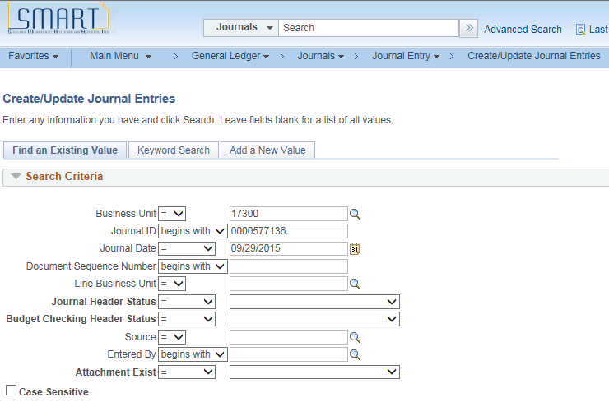
Figure 14. Create/Update Journal Entries Page
Fields | Description
Journal ID | A unique number to identify the journal.
Journal Date | This field defaults to the current date.
Table 5. Create/Update Journal Entries Fields
- Click on the journal entry Lines tab.
Figure 15. Lines Tab
- In the Process box, click on the drop down menu and choose Copy Journal. Click the Process button.

Figure 16. Lines Tab

- On the Journal Entry Copy page, enter/review the new Journal ID and new Journal Date. If needed, click the Reverse Signs box, Recalculate Budget Date box and/or the Save Journal Incomplete Status box. Click OK.
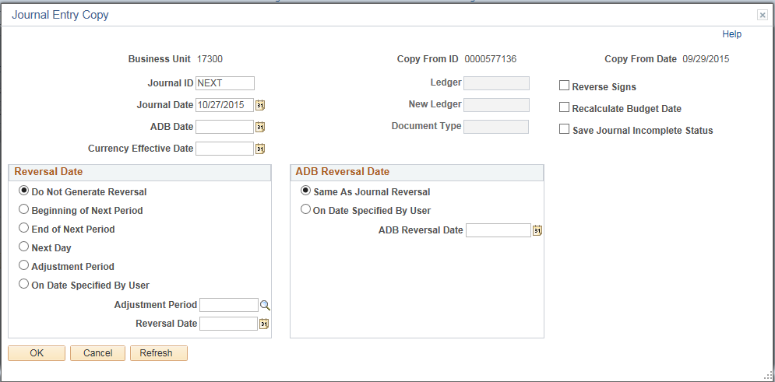
Figure 17. Journal Entry Copy Page

Fields |  | Description
New Journal ID | Accept the default value of “NEXT" in this field to assign the next journal number automatically to the new journal or enter a journal ID.
New Date | Enter a journal date for this new journal. The default is the current date.
Reverse Signs | Select this if you want the new journal to have the opposite sign from the original journal. For example, if you need to reverse a posted journal.
Recalculate Budget Date | If selected, the copy journal process sets the budget date as the journal date; otherwise, it copies the old budget date.
Save Journal Incomplete Status | If selected, the new journal saves in an incomplete status
Table 6. Journal Entry Copy Page Fields

A Journal can be copied using the Copy Journals Request Page.

Procedure:

- Navigate to the Copy Journals Request Page:
Tab Name | Path
Copy Journals Request | Main Menu>General Ledger>Journals>Journal Entry>Copy Journals

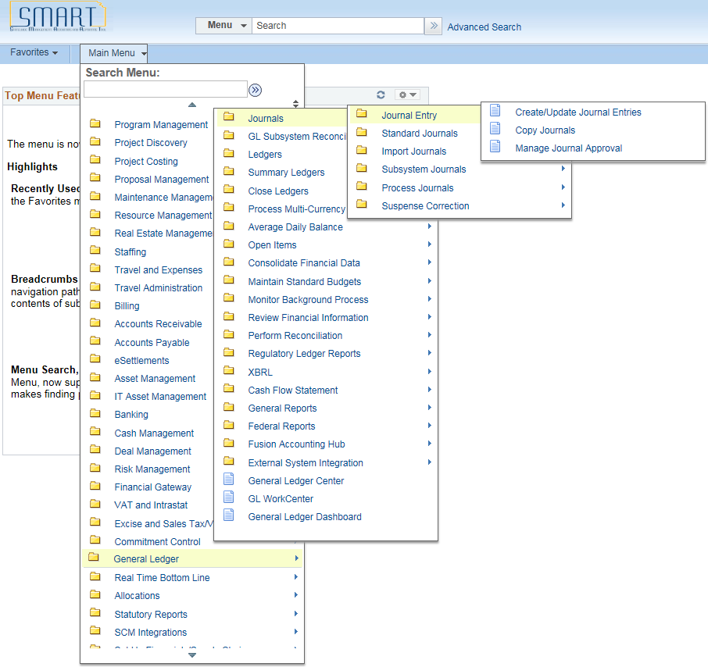

Figure 18. Navigation Page

- Click on the Add a New Value tab, enter a new Run Control ID. Click the Add button
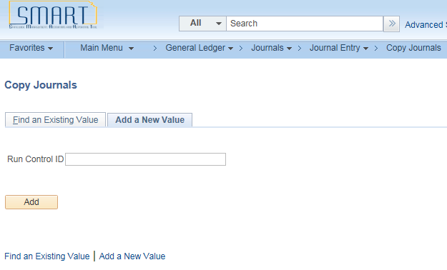
Or
Click on the Find an Existing Value tab, leave the Run Control ID blank and click the Search button. Choose the saved Run Control.
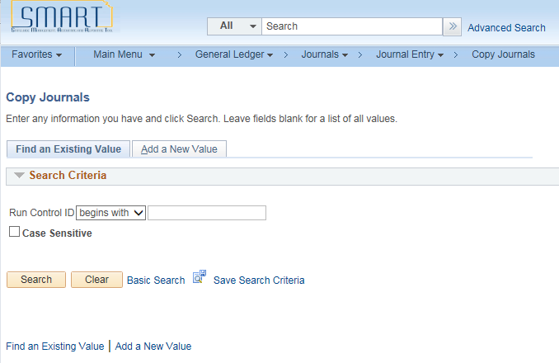
Figure 19. Copy Journals Run Control Page

- On the Copy Journals Request Page, enter the required Fields. Click the Run button.
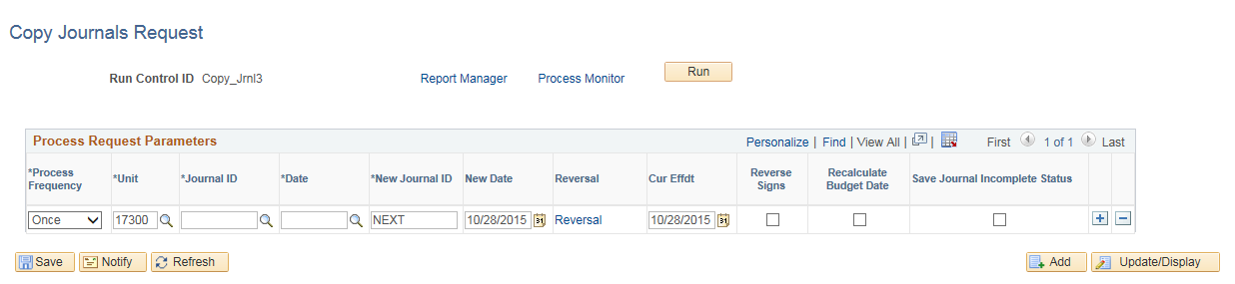Figure 20. Copy Journals Request Page

Fields | Description
Process Frequency | Accept the default value of “Once”
Unit, Journal ID, Date | Enter the values for the journal you wish to copy
New Journal ID | Accept the default value of “NEXT” in this field to assign the next journal number automatically to the new journal or enter a journal ID.
Reversal link | Leave the Do Not Generate Reversal radio button clicked. If the copied journal needs to be reversed at a future date, click and enter the appropriate information.
New Date | Enter a journal date for this new journal. The default is the current date.
Reverse Signs | Select this if you want the new journal to have the opposite sign from the original journal. For example, if you need to reverse a posted journal.
Recalculate Budget Date | If selected, the copy journal process sets the budget date as the journal date; otherwise, it copies the old budget date. Always check this box.
Save Journal Incomplete Status | If selected, the new journal saves in an incomplete status
Table 7. Copy Journals Request Page Fields

- The Process Scheduler Request page will be displayed, click OK.
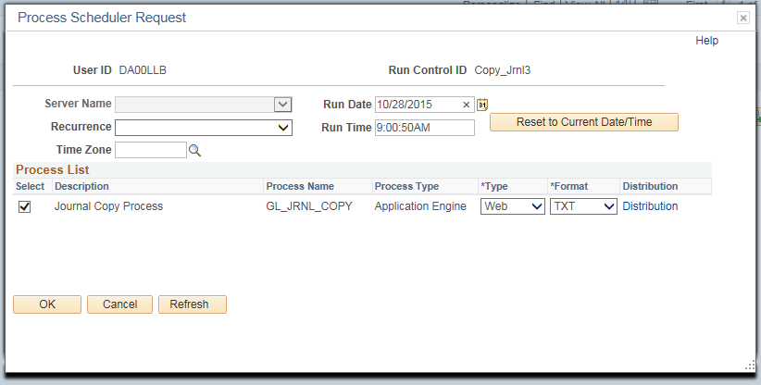
Figure 21. Process Scheduler Request Page

- Click the Refresh button until the Process Instance shows Success and Posted.
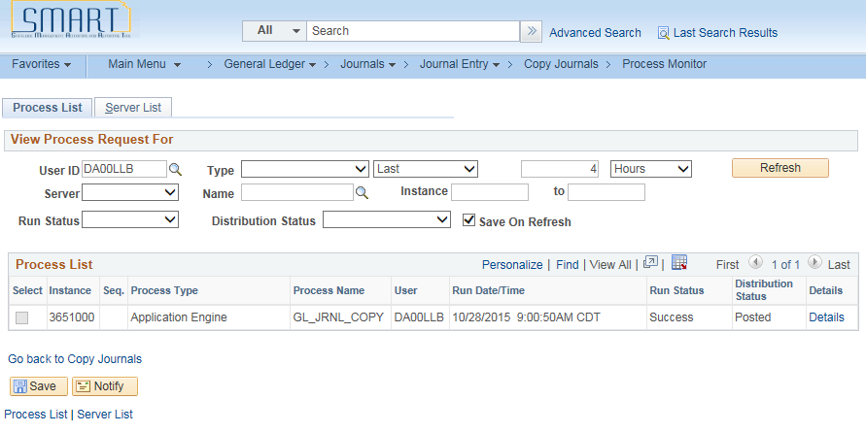
Figure 22. Process List Page
- Navigate to Create/Update Journal Entries, Find an Existing Value tab. Enter the Journal Date from the copied journal and Journal Header Status = No Status – Needs to be Edited. Click Search. The copied journal will be displayed.
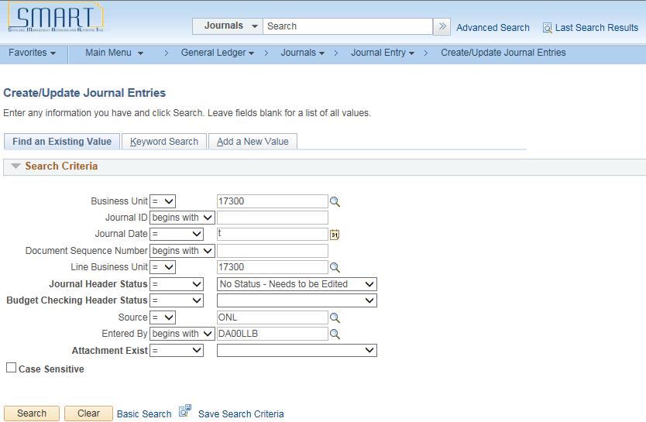
Figure 23. Create/Update Journal Entries Page

- On the copied journal, the Journal Status=N and the Budget Status=N. Review, save, and run the Edit Journal process.
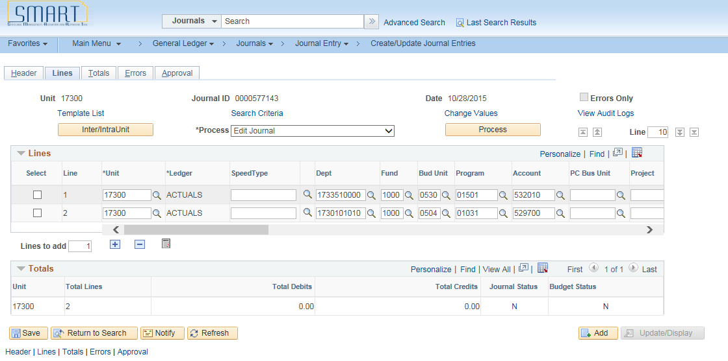
Figure 24. Journal Lines Tab

