**State of Kansas**



**Asset Management: Copying an Existing Asset**

***Statewide Management, Accounting and Reporting Tool***

|  |  |
| --- | --- |
| **Date Created:** | 11/2/2015 |
| **Version:** | 2.0 |
| **Last Updated Date:** |  |
| **Purpose:** | *This document is an update to the 9.0 document with the same name.* |
| **Security:** | Role Security: The following roles are applicable:  Agency Asset Processor  BU Security: Business Unit Security is applied. Agencies will only have access to the assets in their Business Unit. |

Procedure

Copying an asset saves time if the existing asset's financial and physical information is similar to the asset(s) that you want to create.

Note that Child Assets can be copied but Parent Assets cannot.

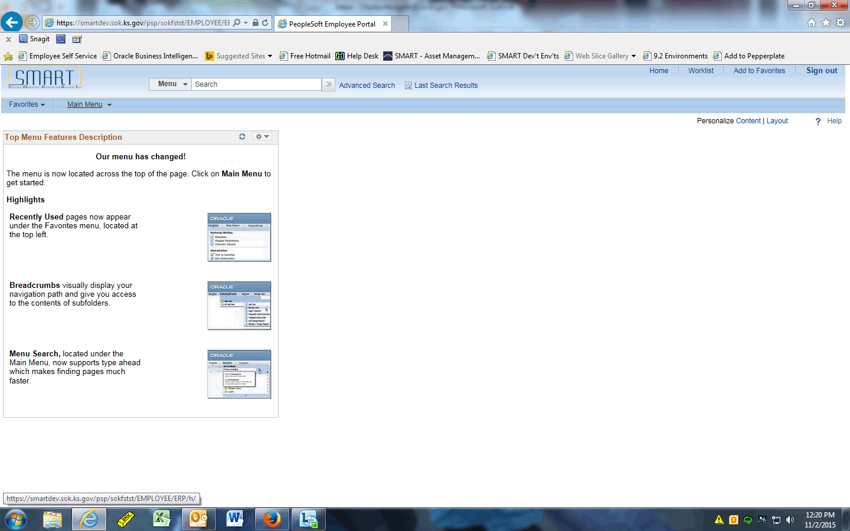

| **Step** | **Action** |
| --- | --- |
|  | Click the **Main Menu** button. |
|  | Click the **Asset Management** menu. |
|  | Click the **Asset Transactions** menu. |
|  | Click the **Owned Assets** menu. |
|  | Click the **Copy Existing Asset** menu. |

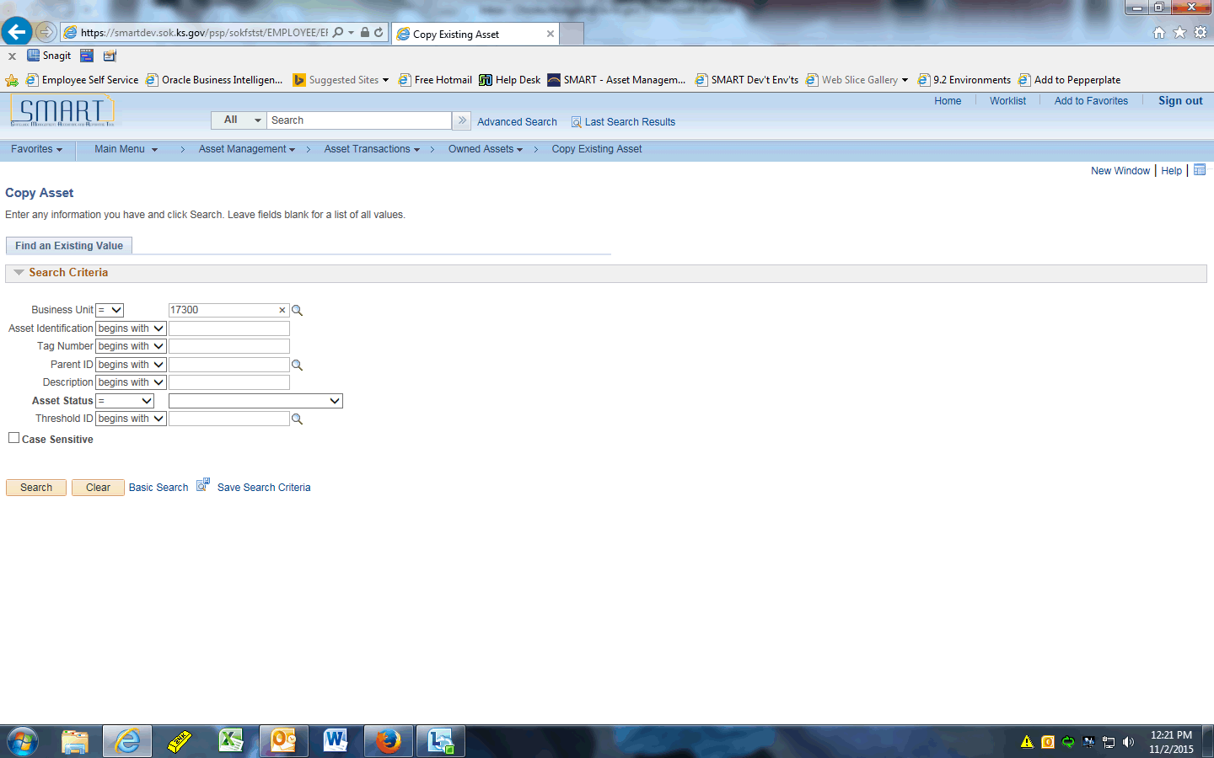

| **Step** | **Action** |
| --- | --- |
|  | Enter the desired information into the **Asset Identification** field. Enter "**000000000045**". |
|  | Click the **Search** button. |
|  | In this example, 2 assets will be created. Both were acquired in a prior month, and one needs to have the funding changed from what defaults from the existing asset.  SMART automatically copies the basic information, book, cost, custodian, and location. Other options are selected in the Asset Copy Options section and can be unchecked if applicable. |

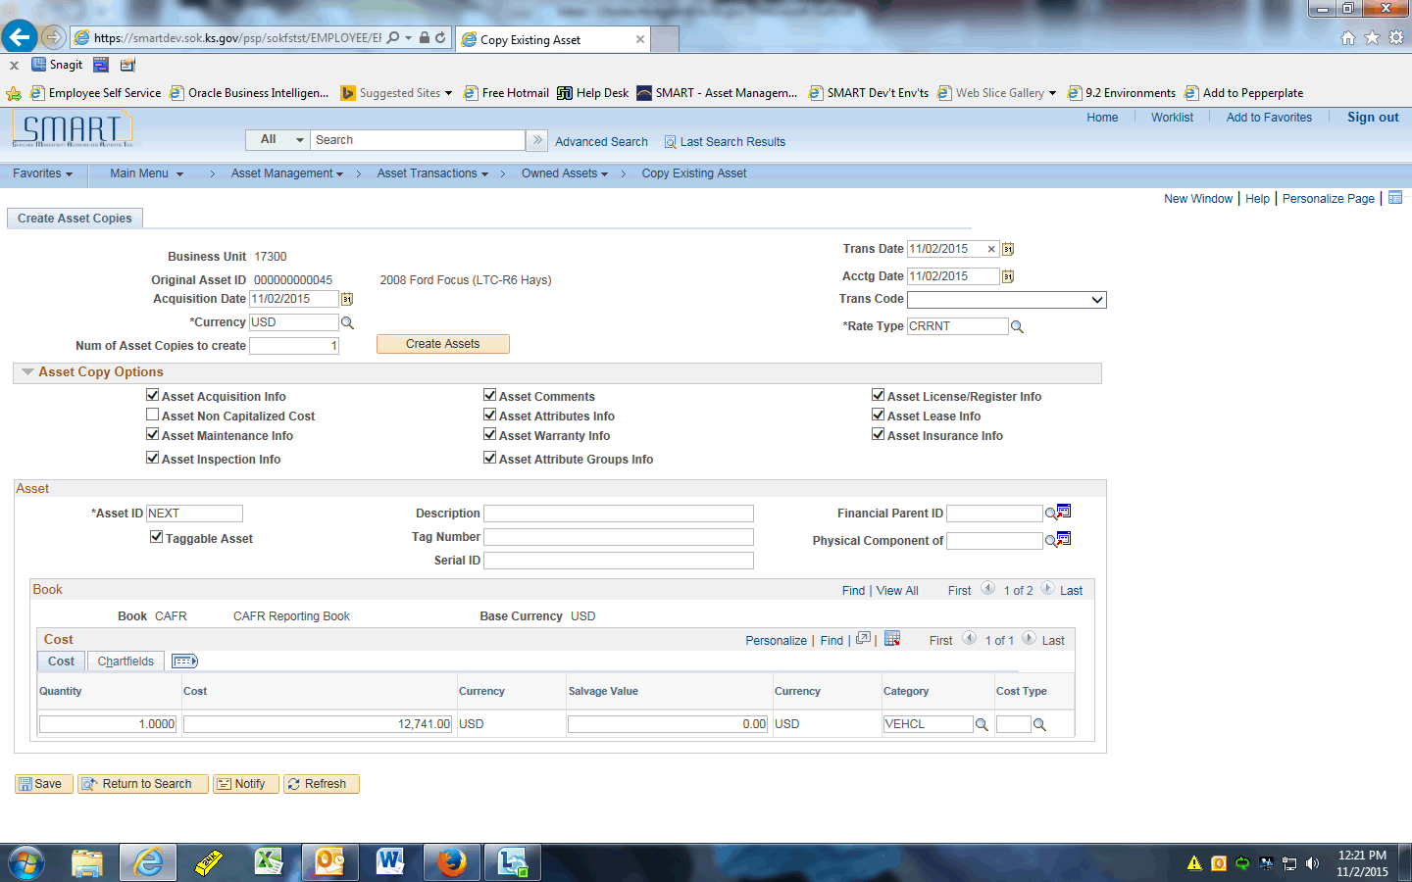

| **Step** | **Action** |
| --- | --- |
|  | Enter the desired information into the **Acquisition Date** field. Enter "**08/01/2015**".  This is the date the asset was acquired, which is why we are backdating this field. |
|  | Enter the desired information into the **Num of Asset Copies to create** field. Enter "**2**". |
|  | Enter the desired information into the **Trans Date** field. Enter "**08/01/2015**".  This is the date the asset was put in service. This drives the depreciation start date. |
|  | Click the **Create Assets** button. |
|  | Notice that the Asset ID fields change to NEXT and NEXT1. This means that the next two available Asset IDs will be used when these copies are saved.  A new asset section is added for every copy being created. This allows you to change any information that defaulted from the original, such as cost and funding. |
|  | Always specify a description in the Description field. Otherwise, the Profile ID’s default description (not the description from the asset being copied) will populate here.  Enter the desired information into the **Description** field. Enter "**2008 Ford Focus Copy 1**". |
|  | Enter the desired information into the **Tag Number** field. Enter "**123QWE**". |
|  | Enter the desired information into the **Description** field. Enter "**Ford Focus Copy 2**". |
|  | Enter the desired information into the **Tag Number** field. Enter "**456POI**". |
|  | Click the **Chartfields** object. |
|  | Now we'll change the default funding on the second asset.  Click the **Look up Fund (Alt+5)** button. |
|  | Click the **2017** link. |
|  | Click the **Save** button. |
|  | The system immediately assigns the Asset IDs. These assets can now be viewed in Basic Add. |
|  | This concludes the 'AM - Copying an Existing Asset' topic. Thank you for taking this course.  **End of Procedure.** |