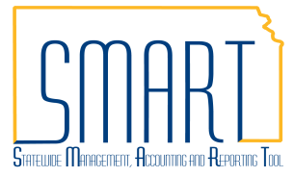**State of Kansas**



**Reviewing Historical Payment Data**

**in Travel and Expenses**

***Statewide Management, Accounting and Reporting Tool***

|  |  |  |
| --- | --- | --- |
| **Date Created:** | | 05/05/2016 |
| **Version:** | | 1.0 |
| **Security:** | | * BU Security: Business Unit Security is applied. Agencies will only have access to view the payment information associated with their agency business unit. * Roles: The Agency Expense Proxy (KAP_Agy_Expense_Proxy) user role is required to access the Payment History page. |
| **Purpose:** | | * The purpose of this job aid is to provide agencies with a way to look up historical payment information. Agencies will be able to view data for payments including the payment method, payment date, payment reconcile status, and supplier/employee address associated with the payment. |
| **Navigation** | | Travel and Expenses > Process Expenses > Review Payments > Payment History |
| **1.** | Find the Check Number for the payment |  |

|  |  |  |
| --- | --- | --- |
| **Navigation** | | Accounts Payable > Review Accounts Payable Info > Payments > Payment |
| **2.** | Navigate to the Payment Inquiry page  Key the Check Number in the Reference field. Clear the Remit SetID field. Click the Search button.  In the results section, click the Payment Reference ID hyperlink. This will allow you to view more details about the payment. |  |

|  |  |
| --- | --- |
| **3.** | View Payment Information |
|  | |