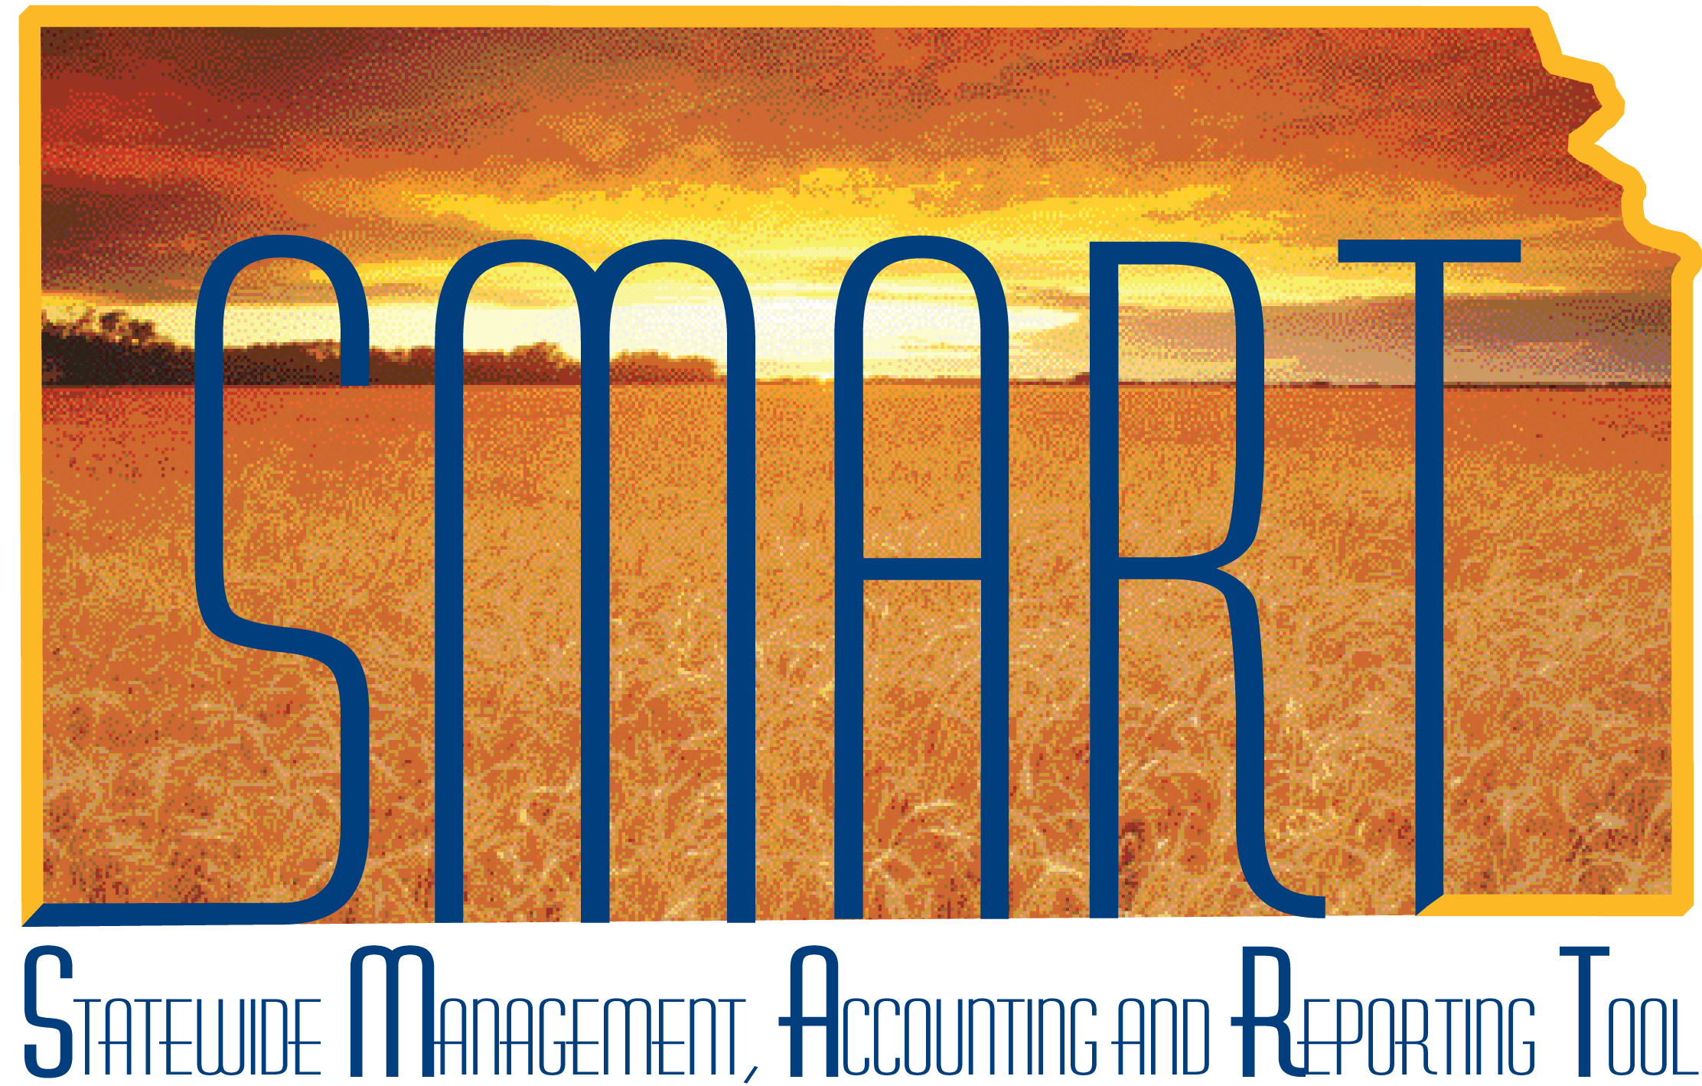

Participant Guide –Entering Supplier Contracts

State of Kansas

Table of Contents
Understanding Supplier Contracts 3
Keys Terms 3
Key Concepts 4
Roles Involved in Supplier Contract Entry 5
Entering a Supplier Contract 6
Contract Entry Page 6
Contract Entry – Contract Page 7
Header Section - Fields 8
Header Section – Checkboxes 10
Header Section – Links 11
Add/Edit Comments 11
Use Standard Comments 14
Contract Activities 17
Primary Contact Info 17
Activity Log 18
Document Status 18
Purchase Order BU Defaults 19
Contract Term/Renewals 20
Additional – Account Summary 21
Contract Open Item Reference 22
Contract Items - Lines 23
Contract Categories – Lines 23
Copying a Supplier Contract 23
Contract Entry – Copy Contract 24
Contract Search 24
Select Contract – Contracts 25
Select Contract – More Details 26
Completing an Agency Supplier Contract 26
Under Delegated Authority or PR $25,000 or Under 27
Prior Authorization OVER $25,000 27

Understanding Supplier Contracts

Keys Terms
Office of Procurement & Contracts (OPC) | K.S.A. 75-3737(a) establishes a centralized division of purchases within the Department of Administration (Office of Procurement & Contracts). Subsequent statutes, 75-3738 & 75-3739 grant authority over purchases made by the state.
Delegated Purchasing Authority | K.S.A. 75-3739(e) allows the Director of Purchases, with the approval of the Secretary of Administration, to delegate authority to any state agency to make purchases of less than $25,000. Under this statute, the Director of Purchases has generally authorized for state agencies to spend up to $5,000 with one supplier during each fiscal year. Under this authorization, the agency can spend up to $5,000 with one supplier using their delegated purchasing authority during a budget year, in addition to any spend which occurs using a prior authorization and/or state contract. (Informational Circular No. 17-A-005)
Fiscal Year | The fiscal year has been defined to be equivalent to the budget year. (July 1, 20XX to June 30, 20XX)
Supplier Contracts | A binding agreement between the State of Kansas and a supplier created from the Supplier Contract module. Contracts may be added online or may originate from Strategic Sourcing bid events.
Statewide Mandatory | Contracts created and managed by the Office of Procurement & Contracts that are required use for state agencies purchasing services or items covered by the contracts.
Statewide Optional | Contracts created and managed by the Office of Procurement & Contracts. Statewide Optional allows agencies to choose which optional contract supplier to use, for example based on region, but agencies are still required to use one of the contracts for services or items covered.

Agency Specific | Different types of agency specific contracts include:  - Contracts created by the Office of Procurement & Contracts from bid events awarded on behalf of one or a specific group of agencies  - Contracts created by the agency with a maximum amount under their delegated purchasing authority  - Contracts created by the agency with a maximum amount above their delegated purchasing authority that has been authorized via an approved Prior Authorization requisition
Political Subdivision Availability | - Yes – Contract can be used by political Subdivisions (such as municipalities) or state agencies other than those directly associated with the contract  - No– Contract cannot be used by political Subdivisions (such as municipalities) or state agencies other than those directly associated with the contract

Key Concepts

When a requisition is created above $5,000 and a contract is applied, purchasing authority is assumed to come from the contract and the requisition will not workflow to the Office of Procurement and Contracts for approval. It is the agency’s responsibility to ensure the contracts they associate to a requisition is accurate for the purchase being made.
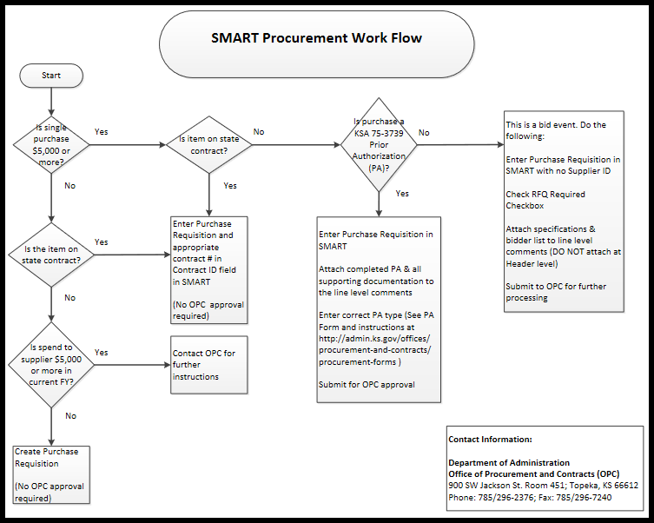

Roles Involved in Supplier Contract Entry
SMART User Role | Key Activities per Role – Supplier Contract Entry
Agency Contract Processor | Enters transactional contract data but cannot maintain contracts. Therefore, if changes are needed after the original save the Office of Procurement and Contracts will need to be contacted.
Central Contract Processor | Enters transactional contract data, creates contract documents, sets up collaborations, and performs contract maintenance.
Central Contract Administrator | Maintains Supplier Contract configuration.

Entering a Supplier Contract

Contract Entry Page

Fluid Navigation: SMART Homepage > Contracts & Strategic Sourcing > Supplier Contracts > Contract Entry > Add a New Value

Classic Navigation: SMART Homepage > NavBar > Navigator > Supplier Contracts > Create Contracts and Documents > Contract Entry > Add a New Value
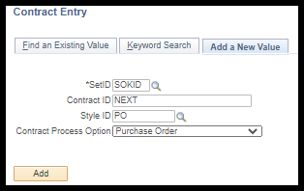

After insuring the Contract Process Option is either Purchase Order or General Contract select Add to create a new supplier contract.

Fields | Description
SetID | Default value is SOKID
Contract ID Description | It is State of Kansas best business practice to accept the NEXT default value.  SMART auto assigns the next available contract number to the supplier contract when saved.
Style ID | An abbreviation corresponding to the Contract Process Option
Contract Process Option | To reference the supplier contract on a purchase order, only the Purchase Order or General Contract options should be used.  Once the Contract has been saved the Contract Process Option cannot be changed.

Contract Entry – Contract Page
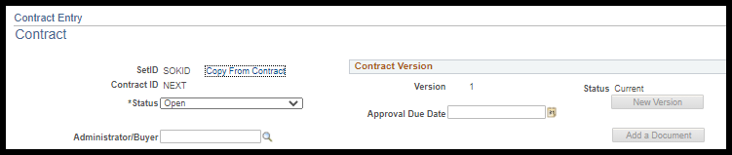

Add the Administrator/Buyer for the agency to the contract.

Fields | Description
SetID | Default value is SOKID
Copy From Contract | This link enables a copy to be made from an existing contract in SMART. For more information see the Copying a Supplier Contract section.
Contract ID | Auto defaults as NEXT. The next Contract ID number is auto generated, assigned, and displayed when the contract is saved.  Note: All agency contracts will be auto-numbered in SMART.
Status | Open - Auto default status  Agencies: If the contract DOES require the Office of Procurement and Contracts (OPC) approval, leave the status as Open before saving. If approved, OPC will change the status to Approved.  Note: Once a contract has been saved, it cannot be changed or edited at an Agency level. If changes are needed on a saved contract, contact OPC.  Approved - Indicates the contract is available to be used on a Requisition and/or Purchase Order  Agencies: If the contract does NOT require OPC approval, the status can be changed from Open to Approved before saving the contract.  Closed - Indicates the contract has been closed by OPC  Canceled – Indicates the contract has been canceled by OPC  On-Hold - Indicates OPC has placed the contract on hold
Administrator/Buyer | The Look-Up icon can be used to search for the Buyer who is the Contract Administrator for the contract.  The administrator must be assigned a Buyer role in SMART for their name to appear in the list of available options for the Administrator field.  They Administrator/Buyer name and phone number will appear on the Contract Search website – Contract Details page.
Approval Due Date | Not used by the State of Kansas. Do not use.
Add a Document | This button is not used by Agency staff. It is used by OPC to create contract documents within the SMART document management system.

Header Section - Fields
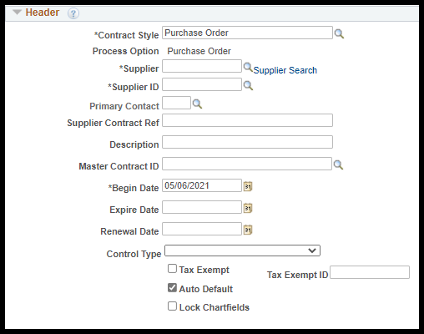

Complete all business process required fields including adding a supplier, a beginning and end dates, and a description. Optional fields may be used by agencies to provide additional information if desired.

Fields | Description
Process Option | Defaults in based on the Contract Style selected
Supplier | Required field. Use the Supplier Look-up button to access the Look Up Supplier page or it will default in based on the Supplier ID selected.
Supplier Search | Use the Supplier Search link to access and use the Supplier Search page to locate existing suppliers in SMART.
Supplier ID | Required field. Use the Supplier ID Look-up button to access the Look Up Supplier ID page or enter the Supplier ID directly into the field.
Primary Contact | Optional field. Can be used to assign a supplier contact to display on the Contract Entry page.
Supplier Contract Ref | Optional field. Can be used to reference a Bid Event number or other type of reference information.
Description | Required field. 30-characters available to provide a description for the contract.  Note: It’s best to use a naming convention that is easily identified. The Description value entered in this field appears in the contract information that is posted on the Contract Search website.
Master Contract ID | Not used by the State of Kansas. Do not use.
Begin Date | Required field. The date the contract is entered in SMART and the contract begins.
Expire Date | Required field. This represents the current expiration date of the contract.  Note: This date may be edited in the future if the expiration date changes. For example, a contract is set to expire, and it is renewed.
Renewal Date | Optional field. Should be after the current date, and before or equal to the expire date.
Control Type | Not used by the State of Kansas. Do not use.
Tax Exempt / Tax Exempt ID | Optional checkbox and field. Available to enter the Agency Tax Exemption number if desired.
Lock Chartfields | Not used by the State of Kansas. Do not use.

Header Section – Checkboxes
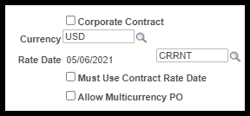

Leave all defaults in place, there are no changes for an agency to make to this section.

Fields | Description
Corporate Contract | The Corporate Contract checkbox defaults as unchecked (unselected).  Agencies: Please DO NOT select (check) the Corporate Contract checkbox when creating agency contracts.  Note: The Corporate Contract checkbox (when selected) enables ALL agencies to have access to a contract in SMART. The Corporate Contract checkbox is to be checked (selected) only by OPC staff for contracts available to all agencies.
Currency | Auto defaults – please do not change this information.
Rate Date | SMART auto defaults this value. Please do not change.
Must Use Contract Rate Date | Not used by the State of Kansas. Do not use.
Allow Multicurrency PO | Not used by the State of Kanas. Do not use.

Header Section – Links
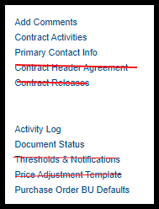
The State of Kansas has chosen not to use the Contract Header Agreement, Contract Releases, Thresholds & Notifications, and Price Adjustment Template links. Do not use.

Add/Edit Comments
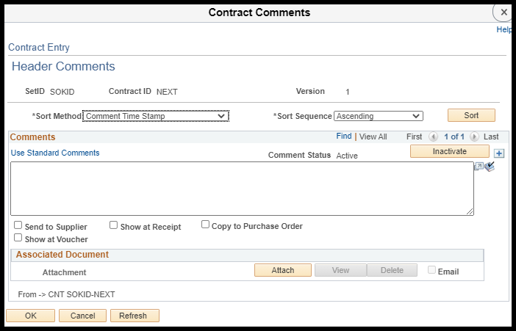
Use the Header Comments page to add comments or attachments that pertain to the entire supplier contract.

Fields | Description
Sort Method | Comment Time Stamp - Sorts the comments by the time stamp that the system assigns when comments are created.  Supplier Flag – Do not use this option
Sort Sequence | Sort options are Ascending or Descending
Sort | After selecting the Sort Method and Sort Sequence, click the Sort button to perform the sort according to those selections.
Use Standard Comments | Required use. Use Standard Comments allows predefined comments to be applied to a contract. See below for more information.
Comment Status | Active – An active comment can be viewed using the sort methods  Inactive – Inactive comments are stored for archive purposes, and they are not able to be viewed using sort methods for current active comments.
Inactivate | Use the Inactivate button to change the status of a comment from Active to Inactive.
+ | Use the + icon to add a new comment.
Spell Check | Use the Spell Check icon to spell check the comment text.
Send to Supplier | Not used by the State of Kansas. Do not use.
Show at Receipt | Not used by the State of Kansas. Do not use.
Copy to Purchase Order | Not used by the State of Kansas. Do not use.
Show at Voucher | Not used by the State of Kansas. Do not use.
Associated Document: Attachment | Enables documents to be attached to the header level of the contract in SMART.  For example: Making an agency contract document that created outside the SMART system that establishes the contract deliverables and prices available to Agency Audit Services.

Attach | Click the attach button to browse, locate and upload file(s) from a local server to the header level of the contract in SMART.  Important reminder: Attachments to the contract should be added BEFORE saving. Once saved, OPC will need to be contacted to add, change, or delete any file attachments.  Note: File attachments stored at the header level of a contract are NOT viewable on the public Contract Search website.
View | The View button is enabled once an attachment has been uploaded to the header level of the contract and can be used to open and view the document.
Delete | The Delete button is enabled once an attachment has been uploaded to the header level of the contract and can be selected to delete (remove) an attachment.
Email checkbox | Not used by the State of Kansas. Do not use.
OK | Clicking the OK button returns the user to the Contract page.  Once returned, the Add Comments link name changes to Edit Comments.
Cancel | Click the Cancel button to return to the Contract page without saving changes made to the Header Comment page.
Refresh | Use the Refresh button to refresh the Header Comment page.

Use Standard Comments
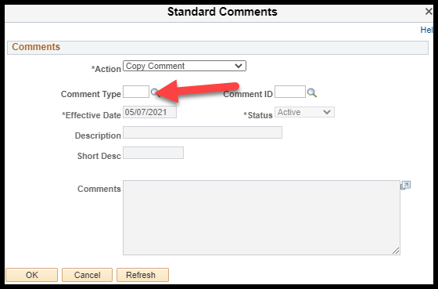
Standard comments are used to provide information about the contract.
Fields | Description
Comment Type | The Comment Type must be selected before a Comment ID can be applied. The Look Up Comment Type icon can be used to see the Comment Types available.  For supplier contracts the Comment Type is SCN – Supplier Contract Comments.
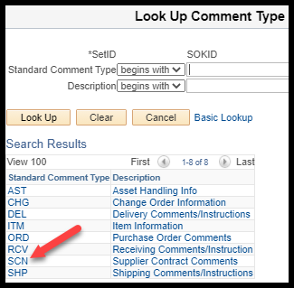
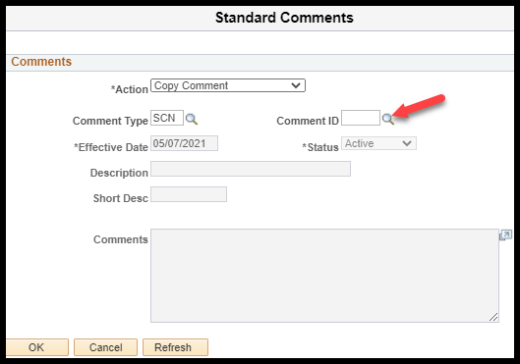
Fields | Description
Comment ID | The Comment IDs associated to the selected Comment Type can viewed using the Look Up Comment ID icon to see the Comment IDs available.
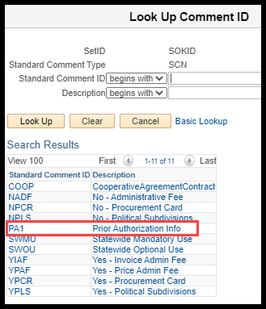
Agencies: For ALL contracts created based on approved Prior Authorization requisitions, the Standard Comment Prior Authorization Info must be added. All other options are used by OPC only.

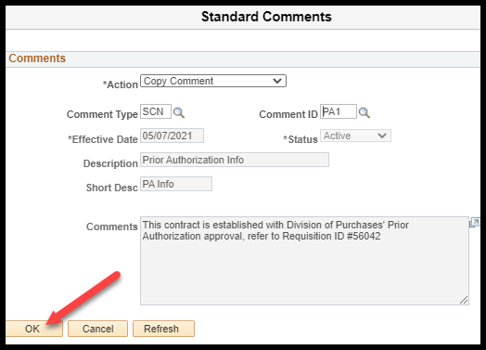

Selecting PA1 defaults in a standardized authorization approval message. Select OK.

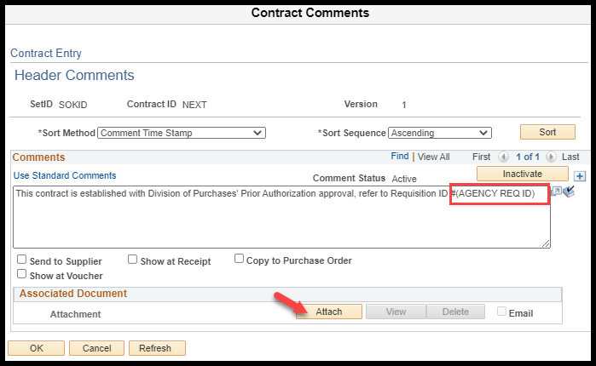
Once back on the Contract Comments page:
- The PA1 standard comment MUST be edited to remove the default requisition ID of 56042 and replace it with the agency’s approved requisition ID that supports the creation of this supplier contract

- The authorized Prior Authorization document must be attached
Select OK to keep these changes.

Contract Activities
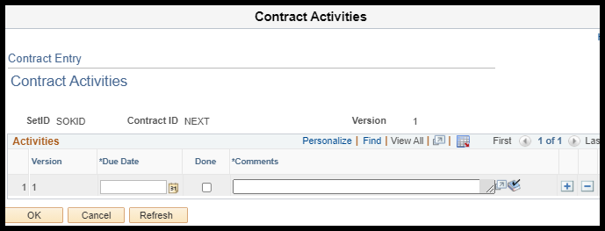
Contract Activities provides note keeping and reporting functionality for agencies. For example: Agencies can choose to use the Contract Activities function to keep track of activities that need to occur on a contract. Agencies must enter these activities before saving the contract.
Note: It is important to know that the Contract Activities page does not contain any functionality in SMART, i.e. SMART does not provide email notifications, or worklist items for any information entered on this page.

Primary Contact Info
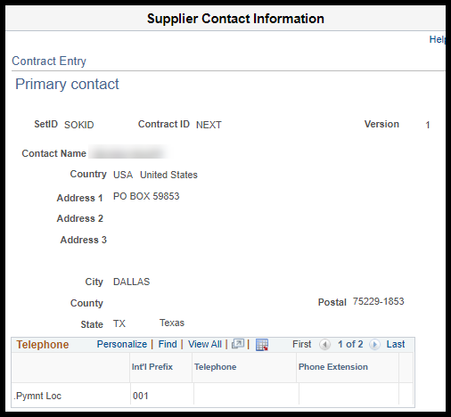
The Primary Contact Info link is only accessible if a Primary Contact has been applied. The Supplier Contact Information page that displays contains the contact details for the selected contact on the supplier.

Activity Log
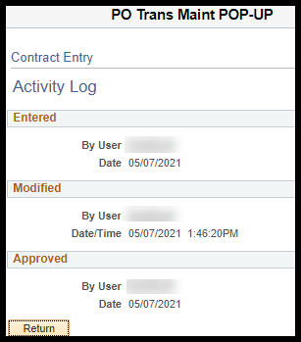
The Activity Log page tracks and keeps history for the contract, including last modified.

Document Status
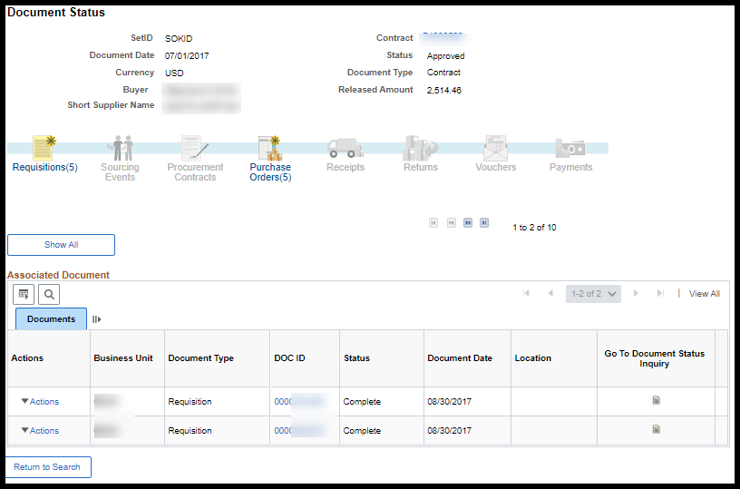
The Document Status page displays all transactions associated to the supplier contract, such as requisitions, POs, Receipts, Vouchers, Sourcing (Bid) Events, etc.

Purchase Order BU Defaults
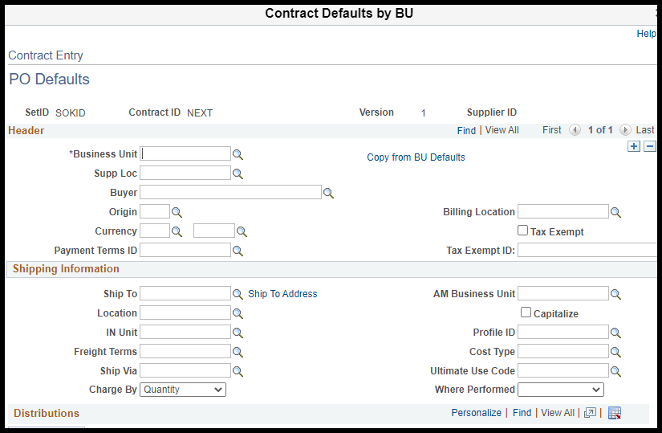
For agency specific contracts, the PO Defaults page is used to assign the Business Unit(s) that will have access to this contract for use. The + icon can be used to add additional agencies if needed.

For Corporate Contracts available to all agencies, each Business Unit does not need to be assigned, however, for the contract to show on the Contract Search website, at least one Business Unit MUST be assigned.
Fields | Description
Business Unit | Required field. This field must be updated for agency specific contracts to define what agencies should have access and for Statewide (Corporate Contracts) so that the contract will appear on the Contract Search page.  Note: If this is left blank, the contract will not show on the Contract Search page.

All other fields on the PO Defaults page are optional.

Contract Term/Renewals
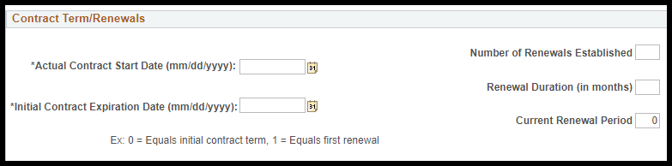

Fields | Description
Actual Contract Start Date (mm/dd/yyyy) | Required field. This date represents the contract start date. Once entered, this date should not change.  Note: This is a custom field used for reporting purposes only.
Initial Contract Expiration Date (mm/dd/yyyy) | Required field. This date represents the the initial expiration date for the contract. Once entered, this date should not change.  Note: This field represents the initial (first) expiration date for the contract. Despite contract renewals, this date should not change.  Note: This is a custom field used for reporting purposes only.
Number of Renewals Established | Enter the number of contract renewals established for the contract with the supplier.
Renewal Duration (in months) | Enter the number of months (duration) for each contract renewal period.
Current Renewal Period | If the contract contains renewal options, change the Current Renewal Period field upon each renewal period.  Note: This field is a manual data entry field and is not calculated by SMART.
Note: Ex: 0 = Equals initial contract term, 1 = Equals first renewal
Use this helpful example to calculate and enter the correct values within the Contract Term/Renewals section on the Contract Entry page. The initial contract will show 0 in the Current Renewal Period field. When the contract is renewed the first time, this field value should be changed to 1. When renewed the second time, the field value should be changed to 2, and so on.

Additional – Account Summary
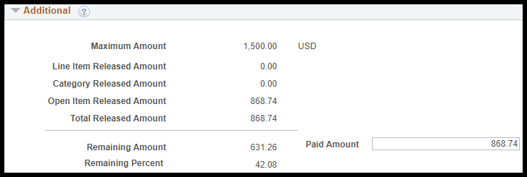

The only field that isn’t calculated by SMART is the Maximum Amount field. The agency MUST add a maximum amount equal to that authorized by the Prior Authorization.

Fields | Description
Maximum Amount | Required field. Agencies MUST use this field to enter the maximum contract amount approved by the Prior Authorization.  Note: This field can ONLY be left blank by OPC when they are creating a Statewide contract (Corporate Contract).
Line Item Released Amount | Not used by the State of Kansas.
Category Released Amount | Not used by the State of Kansas.
Open Item Released Amount | The State of Kansas ONLY uses open item contracts, so this displays the amount that has released onto a purchase order. SMART calculates the released amount based on the PO Merchandise Amount field of a PO line associated to the contract.
Total Released Amount | The Total Released Amount accumulates the amount for all purchase orders issued using the specific Contract ID. See Open Item Released Amount for more details.
Remaining Amount | A SMART calculated amount that displays the remaining amount of the contract that has not yet been released to a PO (Maximum Amount – Total Released Amount = Remaining Amount).
Remaining Percent | A SMART calculated percent that represents the percentage of the contract amount that has not yet been released to a PO (Remaining Amount / Maximum Amount).
Paid Amount | A custom field that displays all spend associated with the contract, including PCard spend where the now retired customization allowed the contract to be applied directly to the transaction without a PO but wasn’t included in the delivered SMART calculations for the Total Released Amount.

Contract Open Item Reference
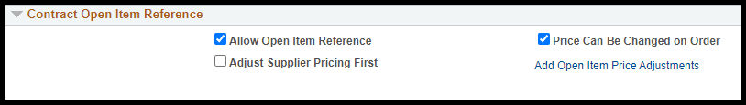
Note: Do not change the defaulted selections.
Fields | Description
Allow Open Item Reference | The State of Kansas is only using open item reference contracts and the Allow Open Item Reference checkbox defaults as checked (selected).  Agencies: Please DO NOT unselect (uncheck) the Allow Open Item Reference checkbox when creating agency contracts.  Note: Unselecting this checkbox would require the agency to add line items to the contract and the agency would be limited to only the specific items, amounts, and quantities listed on the contract.
Adjust Supplier Pricing First | Not used by the State of Kansas. Do not use.
Price Can Be Changed on Order | The State of Kansas is only using open item reference contracts which works with the Price Can Be Changed on Order checkbox which defaults as checked (selected).  Agencies: Please DO NOT unselect (uncheck) the Price Can Be Changed on Order checkbox when creating agency contracts.  Note: Unselecting this checkbox would make the price fields on purchase orders referencing this contract unavailable for entry or editing.
Add Open Item Price Adjustments | Not used by the State of Kansas. Do not use.

Contract Items - Lines
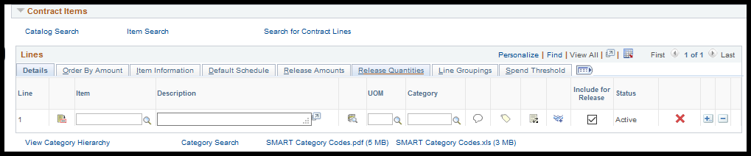
Contract Items – Lines do not need to be populated. They are not used with Open Item Reference contracts, which are the only kind the State of Kansas is currently using.

Contract Categories – Lines
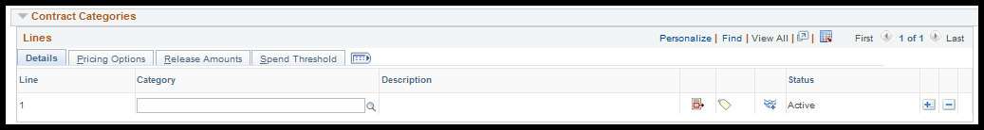
Contract Categories – Lines do not need to be populated. They are not used with Open Item Reference contracts, which are the only kind the State of Kansas is currently using.

Copying a Supplier Contract
Fluid Navigation: SMART Homepage > Contracts & Strategic Sourcing > Supplier Contracts > Contract Entry > Add a New Value > Copy From Contract

Classic Navigation: SMART Homepage > NavBar > Navigator > Supplier Contracts > Create Contracts and Documents > Contract Entry > Add a New Value < Copy From Contract
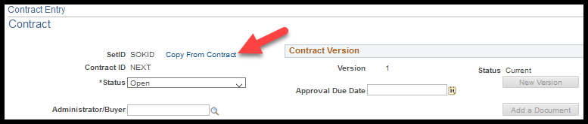

Contract Entry – Copy Contract
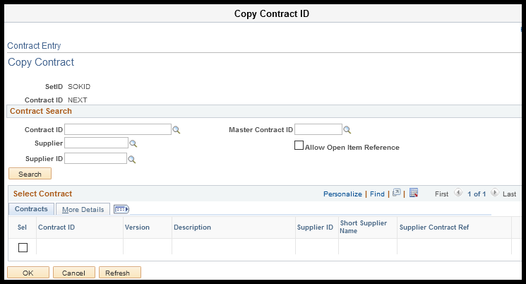
This page is used to locate and select the existing supplier contract to be copied.

Contract Search
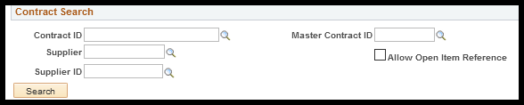
Use the Contract Search section to enter the criteria to search for an existing contract in SMART.
Fields | Description
Contract ID | Use the Contract ID field to search for a specific contract.
Supplier | Use the Supplier to find contracts created for a specific supplier.
Supplier ID | Use the Supplier ID to find contracts created for a specific supplier by supplier ID.
Allow Open Item Reference checkbox | Select the Allow Open Item Reference checkbox to indicate that the contract being searched for contains an open item reference.
Once the search criteria is entered, click the Search button to display the contracts meeting these conditions in the Select Contract section.

Select Contract – Contracts
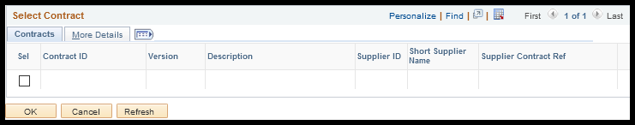
Use the Select Contract section, Contracts tab to select the contract to copy into a new contract.
Fields | Description
Sel checkbox | Use the Sel checkbox to select the contract to copy.
Contract ID | Displays the contract’s ID number.
Version | Displays the version of the contract.
Description | Displays the Description for the contract (sourced from the Description field in the header section).
Supplier ID | Displays the Supplier ID number for the contract.
Short Supplier Name | Displays the Short Supplier Name for the supplier on contract.
Supplier Contract Ref | If a Supplier Contract Ref was entered on the contract (in the Header section), it will be displayed here.

Select Contract – More Details
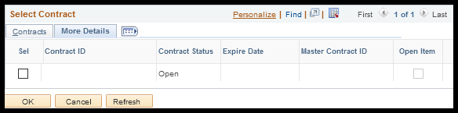
Once the contract to be copied is selected (by clicking the Sel checkbox). When the OK button is then selected the details from the existing contract populates into the Contract page.

Note: This will include Standard Comments.
Fields | Description
Sel checkbox | Use the Sel checkbox to select the contract to copy.
Contract ID | Displays the contract’s ID number.
Contract Status | Displays the contract’s status.
Expire Date | Displays the Expire date (from the Header section) of the contract.
Open Item | If the contract is an Allow Open Item Reference contract, then this checkbox is displayed as selected. If the existing transactional contract is not an open item contract, then this checkbox is displayed as empty (blank).

Completing an Agency Supplier Contract
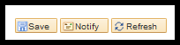
It is imperative that all the necessary new supplier contract information be fully verified and modified before saving the contract. Depending on the authority for the contract different steps need to be taken before saving.

Remember: Agencies can only create supplier contracts, but they are unable to edit or maintain them. If a change needs to be made to an agency specific contract after it has been saved contact the Office of Procurement and Contract (OPC) for assistance.

Under Delegated Authority or PR $25,000 or Under
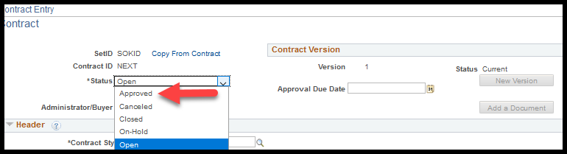
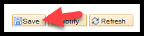
The contract should be Approved before saving and OPC does NOT need to be contacted ONLY if the contract:
- maximum amount is under the agencies delegated authority ($5,000 or less for most agencies) or the
- maximum amount is under $25,000 & there is an approved Prior Authorization.

Prior Authorization OVER $25,000
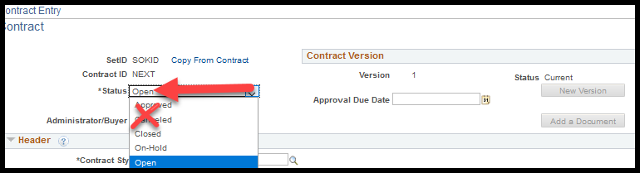
ALL agency contracts over $25,000 WITH an approved Prior Authorization MUST be approved by an OPC officer.
Leave the supplier contract status as Open (DO NOT approve) and select Save.
After saving the agency supplier contract, contact the OPC officer who approved the Prior Authorization by email through Outlook or through SMART by selecting the Notify button.
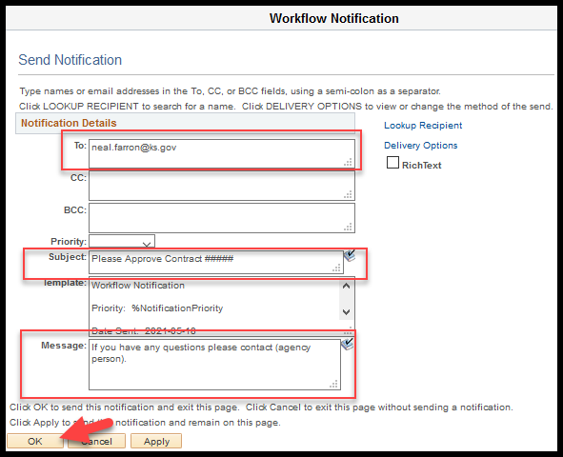
If the Notify button is selected, please update the following fields:
- To: - add the email address of the OPC officer
- Subject: - Request approval & list the contract #
- Message: - provide agency contact information in case of questions or changes needed

