State of Kansas
Assigning / Removing Mass PCard Proxies
Statewide Management, Accounting and Reporting Tool
Date Created: | 2/25/2021
Version: | 2.0
Purpose: | The ‘Assign Proxies’ page allows an Agency PCard Administrator to assign and remove proxies to PCards in mass.  This can assist agencies with the PCard maintenance of assigning a new employee proxy to multiple PCards at the same time or of removing the proxy user IDs of an employee who have left the agency.
Security: | The PO Agency PCard Admin role is required to perform this function.
Fluid Navigation: | Requisitions & PCards > Procurement Cards > Security > Assign Proxies
Classic Navigation: | Purchasing > Procurement Cards > Manage PCards > Assign Proxies
Use the Search Criteria to locate the employee that needs to be added or removed as a proxy. Select Search. | 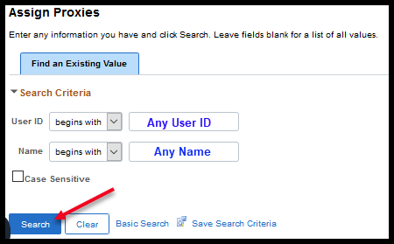
Assigning a Proxy to PCards in Mass
The resulting page will show all the cards that this user is currently assigned to as a proxy.  Click the Select Procurement Cards link. | 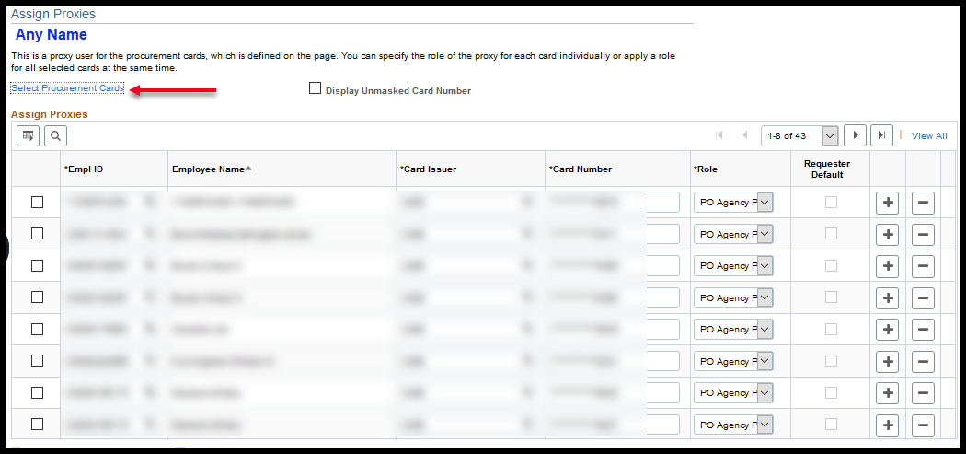
Click the Select Procurement Cards link to display the ProCard Proxy – Select Cards page.  In the Procurement Card Selection Criteria section, enter your agency Business Unit, any other search criteria and select Search. | 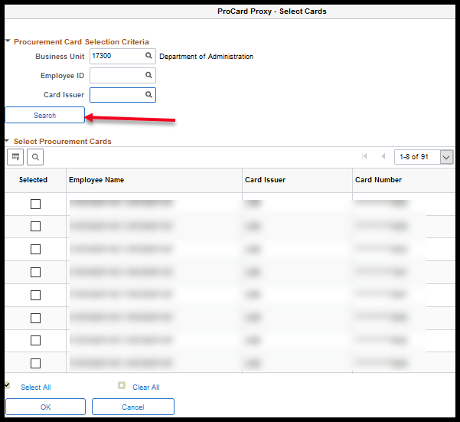
Select all cards that need to be that the employee needs to be a proxy for individually and click OK. | 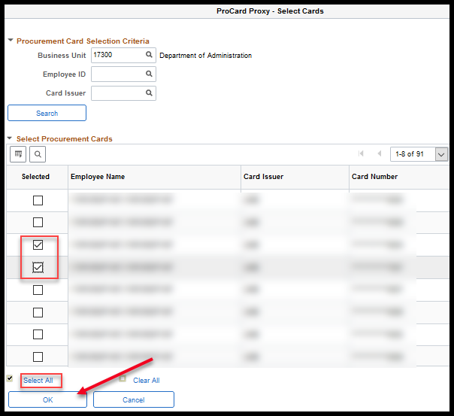
Selected PCards will pull back into the Assign Proxies page for the employee being assigned.  If the employee being assigned only has one PCard role, it will get assigned by default. | 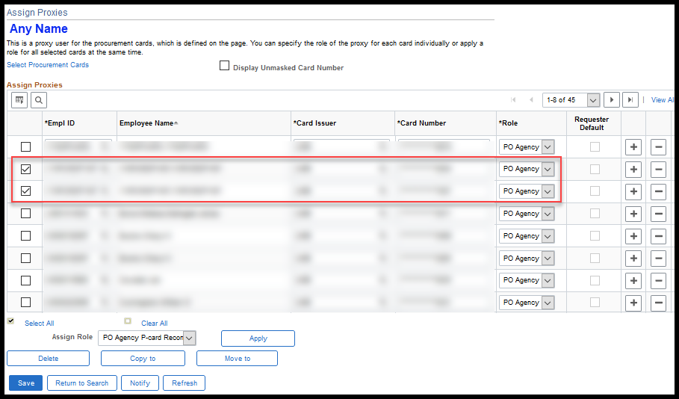
If the employee has more than one PCard role available to them, which role should be used for the Proxy on the cards must be defined.  This can be done on each card individually by the Role column dropdown options. | 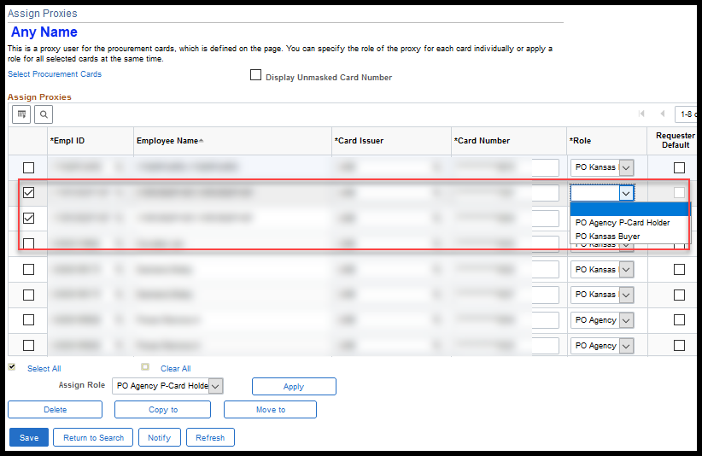
Or the role can be applied to multiple selected PCards at the save time using Assign Role and selecting Apply.  Once the role the user should have for the newly assigned proxy has been defined, select Save. | 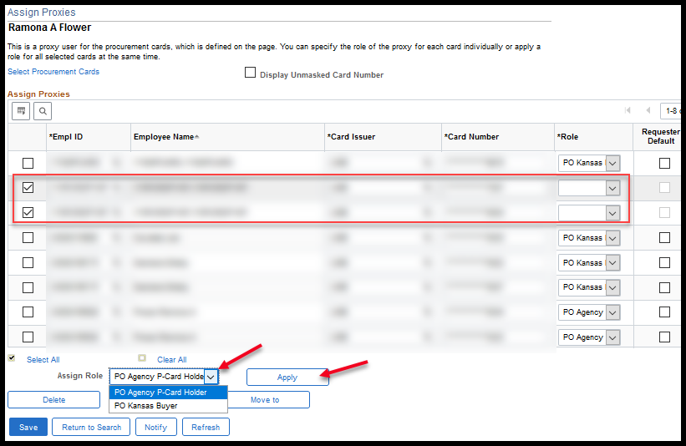
Removing a Proxy from PCards in Mass
The resulting page will show all the cards that this user is currently assigned to as a proxy.  Select the cards this employee should no longer be a proxy for and click Delete and Save. | 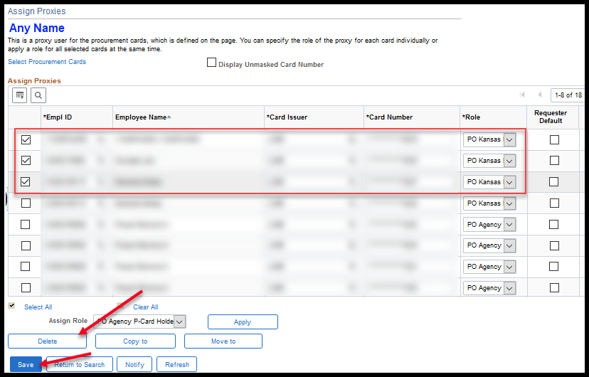
If the employee needs to be removed as a proxy from all cards, click the Select All link before choosing Delete and Save. | 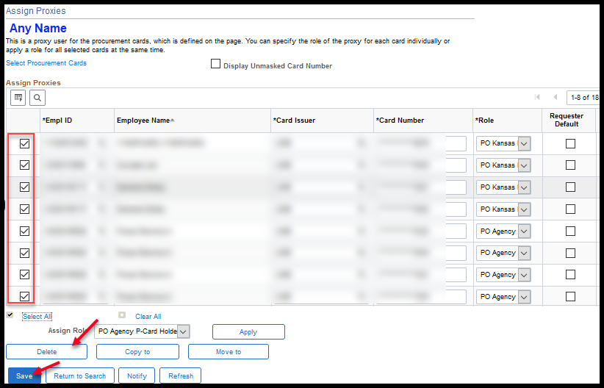
The user will be removed as a proxy on all the selected cards. | 