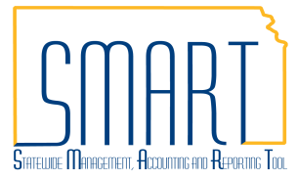**State of Kansas**



**How to Personalize to Show All Accounting Lines**

***Statewide Management, Accounting and Reporting Tool***

|  |  |
| --- | --- |
| **Date Created:** | 11/24/2015 |
| **Version:** | 1.0 |
| **Last Updated Date:** | 11/24/2015 |
| **Process:** | To personalize Accounting Lines. |
| 1. Click the ‘Personalize’ link on the Accounting Lines |  |
| 1. The box to the right will pop up, note that the tab names are listed in the Column Order box in addition to the field names (Tabs are highlighted in this picture). |  |
| 1. To re-order the fields on the page, click on the field that you want to move (highlighted below), then click the up or down arrows to the right of the field list. The fields will display in the order in which they are listed. |  |
| 1. In the picture to the right, **Dept** was moved from “Tab Chartfields2” to “Tab Chartfields1”and will now display between the **Merchandise Amt** and **GL Unit** fields. |  |
| 1. After making any desired changes, scroll to the bottom and click the ‘Preview’ button |  |
| 1. If the changes are complete, then click the ‘OK’ button. If more changes are needed, then scroll back up to make additional updates or click the ‘Cancel’ button to undo the previous changes. |  |