Step | Action
WorkCenters are designed for users who spend many hours using PeopleSoft applications. A WorkCenter can be designed for an individual or for many users to share.

Some of the benefits of WorkCenters are to:
- provide a central area for you to access key components within Financial and Supply Chain applications.
- enable you to access various pages and keep multiple windows open while doing your daily work.
- reduce navigation time and let you accomplish your daily tasks in an efficient manner.

Use the General Ledger WorkCenter page to focus on your daily tasks that are specific to your work.

WorkCenter security follows user roles, permissions lists, and user ID setup.

All WorkCenters are divided into two general areas.

On the left side of the WorkCenter page is the pagelet area. This area has the same structure for all application-specific WorkCenters. It is defined with two tabs.

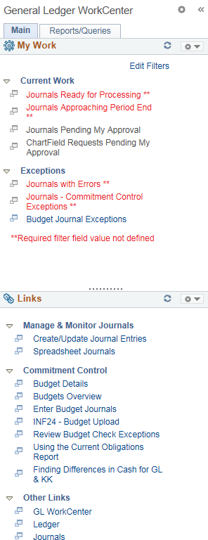
On the right side of the WorkCenter page is the transaction area.

This area can display various items such as a welcome statement and application pages.

You can minimize and personalize the navigational pagelets on the left.

Click the Pagelet Settings dropdown menu.

If you would like to see more of the Links pagelet, you can minimize the My Work pagelet.

Click the Minimize link.

 | Notice that the My Work pagelet is now collapsed and you can view the Links pagelet more easily. You can click the Pagelet Settings button again to expand the My Work pagelet.
 | The Links pagelet makes it possible for you to access your most commonly-used pages with full functionality without ever leaving your WorkCenter.
Expand the My Work pagelet again.

Click the Pagelet Settings button.

 | Click the Expand link.
 | In each WorkCenter, the Main tab displays a My Work pagelet and the Links pagelet.
The My Work pagelet can include links to events and notification alerts, prioritized items needing immediate attention, and worklist tasks for workflow approval.

The pagelet is standardized for all agencies and will not be personalized.
 | Each pagelet can include group headings. Group headings are used to place similar pages and links into logical groupings, and are expandable and collapsible.
The Links pagelet can include additional links to pages and other areas of interest including links that are external to your organization.

You can personalize (from the list enabled by your system administrator) which links appear on your WorkCenter.

 | There are additional navigational tools for the pagelets that appear when your cursor hovers in the area: one is a right-hand vertical scroll area. You can left-click the scroll once it appears, hold down the cursor and drag the scroll bar up or down.
 | You can also resize each WorkCenter pagelet. Just hover over the dotted line in each pagelet until the cursor turns into a double-sided arrow, left-click and hold down, drag and drop up or down to resize the pagelet.
Next, access the Reports and Queries pagelets.

Use the Reports/Queries pagelets to store and run frequently accessed queries, reports, and processes. You can run an ad hoc query, report, or process when you need to.
The Queries pagelet can include links to Query Manager, public queries, private queries, and pivot grids.

You can personalize which links (from the list enabled by your system administrator) appear on your WorkCenter.

The Reports/Processes pagelet can include access to reports and processes that are frequently used.

These links take you directly to the Run Control page for the report or process.

You can personalize which links (from the list enabled by your system administrator) appear on your WorkCenter.

Now let's look at some additional configuration and personalization options that allow you to tailor your pagelets to fit your needs.

Click the Main tab.
Within the My Work pagelet, use the Edit Filters link to modify criteria for alerts.

Some links can be subject to filter criteria that limit the amount of data available.

Click the Edit Filters link.
Use the Edit Filters page to adjust filters for items that appear in the My Work pagelet.

The filters used to select the data for each link in the My Work pagelet can be changed.

Use the Configure Filter Values page to adjust specific values that are used to select the data displayed in the transaction area.

This enables you to change the filters and limit the result set of the data.
 | When you are finished making filter changes, click the OK or Apply button.
The system instructs you to refresh (or reload) the WorkCenter page to view any changes.

Click the OK button.

 | Click the Reload icon to reload the data after you've made changes
 | Use the New Window icon to open the transaction information in a new window.
Your selection in the pagelet area drives what you see in the transaction area.

Note that the count number displays how many transactions will appear.

Use the transaction area to view data that is specific to the pagelet selection and the filter criteria defined in the Configure Filter Values page.

This area enables you to see transaction information, perform needed actions, and drill into additional details for the transaction.

Each transaction area can have a different look for each option selected in the pagelet area.

Blue text indicates a link that will take you to specific transaction pages.

Select the box before the Journal ID item.

An Actions list box enables you to take various actions on selected transactions.

These are the various actions that you can take for selected transactions.

To perform an action on the transactions selected in the grid, select the action in this list box.

Click the Post Journals list item.
 | Click the GO button to perform the chosen action.
 | End of Procedure.

