Date Created: |  | 11/04/2015
Version: |  | 2.0
Last Updated Date: |  | 03/21/2019
Purpose of the Report: |  | This report is designed to displays all journal entries that were entered in the system for a business unit and ledger within the date range and journal status specified.
Report parameters: |  | The report results will be GL journal entries within the report request parameters chosen.  Note: The results are the GL journals and can include transactions from multiple budget periods. If you need expenditures by Budget Period use Commitment Control reports and queries.
Report Prompt Values: |  | Required Prompt Values:  - Business Unit  - Ledger Group  - Ledger  You should add additional prompts to limit the size of the results.
Report Result Sorts: |  | The report results are displayed, sorted by:  - Business Unit ID  - Journal ID  - Journal Line  Page breaks after each journal ID
Security Access: |  | - Role Security: Only those individuals assigned the following security access role will receive results from this query:  - GL Viewer  - BU Security: Business Unit Security is applied. Agencies will have access to only the journals associated with their agency’s business unit(s).
1. | Navigation:  From the SMART Homepage, click on the menus as follows: General Ledger/KK page> GL & KK Reports tile > GL Reports> Journal Entry Detail (FIN2001). | 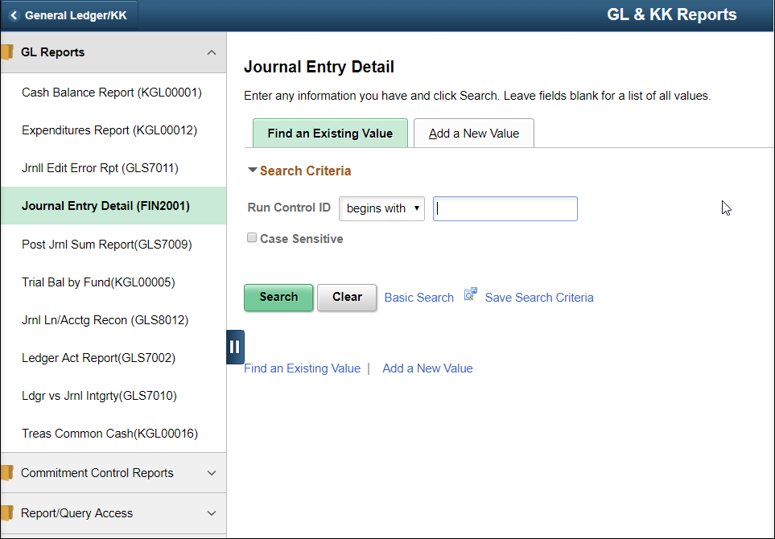
2. | If you have used this report in the past, click on the ‘Find an Existing Value’ tab.  Enter/Find the name of the (previously established) Run Control ID into the Run Control ID begins with: field  Click the Search button.  If you have NOT used this report in the past, use the ‘Add a New Value’ tab.  Enter a new Run Control ID.  Click the Add button. | 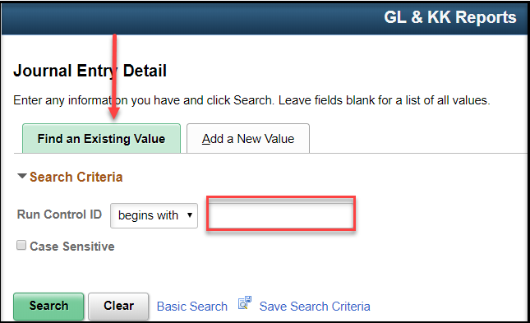  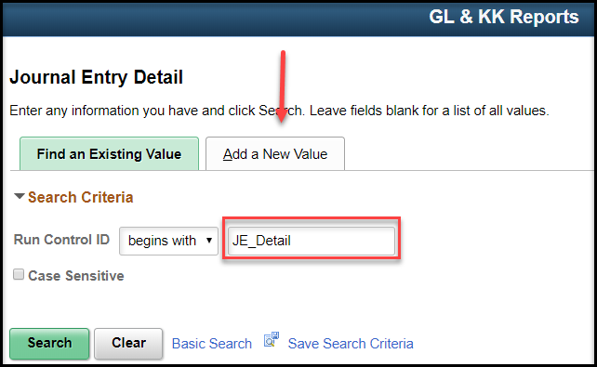

3. | On the Journal Entry Detail Report Run Control page  Business Unit: Enter the agency’s Business Unit number.  Ledger Group: Chose ACTUALS (other Ledger groups are available for special reporting needs)  Ledger: Choose ACTUALS (other ledgers are available for special reporting needs)  Source: Leave blank unless looking for a specific journal source  Journal ID: Leave blank unless looking for a specific journal  From Date: Enter the start date of date range.  (You should enter a date range to limit number of results).  To Date: Enter the end period for the date range. (You should enter a date range to limit number of results).  Journal Status: Pick a Status (i.e. Journals with errors or Posted Journals) or Leave blank  Date Code: All  Show Description on Report: Click box if you want ChartField description to be displayed on report. (The Descr box on the ChartField line must be checked as well to show the description.)  Show Statistics Amount: Leave unchecked  Display Full Numeric Field: Click if you want to see full number. This choice requires more space on the report line.  Refresh/Restore button:  - Refresh will update the ChartFields based on the Ledger chosen.  - Restore will change the selection back to the previous selections.  ChartField Selection:  - Enter the order (sequence) you want to see the ChartFields  - click the include box on the ChartFields line to display the CF on the report  - click on the Descr box to include the CF description on the report | 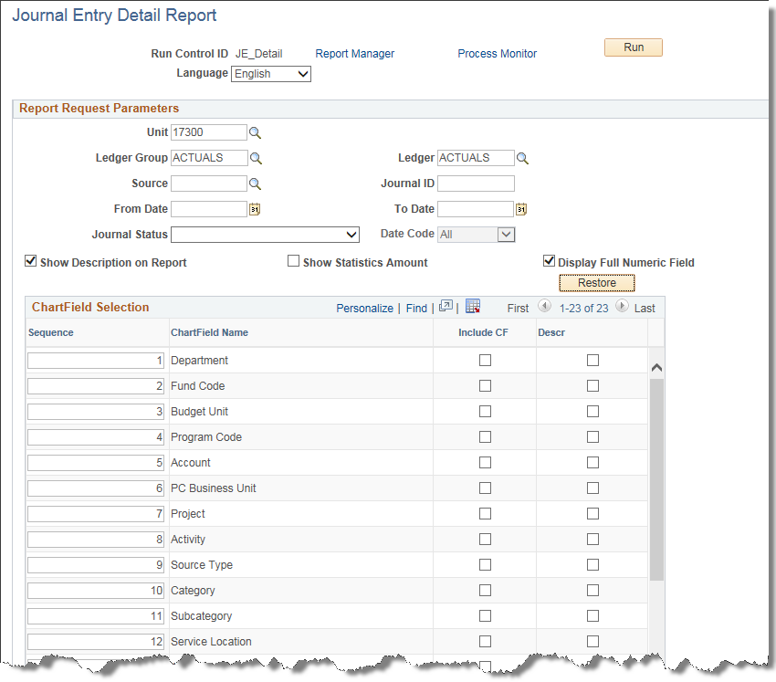  Note: The number of ChartFields included on the report will determine how much each row in the report will wrap.)
4. | Run the Process until the Process List shows Success and Posted. Open the report from the View Log/Trace page. | 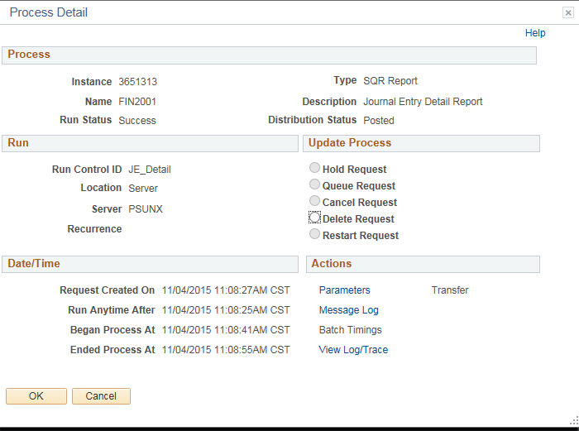
10. | Clicking the file Name link, opens the file in the specified ‘reports results’ Format. | Use the FIN2001 Journal Entry Detail Report results to balance cash by fund/budget unit by agency.  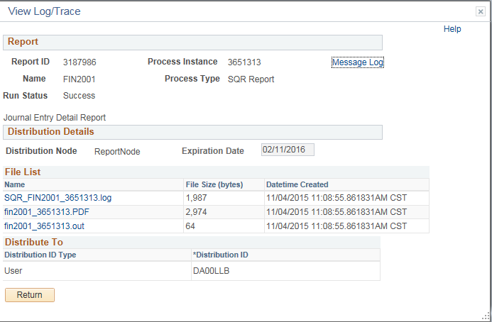  When the Report results are displayed, you may then save or print the file. See below for some examples of the Report.

Example of parameters and report for Journals with Errors, show description for Account:
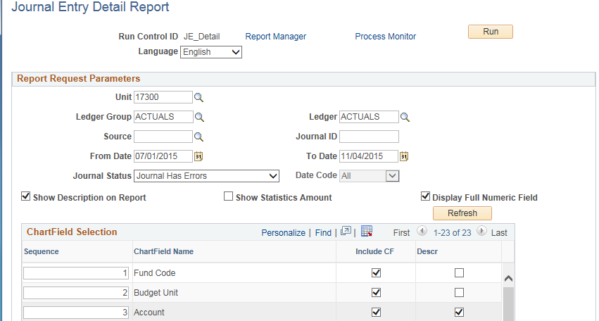

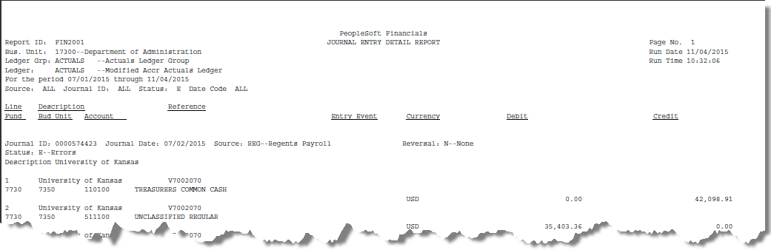
Example of parameters and report for Valid Journals, show description for Fund:


