Training Guide – General Ledger
Requesting ChartFields

Table of Contents
SMART 9.2 - General Ledger Module 1
GL - Requesting ChartFields 1
Adding Funds 1
Updating Funds using Add a New Value 11
Updating Funds using Find an Existing Value 22
Adding Budget Units 31
Updating Budget Units using Add a New Value 38
Updating Budget Units using Find an Existing Value 46
Adding Department IDs 54
Updating Department IDs using Add a New Value 61
Updating Department IDs using Find an Existing Value 71
Adding Program Codes 78
Updating Program Codes using Find an Existing Value 85
Updating Program Codes using Add a New Value 91
Approving ChartField Request via Worklist 98
Approving ChartField Request 102

The Request Chartfield business process to add or update ChartFields is done in SMART. All ChartFields maintained by the Department of Administration (D of A) use this process. The ChartFields maintained by D of A include: Fund Code, Budget Unit, Department ID, and Program Code. Updating a ChartField includes inactivating, re-naming, or changing the budgetary only status.
The Fund Code and Budget Unit values and descriptions will still be assigned by the Central Responsibilities Team and must be requested from the team prior to entering a request in SMART.
The Department ID and Program Code values are assigned by the agency and must fit into the agency's CC_DEPT or CC_PROG tree structures. A copy of the tree structure spreadsheet must be attached to the SMART ChartField Request.

Agency maintained ChartFields which include: Agency Use, Service Location, and ChartField 2 will be entered directly into SMART rather than use the request form. See the Job Aid "Maintaining Agency-Controlled ChartField Values".

There are two options when requesting a ChartField Update:
If a ChartField Request has never been submitted (ChartFields created PRIOR to SMART 9.2 upgrade), the Add a New Value option must be used.
If a Chartfield Request has been submitted, the Find an Existing Value option can be used. This option allows the user to Copy the prior Request and make changes.

Adding Funds
This UPK will demonstrate how to request a new Fund Code. The first step to this process is to request a fund code from the Central Responsibilities Team (CRT) prior to starting the Adding Funds process.
Procedure

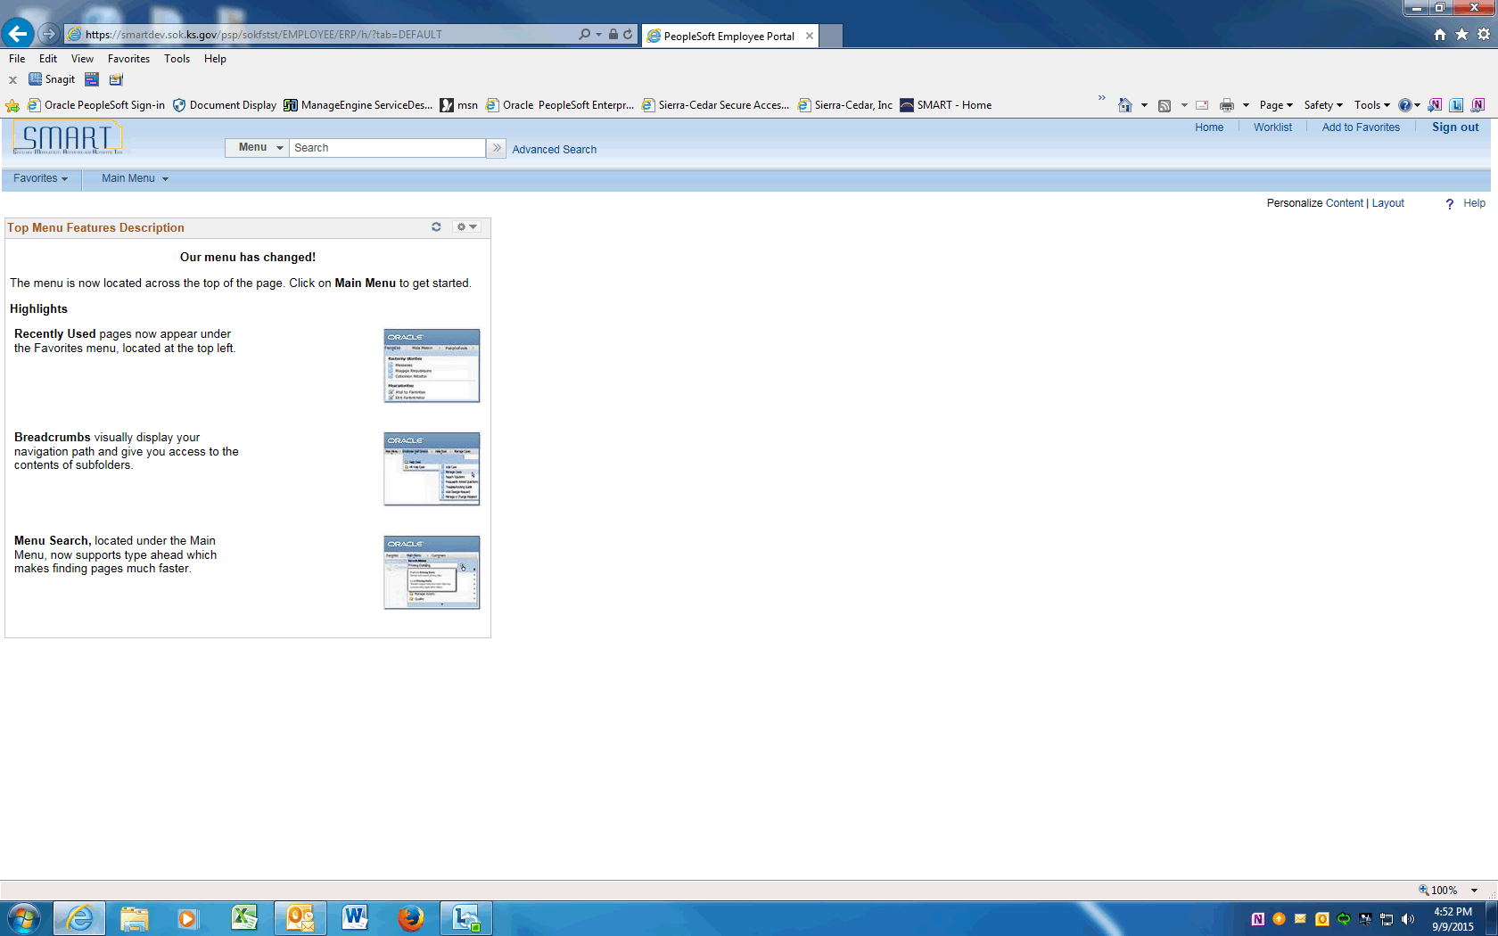

Step | Action
Start by navigating to the ChartField Request page.
Click on Main Menu
 | Scroll down and click the Set Up Financials/Supply Chain menu.
 | Click the Common Definitions menu.
 | Click the Design ChartFields menu.
 | Click the Define Values menu.
 | Click the ChartField Request menu.

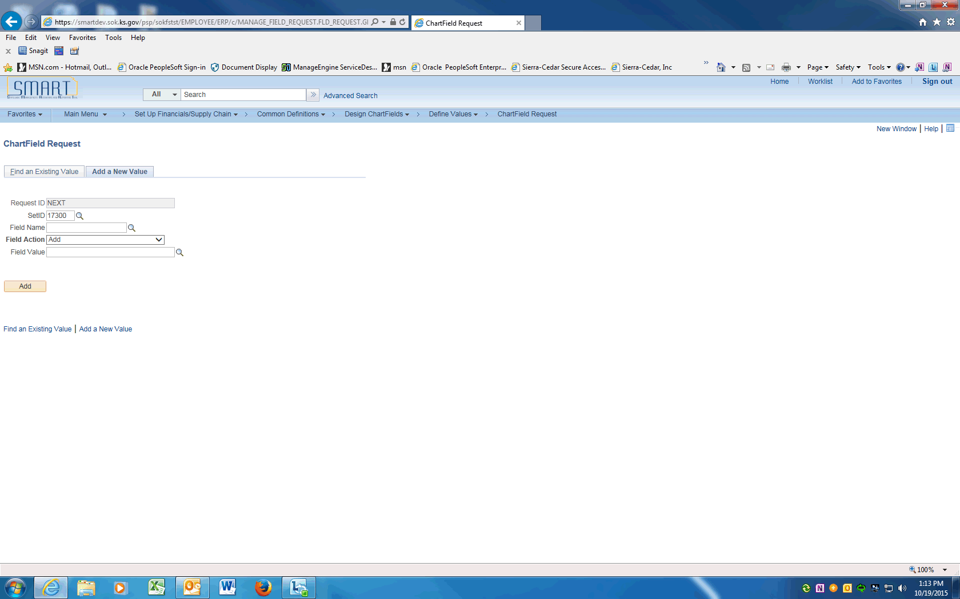

Step | Action
 | Enter your agency SETID into the SetID field. Enter "17300".
 | Click the magnifying glass next to the Field Name to display the Look Up and click on the FUND_CODE link.

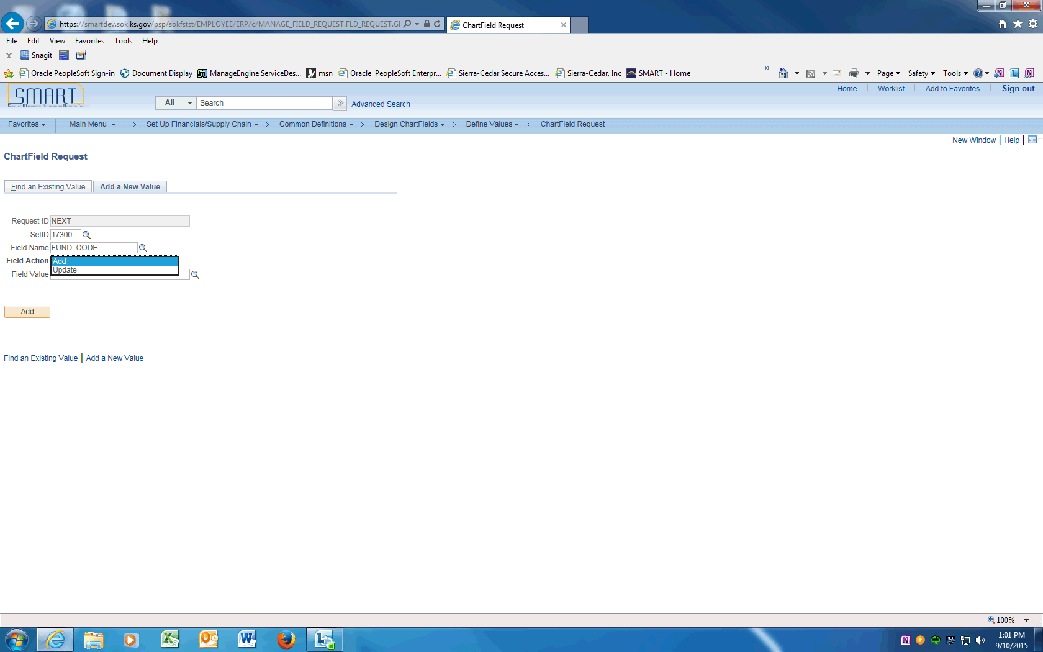

Step | Action
 | Click the magnifying glass next to the Field Action to display the Look Up and choose Add to add a new Fund Code.

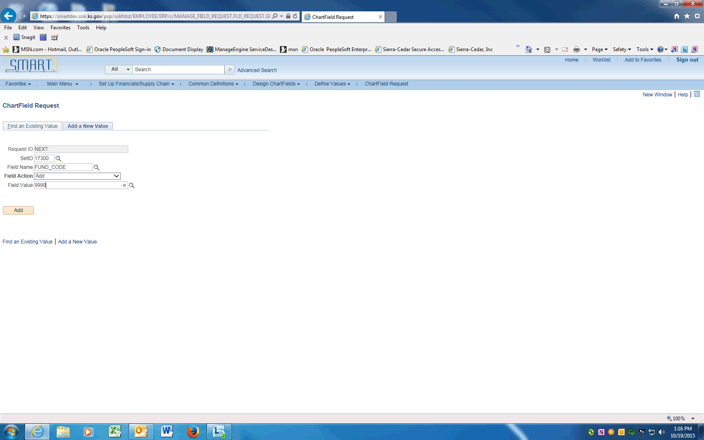

Step | Action
 | Enter the Fund Code value supplied by the Central Responsibility Team into the Field Value field. Enter "9990".
 | Click the Add button.

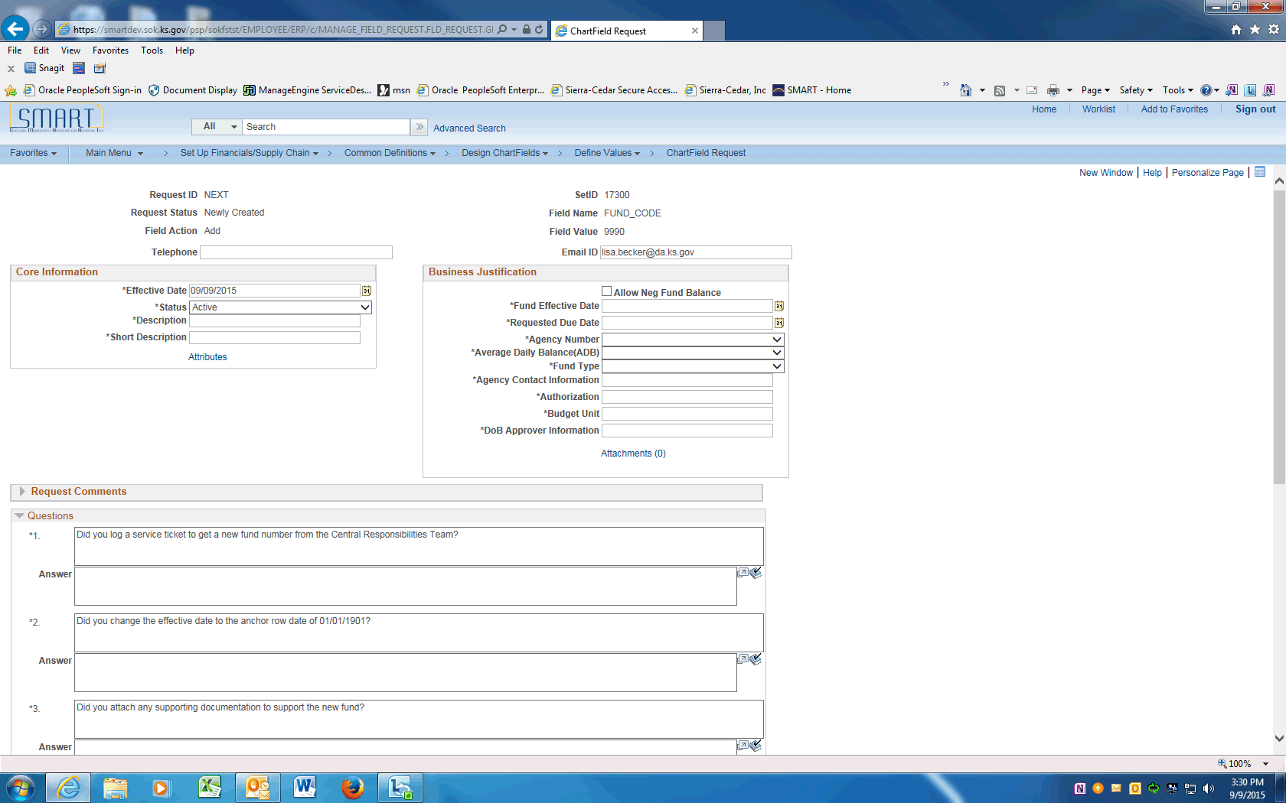

Step | Action
 | On the ChartField Request page, enter the Requester's phone number into the Telephone field. Enter "785-296-0000".
 | Click in the Email ID field and enter the Requester's email address.

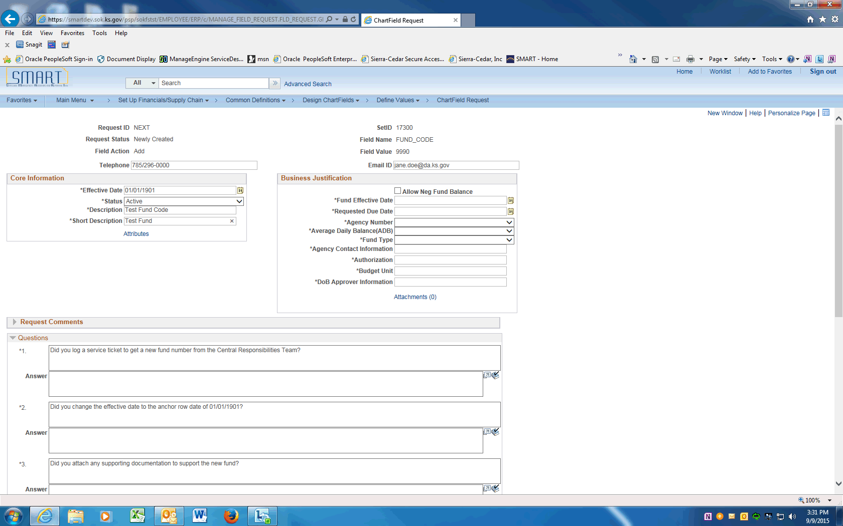

Step | Action
 | Enter the anchor effective date of "01/01/1901" into the Effective Date field

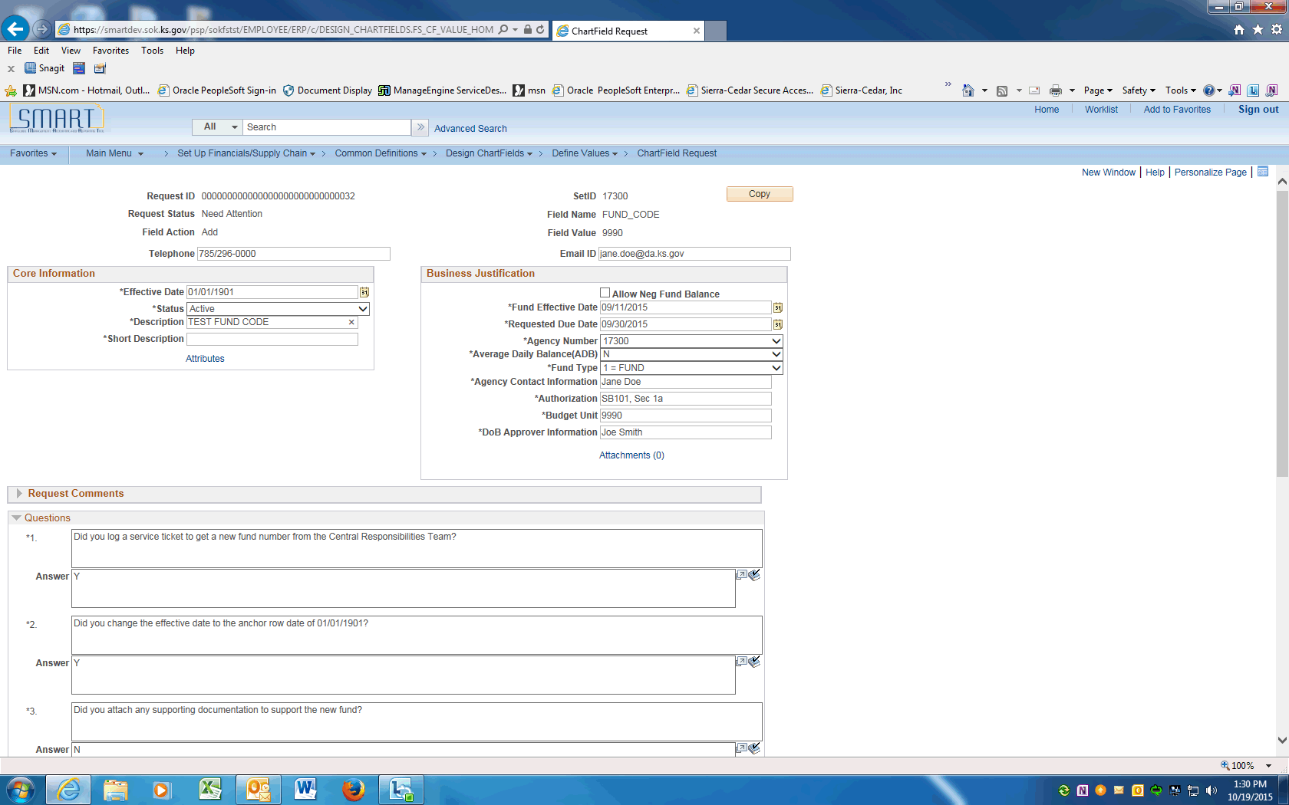

Step | Action
 | Enter in capital letters the Fund Code long description supplied by the Central Responsibility Team into the Description field. Enter "TEST FUND CODE".
 | Enter the Fund Code short description supplied by the Central Responsibility Team into the Short Description field. Enter "TESTFUND".
 | Check the box next to Allow Neg Fund Balance if requesting approval for the fund's cash balance to be allowed to go negative. Attach the justification to this request.
 | Enter today's date into the Fund Effective Date field. Enter "09/11/20105".
 | Enter the due date of this request into the Requested Due Date field. Enter "09/30/2015".

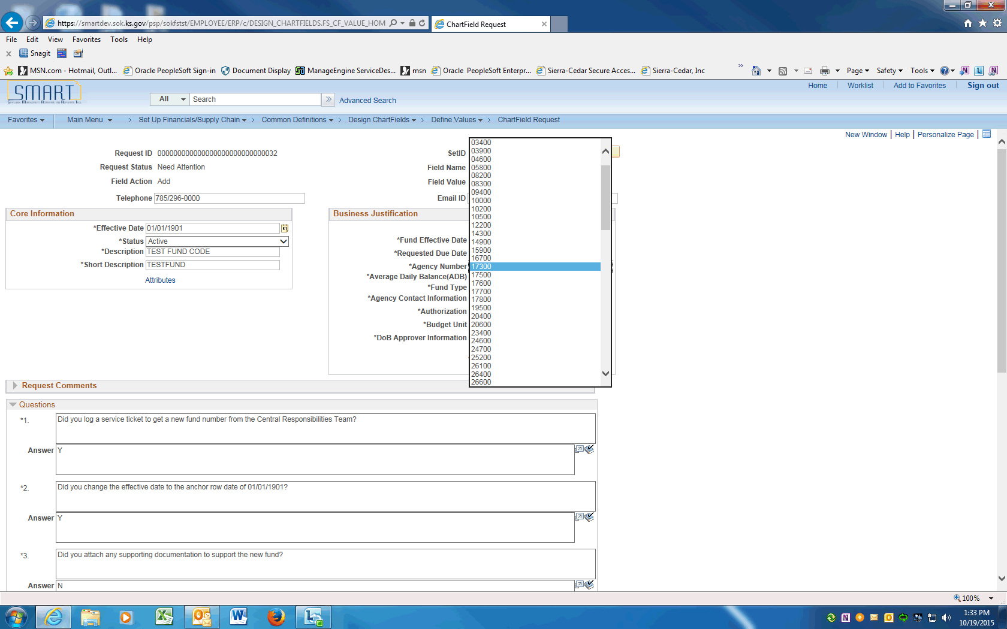

Step | Action
 | Click on the drop down arrow to display agency Business Unit numbers. Click your agency number. In this example, click the 17300.
 | If interest earned by this fund is required by law to be credited to this fund based on average daily balance, click on the dropdown arrow and choose Y=YES otherwise click the N = NO in the Average Daily Balance (ADB) field.
 | If the budget cash balance for this fund is tracked at the Fund level only, click dropdown arrow and choose 1 = FUND. If the balance is tracked at the Fund and Budget Unit level, choose 2 = BUDGET UNIT.

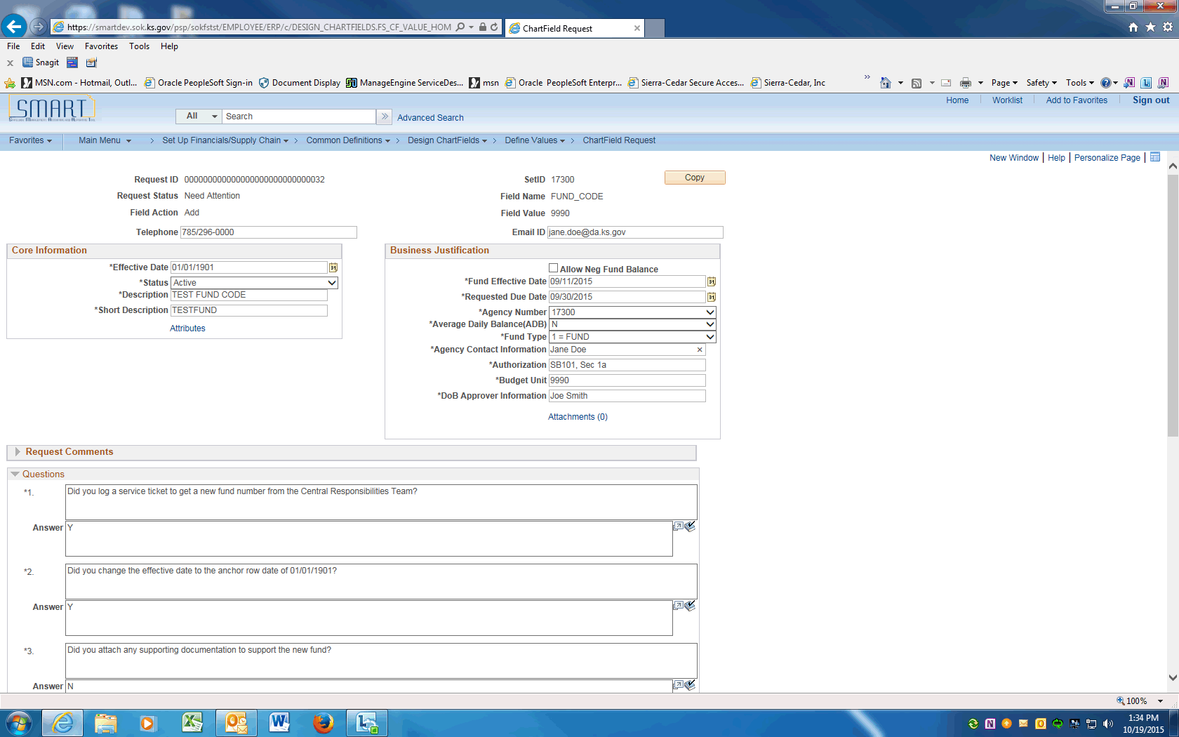

Step | Action
 | Enter the Agency contact name into the Agency Contact Information field. If the Agency Contact is different than the Requestor, include the Contact's email and phone number. Enter "Jane Doe".
 | Enter the Legal Authority for the new Fund including Legislative Session, Appropriation Bill number, Bill section, and Bill paragraph into the Authorization field. Enter "Session 2015, SB101, Sec 1a".
 | Enter the Budget Unit associated to this Fund into the Budget Unit field. Enter "9990".
 | Enter your agency's Division of Budget analyst name, email and phone number into the DoB Approver Information field. Enter "Joe Smith, joe.smith@budget.ks.gov, 785-296-9999".
 | The next Section contains Questions that must be answered prior to saving this request.

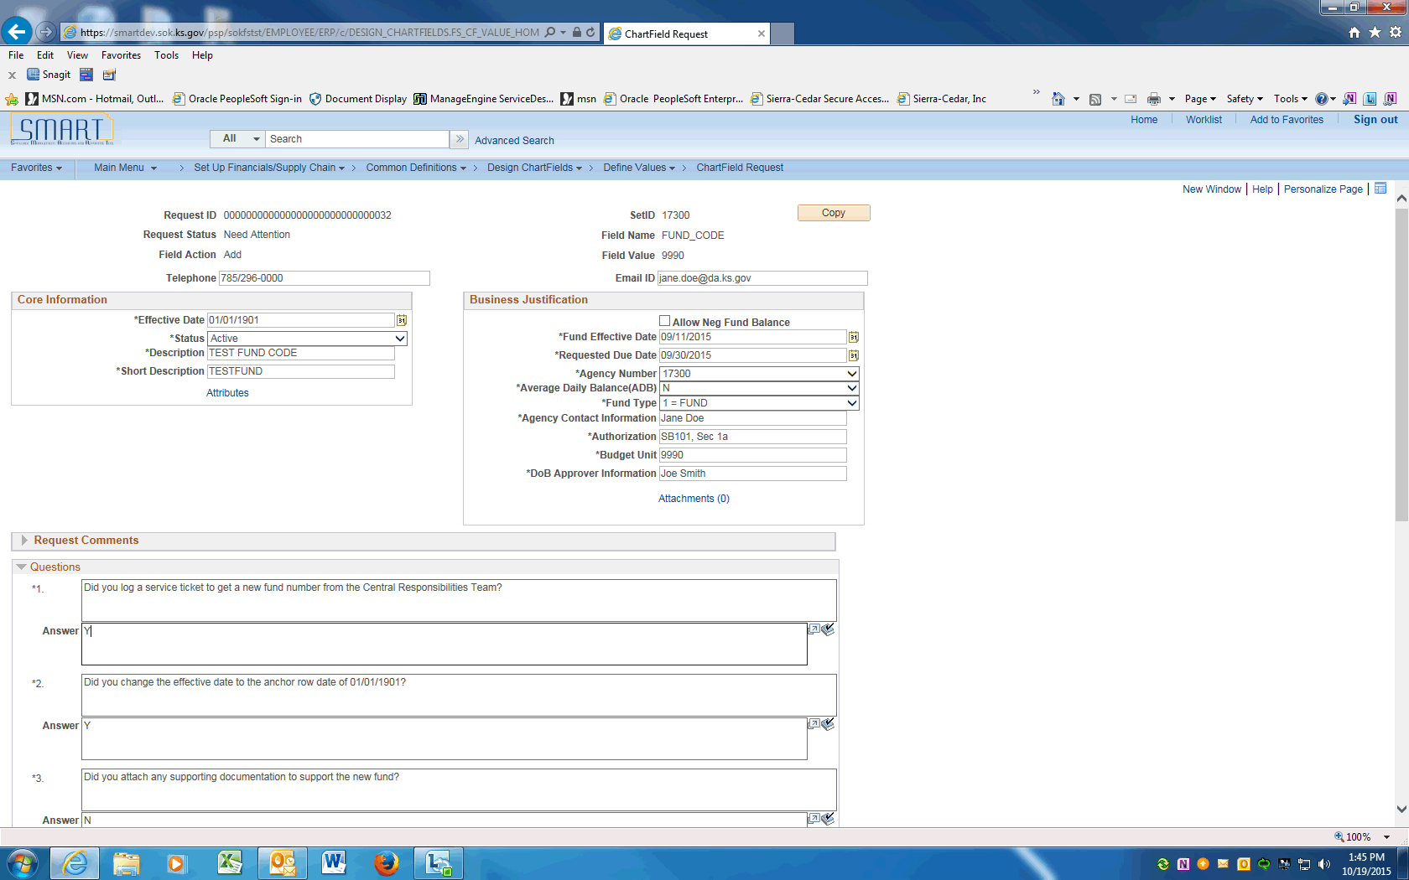

Step | Action
 | The Fund Code value must be requested from Central Responsibilities Team prior to entering a Request for a new Fund. Enter "Y".

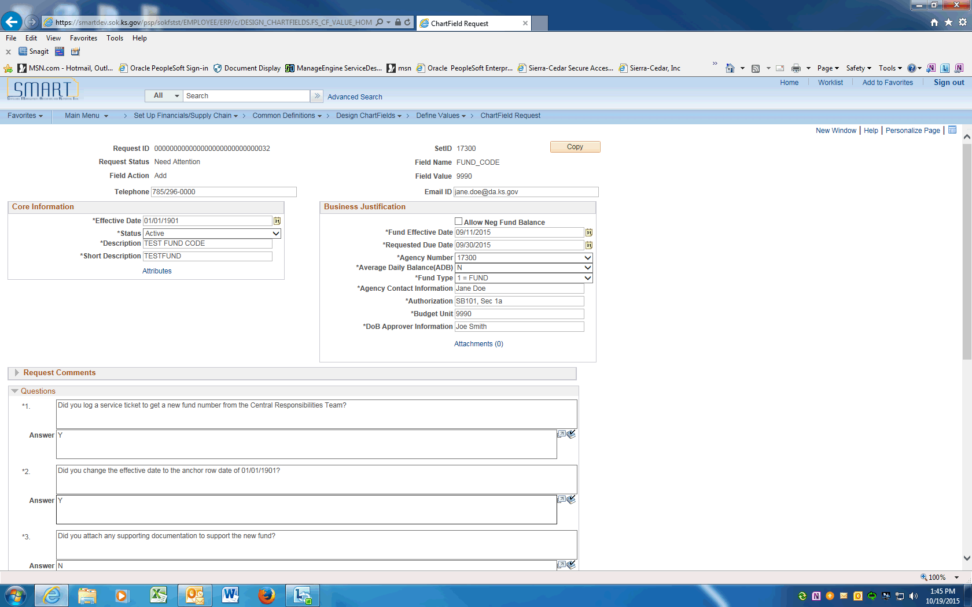

Step | Action
 | The anchor Effective Date will always be '01/01/1901' for a new Fund. Enter "Y".
 | Justification may include a copy of the Statute, CFDA information, etc. If justification is not needed, enter NA. Enter "NA".
ChartField Attributes must be added after the Request is saved.

ChartField Attributes for Fund:
ALLOW NEG BALNC - central use only
APPROPRIATED- central use only
BOND TRAK - bond funds tracked by KDFA
CFDA NUMBER - federal fund Catalog for Domestic Assistance ID number
DESIGNATIONS- central use only
EXCLUDE- central use only
FUND OWNER - the single state Agency designated on a Grant Award or Contract.
LEGAL AUTH - central use only
OFF BUDGET- central use only
 | The Requester's Name, email and phone number must be entered above.
 | CFDA NUMBER is the federal fund Catalog for Domestic Assistance ID number. All federal funds must have a CFDA number.
 | If the Allow Fund to go Negative box is checked above, justification must be attached. Enter N/A if not applicable.
 | Only after all the questions are answered, the request can be saved. Click the Save button.
 | After saving the request, enter the ChartField Attributes. Scroll to the top of the page and click the Attributes link.

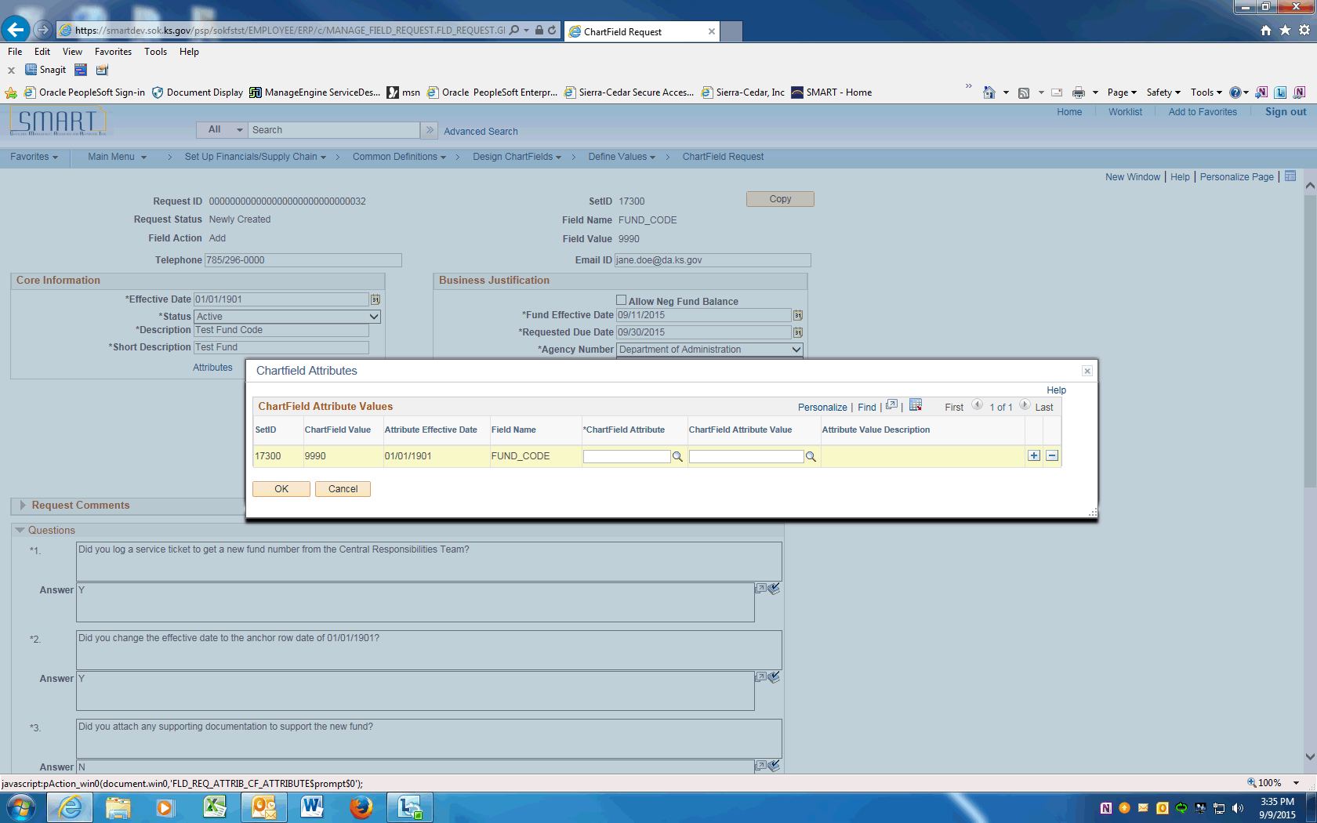

Step | Action
 | Under the ChartField Attribute column, Click the magnifying glass and choose FUND OWNER attribute.
 | Under the ChartField Attribute Value column, click the magnifying glass and choose your agency's Business Unit. If the Fund is shared across agencies, the single state agency designated on the federal award should be chosen.
 | Add other ChartField Attributes as needed. When finished, click the OK button.

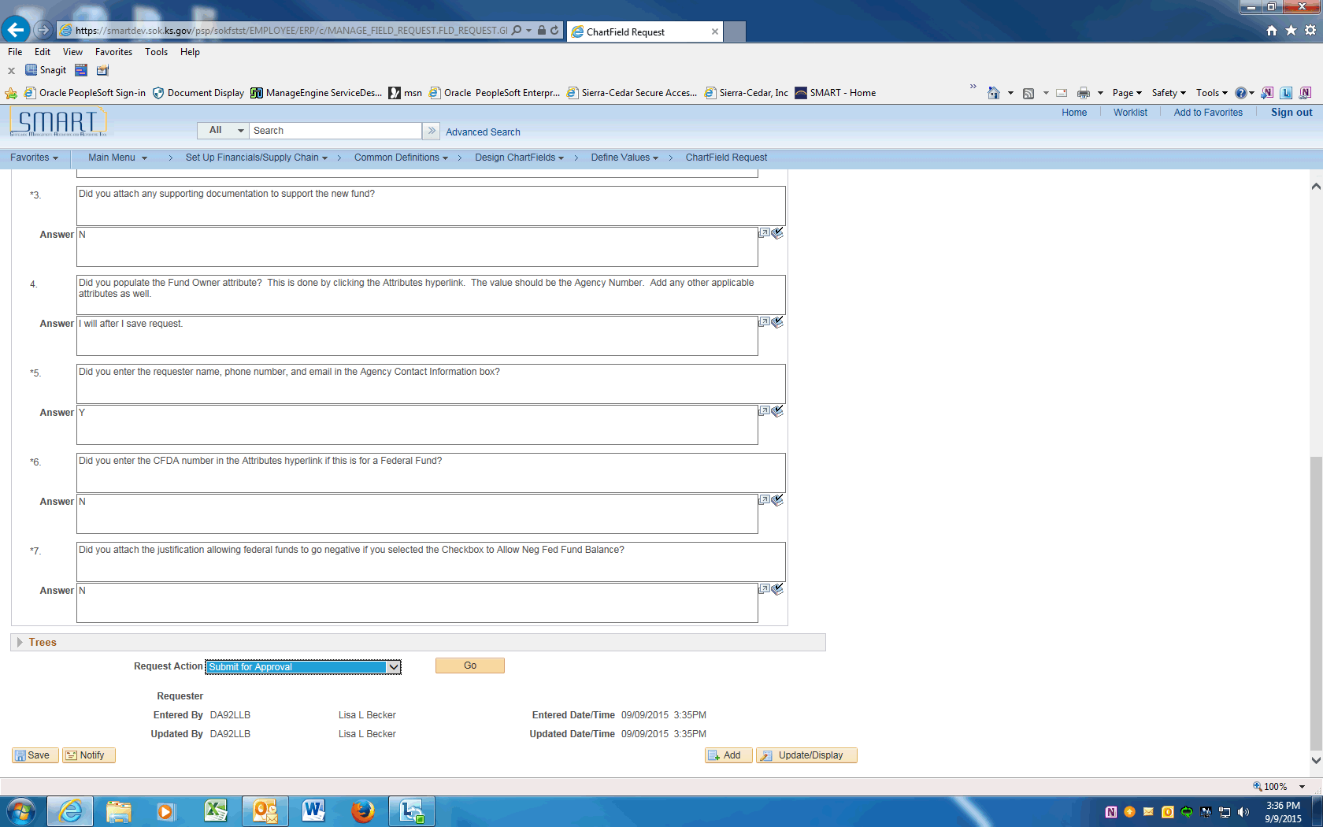

Step | Action
 | Click the dropdown arrow and choose the Submit for Approval item. Click the Go button. This will submit the Request into Approval workflow.
 | Click the View Approval Flow link to see the workflow.

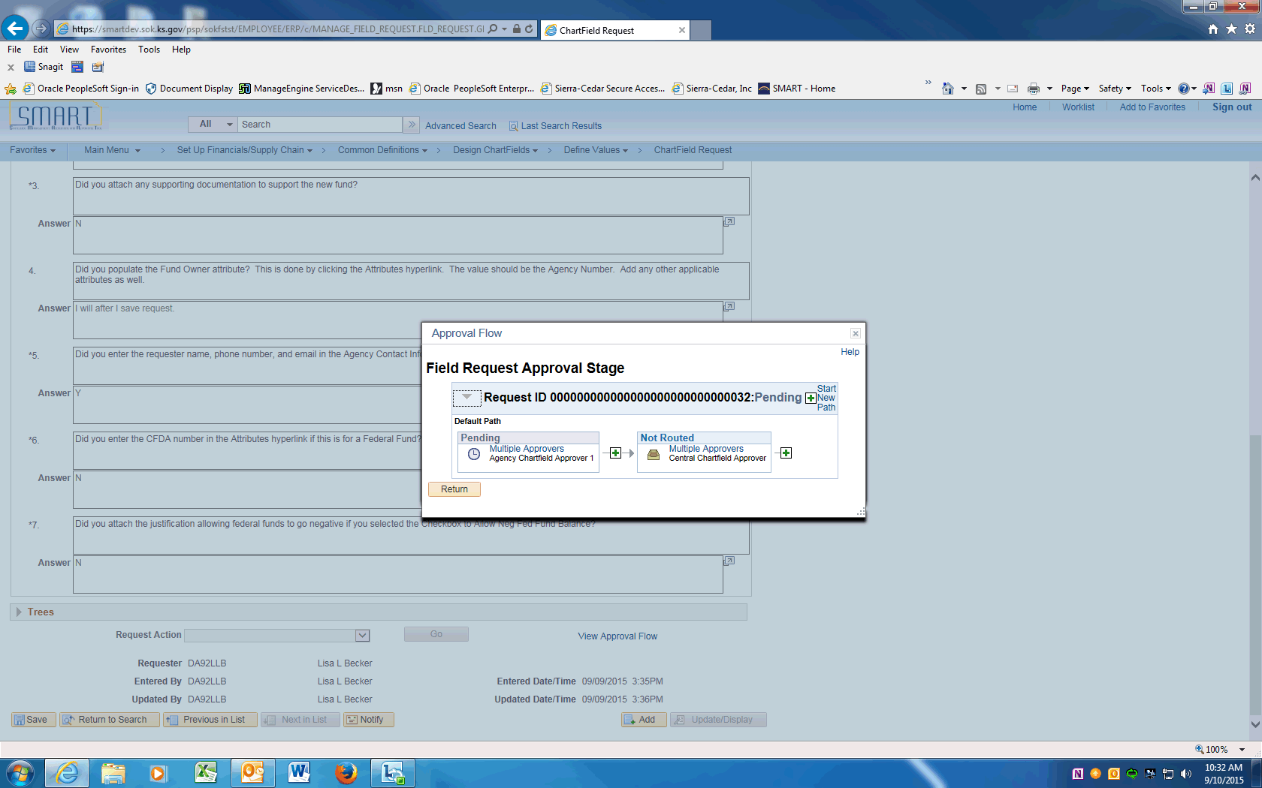

Step | Action
 | Approval Flow is displayed. The Request will need to be approved by the Agency Chartfield Approver and the Central Chartfield Approver. After approval, the ChartField will be available in SMART.
 | End of Procedure.

Updating Funds using Add a New Value
This UPK will demonstrate how to request an update to a Fund Code. An update is effective dated and can include ChartField inactivations, description changes, budgetary only changes, etc.
This option will be used for most ChartField updates.
Procedure

Step | Action
 | Click on Main Menu
 | Scroll down and click the Set Up Financials/Supply Chain menu.
 | Click the Common Definitions menu.
 | Click the Design ChartFields menu.
 | Click the Define Values menu.
 | Click the ChartField Request menu.

Step | Action
 | Click the Add a New Value tab and enter your agency SETID into the SetID field. Enter "17300".
 | Click the magnifying glass next to the Field Name to display the Look Up and click on the FUND_CODE link.

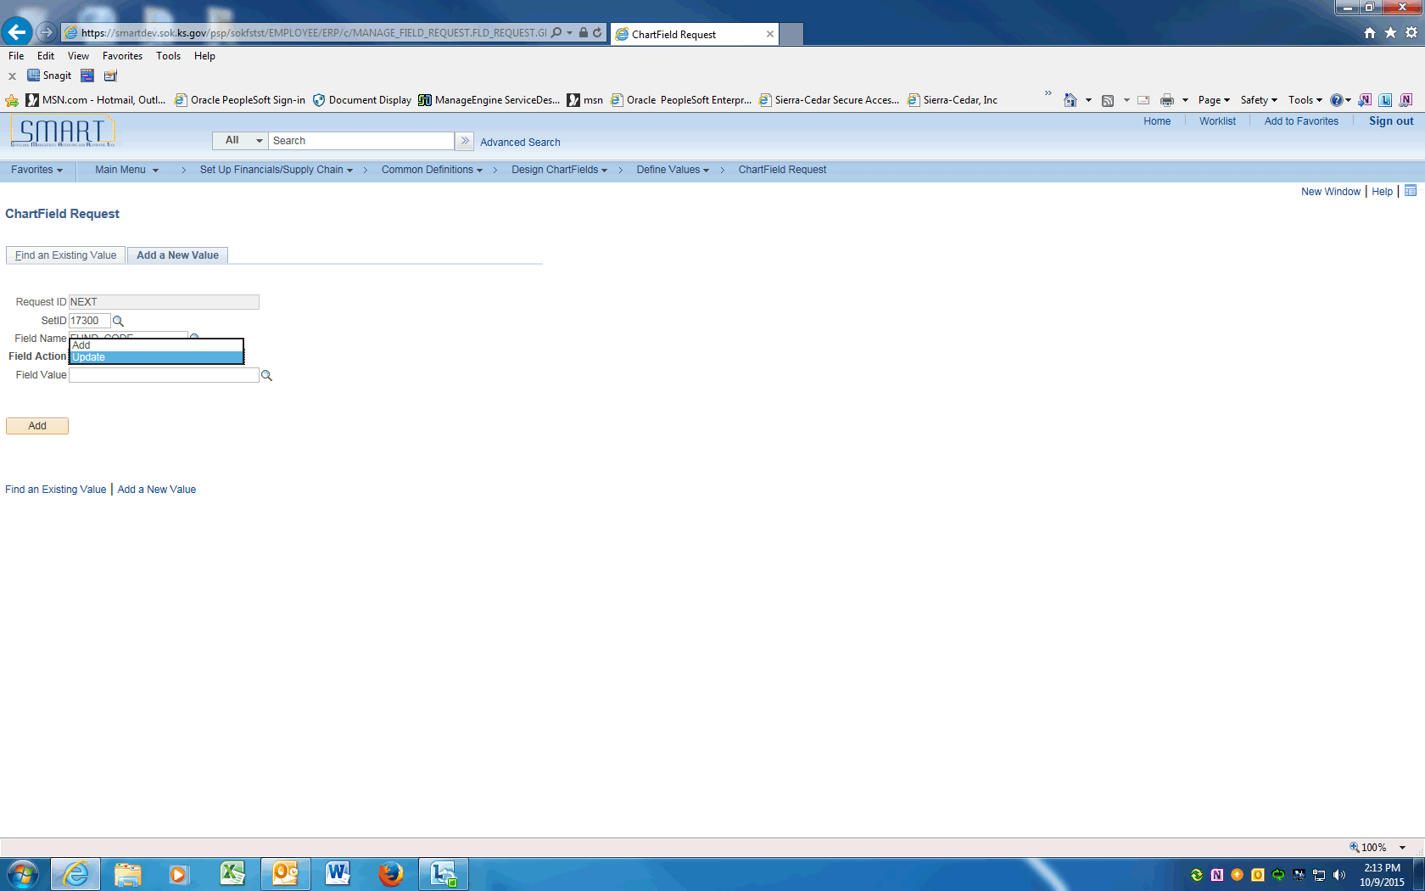

Step | Action
Click the magnifying glass next to the Field Action to display the Look Up. Choose Update to inactivate or change the Fund Code.
Click the Update list item.

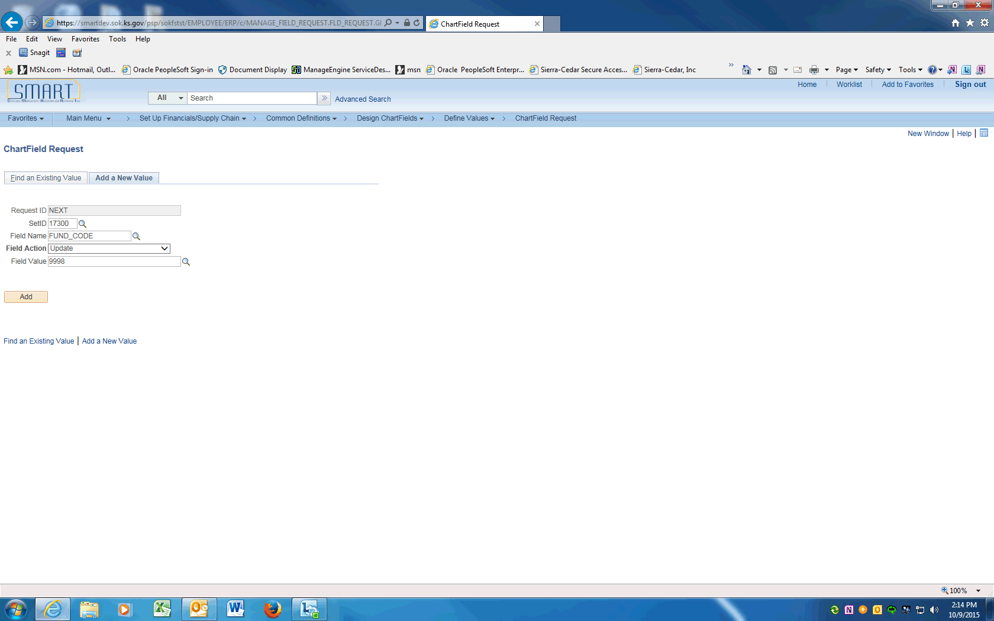

Step | Action
 | Enter the Fund Code value into the Field Value field. Enter "9998".
 | Click the Add button.

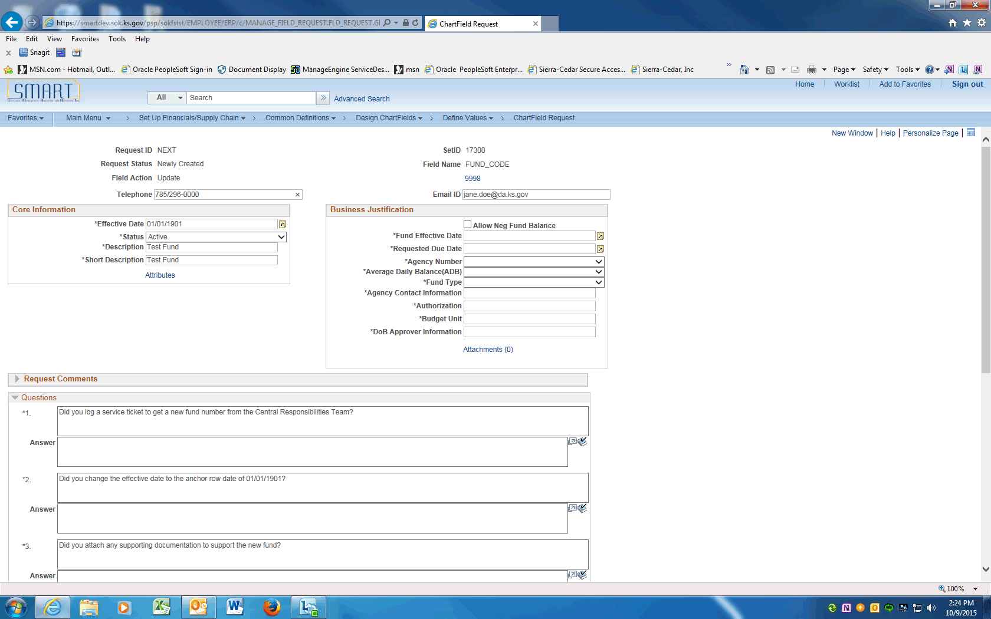

Step | Action
 | On the ChartField Request page, enter the Requestor's phone number into the Telephone field. Enter "785-296-0000".
 | Click in the Email ID field and enter the Requestor's email address.

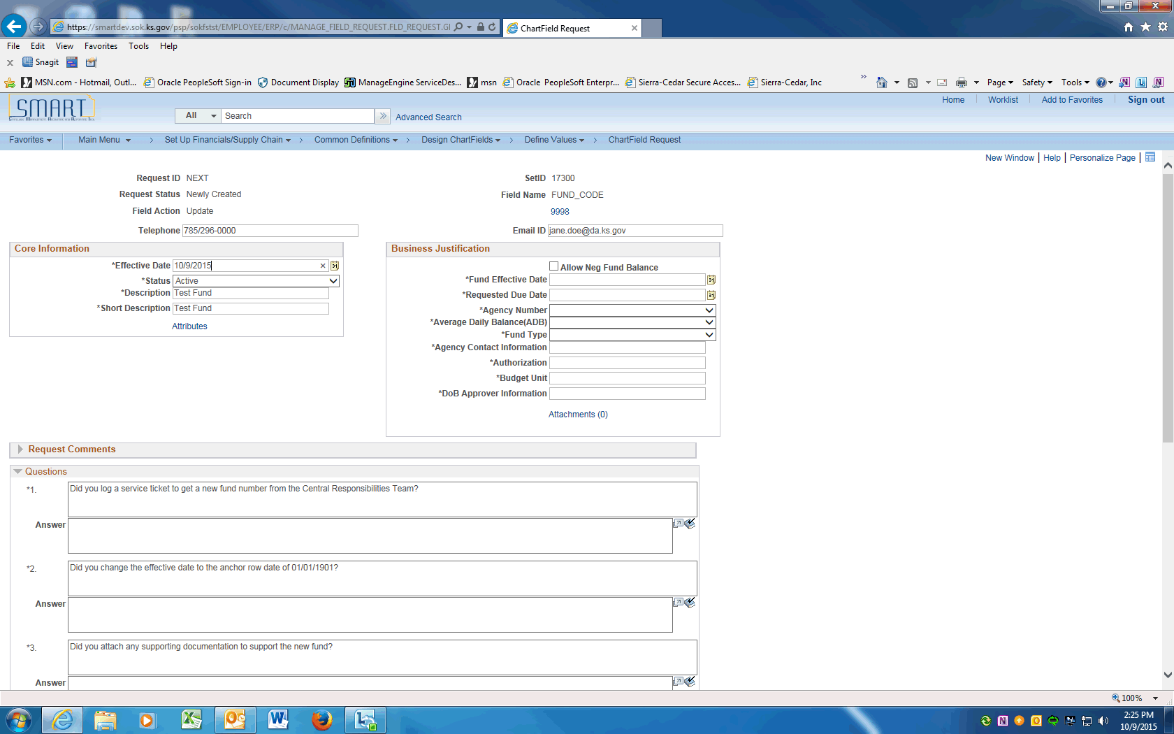

Step | Action
 | Enter the current or future effective date into the Effective Date field
 | Click on the look-up for Status and choose option.

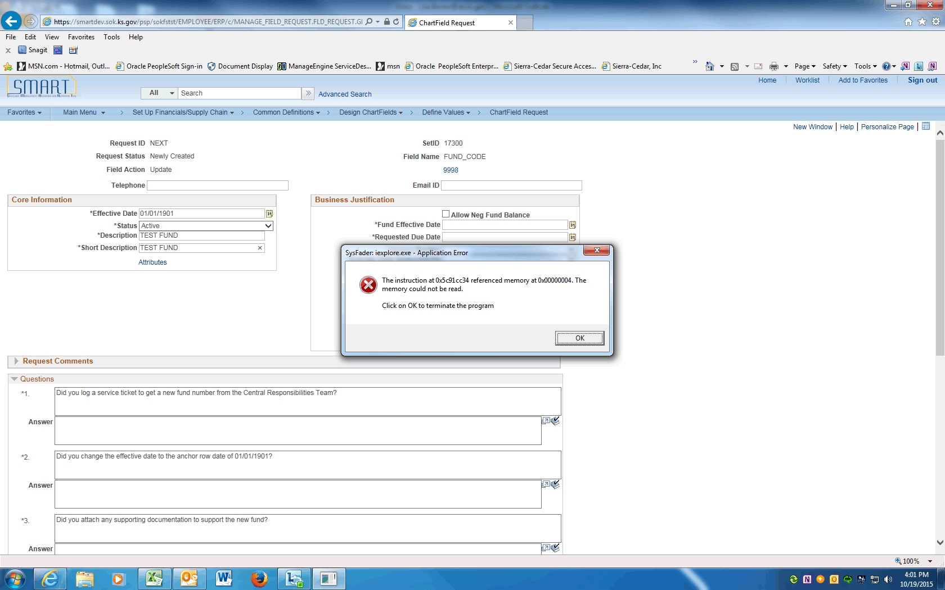

Step | Action
Review/enter in capital letters, the Fund Code long and short descriptions provided by the Central Responsibilities Team, into the Description and Short Description fields.

For updates, the Descripton and Short Description fields should be populated.
For inactivations, Ignore the Allow Neg Fund Balance box.

Mark the box if requesting approval for the fund's cash balance to be allowed to go negative. Attach the justification to this request.
 | Enter the Fund Effective Date which should match the effective date of the update. Enter "10/9/2015".
 | Enter the due date of this request into the Requested Due Date field. Enter "10/15/2015".

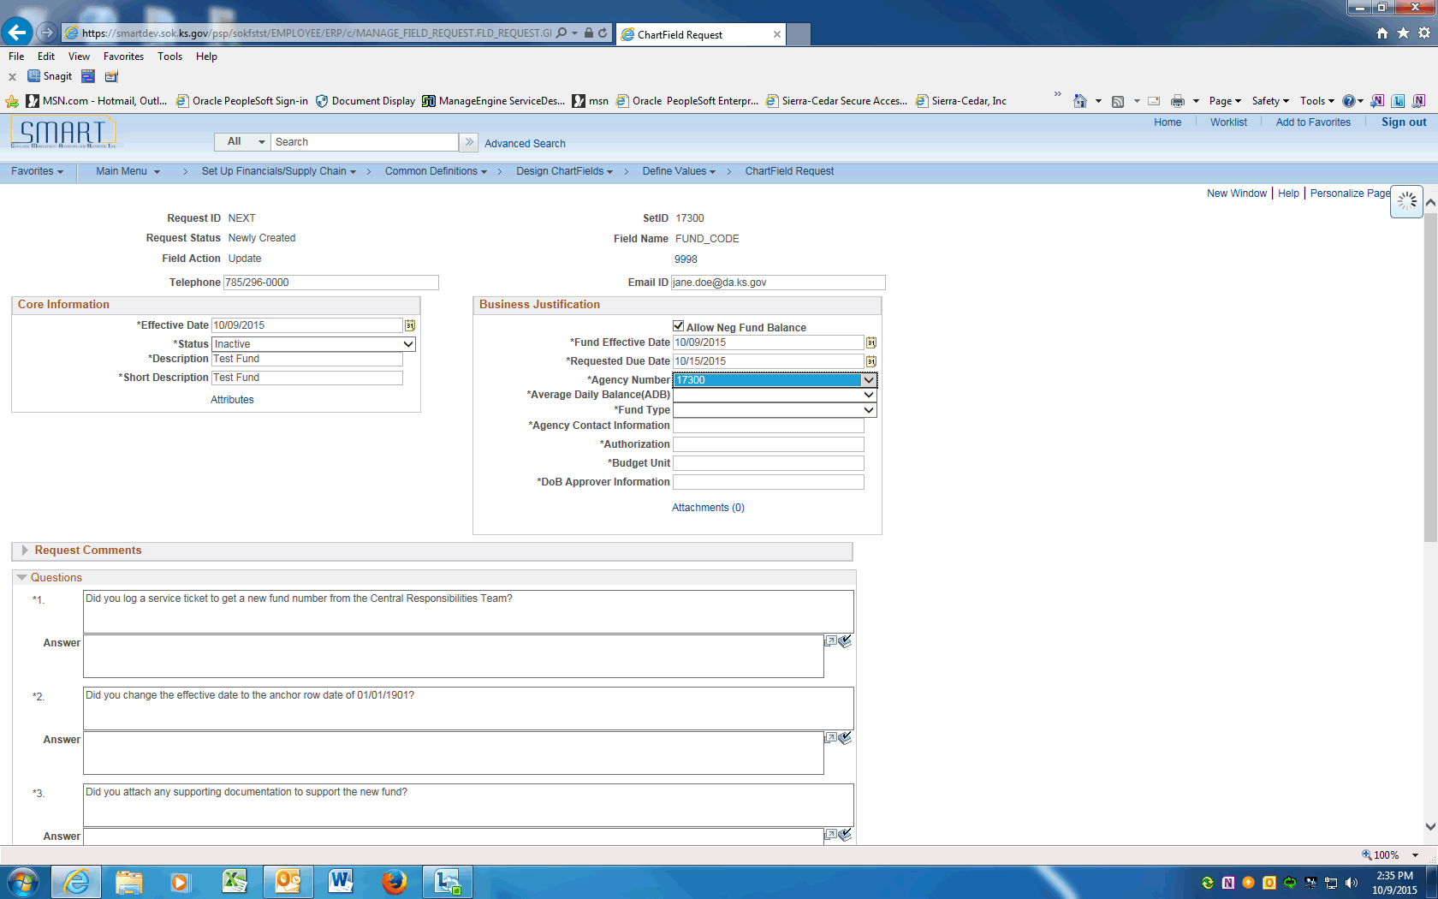

Step | Action
 | Click on the drop down arrow to display agency number. Click your agency's business unit number. In this example, click the 17300 list item.
For inactivations, choose N = NO.

For other updates, if interest earned by this fund is required by law to be credited to this fund based on average daily balance, click on the dropdown arrow and choose Y=YES otherwise click the N = NO in the Average Daily Balance (ADB) field.

For inactivations, leave blank.

For other updates, if the budget cash balance for this fund is tracked at the Fund level only, click dropdown arrow and choose 1 = FUND. If the balance is tracked at the Fund and Budget Unit level, choose 2 = BUDGET UNIT.

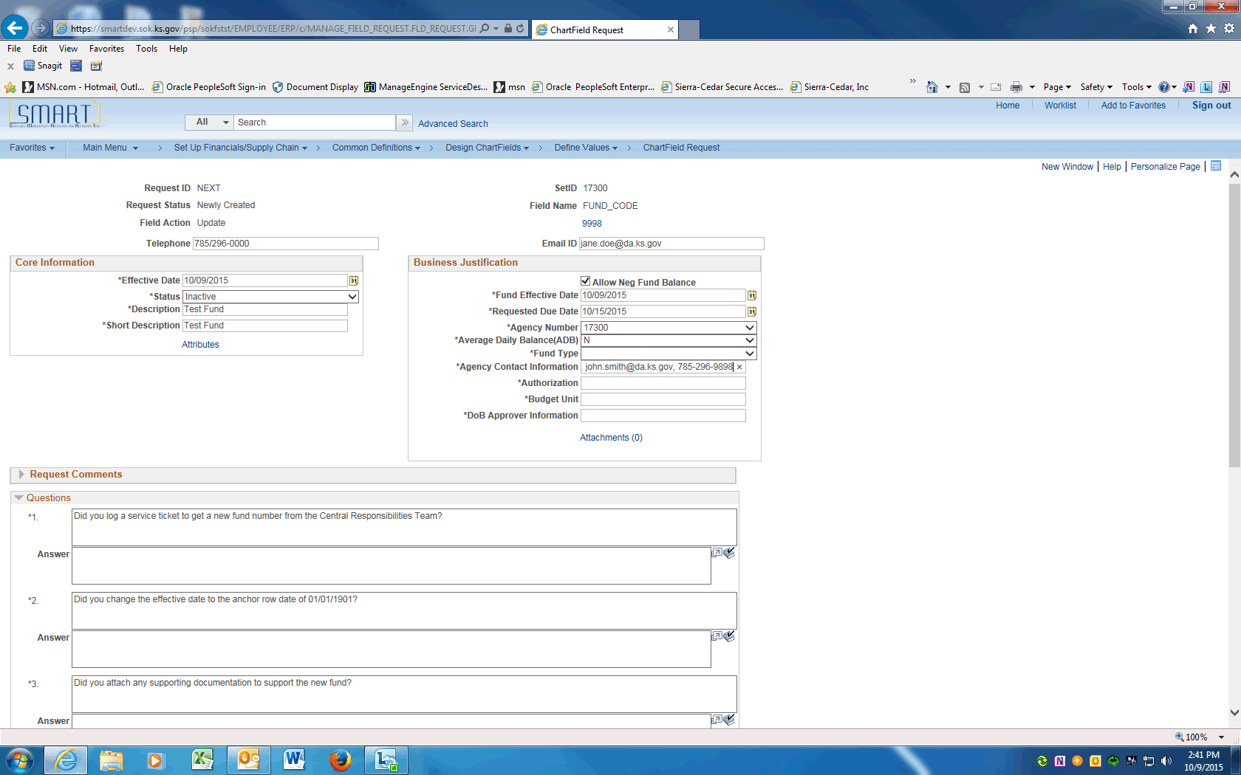

Step | Action
 | Enter the Agency contact name, email, and phone number into the Agency Contact Information field. Enter "John Smith, john.smith@da.ks.gov, 785-296-9898".
For inactivations, enter the reason for inactivation.

For other updates, enter the Legislative Session, Appropriation Bill number, section and paragraph into the Authorization field.
 | Enter the Budget Unit associated to this Fund into the Budget Unit field. Enter "9990".
 | Enter your agency's Division of Budget analyst name, email and phone number into the DoB Approver Information field. Enter "Joe Smith, joe.smith@budget.ks.gov, 785-296-9999".
 | The next Section contains Questions that must be answered prior to saving this request.
 | For updates, enter N/A (not applicable)
 | For updates, enter N/A (not applicable)
 | For updates, enter N/A (Not Applicable)

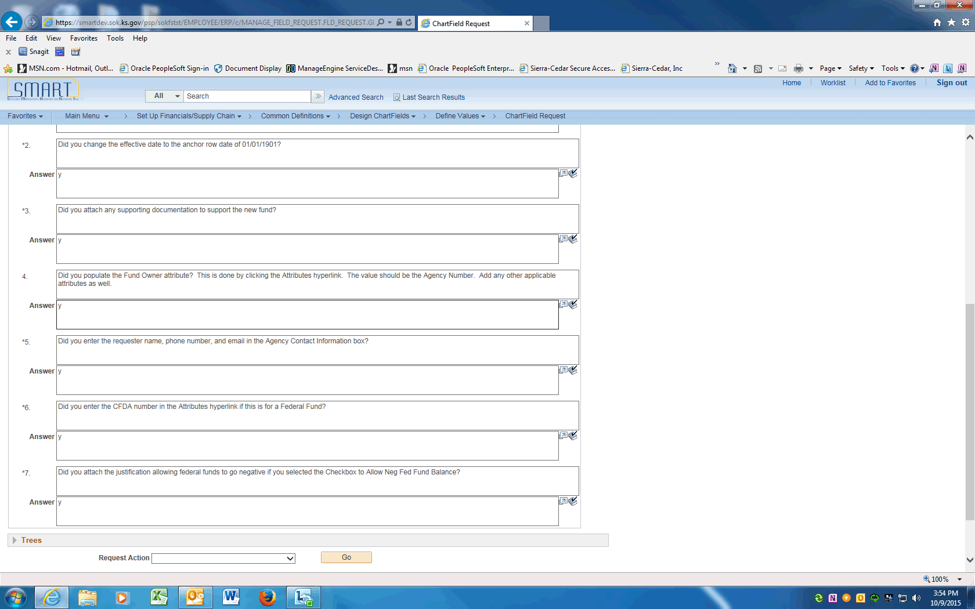

Step | Action
ChartField Attributes must be added after the Request is saved.

ChartField Attributes for Fund:
ALLOW NEG BALNC - central use only
APPROPRIATED- central use only
BOND TRAK - bond funds tracked by KDFA
CFDA NUMBER - federal fund Catalog for Domestic Assistance ID number
DESIGNATIONS- central use only
EXCLUDE- central use only
FUND OWNER - the single state Agency designated on a Grant Award or Contract.
LEGAL AUTH - central use only
OFF BUDGET- central use only

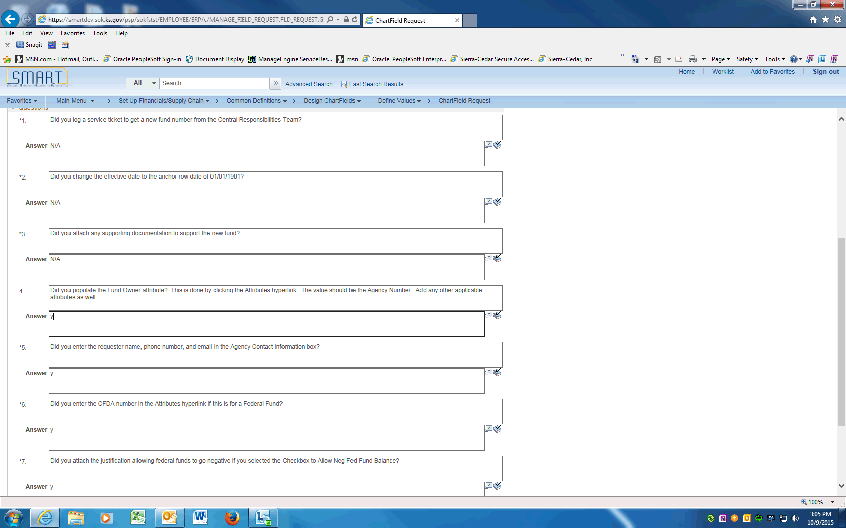

Step | Action
 | Enter the Requester's information above and enter Y in the Answer field. Enter "Y".
 | For federal funds, choose the CFDA NUMBER -the Catalog for Domestic Assistance ID number
For inactivations, enter N/A

For other updates, If the Allow Fund to go Negative box is checked above, justification must be attached. Enter N/A if not applicable.
Click in the Answer field.
 | Only after all the questions are answered, the request can be saved. Click the Save button.
 | After saving the request, enter the ChartField Attributes. Scroll to the top of the page and click the Attributes link.

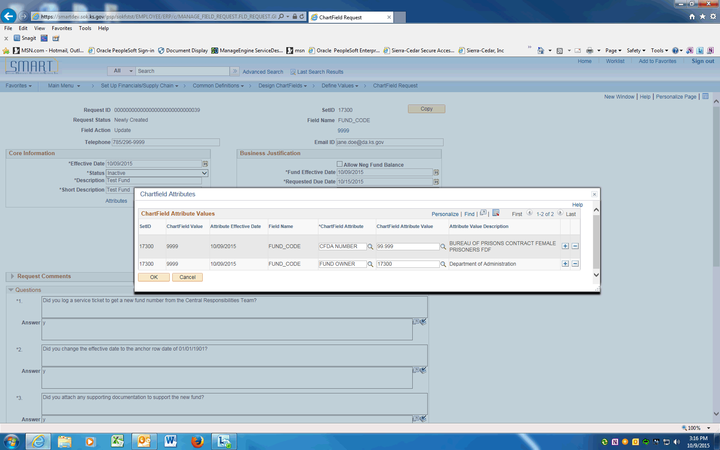

Step | Action
 | Under the ChartField Attribute column, Click the magnifying glass and choose attribute. Under the ChartField Attribute Value column, click the appropriate value.
 | Add other ChartField Attributes as needed. When finished click the OK button

Step | Action
 | Click the dropdown arrow and choose the Submit for Approval item. Click the Go button. This will submit the Request into Approval workflow.
 | Click the View Approval Flow link to see the workflow.

Step | Action
 | Approval Flow is displayed. The Request will need to be approved by the Agency Chartfield Approver and the Central Chartfield Approver. After approval, the ChartField will be available in SMART.
 | End of Procedure.

Updating Funds using Find an Existing Value
This UPK will demonstrate how to request an update to a Fund Code. An update is effective dated and can include ChartField inactivations, description changes, budgetary only changes, etc.
Use the Find an Existing Value option if the Fund Request exists in SMART and can be copied.
Procedure

Step | Action
 | Click on Main Menu
 | Scroll down and click the Set Up Financials/Supply Chain menu.
 | Click the Common Definitions menu.
 | Click the Design ChartFields menu.
 | Click the Define Values menu.
 | Click the ChartField Request menu.

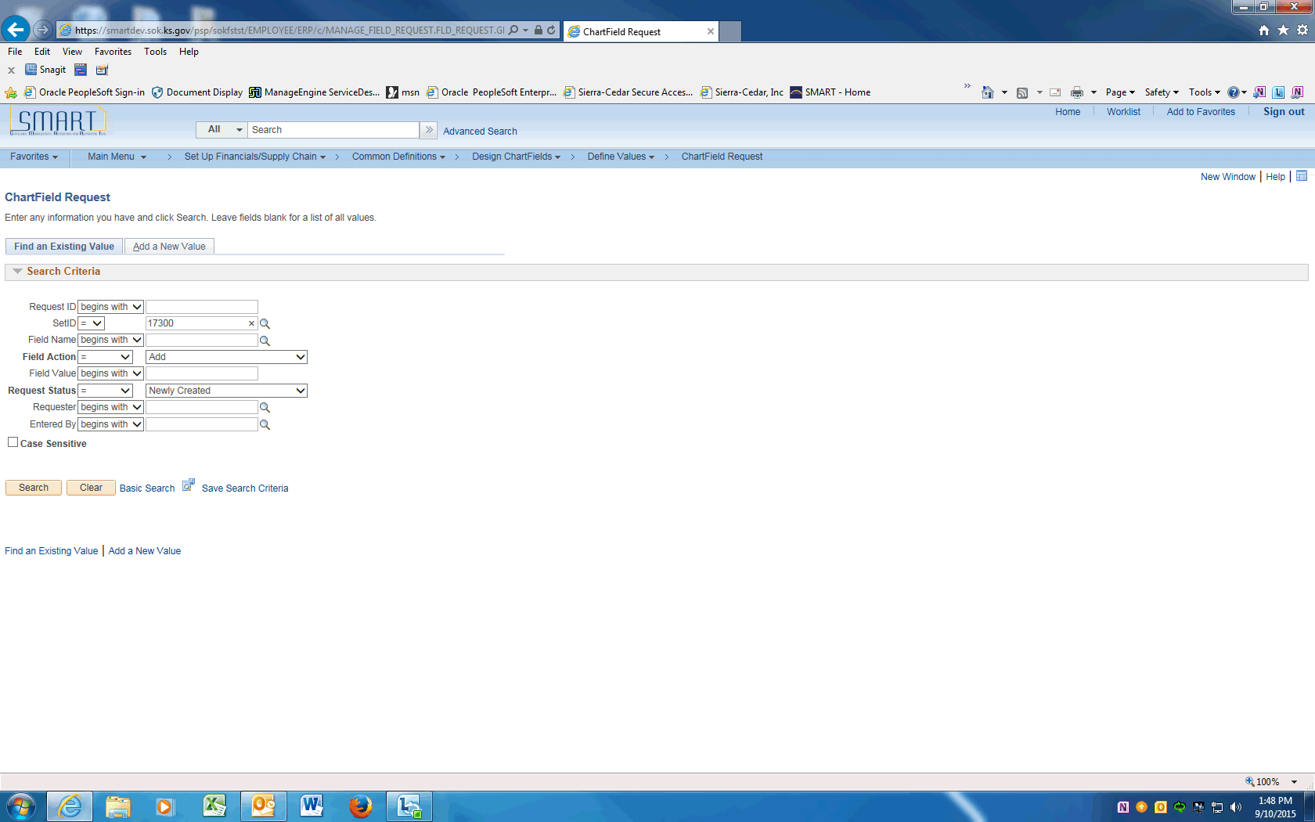

Step | Action
 | Click on the Find an Existing Value tab.
 | Enter your agency SETID into the SetID field. Enter "17300".
 | Click the magnifying glass next to the Field Name to display the Look Up and click on the FUND_CODE link.

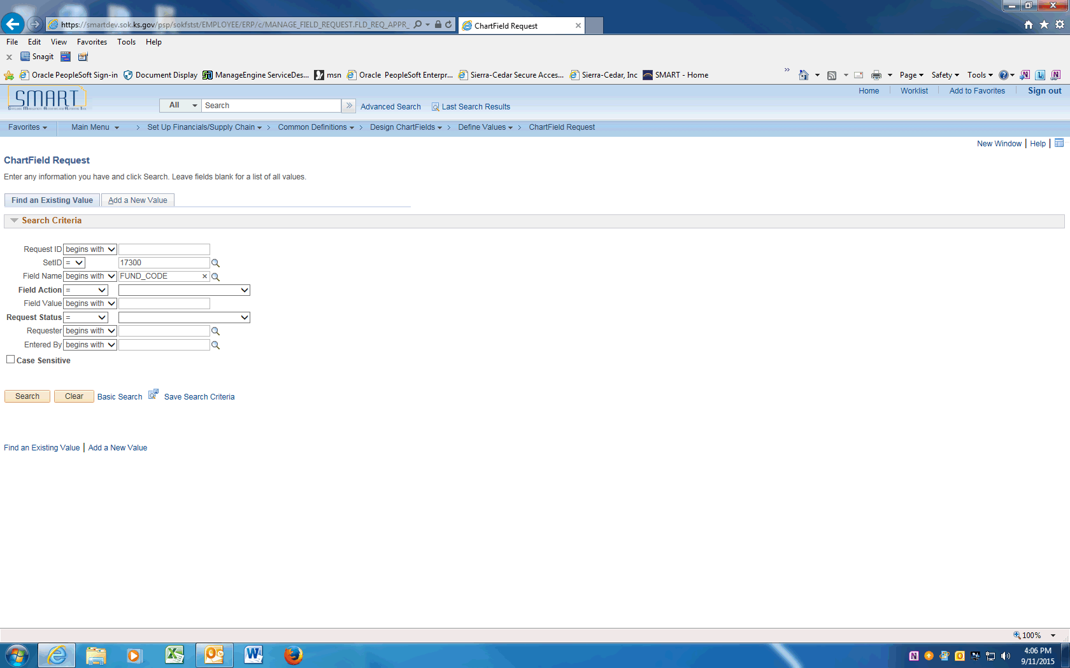

Step | Action
 | Clear the Field Action value.

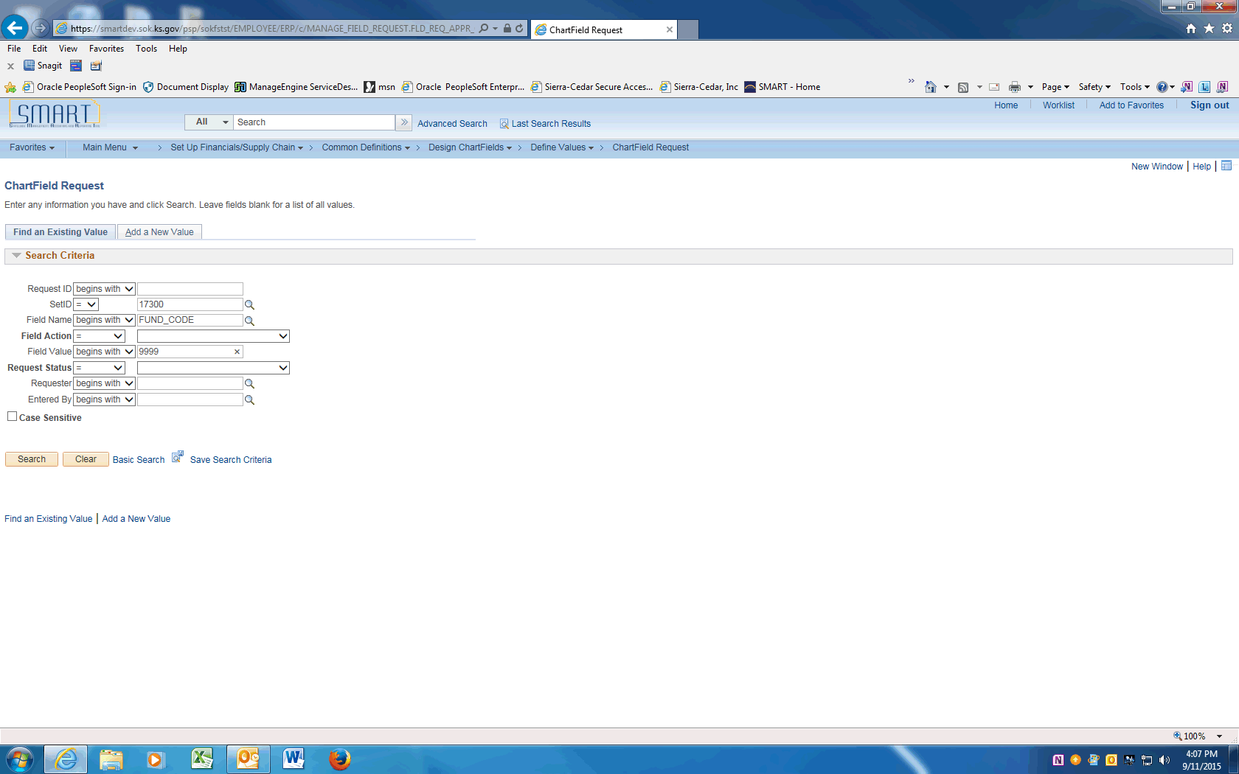

Step | Action
 | Enter the Fund Code value into the Field Value field. Enter "9999".
 | Click the Search button.

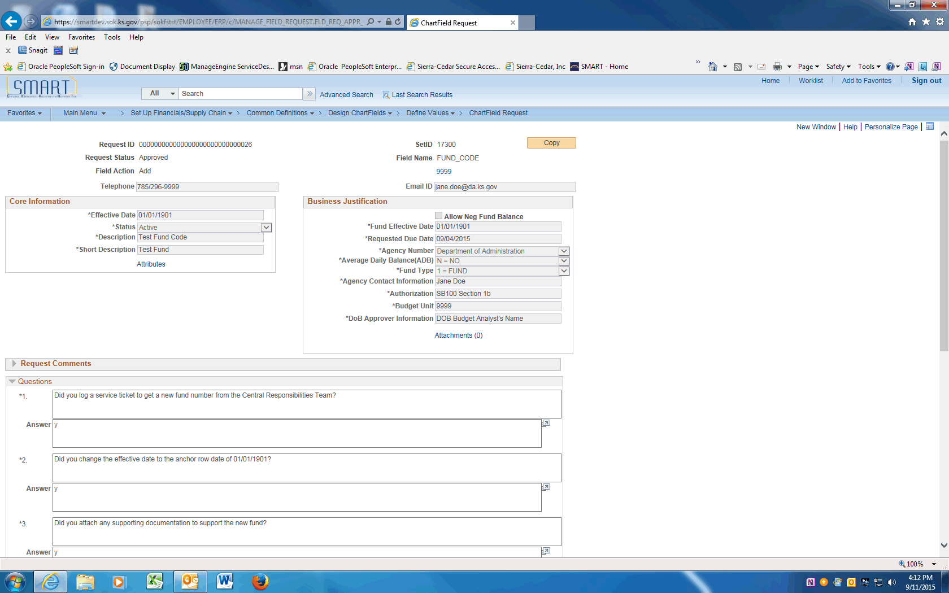

Step | Action
 | Click the Copy button at the top of the screen

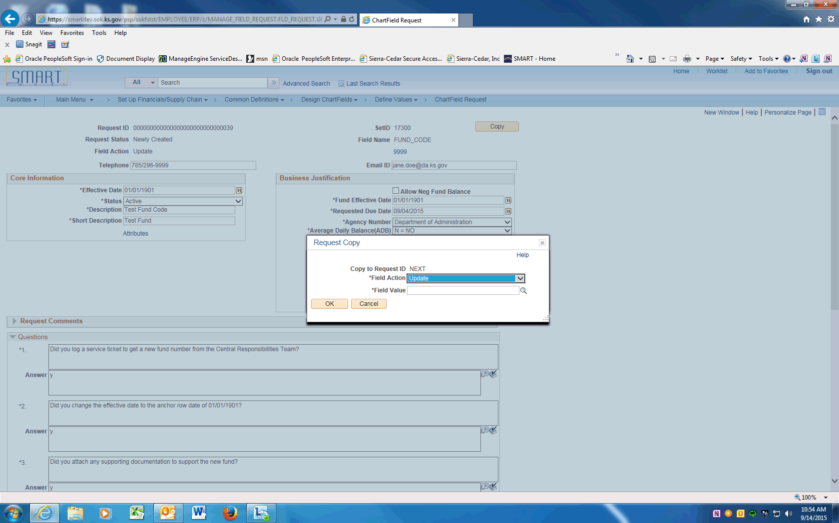

Step | Action
 | On the Request Copy popup, click the dropdown next to the Field Action and choose Update.
 | Click on the Field Value field and enter the Fund Code being updated. Enter "9999".

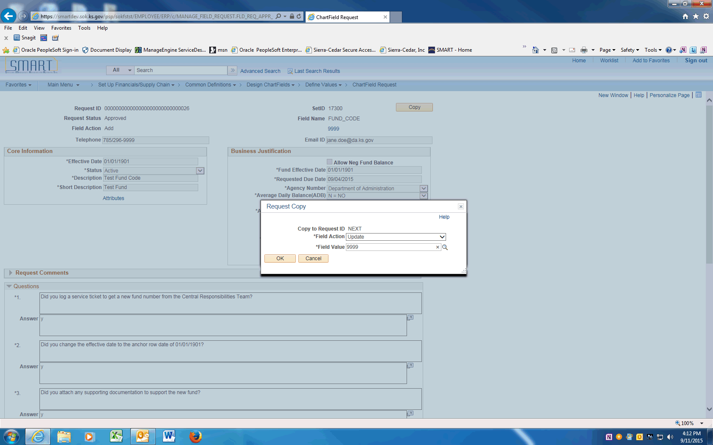

Step | Action
 | Click the OK button.

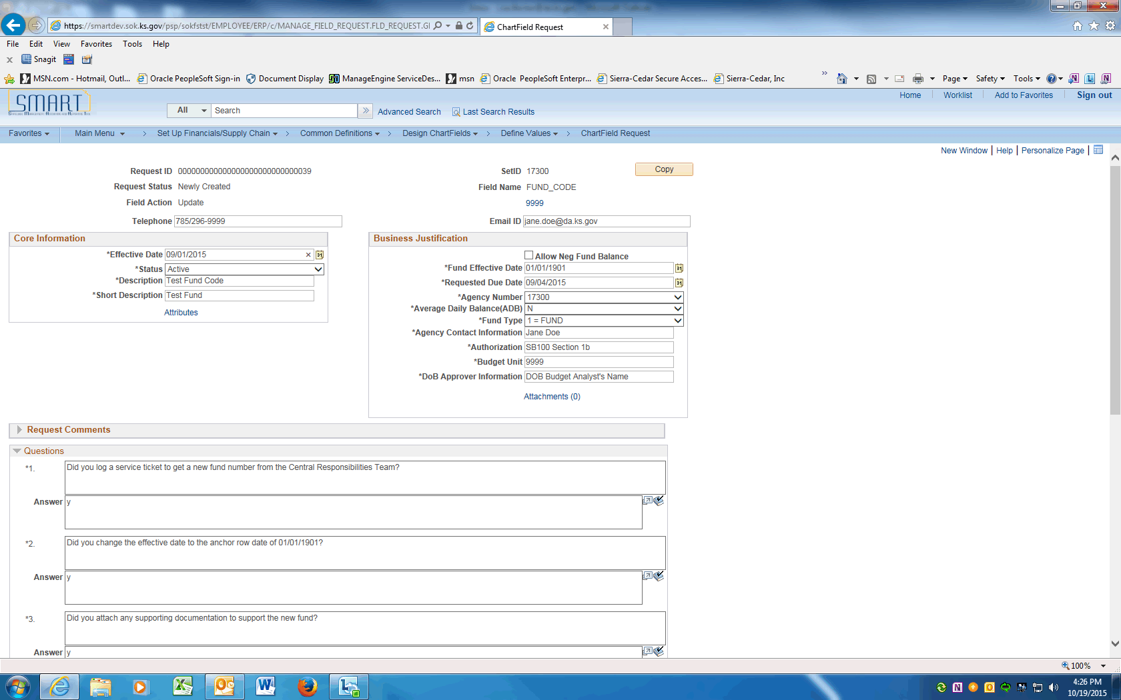

Step | Action
 | Click the Effective Date link and change to the effective date of the Update -- Today's date or a date in the future.

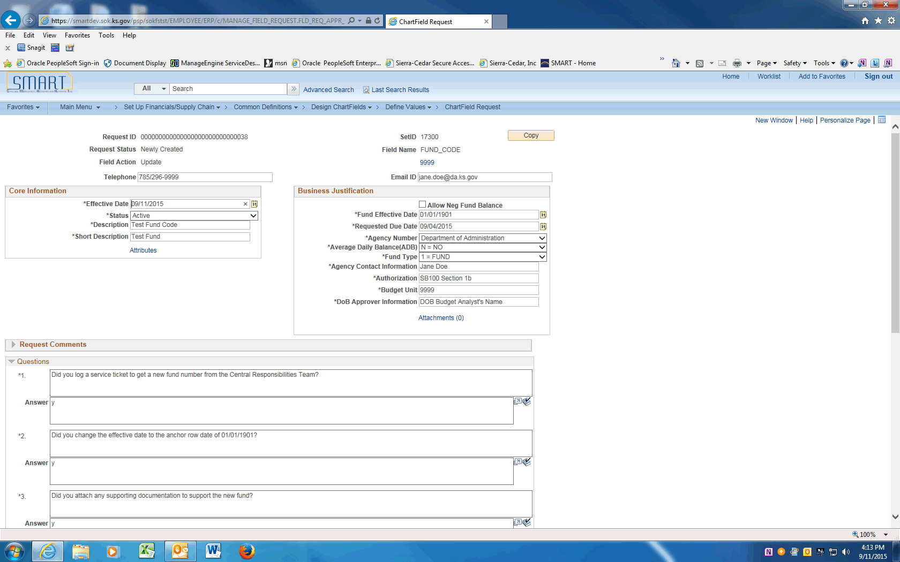

Step | Action
 | To request the Fund Code be inactivated, click the dropdown and choose the Inactive list item. To make a change leave Status as Active.

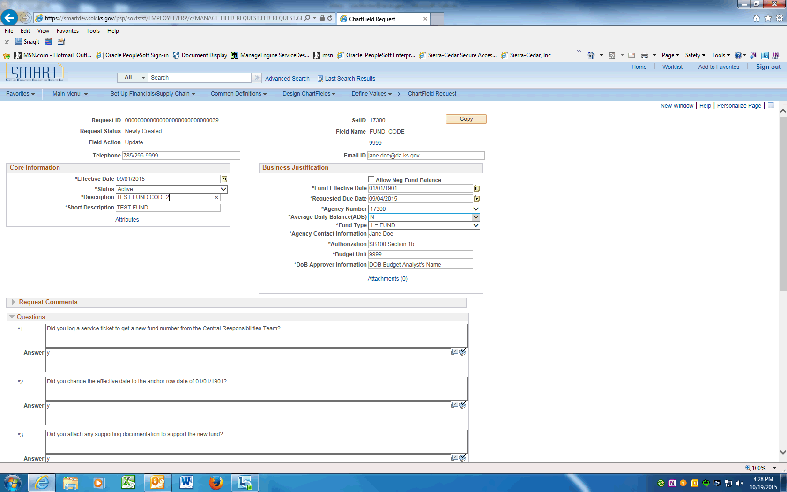

Step | Action
 | For updates, click in the Description field and change the description.
 | For updates, click in the Short Description field and change the short description.
 | Click in the Fund Effective Date field and update with the same value as the Effective Date.
 | Click in the Requested Due Date field and enter the request due date.
 | Other updates may include ChartField Attributes changes, Allow fund to go Negative change, or ADB calculation change. See the Add a Fund UPK for additional information.

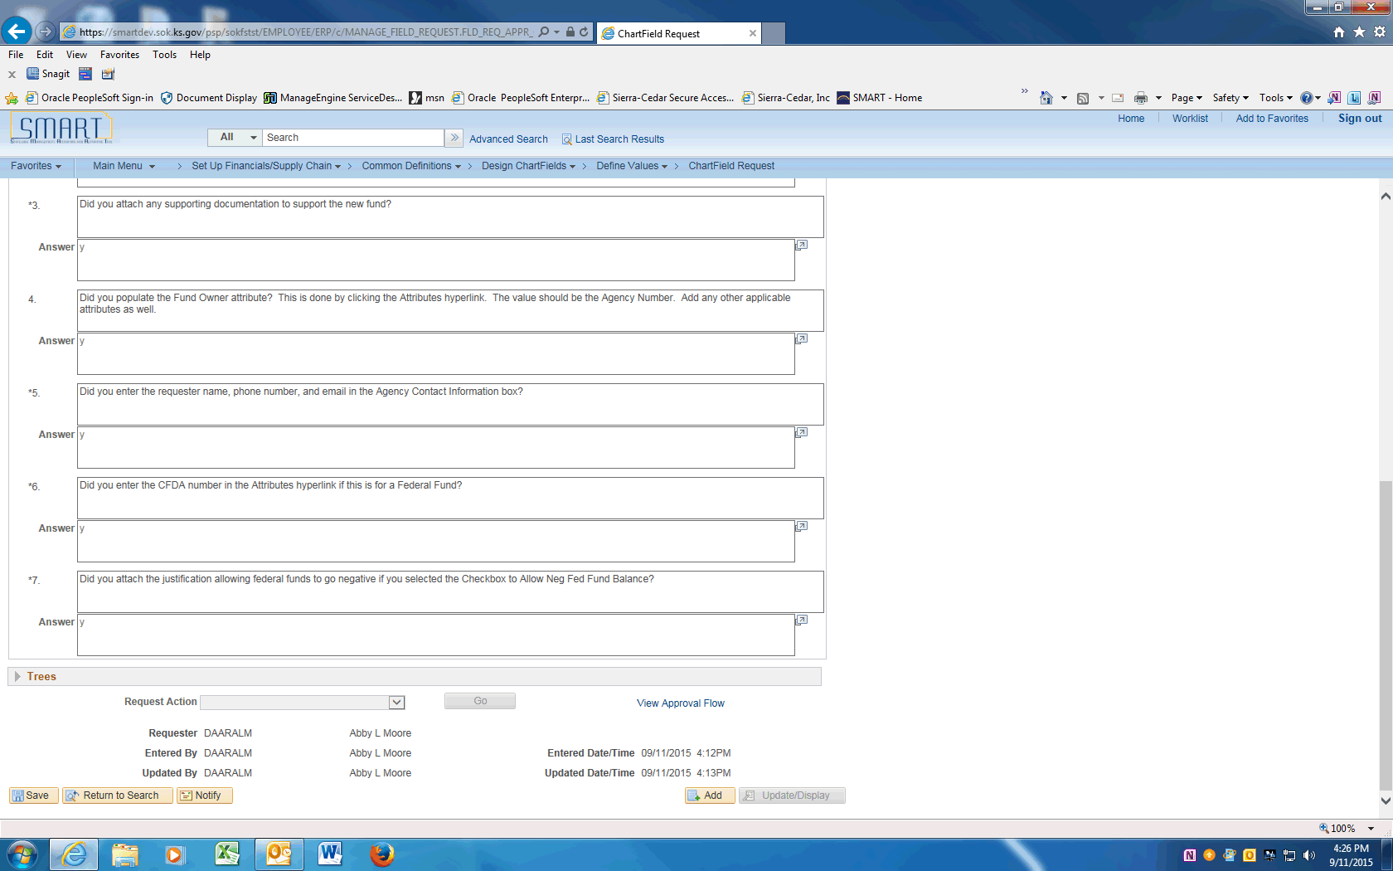

Step | Action
 | After reviewing the questions, click the Submit for Approval list item at the bottom of the page.

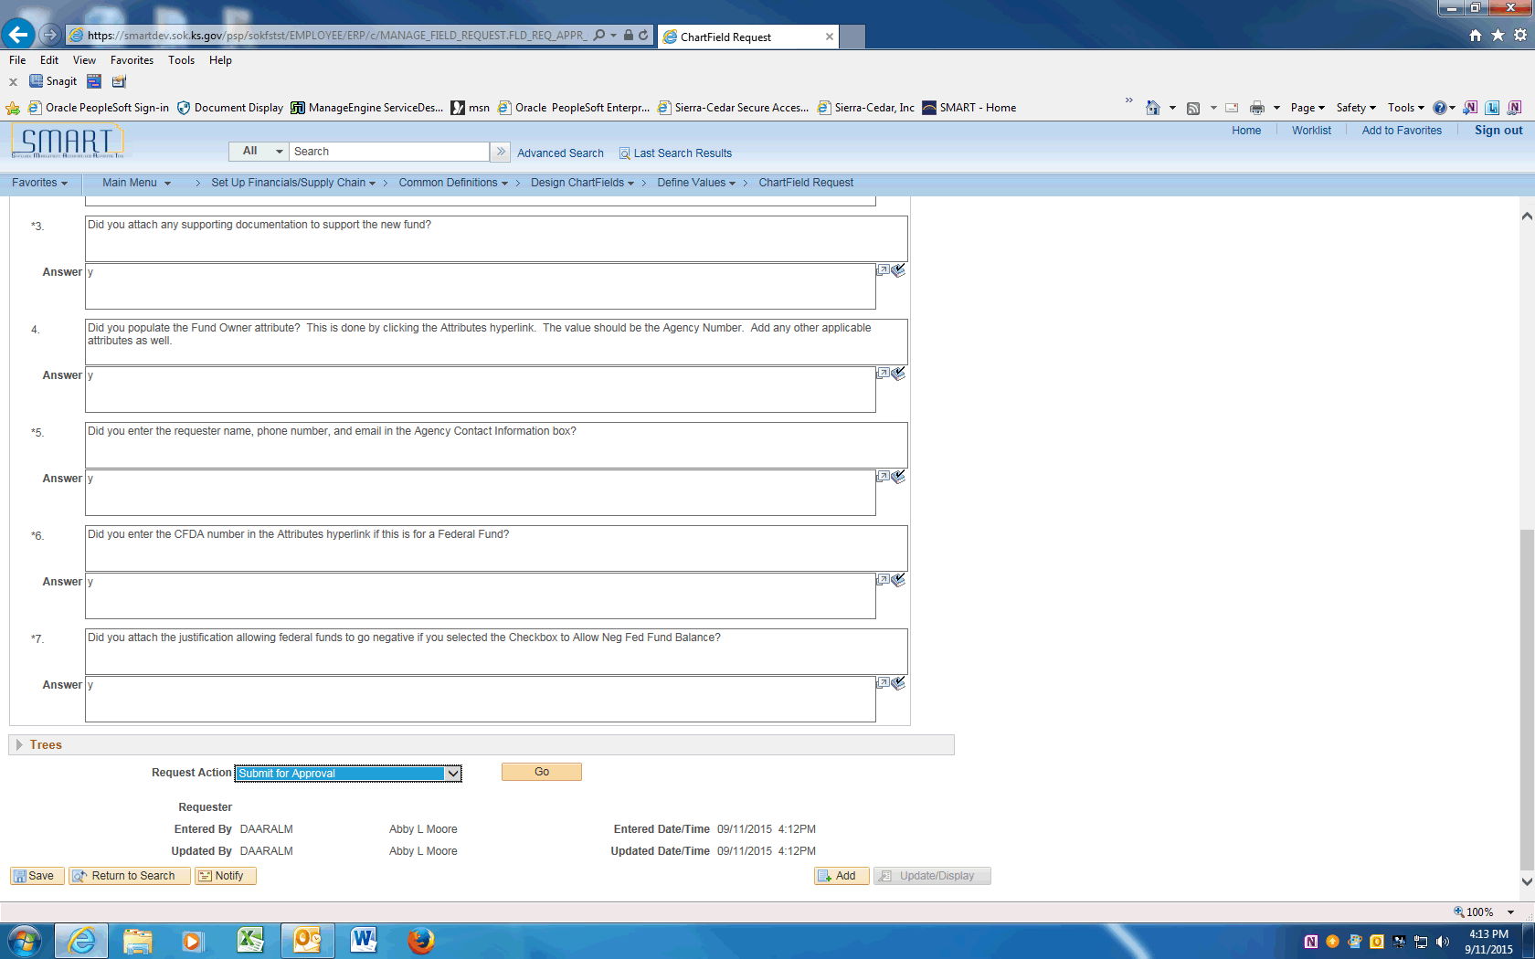

Step | Action
 | Click the Go button to Submit the Request into workflow.
 | Click the View Approval Flow link to see the workflow.

Step | Action
 | Approval Flow is displayed. The Request will need to be approved by the Agency Chartfield Approver and the Central Chartfield Approver. After approval the ChartField will be available in SMART.
 | End of Procedure.

Adding Budget Units
This UPK will demonstrate how to request a new Budget Unit.
Procedure

Step | Action
 | Click on Main Menu
 | Scroll down and click the Set Up Financials/Supply Chain menu.
 | Click the Common Definitions menu.
 | Click the Design ChartFields menu.
 | Click the Define Values menu.
 | Click the ChartField Request menu.

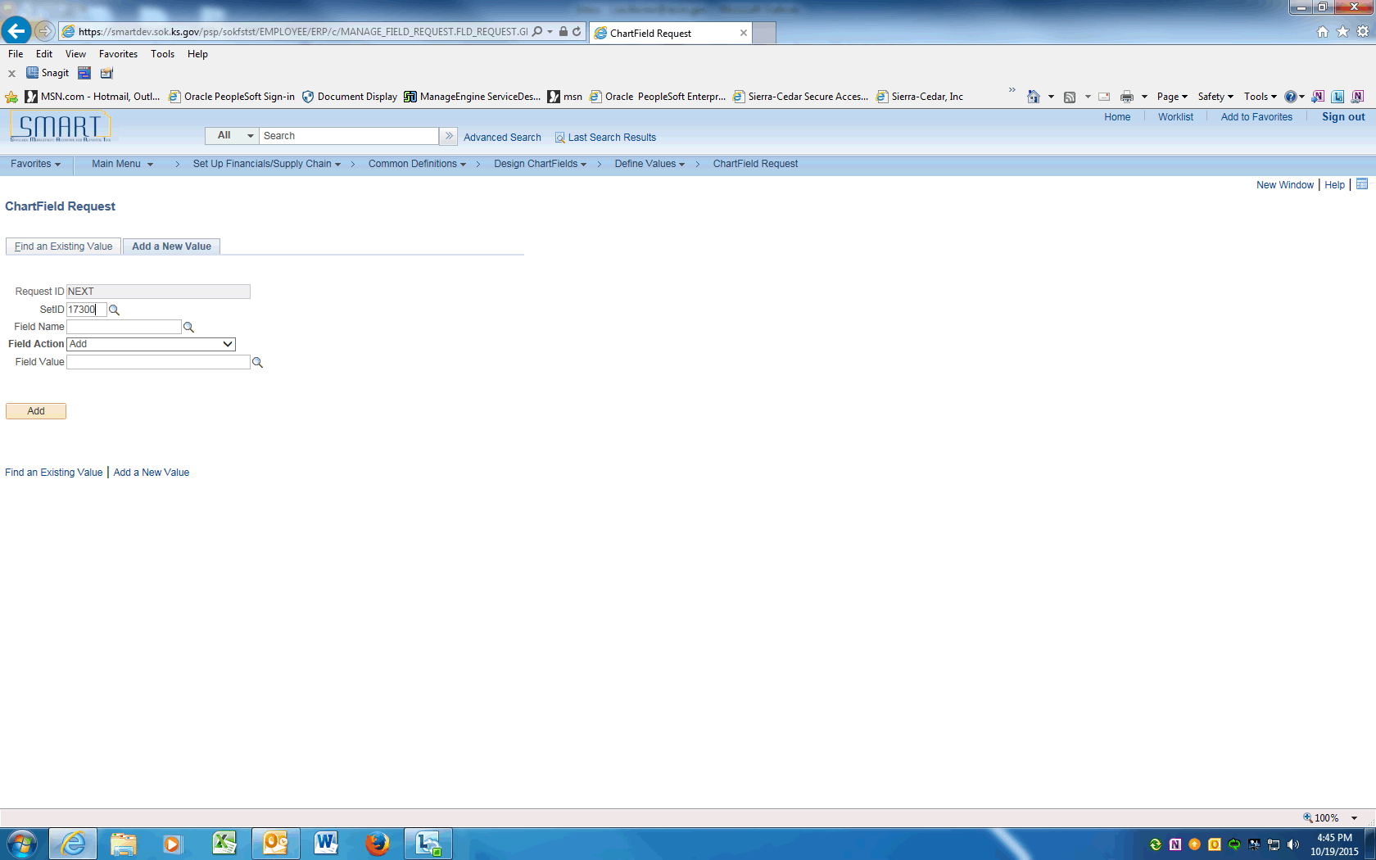

Step | Action
 | Enter your agency SETID into the SetID field. Enter "17300".
 | Click the magnifying glass next to the Field Name to display the Look Up and click on the BUDGET_REF link.

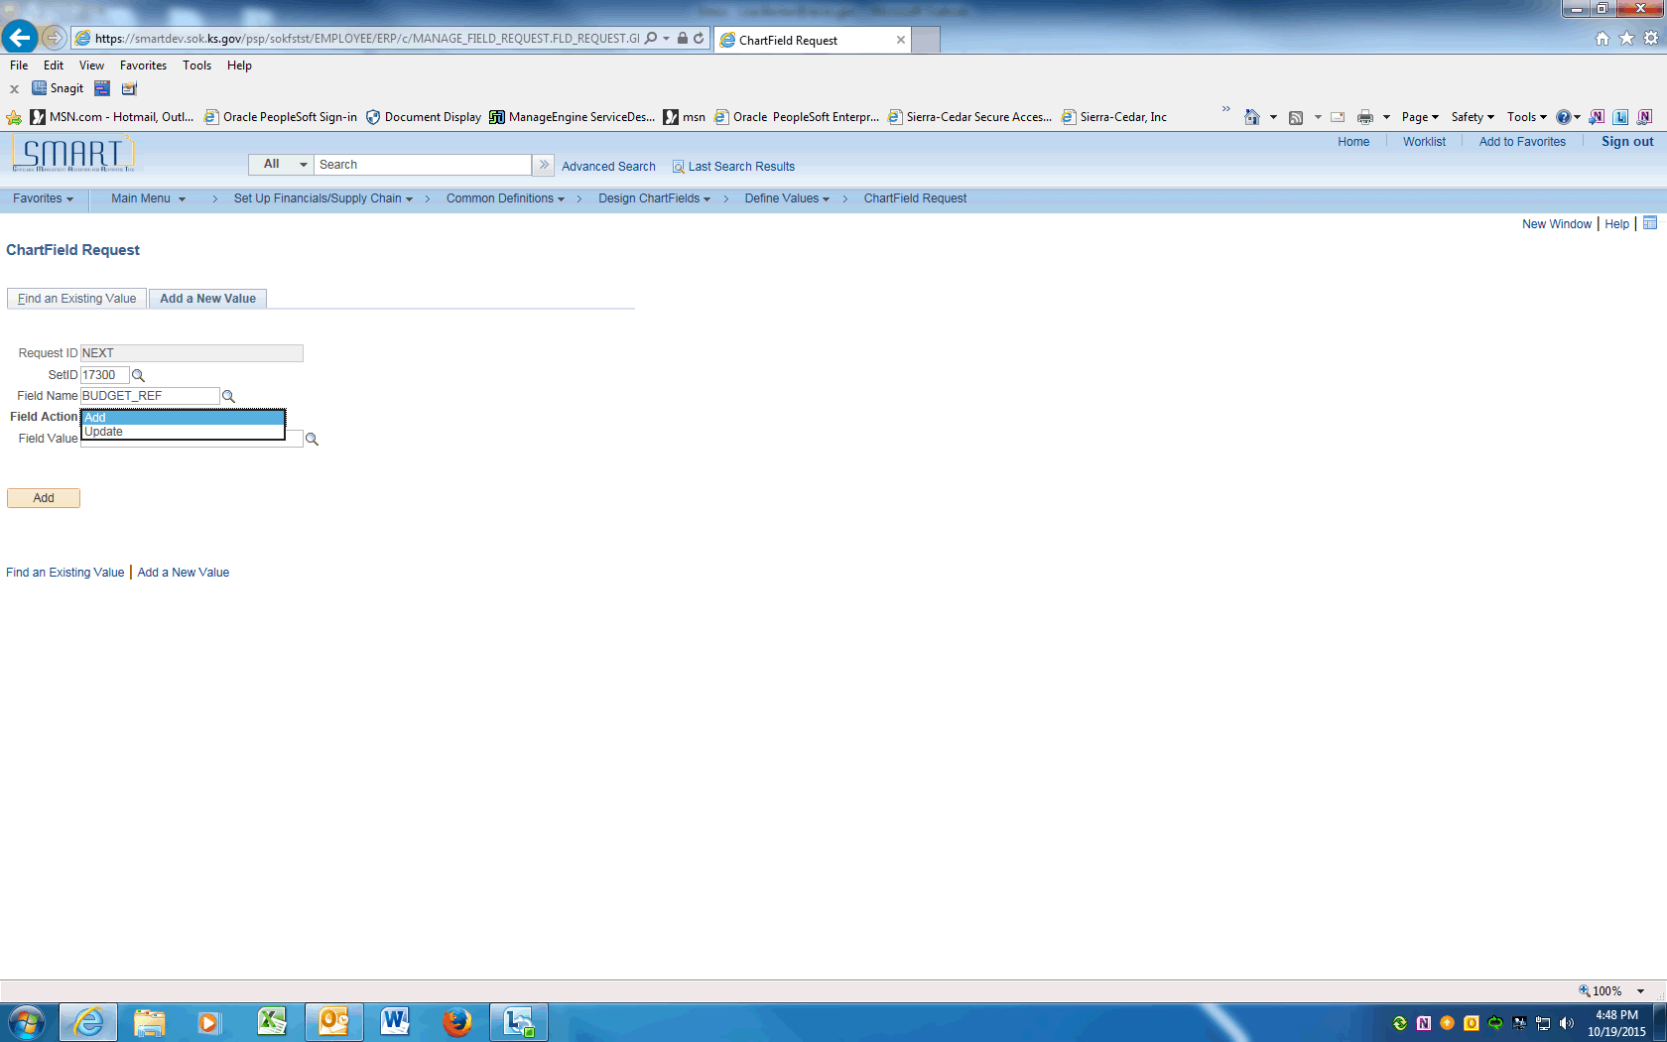

Step | Action
 | Click the drop down arrow next to the Field Action to display options and choose Add to add a new Budget Unit.

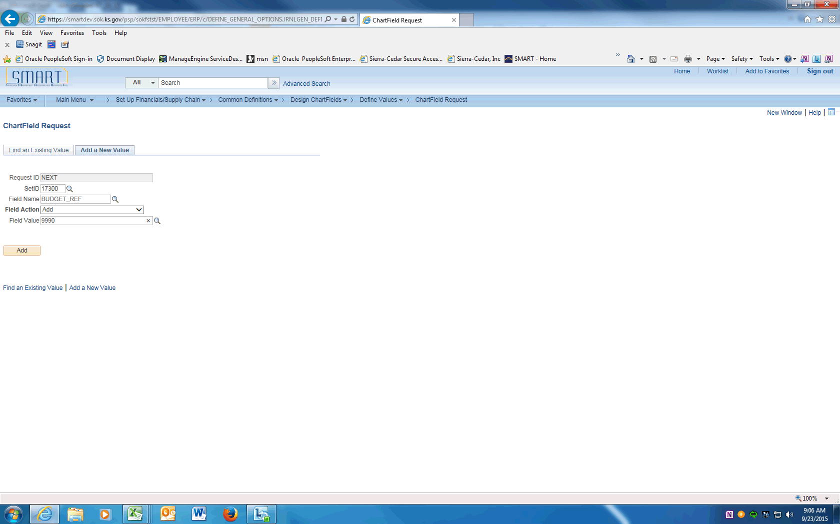

Step | Action
 | Enter the Budget Unit value supplied by the Central Responsibilities Team into the Field Value field. Enter "9990".
 | Click the Add button.

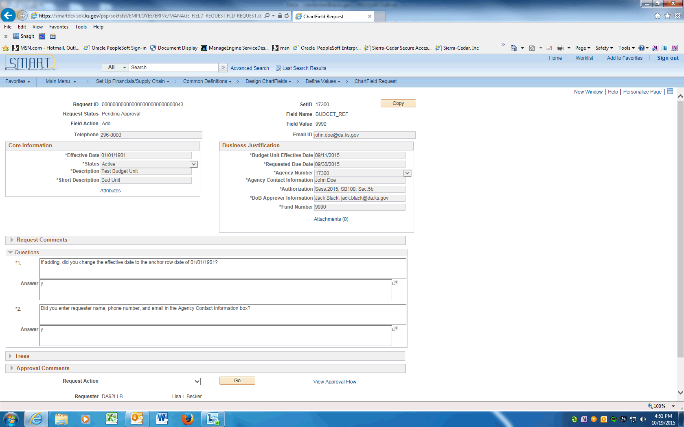

Step | Action
 | On the ChartField Request page, enter the Agency Contact phone number into the Telephone field. Enter "785-296-0000".
 | Enter the Requester's email into the Email ID field. Enter "john.doe@da.ks.gov".

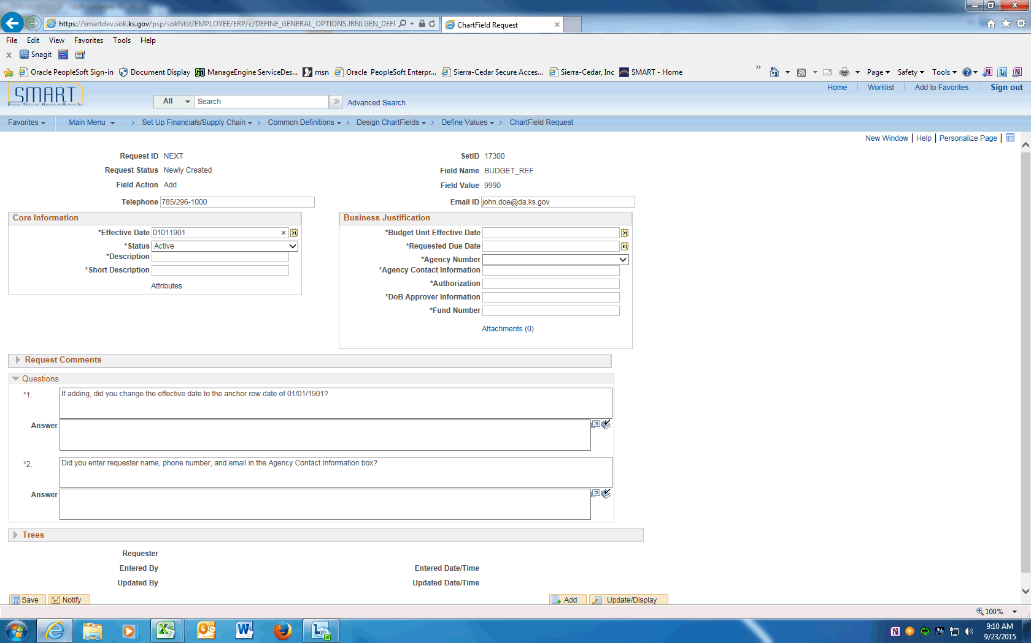

Step | Action
 | Enter the anchor effective date of "01/01/1901" into the Effective Date field

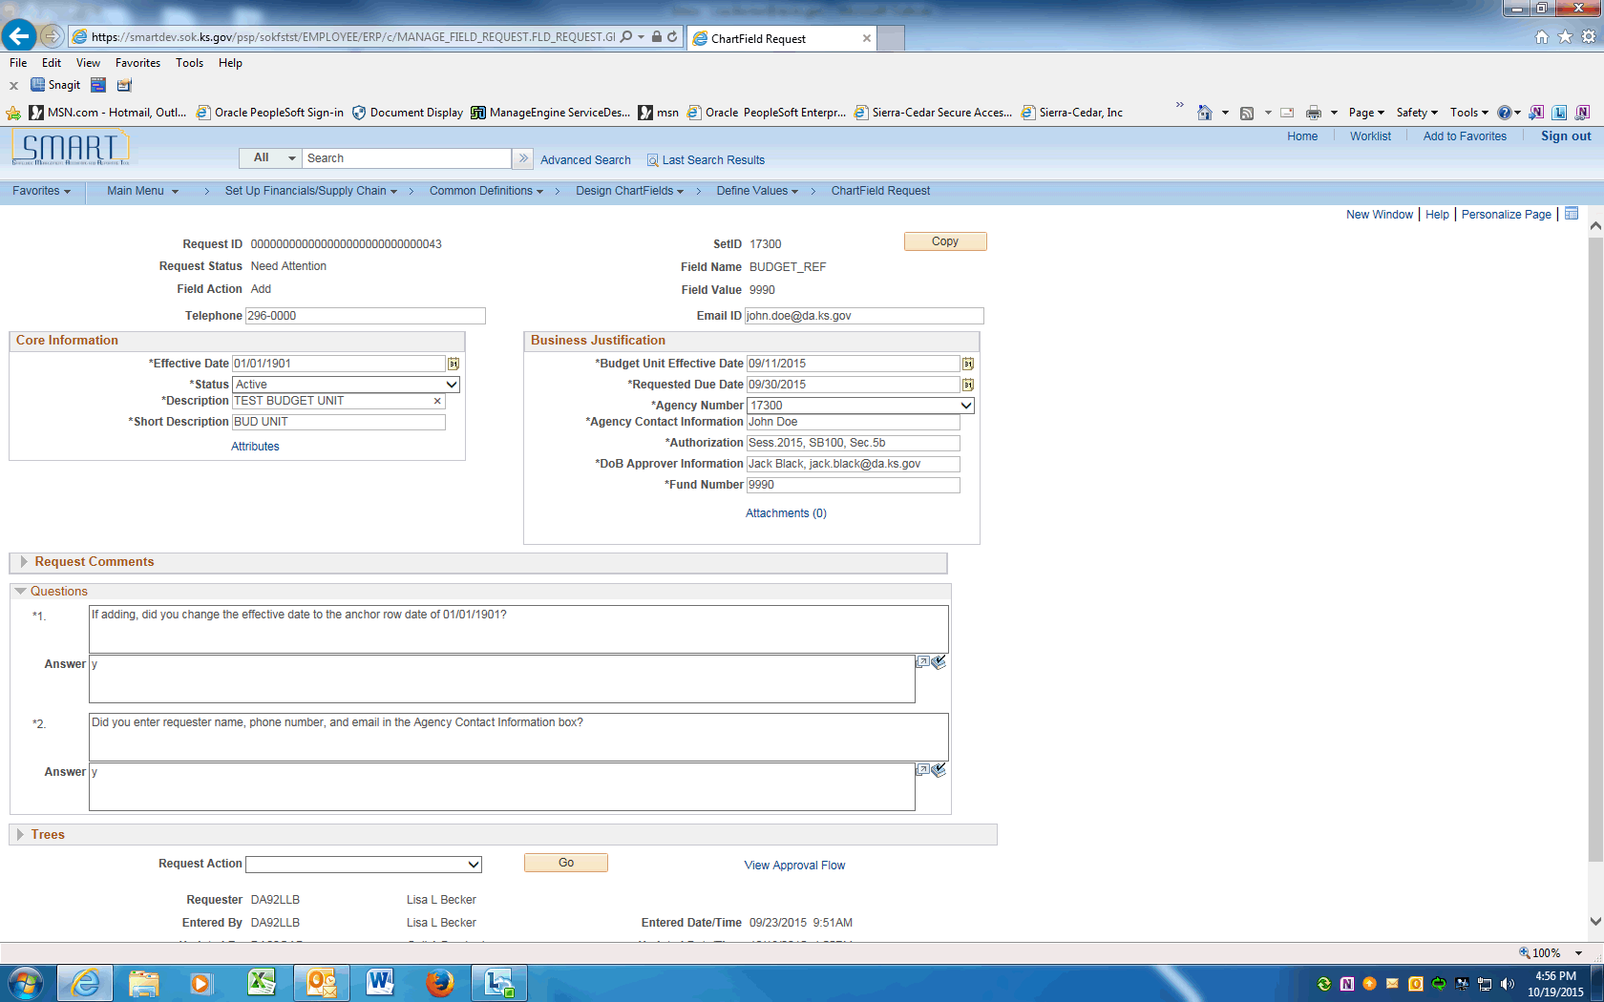

Step | Action
 | Enter in capital letters the Budget Unit long description, supplied by the Central Responsiblities Team, into the Description field. Enter "TEST BUDGET UNIT".
 | Enter the Budget Unit short description into the Short Description field. Enter "TEST BU".
 | Enter today's date into the Budget Unit Effective Date field. Enter "09/11/2015".
 | Enter the due date of this request into the Requested Due Date field. Enter "09/30/2015".

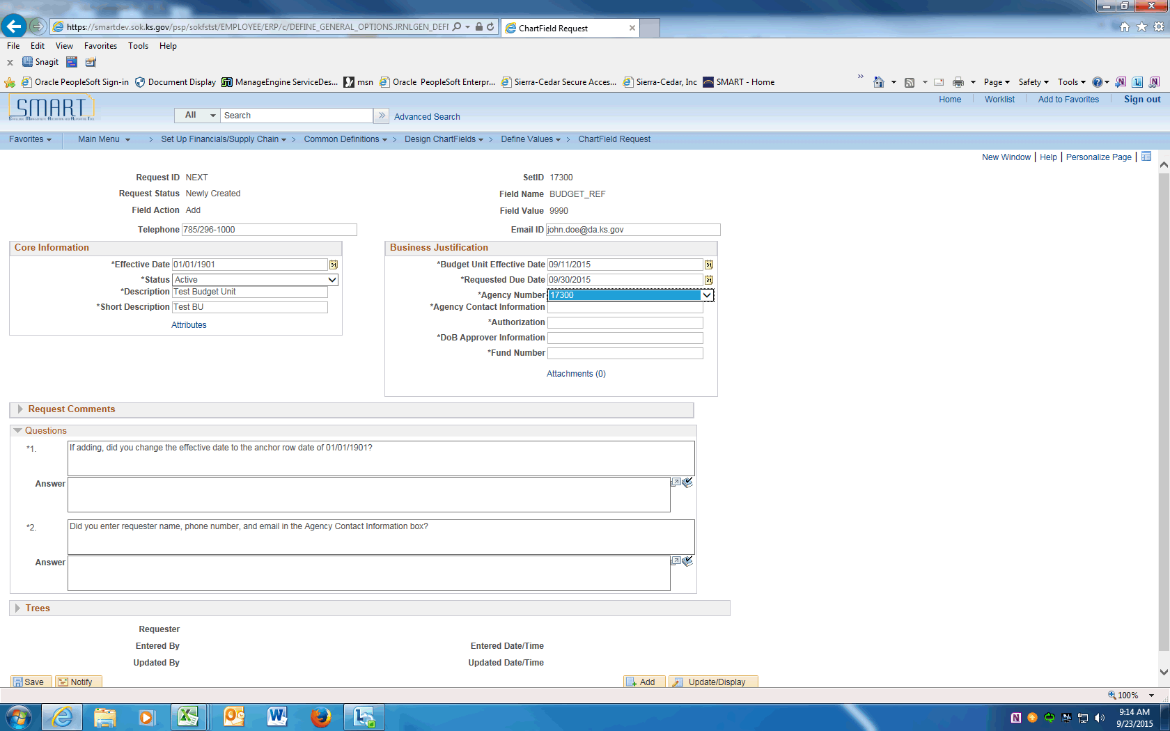

Step | Action
 | Click on the drop down arrow to display Agency Number. Click your agency number. In this example, click the 17300 list item.

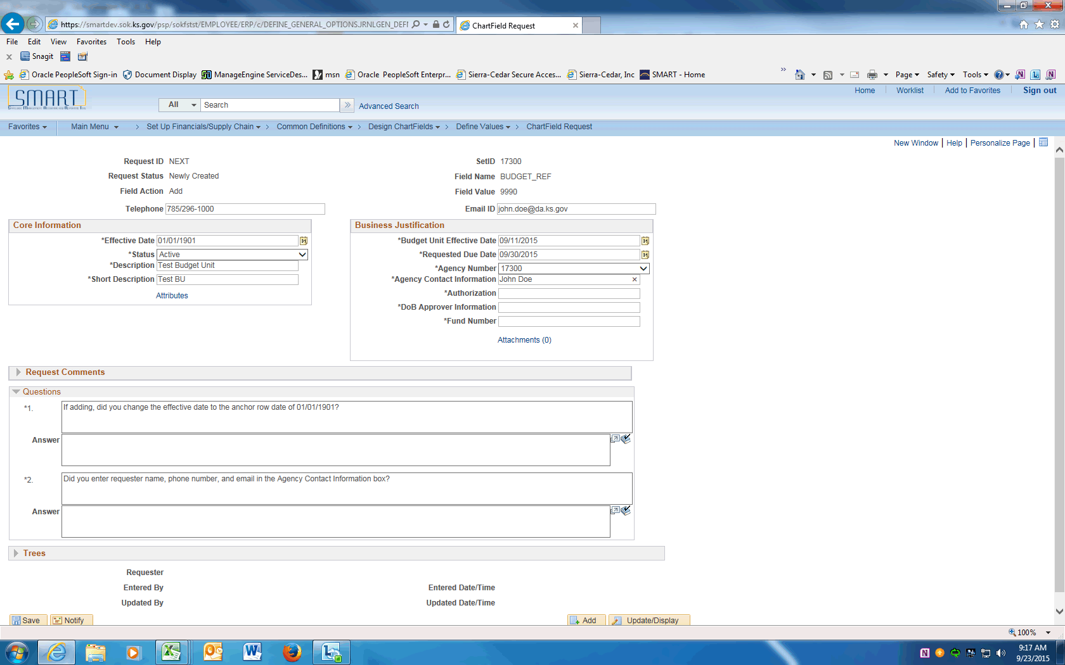

Step | Action
 | Enter the Agency contact name into the Agency Contact Information field. If different than the requester, enter name, email, and phone number. Enter "John Doe".
 | Enter the Legal Authority for the Budget Unit. Enter the Legislative Session, Appropriation Bill number, section and paragraph into the Authorization field. Enter "Session 2015, SB100, Sec 5f".
 | Enter your agency's Division of Budget analyst name, email and phone number into the DoB Approver Information field. Enter "Jack Black, jack.black@budget.ks.gov, 785-296-9999".
 | Enter the Fund Number associated to this Budget Unit.
 | The next Section contains Questions that must be answered prior to saving this request.
 | The Effective Date for a new Budget Unit will always be '01/01/1901'. Enter "Y".
 | Confirm the requested information is completed.
 | Only after all the questions are answered, the request can be saved. Click the Save button.
 | Click the dropdown arrow and choose the Submit for Approval item. Click the Go button. This will submit the Request into Approval workflow.
 | Click the View Approval Flow link to see the workflow.

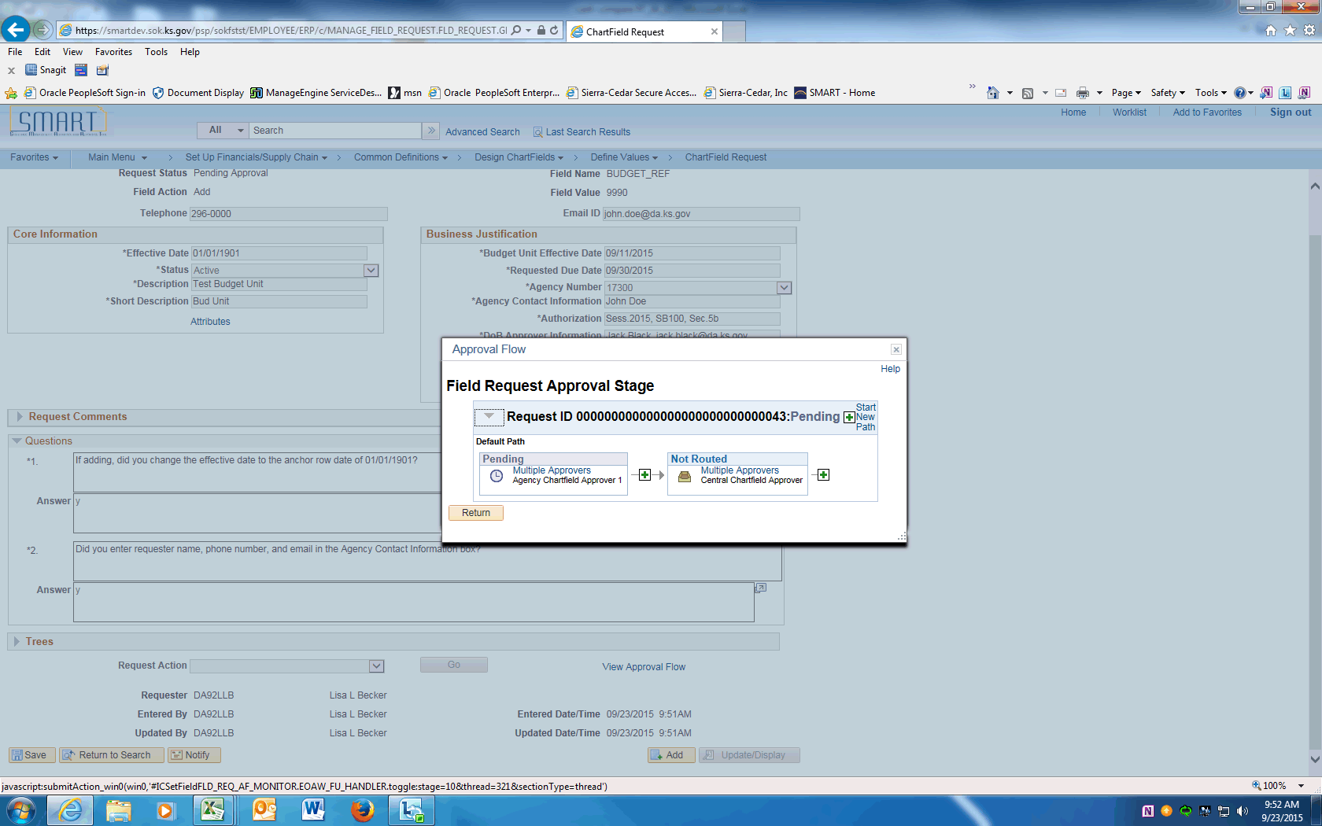

Step | Action
 | Approval Flow is displayed. The Request will need to be approved by the Agency Chartfield Approver and the Central Chartfield Approver. After approval, the ChartField will be available in SMART.
You have completed Adding a Budget Unit and submitting for approvals.
End of Procedure.

Updating Budget Units using Add a New Value
This UPK will demonstrate how to request an update to a Budget Unit. An update is effective dated and can include ChartField inactivations, description changes, budgetary only changes, etc. This option will be used for most ChartField updates.
Procedure

Step | Action
 | Click on Main Menu
 | Scroll down and click the Set Up Financials/Supply Chain menu.
 | Click the Common Definitions menu.
 | Click the Design ChartFields menu.
 | Click the Define Values menu.
 | Click the ChartField Request menu.

Step | Action
 | Click on the Add a New Value tab, enter your agency SETID into the SetID field. Enter "17300".
 | Click the magnifying glass next to the Field Name to display the Look Up and click on the BUDGET_REF link.

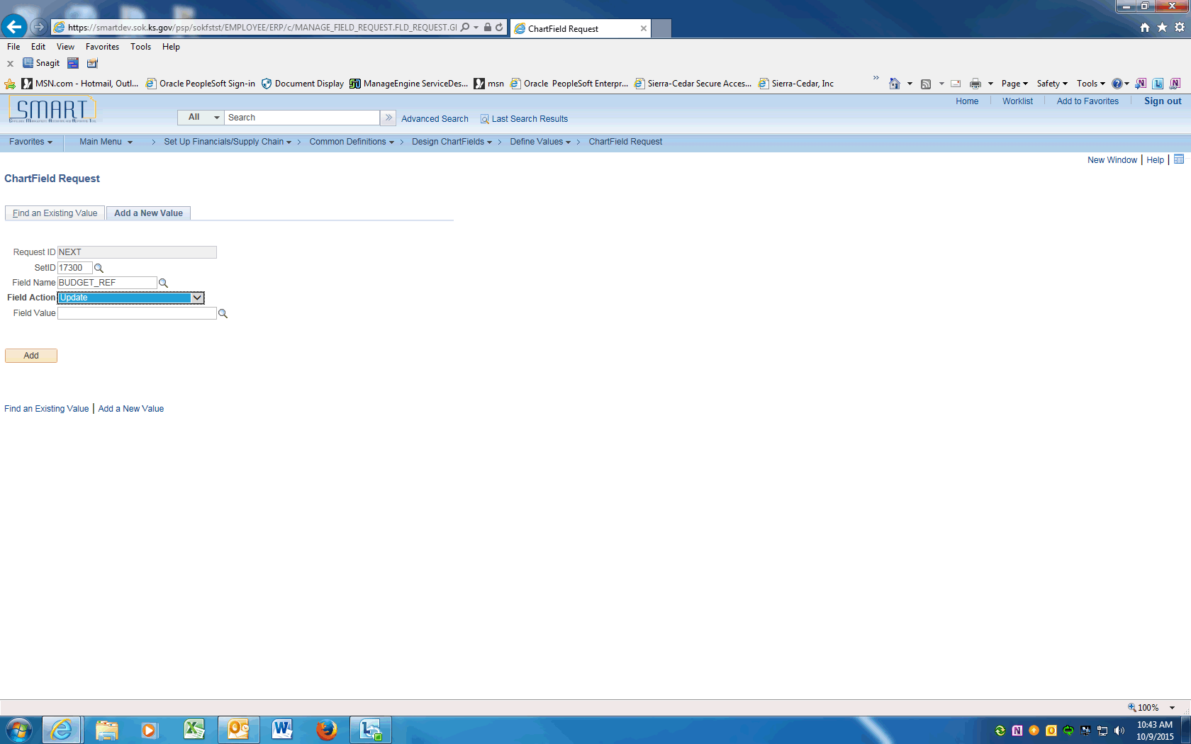

Step | Action
 | Click the drop down arrow next to the Field Action to display the options and choose Update to inactivate or change the Budget Unit.

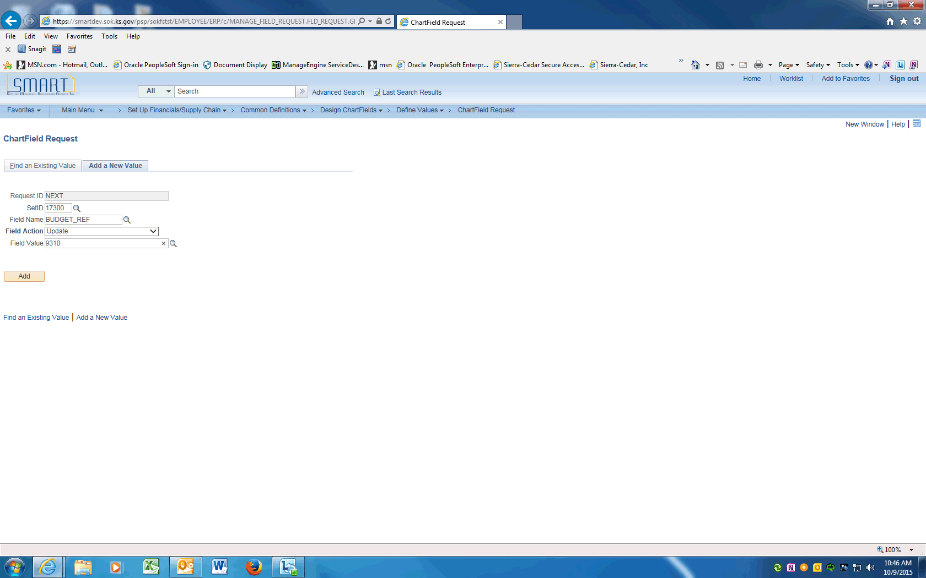

Step | Action
 | Enter the Budget Unit value into the Field Value field. Enter "9310".
 | Click the Add button.

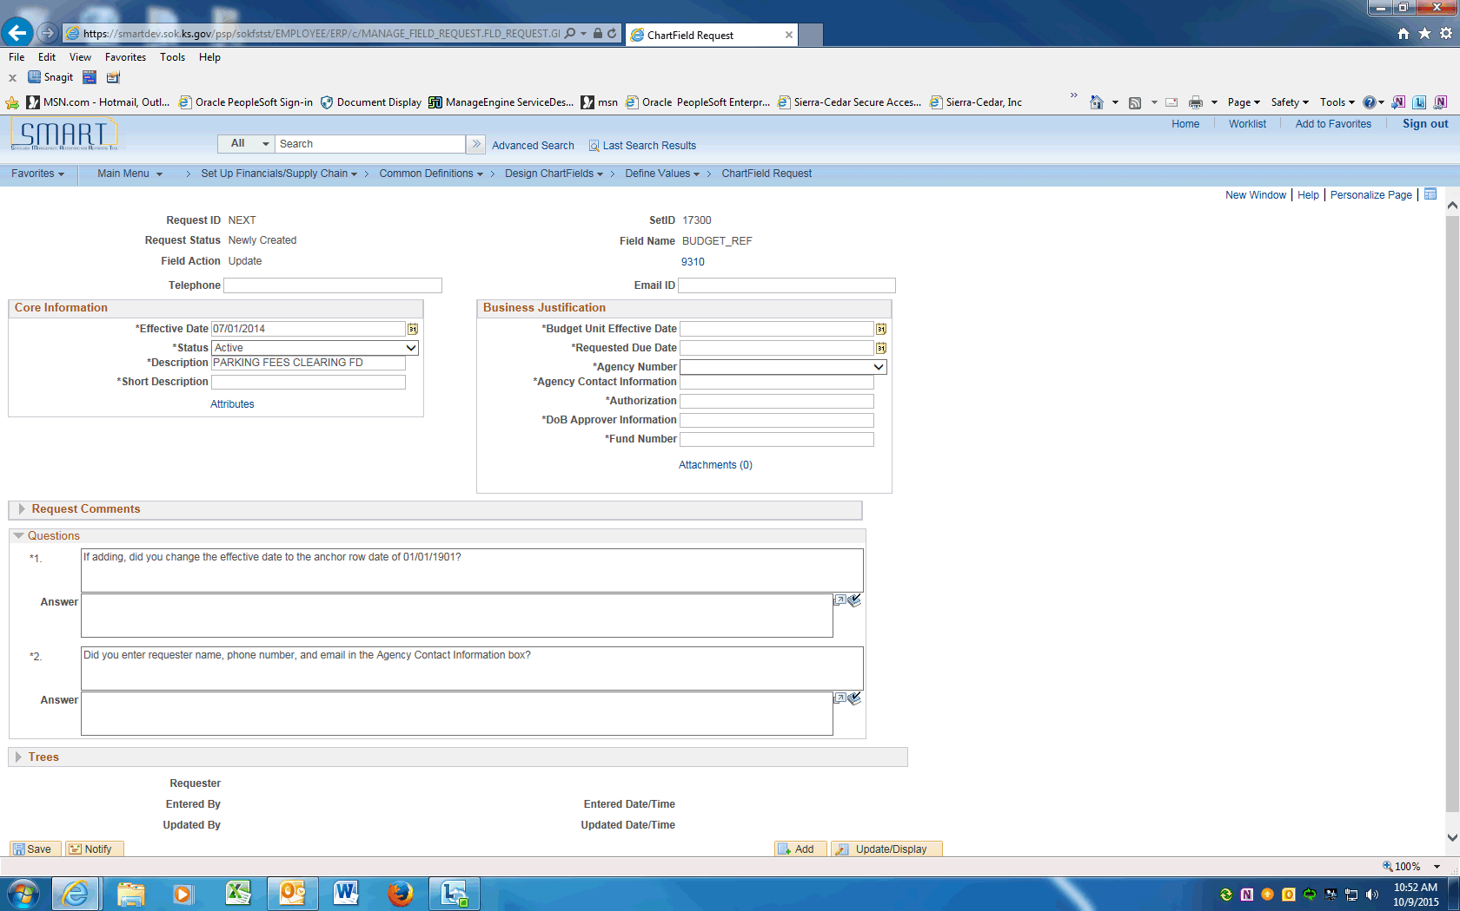

Step | Action
On the ChartField Request page, enter the Requestor's phone number into the Telephone field. Enter "785-296-0000".
Click the object.

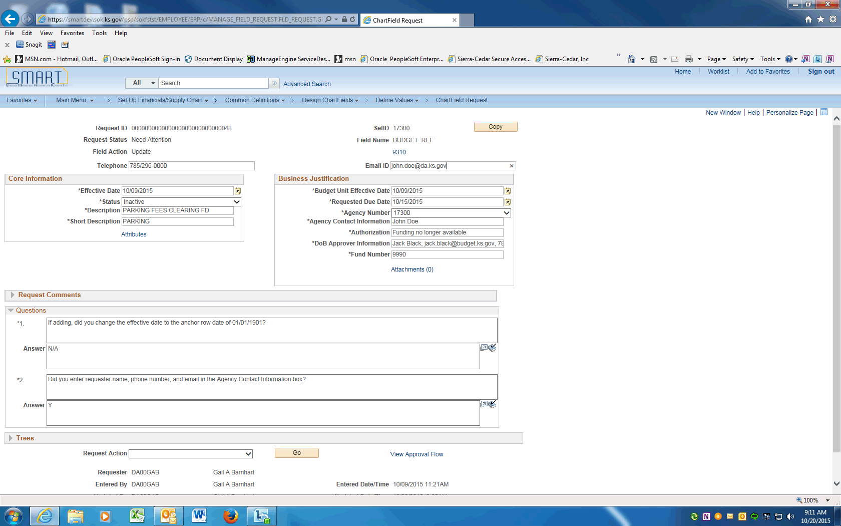

Step | Action
 | Enter the Requestor's email address into the Email ID field. Enter "john.doe@da.ks.gov".

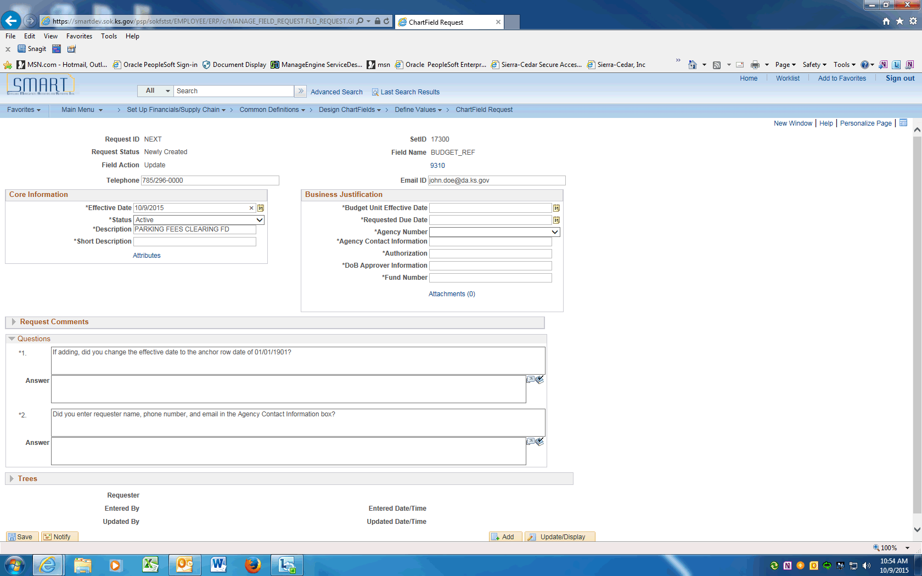

Step | Action
 | Enter the effective date (current or future date) into the Effective Date field.

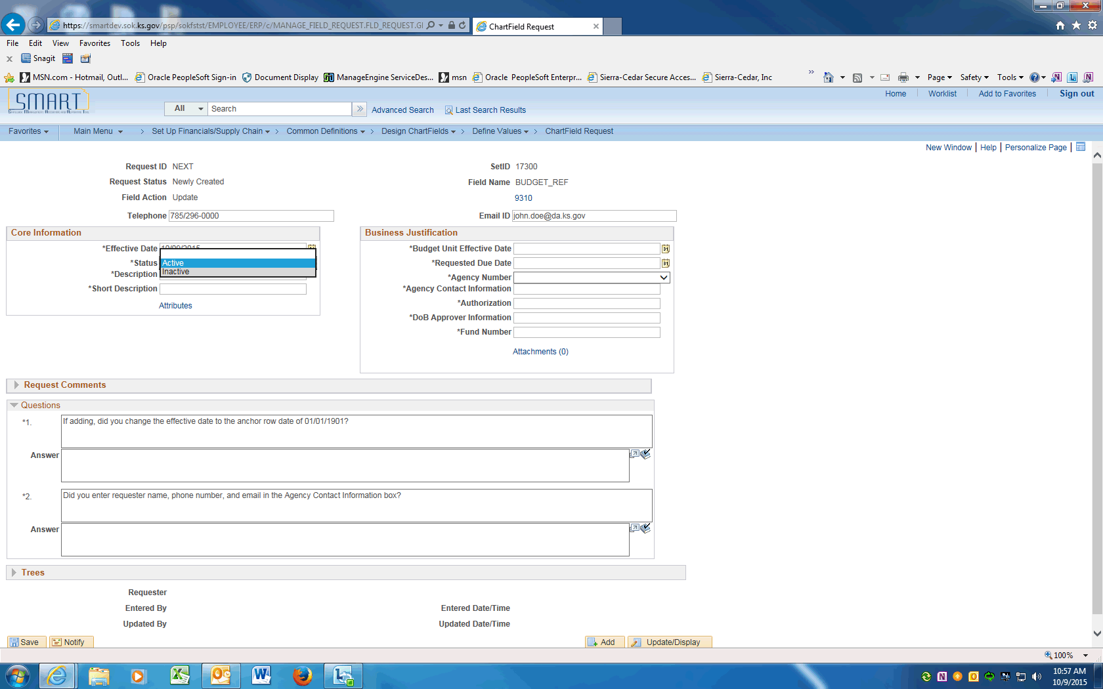

Step | Action
Click on the Status look-up and choose an option.

For this example, choose Inactive.
Review/enter the Budget Unit long description and short description into the Description and Short Description fields.

For updates, the Description and Short description should be populated with the existing information.
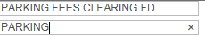
 | Enter the request's effective date into the Budget Unit Effective Date field. This should be the same value as the Effective Date field.
 | Enter the due date of this request into the Requested Due Date field.

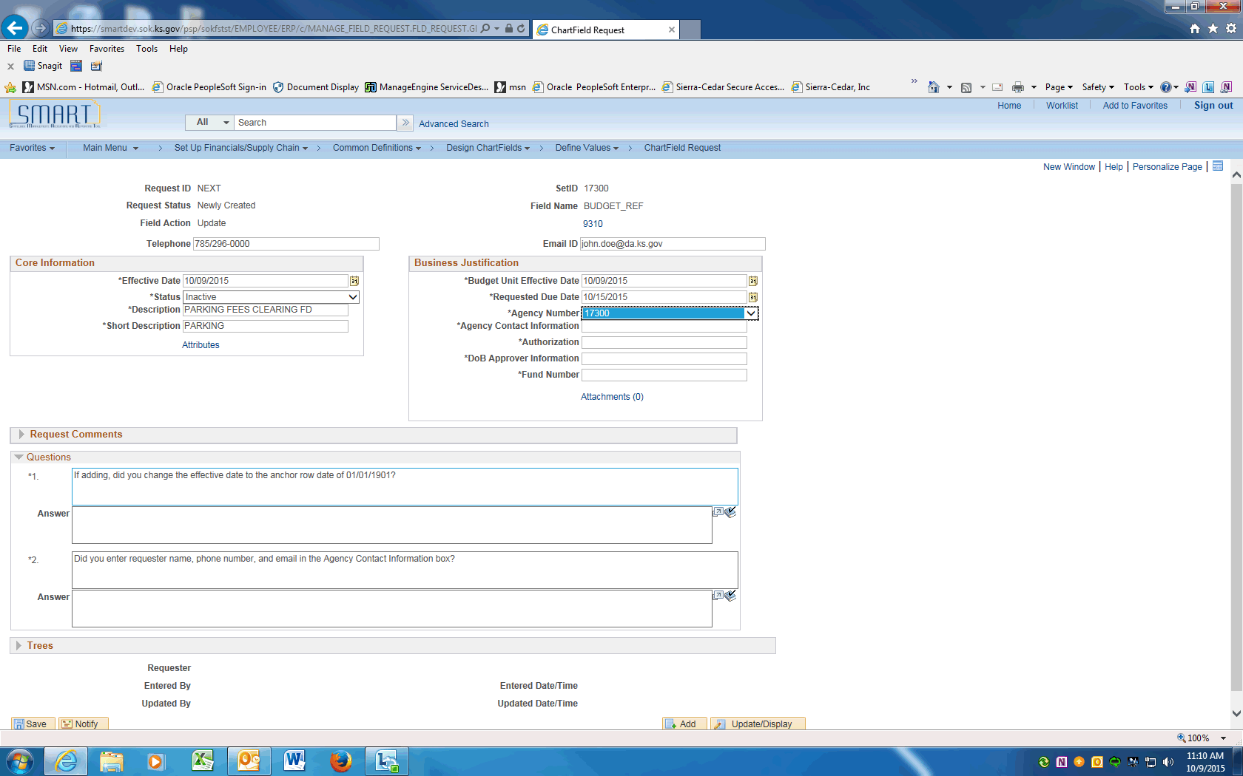

Step | Action
 | Click on the drop down arrow to display Agency Number. Click your agency number. In this example, click the 17300 list item.

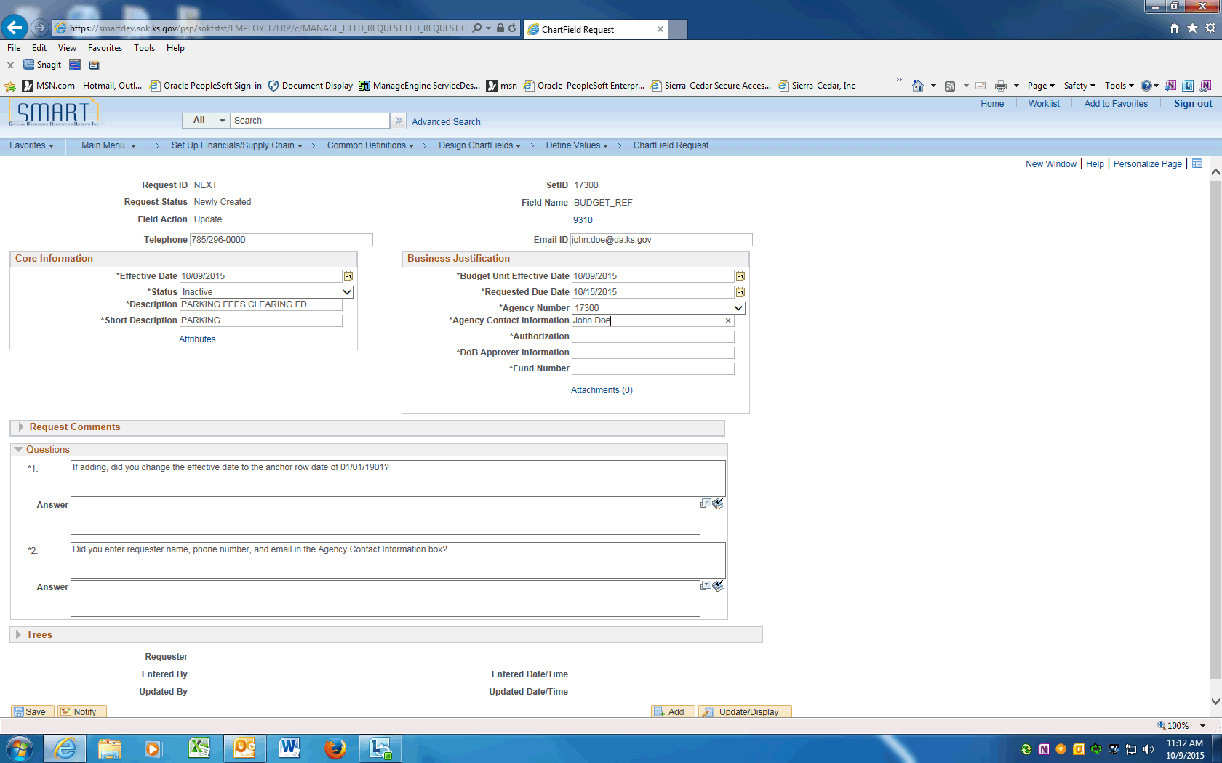

Step | Action
 | Enter the Agency contact name into the Agency Contact Information field. If different than the requester, enter name, email, and phone number. Enter "John Doe".
 | Enter a reason for the change or inactivation. Enter the desired information into the Authorization field. Enter "Funding no longer available".
 | Enter your agency's Division of Budget analyst name, email and phone number into the DoB Approver Information field. Enter "Jack Black, jack.black@budget.ks.gov, 785-296-9999".
 | Enter the Fund Number associated to this Budget Unit.
 | The next Section contains Questions that must be answered prior to saving this request.
 | Review and enter answer. For updates enter N/A (not applicable).
 | Confirm the Requester's contact information is completed.
 | Only after all the questions are answered, the request can be saved. Click the Save button.
The Request is ready to be submitted into WorkFlow.

Click the dropdown arrow and choose the Submit for Approval item. Click the Go button. This will submit the Request into Approval workflow.
 | Click the View Approval Flow link to see the workflow.

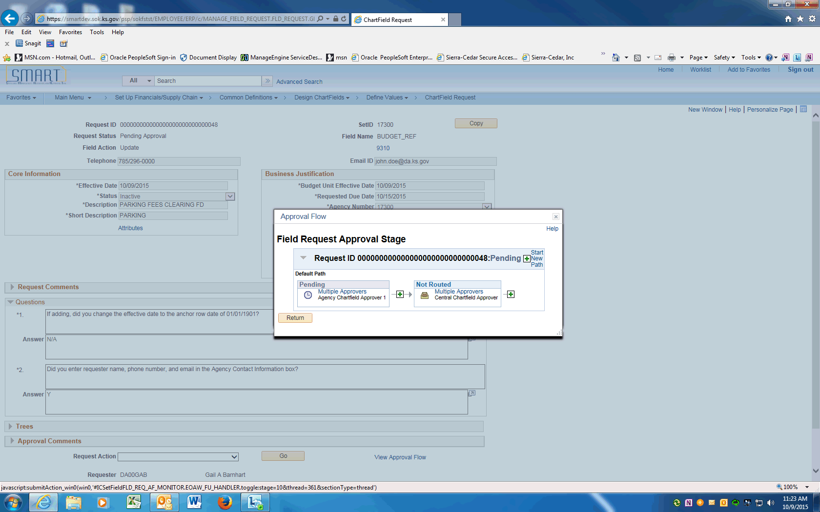

Step | Action
Approval Flow is displayed. The Request will need to be approved by the Agency Chartfield Approver and the Central Chartfield Approver. After approval, the ChartField will be available in SMART.

See the Approving ChartField Requests UPKs to learn more about the Approval process.
 | End of Procedure.

Updating Budget Units using Find an Existing Value
This UPK will demonstrate how to request an update to a Budget Unit. An update is effective dated and can include ChartField inactivations, description changes, budgetary only changes, etc.
Use the Find an Existing Value option if the Budget Unit Request exists in SMART and can be copied.
Procedure

Step | Action
 | Click on Main Menu
 | Scroll down and click the Set Up Financials/Supply Chain menu.
 | Click the Common Definitions menu.
 | Click the Design ChartFields menu.
 | Click the Define Values menu.
 | Click the ChartField Request menu.

Step | Action
 | Click on the Find an Existing Value tab.
 | Enter your agency's SETID into the SetID field. Enter "17300".
 | Click the magnifying glass next to the Field Name to display the Look Up and click on the BUDGET_REF link.
 | Enter the Budget Unit value that needs inactivated or updated into the Field Value field.
 | Clear the Request Status value.
 | Click the Search button.

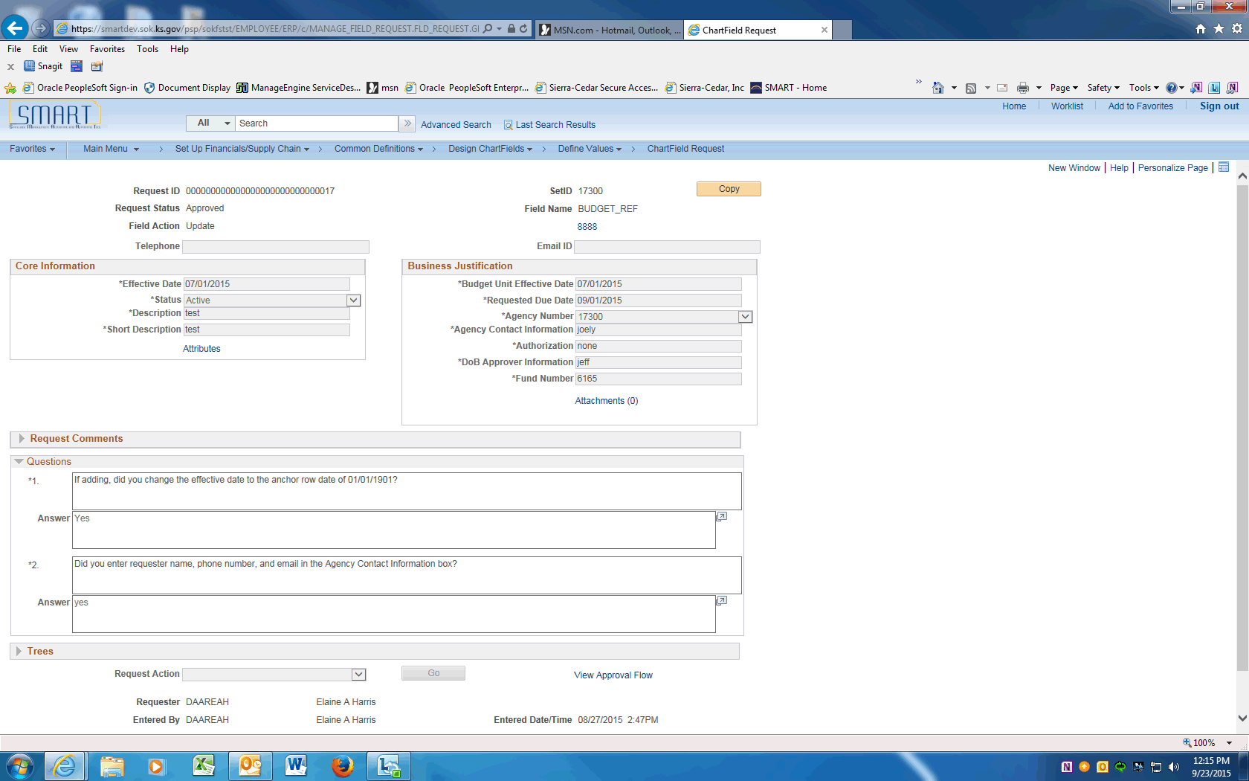

Step | Action
 | Click the Copy button at the top of the screen

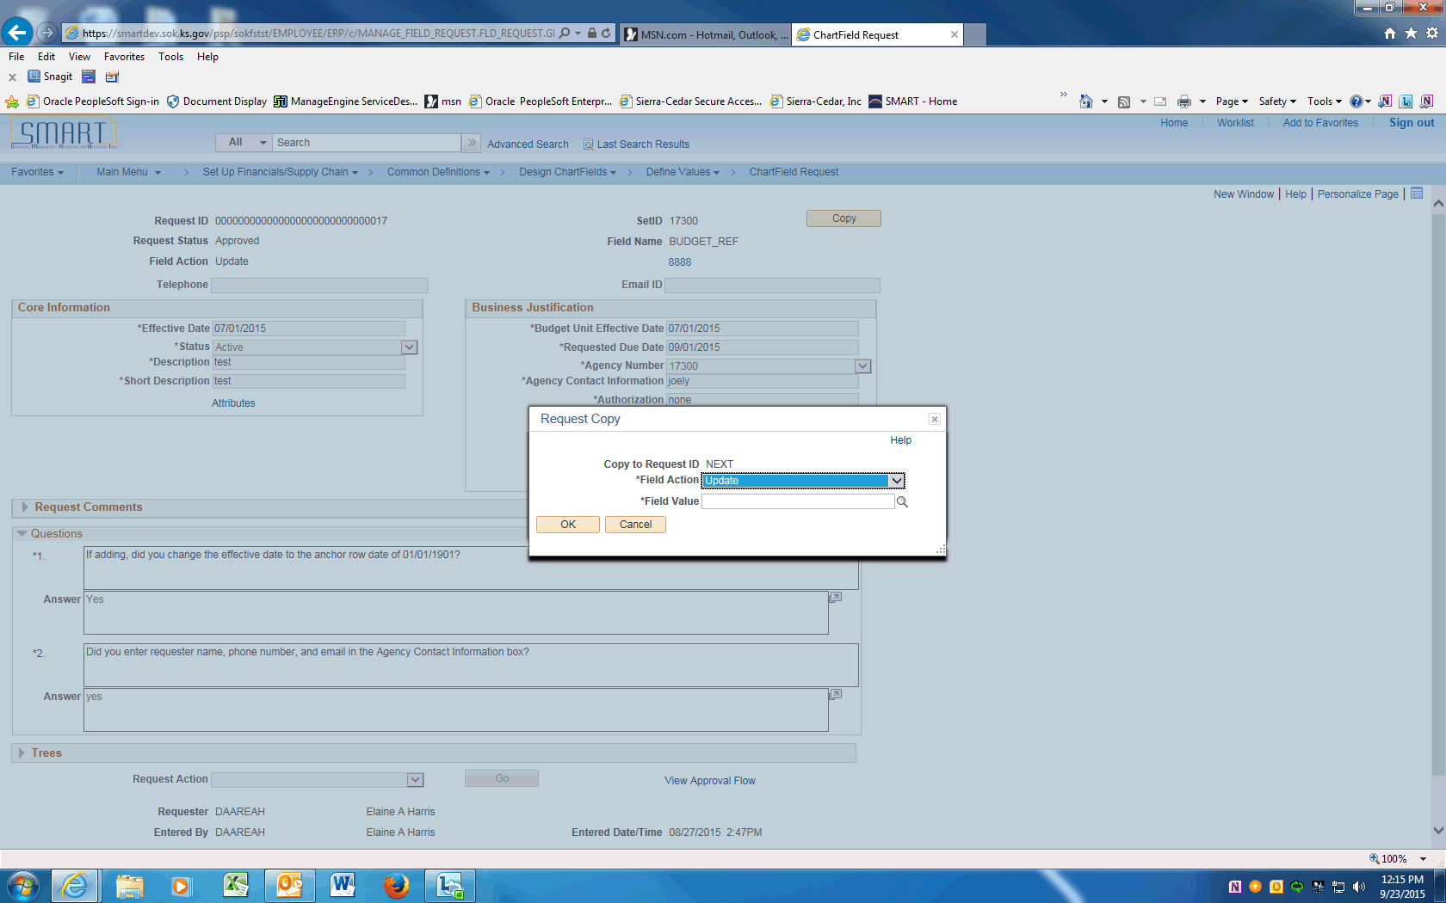

Step | Action
 | On the Request Copy popup, click the dropdown next to the Field Action and choose Update.
 | Click on the Field Value field and enter the Budget Unit being updated.

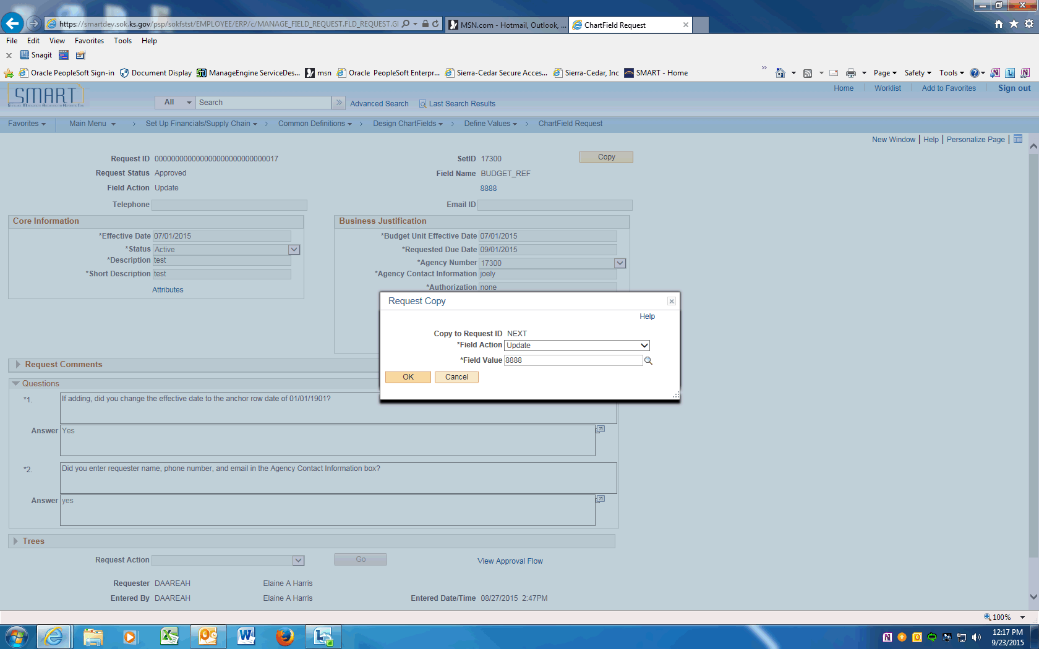

Step | Action
 | Click the OK button.

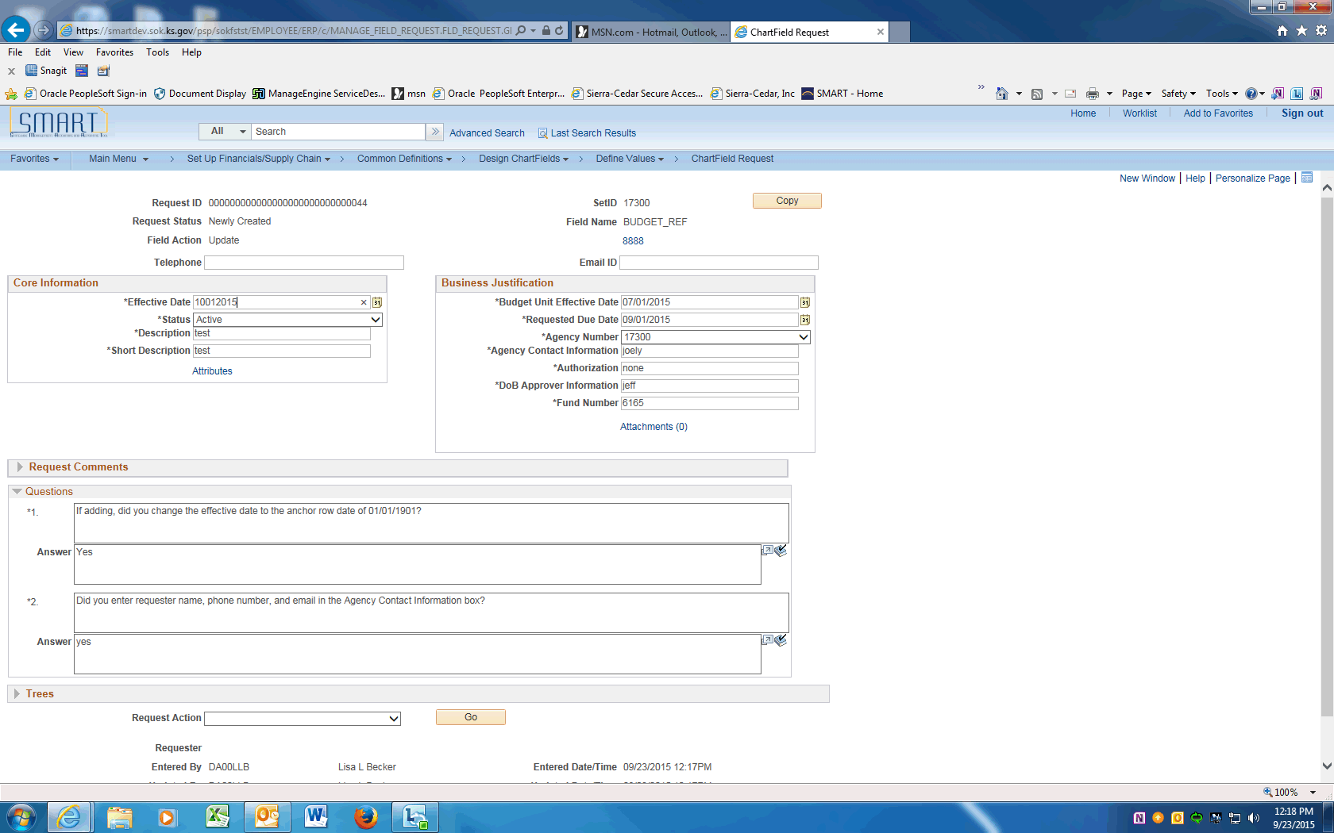

Step | Action
 | Click the Effective Date link and change to the effective date of the Update -- Today's date or a date in the future.

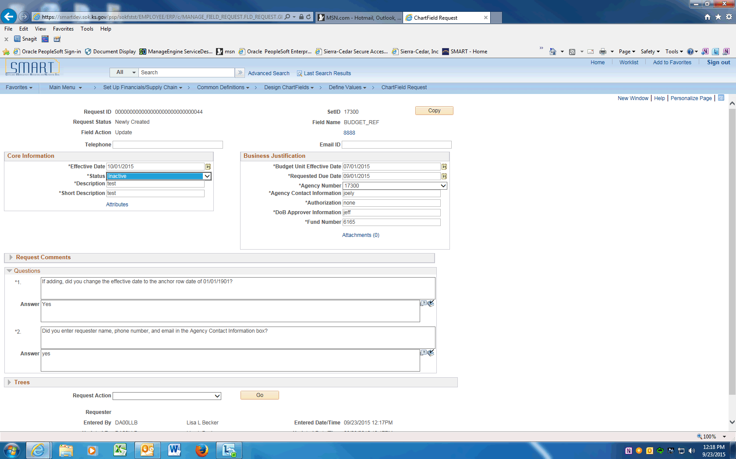

Step | Action
 | To request the Fund Code be inactivated, click the dropdown and choose the Inactive list item. To make a change, leave Status as Active.

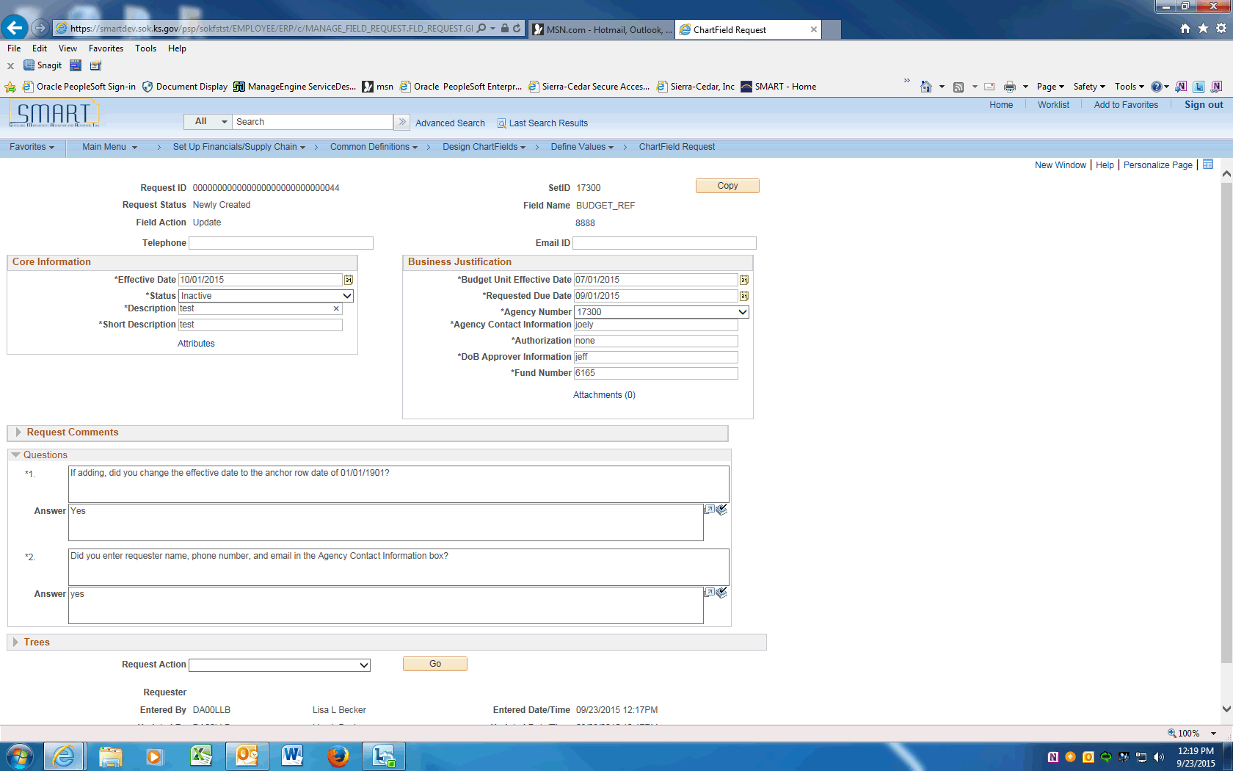

Step | Action
 | For updates only, click in the Description field and change the description.
 | For updates only, click in the Short Description field and change the short description.
 | Click in the Budget Unit Effective Date field and update with the same value as the Effective Date.
 | Click in the Requested Due Date field and enter the request due date.
For additional information, see the Add a Budget Unit UPK.

Review the Questions and update information and answers as needed. In this example the Telephone and Email ID still need input.

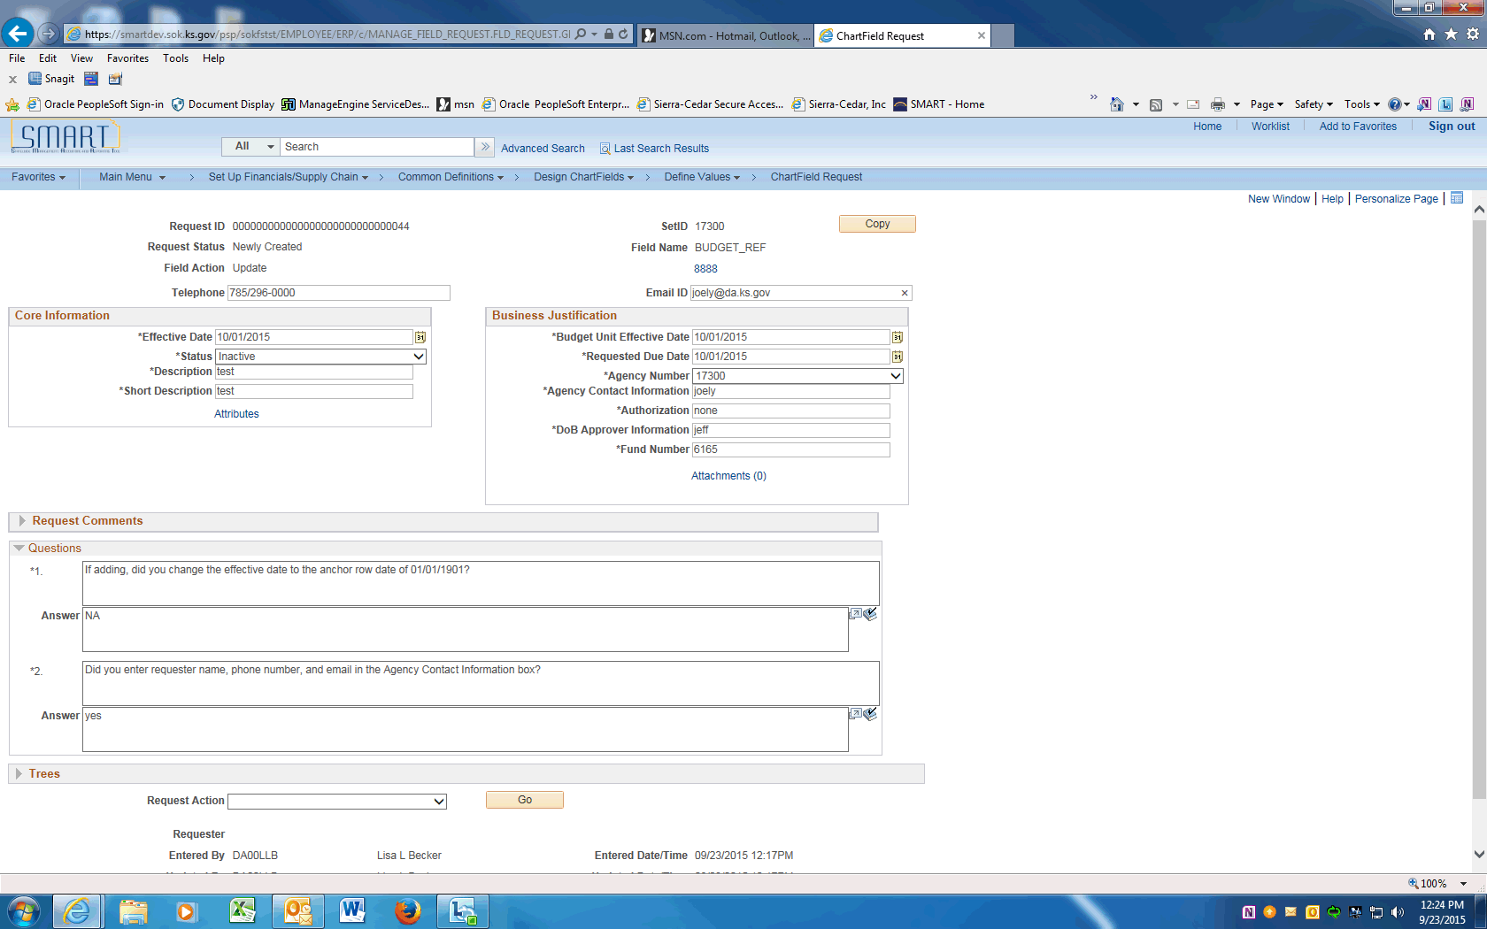

Step | Action
 | Scroll down to the Request Action field. Click the dropdown and choose the Submit for Approval list item.

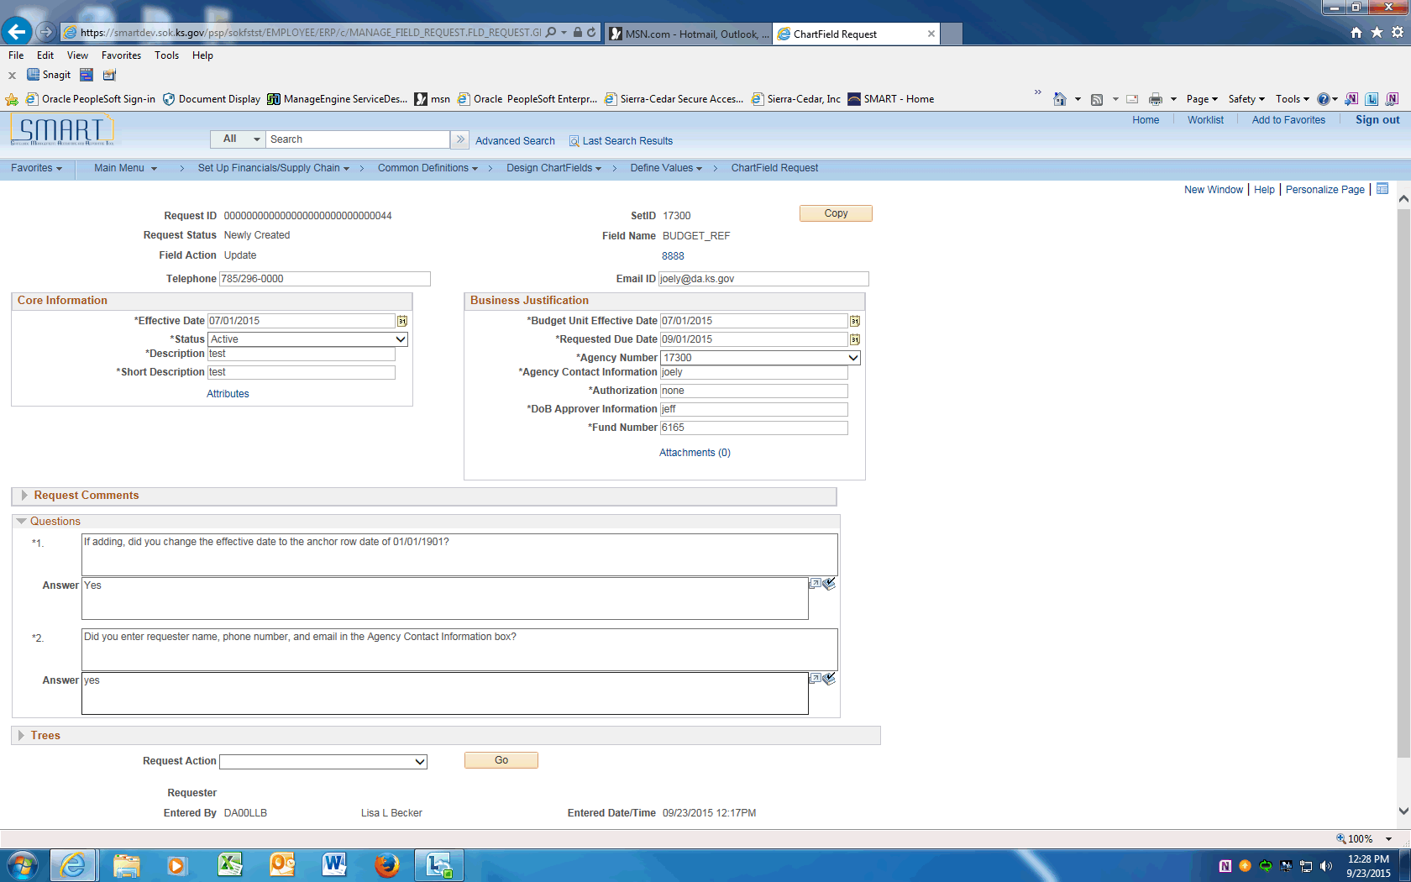

Step | Action
 | Click the Go button to Submit the Request into workflow.
 | Click the View Approval Flow link to see the workflow.

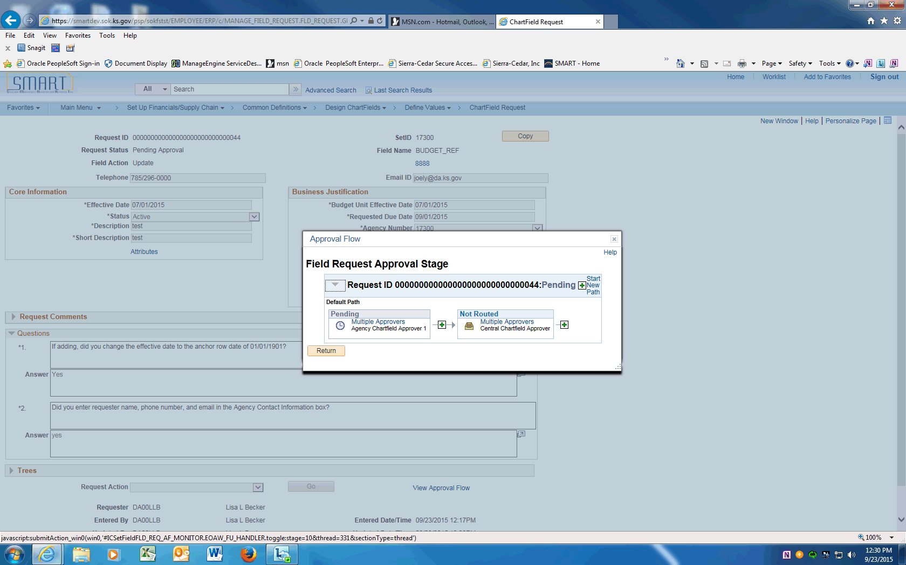

Step | Action
 | Approval Flow is displayed. The Request will need to be approved by the Agency Chartfield Approver and the Central Chartfield Approver. After approval the ChartField will be available in SMART.
 | End of Procedure.

Adding Department IDs
This UPK will demonstrate how to add a new Department ID.
Procedure

Step | Action
 | Click on Main Menu
 | Scroll down and click the Set Up Financials/Supply Chain menu.
 | Click the Common Definitions menu.
 | Click the Design ChartFields menu.
 | Click the Define Values menu.
 | Click the ChartField Request menu.

Step | Action
 | Enter your agency SETID into the SetID field. Enter "17300".
 | Click the magnifying glass next to the Field Name to display the Look Up and click on the DEPTID link.

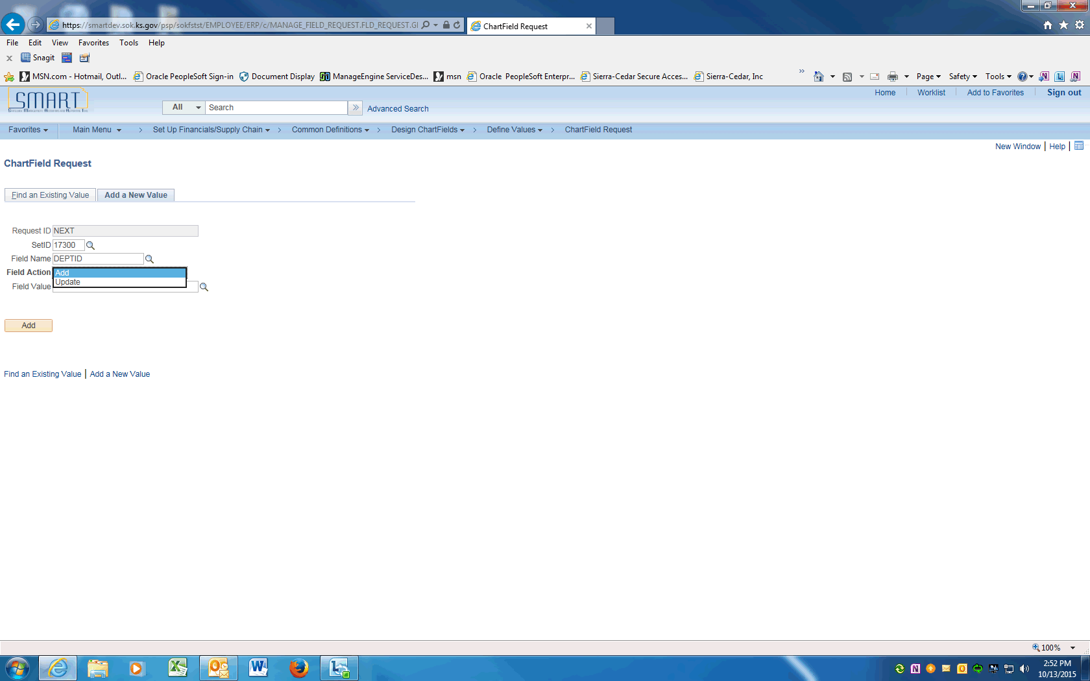

Step | Action
 | Click the magnifying glass next to the Field Action to display the Look Up and choose Add to add a new DEPTID.

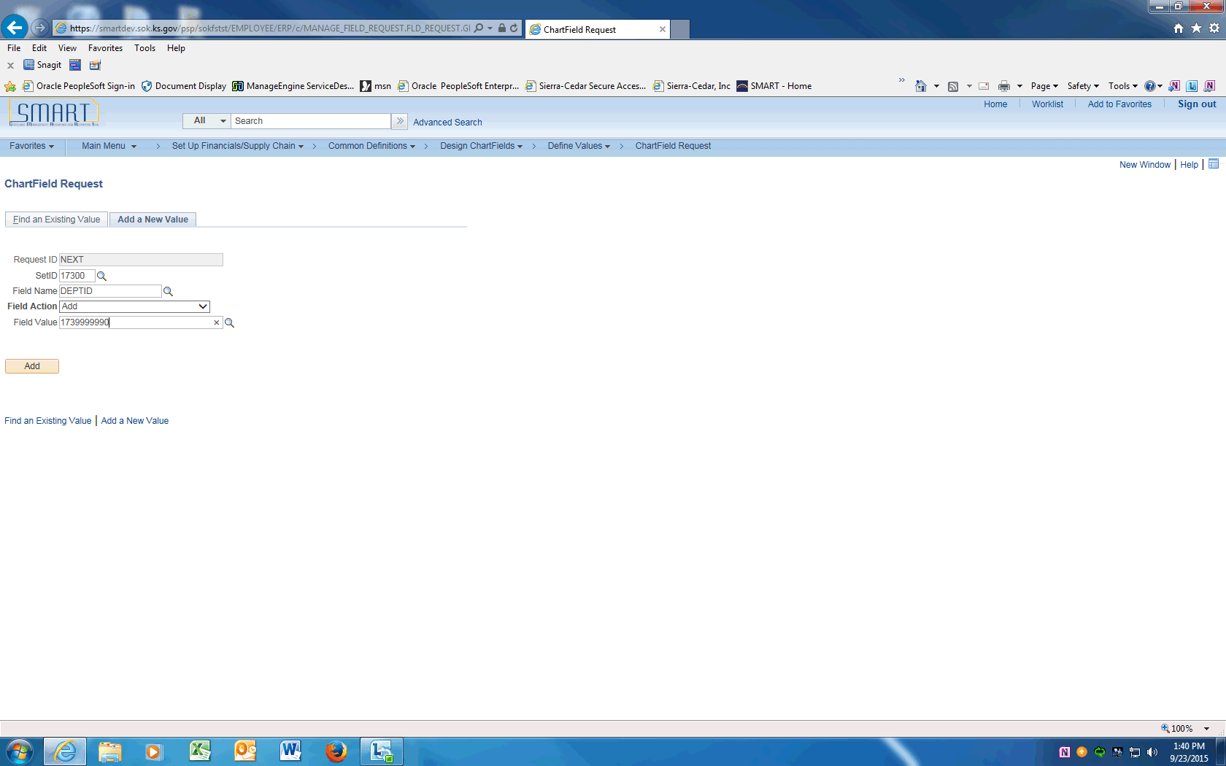

Step | Action
 | Enter the Department ID value into the Field Value field.
 | Click the Add button.

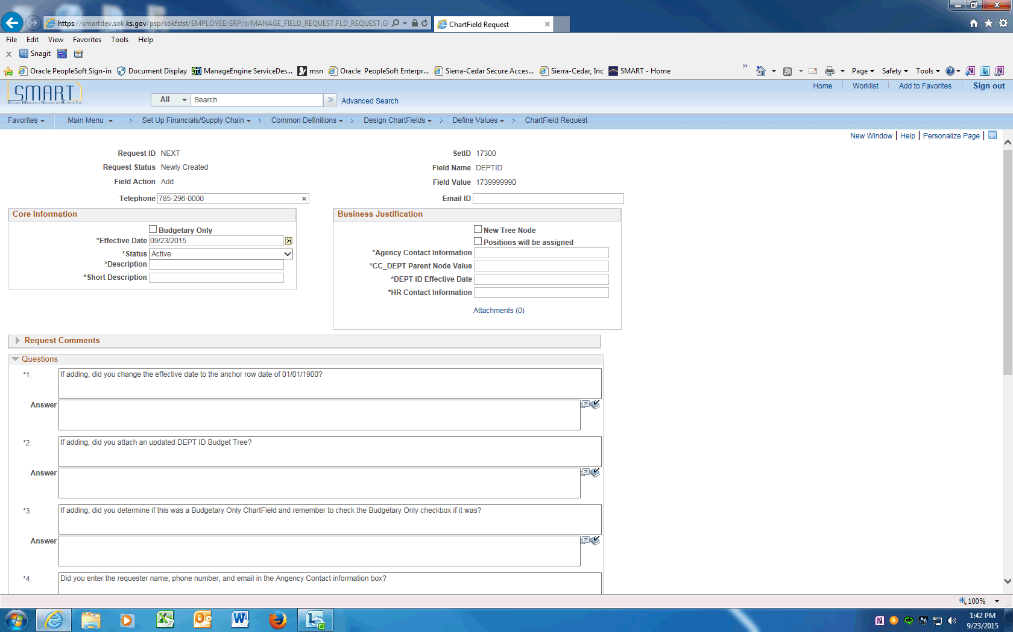

Step | Action
 | On the ChartField Request page, enter the Agency Contact phone number into the Telephone field. Enter "785-296-0000".
 | Click in the Email ID field and enter the Agency contact email address.
 | Click the Budgetary Only box if the new DEPTID is a new node on the CC_DEPT tree and will not be used on transactions.

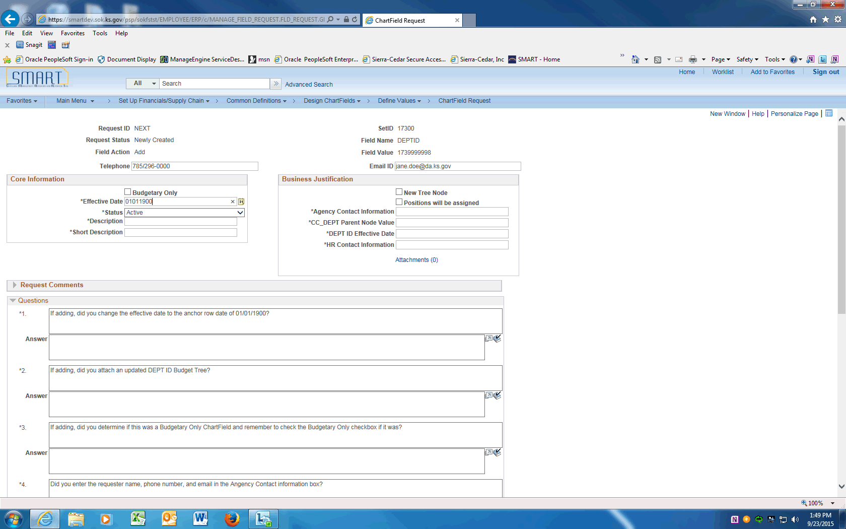

Step | Action
 | Enter the anchor effective date of "01/01/1900" into the Effective Date field. Note that DEPTID uses a different anchor effective date than other ChartFields.

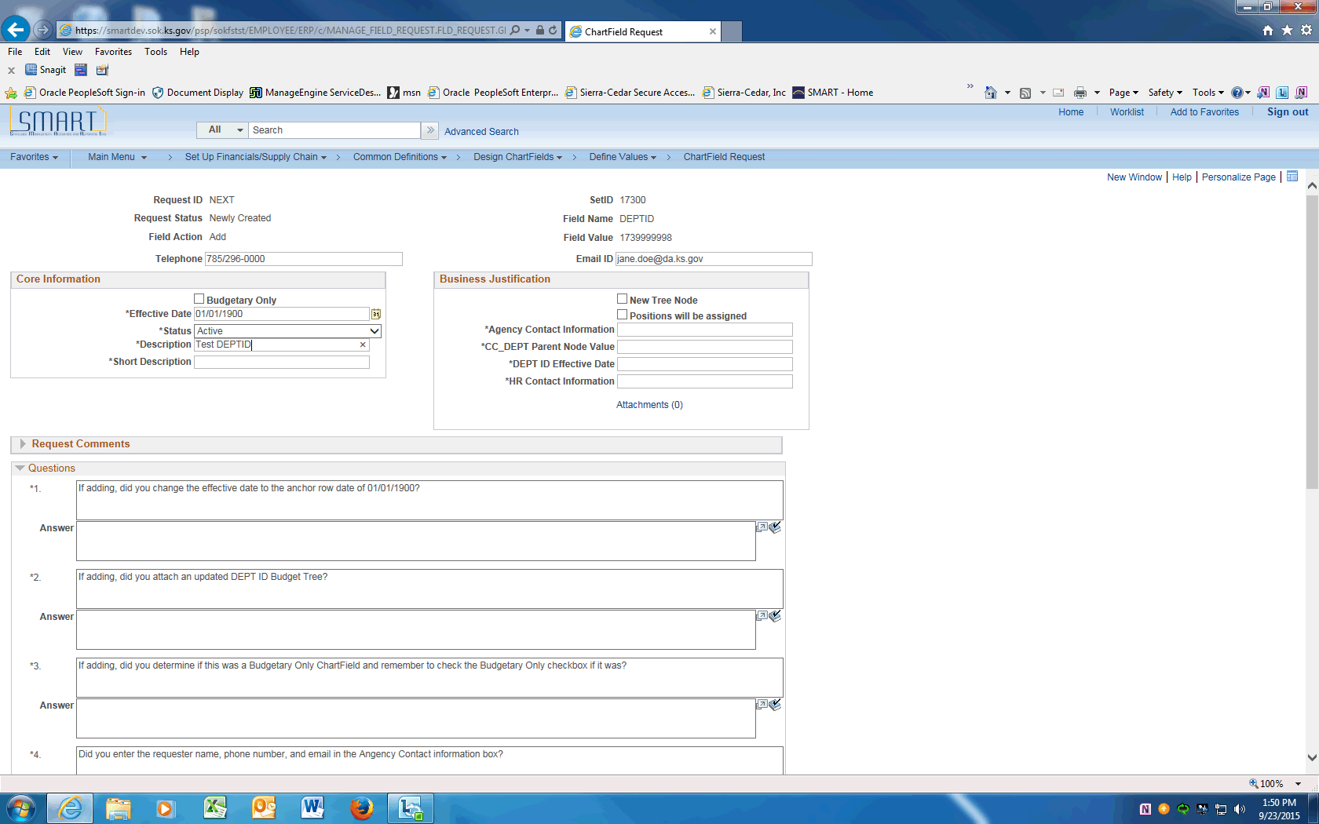

Step | Action
 | The default for Status will be Active. For a new Department ID, this is the correct.
 | Enter the Department ID long description into the Description field. Enter "Test DEPTID".
 | Enter the Department ID short description into the Short Description field. Enter "TestDEPT".
 | Click the New Tree Node box if the value is a new Node on the DEPTID tree.

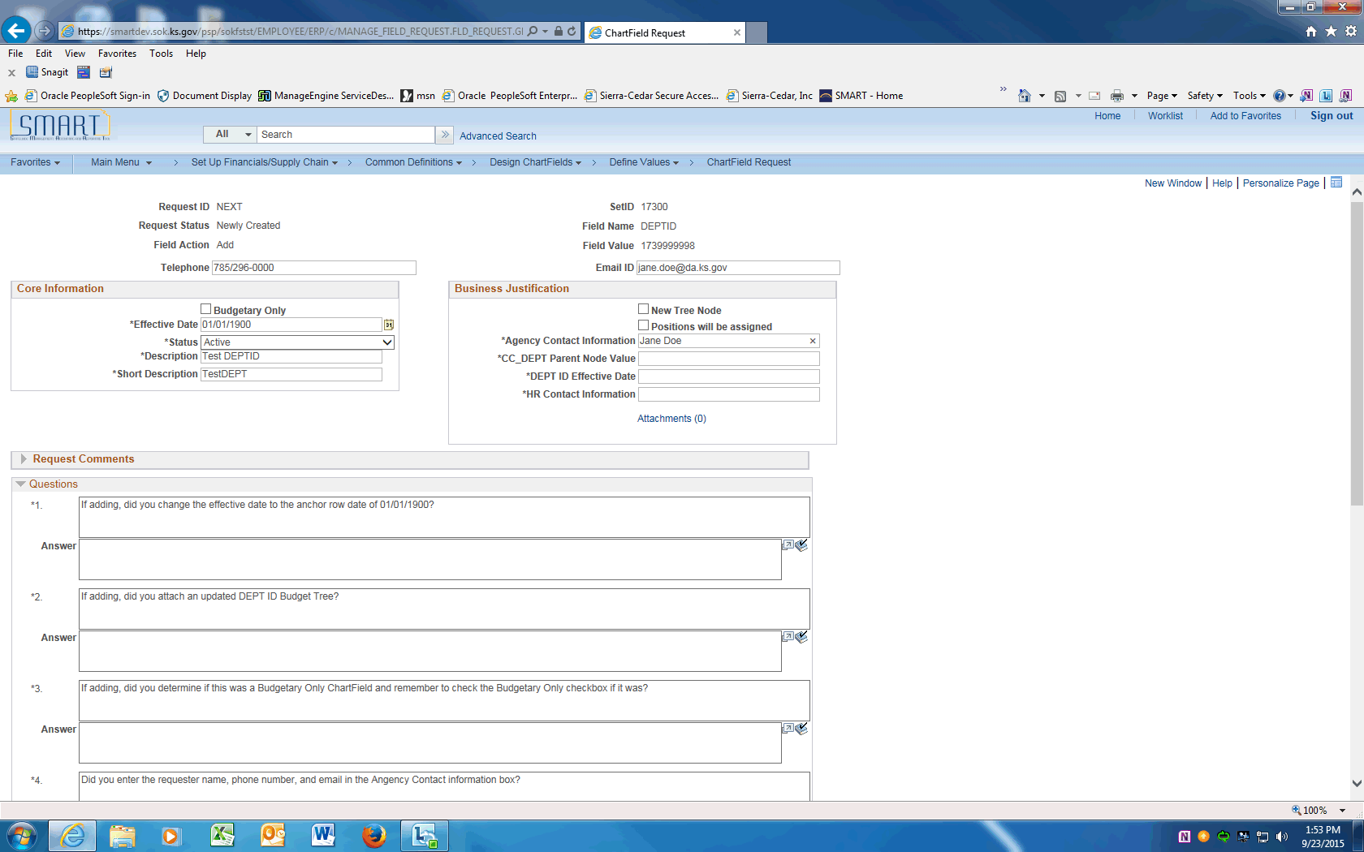

Step | Action
 | Click the Positions will be assigned box if this Department ID will be assigned to positions in SHaRP.

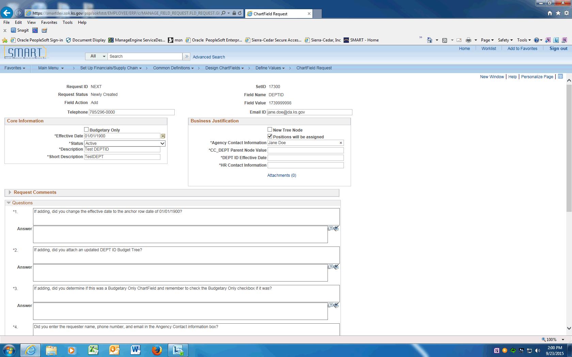

Step | Action
 | Enter the Agency contact name into the Agency Contact Information field. If the contact name is different than the Requester include the contact's email and phone number. Enter "Jane Doe".
 | Enter the Parent tree node the new value will be assigned to on the DEPTID tree.
 | Enter actual effective date of the department ID into the DEPT ID Effective Date field. Enter "09242015".
 | Enter the agency's personnel contact information into the HR Contact Information field. Make sure to include name, email, and phone number. Enter "Katie Brown, katie.brown@da.ks.gov, 296-1234".
 | The next Section contains Questions that must be answered prior to saving this request.
 | For New Department IDs, the anchor row Effective Date will always be '01/01/1900'. Enter "Y".
 | The CC_DEPTID tree must be updated and attached to this request.
 | The Budgetary Only ChartField must be checked if the DEPTID will not be used on transactions.
 | If the requester is different from the Agency Contact Name, you must enter their name, phone number and email. Enter the desired information into the Answer field. Enter "y".
 | The HR contact name, email and phone number must be entered. Division of Personnel Services will contact this person if they have questions. Enter the desired information into the Answer field. Enter "y".
This question is not applicable when adding a new DEPTID.

Enter the desired information into the Answer field. Enter "N/A".
This question is not applicable when adding a new DEPTID.

Enter the desired information into the Answer field. Enter "N/A".
This question is not applicable when adding a new DEPTID.

Enter the desired information into the Answer field. Enter "N/A".
 | Only after all the questions are answered, the request can be saved. Click the Save button.
 | Click the dropdown arrow and choose the Submit for Approval item. Click the Go button. This will submit the Request into Approval workflow.
 | Click the View Approval Flow link to see the workflow.

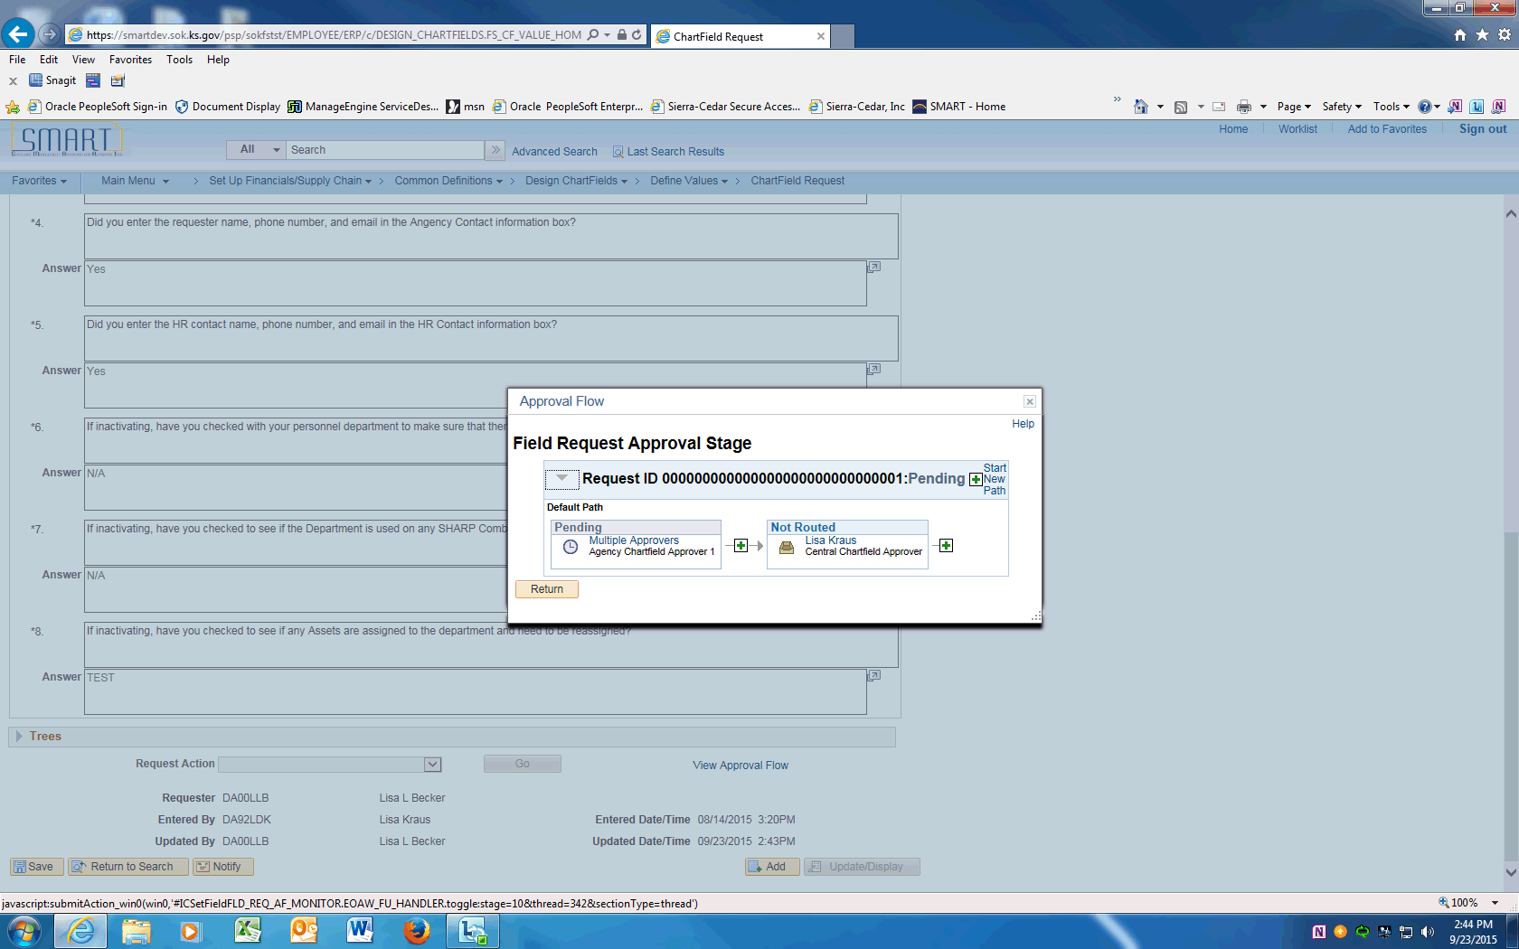

Step | Action
 | Approval Flow is displayed. The Request will need to be approved by the Agency Chartfield Approver and the Central Chartfield Approver. After approval, the ChartField will be available in SMART.
 | End of Procedure.

Updating Department IDs using Add a New Value
This UPK will demonstrate how to request an update to a Department ID. An update is effective dated and can include ChartField inactivations, description changes, budgetary only changes, etc. This option will be used for most ChartField updates.
Procedure

Step | Action
 | Click on Main Menu
 | Scroll down and click the Set Up Financials/Supply Chain menu.
 | Click the Common Definitions menu.
 | Click the Design ChartFields menu.
 | Click the Define Values menu.
 | Click the ChartField Request menu.

Step | Action
 | Enter your agency SETID into the SetID field. Enter "17300".
 | Click the magnifying glass next to the Field Name to display the Look Up and click on the DEPTID link.

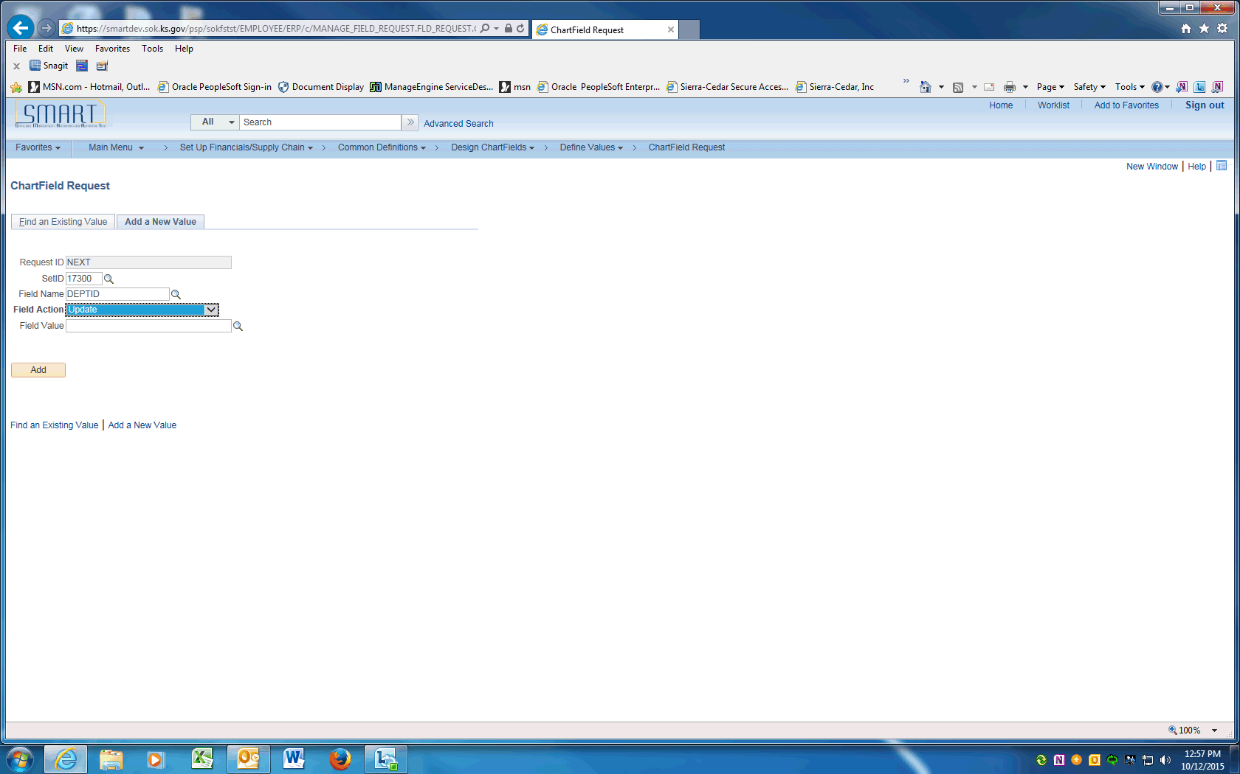

Step | Action
Click the magnifying glass next to the Field Action to display the Look Up and choose Update to inactivate or change the DEPTID
Click the object.

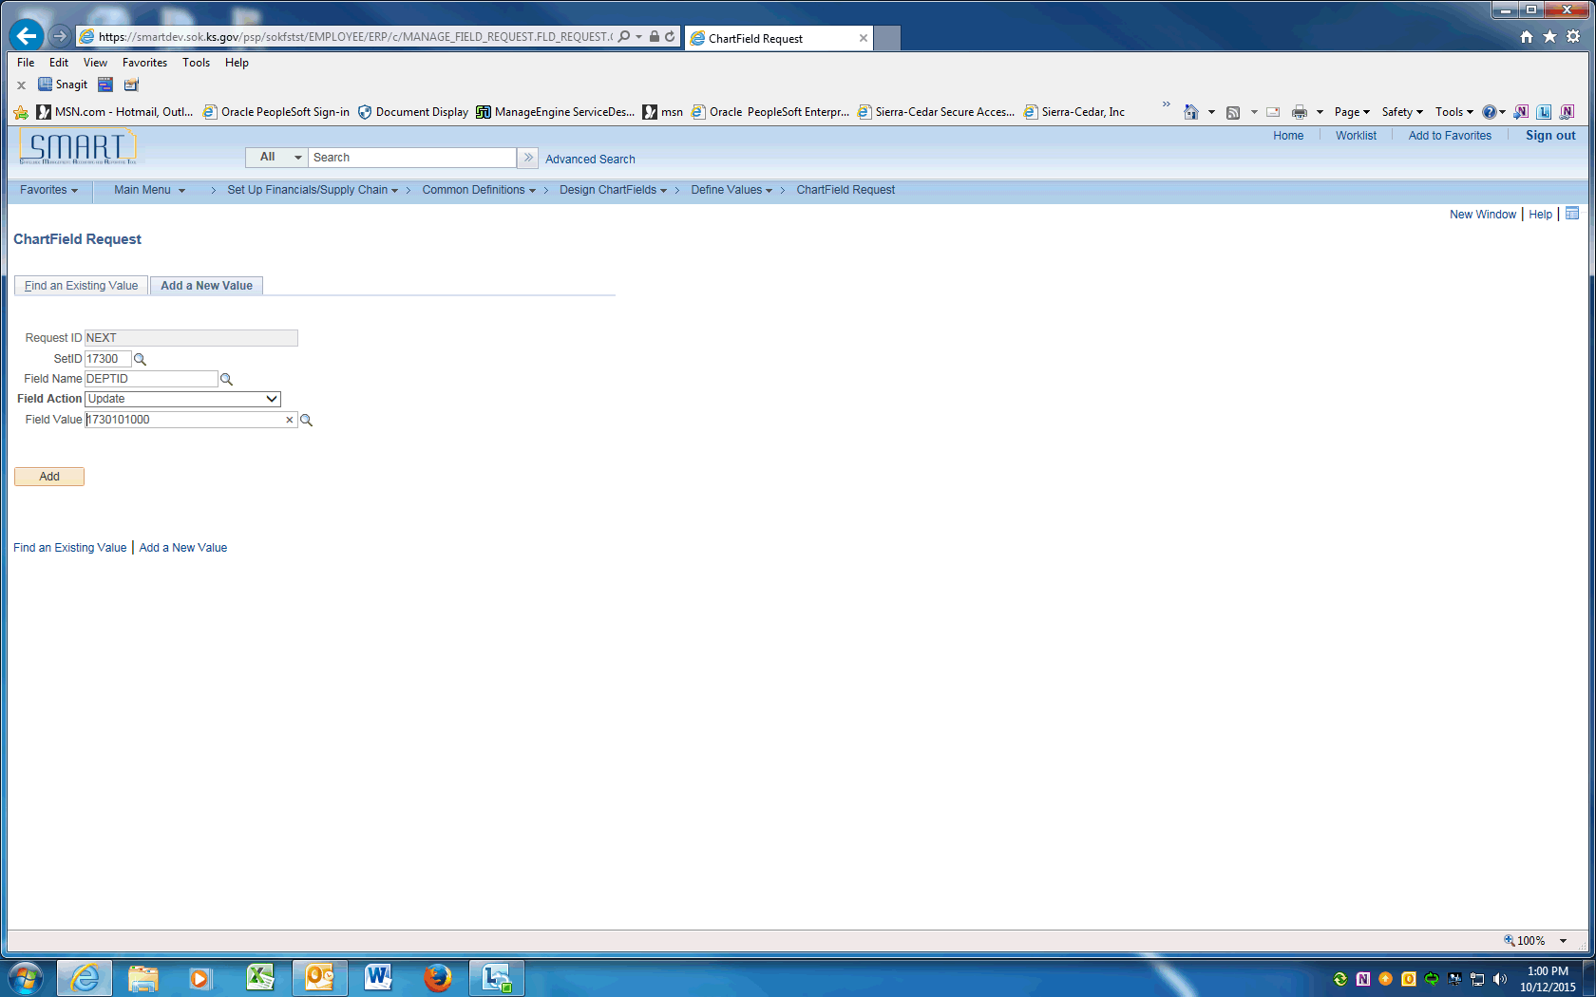

Step | Action
 | Enter the Department ID value into the Field Value field.
 | Click the Add button.

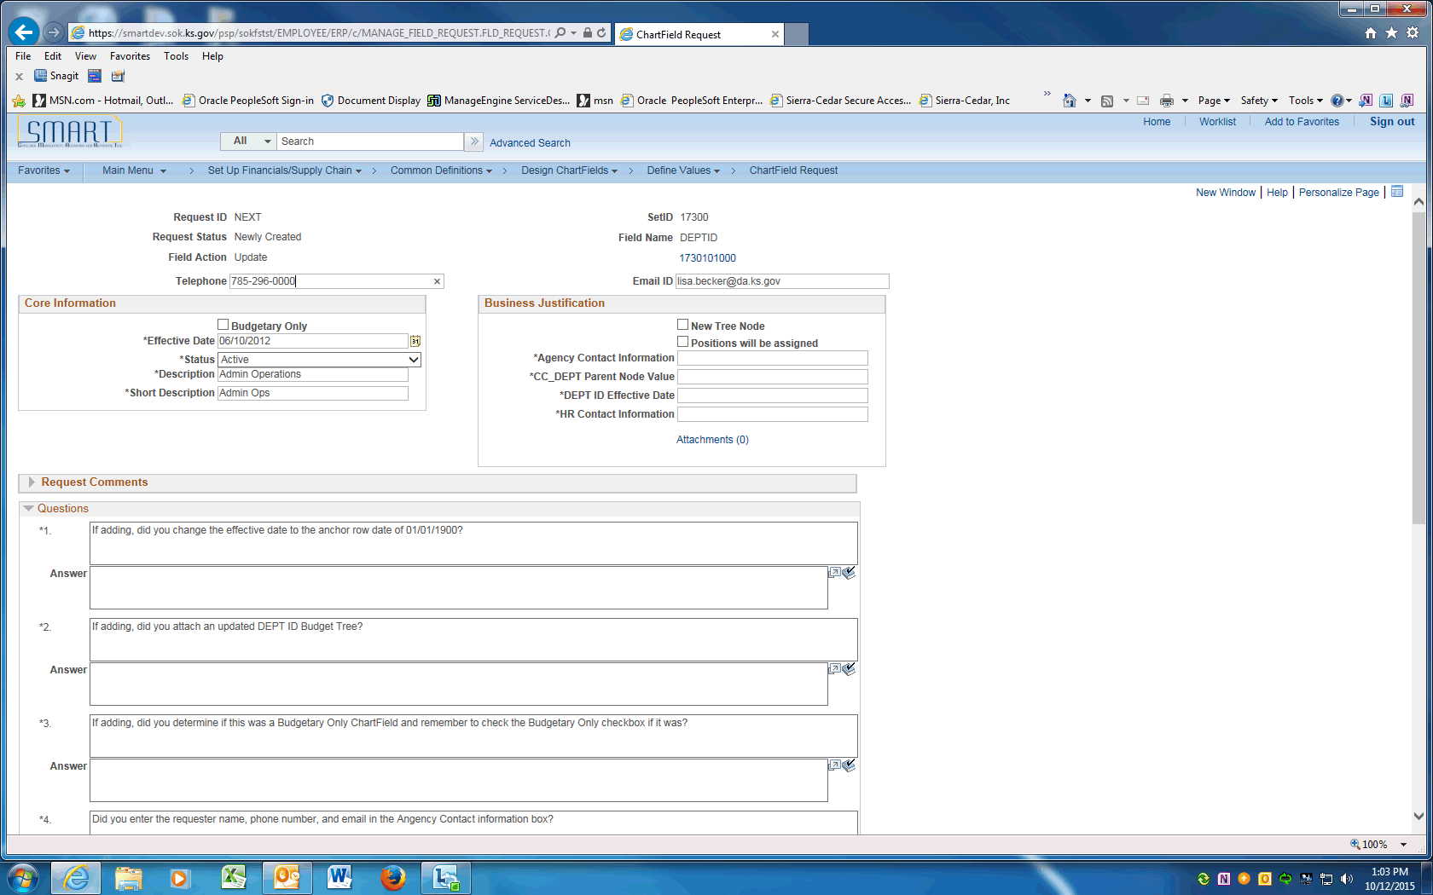

Step | Action
 | On the ChartField Request page, enter the Agency Contact phone number into the Telephone field. Enter "785-296-0000".
 | Click in the Email ID field and enter the Agency contact email address.
 | Click the Budgetary Only box on/off if the DEPTID is changing to/from Budgetary Only on the CC_DEPT tree.

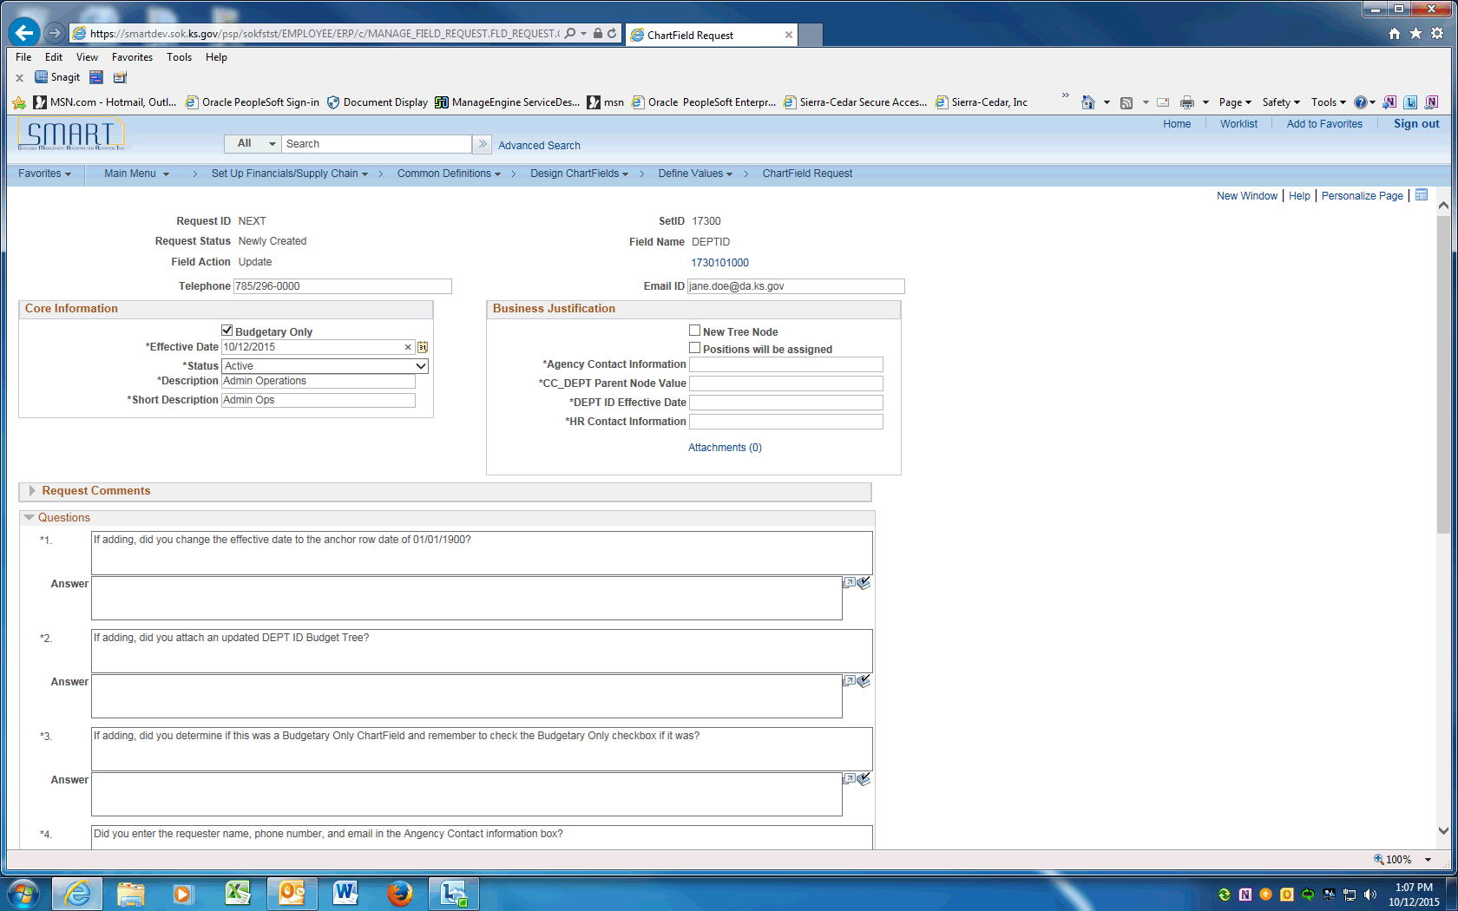

Step | Action
 | Since this is an update, enter a current effective date into the Effective Date field.
 | Review the Status. If the DEPTID is being inactivated change it to Inactive, otherwise leave as Active.

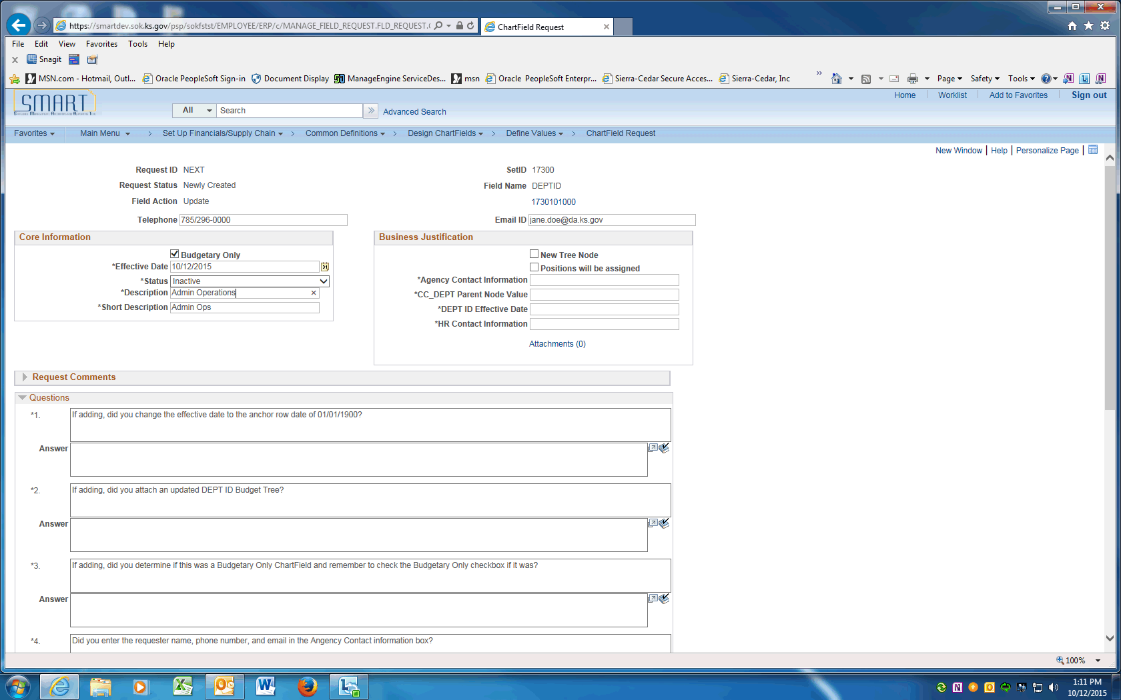

Step | Action
For inactivations, leave the Description and Short Description as shown.

If the name is changing change the Description and Short Description values, if needed.
For inactivations, skip this field.

For other updates (as needed), click the New Tree Node box if the value is a new Node on the DEPTID tree.

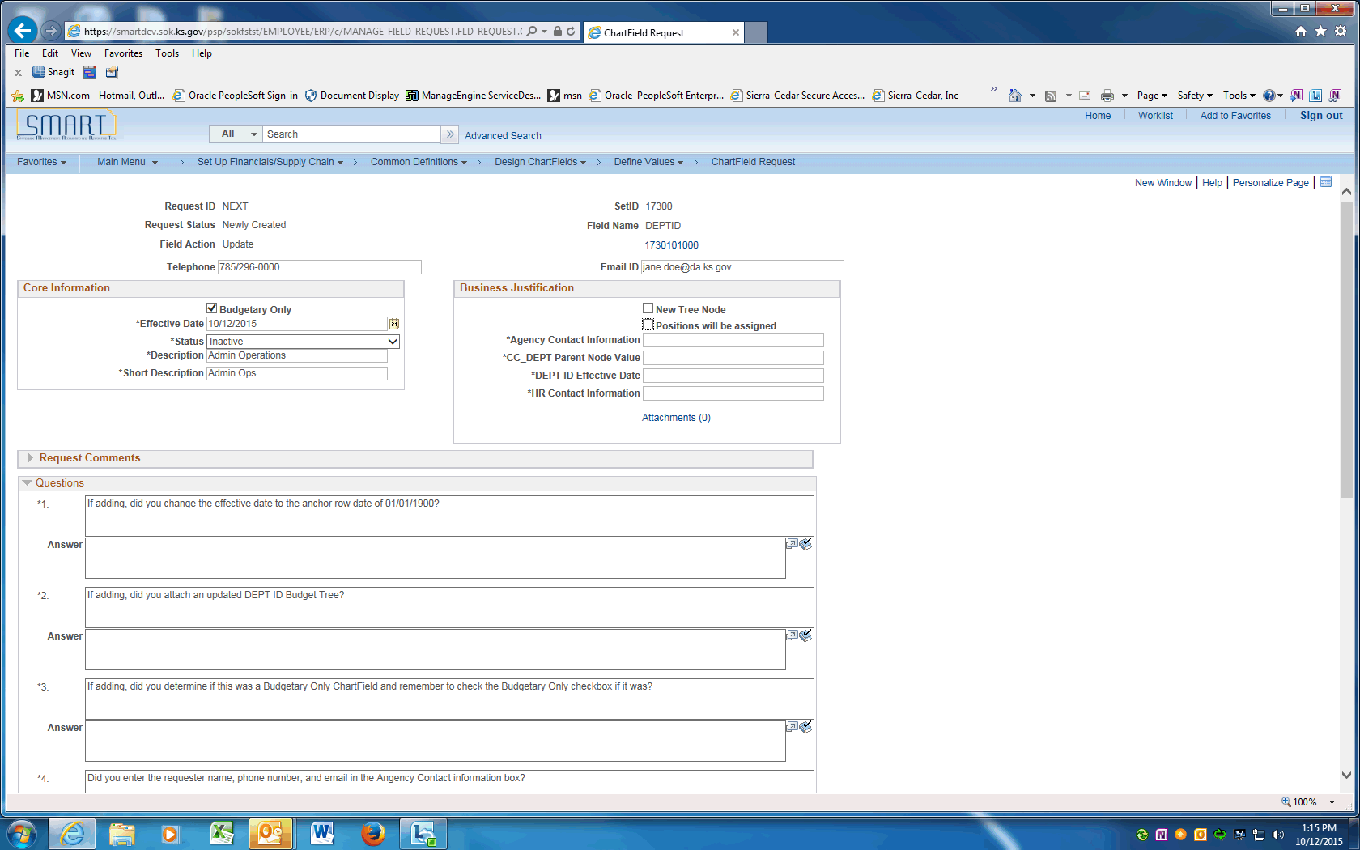

Step | Action
For inactivations, skip this field.

For other updates (as needed) click the Positions will be assigned box if this Department ID will be assigned to positions in SHaRP.

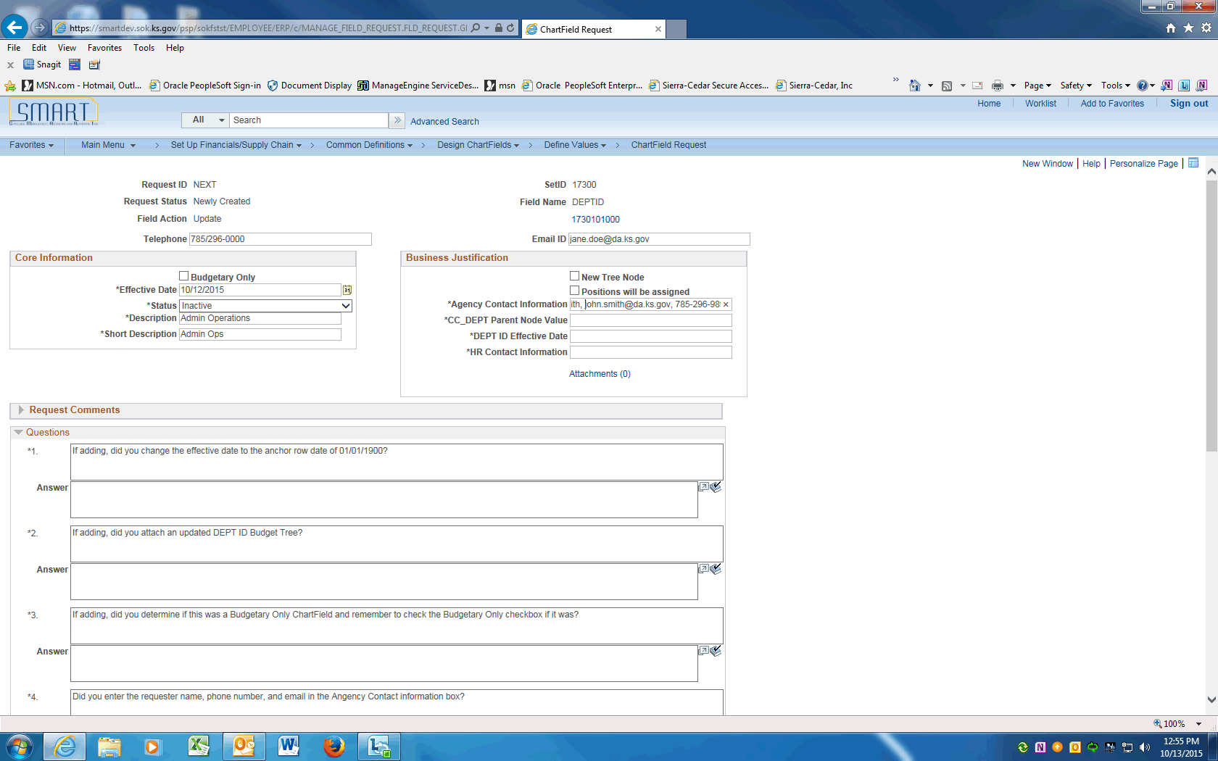

Step | Action
 | Enter the Agency contact name into the Agency Contact Information field. If the contact name is different than the Requester include the contact's email and phone number. Enter "John Smith, john.smith@da.ks.gov, 785-296-9898".
For inactivations, skip this field.

For other updates, enter the Parent tree node the new value will be assigned to on the DEPTID tree.
 | Enter actual effective date of the department ID into the DEPT ID Effective Date field. This value should be the same as the Effective Date. Enter "10122015".
For inactivations, skip this field.

For other updates, enter the agency's personnel contact information into the HR Contact Information field. Make sure to include name, email, and phone number. Enter "Katie Brown, katie.brown@da.ks.gov, 296-1234".
 | The next Section contains Questions that must be answered prior to saving this request.
 | Type N/A. Not applicable for DeptID updates.
 | Type N/A. Not applicable for DeptID updates.

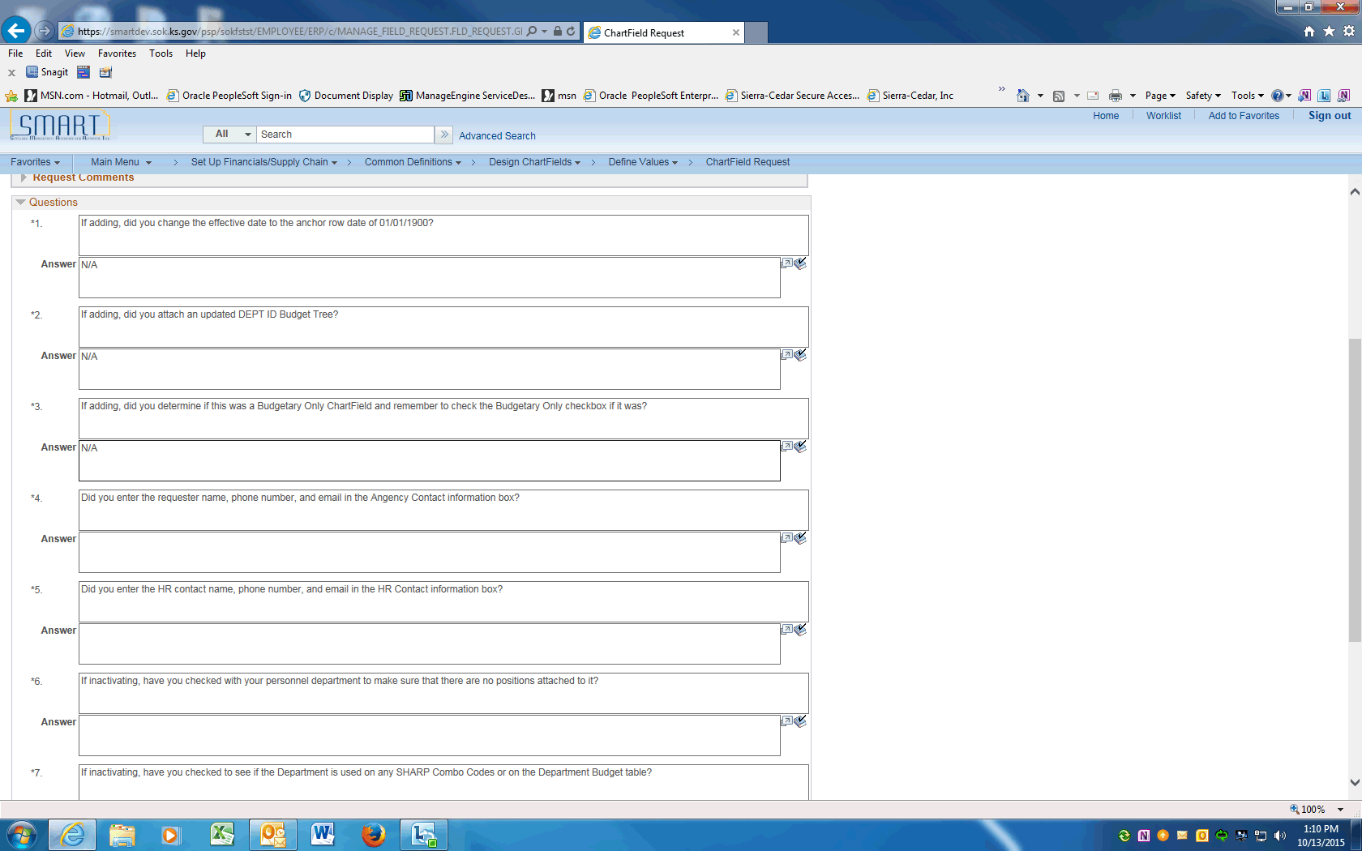

Step | Action
 | Type N/A. Not applicable for DeptID updates.

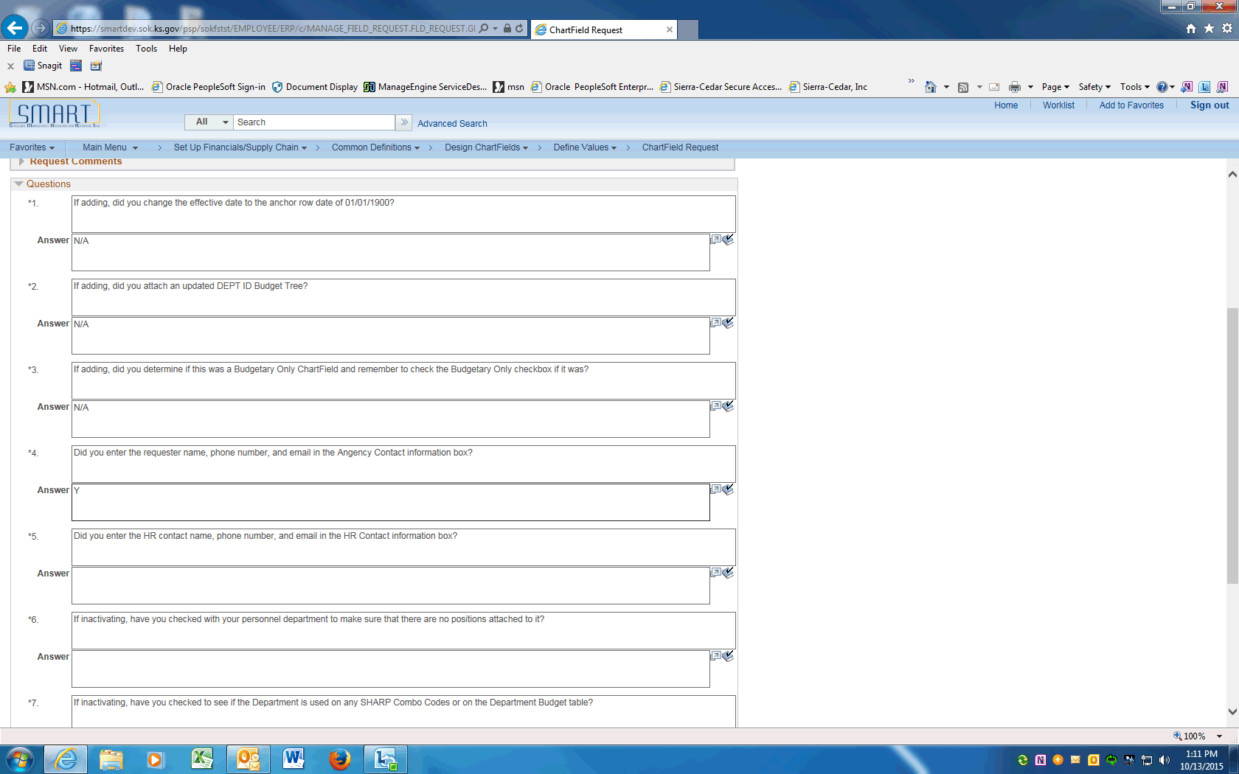

Step | Action
 | If the requester is different from the Agency Contact Name, you must enter their name, phone number and email. Enter "y".
The HR contact name, email and phone number must be entered. Division of Personnel Services will contact this person if they have questions. Enter the desired information into the Answer field. Enter "Y".
Enter the desired information into the Answer field. Enter "Y".
For inactivations, Personnel must be contacted to ensure no positions are assigned to the DEPTID.

For other updates, this question is not applicable.
For inactivations, Personnel must be contacted to ensure the DEPTID is not used by any combo codes or Department Budget Tables.

For other updates, this question is not applicable.

For inactivations, Assets assigned to this DEPTID must be re assigned to an Active DEPTID.

For other updates, this question is not applicable.

 | Only after all the questions are answered, the request can be saved. Click the Save button.
 | Click the dropdown arrow and choose the Submit for Approval item. Click the Go button. This will submit the Request into Approval workflow.
 | Click the View Approval Flow link to see the workflow.

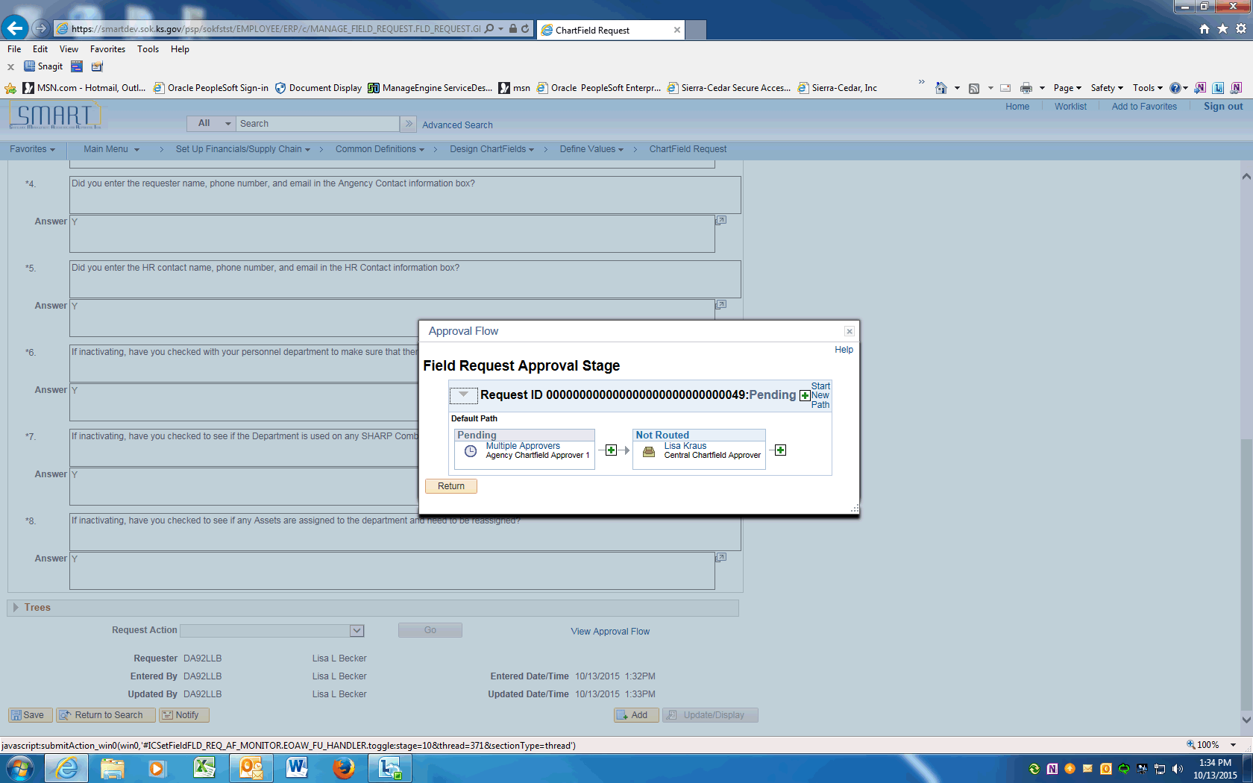

Step | Action
 | Approval Flow is displayed. The Request will need to be approved by the Agency Chartfield Approver and the Central Chartfield Approver. After approval, the ChartField will be available in SMART.
 | End of Procedure.

Updating Department IDs using Find an Existing Value
This UPK will demonstrate how to request an update to a Department ID. An update is effective dated and can include ChartField inactivations, description changes, budgetary only changes, etc.
Use the Find an Existing Value option if the Department ID Request exists in SMART and can be copied.
Procedure

Step | Action
 | Click on Main Menu
 | Scroll down and click the Set Up Financials/Supply Chain menu.
 | Click the Common Definitions menu.
 | Click the Design ChartFields menu.
 | Click the Define Values menu.
 | Click the ChartField Request menu.

Step | Action
 | Enter your agency SETID into the SetID field. Enter "17300".
 | Click the magnifying glass next to the Field Name to display the Look Up and click on the DEPTID link.

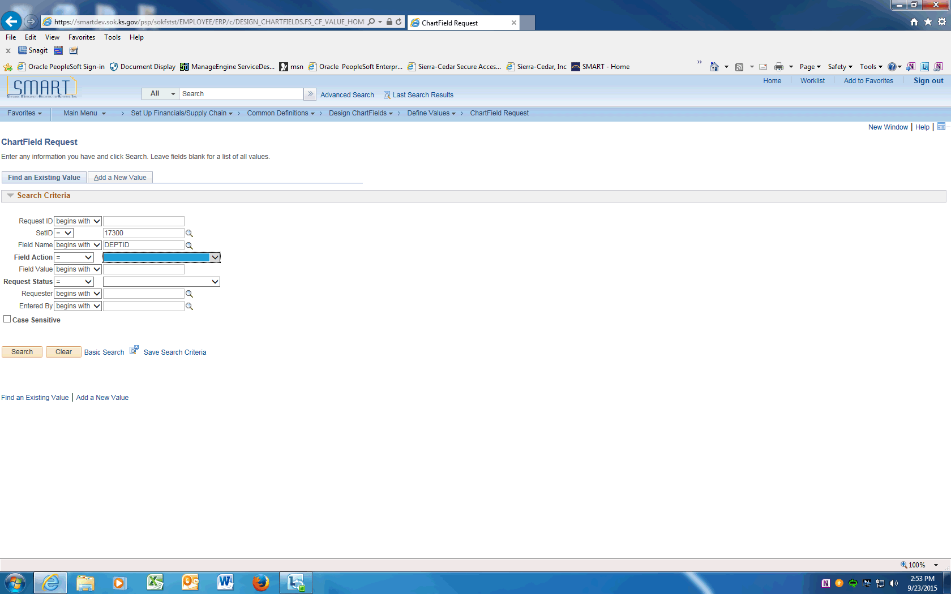

Step | Action
 | Clear the Field Action field.

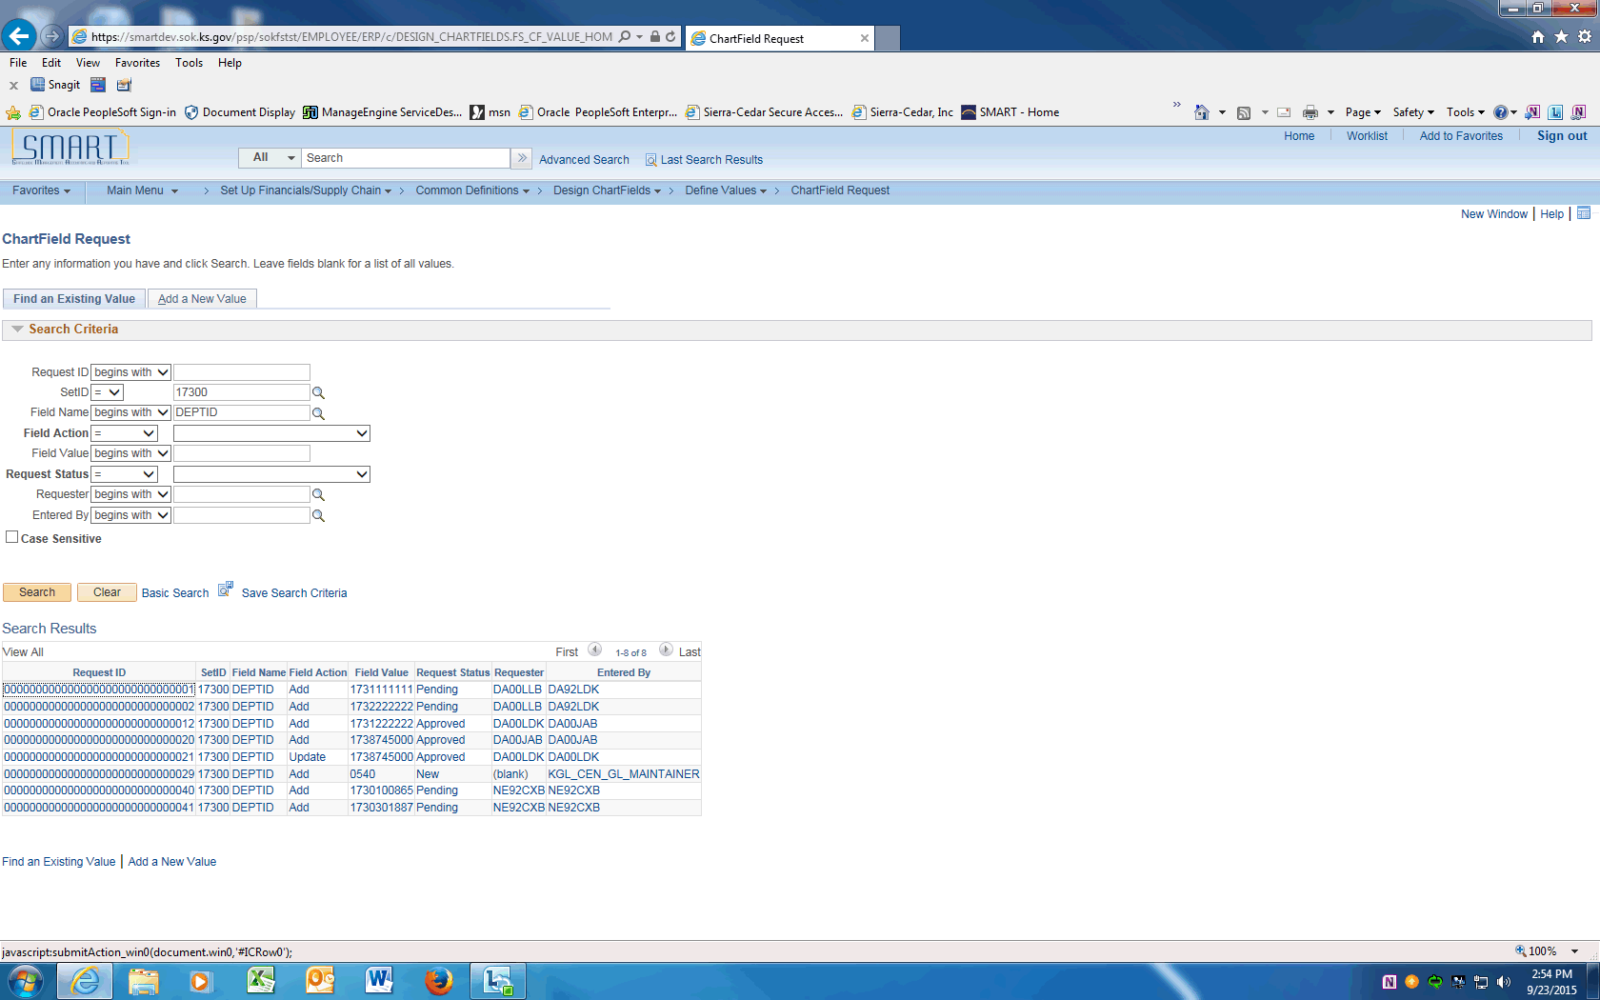

Step | Action
 | Click the Search button. The Search Results will be displayed.
Click the Field Value for the DEPTID being updated.

Only Approved Requests can be updated.

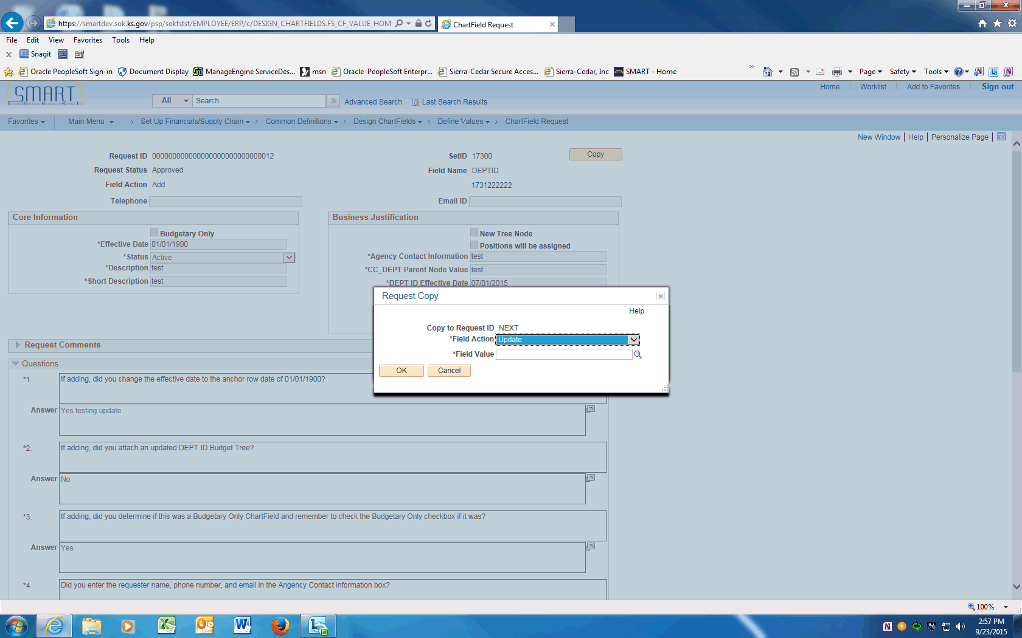

Step | Action
 | Click the Copy button and the Request Copy box will be displayed. Click the dropdown next to the Field Action and choose Update.
 | Enter the DEPTID value being updated into the Field Value field. Enter "173122222".
 | Click the OK button.

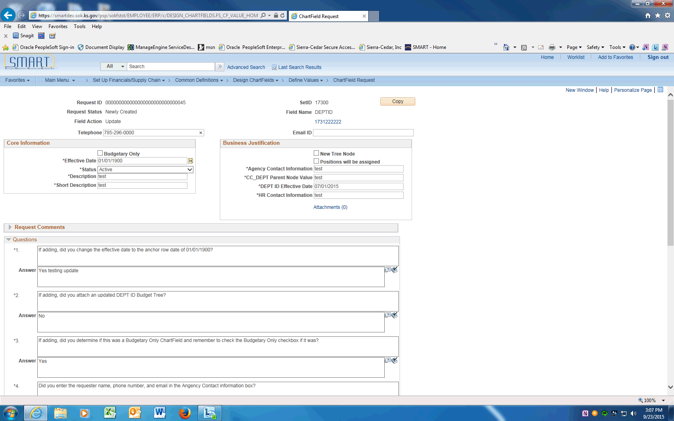

Step | Action
 | On the ChartField Request page, enter the Agency Contact phone number into the Telephone field. Enter "785-296-0000".
 | Click in the Email ID field and enter the Agency contact email address.
 | Click the Budgetary Only box if the DEPTID being changed to Budgetary only (the value is a node on the CC_DEPT tree and will not be used on transacitons).

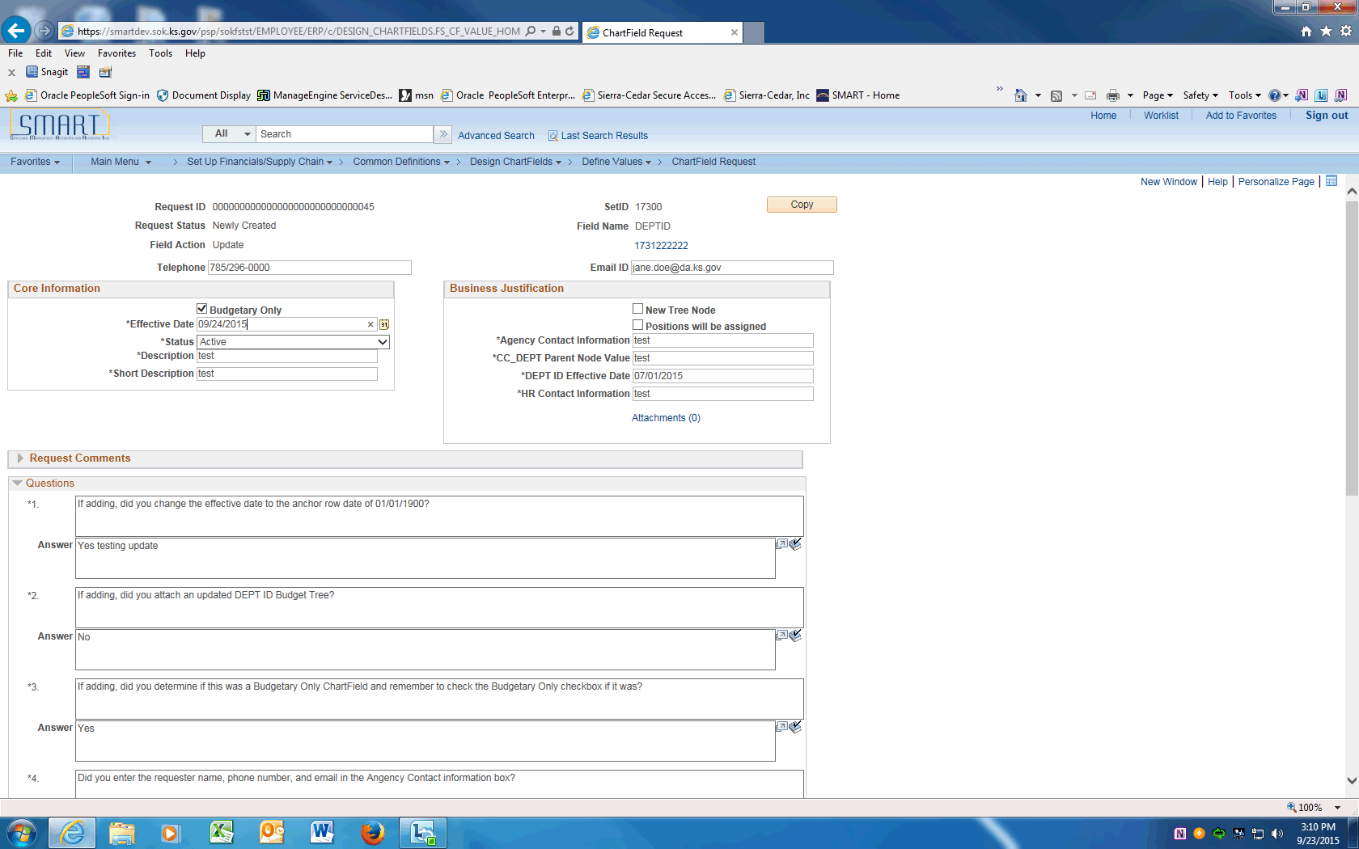

Step | Action
 | Enter the effective date of the change into the Effective Date field.

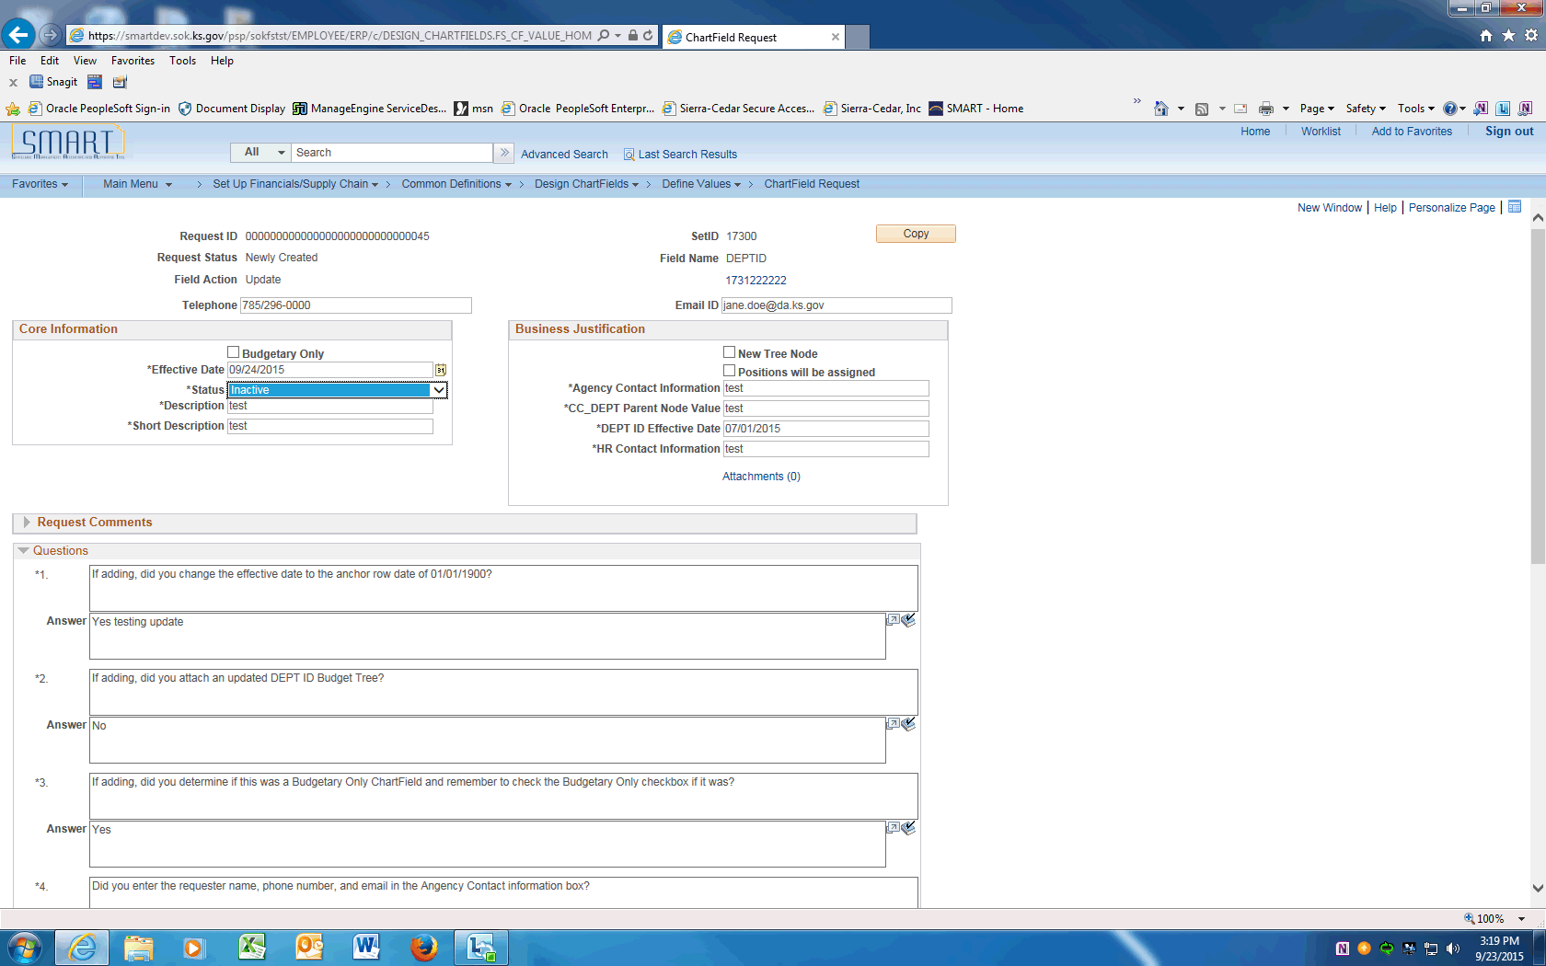

Step | Action
 | If inactivating the DEPTID, click the dropdown next to the Status and choose Inactive. If make changes only, leave as Active.
 | If updating the DEPTID, enter the new Description.
 | If updating the DEPTID, enter the new Short Description.

Step | Action
 | If the updated DEPTID will have Positions assigned in SHaRP, click the Positions will be assigned box.

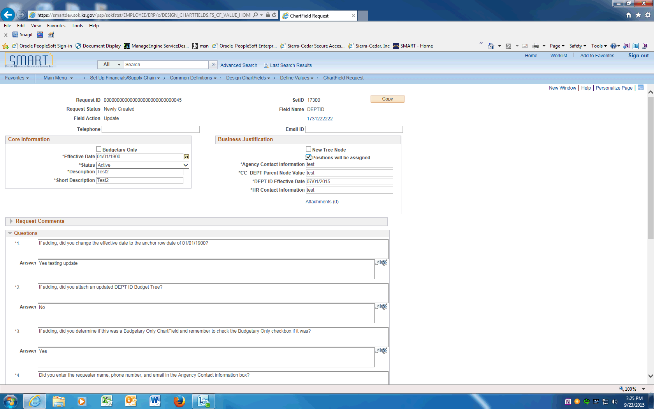

Step | Action
 | If changing, update the contact information in the Agency Contact Information field.
 | If changing, update the Parent Node information in the CC_DEPT Parent Node Value field. Enter "1731200000".
 | Change the DEPTID Effective Date to be the same as the Effective Date.
 | If changing, enter updated information into the HR Contact Information field.
 | The next Section contains Questions that must be answered prior to saving this request.
 | Not applicable for ChartField updates.
 | Not applicable for ChartField update.
 | Not Applicable for ChartField update.
 | If the requester is different from the Agency Contact Name, you must enter their name, phone number and email. Enter the desired information into the Answer field. Enter "y".
 | The HR contact name, email and phone number must be entered. Division of Personnel Services will contact this person if they have questions. Enter the desired information into the Answer field. Enter "y".
 | All positions must be moved to an Active DEPTID prior to inactivating a department ID.
 | The SHaRP Combo codes and Department Budget tables must be changed to an Active DEPTID value when inactivating ChartFields.
 | Assets must be moved to an Active DEPTID. The monthly depreciation journals will be in error if this is not done.
 | Only after all the questions are answered, the request can be saved. Click the Save button.
 | Click the dropdown arrow and choose the Submit for Approval item. Click the Go button. This will submit the Request into Approval workflow.
 | Click the View Approval Flow link to see the workflow.

Step | Action
 | Approval Flow is displayed. The Request will need to be approved by the Agency Chartfield Approver and the Central Chartfield Approver. After approval, the ChartField will be available in SMART.
 | End of Procedure.

Adding Program Codes
This UPK will demonstrate how to request a new Program Code.
Procedure

Step | Action
 | Click on Main Menu
 | Scroll down and click the Set Up Financials/Supply Chain menu.
 | Click the Common Definitions menu.
 | Click the Design ChartFields menu.
 | Click the Define Values menu.
 | Click the ChartField Request menu.

Step | Action
 | Enter your agency SETID into the SetID field. Enter "17300".
 | Click the magnifying glass next to the Field Name to display the Look Up and click on the PROGRAM_CODE link.

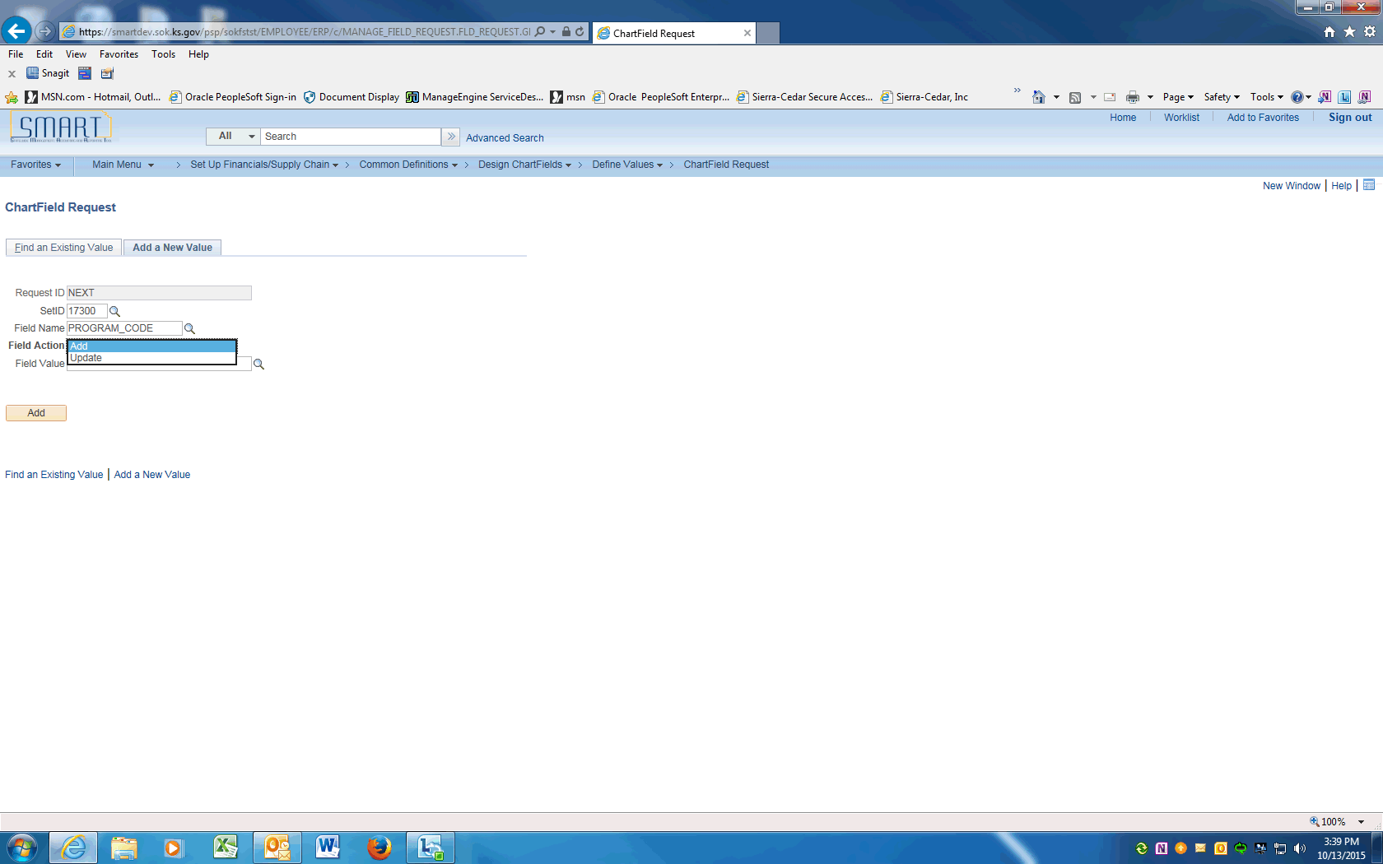

Step | Action
 | Click the magnifying glass next to the Field Action to display the Look Up and click on Add.

Step | Action
 | Enter the new Program Code value into the Field Value field.
 | Click the Add button.

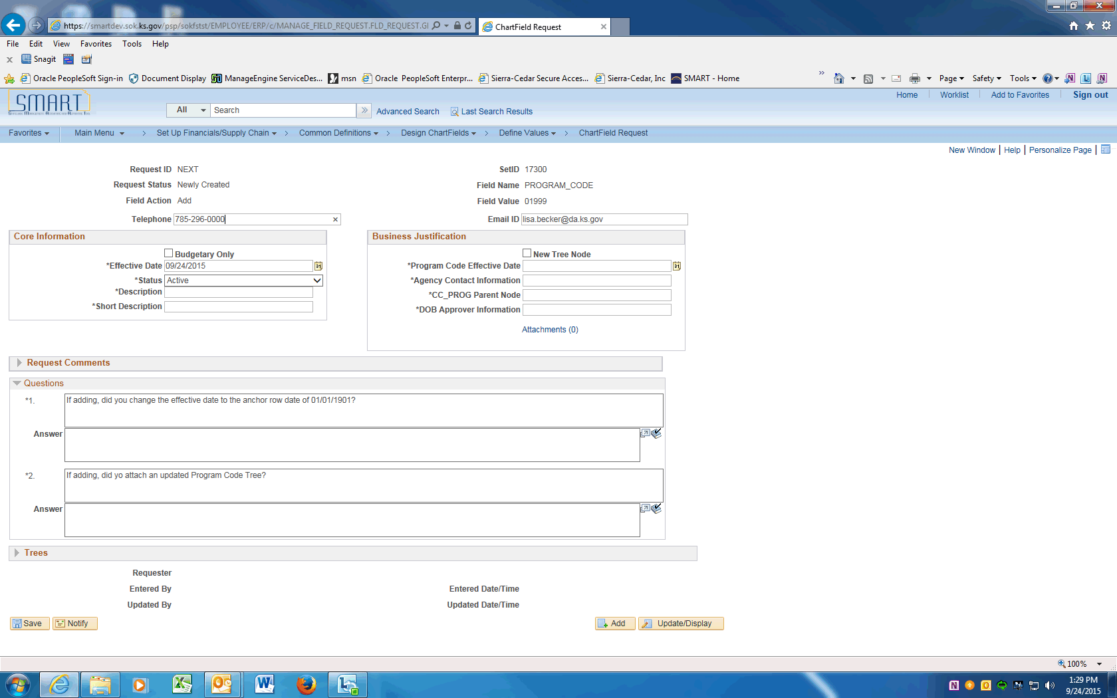

Step | Action
 | On the ChartField Request page, enter the Agency Contact phone number into the Telephone field. Enter "785-296-0000".
 | Click in the Email ID field and enter the Agency contact email address.
 | Click the Budgetary Only box if the new PROGRAM_CODE is a new node on the CC_PROG tree and will not be used on transactions.

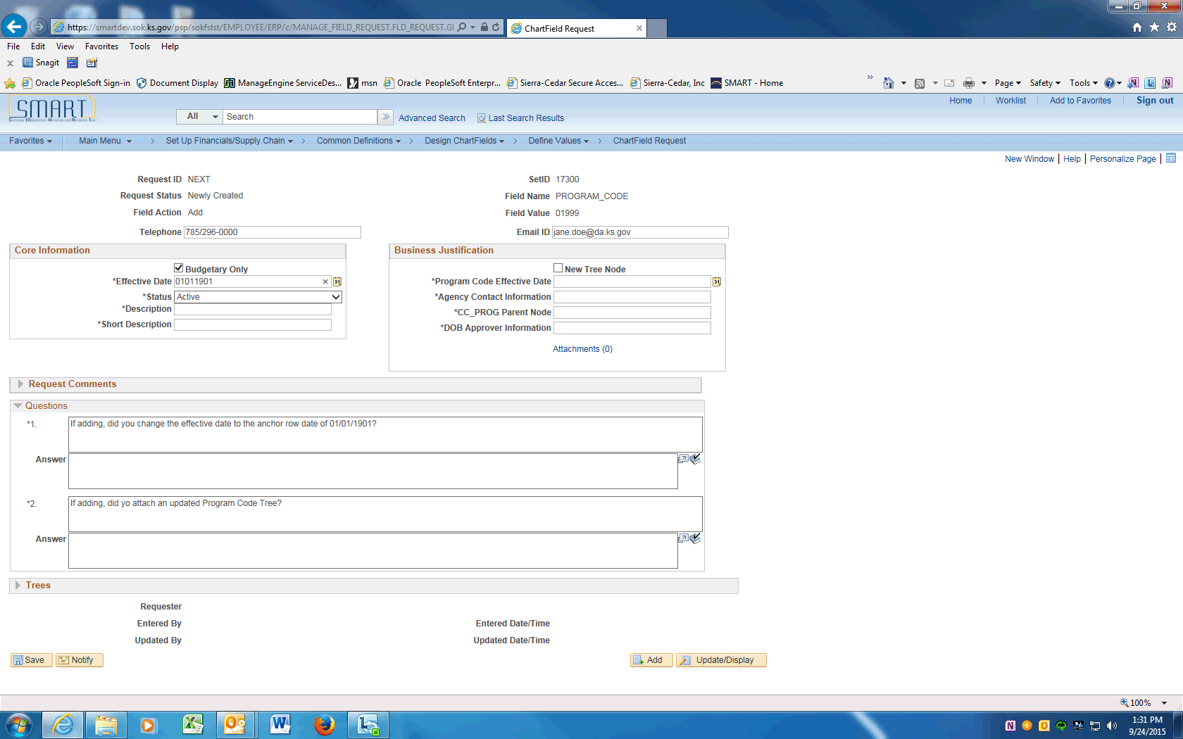

Step | Action
 | Enter the anchor effective date of "01/01/1901" into the Effective Date field.

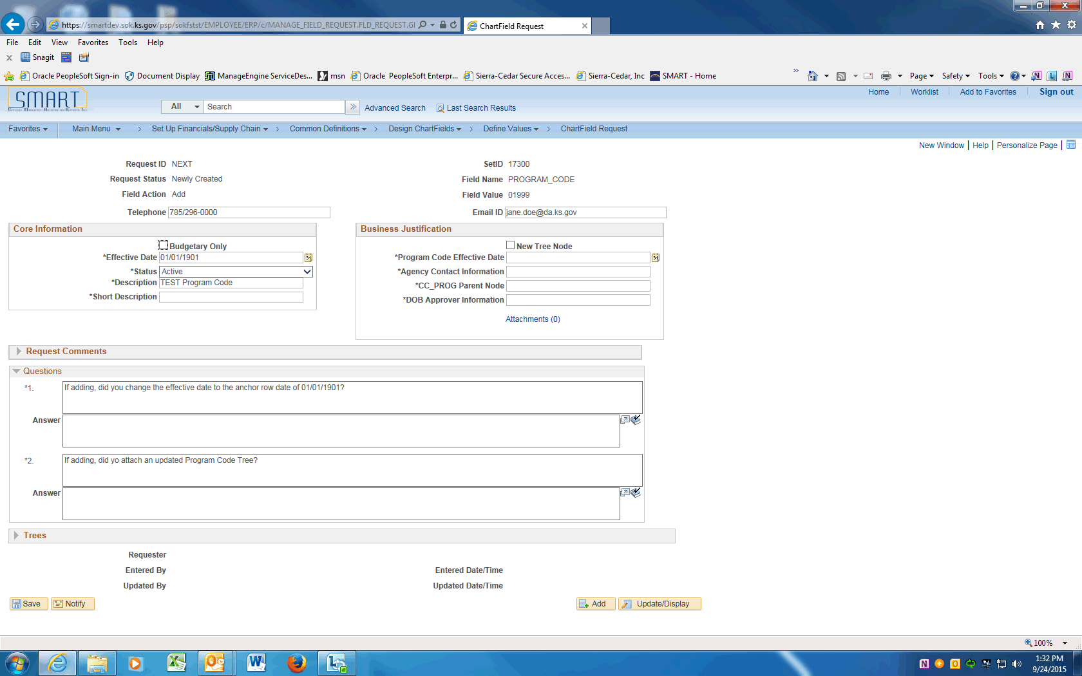

Step | Action
 | Enter the Program Code long description into the Description field. Enter "Test Program Code".
 | Enter the Program Code short description into the Short Description field. Enter "TESTProg".
 | Click the New Tree Node box if the value is a new Node on the PROG tree.
 | Enter actual effective date of the PROGRAM CODE into the Program Code Effective Date field. Enter "09242015".
 | Enter the Agency contact name into the Agency Contact Information field. If the contact name is different than the Requester include the contact's email and phone number. Enter "Jane Doe".
 | Enter the Parent tree node the new value will be assigned to on the PROG tree.
 | Enter the agency's personnel contact information into the DoB Contact Information field. Make sure to include name, email, and phone number. Enter "Katie Brown, katie.brown@budget.ks.gov, 296-9999".
 | The next Section contains Questions that must be answered prior to saving this request.
 | For New Program Codes, the anchor row Effective Date will always be '01/01/1901'. Enter "Y".
 | The CC_PROG tree must be updated and attached to this request.
 | Only after all the questions are answered, the request can be saved. Click the Save button.
 | Click the dropdown arrow and choose the Submit for Approval item. Click the Go button. This will submit the Request into Approval workflow.
 | Click the View Approval Flow link to see the workflow.

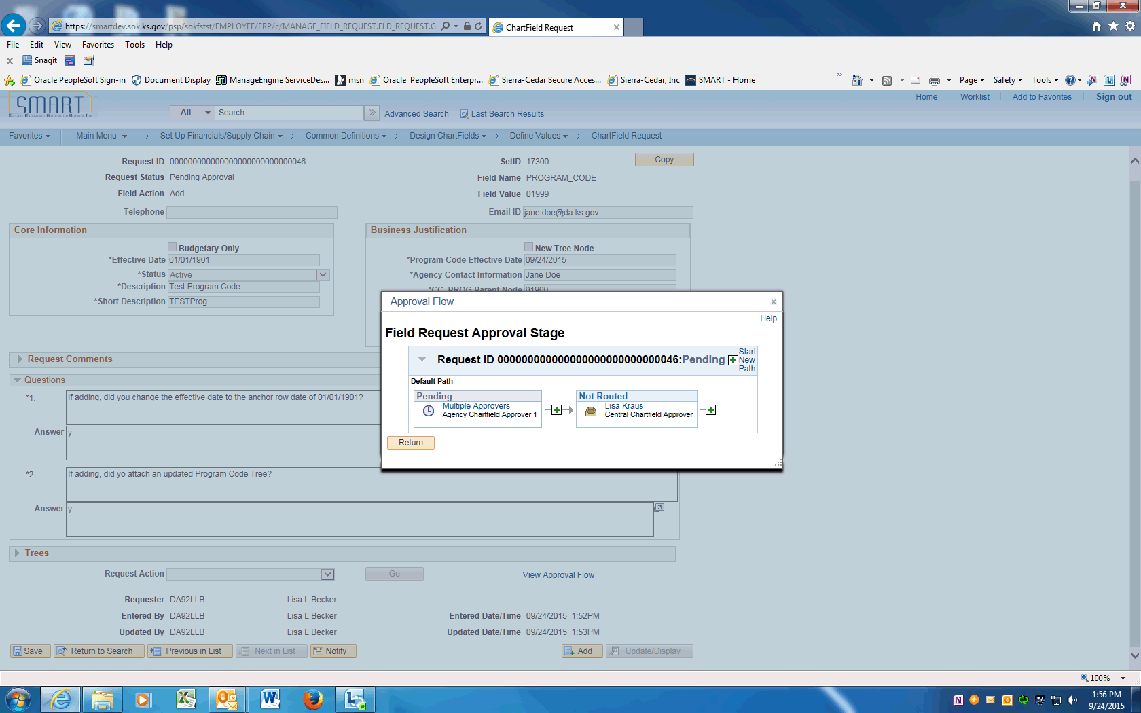

Step | Action
 | Approval Flow is displayed. The Request will need to be approved by the Agency Chartfield Approver and the Central Chartfield Approver. After approval, the ChartField will be available in SMART.
 | End of Procedure.

Updating Program Codes using Find an Existing Value
This UPK will demonstrate how to request an update to a Program Code. An update is effective dated and can include ChartField inactivations, description changes, budgetary only changes, etc. This option will be used for most ChartField updates.
Use the Find an Existing Value option if the Program Code Request exists in SMART and can be copied.
Procedure

Step | Action
 | Click on Main Menu
 | Scroll down and click the Set Up Financials/Supply Chain menu.
 | Click the Common Definitions menu.
 | Click the Design ChartFields menu.
 | Click the Define Values menu.
 | Click the ChartField Request menu.

Step | Action
 | Enter your agency SETID into the SetID field. Enter "17300".
 | Click the magnifying glass next to the Field Name to display the Look Up and click on the PROGRAM_CODE link.

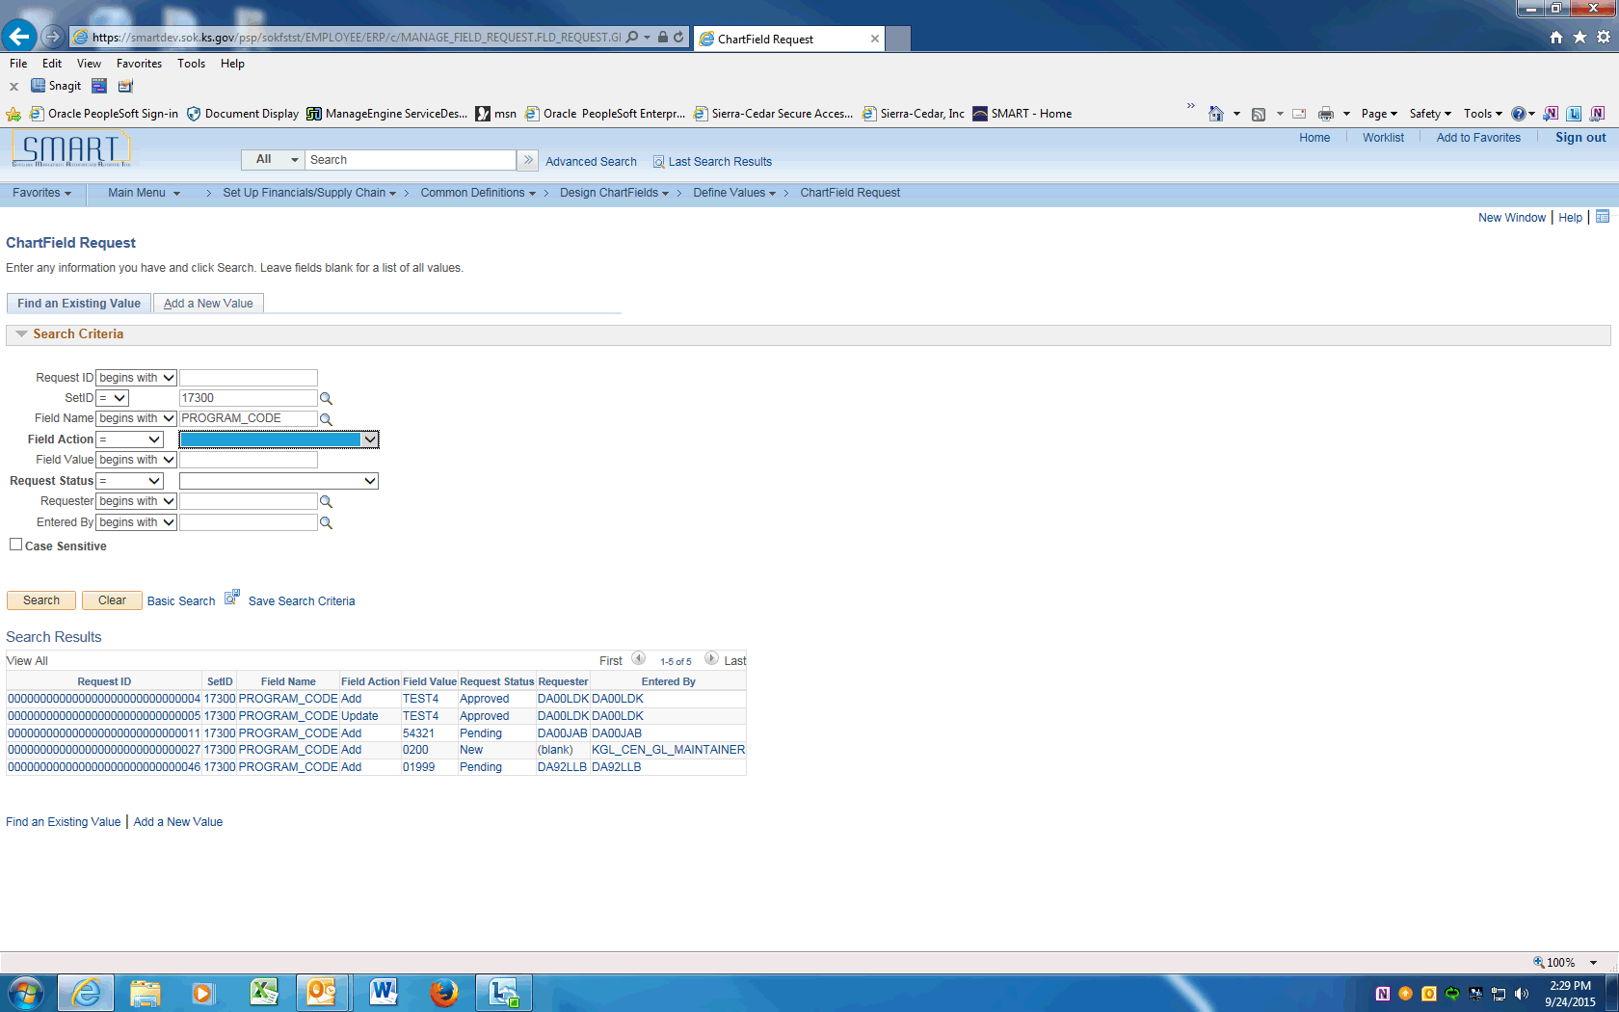

Step | Action
 | Clear the Field Action field.

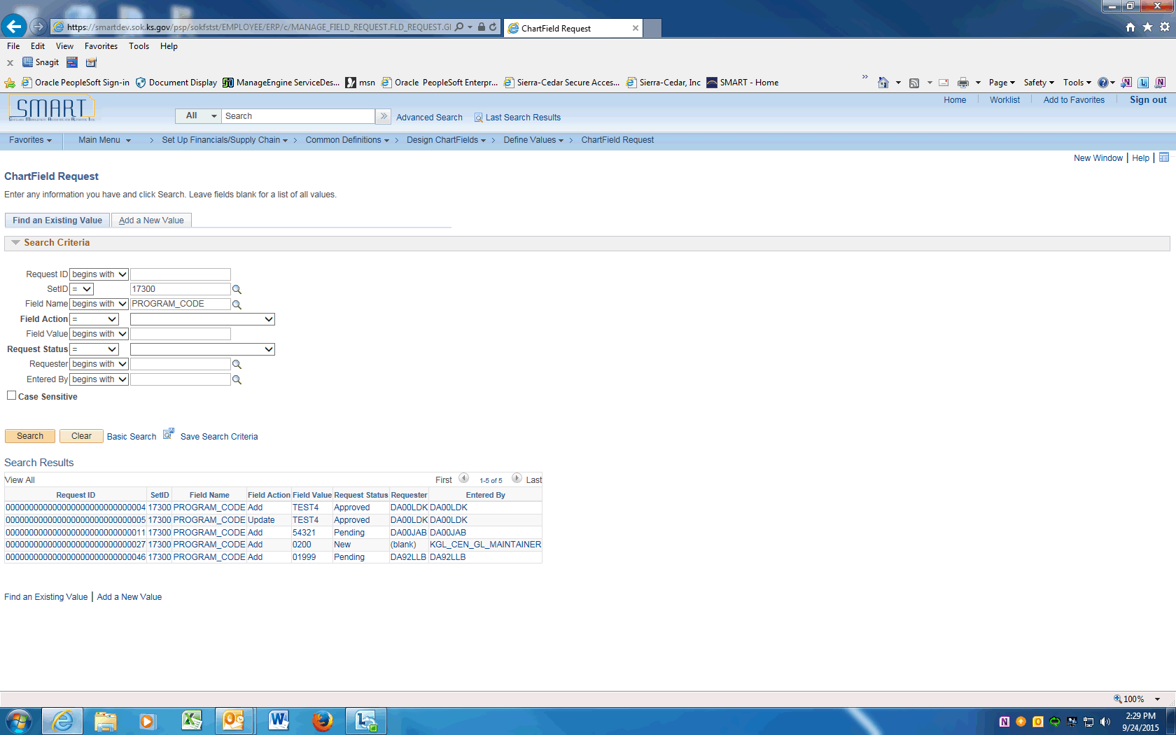

Step | Action
 | Click the Search button. The Search Results will be displayed.
Click the Field Value for the Program Code being updated.

Only Approved Requests can be updated.

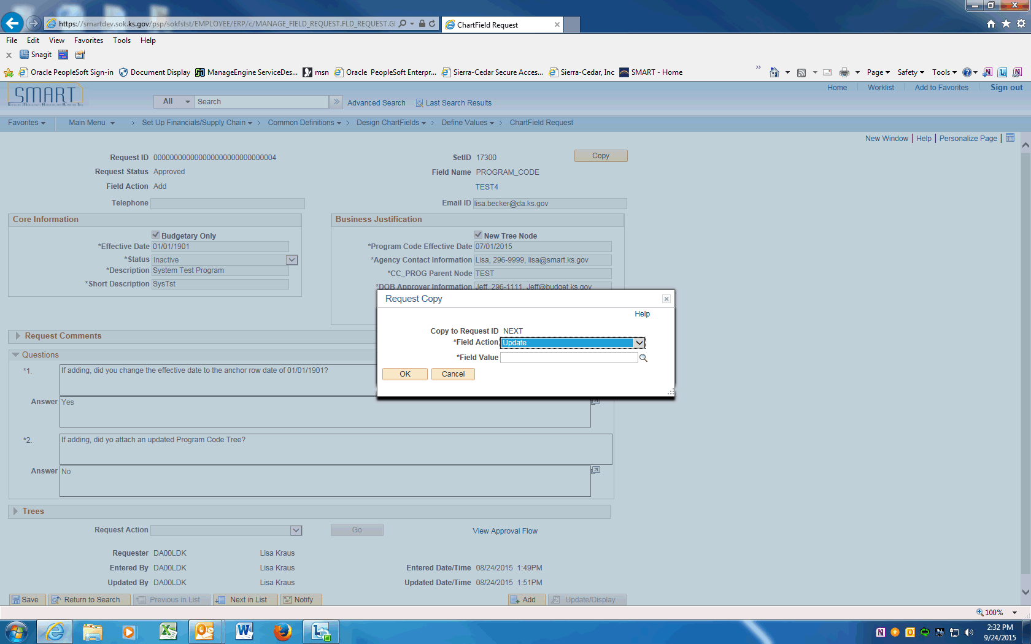

Step | Action
 | Click the Copy button and the Request Copy box will be displayed. Click the dropdown next to the Field Action and choose Update.
 | Enter the Program Code value being updated into the Field Value field. Enter "TEST4".
 | Click the OK button.

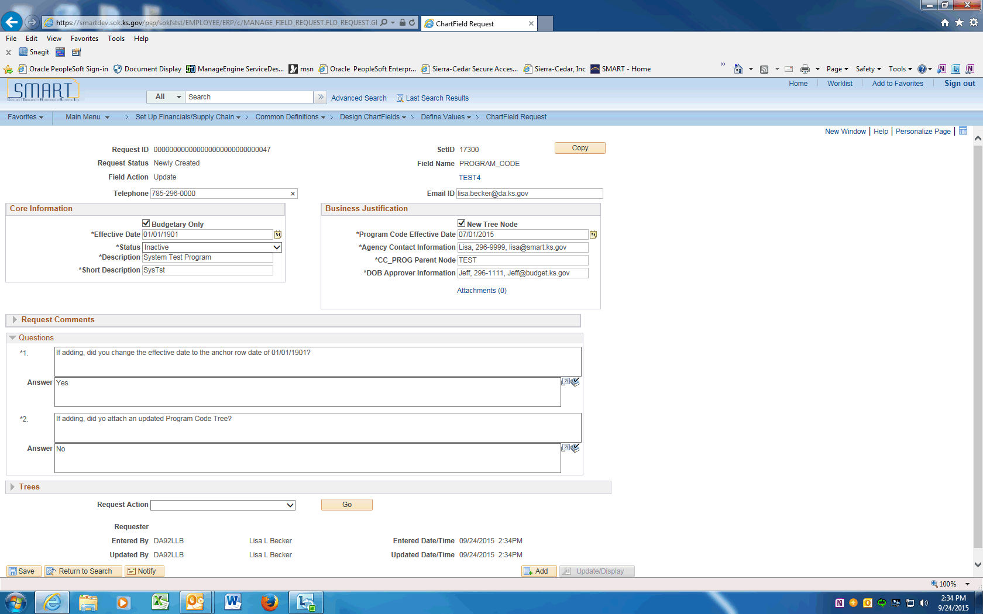

Step | Action
 | On the ChartField Request page, enter the Agency Contact phone number into the Telephone field. Enter "785-296-0000".
 | Click in the Email ID field and enter the Agency contact email address.
 | Click the Budgetary Only box if the Program Code is being changed to Budgetary only (the value is a node on the CC_PROG tree and will not be used on transacitons).

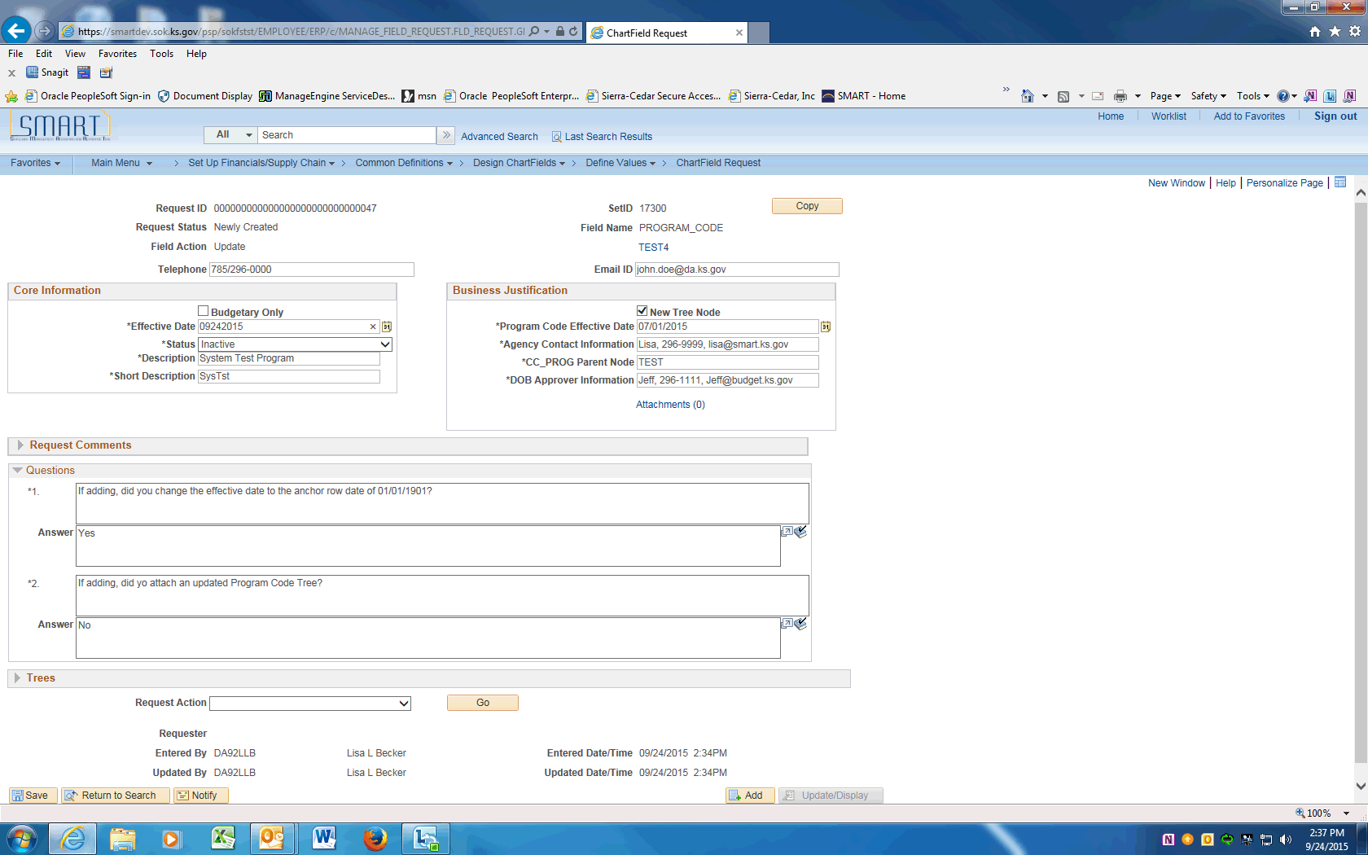

Step | Action
 | Enter the effective date of the change into the Effective Date field.

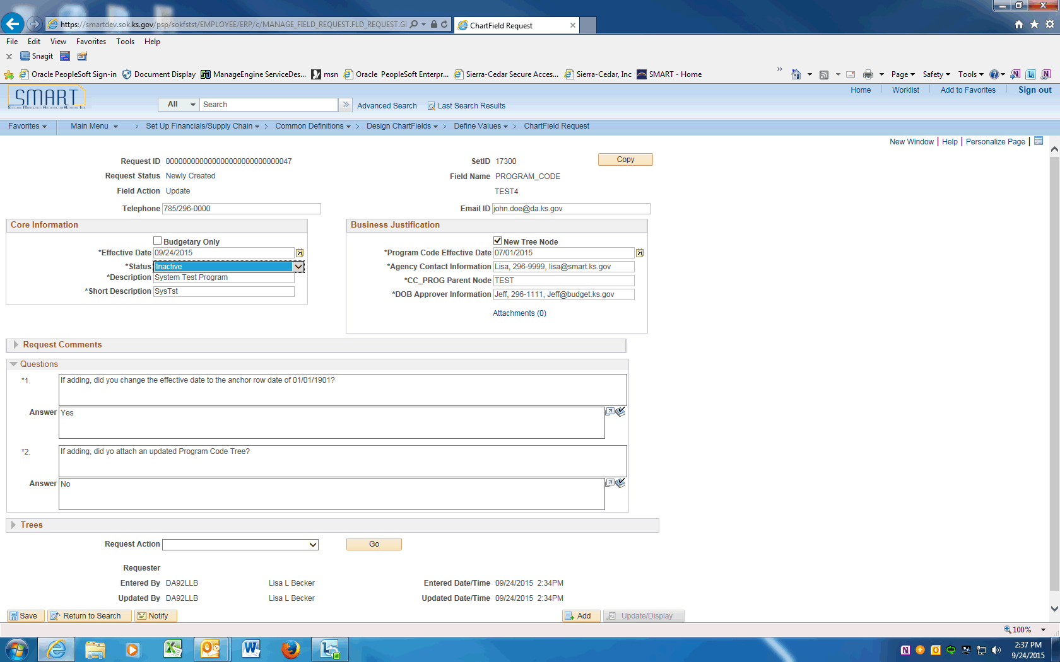

Step | Action
 | If inactivating the Program Code, click the dropdown next to the Status and choose Inactive. If making changes only, leave as Active.
 | If updating the Program Code, enter the new Description.
 | If updating the Program Code, enter the new Short Description.
 | Change the Program Code Effective Date to be the same as the Effective Date.
 | If changing, update the contact information in the Agency Contact Information field.
 | If changing, update the Parent Node information in the CC_PROG Parent Node Value field. Enter "TEST".
 | If changing, enter updated information into the DoB Approver Information field. Make sure to include name, email, and phone number.
 | The next Section contains Questions that must be answered prior to saving this request.
 | Not applicable for ChartField updates.
 | Not applicable for ChartField updates.
 | Only after all the questions are answered, the request can be saved. Click the Save button.
 | Click the dropdown arrow and choose the Submit for Approval item. Click the Go button. This will submit the Request into Approval workflow.
 | Click the View Approval Flow link to see the workflow.

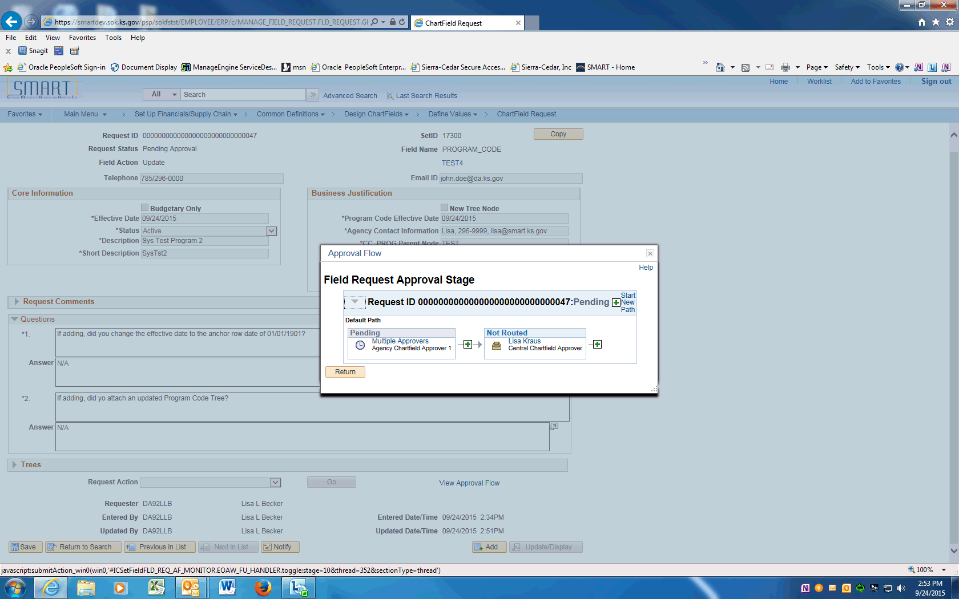

Step | Action
 | Approval Flow is displayed. The Request will need to be approved by the Agency Chartfield Approver and the Central Chartfield Approver. After approval, the ChartField will be available in SMART.
 | End of Procedure.

Updating Program Codes using Add a New Value
This UPK will demonstrate how to request an update to a Program Code. An update is effective dated and can include ChartField inactivations, description changes, budgetary only changes, etc.
This option will be used for most ChartField updates.
Procedure

Step | Action
 | Click on Main Menu
 | Scroll down and click the Set Up Financials/Supply Chain menu.
 | Click the Common Definitions menu.
 | Click the Design ChartFields menu.
 | Click the Define Values menu.
 | Click the ChartField Request menu.

Step | Action
 | Enter your agency SETID into the SetID field. Enter "17300".
 | Click the magnifying glass next to the Field Name to display the Look Up and click on the PROGRAM_CODE link.

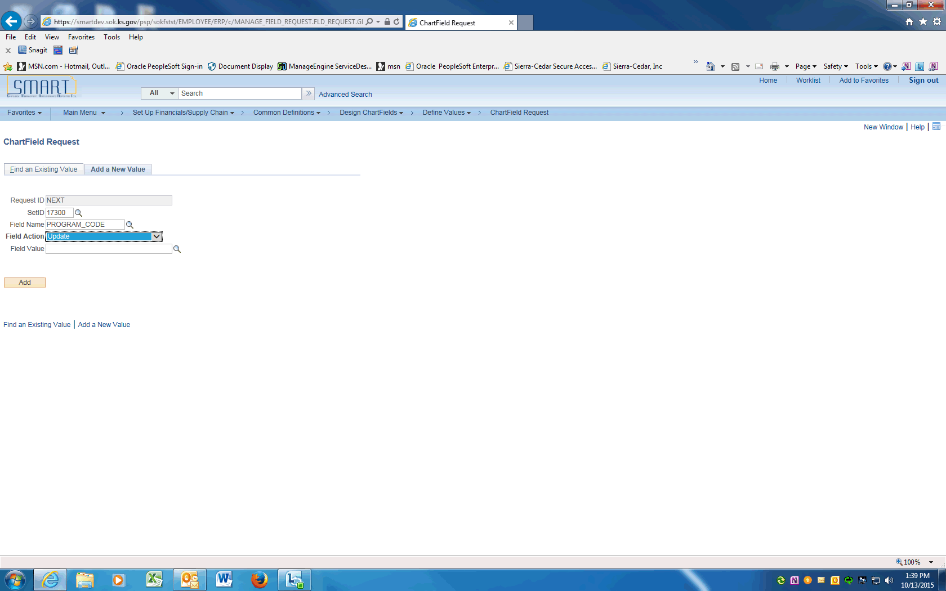

Step | Action
Click the magnifying glass next to the Field Action to display the Look Up and choose Update to inactivate or change a PROGRAM_CODE.
Click the Update list item.

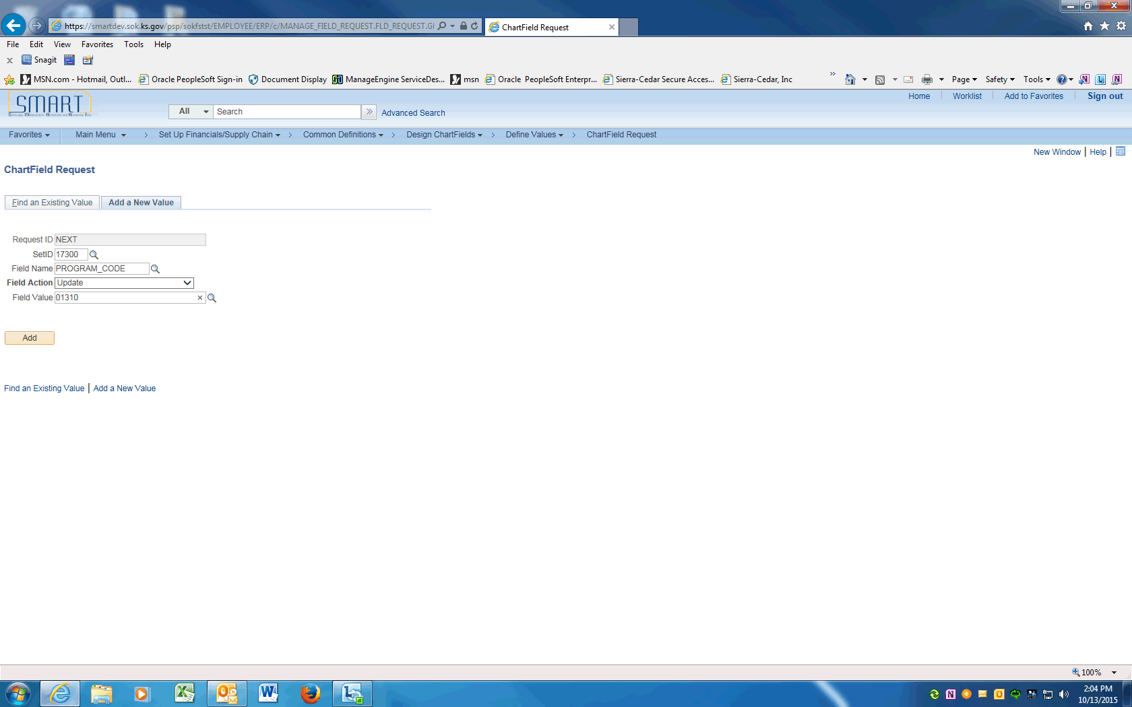

Step | Action
 | Enter the Program Code value into the Field Value field.
 | Click the Add button.

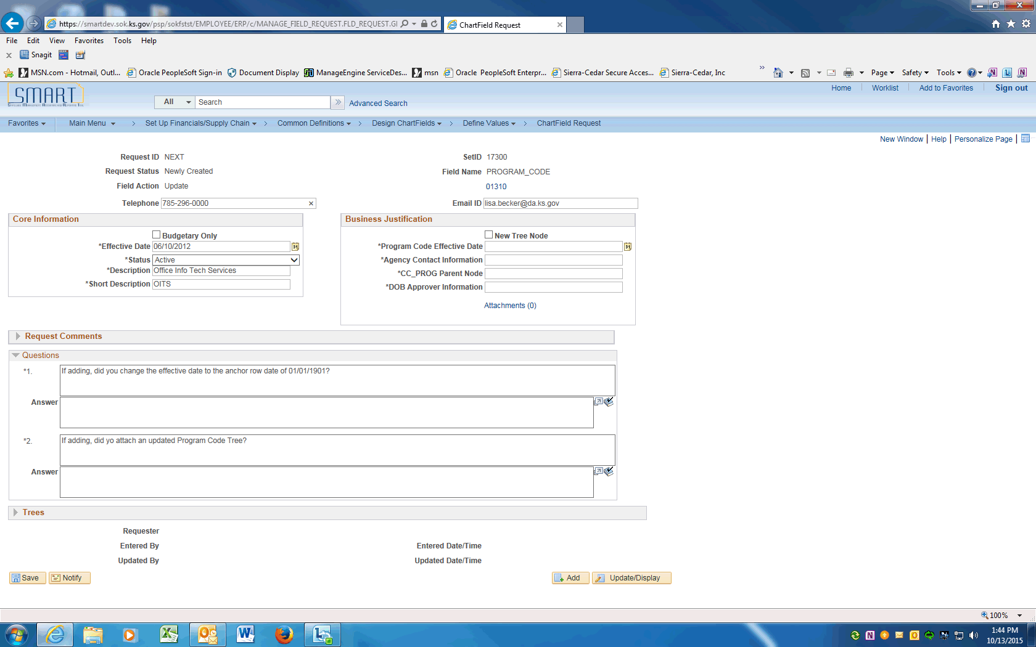

Step | Action
 | On the ChartField Request page, enter the Agency Contact phone number into the Telephone field. Enter "785-296-0000".
 | Click in the Email ID field and enter the Agency contact email address.
For inactivations, skip this field.

For other updates, click the Budgetary Only box if the PROGRAM_CODE is a new node on the CC_PROG tree and will not be used on transactions.

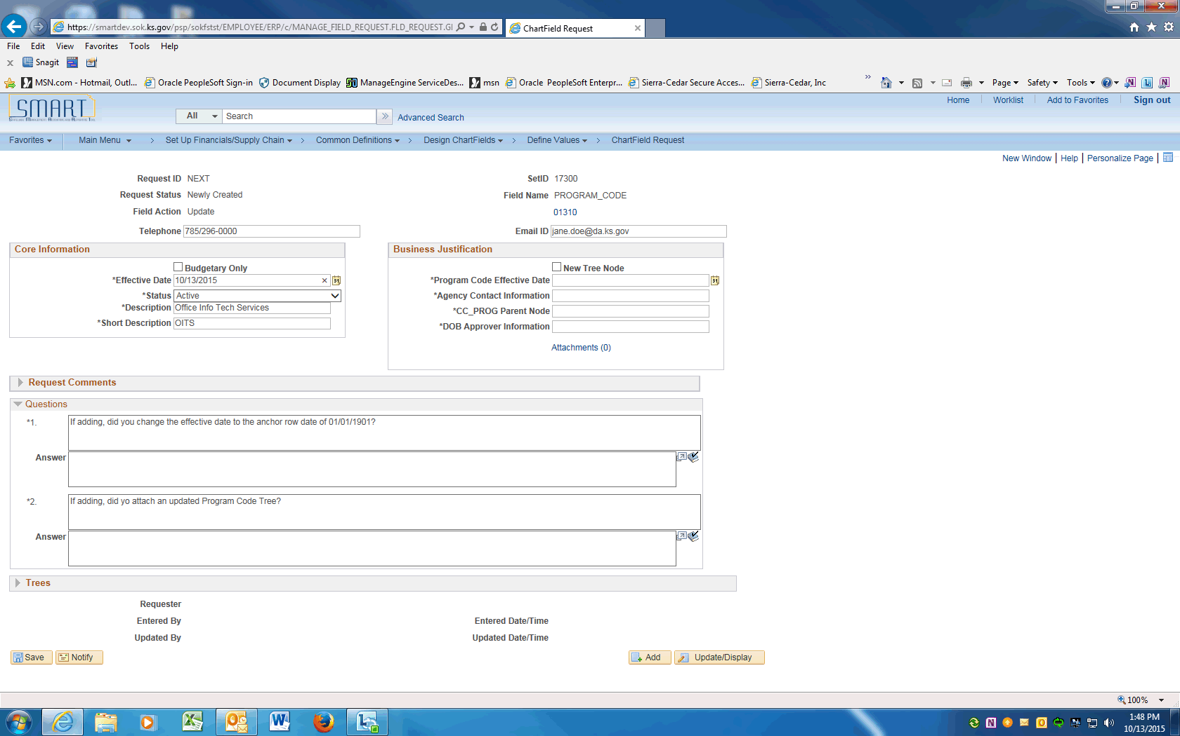

Step | Action
 | The Program code effective date will be populated in this field. Enter a current effective date into the Effective Date field.

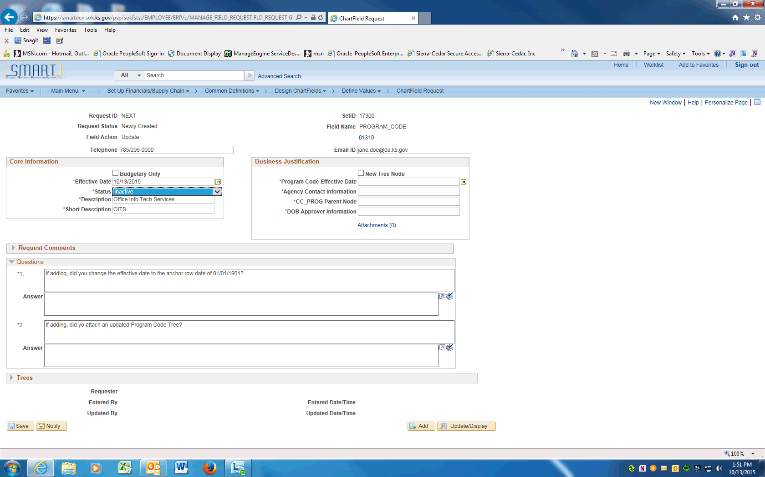

Step | Action
 | Use the Status look up and pick the requested Status.
 | Review/enter the Program Code long description into the Description field.
 | Review/enter the Program Code short description into the Short Description field.
For inactivations, skip this field.

For other updates, click the New Tree Node box if the value is a new Node on the PROG tree.
 | Enter actual effective date of the PROGRAM CODE into the Progam Code Effective Date field. This date should match the Effective Date value.
Enter the Agency contact name into the Agency Contact Information field.

If the contact name is different than the Requester include the contact's email and phone number.
For inactivations, skip this field.

For other updates, enter the Parent tree node the value will be assigned to on the PROG tree.
For inactivations, skip this field.

For other updates, enter the agency's personnel contact information into the DoB Contact Information field. Make sure to include name, email, and phone number.
 | The next Section contains Questions that must be answered prior to saving this request.
 | For Updates, enter N/A (not applicable)
 | For Updates, enter N/A (not applicable)
 | Only after all the questions are answered, the request can be saved. Click the Save button.
 | Click the dropdown arrow and choose the Submit for Approval item. Click the Go button. This will submit the Request into Approval workflow.
 | Click the View Approval Flow link to see the workflow.

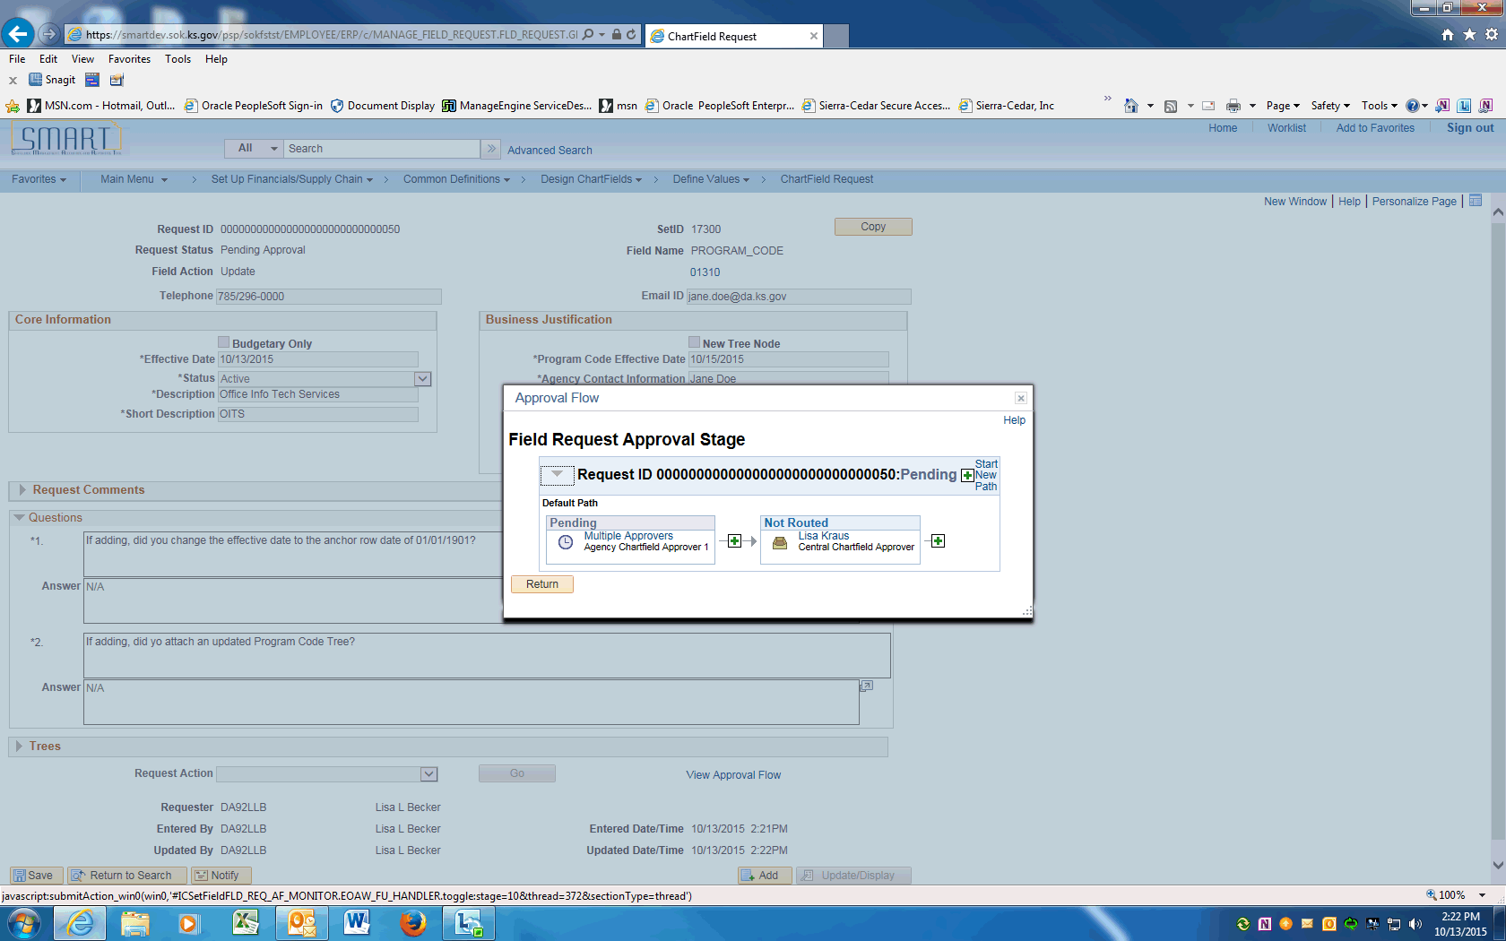

Step | Action
 | Approval Flow is displayed. The Request will need to be approved by the Agency Chartfield Approver and the Central Chartfield Approver. After approval, the ChartField will be available in SMART.
 | End of Procedure.

Approving ChartField Request via Worklist
This UPK will demonstrate how to Approve a ChartField Request using the Worklist.
Procedure

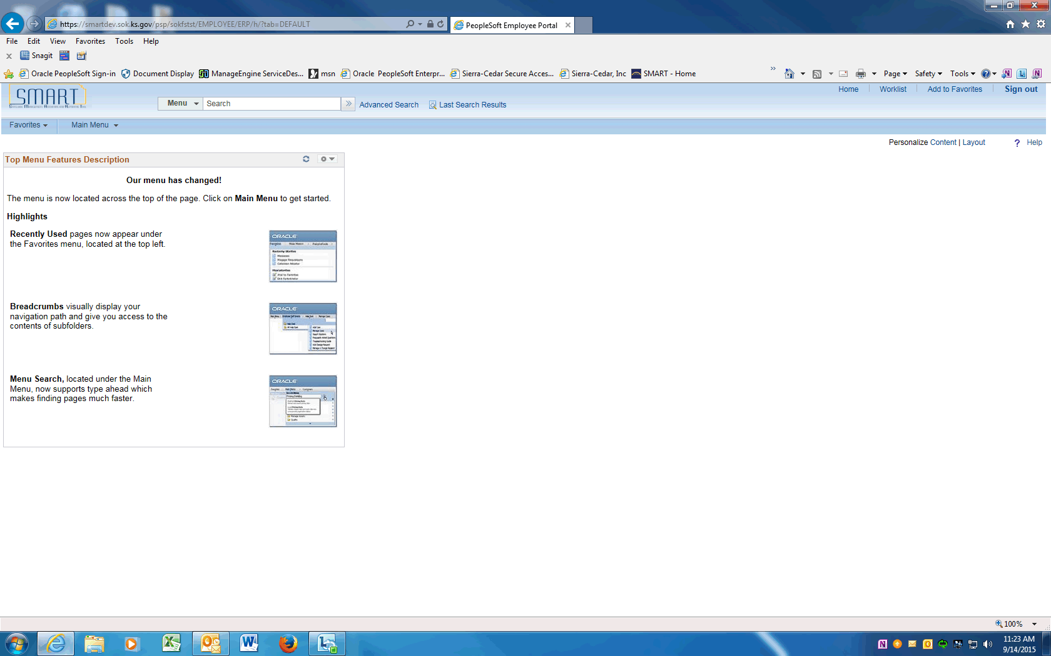

Step | Action
 | From the Home page, click the Worklist link.

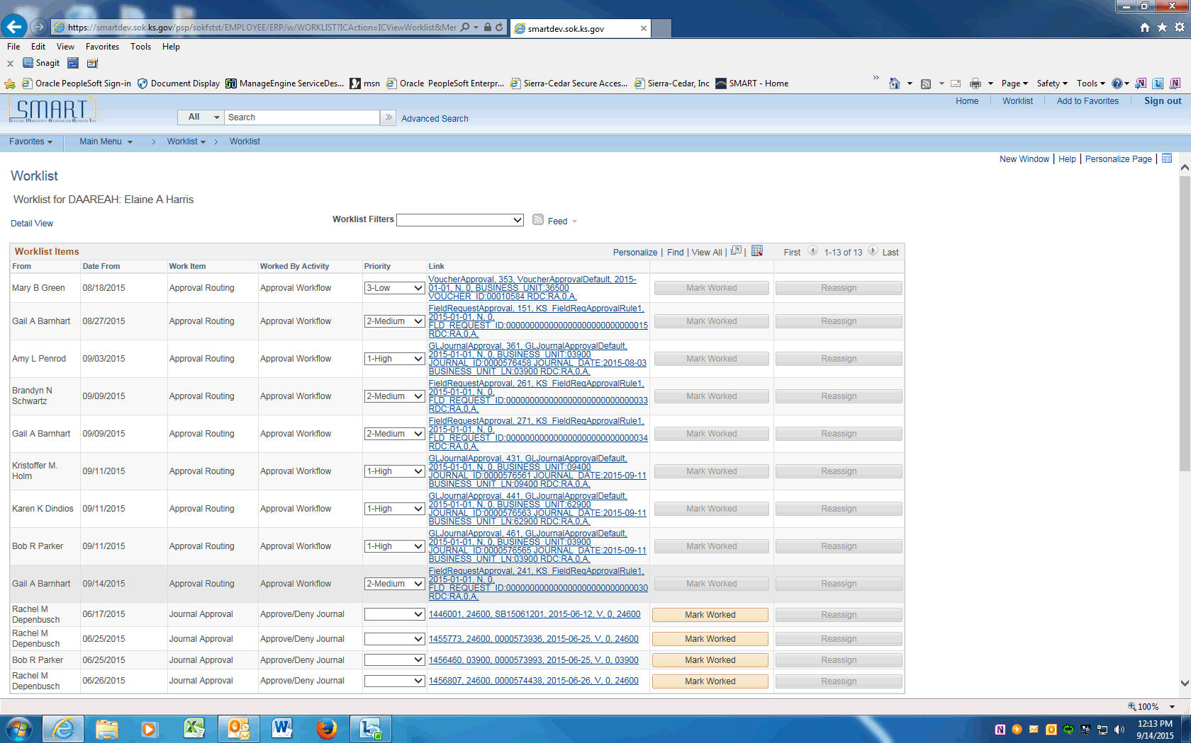

Step | Action
The WorkList Items will be displayed. Under the Link column, click the FieldRequestApproval link.
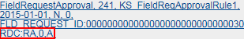

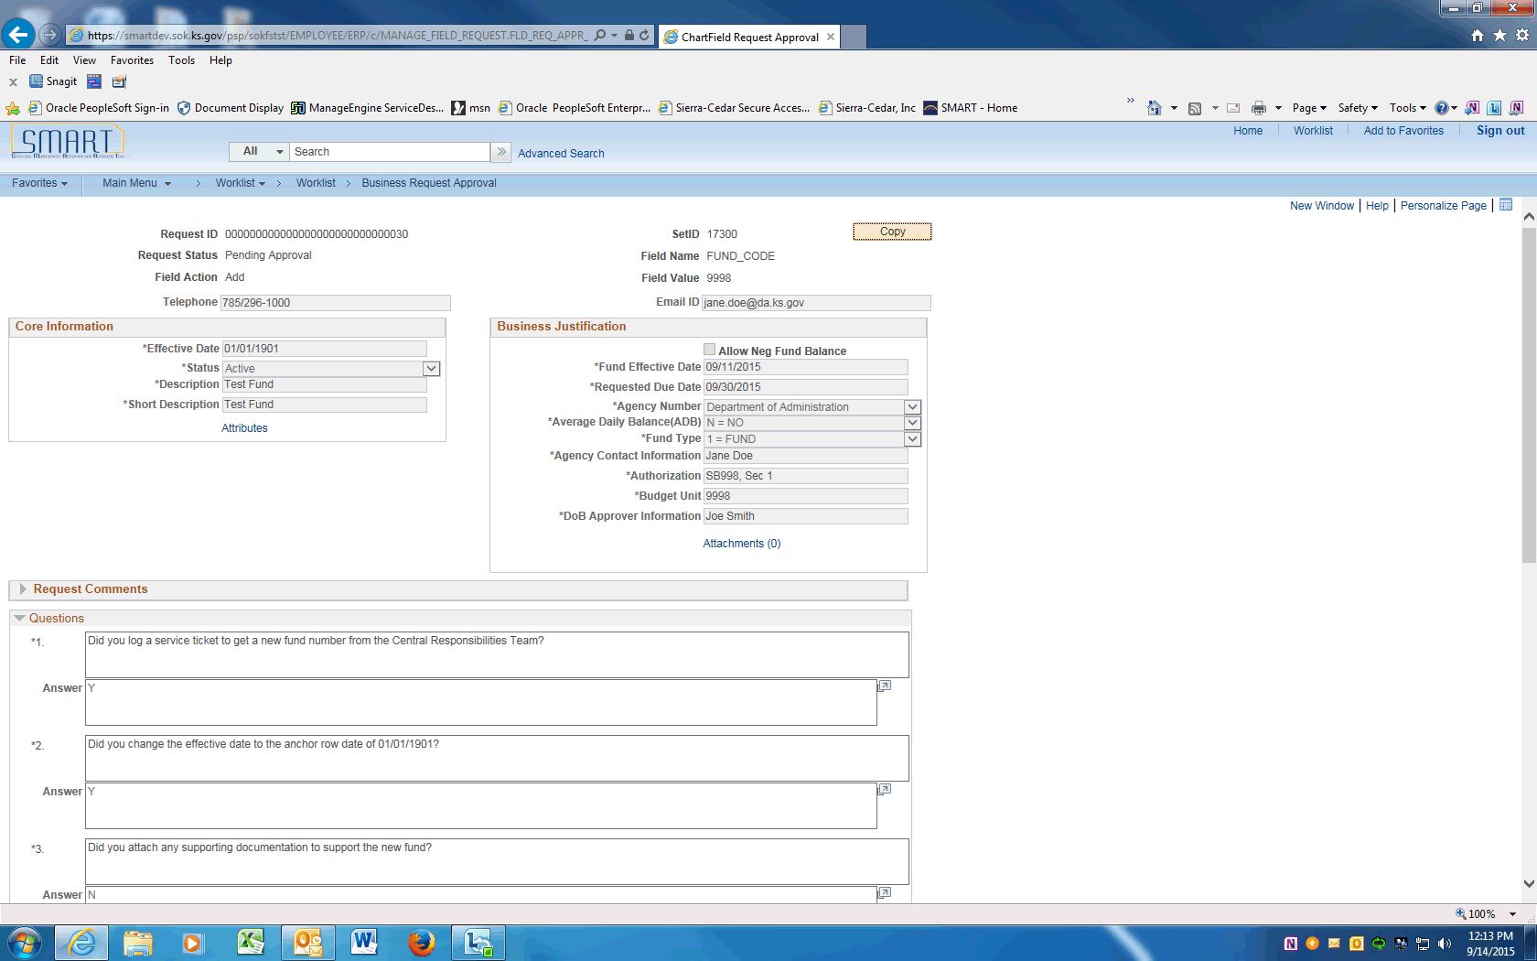

Step | Action
 | The Request Summary will be displayed with a status of Pending Approval.

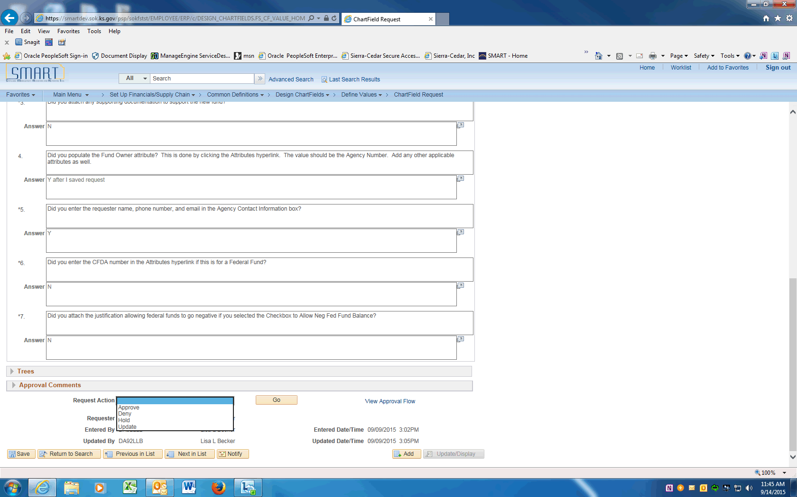

Step | Action
Review the Request. Scroll to the bottom of the page and choose the desired Request Action --

Approve will save the ChartField to the SMART ChartField table and the ChartField will be available for use.
Deny will allow requestor to Update or Cancel the request.
Hold request is put on hold seeking more information
Update request is modified and the page made editable

Click the Approve list item.

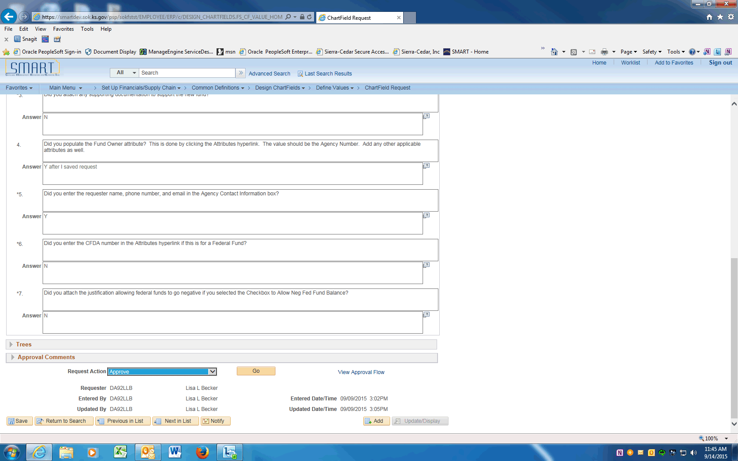

Step | Action
 | Click the Go button to process the request action.
 | Scroll to the bottom of the page. Click the View Approval Flow link.

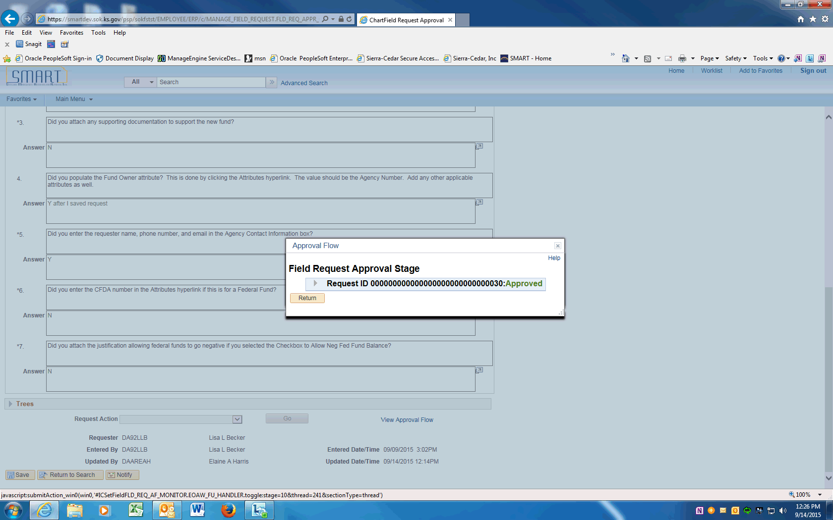

Step | Action
 | Click the Expand button.
 | The Approval Flow will show the final Approval.
 | End of Procedure.

Approving ChartField Request
This UPK will demonstrate how to approve ChartField Requests using the Request ChartField pages.
Procedure

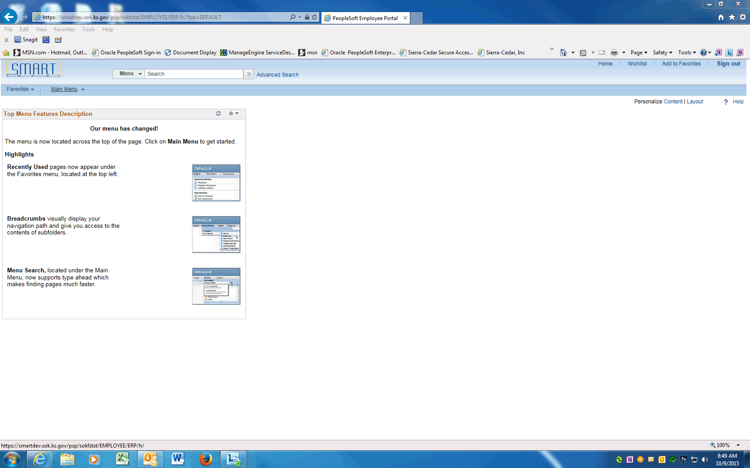

Step | Action
 | Start by clicking on the Main Menu

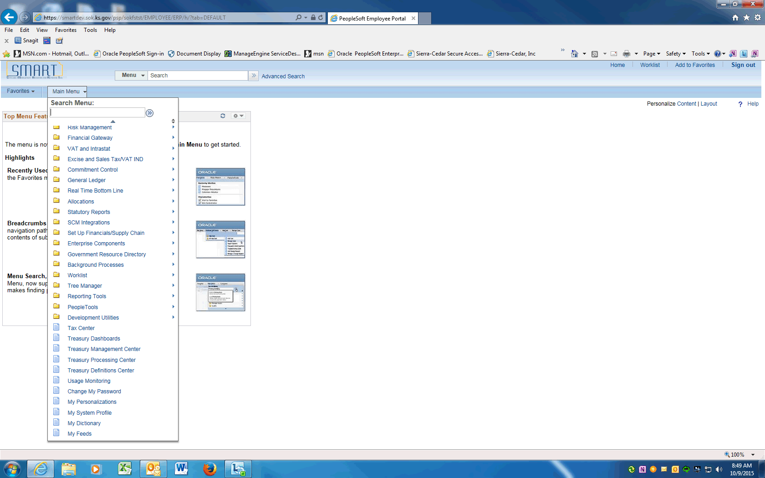

Step | Action
 | Scroll down and click on Set Up Financials/Supply Chain

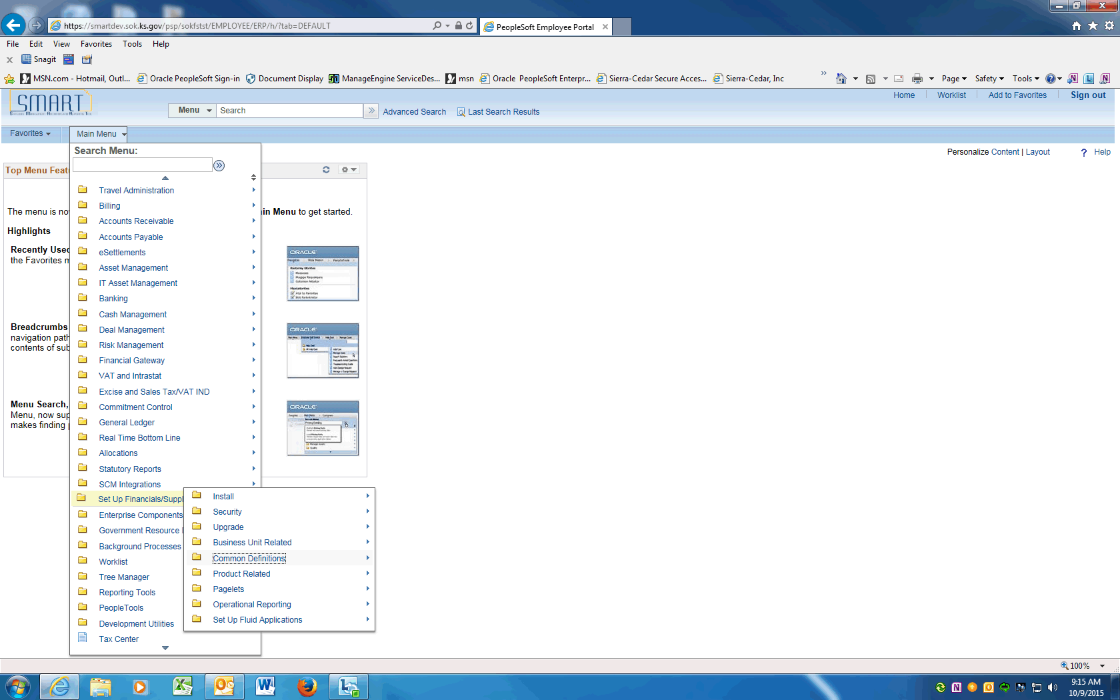

Step | Action
 | Click the Common Definitions menu.
 | Click the Design ChartFields menu.
 | Click the Define Values menu.

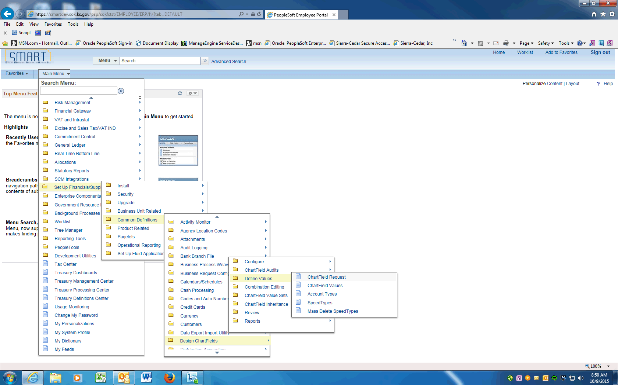

Step | Action
 | Click the ChartField Request menu.

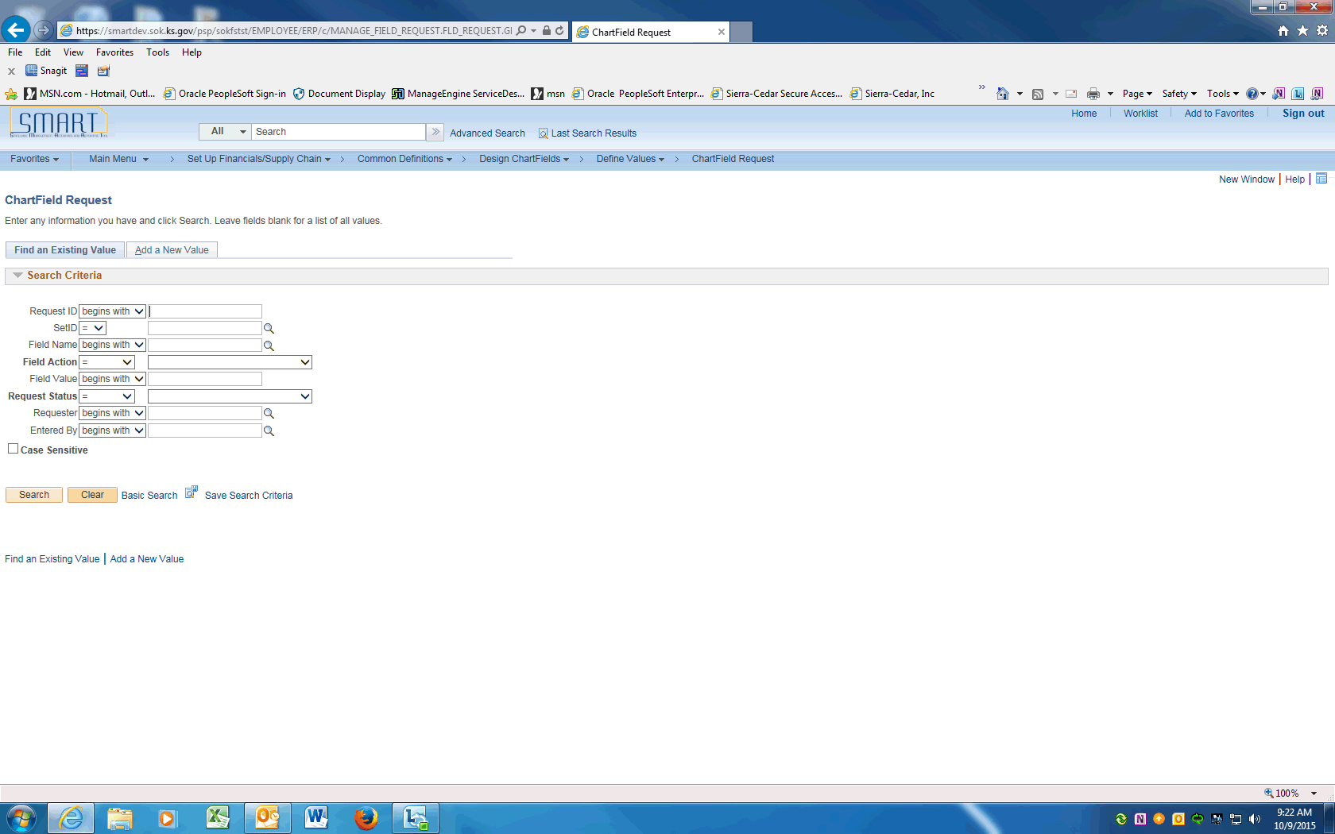

Step | Action
 | The ChartField Request page will be displayed. Click on the Find an Existing Value tab, click the Clear button to remove the Search Criteria.

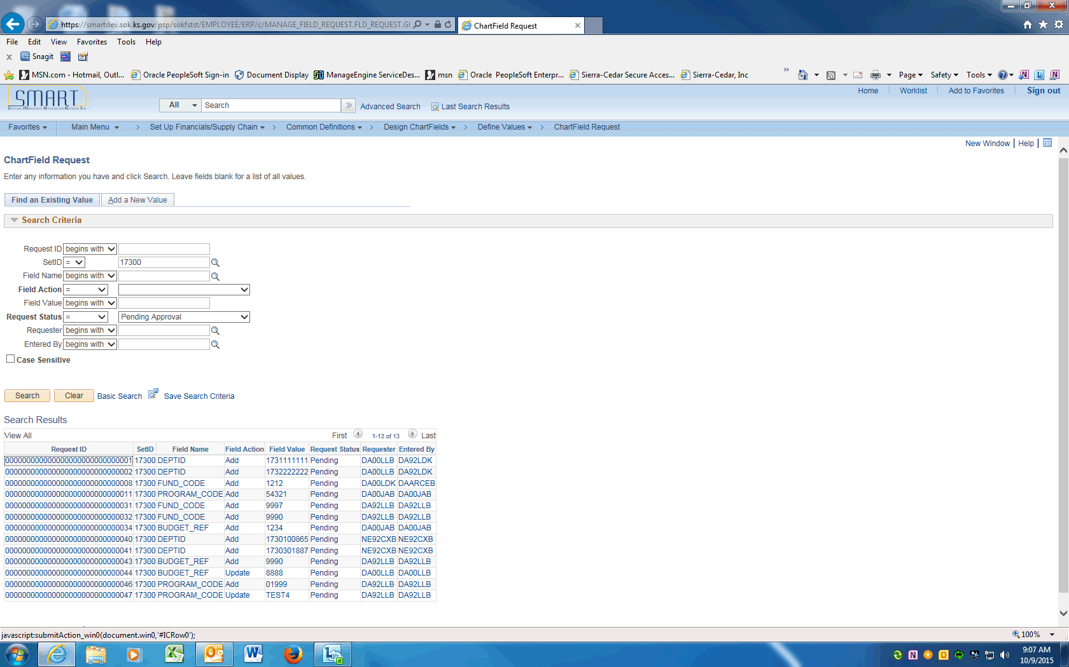

Step | Action
Enter your agency's SETID and choose Request Status = Pending Approval. Click on the Search button.

The Requests that are Pending Approval will be displayed.
 | Click on the first Request ID on the list.

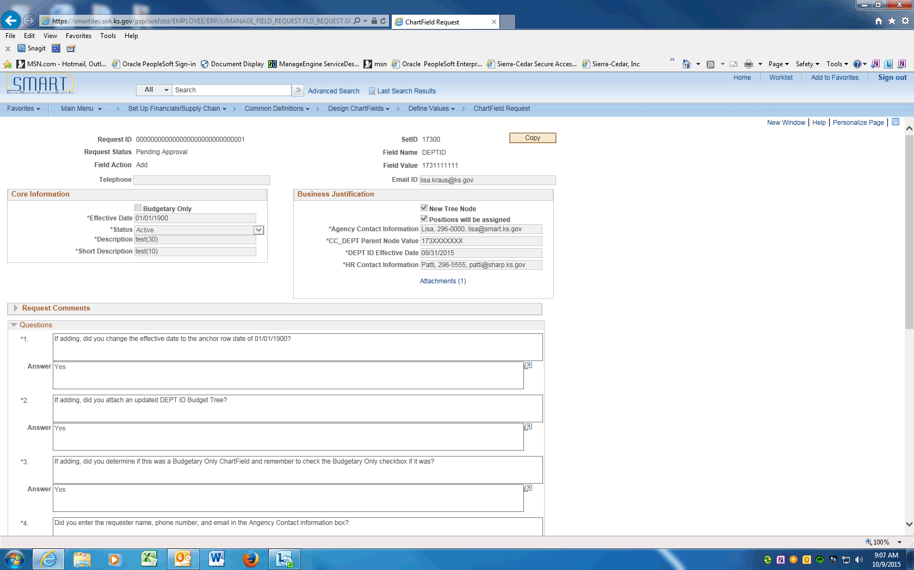

Step | Action
 | The ChartField Request will be displayed. The Request Status will show Pending Approval.

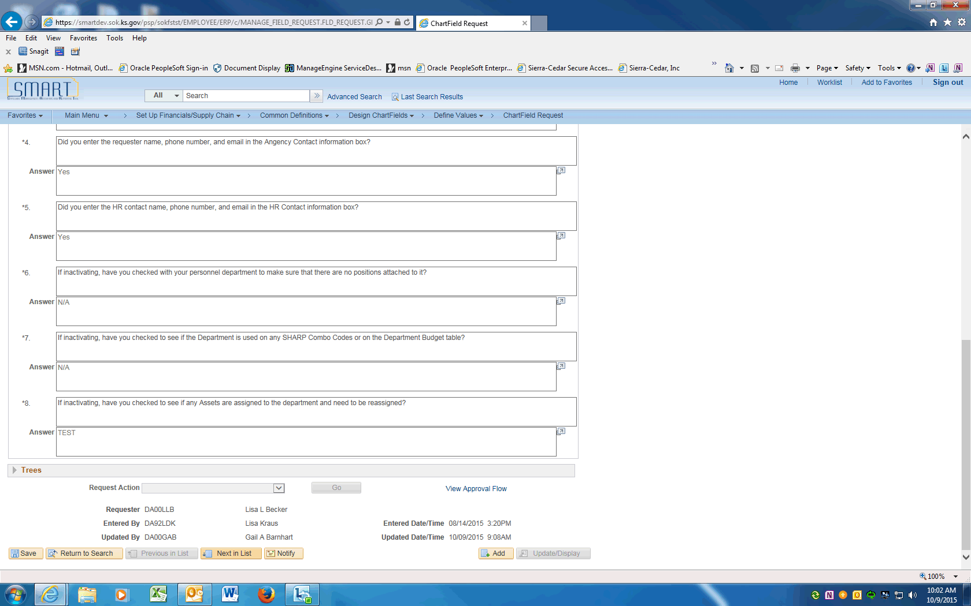

Step | Action
Scroll to the bottom of the ChartField Request.

If the Request Action is grayed out, you do not need to approve this request.

Click on the Next in List button to review the next request.

If the Request is available to approve, click on the look up for the Request Action.

Choose the desired Action --

Approve will save the ChartField to the SMART ChartField table and the ChartField will be available for use.
Deny will allow requestor to Update or Cancel the request.
Hold request is put on hold seeking more information
Update request is modified and the page made editable

Click the Approve list item.

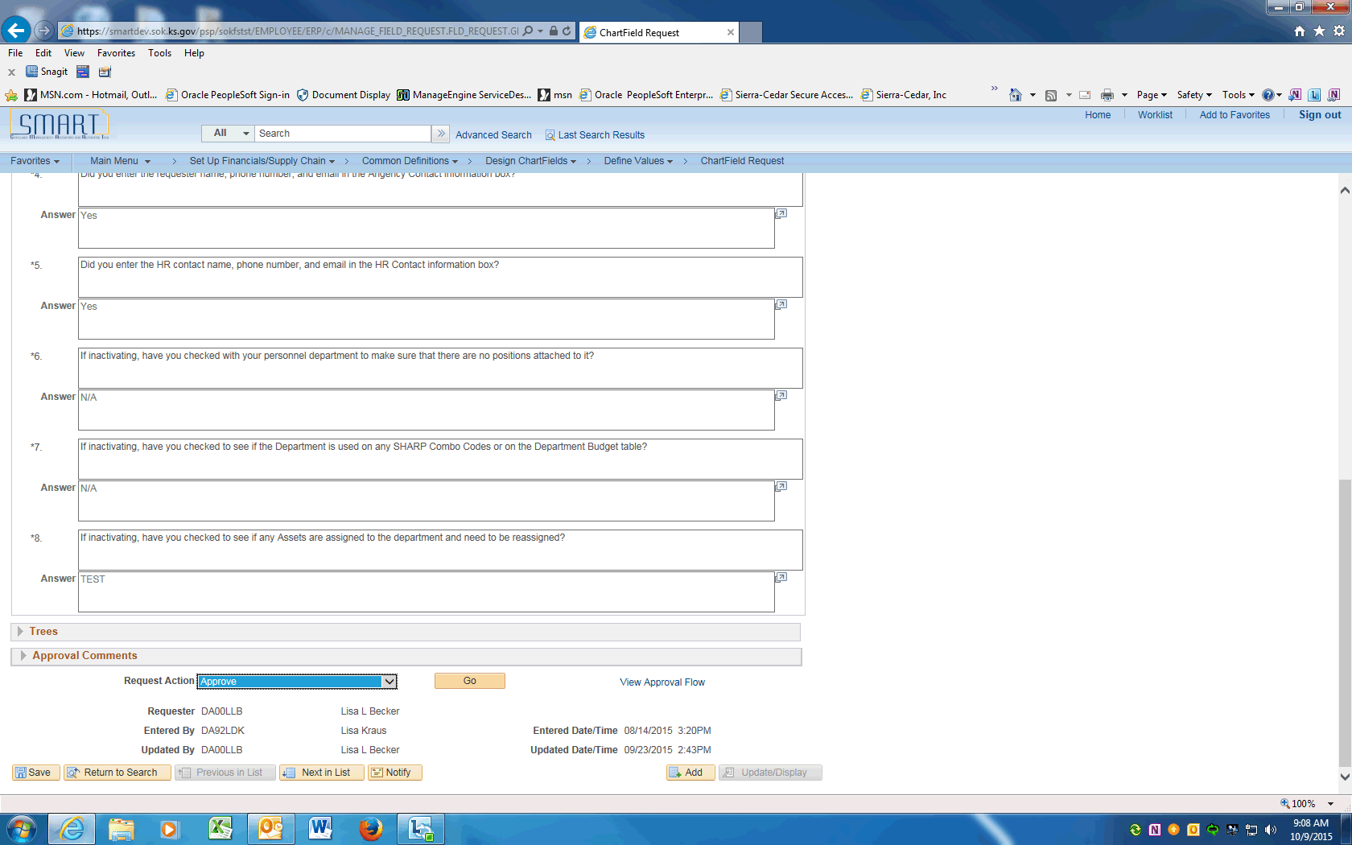

Step | Action
 | Click the Go button to process the Request Action.
 | After the Request Action is complete, click the View Approval Flow link to see the status of the Approvals.
The Agency ChartField Approver will show the Request Action taken.
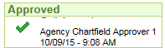
 | Click the Return button to go back to the ChartField Request.
 | End of Procedure.

