Table of Contents
GL - Workflow 1
Approvals using Manage Approvals 2
Approvals via WorkList 4
Assign Proxy (Alternate) Approver 8
Insert Ad Hoc Reviewers/Approvers 10

GL - Workflow
The Approval Framework (aka Approval Workflow Engine (AWE)) is used to automatically route transactions, as necessary, to users within the system. PeopleSoft delivers workflows in the following modules:
Accounts Payable;
eProcurement;
Expenses; and
General Ledger.
These workflows track approvals within the system which makes them easy to track and audit.

Workflow is used to push a transaction (ex. requisition, expense report) through an approval process. The actions available to an approver through AWE include approve, deny, hold and push pack.
Approve -- Transactions can be approved at the header level, line level, or a combination of the two. All required approvers must approve the transaction to make the status approved.
Deny -- A denied transaction sends the transaction back to the user who submitted it into workflow. For example, if a requisition is denied, it will be sent back to the requester.
Hold -- Putting a transaction on hold gives the approver time to gather additional information before making the choice to approve or deny and gives others visibility into why a transaction is taking longer than anticipated to flow through workflow.
Push back --The push back functionality allows the approver to send the transaction back to the prior approver for additional review. For example, if the approver learned of additional information that they believe the first approver was unaware of, they could send the transaction back.
Escalations can be set up within the workflow to remind users to approve a transaction or to notify other users that the transaction has not been approved.
Additionally, the transaction can be advanced to the next step or sent to a different approver if the transaction sits for too long. This functionality effectively eliminates bottlenecks by pushing transactions through the system in spite of user inaction.
Proxy approvals can be set up to receive the work item instead of the usual approver. This functionality is beneficial for users on vacation or a leave of absence. No change to the actual workflow setup is required to use proxies.
Ad hoc approvals allow the original submitter of the transaction or approvers to add additional approvers or reviews to the workflow. The ad hoc user is only added for that particular transaction. Similar to proxies, no change to the actual workflow setup is required.
Approvers will receive notification throughout the workflow.

Approvals using Manage Approvals
Procedure

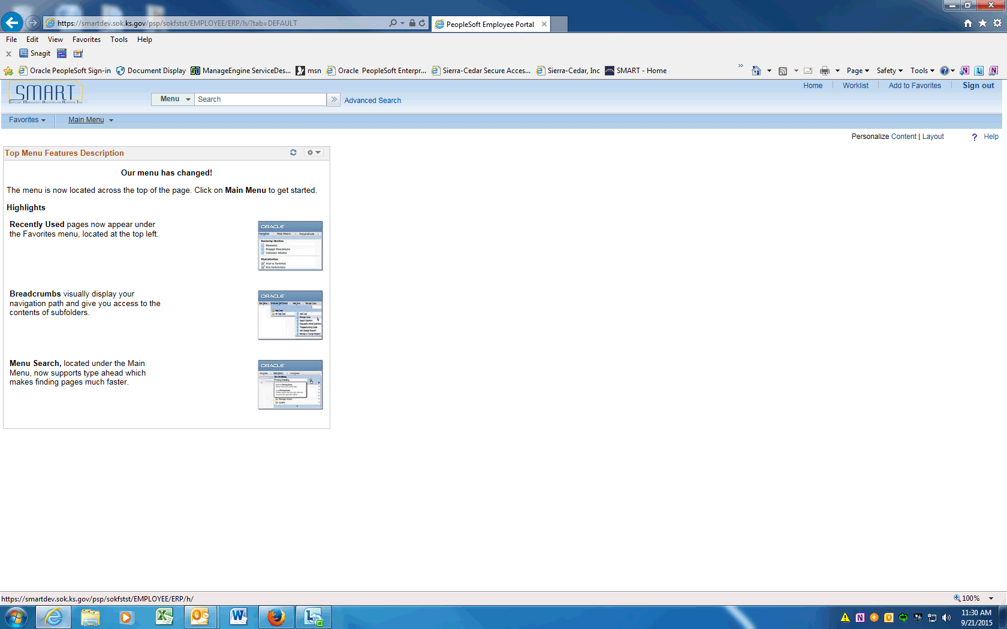

Step | Action
 | Click the Main Menu menu.
 | Scroll down and click the General Ledger menu.
 | Click the Journals menu.

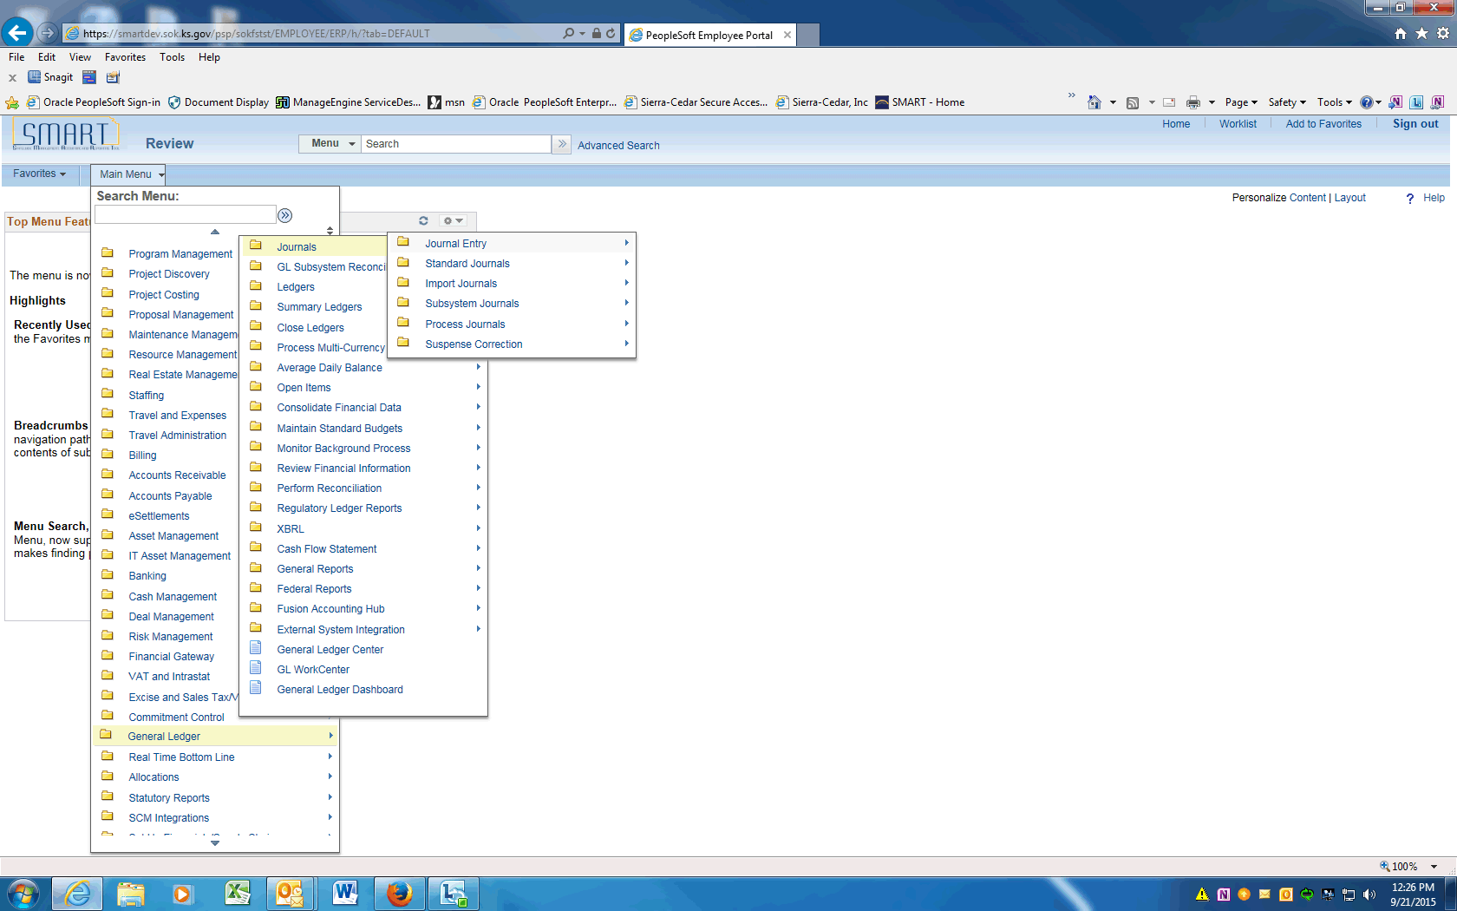

Step | Action
 | Click the Journal Entry menu.
 | Click the Manage Journal Approval menu.

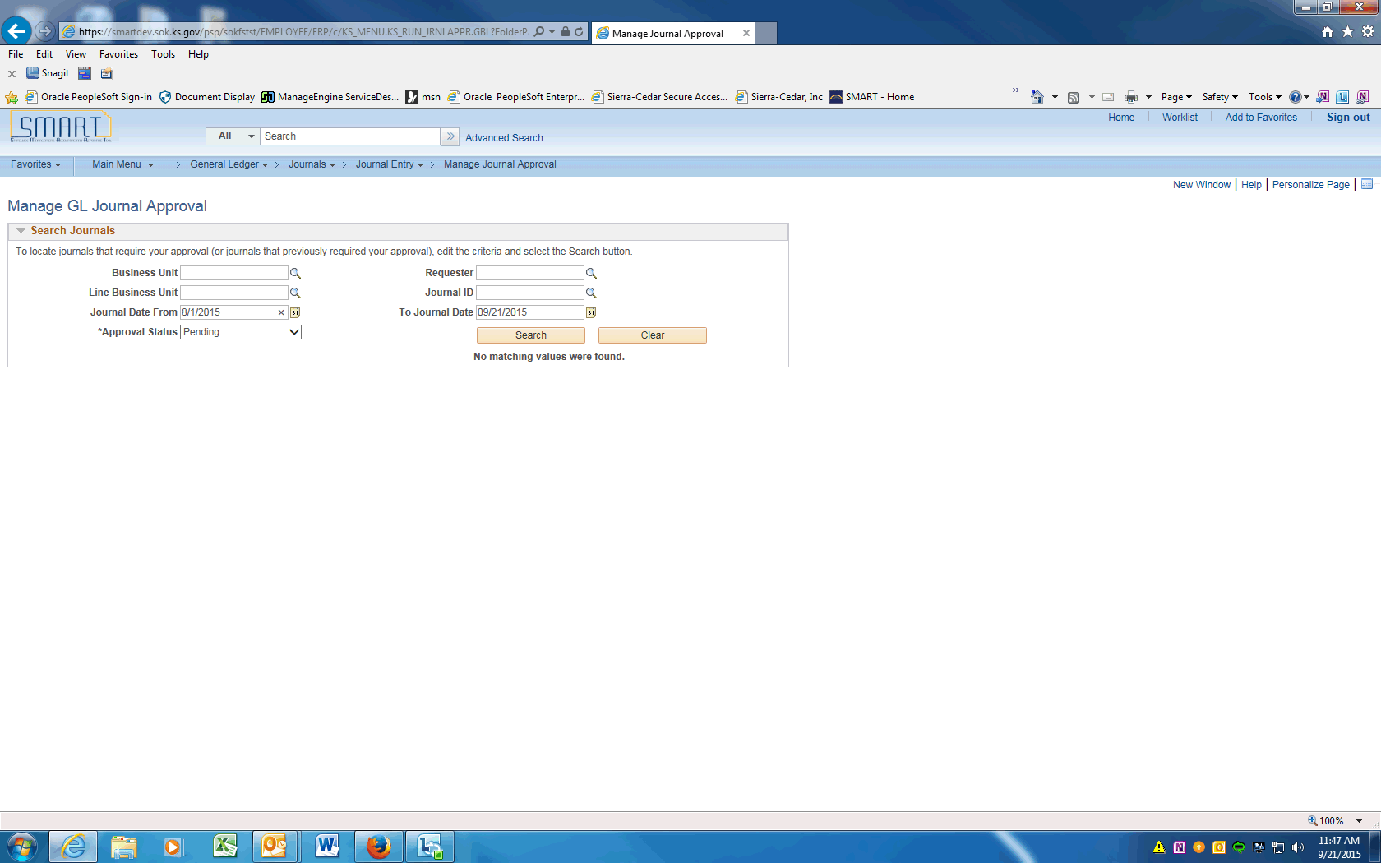

Step | Action
 | Enter Search criteria. Enter the desired information into the Journal Date From field. Enter "8/1/2015".
 | Add other Search Criteria to further define the Search i.e. Journal ID, Approval Status, Requester. When all the Search data has been entered, click the Search button.
 | The Journals pending approval will be displayed. Click on a Journal ID.
 | The GL Approvals Workflow path will be displayed. Click the Retrun to Manage Approvals link.
 | Click the Select box next to the Journal that needs approval.
 | Click the Approve button.
 | End of Procedure.

Approvals via WorkList
Procedure

Step | Action
 | Click the Main Menu menu.
 | From the Main Menu screen, click the Worklist link.

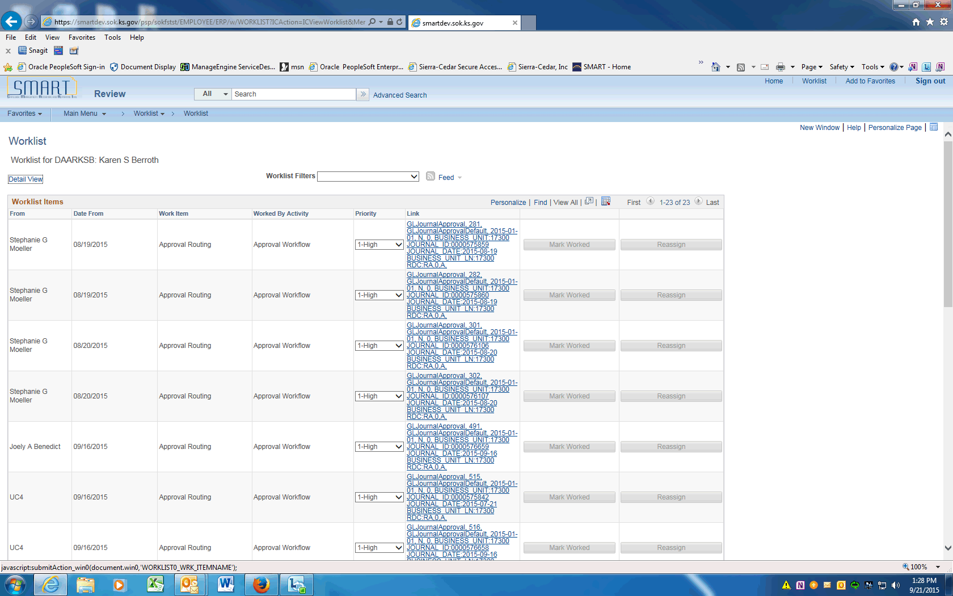

Step | Action
The Worklist items that need approval are listed. Choose the Journal ID you want to approve.
Click the Link object.
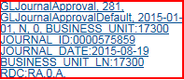

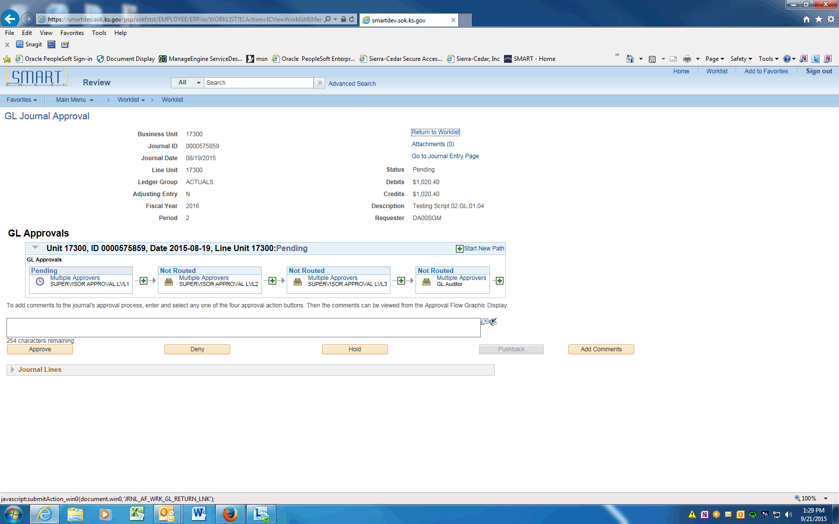

Step | Action
 | The GL Journal Approval screen will be displayed. To review the GL Journal click the Go to Journal Entry Page link.

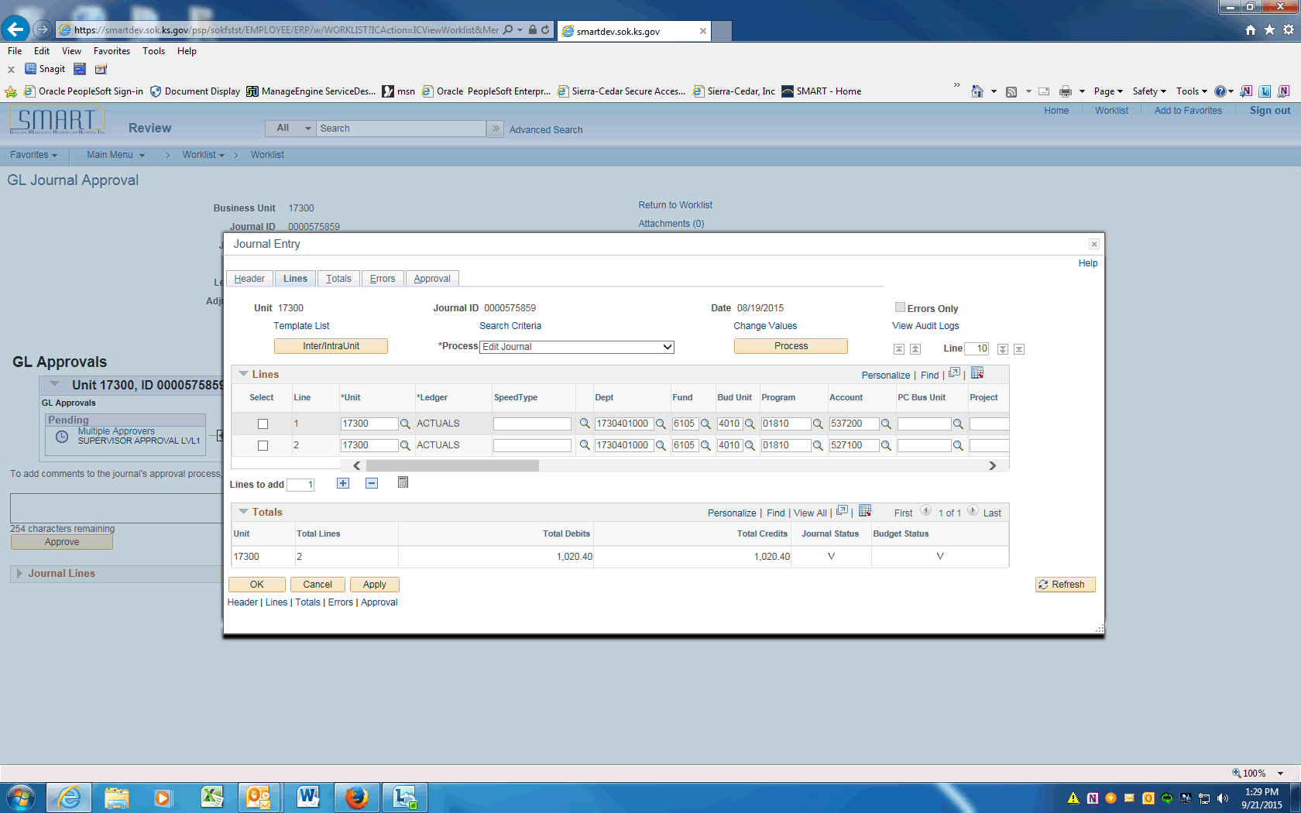
Step | Action
 | Review the Lines page of the Journal, then click the Header tab.

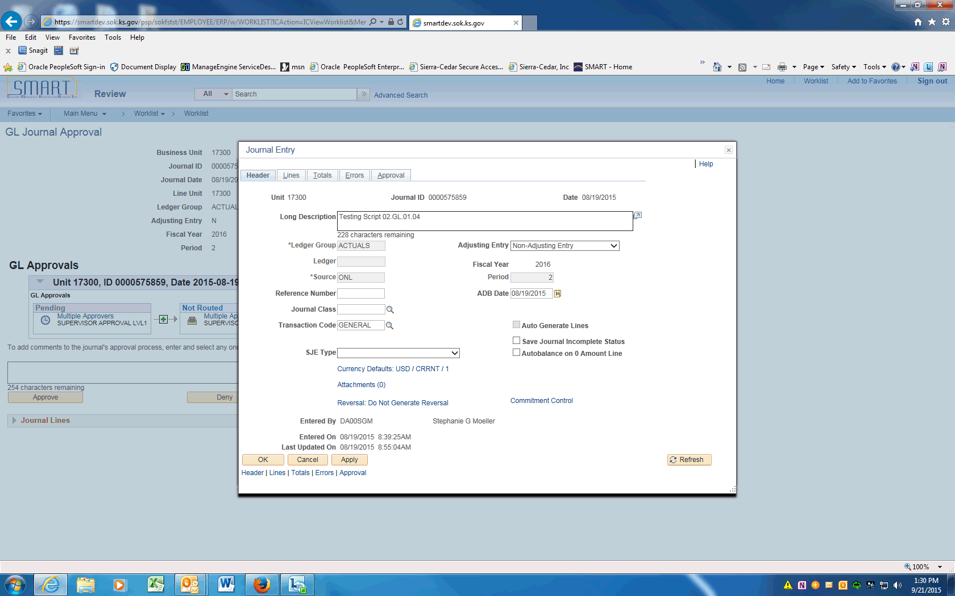

Step | Action
 | On the Header tab check the Long Description. To return the Approval Page click the close button.
 | The Lines can also be viewed by expanding the arrow next to the Journal Lines button.
 | The Journal lines are displayed
 | Click a button to Approve, Deny, Hold, or Pushback the journal. Click the Approve button.

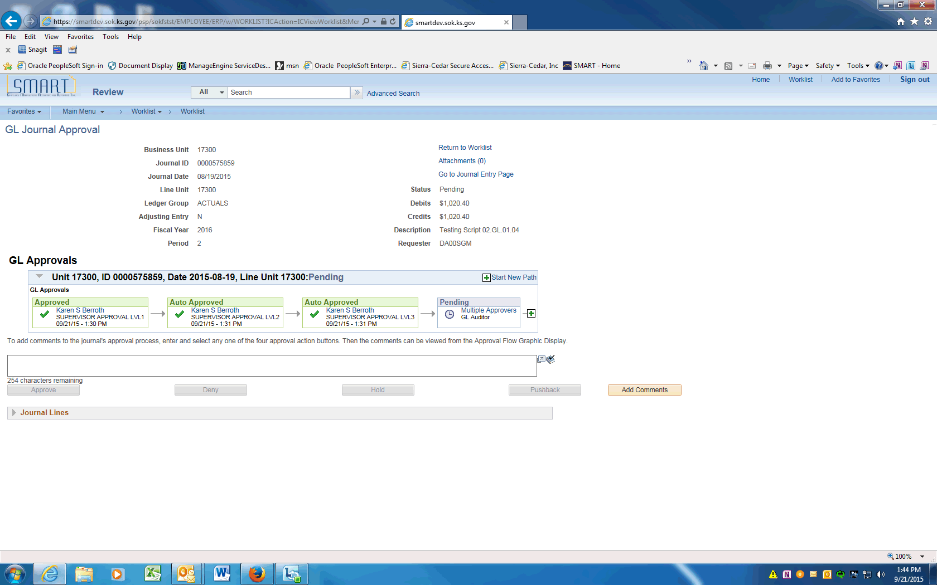

Step | Action
 | The Approval Flow will be updated with the Approver's name. In this example the Approver was the Level 1, Level 2 and Level 3 Approver. The GL Auditor Approval is still Pending.
 | End of Procedure.

Assign Proxy (Alternate) Approver
Procedure

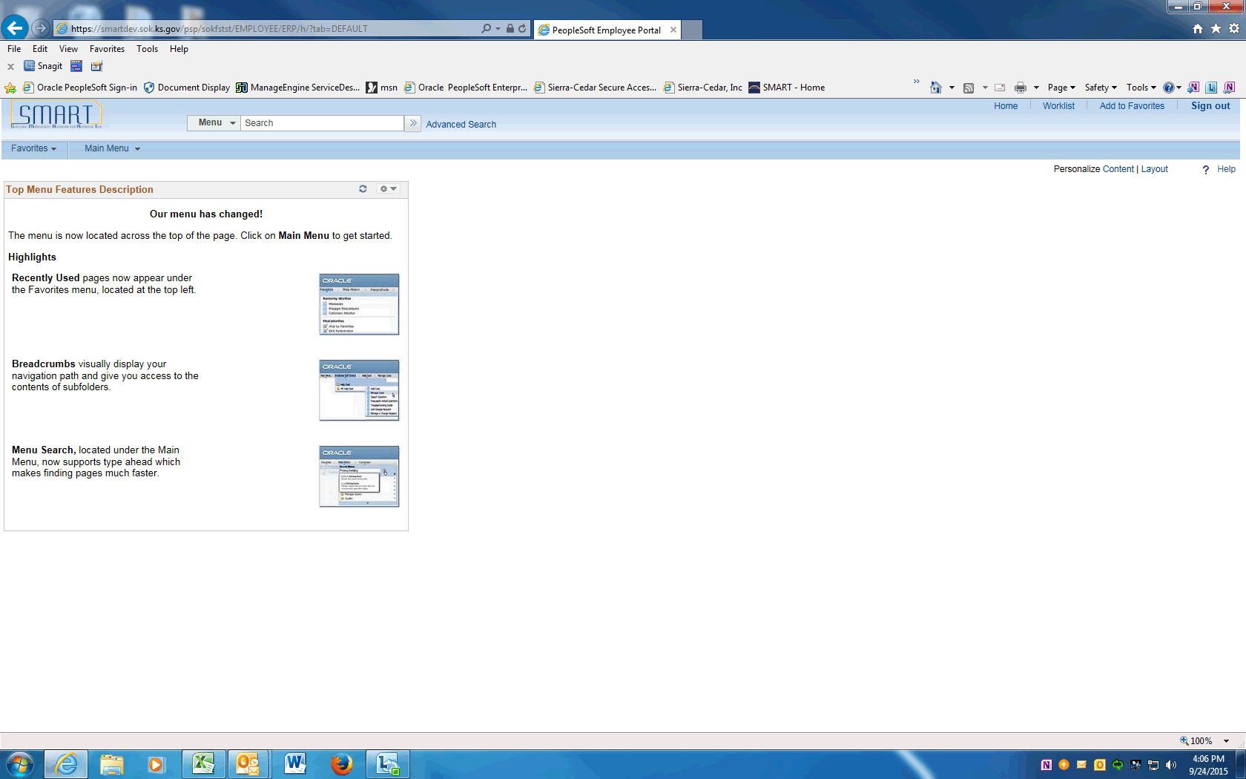

Step | Action
 | On the Home screen, Click the Main Menu.
 | Scroll down to the bottom of the list and click the My System Profile menu.

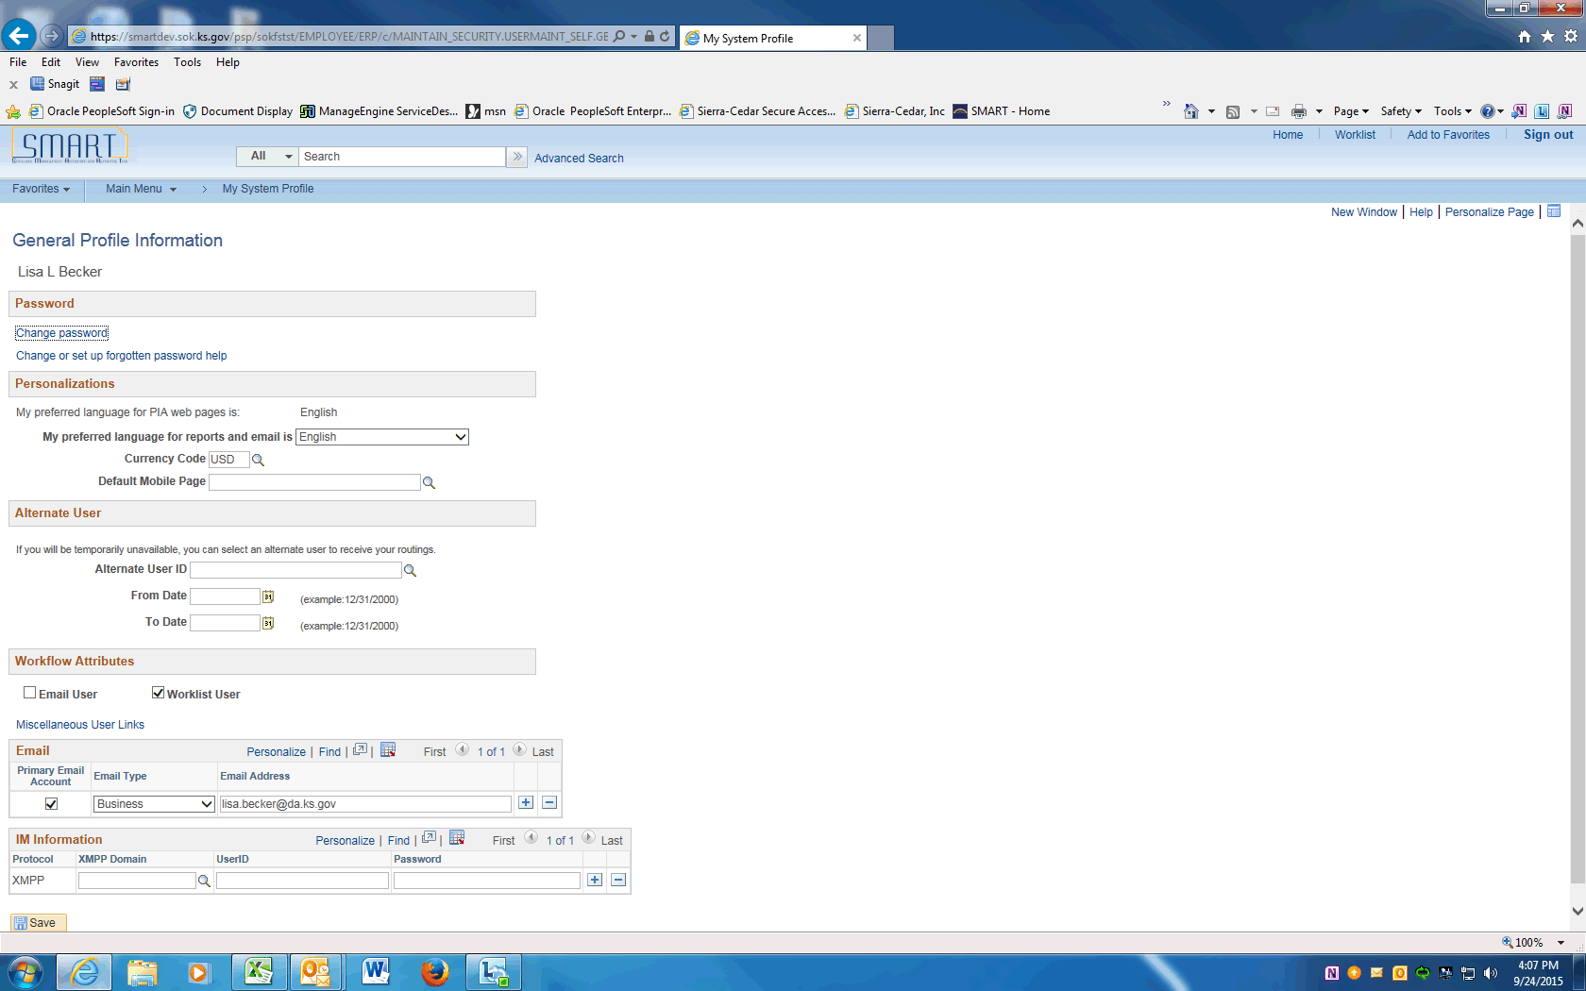

Step | Action
 | Enter the User ID for the person who will approve transactions in your absence into the Alternate User ID field. Enter "DA00LLB".
 | Enter the begin date of the approver's absence into the From Date field. Enter "9/24/2015".
 | Enter the last date the substitute approver will review transactions into the To Date field. Enter "9/25/2015".
Click the Save button at the bottom of the page.

The alternate approver is now set up for the time period chosen.
 | End of Procedure.

Insert Ad Hoc Reviewers/Approvers
Procedure
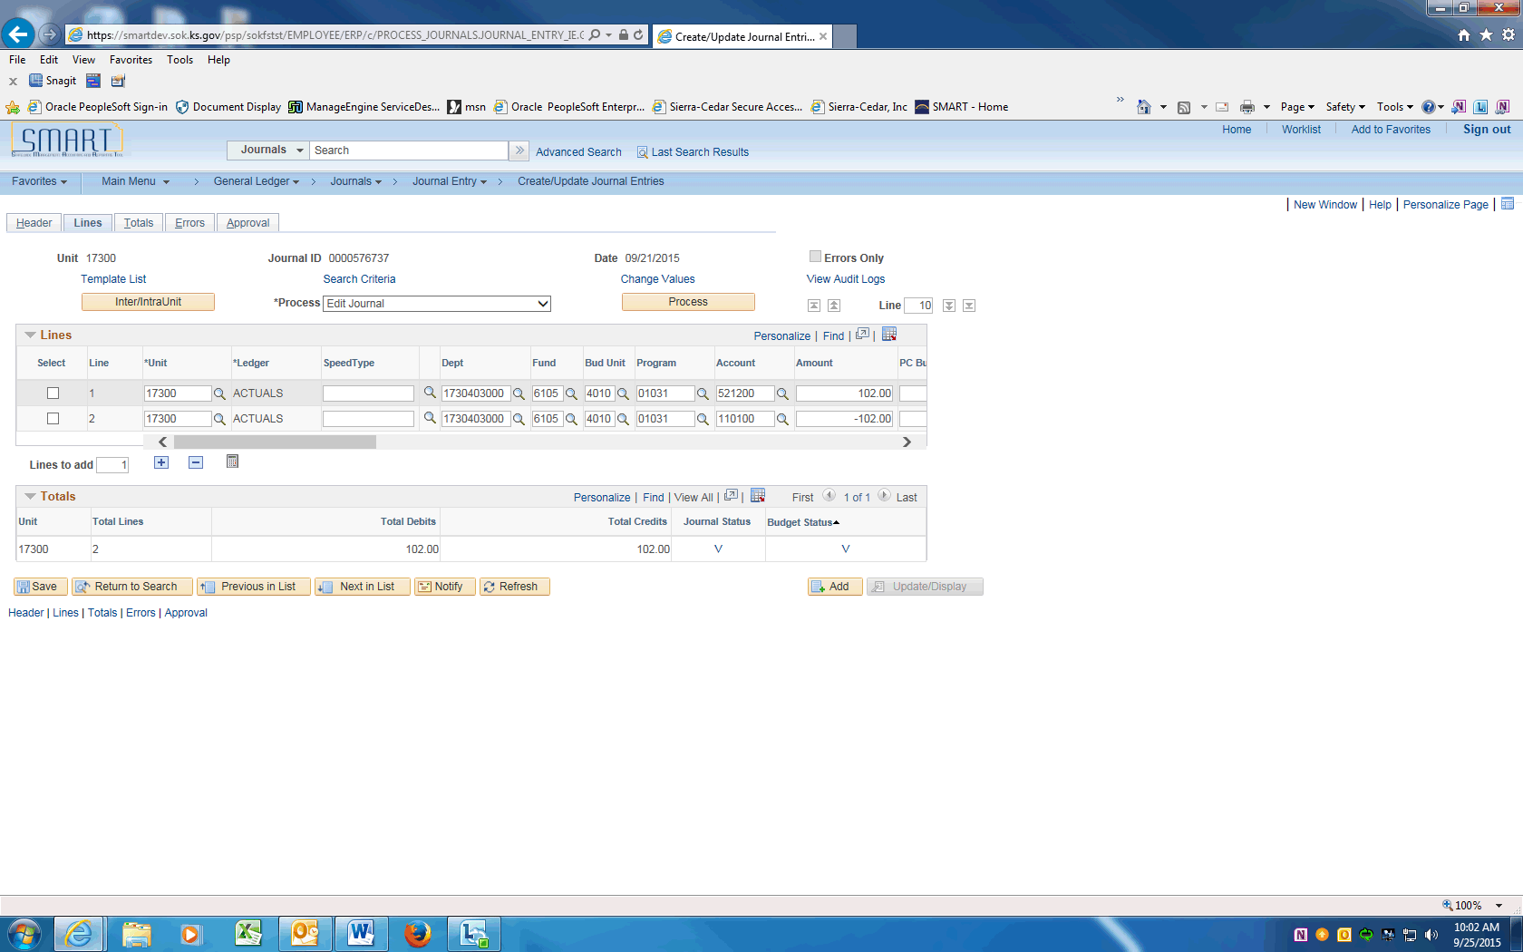

Step | Action
 | Enter a Journal Entry in SMART. After the Journal has successfully Edited and Budget Checked, click Approval tab.

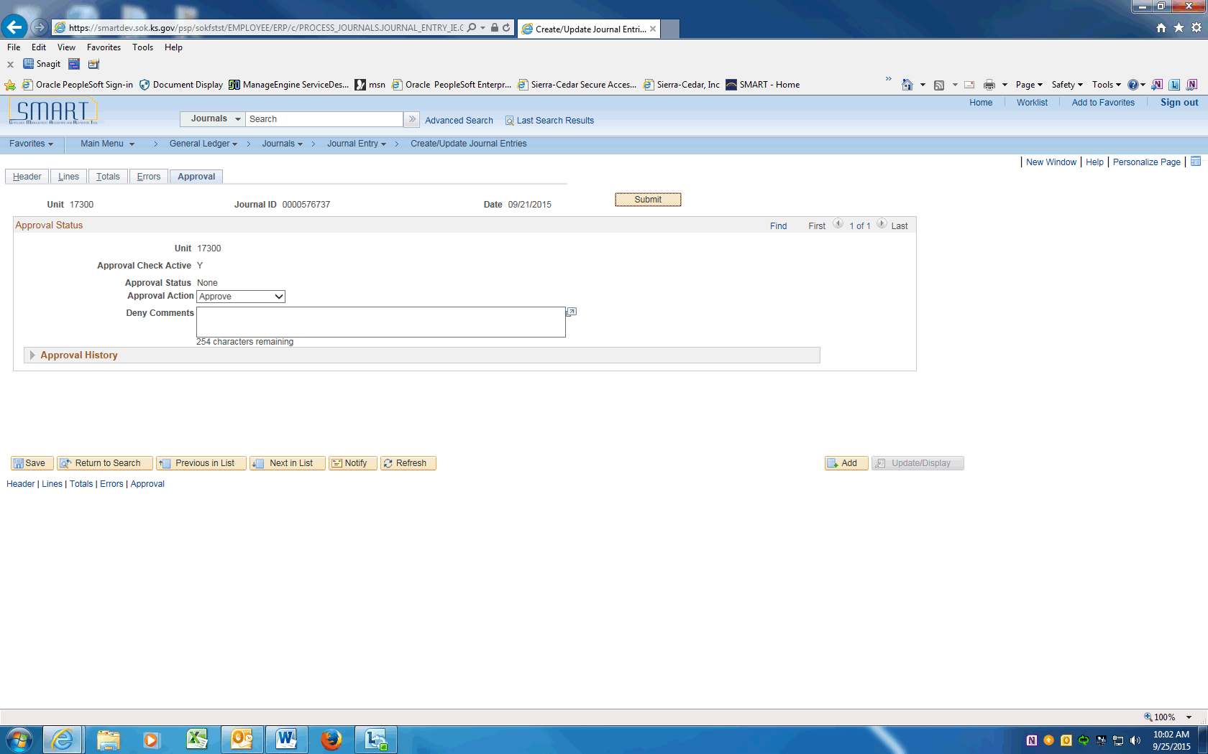

Step | Action
 | The Journal Processor clicks the Submit button to send journal into workflow.

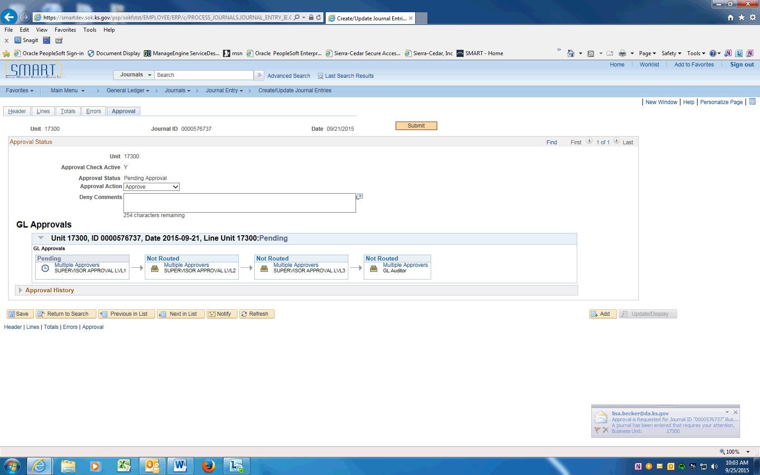

Step | Action
 | The GL Approvals Workflow will be displayed.
 | The Journal Approver will navigate to their worklist to find the Journal(s) that need Approval.

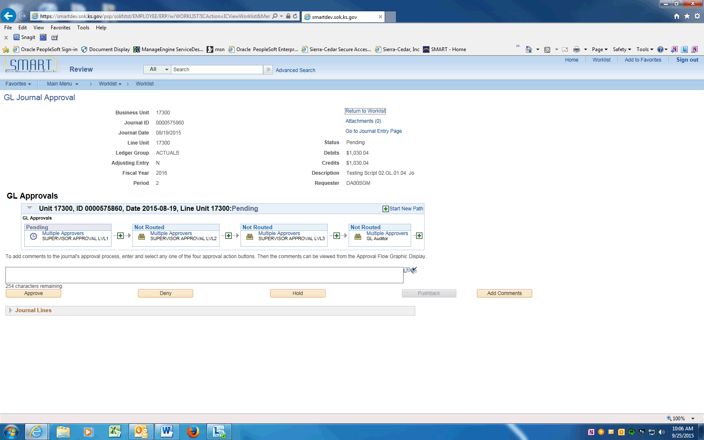

Step | Action
 | The Approver has determined that an additional user needs to Review or Approve the Journal. The Approver clicks the Insert Approver button.
 | The Insert additional approver or reviewer page is displayed. Enter the User ID or click the look up to Search for user.
 | On the Approver/Reviewer Search page find the user by name or User ID. Click Search.
 | On the Insert page, choose if the User will Approve or Review the Journal. Click the Insert button.
 | The Reviewer has been added to the Workflow. The Level 1 Approver clicks the Approve button.

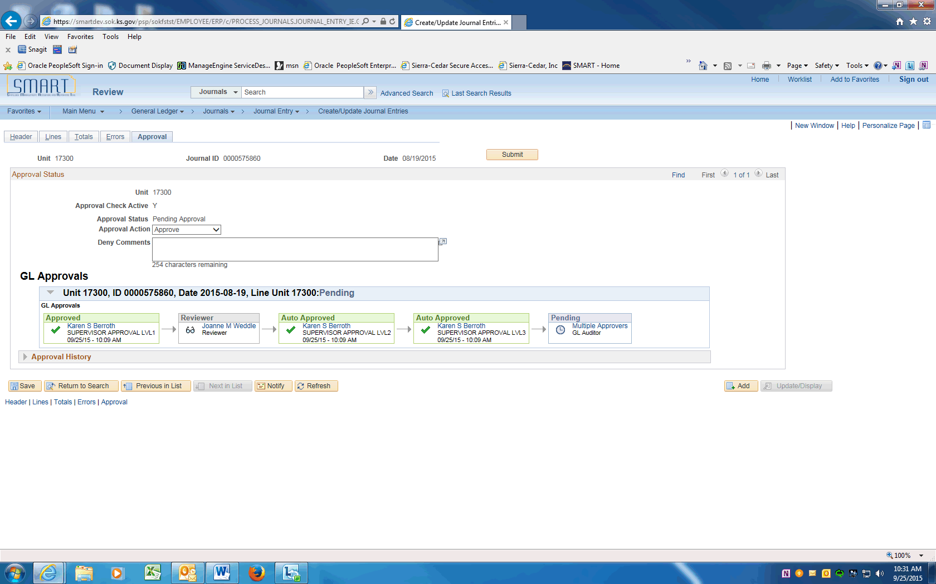

Step | Action
 | The Level 1, 2, and 3 Approval has been done (the user has all levels of agency approver) and the Journal has been routed to the Reviewer and to the GL Auditor. Click the Save button.

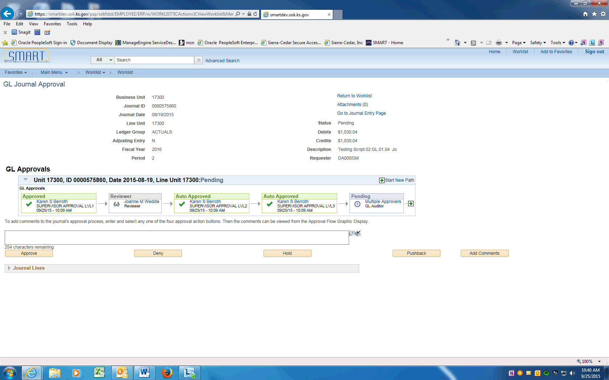

Step | Action
 | The GL Auditor wants to add another approver. Click the + button.
 | Enter the User ID and click the Approver button on the Insert additional approver or reviewer page. Click the Insert button.

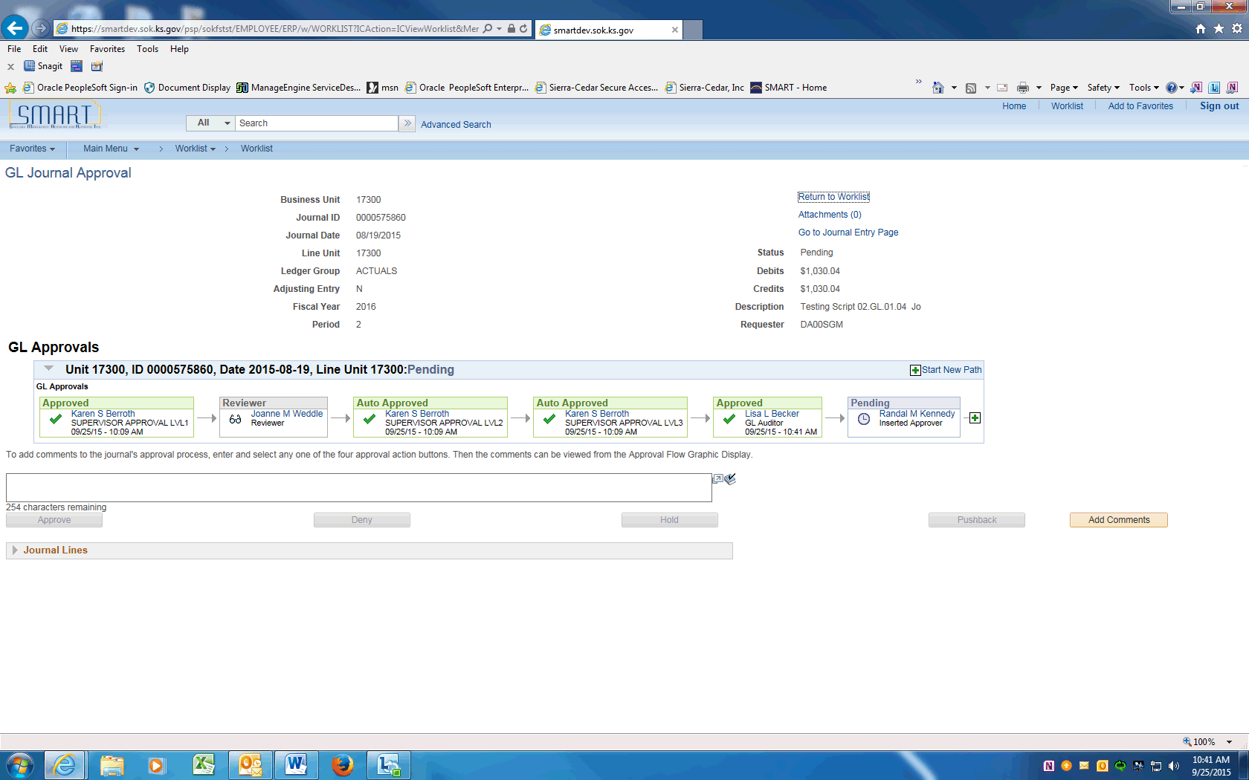

Step | Action
 | The GL Auditor approves the Journal. Click the Approve button. Note that the Journal Approval is still Pending.

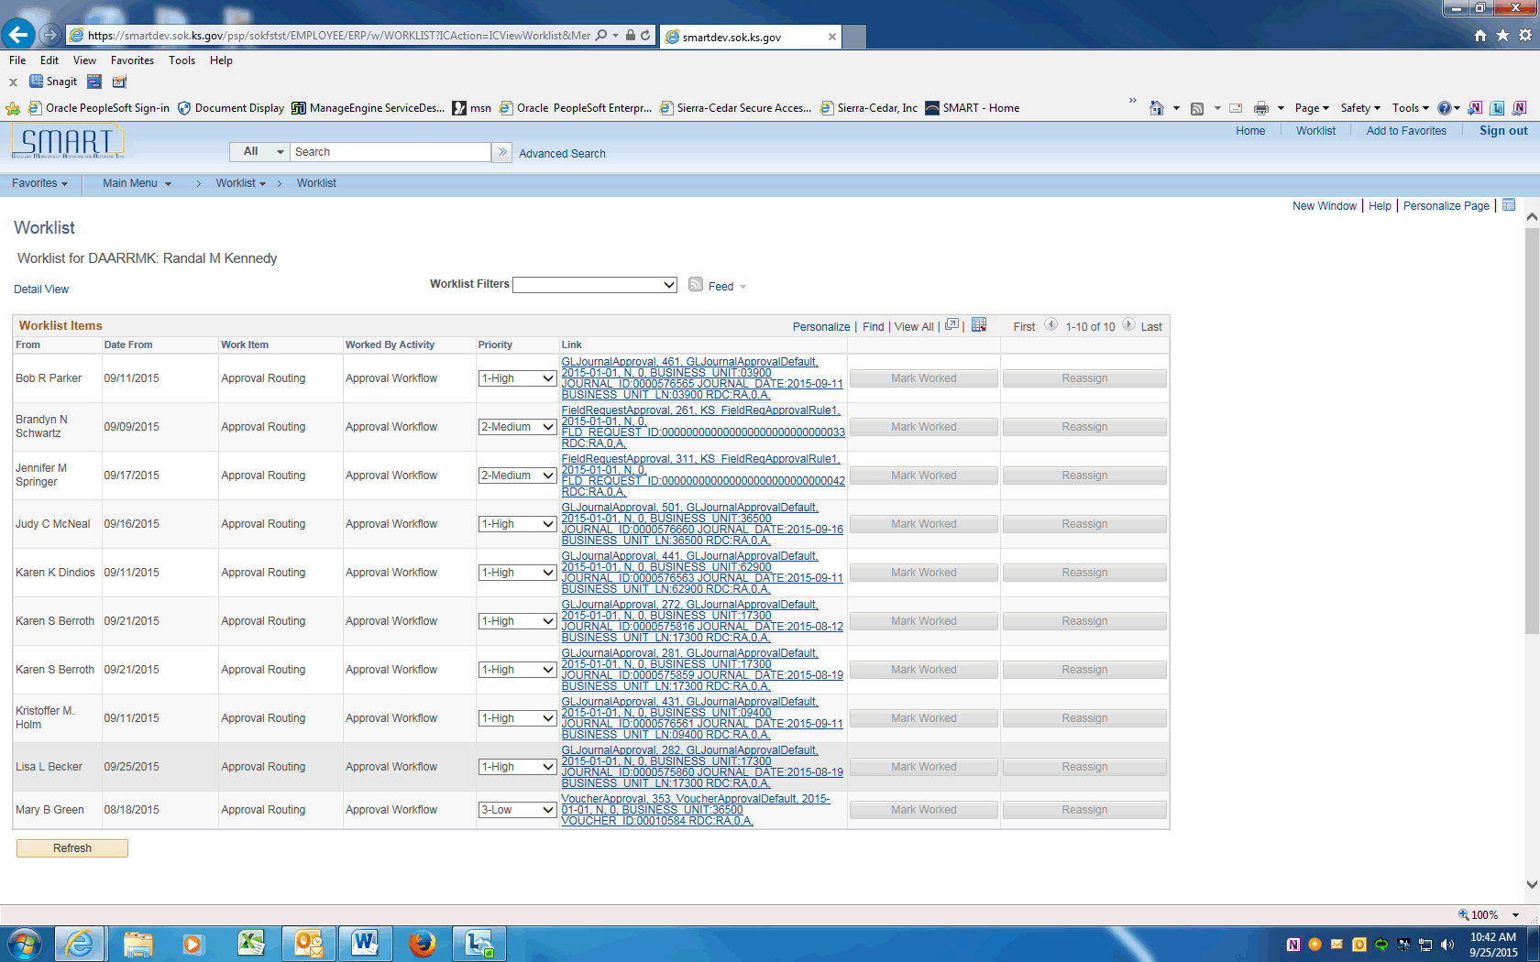

Step | Action
Click the + button before the GL Journal Approval Return to Worklist Business Unit 1730 tree item.
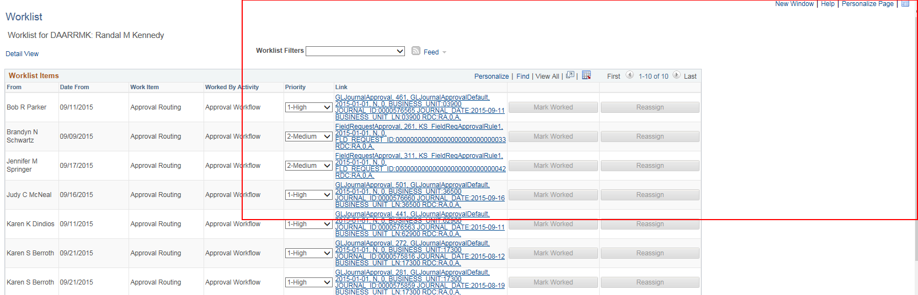
 | The Inserted Approver approves the Journal. Click the Approve button.
 | The journal is now Approved.
 | End of Procedure.

