**State of Kansas**



**High-Level Changes from 9.0 to 9.2 in Asset Management:**

**Printable View of an Asset**

***Statewide Management, Accounting and Reporting Tool***

|  |  |
| --- | --- |
| **Date Created:** | 10/28/2015 |
| **Version:** | 1.0 |
| **Last Updated Date:** |  |
| **Purpose:** | *This document highlights one of the changes between 9.0 and 9.2 in the Asset Management module.* |
| **Security:** | * Role Security: The following roles are applicable:   Agency Asset Processor  KS Assets Viewer  BU Security: Business Unit Security is applied. Agencies will only have access to the assets in their Business Unit. |

Procedure

The Print an Asset page is enhanced in 9.2 to include additional asset information fields, like Asset Type and Asset Subtype. This page provides a concise way to view asset data. A PDF can also be generated and then saved/printed.

*Please keep in mind it is not recommended to print asset information, as all asset details are readily available to view online in SMART.

| **Step** | **Action** |
| --- | --- |
|  | Click the Main Menu. |
|  | Click the **Asset Management** menu. |

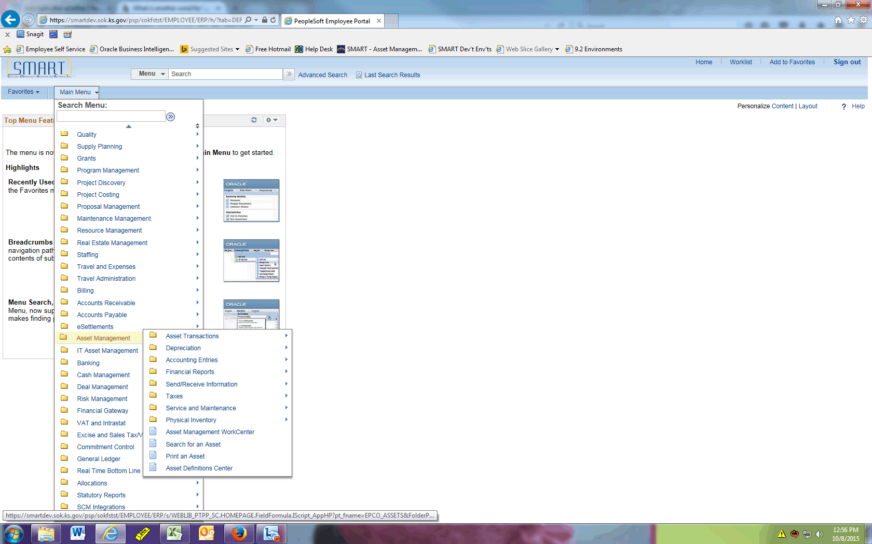

| **Step** | **Action** |
| --- | --- |
|  | Click the **Print an Asset** menu. |
|  | Click the **Search** button. |
|  | Select the asset you wish to open. |

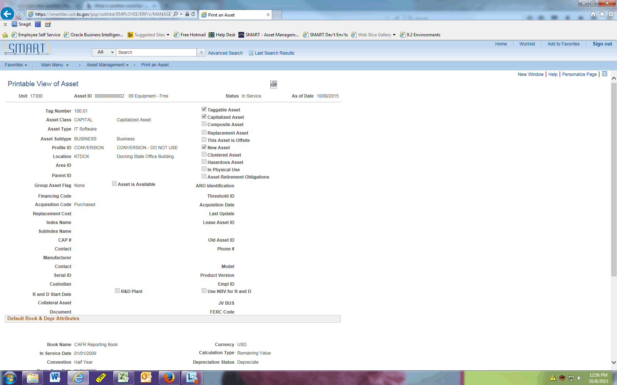

| **Step** | **Action** |
| --- | --- |
|  | The Printable View of Asset page displays physical attributes at the top of the page. |

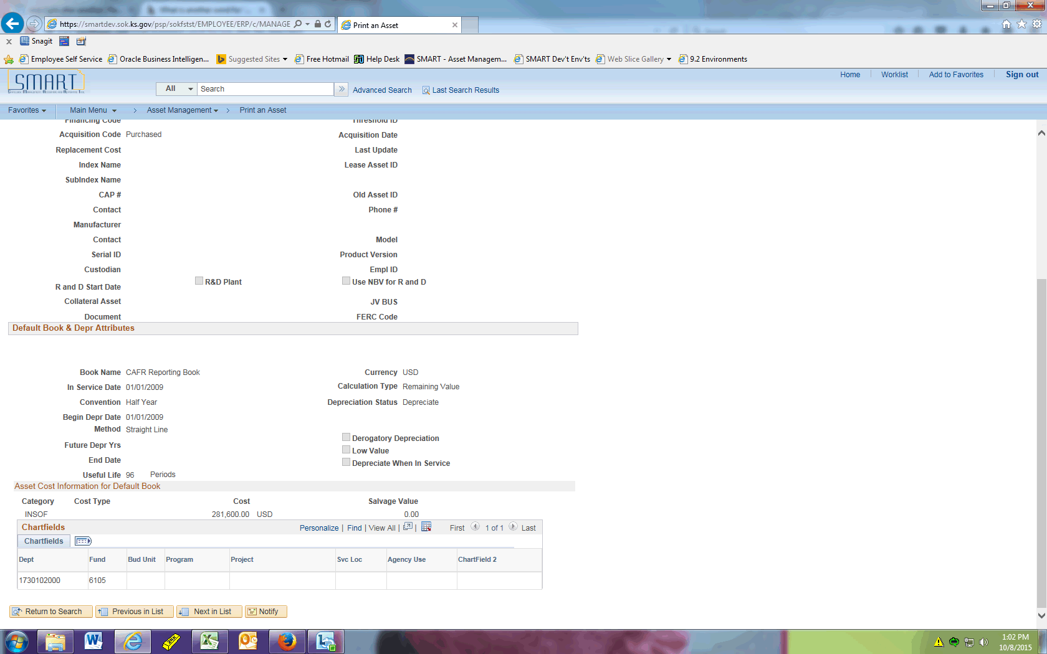

| **Step** | **Action** |
| --- | --- |
|  | The Default Book and Depr Attributes section displays financial data for the asset. |
|  | You can click the printer icon at the top of the page to generate a PDF version of the Printable View of Asset page. This can be printed and/or saved as a PDF file. |
|  | This concludes the 'AM - Printable View of an Asset' topic. Thank you for taking this course.  **End of Procedure.** |