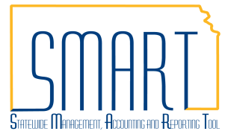
State of Kansas
WIRE Transfer Voucher
Statewide Management, Accounting and Reporting Tool

Date Created |  | 11/19/2012
Version |  | 2.1
Last Update |  | 04/26/2019
Security: |  | - Role Security: Only those individuals with the following roles will have  access to accomplish the following actions in SMART:  Create and modify a voucher:  - Agency AP Processor (KAP_Agy_AP_Processor)  Approve a voucher:  - Agency AP Approver (KAP_Agy_AP_Approver)  - BU Security: Business Unit Security is applied. Agencies will only have access to the vouchers associated to their agency business unit.
Additional Information:
- This process is to be used for any type of payment that utilizes the State Treasurer’s Office to wire funds, or to recognize debits (i.e. tax payments) to the State’s account.
- The voucher should be created and Saved, matched (if applicable), budget checked, and agency approved in SMART prior to the funds being released by the State Treasurer’s Office (STO). This needs to be completed no later than 9:30am on the date the wire is to be transferred. Vouchers may be entered ahead of time (i.e. the day prior) in order to accommodate meeting the 9:30am deadline.
- For foreign currency wire transfers, the agency must confirm the daily currency exchange rates with the State Treasurer’s Office and ensure the voucher reflects the correct rates.
- See Informational Circular 19-A-004 Agency Wire Transfer Policy for additional information.
Navigation |  | - Accounts Payable Homepage > Vouchers > Add/Update > Regular Entry  - NavBar: Navigator > Accounts Payable > Vouchers > Add/Update > Regular Entry
1. | Create a voucher and modify it to reflect the wire transfer payment method  - Use the ‘Add a New Value’ tab to Add a voucher and populate the fields as necessary for the voucher creation.  - On the Payments tab of the voucher enter the date the wire will be transferred into the ‘Scheduled Due’ field.  - Update the payment Method field to ‘WIR’.  - Enter pertinent info about the payment in the ‘Message’ field.  Save the voucher. | 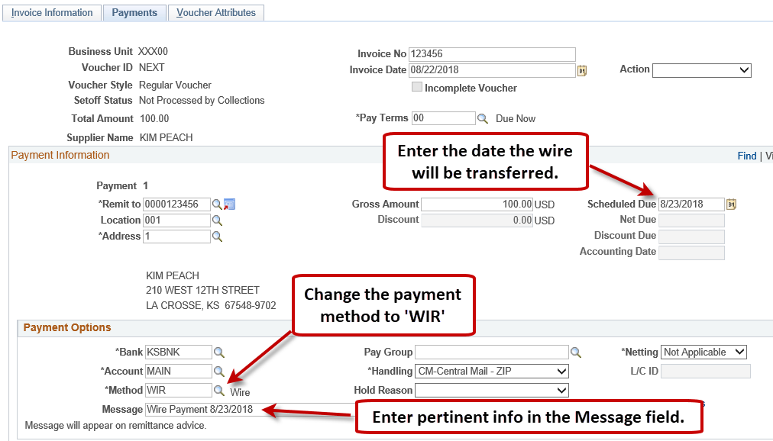

2. | Notify Agency Audit Services and the State Treasurer’s Office (STO) of the wire payment. | By 9:30am, send an email to Agency Audit Services (arpreaudit@ks.gov) and the State Treasurer’s Office (treascash@treasurer.state.ks.gov) with the following information about the wire payment:  - Voucher ID  - Supplier name  - Amount  - Date the wire is to be transferred
3. | By 9:30am, the Summary tab of the voucher should reflect the following statuses in order for the wire to be transferred:  - Match Status: ‘Matched’ or ‘No Match’  - Budget Status: ‘Valid’  - Approval Status: ‘Approved’*  Note: The batch processes that run matching, budget checking, and submit vouchers into approval workflow run at the top of the hour during the day. Ensuring the voucher is Saved before the 9am hourly batch process kicks off, on the date the wire is to be transferred, allows for the voucher to be ready for approval before the 9:30am deadline.  *If the voucher amount is over the agency’s delegated authority, confirm that the Agency Fiscal Office Level approvals are complete by viewing Approval History. | 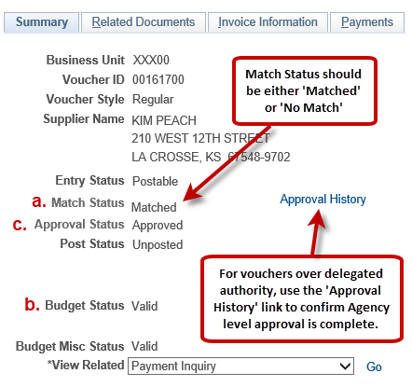  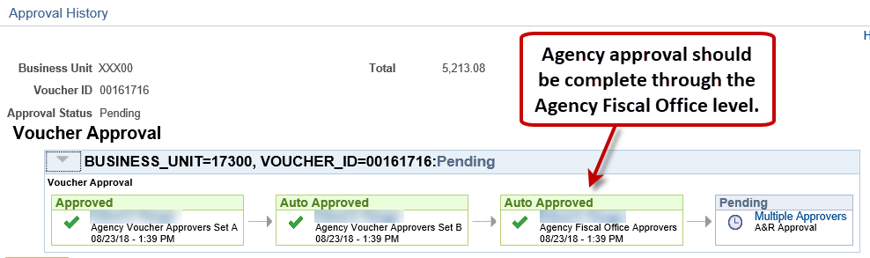
4. | Wire is transferred and payment is recorded on the voucher | After the voucher has been reviewed and approved, Agency Audit Services will contact the State Treasurer’s Office to confirm the wire should be sent. At this point, STO will transfer the wire payment and Agency Audit Services will record the payment on the voucher. The Payment Date and Reference fields on the Payments tab of the voucher will be populated.  