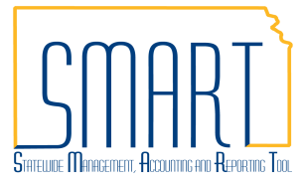
State of Kansas
Reviewing Historical Payment Data
for Accounts Payable Vouchers
Statewide Management, Accounting and Reporting Tool

Date Created |  | 04/29/2016
Version |  | 1.1
Last Update |  | 05/08/2019
Security: |  | - Role Security: Only those individuals with the following roles will have access to view Budget Errors for vouchers:  - Agency AP Processor (KAP_Agy_AP_Processor)  - BU Security: Business Unit Security is applied. Agencies will only have access to view the payment information associated with their agency business unit.
Purpose: |  | - The purpose of this job aid is to provide agencies with a way to look up historical payment information. Agencies can view data for payments including the payment method, payment date, payment reconcile status, voucher ID(s) associated with the payment, and supplier address associated with the payment.
Navigation
- Accounts Payable Homepage > Voucher > Add/Update > Regular Entry: Find an Existing Value
- NavBar: Navigator > Accounts Payable > Vouchers > Add/Update > Regular Entry: Find an Existing Value
1. | Find the Reference number for the payment.  Navigate to the Payments tab of the Voucher.  The Reference number on the voucher is the same as the check number. | 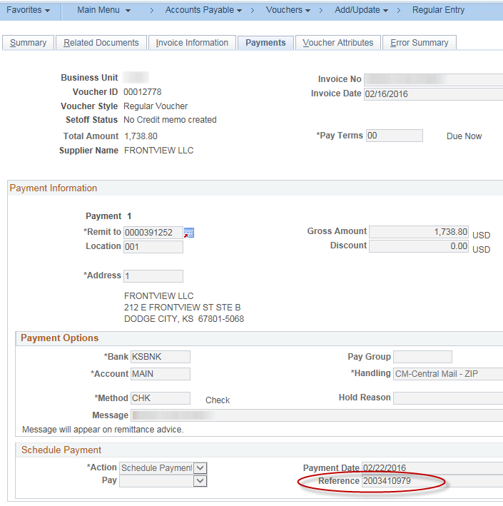

Navigation
- Accounts Payable Homepage > Payments > Payment Inquiry > Payment
- NavBar: Navigator > Accounts Payable > Review Accounts Payable Info > Payments > Payment
2. | Navigate to the Payment Inquiry page  Key the check number/payment reference in the ‘From Ref ID’ field. Click the Search button.  In the results section, click the Payment Reference ID hyperlink. This will allow you to view more details about the payment. | 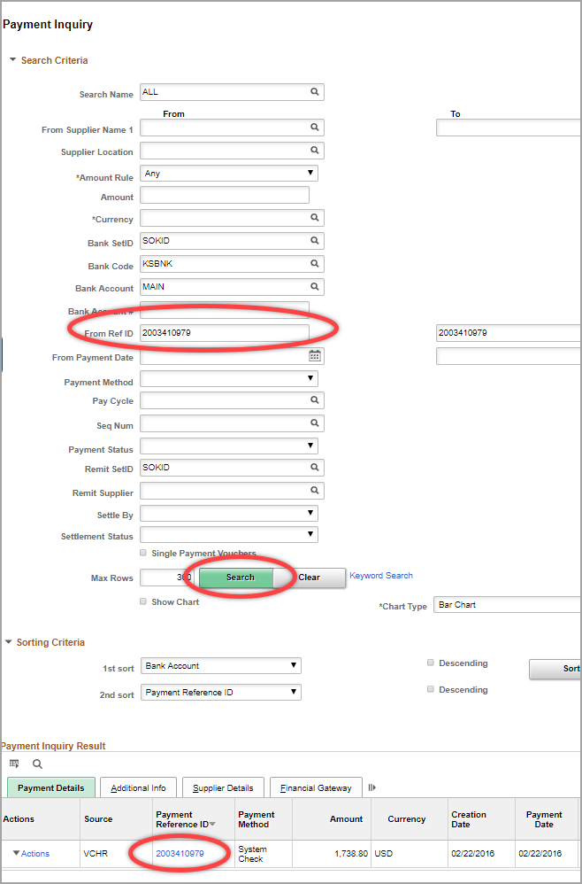

3. | View Payment Information
