
State of Kansas
Cancel for Reissue (DA-6)
Statewide Management, Accounting and Reporting Tool

Date Created: |  | 07.08.14
Version: |  | V.1.0.
PPM 11,961 Deletion |  | As of July 15, 2014, PPM 11,961 has been deleted from the website. The practice for cancelling checks has become more procedural rather than policy driven.  No additional documentation is to be sent to the Financial Systems Desk (i.e., paper checks or DA-6 form). If agency has paper check in hand, it is at their discretion on how they wish to retain this instrument. The DA-6 form attached to the Manage Engine Help Desk ticket will be sufficient documentation for Financial Systems Desk use.
Reason for Job aid - |  | This job aid is to be used as reference for submitting the correct form to the Financial Systems Desk via Manage Engine Help Desk ticket.  Each form’s example will enable agency to determine which form best suits agency’s situation.
1. | Processing time | In order to process requests in a timely manner, the Financial Systems Desk has a cut-off time of 12:30 p.m. daily.  Tickets received before 12:30 p.m. will be processed that day.  Tickets received after 12:30 p.m. will be processed the following day.
2. | Go to the Department of Administration website’s document center | http://www.admin.ks.gov/resources/document-center
3. | There are four (4) separate forms that can be used. | 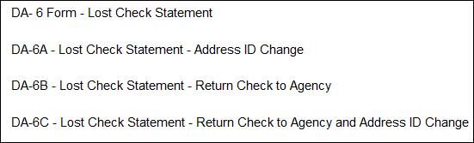
4. | Decide which form best suits the agency’s situation | DA-6 – Lost Check Statement. Agency needs to have a check reissued and there are no changes to be made to replacement check.  DA-6A – Lost Check Statement – Address ID Change. Agency needs to have a check reissued and the ONLY change is to a different address ID (handling code is fine).  DA-6B – Lost Check Statement – Return Check to Agency. Agency needs to have a check reissued and the ONLY change is to have replacement check come back to agency (address ID is fine).  DA-6C – Lost Check Statement – Return Check to Agency. Agency needs to have a check reissued and needs to have the check come back to agency as well as check issued to a different address ID than original check.
5. | After determining which form best suits agency’s need, download proper form and complete. | Each form has been created to be used as an example in assisting agency in correctly completing the proper form for their request.
6. | Completing DA-6 – Lost Check Statement (example)  **This form is to be used when there are NO changes needed to a replacement check** | 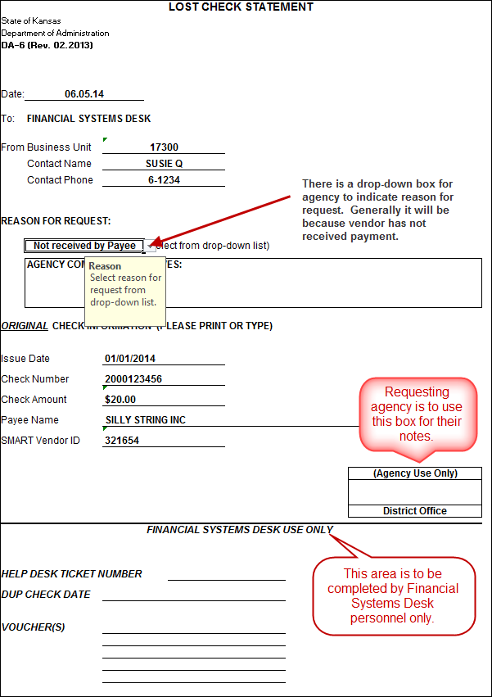
7. | Completing DA-6a – Lost Check Statement – Address ID Change (example)  **This form is to be used when the replacement check needs to be issued to a different address ID only** | 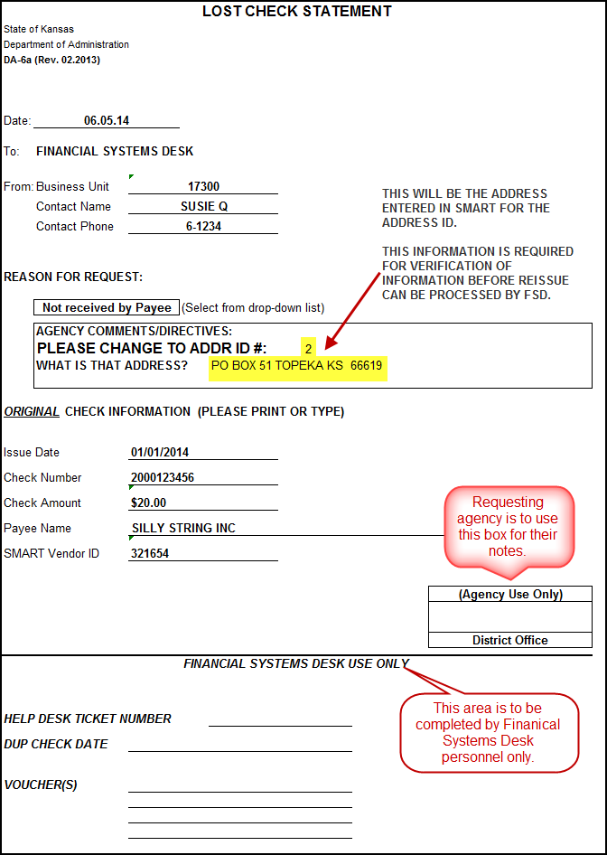
8. | Completing DA-6b – Lost Check Statement – Return Check to Agency (example)  **This form is to be used when the replacement check needs to be returned to issuing agency only**  Agency is to review how original check was coded when deciding to use this form.  Example:  If original check was coded as CM (Central Mail), and agency needs to have replacement check returned to agency for agency to mail out, then this is the form to complete. | 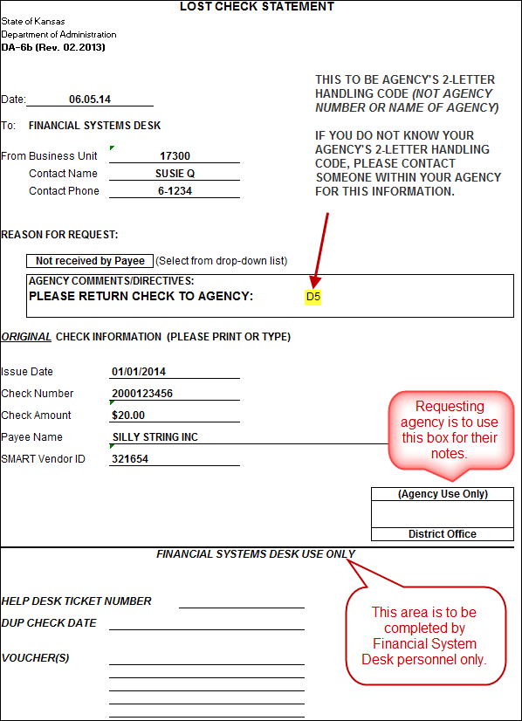
9. | Completing DA-6c – Lost Check Statement – Return Check to Agency (example)  **This form is to be used when the replacement check needs to be returned to issuing agency as well as an address ID change**  Agency is to review how original check was coded when deciding to use this form.  Example:  If original check was coded as CM (Central Mail), and agency needs to have replacement check returned to agency for agency to mail out, then agency’s 2-letter handling code is to be entered. | 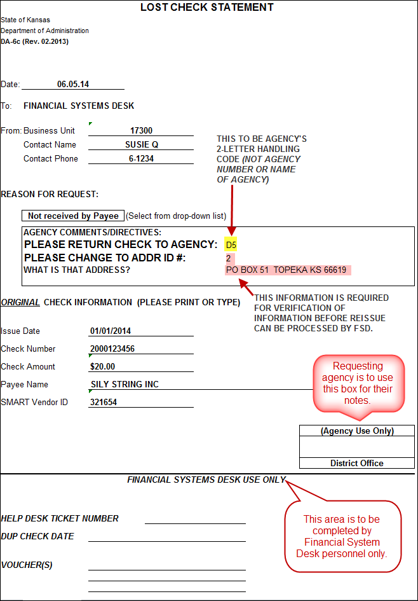
10. | Submit completed form via Manage Engine Help Desk ticket. | https://dahelpdesk.ks.gov  NOTE: If you are unsure how to complete a Manage Engine Help Desk ticket, please refer to the Manage Engine – Job Aid “Creating a Vendor Service Desk Request “ job aid for further instructions.  Here is the link: http://smartweb.ks.gov/training/manageengine/creating-a-help-desk-ticket
11. | Subject Line | The subject line of the ticket should have DA-6 Cancel for Reissue in it.  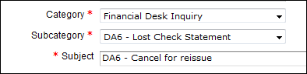
12. | EMERGENCY requests only | If request is an emergency (i.e., reissue request needs to be processed same day to prevent vendor’s utility from being terminated), this information needs to be conveyed in subject line, in body of help desk ticket body,  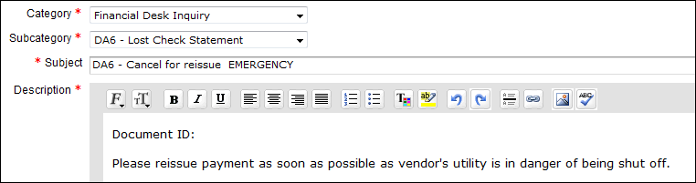  and on the DA-6 form in the COMMENTS/DIRECTIVES box.  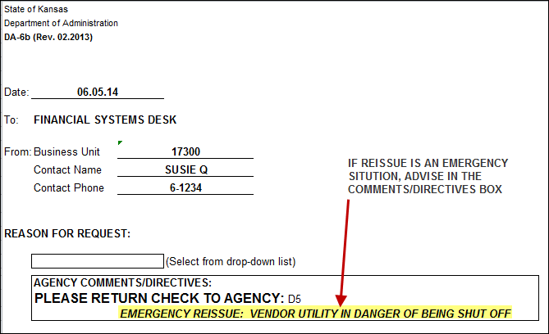
13. | Ticket closed – SUBJECT LINE | When the Financial Systems Desk has processed request, the ticket will be closed. Requestor will receive an email notifying of the ticket being closed.  A short statement will be noted in the subject line advising what was processed  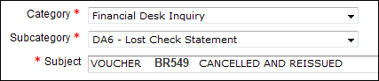
14. | Ticket closed – RESOLUTION TAB | Agency is able to view the Resolution tab of the ticket to see when the ticket was closed as well as viewing any additional information which might not be in the Subject line.  

