State of Kansas
Using the KS_ACCT_REGISTER_ESCHEATMENT_REPORT
(Kansas Account Register Report for Escheated Checks)

Date Created: | 11/18/2013
Version: | 2.0
Last Updated Date: | 10/28/2014
Purpose of the Report: | The purpose of this report is to identify escheated checks.  A check is escheated when it is 12 months old (or more) and has not cleared the State Treasurer’s Office for payment.  This report provides results of all checks that have been escheated within the date parameters entered.  The report results include: Check Number, Transaction Amount, Issue Date, Payment Status, Payment Detail, Reconciliation Method, Status
Report parameters: | The report parameters are:  - Bank ID: (Use Look-up to find ‘STATE OF KANSAS BANK’)  - Bank Account #: (Use Look-up to find ‘ST BANK’)  - Business Unit: (Enter Agency Business Unit)  - Reconciliation Status: Reconciled  - Payment Status: Escheated Check  - Payment Method: System Check  - Reconcile From Date: (See Section 2.(A) or 2.(B) of this document)  - Reconcile Thru Date: (See Section 2.(A) or 2.(B) of this document)  - Issue From Date: (See Section 2.(A) or 2.(B) of this document)  - Issue To Date: (See Section 2.(A) or 2.(B) of this document)
Prompt Values: | Required Prompt Values:  - Business Unit  - Issue From Date  - Issue To Date
Result Sorts: | The Report results are displayed, sorted in the following order:  - Check Number
Security: | Security Role Access: Only those individuals assigned the following security access roles will receive results from this report:  - KS_AGY_AP_PROCESSOR  Business Unit Access: Business Unit Security is applied

1. | Navigation:  From the Home page  in SMART, on the left  navigation menu, click  on ‘Banking’,  then click on ‘Reports’,  then click on ‘Kansas Account Register’.  Add a ‘Run Control ID’.  Click the ‘Add’ button. | 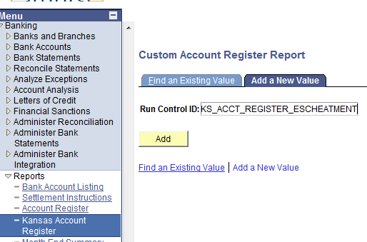
2.(A) | Clicking the ‘Add’ button opens the ‘Custom Account Register Report’ page in a new window.  Enter the Input Parameters:  Bank ID: (Use Look-up to find ‘STATE OF KANSAS BANK’)  Bank Account #: (Use Look-up to find ‘ST BANK’)  Business Unit: Enter your Business Unit number  Reconciliation Status: Reconciled  Payment Status: Escheated Check  Payment Method: System Check  Reconcile From Date: (leave blank)  Reconcile Thru Date: (leave blank)  Issue From Date: Enter Beginning Date  Issue To Date: Enter Ending Date  Using the ‘Issue From’ and ‘Issue To’ dates will retrieve checks that were originally issued between the date ranges entered (that have since been escheated).  In the ‘Reporting Option’ section, select the ‘Both’ radio button.  Next click the ‘Save’ button, and then click the ‘Run’ button. | 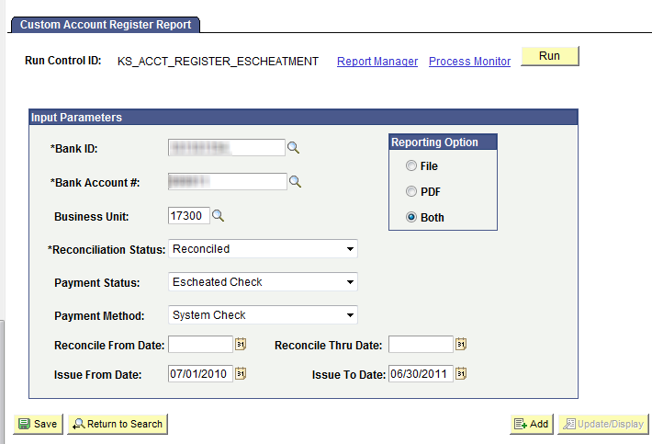
OR  2.(B) | Clicking the ‘Add’ button opens the ‘Custom Account Register Report’ page in a new window.  Enter the Input Parameters:  Bank ID: (Use Look-up to find ‘STATE OF KANSAS BANK’)  Bank Account #: (Use Look-up to find ‘ST BANK’)  Business Unit: Enter your Business Unit number  Reconciliation Status: Reconciled  Payment Status: Escheated Check  Payment Method: System Check  Reconcile From Date: Enter Beginning Date  Reconcile Thru Date: Enter Ending Date  Issue From Date: (leave blank)  Issue To Date: (leave blank)  Using the ‘Reconcile From’ and the ‘Reconcile Thru’ dates will retrieve checks that were escheated within the date ranges entered.  Next, in the ‘Reporting Option’ section, click the ‘Both’ radio button.  Next, click the ‘Save’ button, and then click the ‘Run’ button. | 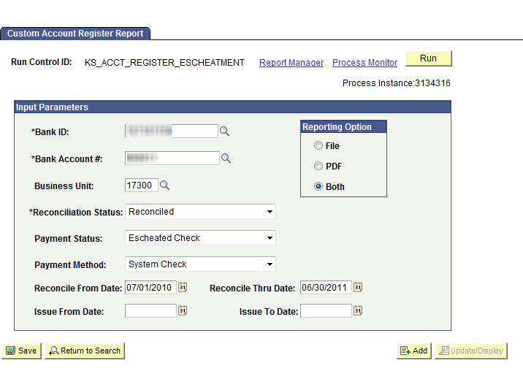
3. | Clicking the ‘Run’ button opens the Process Scheduler Request page in a new window.  Since the Account Register Report defaults in as selected, simply click the ‘OK’ button. | 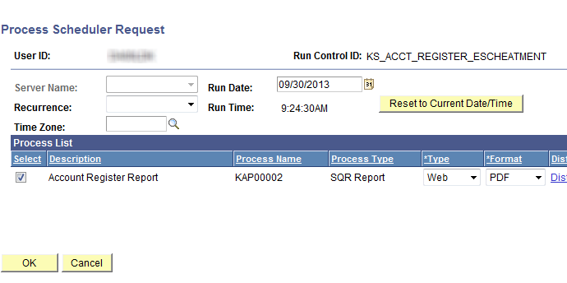

4. | Clicking the ‘OK’ button, returns you to the ‘Custom Account Register Report’  page.  Click the ’Process Monitor‘ link. | 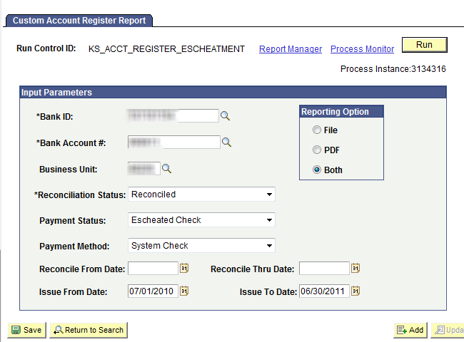
5. | Clicking the Process Monitor link opens the Process List page.  Click the ‘Refresh’ button every couple of minutes until the report status is ‘Success’ and ‘Posted’.  Next, click the ‘Details’ link. | 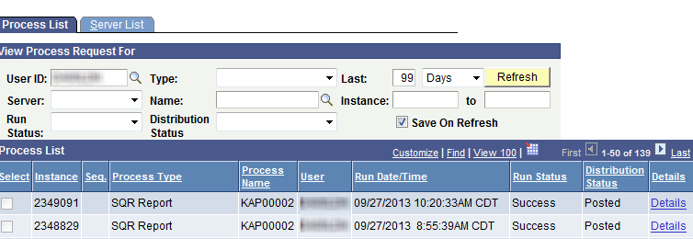
6. | Clicking the Details link opens the Process Detail page.  In the Actions section, click the ‘View Log/Trace’ link. | 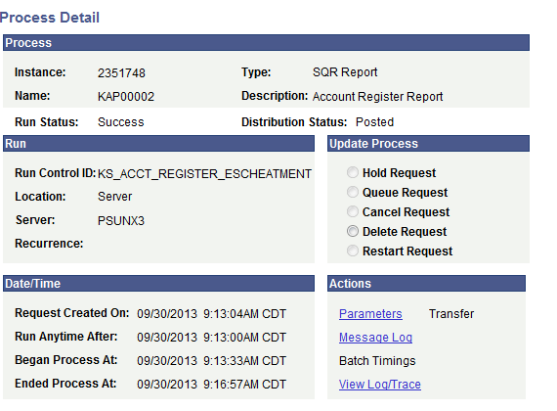
7. | Clicking the ‘View Log/Trace’ link opens the ‘View Log/Trace’ page.  Use the ‘View Log/Trace’ page to specify HOW you wish to view the report results.  There are several options available.  Example One:  Select the PDF file link.  In this example: The ‘kap00002.####### .PDF’ link is selected. | 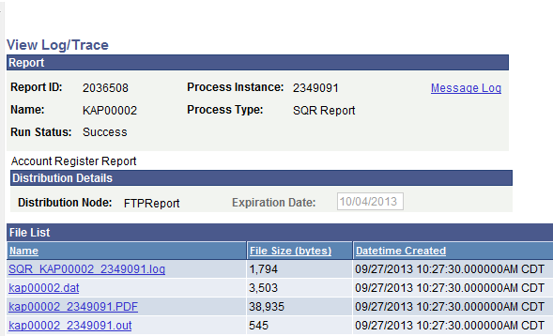
8. | Clicking the PDF file link opens the ‘Kansas Account Register’ Report as a PDF document. | 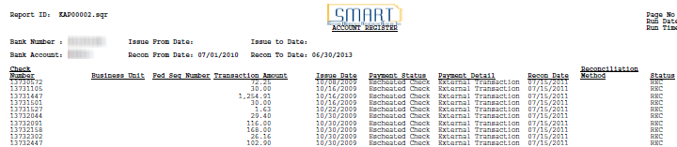
9. | Example Two:  To export a report into Excel, right click on the ‘kap00002.dat’ link.
10. | Right clicking on the ‘.dat’ link prompts a ‘Save As’ window to appear.  Save the ‘kap00002.dat’ file to the desired file location, by clicking on the ‘Save’ button. | 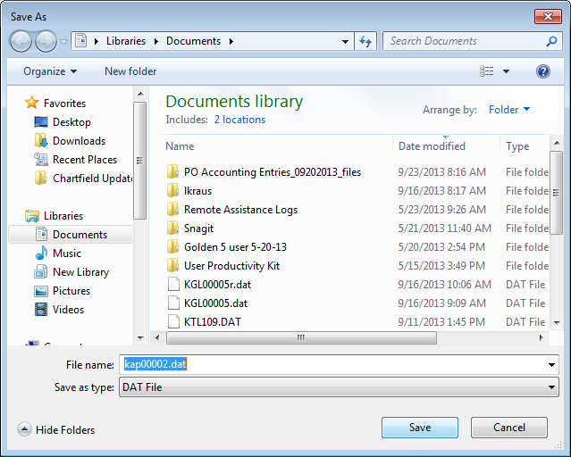
11. | Next, open the file using Excel.  Open Excel, locate the file you want to open, and click the ‘Open’ button.  . | 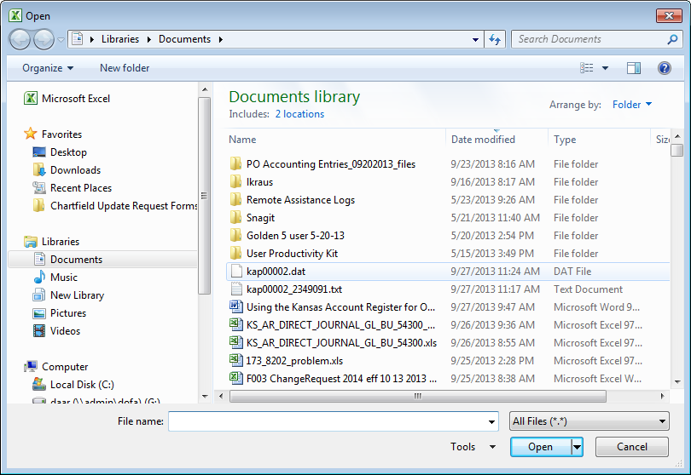
12. | Clicking the ‘Open’ button, prompts a ‘Text Import Wizard’ to display.  Step 1 of 3: Select the ‘Delimited’ radio button, and then click the ‘Next’ button, located at the bottom of the page. | 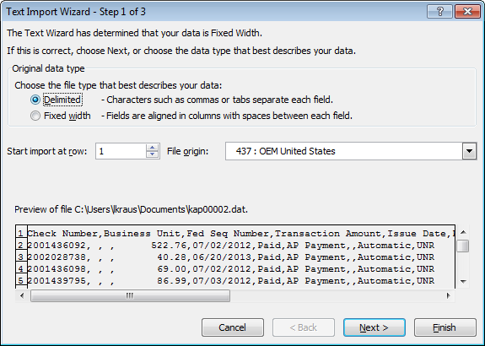
13. | Step 2 of 3: In the ‘Delimiters’ section, click the ‘Comma’ checkbox. Then, click the ‘Next’ button located at the bottom of the page. | 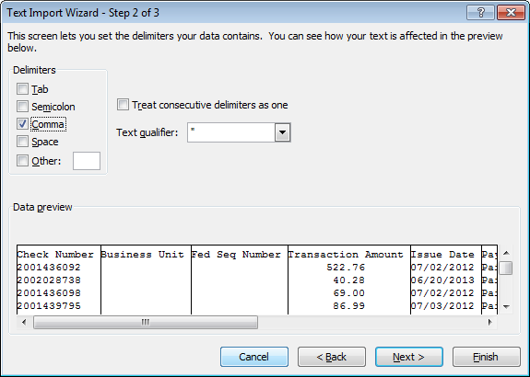
14. | Step 3 of 3: Click the ‘Finish’ button. | 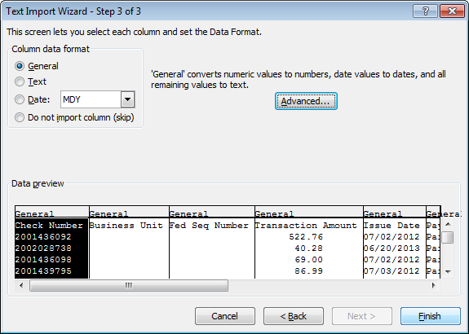
15. | The file is imported into Excel where it can be manipulated with many of Excel’s functions. | 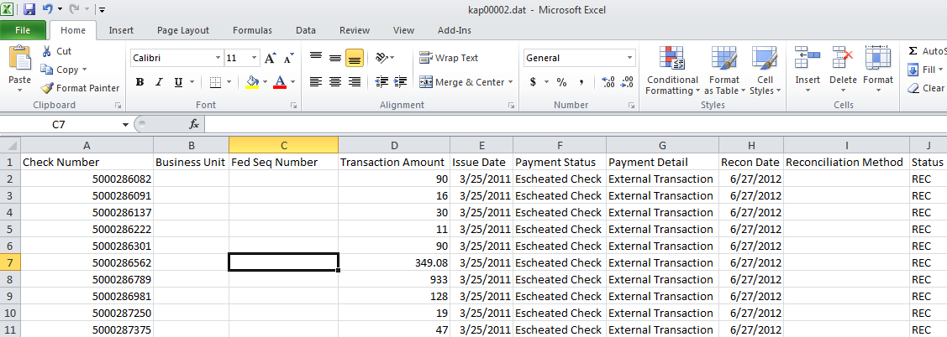
NOTE: |  | This use of the Kansas Account Register(KAP00002) will provide agencies with a listing of checks that have been escheated.

